Professional Development Guide for Overseas Nurses

Name:

# 

*CapitalNurse is jointly sponsored by Health Education England, NHS England and NHS Improvement*

Contents

**Introduction** 3

**A bit about yourself** 5

**SWOT Analysis** 6

**Career Aspirations** 7

**Self-assessment** 10

**Reflection** 11

**Useful resources** 12

**First week checklist** 14

**Meeting with your manager** 15

**Understanding the NMC Code** 16

**Preparing for your OSCE** 19

**Useful tips and advice** 19

**Revalidation** 21

# **Introduction**

Congratulations on making the first steps to becoming a Nurse in London. We know that starting a career can be tough, even more so if it involves moving to another country. We want to make this transition as easy as possible for you by supporting you with settling into your new role.

The CapitalNurse programme is a collective action in London and our vision is to ‘get nursing right for London’; ensuring that London has the right number of nurses, with the right skills in the right place, working to deliver excellent nursing wherever it is needed. As part of our CapitalNurse offer we have developed a toolkit to support your transition and to give you some helpful resources that will prepare you for the next few months and in your career as registered nurse in London. Please take some time to read this toolkit and begin completing the relevant sections before you arrive in London, and then throughout the registration process, until you have successfully obtained NMC registration. Your manager will also refer to the toolkit through the appraisal system, in order to support you in your professional development.

The toolkit is broken down into 3 domains:

|  |  |
| --- | --- |
|  |  |
|  |  |

**Pre-Arrival**

**A bit about yourself**

Please use this section to tell us a bit about yourself and your background. This will help us determine what support we can put in place for you.

|  |
| --- |
| What is your current job and what does it involve? |
|  |
| Why did you want to become a nurse and how long have you been nursing? |
|  |
| What are your skills? |
|  |
| What are you looking forward to by working for the NHS? |
|  |
| What are your concerns working for the NHS? |
|  |
| What are your expectations working for the NHS? |
|  |

**SWOT Analysis**

Use this page to identify your own strengths, weaknesses etc. For the exercise it is helpful to be both honest and realistic.

|  |  |
| --- | --- |
| Strengths  What am I good at? | Weaknesses  What do I find difficult? |
|  |  |
| Opportunities  What resources are available to me? | Threats  What constraints do I have? e.g. time, family, etc |
|  |  |

**Career Aspirations**

Use this page to tell us about your career aspirations. Your manager will be able to refer to this section when it comes to your annual appraisal.

|  |
| --- |
| When you start your first job as a Nurse in London, what are initial goals? |
|  |
| What are your career aspirations/goals? |
|  |
| How will your talent and skills help you develop your career? |
|  |
| Describe how we can help you? |
|  |

**CapitalNurse Career Framework**

This tool is designed to progress a London-wide approach to career progression in nursing. The aim of the workstream is to reduce variability in education and training approaches and to achieve greater standardisation across the capital

The framework has nine domains:

1. Clinical practice
2. Communication
3. Teamwork
4. Leadership
5. Professionalism and integrity
6. Research and evidence
7. Safety and quality
8. Facilitation of learning
9. Development of self and others

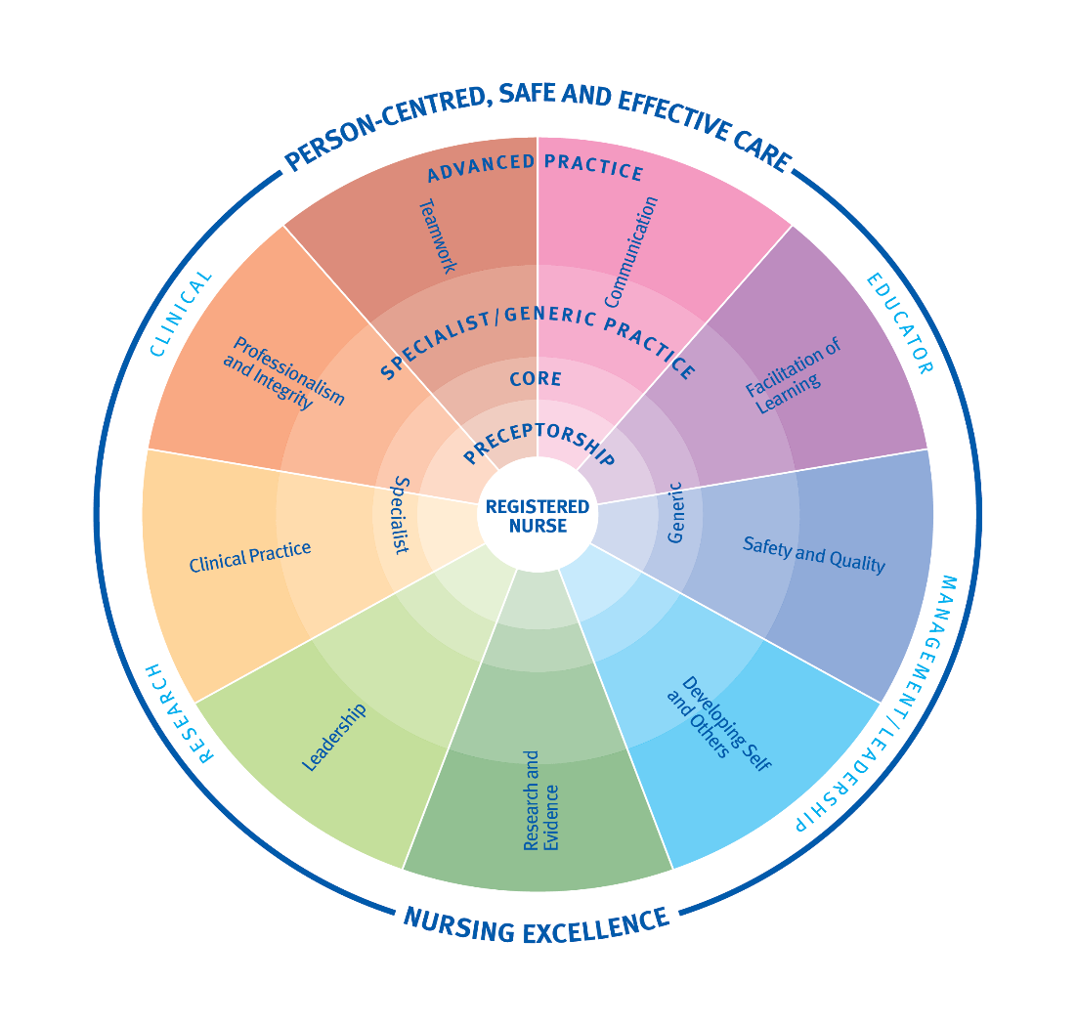

Figure 1 Career Progression Framework *© Capital Nurse, 2016*

**Definition of the nine domains**

|  |  |
| --- | --- |
| **Domain** | **Definition** |
| 1. **Clinical practice** | Delivery of person-centred, safe and effective care. |
| 1. **Communication** | Sharing of health and care related information between a nurse and those in their care with both participants as sources and receivers. Information may be verbal or non-verbal, written or spoken. |
| 1. **Teamwork** | A dynamic process involving two or more health care workers who work together effectively to achieve value added, patient, staff and organisational outcomes (WHO, 2012). |
| 1. **Leadership** | The capacity to influence people by means of personal attributes and/or behaviours to achieve a common goal (CIPD, 2016). |
| 1. **Professionalism and integrity** | A set of values, behaviours and relationships which underpins the trust the public has in nurses. |
| 1. **Research and evidence** | Contributing to the body of nursing knowledge and using evidence to inform safe and effective practice. |
| 1. **Safety and quality** | Reducing the risk of harm and ensuring the best possible health outcomes for those receiving care. |
| 1. **Facilitation of learning** | Creating an environment for learning and engaging in teaching and assessment. |
| 1. **Development of self and others** | Helping self and others to identify learning needs and opportunities to achieve agreed goals. |

Each practitioner will demonstrate a level of practice within each domain to varying degrees throughout their career. For example, the newly registered practitioner would be expected to maintain a high level of clinical practice and professionalism, trust and progress to higher levels of the other domains during their preceptorship period.

We have provided you with some of the Career Framework templates to start supporting your professional development. We recommend signing up to the electronic version of this framework upon completion of this workbook.

<https://www.hee.nhs.uk/our-work/capitalnurse/workstreams/career-framework>

**Self-assessment**

Use this self-assessment tool to determine your strengths and areas to develop.

|  |  |  |
| --- | --- | --- |
| **Domain** | **Self-Assessment** | **Score** |
| Clinical practice | 10 9 8 7 6 5 4 3 2 1    Very confident         Fairly confident         Not very confident          Not confident |  |
| Communication | 10 9 8 7 6 5 4 3 2 1  Very confident         Fairly confident         Not very confident          Not confident |  |
| Teamwork | 10 9 8 7 6 5 4 3 2 1  Very confident         Fairly confident         Not very confident          Not confident |  |
| Leadership | 10 9 8 7 6 5 4 3 2 1  Very confident         Fairly confident         Not very confident          Not confident |  |
| Professionalism & integrity | 10 9 8 7 6 5 4 3 2 1  Very confident         Fairly confident         Not very confident          Not confident |  |
| Research & evidence | 10 9 8 7 6 5 4 3 2 1  Very confident         Fairly confident         Not very confident          Not confident |  |
| Safety & quality | 10 9 8 7 6 5 4 3 2 1  Very confident         Fairly confident         Not very confident          Not confident |  |
| Facilitation of learning | 10 9 8 7 6 5 4 3 2 1  Very confident         Fairly confident         Not very confident          Not confident |  |
| Development of self and others | 10 9 8 7 6 5 4 3 2 1  Very confident         Fairly confident         Not very confident          Not confident |  |

**Reflection**

Reflection is the process of making sense of an experience in order to learn and improve as a practitioner. Often, we reflect as part of our everyday practice without being aware that we are doing it – for example, on the way home from work.

Using reflection within health and social care has benefits for patients and the profession. In order to do this effectively, reflection involves describing, analysing and evaluating experiences from practice in a way that helps you make sense of it. Reflection can occur prior to, during and often after an event or experience, all of which can allow learning.

When you obtain your Nursing and Midwifery Council (NMC) PIN to practice as Nurse in the UK you will be asked to revalidate every three years, and part of that process is to write reflections. However, we will go through this a bit further in the document.

To start thinking about reflection before you arrive in the UK, try having a go writing a small reflective piece on an experience where you learnt something in your nursing career in your own country.

|  |
| --- |
| **What was the experience?** (describe what happened) |
|  |
| **What did you learn?** (think about what went well/didn’t go so well) |
|  |
| **What would you do differently next time?** (would you change anything about your practice in relation to that event) |
|  |

**Useful resources**

To prepare you for your arrival in the UK to work as a registered nurse, we have put together some useful resources for you to familiarise yourself.

|  |  |
| --- | --- |
| Nursing and Midwifery Council (NMC) | <https://www.nmc.org.uk/>  <https://www.nmc.org.uk/standards/code/> |
| CapitalNurse | <https://www.hee.nhs.uk/our-work/capitalnurse> |
| Transport for London | <https://tfl.gov.uk/> |
| London Mayors Website | <https://www.london.gov.uk/> |
| NHS | <https://www.nhs.uk/> |
| Royal College of Nursing (RCN) | <https://www.rcn.org.uk/> |
| Unison | <https://www.unison.org.uk/> |

**Preparing for NMC Registration**

**First week checklist**

Welcome to your team!

The first few weeks in a new job and preparing for your OSCE can be daunting, right? We want to make sure you settle in with ease and have provided you with some resources/tools to help you. Whilst you may not have the time to complete everything, it gives you some pointers and helpful reminders.

|  |  |
| --- | --- |
| **Familiarise yourself with your department and Trust** | Make sure you know where you are going. It might even be worth asking your manager for a map of the hospital site you are working in. |
| **Complete your E-learning** | It’s a great idea to start completing all of your e-learning as soon as possible. |
| **Take a look around the intranet** | Familiarise yourself with the intranet site as that is where you can keep up to-date with what’s happening in the Trust. |
| **Introduce yourself to your colleagues** | It is a great idea to introduce yourself to your new team when you are given your local induction. |
| **Don’t be afraid to ask questions** | Everybody has been in a new job. Your manager is there to support you, so don’t be afraid to ask him/her questions. |
| **Social media** | Follow your Trust’s social media account. It can be a great way to keep up to date with what’s going on |
| **Trust values** | Familiarise yourself with your Trust values and think about what they mean to you and care you will be delivering to your patients. |

**Meeting with your manager**

Please complete this section with your manager.

Your initial meeting should take place within 7 days of starting in your clinical area

|  |  |
| --- | --- |
| Area of Practice: | |
| Managers Name: Date of Meeting: | |
| Your expectations: | |
| Identify learning needs for the next 4 weeks (this can be drawn from your SWOT analysis and linked with any OSCE preparation and local/Trust induction) | |
| Outline of learning plan? | How will this be achieved? |
| Next meeting date: | |
| Signature: | |
| Managers Signature: Date: | |

**Understanding the NMC Code**

Registered nurses are required to demonstrate high standards of professional conduct at all times, work within ethical and legal frameworks,and be able to articulate the underpinning values of The Code (NMC, 2018). Professional Values reflect a number of proficiency statements and are captured under the 4 sections of The Code.

Before you obtain registration, we recommend reading The Code and to asses yourself on how you would be able to demonstrate the proficiency’s in clinical practice.

|  |  |
| --- | --- |
| **Professional values** | **Give 3 examples of how you would evidence in practice**  **(tip: look up the NMC code)** |
| **Prioritise People**   * Treat people as individuals and uphold their dignity * Listen to people and respond to their preferences and concerns * Make sure that people’s physical, social and psychological needs are assessed and responded to * Act in the best interests of people always * Respect people’s right to privacy and confidentiality |  |

|  |  |
| --- | --- |
| **Practice Effectively**   * Always practise in line with the best available evidence * Communicate clearly * Work cooperatively * Share your skills, knowledge and experience for the benefit of people receiving care and your colleagues * Keep clear and accurate records relevant to your practice * Be accountable for your decisions to delegate tasks and duties to other people * Have in place an indemnity arrangement which provides appropriate cover for any practice you take on as a nurse, midwife or nursing associate in the United Kingdom |  |
| **Preserve Safety**   * Recognise and work within the limits of your competence * Be open and candid with all service users about all aspects of care and treatment, including when any mistakes or harm have taken place * Always offer help if an emergency arises in your practice setting or anywhere else * Act without delay if you believe that there is a risk to patient safety or public protection * Raise concerns immediately if you believe a person is vulnerable or at risk * Advise on, prescribe, supply, dispense or administer medicines within the limits of your training and competence, the law, our guidance and other relevant policies, guidance and regulation |  |
| **Promote professionalism and Trust**   * Uphold the reputation of your profession at all times * Uphold your position as a registered nurse * Fulfil all registration requirements * Cooperate with all investigations and audits * Respond to any complaints made against you professionally |  |

**Preparing for your OSCE**

The OSCE is designed to assess your ability to competently apply your professional skills and knowledge in the UK. It is set at the level expected of nurses and midwives as they enter the profession. This means you must show that you can apply knowledge to the care of patients at the level expected of a newly registered nurse or midwife. You should already be undertaking the OSCE preparation with your Trust. However, you may find these links also useful for your preparation:

* <https://www.nhsemployers.org/news/2018/02/new-resource-launched-to-support-transition-into-uk-nursing-practice>
* <http://www.northampton.ac.uk/wp-content/uploads/2015/10/Preparing-for-your-OSCE-examination-June2017-v3.pdf><https://www.northampton.ac.uk/wp-content/uploads/2017/03/Preparing-for-your-OSCE-examination-Feb2017-v2.pdf>

**Useful tips and advice**

1. Try not to be nervous, stay calm - you know this
2. Read, read and read again the paperwork for the stations and make sure you understand fully what is expected of you during the assessment.
3. Ensure you are presented as you would need to be in practice. This includes: no jewellery, long hair tied up, no nail polish, flat shoes and short sleeves.
4. When introducing yourself to the patient, introduce yourself as one of the nurses at the hospital not as an NMC applicant
5. Make sure you have eaten before your OSCE assessment. You will be in the test centre for at least 3 hours; once you are registered you are not allowed to go outside of the centre.
6. Arrive in plenty of time to allow for traffic.
7. Reading tip – The assessment is based on the Royal Marsden, we advise (if you can) to read elements of this for reference purposes
8. Make sure you prepare for your OSCE at the appropriate level, remember the OSCE is set at the level expected of nurses entering the register.

**Post NMC Registration**

**Revalidation**

Congratulations on joining the NMC register. This section of the toolkit offers you some simple step-by-step professional development tools, to develop your skills and practice through reflection and personal growth. You may find this useful in applying for future roles in the NHS. It will also help with gathering your revalidation evidence.

**Continuing Professional Development (CPD)**

In April 2016, the NMC introduced revalidation and a requirement that every UK registered nurse needs to obtain a minimum requirement of 35 hours of CPD over the three years for nurses to be able to remain on the register, and will need to evidence this by recording them in a portfolio.

**What is CPD**

The main purpose is to help staff to maintain and develop the skills they need to delivery high quality, safe and effective care across all roles and settings.

Examples of CPD:

* Reading and reviewing publications
* Attending workshops or conferences
* Undertaking research
* Distant learning and webinars
* Mandatory training directly relevant to a nurse’s speciality
* Taking part in clinical audits
* College or university level education or training
* Practice visits to different environments
* Shadowing or secondments
* Structured clinical supervision
* Peer review activities
* Coaching or mentoring of others, or being coached or mentored

**Why is CPD important?**

CPD is important for all nursing staff in all settings. Everyone should be given the opportunity to access learning, whether to develop their career, or remain in their current role and be the best they can. There is international evidence that CPD is vitally important for nursing staff in terms of their professional and personal development and in contributing to improved patient outcomes and increased public confidence.

**Practice Hours**

The NMC require nurses in the UK to practice a minimum of 350 hours over the three years in order to remain on the register.

**Practice related feedback**

You must have obtained five pieces of practice-related feedback in the three-year period since your registration was last renewed or you joined the register.

**Reflective accounts**

We briefly referenced reflections earlier in the toolkit. You must have prepared five written reflective accounts in the three-year period since your registration was last renewed or you joined the register. Each reflective account must refer to:

* an instance of your CPD, and/or
* a piece of practice-related feedback you have received, and/or
* an event or experience in your own professional practice
* and how they relate to the Code.

**Reflective discussion**

You must have had a reflective discussion with another NMC registrant, covering your five written reflective accounts on your CPD and/or practice-related feedback and/or an event or experience in your practice and how this relates to the Code.

All revalidation information/templates can be found <http://revalidation.nmc.org.uk/index.html>

**Recording reflections**

Use this NMC reflective template to record an event, CPD event or feedback since practicing in your clinical areas as a UK registered nurse. Remember you can use this for your revalidation in three years.

|  |
| --- |
| **Reflective account:** |
| **What was the nature of the CPD activity and/or practice-related feedback and/or event or experience in your practice?** |
|  |
| **What did you learn from the CPD activity and/or feedback and/or event or experience in your practice?** |
|  |
| **How did you change or improve your practice as a result?** |
|  |
| **How is this relevant to the Code?**  Select one or more themes: Prioritise people – Practise effectively – Preserve safety – Promote professionalism and trust |
|  |

**Review meeting with your manager**

Please complete this section with your manager. Your review meeting should take place within 1 month of obtaining your NMC registration

|  |
| --- |
| Area of Practice: |
| Managers Name: Date of Meeting: |
| Your self-assessment/reflection on progress. What has gone well and any challenges: |
| Review of previous development objectives: |
| Development plan: Objectives should be SMART – Specific, Measurable, Achievable, Realistic and Timebound |
| Next meeting date: |
| Signature: |
| Managers Signature: Date: |

**Self-Assessment**

Use this self-assessment tool again to record your current levels of confidence in practice. You may want to reflect on any noticeable progress.

|  |  |  |
| --- | --- | --- |
| **Domain** | **Self-Assessment** | **Score** |
| Clinical practice | 10 9 8 7 6 5 4 3 2 1    Very confident         Fairly confident         Not very confident          Not confident |  |
| Communication | 10 9 8 7 6 5 4 3 2 1  Very confident         Fairly confident         Not very confident          Not confident |  |
| Teamwork | 10 9 8 7 6 5 4 3 2 1  Very confident         Fairly confident         Not very confident          Not confident |  |
| Leadership | 10 9 8 7 6 5 4 3 2 1  Very confident         Fairly confident         Not very confident          Not confident |  |
| Professionalism & integrity | 10 9 8 7 6 5 4 3 2 1  Very confident         Fairly confident         Not very confident          Not confident |  |
| Research & evidence | 10 9 8 7 6 5 4 3 2 1  Very confident         Fairly confident         Not very confident          Not confident |  |
| Safety & quality | 10 9 8 7 6 5 4 3 2 1  Very confident         Fairly confident         Not very confident          Not confident |  |
| Facilitation of learning | 10 9 8 7 6 5 4 3 2 1  Very confident         Fairly confident         Not very confident          Not confident |  |
| Development of self and others | 10 9 8 7 6 5 4 3 2 1  Very confident         Fairly confident         Not very confident          Not confident |  |

**Feedback from colleagues**

Obtaining feedback from your patients and/or colleagues will increase your confidence as a registered nurse, either from receiving positive feedback or from feeling a sense of achievement from making areas of improvement based on previous constructive practice you have received. Use this feedback form and ask a colleague you work with to give you some feedback on your practice.

|  |  |  |  |  |  |  |  |
| --- | --- | --- | --- | --- | --- | --- | --- |
| **Domain** | **Statements** | **Feedback rating** | | | | | |
| **Almost never** | **Seldom** | **Sometimes** | **Usually** | **Almost always** | |
| 1. Clinical Practice | Delivers person centred, safe and effective care | 1 | 2 | 3 | 4 | 5 | |
| 1. Communication | Effectively communicates health and care related information with those in their care. Information may be verbal or non-verbal, written or spoken. | 1 | 2 | 3 | 4 | 5 | |
| 1. Teamwork | Works effectively as part of a team to achieve value added patient, staff and organisational outcomes. | 1 | 2 | 3 | 4 | | 5 |
| 1. Leadership | Effectively utilises personal skills and attributes to inspire people to achieve a common goal. | 1 | 2 | 3 | 4 | | 5 |
| 1. Professionalism & integrity | Demonstrates a strong sense of professionalism through values, behaviours and relationships in line with NMC Code of Conduct (2015). | 1 | 2 | 3 | 4 | | 5 |
| 1. Research & evidence | Uses evidence to inform safe and effective practice. | 1 | 2 | 3 | 4 | | 5 |
| 1. Safety & Quality | Takes active measures to reduce the risk of harm and ensure the best possible health outcomes for people receiving care. | 1 | 2 | 3 | 4 | | 5 |
| 1. Facilitation of learning | Contributes to the creation of a learning environment and engages in learning and assessment. | 1 | 2 | 3 | 4 | | 5 |
| 1. Development of self & others | Actively supports self and others to identify learning needs and opportunities to achieve agreed goals. | 1 | 2 | 3 | 4 | | 5 |
| **Date completed:** | | | | | | | |

**Feedback from patients/people receiving care or their relatives/carers**

Your views about the way the nurse has looked after you are important.

* Your feedback will help the nurse’s development
* The feedback you give will not change the way you are looked after
* You do not need to participate

|  |  |  |  |  |  |
| --- | --- | --- | --- | --- | --- |
| **Tick if you are: Person receiving care Relative or carer** | | | | | |
| **How happy are you with the way the nurse:** | Very Happy  MC900423171[1] | Happy  MC900423169[1] | MC900434403[1]I’m not sure | Unhappy  MC900423165[1] | Very unhappy  MC900423163[1] |
| **Cared for you?** |  |  |  |  |  |
| **Listened to you?** |  |  |  |  |  |
| **Understood the way you felt?** |  |  |  |  |  |
| **Talked to you?** |  |  |  |  |  |
| **Showed you respect?** |  |  |  |  |  |

**Career Conversation**

Use this template to record your career conversation with your manager. This should be planned as part of the Capital Nurse offer and take place at 6 months of you starting in your team.

|  |
| --- |
| **How am I doing?** |
|  |
| **How do I fit into the organisation?** |
|  |
| **What is expected of me?** |
|  |

|  |
| --- |
| **Career conversation review *continued*** |
| **What and how should I develop?** |
|  |
| **How will my talents and contributions be recognised?** |
|  |
| **What is next for me?** |
| *[Consider the Pillars of Practice as areas of interest and a potential career path)* |