AHP Workforce in Social care. Optimising collaboration for integration.

­

.



**Carolyne Hague**

**Principal Occupational Therapist, Devon County Council, National AHP HEE Subject Matter Expert**

# Contents

Executive Summary 3

1 Introduction 6

* + Background
  + AHP in social care - workforce data and intelligence

2 Methodology and Objectives ……………………………………………………… ..10

3 Key Observations 17

4 Potential next steps 30

5 References……………………………………………………………………………..37

6 Appendices 40

7.1 Regional POT/Strategic lead OT Networks and Chairs

7.2 Health and social collaboration - Evidence and research

7.2 Building and developing relationships

7.2 Regional workforce discovery workshops

7.3 Regional OT networks - Chair contact details.

# Executive Summary

Alignment, integration and collaboration across health and care services is now a key priority (NHS England, 2019a, 2019b; DHSC,2021). Our Integrated Care Systems (ICSs) and the collaborative and diverse professional leadership, partnerships and relationships built within, have a central function in helping to create an environment where it is possible to design and deliver new models of care and to work together to ensure we have the workforce we need to work differently, more collaboratively and flexibly, whilst meeting policy ambitions of health and social care reform (DHSC,2021; NHS England and NHS Improvement,2021). Whilst AHPs are currently the smallest registered profession in social care, Allied Health Professions (AHPs), diverse professionals that work across health, care and housing pathways can utilise and develop the existing AHP architecture at a system, regional and national level. An important enabler to working together to ensure we have the workforce we need to achieve a more sustainable, seamless, person-led, care experience for our population.

This report, produced following a national project, commissioned by Health Education England (HEE) focuses on what exists in relation to the AHP workforce in social care; shares key observations from AHP health and care leaders across England, around collaborative workforce opportunities for AHPs across health and social care and suggests potential next steps to ensuring we understand, support and grow the AHP workforce we need to support reform.

Whilst there is limited data available about the wider AHP social care workforce in the provider sector e.g. there is limited information about roles and location of employment, the national social care AHP workforce dataset (2021a) offers a helpful insight into the Occupational Therapy workforce, working within Local Authorities. Developing the Skills for Care dataset to include AHPs and overtly include AHPs within the Local Government Association (LGA) Health check professional workforce standards survey, as is the case for Social Workers, will help to support more effective workforce planning and transformation across health and social care. This will help to understand our workforce and work together to support social care AHPs to keep pace and achieve parity with workforce developments and opportunities for AHPs within NHS organisations.

Through regional engagement events with Strategic OTs and the most senior AHPs in Local Authorities, it was identified that more strategic OT leadership, such as Principal Occupational Therapists (POTs) in Local Authorities are needed to optimise health and social care system level collaboration around workforce initiatives. However, despite the need to grow and invest in more strategic OT leadership, existing leaders were proud of what they could achieve when positioned at the right strategic level, working alongside Principal Social Workers and AHP NHS colleagues to influence and deliver workforce planning and transformation. An example included developing degree level OT apprenticeships in Local Authorities. Leaders were keen to showcase the skills their workforce has and the personalised approach they take, to promoting the independence of our population by reducing, delaying and preventing the need for care and support.

AHP leaders identified key opportunities for workforce development and planning including expansion of OT student placements in social care settings; development of place-based health and social care OT rotations; establishment and support to deliver and grow degree level OT apprenticeships in Local Authorities and across adult social care providers; increasing health and social care collaborative learning opportunities; offering a clear career progression pathway; increased opportunity to showcase the knowledge and skills of the social care OT workforce at organisational and system level and to share how rewarding it is to have a career in social care, supporting people in their homes and communities, where they live their lives.

Potential next steps around workforce collaboration are also shared within this report such as the importance of investing time in developing relationships, particularly initially at regional level, in order to utilise the collective capacity of existing strategic leaders, whilst OT leadership capacity grows within Local Authorities. Opportunities identified at the regional OT workforce discovery workshops can also be utilised to initiative integrated workforce projects that strategic/OT leads in Local Authorities identified.

Where possible, workforce examples are given and specific suggestions around the development of the AHP workforce dataset in social care have also been made. Identified challenges to optimising health and social care workforce collaboration are also shared.

It is hoped this information and the work carried out within this project will help to give direction to inform the focus and investment needed to develop the current and future AHP workforce we need to meet our populations needs. Supporting and continuing to develop the local, regional and national leadership and architecture for AHPs in social care will be key in achieving this.

If we invest in our workforce, our workforce will deliver better outcomes for the people they serve (West et al,2014;2017) and as Messenger et al (2022) stated ‘The best organisations are those which invest in their people to unlock their potential, foster leadership and responsibilities at every level, with good leadership running through the entire workforce. This must be a goal ….’. A goal supported by the key observations and proposed next steps within this project, which can help us to ensure we have the workforce we need working across health, social care and housing, to optimise outcomes for our population and truly put people at the heart of care.

# 1.Introduction

## 1.1 Background

The Allied Health Professions (AHP’s), comprise of 14 diverse professions, including art therapists, dietitians, drama therapists, music therapists, occupational therapists, operating department practitioners, orthoptists, osteopaths, paramedics, physiotherapists, podiatrists, prosthetists and orthotists, diagnosing therapeutic radiographers and speech and language therapists. As the third largest workforce across health and social care, we have significant opportunity through our AHP governance architecture, which has been established at a national, regional and local (System) level. At system level we have AHP Councils and AHP Faculties, where we can continue to build on achieving Local Authorities (LA) representation to support this collaborative alignment, ensuring we work together to have the skills and people we need to achieve better health and care outcomes for our population.

This project and report will focus on understanding more about workforce in LAs, who are the social care employer with the largest recorded numbers of AHPs, with the majority being Occupational Therapists. In order to achieve this together, understanding the AHP leadership and workforce in LAs and health Services, is vitally important.

In 2021, a project was commissioned by the Chief AHP Officer of NHS England and NHS Improvement, ‘AHP Leadership in Local Authorities’ and informed by AHP leaders in social care across England. This sought to scope and understand AHP Leadership in LAs.

Findings suggested further investment was required into AHP/OT leadership in LAs, where the most strategic leaders, Principal Occupational Therapists, reported having the biggest impact on outcomes for people. Continued focus on AHP/OT leadership development in LA is still required to ensure we increase leadership capacity to optimise the building of organisational and system relationships, however, some recommendations from the AHP Leadership in Local Authorities (2021) project have already been taken forward including:

1. Publication of the RCOT Principal OT roles and responsibilities document (RCOT,2021)
2. Development of an aspiring OT leaders programme, led by Skills for Care
3. The establishment of the AHP Care and Health National Advisory Group - co chaired by Chief Allied Health Professions Officer and Chief Social Worker for DHSC

This report will focus on the outputs achieved from a project commissioned by the Deputy Chief AHP Officer/HEE, which provided the opportunity to deliver the ‘AHP Leadership in Local Authorities’ workforce related recommendations. To:

* Scope and understand the Local Authority AHP workforce
* Continue to seek and optimise opportunity for system collaboration within AHP faculties.

Key observations and findings from this HEE commissioned project are made about AHP workforce in social care and potential next steps will be shared including continuing to optimise and develop system collaboration, with the aim to support, develop and achieve the current and future AHP workforce supply.

## 1.2 AHP Workforce data and intelligence

The main source of AHP workforce data for AHPs in Social Care is available through the Skills for care Adult Social Care workforce dataset (Skills for Care,2021a).

Published annually and offering insights into the adult social care workforce at an organisational, regional and national level, key observations from this data, in relation to AHPs, are shared below.

### 1.2.1. AHP workforce in Social Care settings

The Skills for Care dataset presents 3 specific regulated professions, working in Social Care settings. This includes, Nursing (34,000), Social Workers (23,000) and Occupational Therapists (3500). Occupational Therapy is the only AHP captured within this dataset.

3500 OTs are currently identified as working in social care settings. 3000 of which are employed by LAs, with an estimated further 1,100 qualified OTs identified as working in a range of other practitioner or management roles.

This workforce is the smallest group of the registered professionals in social care. Whilst small, leaders recount that productivity and demand remain very high.

Anecdotally, one might expect to see other AHP’s within this dataset, particularly Physiotherapists. Social Care AHP leaders reported they have a growing number within their teams, many within health and social care integrated roles but also a small but growing number in LA organisations.

### 1.2.2 AHP Apprenticeships

LA AHP leaders reported the establishment of OT apprenticeships within their LAs, as being one of their biggest successes in recent years in relation to workforce recruitment and retention and they are keen to continue to establish and increase this opportunity.

Within the Skills for Care adult social care dataset, there is AHP apprenticeship data available including Occupational Therapists (260) and Physiotherapists (90) recorded as having commenced degree level apprenticeships.

It is not possible to ascertain whether these apprenticeships are hosted solely within social care and/or LA organisations and the increase in the dataset is suggested to be due to the increasing integration of health and social care services/organisations. However, whilst this is likely to be a contributing factor to the increase, the integrated nature of teams is likely not to be the sole reason for an increase in OT apprenticeships.

### 1.2.3 Vacancy rate

In 2021 all regulated professionals in social care saw a sharp increase in vacancy rate, perhaps due to the pandemic. Before this time vacancy rate was showing a steady reduction.

OT is the only AHP that has recorded data regarding vacancies.

***In 2021 the OT vacancy rate was 6.7% and in 2022 we have seen an increase of vacancies to 8.9% (329 vacancies).***

Whilst this number may appear low, the workforce is already small and OT leaders report large workloads, quoting increasing vacancies as having a significant impact on productivity, wait times, outcomes for people and increased risk of burnout of the OT workforce.

# 2. Methodology and Objectives

Between Jan-April 2022 an AHP Subject Matter Expert, worked for 30 days, within the National AHP Team, at Health Education England (HEE), was asked to lead a project to scope and understand the AHP workforce in social care.

The methodology to this project was supported by current evidence base, taking into consideration enablers and barriers to optimising health and social care collaboration, the focus of the Subject Matter Expert’s recent MSc research. For more information about evidence to support health and social care collaboration, please see Appendix B

At the beginning of the project engagement achieved and initial meetings undertaken with Principal OT/Strategic OT leads and regional groups in social care; AHP regional heads and workforce leads at HEE; national workforce and AHP leads across England; a national survey completed by AHP Faculty Chairs and attendance at national and regional AHP faculties,

## Objectives - The main objectives and associated activities that were undertaken:

### Progress workforce related recommendations from the ‘AHP in Local Authorities’ project report

#### **1.1 To scope and understand the Local Authority AHP workforce**

* **Sourcing available social care datasets**
* **Meetings and discussion** with skills for care and HEE data analysts
* Design and development of **8** **online regional workforce discovery workshops** with Regional Principal OT/Strategic AHP leads in social care to understand the issues and challenges of the AHP workforce in social care.
  + Regional and/or system HEE colleagues were given the opportunity to listen and understand the AHP workforce in social care.
  + Data was collected through online discussions around a SWOT analysis relating to AHP workforce in social care.
  + Data analysis drew together regional data/perspective into a summary of national themes, which are shared in the key observations section of this report.

#### **To continue to seek and optimise opportunity for system collaboration with AHP faculties**

#### **National AHP Faculty network survey** – LA related questions added to the national survey that was led by the National AHP Faculty Network Chair.

* + - 31 AHP Faculties already have Local Authority AHP representation.
    - Those who did not have LA AHP faculty representation were keen to be connected to the strategic AHP/OT lead for their ICS
    - Many AHP faculties were connected and taking forward clinical projects/initiatives e.g. D2A; falls and frailty, but were unsure how to engage LA AHP colleagues in workforce related workstreams
    - AHP faculty Chairs wanted assistance with sharing/communicating with LA AHPs the purpose of the AHP faculty
  + **Connecting and building relationships** with health and social care leaders through activities, meetings and discussions were completed. See Appendix C for detail about this activity.
  + **Continuing to build on the promotion, investment, and development of AHP leadership in Local Authorities**
    - Co-led and presented at a national launch with RCOT and skills for care, the RCOT roles and responsibilities document, attended by 145 health and social care leaders.
* **Delivered 8 Regional Workforce discovery workshops** 
  + Information was shared around the function of AHP faculties including the examples where this collaboration and engagement with the AHP faculty had worked well for others
  + Findings shared HEE AHP Regional heads, Workforce leads, Principal OT network groups which identified opportunity for collaborative initiatives and projects that could be taken forward within regions and systems.
  + See Appendix D for details of the regional discovery workforce workshop
* **Promotion of the use of the Principal OT/Strategic AHP lead NHS Futures Collaborative platform**
* NHS Futures Collaborative Platform promoted to encourage networking and communication – a platform where AHP leaders in Local Authorities can collaborate, discuss and share document, practice and resources.
  + **Further development of the AHP system architecture:** 
    - **Regional support** for the remaining regional principal OT/Strategic Lead networks to establish, completing the regional architecture (East of England and Northwest) – 8 regional networks now in place
    - **National Event** - Organised and delivered a National event for Principal OTs/Most Strategic AHP in Local Authorities to share emerging themes from projects, share current policy context; Including an overview of the next AHP strategy, presented by Suzanne Rastrick and opportunity outlined by Jennie Keane the national director of discharge and rehabilitation
    - **National network** - Achieved commitment from LA AHP leaders and our national CAHPO and Chief SW, DHSC to establish a national POT/Strategic Lead network, a network akin to that already in place for Principal Social Workers and Chief AHPs.

### To support and scope the setup of Advanced Clinical Practitioners in social care settings (Project led by Skills for Care).

* + Skills for care Advanced Clinical Practitioner in Social Care
    - This, Skills for Care led, project did not commence during the time of this project.
    - Engagement events, led by skills for care scoping and understanding the potential for Advanced Clinical Practice in social care will commence shortly.

### To support and scope return to practice in social care setting

* + **Discussions and increasing of understanding** of the potential of return to practice as a recruitment initiative suitable for social care settings with National return to practice lead.
  + **Worked with the national** **Return to Practice** lead
    - Developed the social care pathway into return to practice for LAs.
    - This was developed using the information that was obtained during an HEE funded student placement expansion project across Devon and Somerset, in the Southwest region.
  + **National return to practice quick guide (HEE,2022) update for social care**
    - Updated with support from Principal OTs in LAs across England.
    - This includes amending the language to be inclusive of social care and the additional of the voluntary route into the process.
    - At present the paid route into LAs is being developed (within Somerset and Devon County Councils) and the quick guide will be updated accordingly when this is complete.
  + **Return to practice survey launched**
    - Developed with national lead to understand opportunity for return to practice and what help was needed to embed this initiative in LA’s.
  + **Promoted return to practice resources**
    - Resources shared at the National Principal OT/Strategic AHP in Local Authorities Event.
  + **A case study of an Occupational Therapist** **using returning to practice pathway in social care, is being finalised**
    - Whilst requests were made for examples of return to practice in social care, this was the only person that has come forward.
    - It is hoped the above survey will allow us to find others who have returned to practice in social care and are willing to share their experience to benefit others.
    - This will continue to be led by the National return to practice lead.

### To support the AHP placement work commissioned with skills for care (when contract commences)

The ‘Optimising OT placements in social care’ project, led by Skills for Care did not commence until the last week of this project contract time, however there is huge potential benefit from taking this forward, where Skills for Care will work with stakeholders to develop a resource promoting the development of OT placements in social care. This will be a resource similar to the previously published and well received nursing resource (Skills for Care, 2021b)

When meeting with the project lead who had led on the nursing resource produced above reflections and learning that can be applied to the development an OT placement in social care resource were discussed.

The project lead for this resource reflected on the positive outcomes of the nursing document that was published previously and learning that can be taken forward into this work e.g.

* **Importance of connection/presence of ‘experts by experience’** to share the impact and benefit of OTs – using LA user forums to get this engagement and content for the document
* **Sharing the ‘what it means to be an OT’** from OTs perspective and including content about this – this responds well to what regional principal OT groups are saying (at regional discovery meetings in relation to the project I have been leading) about articulating the role of OT in social care to social care colleagues, students, placement providers and HEIs.
* **Focusing the document to speak to students**, social care colleagues, placement providers and HEIs

Whilst this document is focused on OTs, considering the transferability of this work to wider AHP groups e.g. physios are a growing workforce in social care, as well as SLTs; dietitians - it would be fantastic to see the basic successful formula developed for nursing be utilised/developed for OTs and then potentially the wider AHP workforce.

# 3. Key Observations

### 3.1. The strengths of the AHP workforce in social care

### Leadership

Whilst leadership was identified as one of the biggest challenges in relation to workforce, LA OT/AHP Leaders felt that when they have the right leadership at the right strategic level, this gave the workforce the voice and leadership needed to optimise impact.

‘A well led, motivated, valued, collaborative, inclusive, resilient workforce is the key to better…health outcomes and must be a priority’ Messenger et al (2022)

Continued investment in leadership is required.

### Apprenticeships

Whilst apprenticeships had not been established in all LAs, those who had gained support from their Senior Leadership Teams to develop and establish a degree level OT apprenticeship talked about this being a positive step forward in terms of care progression for our support worker and/or unregistered workforce in social care.

Many leaders identified that they were already reaping the benefits of having OT apprentices within their teams, finding that their enhanced skills and knowledge were already noticed and having a positive impact on how they were approaching their work, from an OT perspective.

### 3.2 ‘The skills we bring….’

OTs in LA’s were keen to showcase and share their unique combination of knowledge and skills as OTs, supporting and assessing people where they live their lives, in their home environments, in relation to risk enablement, housing adaptations, preventative interventions that reduce, delay and prevent the need for care and support, such as complex moving and handling and specialist knowledge and expertise in using equipment to promote independence and wellbeing, often feeling type cast as therapists who just offer toilet seats. OTs in LA were keen to dispel this myth. A clear need to showcase the knowledge and skills.

**Figure 1:** Summary of words OT leaders in LA’s used to describe their skills

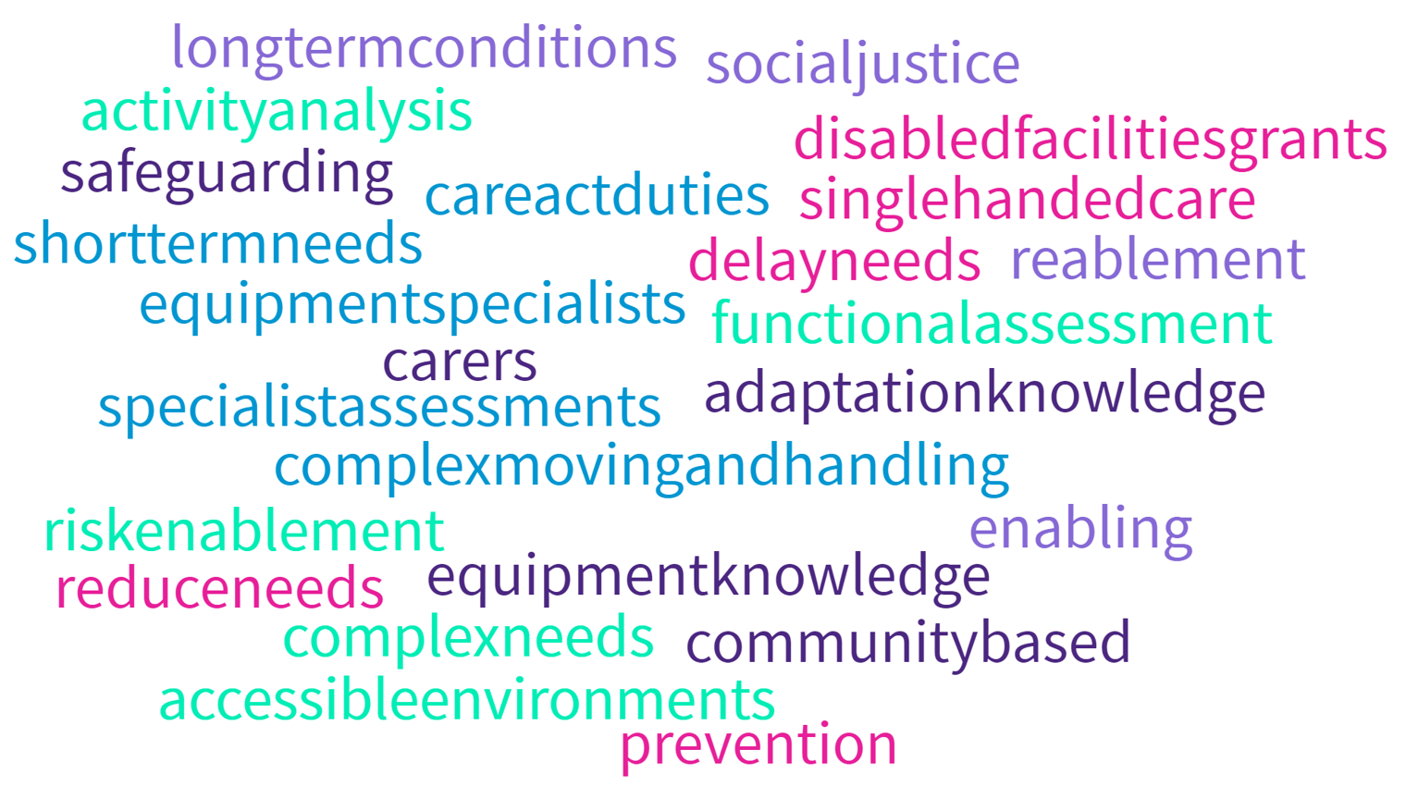

**3.3 Sharing skills to address workforce challenges**

Whilst there are numerous shared skills opportunities stated above, all groups talked about the opportunity around sharing their knowledge and skills relating to single-handed care to:

* Improve outcomes for people
* Prevent, delay and reduce the need for care and support
* Help address the shortage of our care workforce

Opportunity to do so would enable the OT workforce to share their expertise around single-handed care, where a person-centred approach, expertise around risk enablement, moving and handling and equipment are combined to promote independence of the individual receiving care avoiding the need for unnecessary physical care.

### 3.4 ‘The approach we take……’

OT leaders talked about the approach that the OT workforce take within their services, an approach that aligns well with the preventative agenda and interventions associated with health and social care legislation (Care Act) and policy (Health and care bill) and another reason for further investment in this workforce to achieve outcomes of this policy/legislation.

Figure 2 shares the most frequently stated terms that leaders used to describe their approach.

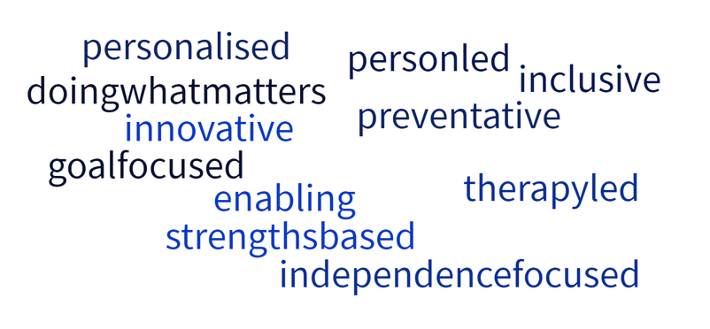

### 3.5 ‘The people and professionals we are….’

Social Care OT leaders described behaviours and traits

Figure 3: Behaviours and Traits

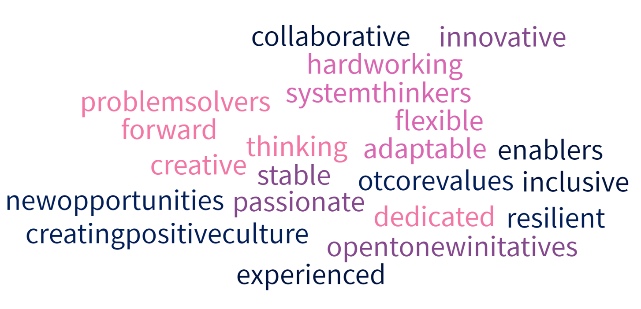

### 3.6 Opportunities for system and regional AHP workforce collaboration

### AHP colleagues shared that they were keen to understand opportunities for collaboration at AHP faculties in terms of system health and social care collaborative opportunities.

Within the regional discovery workforce workshops, we discussed opportunities to take forward collaborative workforce initiatives. This may be at system level within AHP Faculties AHP Faculties where learning can be shared, and initiatives developed together or at a place level within organisations at a locality level.

The most commonly stated workforce initiatives/areas for opportunity to collaborate at a system level, within AHP faculties were:

1. **Expansion of OT student placements in social care** and exploring options to do this given the challenge of a small OT workforce, whilst developing and improving opportunity alongside Higher Education Institute’s.
2. **Integrated health and social care OT** **rotations** - navigating NHS and LA organisational processes to establish health and social care rotations in order to optimise integration and reduce duplication, increasing understanding of each other’s roles across acute and community services, increasing acute understanding of community support, with the aim of optimising outcomes for the people we support.

Below is a summary of the themes and suggestions raised in relation to collaborative workforce opportunities:

### 3.7 Expansion of OT/AHP student placements

### Expansion of OT student placements was the most stated collaborative opportunity. Leaders felt there was significant opportunity to learn from NHS colleagues around the work that they had and continue to complete to expand and increase student placements, however they were keen to understand more about the data associated with OT student placements in social care, as suggested in the data section of potential next steps.

Leaders were keen to explore with health colleagues how to utilise the existing knowledge and expertise from NHS and HEE colleagues around expansion of student placement and apply this to a much smaller AHP workforce in social care/local authorities who are already feeling the pressure of increasing demands and their skills and time.

There have already been some positive examples of collaborative working that can be built on including in the Southwest around expansion of student placements, where HEE Southwest supported a bid, via their AHP faculties, from Devon and Somerset County Councils to scope and explore the expansion of student placements. This project, led by a regional placement OT lead, positively impacted on several areas of workforce development and planning including:

1. Increase in OT placements across both Local Authorities, which exceeded the 50%
2. Increase in number of Practice Educators
3. Embedded Practice education toolkits
4. Successful trial of role emerging and placement swaps
5. Working in partnership with retired OTs to provide long arm supervision
6. Increase in OT apprenticeship opportunities, supported by additional mentors and practice educators.

In addition to expansion of OT student placements

1. The development of a substantive OT workforce development role in DCC, following the demonstration of outcomes on workforce and retention initiatives/outcomes.
2. Return to practice - development of voluntary and paid pathway for LAs
3. Development of system collaborative and partnership working across networks

For more information about this successful health and social care collaborative project, including the learning at an organisational, system and regional level, a full report is available from the South West HEE AHP team.

Leaders were also keen to engage with the work that Skills for Care will be taking forward in relation to optimising student placements in social care.

### Partnership working with HEIs and Universities in closer working relationships with HEI’s and Universities to talk about the role of OT in social care with students as well as increasing the opportunity to promote OT in social care on the curriculum.

### Leaders who had strong collaborative relationships with HEI’s and Universities shared how offering to provide guest lectures, support with interviewing prospective students and attending the annual programme review had proven to be effective ways to continue to build these relationships between provider organisations in social care and HEI’s/Universities.

**Utilising placements to attract newly qualified OTs into social care -** There was interest in leaders working more closely with HEI’s/Universities to find out more about how many social care placements are utilised on an annual basis, within regions, where students go on completion of their pre-registration degrees and how they may support more newly qualified OTs to start their careers in social care. There was a sense that historically, to work in social care, there had been an unspoken need for at least two years post qualifying experience, which is not the case.

### 3.8 Place based health and social care integrated OT rotations

### AHP Leaders were particularly keen to establish integrated health and social care OT rotations within their localities, offering an opportunity for OTs across health and social care to develop knowledge and skills across sectors, to gain mutual understanding of each other’s roles and pressures, with the aim to optimise outcomes for people.

This was suggested as an important step towards health and social care workforce integration that the AHP workforce is in a unique position to achieve, and a potentially workable solution to the challenge that had been experienced when previously attempting to have an integrated health and social care OT role, where organisational barriers such as HR processes, pay and conditions (most LA do not have OTs on an agenda for change pay scale, although a handful do) and IT systems had got in the way of making this a reality.

### AHP leaders in integrated health and social care organisations delivering social care functions/duties, talked about the benefits of their whole OT workforce having the opportunity to experience and develop knowledge and skills delivering the health and social care function.

### An example of achieving a health and social care Band 5 OT rotation in Devon, where a standard operating procedure and rotation guidance was developed in partnership with health and social care providers to address the operational management of the rotation around areas such as annual leave, supervision, appraisal, working hours, job descriptions (where the NHS employed signed up to the LA OT Job description when they rotated around to social care) overcoming many of the aforementioned organisational barriers to achieving a health and social care rotation in practice.

Further scoping to understand existing health and social care OT rotations in place and develop a resource including principals and practice to support others to establish this across England would help to integrate our health and social care OT/AHP workforce, further increase the opportunity for OTs to gain knowledge, skill and experience in social care and help to address some of the issues associated with attracting newly qualified OTs into social care.

### 3.9 Investment in Leadership

### As per the main finding of the aforementioned ‘AHP leadership in Local Authority’, NHS England commissioned project, currently AHP leadership roles in LAs remain widely interpreted, with varying titles, most commonly associated with Occupational Therapy e.g. Principal OT, OT Service Lead, OT Service Manager or a specific service lead e.g. Community Equipment Service Lead with bolt on principal OT responsibilities.

As OT/AHP leadership roles tend to be positioned at an operational rather than strategic level, leaders reported, this significantly effects their ability to have impact within their organisations and at system level. This correlates with the statement in the Messenger et al (2022) leadership report that AHPs lack the visibility of their leaders on boards.

Leaders were however, pleased to be able to share the recently published RCOT Principal OT roles and responsibilities document (RCOT,2021), to help them make the case for a more strategic role, but many still reported it being difficult to achieve this role without statutory recognition of their value, as is the case for Principal SW colleagues.

Leaders explained that whist many have connected with AHP faculties and Councils at a system level, this lack of strategic leadership capacity impacted on their opportunity to fully engage and collaborate around workforce priorities at a system level. Therefore, the opportunity to meet with social care peers at a regional level and collaborating at a regional level together with HEE colleagues, seemed the most achievable at present for most.

### 3.10 Showcasing the role and skill of OTs in Local Authorities at a system/locality level

Almost all regional groups identified the need for the role of the OT to be better understood.

Giving the opportunity for Principal OTs/Strategic AHP Leaders in LAs to showcase their skills within integrated care systems would help people to understand OTs roles, responsibilities, and the skill they bring. Equally evidence suggests understanding roles and responsibilities helps to breakdown professional boundaries and optimise collaboration.

A positive example of showcasing AHP roles in social care was shared by Northeast and Yorkshire region where they were offered the opportunity for a social care ‘social media takeover’ of their AHP council and faculty.

### 3.11 Career progression and development of OTs and Strategic leads

### Leaders identified the need for a clearly articulated attractive career progression pathway and development to address the lack of senior practitioner OT/AHP opportunities within social care, which often leads to the loss of experienced social care OT/AHP workforce.

### Whilst many talked about the advanced practitioner roles that they have within their LAs, these roles did not correlate with those found within NHS organisations, offering less favourable terms and conditions.

### More work is required to understand how these roles can be developed in terms of education e.g. higher level apprenticeship opportunities and to ensure these roles can be established, offering the same opportunity and reward as NHS organisations.

### 3.12 Shared learning and development opportunities– across health/social care and across Local Authorities.

### Leaders identified that they would be interested in increasing shared learning opportunities:

### Across LAs/adult social care providers - commissioning training and development across LA organisations, which may be at a system, regional or national level (dependent on the subject) particularly given the opportunities with virtual/online training, would help to increase opportunity to share learning and good practice across organisations and resource with the potential to stretch limited training budgets further. Topics such as equipment and minor adaptations, disabled facilities grants, legal literacy, moving and handling, specialist seating and managing long term conditions were examples that could be considered.

### Across health and NHS providers - social care leaders were keen to explore the opportunity to have more joined up learning and development with health AHP colleagues. For example, safeguarding, strengths-based approach, single-handed care, personalised care, intermediate care.

1. **Sharing skills** - LA OTs were keen to share their knowledge and skills with colleagues, particularly around prescription of simple equipment, to prevent duplication and reduce waiting times for people; single handed care, an approach used to optimise independence for people and reduce, where appropriate, reduce, delay, and prevent the need for care and support.

## 3.13 Challenges to optimising the AHP/OT workforce to impact on people’s lives

Below are the areas that OT leaders identified as making it challenging to engage and collaborate at a system level:

# Potential next steps

### 4.1 Enhancing the AHP Workforce dataset and intelligence

The development of this dataset would bring visibility to the AHP workforce in social care, not only within LA and social care organisations, but at a Local (Integrated Care System), regional and national level, enhancing the opportunity for increased collaborative and integrated workforce planning across health and social care.

Some specific suggestions to develop the Skills for Care dataset:

* **Specific AHP section** **within the Skills for Care national dataset**
  + Add a section specifically for all AHPs, separated by each profession, as is the case for Social Workers.
* **AHP Apprenticeships**
  + Add an option for organisations to record whether an apprenticeship is integrated across health and social care or specific to a LA
* **Return to practice**
  + Add a return to practice option for AHPs, which would allow opportunity to monitor the number of AHP/OT returnees into social care.
* **Student OT placements in social care**
  + Better understand the numbers of OT placements that social care currently offers annually across England.
  + Better understand data around where students gain employment following their pre-registration degrees to potentially increase the number of newly qualified OTs coming into social care and understand what LAs/Social care providers need to do to support this e.g. Development of preceptorship; articulating career progression opportunities more clearly.

In addition to the above suggestions around the skills for care dataset, the following suggestions are made:

* **Demand and capacity data**
  + Scope, understand and expand data of AHPs in social care to develop demand and capacity data to more accurately predict the skill mix and workforce required to meet current and future demand of the service
* **Adult Social Care Health check for AHPs**
  + Understand more about workforce areas such as continued professional development, effective workforce planning, workload, wellbeing and supervision standards for the OT/AHP workforce in LAs by overtly adding AHPs/OTs to the national Local Government Association Health Check survey which is an annual survey, currently published for Social Workers (LGA,2022)
  + Develop AHP Local Government Association (LGA) employer standards for AHPs/OTs to inform the survey, as per the LGA Employer standards for Social Workers (LGA,2020)

### 4.2 Develop and build the AHP system, regional and national architecture for social care

Investment in health and social care partnership/integration at regional level is required. Whilst AHPs work towards place/neighbourhood working, there is work to do support in the regions, whilst leadership visibility/capacity/capability increases in the system space.

* **System AHP workforce collaboration**
  + Utilise observations from regional workforce workshops (shared with Regional Heads, HEE) and from this report continue to develop workforce initiatives and projects
* **Invite a representative from the regional OT/AHP leadership networks** to attend the regional AHP faculty/council meetings to ensure there is at least one lead keeping the group abreast of developments/opportunities within their systems/faculties. See Appendix A for information regarding regional chairs.

### Help to manage the current leadership gap in social care but optimise communication/collaborative opportunities/engagement with AHP priorities.

### Support the ongoing development of a national Principal OT/Strategic AHP network

* Help support the policy communications from DHSC, to be shared and then cascaded to regional and then system groups/networks.

### 4.3 Attracting and recruiting AHP workforce in social care

* **Advertising social care AHP vacancies**
  + Ensure all LA organisations have access to the NHS jobs website for advertising.
  + Consider a social care vacancies online platform to hold all collective social care AHP vacancies (like NHS Jobs e.g. social care jobs)
  + This will increase visibility of opportunities in social care like NHS organisations
* **Promoting AHP Careers in social care**
  + Promote and showcase AHP/OT careersin social care
  + Promotion of the role of OT in social care, at a system level.
  + Continue to develop AHP apprenticeships in social care
  + A clearly articulated career progression framework- including advanced practice and senior leadership opportunities, as is the case forSocial worker colleagues with their Professional Capabilities Framework (BASW, 2018)
  + Explore the opportunities to attract newly qualified AHPs
* **Explore opportunity to develop the role of Physiotherapy in social care**
  + Particular opportunity around preventative interventions such as reablement services and potential to offer an alternative career progression route in terms of physio apprenticeships.

### 4.4. Collaborative learning and development

### Increase, develop and implement shared learning and development opportunities across:

### Local Authority/adult social care providers - commissioning training and development opportunities together

### Social care and health providers - more joined up learning and development with health AHP colleagues.

* Sharing of existing knowledge and skills to address practice and workforce issues – perhaps through development of national KPIs to enable comparative analysis across services/statistical neighbours e.g. around the single handed care approach to moving and handling.
* Continue to upskill and to ensure existing workforce remains agile, with the skill set required as we move towards greater health and social care integration and new ways of learning.

### 4.5. Collaborative workforce opportunities/initiatives

### Develop workforce initiatives/opportunities for social care. The most identified areas included:

* Expansion of AHP student placements
* Establishing integrated rotations and working models across health and social care – including placements/apprenticeships and early careers
* Return to practice – support LA’s to develop organisational policies/guidance to establish this

For more collaborative opportunities see the key observations section.

### 4.6 Leadership and Influence

* **Investment in strategic OT Leadership roles in LA’s**
  + Increase principal OTs in Local authorities, positioned at a strategic level, working alongside Principal Social Workers
  + Utilise Principal OT roles and responsibilities document to support the development of job descriptions and impact of the role.
* **Leadership knowledge and skills**
  + **I**nvest in strategic and system leadership training and development of AHPs in social care enabling LA AHP leaders to rise up and represent the AHP social care workforce and increase their influence and impact at system and locality level.
  + Funding - This may be something that regional leads might consider investing in.
* **Increase partnership working with ADASS at a regional and national level** 
  + To optimise engagement, direction and support from with the most senior leaders in social care
* **Establish National AHP/OT social care leadership role** **within Department of health and social care** 
  + To ensure AHPs are represented and supported to optimise health and social care reform.

# References

BASW (2018) **The Professional Capabilities Framework** [The Professional Capabilities Framework (PCF) | www.basw.co.uk](https://www.basw.co.uk/professional-development/professional-capabilities-framework-pcf/the-pcf)

DHSC (2021a) **People at the Heart of Care – adult social care reform white paper** [People at the Heart of Care: adult social care reform white paper - GOV.UK (www.gov.uk)](https://www.gov.uk/government/publications/people-at-the-heart-of-care-adult-social-care-reform-white-paper) Accessed 16.06.22

DHSC (2022) [Leadership for a collaborative and inclusive future - GOV.UK (www.gov.uk)](https://www.gov.uk/government/publications/health-and-social-care-review-leadership-for-a-collaborative-and-inclusive-future/leadership-for-a-collaborative-and-inclusive-future) – Independent report. The Messenger leadership review. Accessed 16.06.22

Health Education England (2022) Return to practice : HCPC: A guide for Organisations [AHP - Website Content - Return to Practice HCPC Quick guide.pdf - All Documents (sharepoint.com)](https://healtheducationengland.sharepoint.com/sites/AHPWC/Shared%20Documents/Forms/AllItems.aspx?ga=1&id=%2Fsites%2FAHPWC%2FShared%20Documents%2FReturn%20to%20Practice%20%2D%20allied%20health%20professionals%2C%20healthcare%20scientists%20and%20practising%20psychologists%2FResources%2FResources%2FReturn%20to%20Practice%20HCPC%20Quick%20guide%2Epdf&parent=%2Fsites%2FAHPWC%2FShared%20Documents%2FReturn%20to%20Practice%20%2D%20allied%20health%20professionals%2C%20healthcare%20scientists%20and%20practising%20psychologists%2FResources%2FResources) accessed 16.06.22

Local Government Association (2020) The standards for employers of social workers in England 2020. [The Standards for employers of social workers in England | Local Government Association](https://www.local.gov.uk/standards-employers-social-workers-england-0). *Accessed 06.6.22*

Local Government Association (2021) National summary report of the emploter standards survey for registered social workers [The Standards for Employers of Social Workers: National report summary 2021 | Local Government Association](https://www.local.gov.uk/publications/standards-employers-social-workers-national-report-summary-2021). *Accessed 06.06.22*

NHS England and NHS Improvement (2019a) We are the NHS: People Plan 2020/2021 – action for all of us [We-Are-The-NHS-Action-For-All-Of-Us-FINAL-March-21.pdf (england.nhs.uk)](https://www.england.nhs.uk/wp-content/uploads/2020/07/We-Are-The-NHS-Action-For-All-Of-Us-FINAL-March-21.pdf) Accessed 16.06.22

NHS England and NHS Improvement (2019b) The NHS Long Term Plan [NHS Long Term Plan v1.2 August 2019](https://www.longtermplan.nhs.uk/wp-content/uploads/2019/08/nhs-long-term-plan-version-1.2.pdf) Accessed 16.06.22

NHS England and NHS Improvement (2021) **Building strong Integrated Care Systems** **everywhere** [B0664-ics-clinical-and-care-professional-leadership.pdf (england.nhs.uk)](https://www.england.nhs.uk/wp-content/uploads/2021/06/B0664-ics-clinical-and-care-professional-leadership.pdf)People at the Heart of Care: adult social care reform white paper - GOV.UK (www.gov.uk)

Accessed 16.06.22

Royal College of Occupational Therapists (2021) **Principal Occupational Therapists - Roles and responsibilities** Principal Occupational Therapists in Adult Social Care Services (1).pdf Accessed 16.06.22

Skills for Care (2021a) Workforce Dataset [Data and publications (skillsforcare.org.uk)](https://www.skillsforcare.org.uk/Adult-Social-Care-Workforce-Data/Workforce-intelligence/publications/Data-and-publications.aspx)

Accessed 16.06.22

Skills for Care (2021b) How to make the most of student nurse placements in social care settings – for the person who needs care and support, employer, student and education provider. [How to make the most of student nurse placements in social care settings (skillsforcare.org.uk)](https://www.skillsforcare.org.uk/resources/documents/Regulated-professions/Nursing/How-to-make-the-most-of-student-nurse-placements/How-to-make-the-most-of-student-nurse-placements-in-social-care-settings.pdf) Accessed 16.06.22

West M,A;Topakas,A, Dawson JF(2014) **Climate and culture for health care performance** Schneider b, Marbara K,M (eds) The Oxford handbook of organisational climate and culture for health pp 335-59 Oxford: Oxford University Press

West,M, Echert,R,Collins,B,Chowla (2017) **The Kings Fund: Caring to Change: How compassionate leadership can stimulate innovation in health care** [Caring to change | The King's Fund (kingsfund.org.uk)](https://www.kingsfund.org.uk/publications/caring-change) Accessed 16.06.22

# Appendices

**Appendix A: Regional Principal OT/Strategic AHP lead Networks – Chairs**

Below is the summary of the established regional networks and their chairs who are leading the regional principal OT/most strategic AHP in LA networks. These groups have varying names including Principal OT Network; OT Lead Network; ADASS Principal OT Network, as many of these groups are supported by their regional ADASS. Where this is in place it appears the additional business support and coordination really helps to establish and maintain this group which allows LA OT/AHP leaders to come together to offer the opportunity for peer support, sharing of practice, processes and service development as well as opportunity to provide a regional opinion regarding policy and practice development from an OT/AHP perspective in LAs/social care provider organisations.

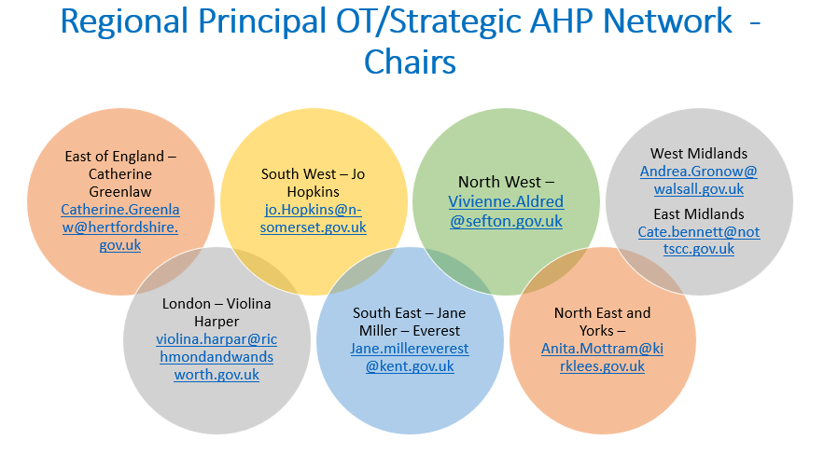

**Appendix B – Health and social care collaboration – Research enablers and barriers.**

**1.Optimising health and social care collaboration – the enablers**

1. **Optimising health and social care collaboration: The barriers**

**Appendix C - Activity to connect and build relationships during the project…**

**Connecting and building relationships** with health and social care leaders through activities, meetings and discussions were completed:

* **Regional Heads/Workforce leads and AHP Faculties** – met with all regional heads to discuss project; invitation to co-led/attend regional discovery workshops; shared the outputs from the workshops to support future collaboration/partnership working.
* **Individual meetings with health and social care system leaders** – various discussions to support health and social care AHP integration at system and place.
* **Initial meetings and introduction to project at Principal OT networks** – they asked for more time to discuss workforce(regional workshops arranged)
* **Support and influence to set up NW/E of E Principal OT network groups** – both now have regional groups and are connected to regional heads/workforce leads in their areas with an understanding of what areas of workforce priorities they can take forward together.
* **National AHP faculty Network** – added LA questions for national survey; attended and presented; developed regional workshops in response; connecting those who want to with AHP faculties/regional principal OT network groups/leads in ICSs.
* **National ADASS workforce subgroup chair** – met – healthcheck item on the agenda in June; developiong regional representation from principal OTs with chair.
* **RCOT** – link with re. project; opportunity around career progression work – linked with skills for care. Attended group meeting re. shaping this prohect
* **Skills for care** – link re. projects, aspiring leaders programme (first cohort just complete) and national launch for RCOT principal OT document.
* **Connected with Suzanne Ratrick** re. plan/project/taking forward – speaking at national event
* **Met with National Director for discharge and rehabilitation** re. Opportunity and potential of LA OT workforce to contribute and add value to the intermediate care framework
* **Connecting osteopath** lead with expansion of student placement project in Devon – meeting with CPEP leads re. potential to progress.
* **Communication/survey from CAHPO to update list of LA principal OTs distribution list** – with permission to share with AHP council and AHP faculties as well as sending out via distribution list (Magortu actioning this); mapping contacts regionally.

**Appendix D: Online regional workforce discovery workshops:**

In response to ask at National AHP faculty network and regional POT/strategic AHP networks included:

* Introduction
* Building relationships
* Developing mutual understanding
* Identifying priorities together
* Finding a hock to start/create opportunity for collaboration and engagement
* Giving LA OTs a voice re. workforce (formula/approach informed by my recent MSc   
  research and evidence based re. optimising health and social care collaboration to impact on population outcomes)

**Developing and delivering the workshops:**

1. **Introductory meeting - Following an initial introductory meeting** and discussion, led by the project lead, on how social care AHP leadership would like to engage with the project, it was clear that a standalone session would be helpful to have a more focused discussion around the AHP workforce in social care. This is where regional workshops were developed.
2. **8 Regional workshops completed** - the East of England and North West group met for the first time at this workforce and will now continue to meet, completing the regional infrastructure for Principal OTs/Strategic AHPs in social care. See Appendix A for regional network chairs. For Southeast, only 3 colleagues were able to attend so we gained further insight using a SWOT around workforce in a survey.
3. **Completed with principal OT/AHP lead ADASS/OT networks** and HEE regional colleagues/regional heads/workforce leads invited to engage in these workshops.

**The workshop aim to:**

* 1. Optimise connection and collaboration opportunities across health and social care regarding workforce
  2. Listen and understand challenges and opportunity around the AHP workforce within social care, specifically LA in this instance.
  3. Increase participants knowledge and understanding of the role of the AHP faculties and opportunities to connect and collaborate regarding workforce, by sharing good practice examples and experience.

1. **Content of the sessions**
   1. Introduction to the project and how this has led from the initial scoping project around AHP in Leadership, lead by the National CAHPO team in 2021.
   2. Introduction to AHP faculties – purpose and role.
   3. Sharing of examples of opportunity and impact health and social care AHP faculties has already achieved
2. **Outputs from the session**
   1. **Summary of regional session output** - Following each workshop a summary of session outputs were shared with regional heads/workforce leads and POT networks, sharing specific opportunities that were discussed as being priorities to take forward within regions/system faculties to be used to aid further discussion between regional heads/workforce leads/POT/Strategic AHP leader in LA networks.
   2. **Thematic analysis** of the outputs of all workshops – shared in this report.