**Information and Resources**

**Supporting the Allied Health Professions (AHP) Integration Agenda**

Published 30 June 2023

**Author/Editor: Claire Guyatt**

AHP National Clinical Fellow (2022-2023), Occupational Therapist

Workforce, Training & Education Directorate, NHS England

Co-written with contributions from AHPs across England (see **acknowledgments page**)

**In collaboration with:**

* **Principal & Strategic Lead Occupational Therapist (PSLOT) Network**
* **Sara Ennew** (Regional Head of AHPs, East of England, Workforce, Training & Education Directorate, NHS England)
* **Beverley Harden** (Deputy Chief Allied Health Professions Officer, NHS England)



**Contents**

**Introduction** 3

**Key Terms** 5

**Part 1: The Integration Agenda**

The Framework Explained 6

Framework for AHPs Supporting Integration 8

Adapt & Adopt: AHP Integration in Action 11

**Regional Spotlight: Integration in Action 13**

* London: Adapt & Adopt 13
* South East: Adapt & Adopt 14
* South West: Adapt & Adopt 16
* North East and Yorkshire: Adapt & Adopt 18
* Midlands: Adapt & Adopt 20
* East of England: Adapt & Adopt 23
* North West: Adapt & Adopt 27

**Part 2: Principal & Strategic Lead Occupational Therapist (PSLOT) Leadership and Architecture**

Local Authority AHP Leadership 28

PSLOT Leadership and Architecture 30

PSLOT Network and Task-Force Member Testimonies 32

PSLOT Network and Task-Force Impact and Influence 35

**Useful Resources** 36

**Acknowledgements and Thanks** 37

# **Introduction**

This resource has been created to support the integration agenda for the Allied Health Professions (AHPs) in England. This national portfolio aims to support integrated ways of working across regions, systems, and in place-based partnerships. The journey towards integration will be complex and multi-faceted. Therefore, this resource has initially focused on building connections across social care and health colleagues, within local authorities and the NHS, respectively.

The resource is aligned to the enhanced foundations and areas of focus of the AHP Strategy for England (2022 – 2027): [AHPs Deliver](https://www.england.nhs.uk/publication/the-allied-health-professions-ahps-strategy-for-england/). It is acknowledged that a specific focus has been placed on the Occupational Therapy workforce. This is because Occupational Therapists constitute the largest of the AHP groups employed in local authorities ([Skills for Care, 2022](https://www.skillsforcare.org.uk/Adult-Social-Care-Workforce-Data/Workforce-intelligence/publications/Topics/Occupational-therapists.aspx)). Nevertheless, wider application to other AHP groups in social care is essential for sustainability in integration. Therefore, there are some showcase examples of this in the ‘Adapt and Adopt’ section of this resource.

The first section of this resource relates to the AHP integration agenda, a national portfolio led by Sara Ennew (Regional Head of AHPs, East of England: Workforce, Training & Education Directorate (WT&E) NHS England). This formed the project focus for Claire Guyatt’s AHP National Clinical Fellowship. The project ran from September 2022 - June 2023. The primary drivers and key workstreams were shaped by the recommendations from preceding national projects led by Carolyne Hague (Principal Occupational Therapist, Devon County Council). These focused on leadership in local authorities and the AHP workforce in social care, respectively.

The overarching aim of the current project was to: **value and support the AHP social care workforce as vital contributors to the integration agenda.**

The four specific workstreams were:

1. Integrated AHP workforce data and intelligence
2. Leadership and AHP architecture for social care
3. Attracting and recruiting the AHP social care workforce
4. Collaborative learning, development and AHP workforce initiatives.

Key recommendations aligning with the above workstreams can be found on **page 8** of this resource. The recommendations are also subsequently aligned with each ‘Adapt & Adopt’ showcase example. This demonstrates their ability to be embedded in practice.

Another essential purpose of this resource is to educate the AHP community and wider stakeholders about AHPs in local authorities. There is a newly established and maturing National Principal and Strategic Lead Occupational Therapist (PSLOT) Network in England; comprised of the most senior and strategic OT leaders in local authorities. Therefore, the second part of this resource outlines the governance and structure of this network alongside the affiliated regional networks, task-force and strategic advisory group. The PSLOT network and leadership architecture is pivotal in setting the strategic direction for Occupational Therapists and AHPs in local authorities; the prominence of which is essential for integration.

Paramount to integration is co-production and anti-discrimination; overarching principles of AHPs Deliver. The benefits of this are two-fold: ensuring that lived experience and inclusivity are central to integration, whilst improving equity, diversity and belonging for the future of integrated care. These fundamentals should be central to every stage of the journey towards integration, from inception to implementation.

# **Key Terms**

**Social Care** is an umbrella term for a complex system of care and support. This is inclusive of provider provision, voluntary, community and social enterprise as well as local authorities.

**Local Authority**

There are [152 local authorities in England](https://www.skillsforcare.org.uk/adult-social-care-workforce-data/Workforce-intelligence/Commission-our-services/Local-authorities.aspx) with care service responsibilities. This may include services such as: adult’s services, children’s services, housing services and public health prevention.

[**ADASS (Association of Directors of Adult Social Services)**](https://www.adass.org.uk/)

A leading independent voice of adult social care. A membership charity to promote higher standards of social care services to influence policy and decision-makers.

[**AHPs Deliver**](https://www.england.nhs.uk/publication/the-allied-health-professions-ahps-strategy-for-england/)

The Allied Health Professions strategy for England. This is for the whole AHP community: support workers, assistant practitioners, registered professionals, pre-registration apprentices and students. It is inclusive and can be used as part of the AHP community working in a variety of health and care sectors to continually improve and redesign services.

[**Local Government Association (LGA)**](https://www.local.gov.uk/)

The national voice of local government, working with councils to support, promote and improve.

**NHS England**

The organisation that leads the NHS in England to deliver high quality services for all. In April 2023, Health Education England, NHS Digital and NHS England merged into one organisation.

[**Skills for Care**](https://www.skillsforcare.org.uk/About-us/About-us.aspx)

The workforce planning and development body for Adult Social Care in England.

*Please note: Health Education England (HEE) merged with NHS England in April 2023. The work of HEE is now delivered through the Workforce, Training and Education (WTE) Directorate in NHS England. Therefore, HEE and the WTE Directorate in NHS England may be referred to interchangeably in this resource.

# **The Framework Explained**

The following recommendations on **page 8** have been co-written with AHP leaders in the NHS and Occupational Therapy (OT) leaders in local authorities. They are aimed at the whole AHP workforce across both social care and health. To achieve integrated working and a move towards ‘one workforce’, it is essential that AHPs in local authorities and the NHS take tangible actions towards integration; seamlessly optimising the workforce, thus delivering high quality services to our populations. Working cohesively within organisations, as well as outwardly with colleagues across health and social care is essential. The recommendations can be implemented by all; at place-based and locality level, at system and at regional levels.

To support more robust conversations and actions towards integration, it is essential that we level-up our understanding, support and leadership of our AHP workforce across social care and health. This will enable better conversations about ‘one workforce’; ultimately leading to integrated and cohesive working. Through the lens of valuing social care AHPs as vital to the integration agenda, an assumption has been made that the AHP workforce in the NHS may have already had the opportunity to better understand its key facets through the [AHP Supply Projects 2021-2022](https://www.hee.nhs.uk/our-work/allied-health-professions/enable-workforce/national-allied-health-professionals-workforce-supply-project). Therefore, some of the ensuing recommendation domains give prominence to the AHP social care workforce in local authorities.

By following these recommendations, you can either develop existing points of integration for the workforce, or they can be used to identify areas and actions as a starting point towards integration.

## **The lens for viewing the recommendations:**

| **Emerging** | **Developing** | **Maturing** |
| --- | --- | --- |
| Health and social care AHPs are currently working relatively separately but starting to identify areas for developing integrated ways of working. | Health and social care AHPs are working mostly in separation, but there are tangible shifts towards integrated working in particular facets of workforce development. | AHPs across health and social care are working seamlessly as ‘one workforce’ at place-based, system and regional level; working together to navigate workforce challenges and provide cohesive delivery of services. |

The intention of the recommendations is to appreciate that each of the four recommendation domains are interlinked and not mutually exclusive. The intention is not to move prescriptively and sequentially through emerging, developing and maturing. Integration is multi-faceted and therefore you may self-assess your current position as emerging in one facet within a domain yet maturing in another facet of the same domain. Moving towards integration is an iterative process. Therefore, the recommendations are aimed at supporting AHPs in social care and health to move in the same direction together.

## **Culture & Climate: A vital fifth dimension**

Underpinning the following recommendations is an appreciation of the differing cultures and climates of the AHP workforce in local authorities and the NHS. To work as ‘one workforce’ we must initially appreciate, understand and value our differences before moving forwards cohesively. We have utilised the term ‘language’ to refer to this. A key facet to fully appreciate and enact the recommendations is to initially recognise the language differences, whilst also being cognisant of our joint language maturing together. The ensuing framework of recommendations should be viewed through the following culture and climate lens:

**Emerging:** Separate languages of health and social care

**Developing:** Separate languages, but learning one another’s language

**Maturing:** Speaking the same language

# **Framework for AHPs Supporting Integration**

## **1. Integrated AHP workforce data and intelligence**

| **Emerging** | **Developing** | **Maturing** |
| --- | --- | --- |
| * Principal OTs /AHPs in local authorities (LAs) nominate somebody to work alongside their LA data representative to ensure data is correct for input to the annual Skills for Care data set. * Clear internal understanding of the current workforce and creating plans for the future workforce in local authorities. | * Shared workforce planning: Building relationships with Integrated Care System (ICS) AHP Councils/Faculties, bringing social care data to the table, and having collaborative conversations for the benefit of the people we deliver services to. | * Fully integrated data aligned with Electronic Staff Record (ESR)/NHS data and local authority data collection. * Ownership taken by each PSLOT in local authorities to input into Skills for Care data set; directly aligning with the priorities of the Long-Term Workforce Plan. |

## **2. Leadership and AHP architecture for social care**

| **Emerging** | **Developing** | **Maturing** |
| --- | --- | --- |
| * Building relationships and rapport between regional PSLOT chair and Regional NHS England AHP Leads. * Involvement with AHP Councils and Faculties. * Ensure diversity and inclusion in representation in the PSLOT networks. | * Fully functioning and sustainable PSLOT networks in each region. * All 152 local authorities have a named Principal OT. * Ongoing collaboration with professional bodies (e.g. RCOT). * Robust links and relationships between regional networks, and wider AHP networks, AHP Councils and Faculties at system and regional level. * Utilising the key principles of [Clinical and Care Professional Leadership (CCPL)](https://www.england.nhs.uk/wp-content/uploads/2021/06/B0664-ics-clinical-and-care-professional-leadership.pdf) as an enabler towards diverse and integrated leadership. | * Sustainable business support for the regional PSLOT networks and task-force. * All Principal OTs identify as an AHP Lead within their local authority. * Clearly defined and direct links into: DHSC, ADASS, LGA and Skills for Care via the regional and national PSLOT network. * PSLOT representation in all health and social care strategic decision-making and pathway development activity e.g. intermediate care and [care workforce pathway](https://www.gov.uk/government/consultations/care-workforce-pathway-for-adult-social-care-call-for-evidence). |

## **3. Attracting and recruiting the social care AHP workforce**

| **Emerging** | **Developing** | **Maturing** |
| --- | --- | --- |
| * Sharing and taking on board best practice and showcase examples of Occupational Therapy in local authorities within systems, regions and nationally. * Actively offering social care as an AHP career option. e.g. liberating placement expansion in local authorities. | * Recognition and development of AHP roles in local authorities and wider sectors of social care, inclusive of the voluntary and charitable sector. e.g. role-emerging placements. * Local authorities working with Higher Education Institutions (HEIs) to recognise and promote the value of a social care career. * Social care AHPs guest lecturing on local HEI courses. | * Clear and equitable AHP workforce development frameworks for both social care and health that are fully aligned. e.g. integrated AHP support workforce strategy, rotational posts across health and social care. * One workforce offer at place-based level: Coordinated and fully aligned approach to pre-registration attraction and post-registration career development opportunities, with fluidity across health and social care as equal partners. |

## **4. Collaborative learning, development and AHP workforce initiatives**

| **Emerging** | **Developing** | **Maturing** |
| --- | --- | --- |
| * A mutual appreciation of all AHP roles across social care (local authorities) and health (NHS). * A clear understanding of workforce learning and development requirements within both social care and health. | * Joint and equitable access and availability of all relevant learning and development opportunities across health and social care at place-based, system and regional level. * Collaborative practice education and practice-based learning models across local authorities and NHS organisations. e.g. hybrid student placements. * Shared continuing professional development (CPD) and training opportunities across all levels of staff. The beginnings of more collaborative thinking across preceptorship, enhanced (ECP), and advanced (ACP) level practice. | * Integrated services and aligned workforce initiatives at place and ICS level. * Integrated approaches to workforce and succession planning: e.g. cross-organisational rotations, flexibility of workforce through skills passporting. * Enhanced practice programme working across health and social care settings. * Developing advanced practice training opportunities; building a flexible skills-set across health and social care. * Mutually agreed consultant AHPs driving fundamental shifts in service delivery across health and social care. |

# **Adapt & Adopt: AHP Integration in Action**

This section of the resource showcases a breadth of examples demonstrating the creative ways that AHPs can drive forwards integration. These examples could be adapted and adopted across other regions, at system, or place-based level.

It is important to note that the spotlight examples of best practice featured on the following pages are not an exhaustive list of all AHP integrated work, neither are they necessarily exclusive to that region.

Each of the ‘Adapt & Adopt’ integration examples align with the four themes of recommendations in the framework for AHPs supporting integration **(page 8)**. The aligning recommendation/s will be indicated at the start of each one-page example. The regional spotlight examples include:

### **North West**

* Regional Social Care Workforce Team **(page 26)**

### **North East and Yorkshire**

* AHP Social Care Placement Expansion **(page 18)**

### **Midlands**

* Integrated rotations**(page 20)**
* Single-handed care/optimised handling **(page 21)**

### **South West**

* Leadership in Local Authorities **(page 16)**

### **London**

* Local Authority data deep-dive **(page 13)**

### **East of England**

* Hybrid practice-based learning **(page 23)**
* OT Workforce Action Group (WAG) **(page 25)**

### **South East**

* AHP Faculties and Social Care **(page 14)**
* Workforce planning tool**(page 15)**

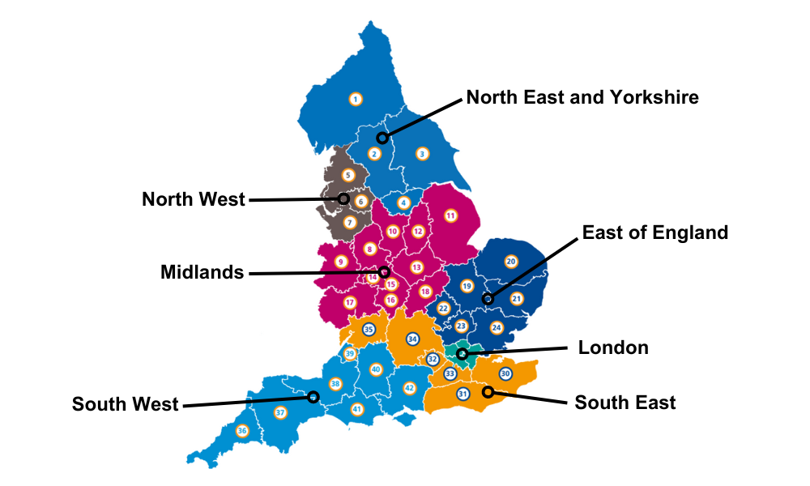

# **Regional Spotlight: Integration in Action**

# **London: Adapt & Adopt**

**Recommendation 1:** Integrated AHP workforce data and intelligence

## **AHP in Social Care Data and Intelligence: Local Authorities**

Care City are working in partnership with local authorities and AHP Faculties in London to scope, understand and expand the AHP social care workforce data and intelligence. This project is due to commence in May 2023, with a final report due in October 2023.

## **Project Objectives and Intended Outcomes**

1. To scope, understand and expand data of AHPs working in social care in London. Outcome; a current workforce profile, action plan.
2. Scope the current Local Authority workforce supply pipeline across London: pre-registration students, apprentices, etc. Outcome: establish baseline, action plan and next steps. 
3. To work collaboratively with and further characterise the London Principal OT network. Outcome: examples of good practice, action plan and next steps
4. Work with AHP Councils/Faculties and social care AHPs to scope social care engagement. Outcome: Establish representation, co-develop potential solutions.

## **Proposed data-set requirement:**

* Numbers of AHPs and support workforce in local authorities
* Role, grade and whole-time-equivalent (WTE) of each role
* Vacancy rate
* Attrition rate
* Workforce demographics: age, gender, ethnicity
* Equity, diversity and inclusivity data in relation to position

## **Data Deep Dive**

* A closer inspection and exploration of AHP workforce data in Local Authorities in London

In partnership with 

# **Regional Spotlight: Integration in Action**

# **South East: Adapt & Adopt**

**Recommendation 1:** Integrated AHP workforce data and intelligence

**Recommendation 3:** Attracting and recruiting the social care AHP workforce

## **Local Authority AHP Workforce Supply Project**

Funded through the Buckinghamshire, Oxfordshire & Berkshire West (BOB) AHP Faculty

West Berkshire Council Local Authority deep-dive into their AHP workforce

**The project funding covered a data and intelligence deep-dive into:**

* Existing establishment of AHPs and Support Workforce
* Identification of risks and actions relating to workforce supply issues

**This enabled the…**

* Creation of a strategic workforce development plan with tangible supply, recruitment and retention outputs

### **Outputs**

* Preceptorship programme in place
* New Principal OT post proposed
* New Specialist OT post created
* Upskilling complete: Equipment training
* Re-vamped job adverts
* Increased interest in jobs: recruitment of two OTs and one OT assistant

## **Social Care and PIVO Placement Expansion**

Buckinghamshire, Oxfordshire & Berkshire West (BOB) ICS placement team

A focus on AHP placement expansion in private, independent and voluntary organisations and social care services

* Since August 2022, BOB ICS placement team have opened 23 new placement providers in social care and the private, independent, voluntary and charity sector.
* This equates to 69 new placement offers.
* Organisations have included: care homes, charities, special educational needs schools, private schools and private hospitals.
* There is a collaborative network for AHP Practice Educators within the BOB and Frimley ICS. This runs every 6-8 weeks and is a time for reflection and peer support.

### **Ongoing Projects**

1. E-learning package for care homes: to support staff to understand AHP student roles when on placement
2. Video production – capturing OT student experience of a placement within a horticultural charity

Find out more on Twitter: @BOBICSPlacement

## **Workforce Planning Tool**

### **AHP Collaborations with Partners in Care and Health**

(Joint programme between ADASS and LGA)

* As part of ‘one integrated workforce’, there is an ongoing project led by the LGA who are using the [Skills for Care workforce data](https://www.skillsforcare.org.uk/Adult-Social-Care-Workforce-Data/Workforce-intelligence/publications/Topics/Occupational-therapists.aspx) to drive a workforce model for forward-planning the social care workforce over the next five years.
* Aligned with an integrated approach, the project team plan to collaborate with South East AHPs and particularly Principal OTs from local authorities. The aim being to ensure the integrity and inclusion of AHP workforce data and intelligence in the project.

# **Regional Spotlight: Integration in Action**

# **South West: Adapt & Adopt**

**Recommendation 2:** Leadership and AHP architecture for social care

## **Principal OT Network: System Leadership Development**

The Principal and Strategic Lead OTs (PSLOTs) in the South West meet monthly for peer support, problem solving and networking.

The group recognised a lack of voice in wider strategic meetings, finding the need to ask: “Have you thought about social care?” and “Have you thought about Occupational Therapy?”

Through funding from NHS England (formerly HEE), a tailored AHP leadership programme was invested in.

## **Aims of the programme**

* To promote the identity of the Principal OT (POT) role
* Increase confidence as a POT and leader in a complex system
* Influencing within a range of complex systems
* Developing strategic thinking
* Diversity in leadership

## **Design and Delivery**

Step-by-step:
1. Training provider identified
2. Idea generation session between training provider and network
3. Agreement of proposed plan with network
4. Network members complete a survey with individual development needs
5. Results compiled and the programme was designed for delivery
Leads to three-part programme:
1. Express coaching (two 1 hour sessions)
2. Action Learning Set (8 sessions)
3. Masterclasses (3): Project management, writing a business case, Action Learning Sets

## **Top-Tips**

* Cultivate psychological safety in the sessions
* A tailored approach: no one size fits all
* Distribute the opportunities across the year (e.g. for those new into role)
* Nominate a link person to gain momentum

## **The Impact**

* Improved network representation at ADASS meeting and national POT task-force
* All POTs connected with AHP Councils/Faculties
* Strengthened relationships within and outside of network
* Improved reputation of the network
* Mapping of learning and development opportunities for network
* Network chair leads on inducting new network members

# **Regional Spotlight: Integration in Action**

# **North East and Yorkshire: Adapt & Adopt**

**Recommendation 3:** Attracting and recruiting the social care AHP workforce

**Recommendation 4:** Collaborative learning, development and AHP workforce initiatives

## **Wider AHP Social Care Practice-Based Learning**

**In the North East and Yorkshire, there have been social care practice-based learning opportunities for learners in Dietetic and Paramedic student cohorts.**

## **1. Dietetics: Social Care Placement Expansion**

* Teesside University have trailblazed placement expansion in social care and public health settings.
* Placement projects include:
  + Developing nutritional policies in hospices
  + Developing weight management courses in learning disability and mental health social care settings.
* The development and evaluation of the impact and value of this practice-based learning is iterative and ongoing.
* [**Practice-Based Learning Blog**](https://www.bda.uk.com/uploads/assets/f83bbdea-811d-4c4d-b5d426957fe64f97/PBL-Learner-Blog-Jess-Sophie.pdf)
* [**Practice-Based Learning Video**](https://www.youtube.com/watch?v=RkUaOCEbMd4)

## **2. Paramedicine: PISCES (Paramedics in Social Care EnvironmentS)**

### **Phase 1 Pilot Project**

**Aim:** Year 1 pre-registration Paramedic Learners at two HEIs to align pre-registration programme with the Care Certificate competencies.

**Planned Outcomes**

* Care Certificate competencies will be collated in a practice- based learning competency document to focus on what learners need to achieve within the social care practice-based learning environment.
* Learners will build on skills, knowledge and behaviours covered within the pre-registration programme. This supports the College of Paramedics Spiral Curriculum (College of Paramedics, 2017).

**Benefits for Learners**

* Development of transferrable skills in general care competence and communication.
* Professional understanding of social care and the wider system
* Improved understanding of the effects of long-term conditions on people’s care needs, anticipatory care needs and advanced care planning.
* Upon successful completion of all Care Certificate competencies, the learner can choose to undertake flexible paid work within a social care environment.

**Benefits for the Integrated Care System**

* Increased placement capacity by utilising social care providers
* Experience of multi-professional working across health and social care for all involved

College of Paramedics (2017) *Practice Educator Guidance Handbook.* Class Publishing. Bridgewater

# **Regional Spotlight: Integration in Action**

# **Midlands: Adapt & Adopt**

**Recommendation 3:** Attracting and recruiting the social care AHP workforce

## **Integrated Rotations**

The Nottingham and Nottinghamshire AHP Faculty have worked collaboratively to create Speech and Language Therapy rotations across organisations. They have now progressed the level of integration further by offering Occupational Therapy rotations across social care, mental health and physical health services in a variety of settings.

### **Critical Success Factors**

* Trusting and established relationships with key players across the ICS footprint.
* AHP Faculty and leadership as a driving force for change; specific project management is essential.
* Integrated Care Board (ICB) funded: system support for AHP workforce transformation.

## **How-To Guide:**

The below infographic shows the timeline and key actions taken to create and launch the Occupational Therapy rotations.

Thanks to the Nottingham & Nottinghamshire AHP Faculty for producing this infographic for inclusion in this resource.

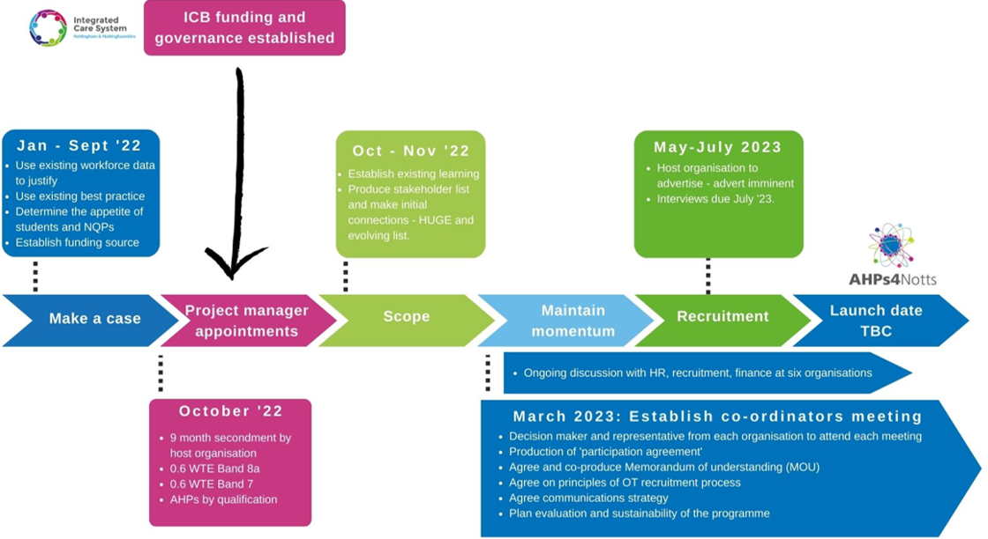

# **Regional Spotlight: Integration in Action**

# **Midlands: Adapt & Adopt**

**Recommendation 4:** Collaborative learning, development and AHP workforce initiatives

## **Single-Handed Care/Optimised Handling**

**“Single-handed care is defined as a moving and handling or care task provided by a single handler.**

Historically, there was a belief that the provision of two handlers, or a ‘double-up’ was safer than one. More recently, the onset of new technology and an influx of assistive devices has enabled opportunities for greater use of optimised handling techniques.“

**Anita Mottram (Principal OT, Kirklees Council).**

There have been numerous local projects across England relating to single-handed care/optimised handling across local authority and NHS organisations. There have also been events at a regional level facilitated by an external partner to enhance understanding, learning and plans for implementing change.

Most recently, in April 2023, the Midlands region hosted a joint event between local authority and NHS colleagues.

### **Midlands Single-Handed Care Event**

**Content**

* Examples and cases for change
* Practical moving and handling session
* Identifying barriers and enablers to change

**Next Steps**

Follow-up meetings/working groups to take single-handed care plans forward at a place-based level, including key stakeholders in NHS and local authority organisations.

### **Adapt & Adopt in Action:**

Single-Handed Care/Optimised Handling is an AHP integration example which is not exclusive to the Midlands region. For example, there are numerous other regions, systems and place-based partnerships who are implementing and developing this area of practice.

More specifically, there has been extensive work in the North-East and Yorkshire, where Kirklees Council local authority’s Moving and Handling Team have been instrumental in leading this change in practice. This has had impact and influence across place-based partnerships, at system, regional and national level.

# **Regional Spotlight: Integration in Action**

# **East of England: Adapt & Adopt**

**Recommendation 3:** Attracting and recruiting the social care AHP workforce

**Recommendation 4:** Collaborative learning, development and AHP workforce initiatives

## **Hybrid Practice-Based Learning: Local Authority and NHS**

### **Planning**

A collaboratively planned placement between Scott Gunton (BSc 3rd Year OT Student), the University of East Anglia (UEA), and practice educators in Norfolk County Council (NCC) and Health Education England ([HEE] now NHS England).

This placement model provided learning partly in local authority practice, and partly in the national AHP team in HEE. The latter focusing on the integration agenda and the leadership pillar of practice.

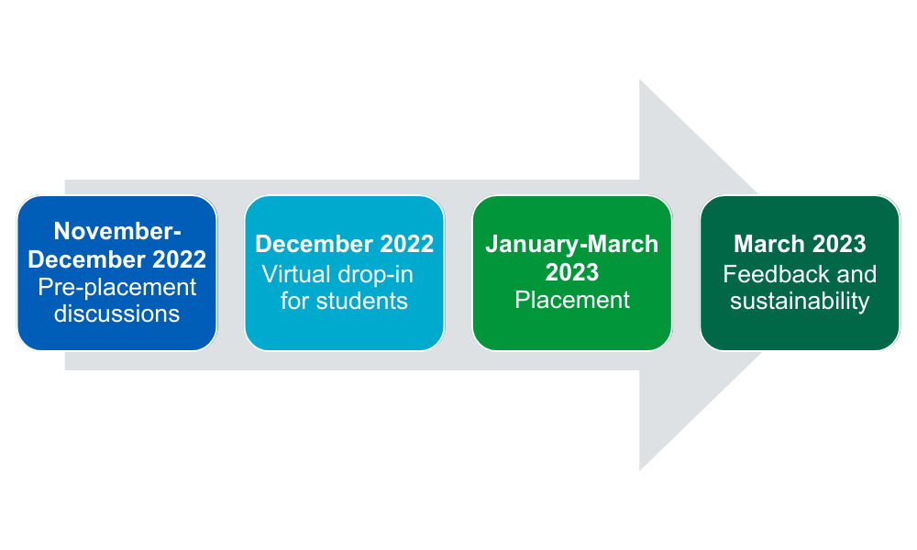

### **Design**

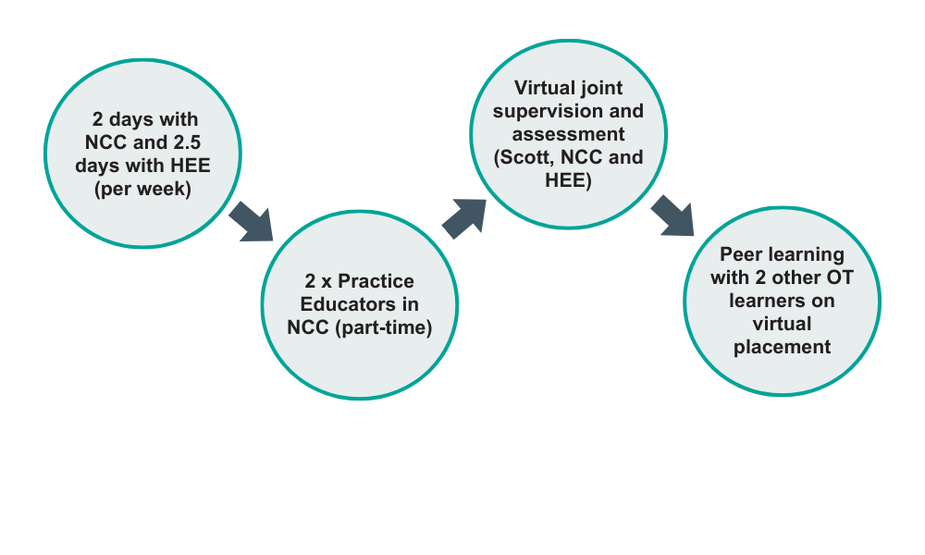

### **Outcomes**

**Benefits**

* A flexible and creative approach to liberate practice-education opportunities across health and social care.
* Social care placements as a strategy for future workforce recruitment.
* Creating a 21st Century ready workforce: portfolio careers, optimising learning across the pillars of practice, system-ready AHPs.
* OT leaders in local authority role-modelling practice-education.
* Optimising leadership and management skills ready for practice: e.g. project management and network development.



“I have had the opportunity to pair my patient/client contact at NCC with learning new skills and leadership approaches with HEE. This has involved exploring project management and observing nationwide meetings that look to improve the profession of Occupational Therapy.” **Scott Gunton, OT student**

See Useful Resources **(page 36)** to view the infographic Scott co-produced with the Principal Occupational Therapy task-force.

  

# **Regional Spotlight: Integration in Action**

# **East of England: Adapt & Adopt**

**Recommendation 4:** Collaborative learning, development and AHP workforce initiatives

## **Occupational Therapy Workforce Action Group (OT WAG)**

The East of England OT WAG commenced with a collaborative event between HEE (now NHSE) and the Royal College of Occupational Therapists (RCOT) in June 2022 in an OT workforce summit.

Between September 2022 and June 2023 there have been six OT WAGs and in January a survey and review session was held. This enabled the setting of the future direction and purpose of the OT WAG.

**Next Steps… (May 2023)**

* Pump-prime funding of £15,000 per AHP Faculty/Council to focus on Occupational Therapy and integrated ways of working

## **Themed work**

* Promoting the role of Occupational Therapy
* Integration agenda: health and social care
* Widening participation and diversity
* The role of the support worker
* International recruitment and retention

## **70 Members from…**

* Local authorities
* NHS
* Universities/Higher Education Institutions (HEIs)
* Primary, acute and community settings
* Physical and mental health
* Integrated Care Systems (ICSs)
* Registered OTs and support workforce
* Adult’s and children’s services

## **Co-Facilitation**

“Having the opportunity to work alongside Sara our Regional Head of Allied Health Professionals to co-chair the OTWAG - I did not hesitate! As Chief AHP for a large community mental health organisation and having a significant operational leadership background, **I knew I could bring a very different perspective which adds to the diversity of the discussions.** We complement each other and have a mutual respect. The exposure to working at a regional level has **supported my development** in this role and I truly believe having a co-chair approach from regional and provider level showcases to our Occupational Therapists attending the monthly meetings, **the importance of system working and collaboration.**”

**Poonam Hyland**

(Director of AHPs; Cambridgeshire & Peterborough NHS Foundation Trust)

# **Regional Spotlight: Integration in Action**

# **North West: Adapt & Adopt**

**Recommendation 4:** Collaborative learning, development and AHP workforce initiatives

## **Regional Social Care Workforce Team**

A newly established team to drive a step-change in social care workforce transformation at regional and sub-regional level.

### **Key Partners**

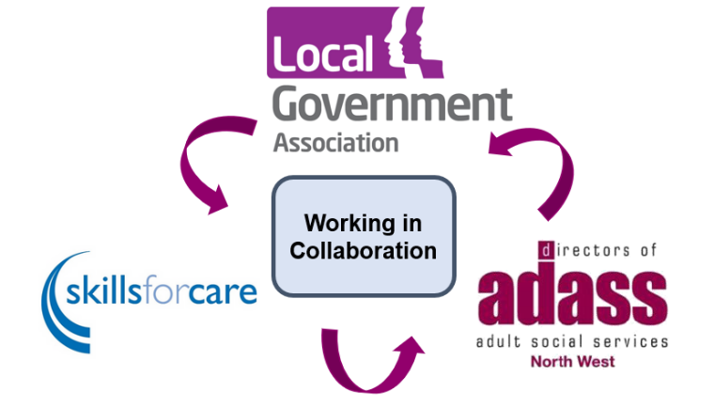

### **Team Priorities**

* Create social care placement opportunities and learning insights at entry level, undergraduate and postgraduate level, including those undertaking apprenticeships.
* Access clinical development (upskilling) training and resources for those employed in social care in non-registered and registered roles.
* Work with education providers including Manchester University, University of Liverpool, Lancaster University, University of Central Lancashire, Edgehill University and the University of Chester, helping to inform how curriculums can become more orientated towards social care as a destination career.

**Regional Lead for Social Care Workforce:** Gil Ramsden

**NHSE Social Care and Private Independent and Voluntary Organisations (PIVO) Workforce Development Managers** **(aligned with each of the three ICSs in the North-West):**

* Kate Burgess: Lancashire & South Cumbria
* Annette Baines and Susan Clarke: Greater Manchester
* Sue Noon: Cheshire & Merseyside

[**More information here.**](https://www.hee.nhs.uk/about/how-we-work/your-area/north-west/north-west-news/meet-team-social-care-workforce-team)

# **Part 2: Local Authority AHP Leadership**

The NHS divides England into seven regions, with varying numbers of Integrated Care Systems (ICS) in each (shown in map).

ADASS (Association of Directors of Adult Social Services) divides England into nine regions. These align with the NHS regions but have additions by dividing the Midlands and North-East and Yorkshire into two.

There are 152 Local Authorities in England that have care service responsibilities [(Skills for Care, 2023).](https://www.skillsforcare.org.uk/adult-social-care-workforce-data/Workforce-intelligence/Commission-our-services/Local-authorities.aspx)

**North East and Yorkshire**

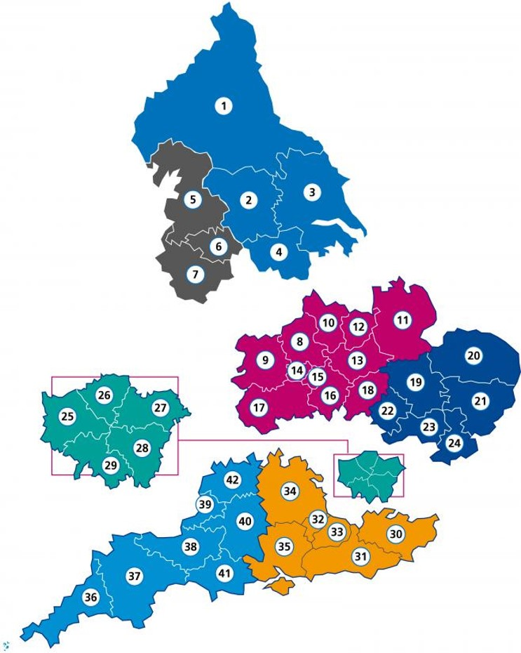1. North East and North Cumbria

2. West Yorkshire

3. Humber and North Yorkshire

4. South Yorkshire

**North West**

5. Lancashire and South Cumbria

6. Greater Manchester

7. Cheshire and Merseyside

**Midlands**

8. Staffordshire and Stoke on Trent

9. Shropshire, Telford and Wrekin

10. Derby and Derbyshire

11. Lincolnshire

12. Nottingham and Nottinghamshire

13. Leicester, Leicestershire and Rutland

14. Black Country

15. Birmingham and Solihull

16. Coventry and Warwickshire

17. Herefordshire and Worcestershire

18. Northamptonshire

**East of England**

19. Cambridgeshire and Peterborough

20. Norfolk and Waveney

21. Suffolk and North East Essex

22. Bedfordshire, Luton and Milton Keynes

23. Hertfordshire and West Essex

24. Mid and South Essex

**London**

25. North West London

26. North Central London

27. North East London

28. South East London

29. South West London

**South East**

30. Kent and Medway

31. Sussex

32. Frimley

33. Surrey Heartlands

34. Buckinghamshire, Oxfordshire and Berkshire West

35. Hampshire and Isle of Wight

**South West**

36. Cornwall and the Isles of Scilly

37. Devon

38. Somerset

39. Bristol, North Somerset and South Gloucestershire

40. Bath and Northeast Somerset, Swindon and Wiltshire

41. Dorset

42. Gloucestershire

<https://www.nhsconfed.org/publications/integrated-care-systems-ics>

<https://www.england.nhs.uk/system-and-organisational-oversight/system-directory/>

# **Principal & Strategic Lead Occupational Therapists (PSLOT) Leadership and Architecture**

**Principal & Strategic Lead Occupational Therapists (PSLOTs)** are the most senior strategic OT leaders working in Local Authorities (LAs) as part of social care.

Find out more here:

* [LGA OT Employer Standards](https://www.local.gov.uk/our-support/workforce-and-hr-support/lga-standards-employers-occupational-therapists-england-2022)
* [RCOT Principal OT Roles and Responsibilities](https://www.rcot.co.uk/sites/default/files/Principal%20Occupational%20Therapists%20in%20Adult%20Social%20Care%20Services.pdf)
* Twitter: @principal_leads

Across England, there are eight Principal and Strategic Lead Occupational Therapist networks. The chairs of these networks represent their regional network at a national task-force. This is an action-orientated group focusing on the completion of high priority projects from start to finish.

Some examples of the projects that have been completed are below.

Graphic of PSLOT networks. Includes:
AHP Care and Health Strategy Advisory Group (meet every six months, December and June). PSLOT National Task-Force (meet 6 weekly), chair: Carolyne Hague. Example task force action projects: design and implementation of the LGA Health Check survey, Co-producing Occupational Therapy in social care infographics, and expert consulting on national projects (eg Intermediate Care Framework).
Regional Networks meet 4-8 weekly or quarterly, and include: North West, South West, London, East of England, North East and Yorkshire, Midlands and South East. PSLOT National Network (March and September).

## **Group: AHP Care and Health Strategic Advisory Group**

* 6 monthly (June and December)

### **Purpose and membership**

* + This consists of representatives from the health and social care sectors. Members have specific expertise in relation to the development of policy and strategy. The groups aims to bring together these workstreams. The group is jointly chaired by the Chief Allied Health Professions Officer for England (NHS England) and the Chief Social Worker for Adults (Department of Health and Social Care).

## **Group: PSLOT Regional Networks**

* 4-8 weekly/quarterly in each region

### **Purpose and membership**

* + There are eight regional networks across England. These consist of Principal and Strategic Lead Occupational Therapists from local authorities. Some regional networks are co-chaired by an ADASS representative and some link with Skills for Care. The networks have differing levels of maturity and individual Terms of Reference.

## **Group: PSLOT Task-Force Group**

## Bi-monthly

### **Purpose and membership**

* + This the ‘engine room’ that organises the PSLOT national network meetings. It is a task orientated group to take actions forwards, often at national level. The task-force have specific task and finish break-out groups for members to put change into action.
  + Membership consists of the PSLOTs who chair the regional networks and up to two other PSLOT representatives from each region.

## **Group: PSLOT National Network**

* 6 monthly (March and September)

### **Purpose and membership**

* + The national network meet 6 monthly and is open to all Principal and Strategic Lead Occupational Therapists from local authorities in England. The agenda is coordinated and organised by the task-force. It provides opportunity to share national updates and strategic direction.

# **PSLOT Network and Task-Force**

# **Member Testimonies**

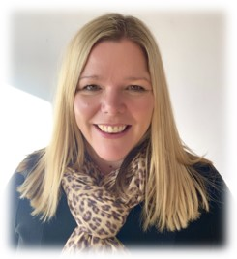“The National PSLOT network and task-force are helping to provide a collaborative environment where our most senior Occupational Therapy leaders, within local authorities can connect, interact, collaborate, influence and learn and grow, together. Our Occupational Therapy leaders have a lot to offer in terms of influencing policy decisions, showcasing the value of OT; developing resources and sharing and exchanging best practice. This optimises the impact their work has across England and most importantly on the health and wellbeing of our population. United, we can accomplish greater things, with gusto. What members have already achieved together, in a short space of time, is testament to that.”

**Carolyne Hague, Task-Force Chair**

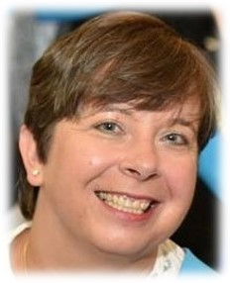

“Local authority OTs are a small resource who have a significant impact on the outcomes for our respective populations. The PSLOT network and national taskforce provides us with the opportunity to develop innovative practice through learning from each other at an organisational and individual level. I really value the support and communications of my network colleagues.”

**Anita Mottram, Principal Occupational Therapist**

**Kirklees Council**

“I highly value the national and regional networks for Principal OTs. Without these groups, I would have nowhere to benchmark our local practice or find valuable peer support. The speakers are thoughtfully invited to make sure it has 100% relevance to your role and enables you to stay at the peak of knowledge.

Being part of the national task-force drives my passion for change and it is exciting to see change happening at pace when we focus together. I would recommend it to anyone who is passionate to be the best POT that they can be, as long as you have time and commitment within your gift to give.”

**Jo Hopkins, Principal Occupational Therapist**

**North Somerset Council**

“The network brings together senior Occupational Therapists in local authorities. Our combined voice and authority raises the profile of Occupational Therapy within local authorities at a national level. This ensures we are seen, valued and heard, and as a consequence, we can influence.

In my view local authorities benefit enormously from wide senior Occupational Therapy leadership, and that leadership needs to be upwards and outwards in its focus. Being part of the networks and task-force supports me in my current role as well as previously when I was the Principal Occupational Therapist.”

**Catherine Greenlaw, Head of Practice and Assurance, Hertfordshire County Council**



“As the newest member of the PSLOT task force, I value networking with my senior OT colleagues to equip me with the platform and tools to be the best version of me.

I am honoured to be working with strategic OT leaders to raise the profile of the Social Care OT and honour the achievements of the OT workforce at a national, regional and organisational level.

‘Occupational Therapy turns impossible into possible’.”

**Jumaimah Iqbal, Principal Occupational Therapist,**

**Calderdale Metropolitan Borough Council**



“Being a member of the West Midlands region Principal OT network has opened lots of networking opportunities and facilitated a deeper understanding of regional and national issues. Similarly, the PSLOT network has enabled me to participate in national and strategic conversations. Ultimately these groups encourage best practice and ensure the succession of our profession.”

**Andrea Gronow, Team Manager**

**Dudley Council**

# **PSLOT Network and Task-Force**

# **Impact and Influence**

## **Achievements from June 2022 - June 2023**

* Three National Principal & Strategic Lead OT (PSLOT) network meetings across England
* National task-force input to the development of the national Intermediate Care Framework and [Care Workforce Pathway](https://www.gov.uk/government/consultations/care-workforce-pathway-for-adult-social-care-call-for-evidence)
* Co-designing a national logo for the PSLOT network
* Co-production of infographics showcasing the role of Occupational Therapy in Local Authorities
* Co-production of the [LGA Employer Standards for the Occupational Therapy Workforce in England](https://www.local.gov.uk/our-support/workforce-and-hr-support/social-workers/lga-standards-employers-occupational-therapists)
* Co-production of the Occupational Therapy [LGA Health Check Survey](https://www.local.gov.uk/our-support/workforce-and-hr-support/social-workers/employer-standards-health-check) and subsequent review of the findings, measured against the LGA Employer Standards
* Ongoing peer support and leadership architecture through the regional and national infrastructure for Principal and Strategic Lead Occupational Therapists across England
* Ongoing support for Skills for Care ‘Aspiring Allies’ leadership programme for Occupational Therapists in social care

## **Next steps for June 2023 - June 2024**

* A focus on equity, diversity and belonging: September 2023’s national PSLOT network topic. A critical reflection of the OT social care workforce and its representation of diversity across roles. To embed this into the strategic direction moving forwards.
* Ongoing development of relationships with partners in the Department of Health and Social Care (DHSC), Elizabeth Casson Trust, Local Government Association (LGA), Skills for Care, Association of Directors of Adult Social Services (ADASS), British Association of Social Workers (BASW), Royal College of Occupational Therapists (RCOT) and NHS England across regional and national networks.

### **Upcoming Priorities:**

* The preventative value of Occupational Therapy in Housing and in relation to disabled facilities grants (DFGs)
* Input and influence in co-designing the LGA Health Check Survey 2023

# **Useful Resources**

Infographic co-designed by Principal and Strategic Lead Occupational Therapists from local authorities across England. This was an output from the East of England Hybrid placement **(page 23)**, where Scott Gunton (OT BSc student) facilitated and led the task and finish group. The infographics have been shared on social media and used by some local authorities at recruitment and careers events.

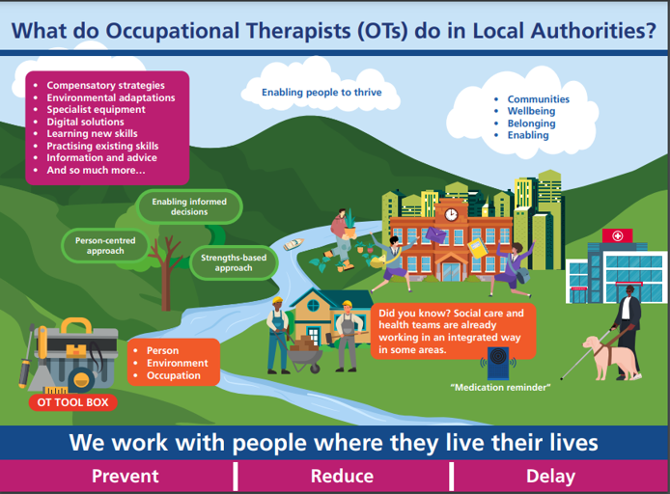

As well as the hyperlinks provided throughout this resource, and specifically on **page 5**, you may also find the following resources useful in relation to AHPs and integration:

* **Integrated newsletter:** [Sign up here](https://www.england.nhs.uk/email-bulletins/integrated-care-bulletin/) to keep updated on latest news and events on integrating health and care across England.
* [**LGA Standards for Employers of Occupational Therapists in England 2022**](https://www.local.gov.uk/our-support/workforce-and-hr-support/social-workers/lga-standards-employers-occupational-therapists)
* [**Local contacts in Skills for Care**](https://www.skillsforcare.org.uk/Support-for-leaders-and-managers/Skills-for-Care-support-in-your-area/Skills-for-Care-support-in-your-area.aspx)**:** Connect with the locality manager in your area.
* [**RCOT (2021): Principal Occupational Therapists in Adult Social Care Services in England: Roles and Responsibilities**](https://www.rcot.co.uk/sites/default/files/Principal%20Occupational%20Therapists%20in%20Adult%20Social%20Care%20Services.pdf)
* **Skills for Care (2022) Occupational Therapy Workforce Data:** [View the local authority workforce data](https://www.skillsforcare.org.uk/Adult-Social-Care-Workforce-Data/Workforce-intelligence/publications/Topics/Occupational-therapists.aspx) for Occupational Therapists

# **Acknowledgements and Thanks**

This resource would not have been possible without the determination, leadership and contributions from the national and regional Principal and Strategic Lead Occupational Therapists in local authorities, AHP Leads in NHS England, AHP Councils and Faculties, and AHPs in HEIs, whose work is showcased in this resource.

Below is a list of people and networks whose contributions and leadership are much appreciated:

## **Principal and Strategic Lead OT Task-Force and Network**

* **Carolyne Hague** (Principal and Strategic Lead Occupational Therapist Task-Force Chair)
* **Catherine Greenlaw and Dr. Anita Mottram** (Principal and Strategic Lead Occupational Therapist Task-Force Vice-Chairs)
* **Vivienne Aldred , Cate Bennett, Alex Crisp, Andrea Gronow, Violina Harpar, Jo Hopkins, Jumaimah Iqbal, Jane Miller-Everest and Laura Owers** (Members of the Principal and Strategic Lead Occupational Therapist Task-Force and Regional Network Chairs)

## **Regional AHP Leads (NHS England)**

* All AHP Regional Leads, Chief AHPs and the Chief Allied Health Professions Office (NHS England)

Specific thanks to: **Claire Arditto,** **Carrie Biddle, Sara Bolton and Dr. Janice St. John-Matthews** for your input and feedback.

## **Regional Showcase Examples**

### **London**

* London Principal and Strategic Lead Occupational Therapist Network
* London AHP Councils and AHP Faculties
* Care City

### **South-East**

* **Marion Angas** (Lead Occupational Therapist [OT]; West Berkshire Council)
* **Kathryn Blair** (BOB ICS Clinical Placement Lead)
* **Sajida Hanif** (Buckinghamshire, Oxfordshire & Berkshire West [BOB] Integrated Care Board [ICB] Allied Health Professional [AHP] Workforce Programme Lead)
* **Gemma Marshall** (OT Workforce Development Project Lead; West Berkshire Council)
* **Rachel Try** (BOB ICS Clinical Placements Team)
* **Amanda Whittaker-Brown** (Senior Advisor, Workforce; Partners in Care and Health [PCH]; Local Government Association [LGA])

### **South-West**

* South-West Principal and Strategic Lead Occupational Therapist Network
* **Jo Hopkins** (South-West Principal and Strategic Lead OT Network Chair)

### **North-East and Yorkshire**

* **Steph Sloan** (Senior Lecturer in Dietetics, Teesside University)
* **Kim Toon** (Project Manager-Paramedics; NHS England, North East and Yorkshire)

### **Midlands**

* Nottingham & Nottinghamshire AHP Faculty Members (Special mention to: **Cate Bennett and Leanne Horsley**)
* **Deborah Harrison** (A1 Risk Solutions)

### **East of England**

* **Vicky Brown** (Practice Consultant Occupational Therapist, Norfolk County Council)
* **Vicky Dobson** (Practice Consultant Occupational Therapist, Norfolk County Council)
* **Scott Gunton** (BSc Occupational Therapy Student, University of East Anglia)
* **Dr. Jane Hibberd** (Academic Lead for Practice Education; University of East Anglia)
* **Poonam Hyland** (Co-chair East of England OT Workforce Action Group)

### **North-West**

* **Gil Ramsden** (Regional Lead for Social Care Workforce; NHS England, North West)

A special thanks to Shelley Smith (Graduate and Placement Scheme, Programme Communications Officer; NHS England)