Health Education England

To: The chief executives and primary care leads of Sustainability and Transformation Partnerships (STPs) and Integrated Care Systems (ICSs)
Copy:
Integrated care system chairs
Primary care board members
Clinical directors of primary care networks
CCG Leads for Continuing Healthcare
Clinical Commissioning Groups accountable officers and clinical chairs

March 8th 2021

RE: National project support for innovation in Anticipatory Care - Invitation to submit Expression of Interest

Dear colleagues,

Health Education England (HEE) is offering support to local projects that deliver innovation and education for local teams delivering anticipatory care.
The National CLEAR Programme (Appendix 1) is supporting the development of Anticipatory Care approaches across primary care networks. Anticipatory Care is designed to support those patients who are at high risk of unwarranted health outcomes to live well and independently for longer, through structured proactive care. This supports the prevention of ill health in line with the NHS Long-Term Plan, with the ambition that people will be able to enjoy at least five extra healthy, independent years of life by 2035.
Expressions of interest are welcomed from primary care networks (PCNs) and integrated primary and community care teams interested in co-producing Anticipatory Care pathways with support from HEE’s CLEAR programme, with a particular focus on developing workforce capabilities for Anticipatory Care delivery. CLEAR stands for Clinically Led WorkforcE Activity Redesign. The national CLEAR team has been commissioned by NHS England and NHS Improvement’s Anticipatory Care policy team and HEE to develop optimum workforce capabilities and support the co-production of national best practice evidence in Anticipatory Care. We are seeking seven areas to take part in the programme and develop two Anticipatory Care pathways: one focussed on COVID-19 and the other chosen from a short list of conditions (Appendix1).

Project support for anticipatory care is offered as part of the National CLEAR Programme, which stands for Clinically Led workforcE and Activity Redesign. CLEAR is a work-based learning programme sponsored by HEE. It supports projects with innovation expertise, data analysis and service modelling; but it also delivers an in-depth education for local frontline clinicians to equip them with data, tools and techniques for service and workforce transformation. The approach supports system working, creates portfolio careers for staff, delivers efficiencies for services and improves patients’ experience of care whilst enhancing outcomes. Each PCN and ICS will have the ability to deliver proactive personalised care in the community, to patients with complex needs. It will improve partnership working between the health system and community providers. Clear will assist PCN’s and ICSs to develop a standardised approach to identifying patients, with the ability to use this to support wider system redesign. CLEAR will assist PCN’s and ICSs to retain the capability to perform workforce redesign with its own permanent workforce in other tenants of anticipatory care.

Timeline requirements for the expression of interest (Appendix 2)
The deadline for submission of an expression of interest is 30th April. During April, information and help is available with a series of webinars to introduce the CLEAR programme, explain how it works and the benefits to participants, both organisations and individuals. See further information in Appendix 2.

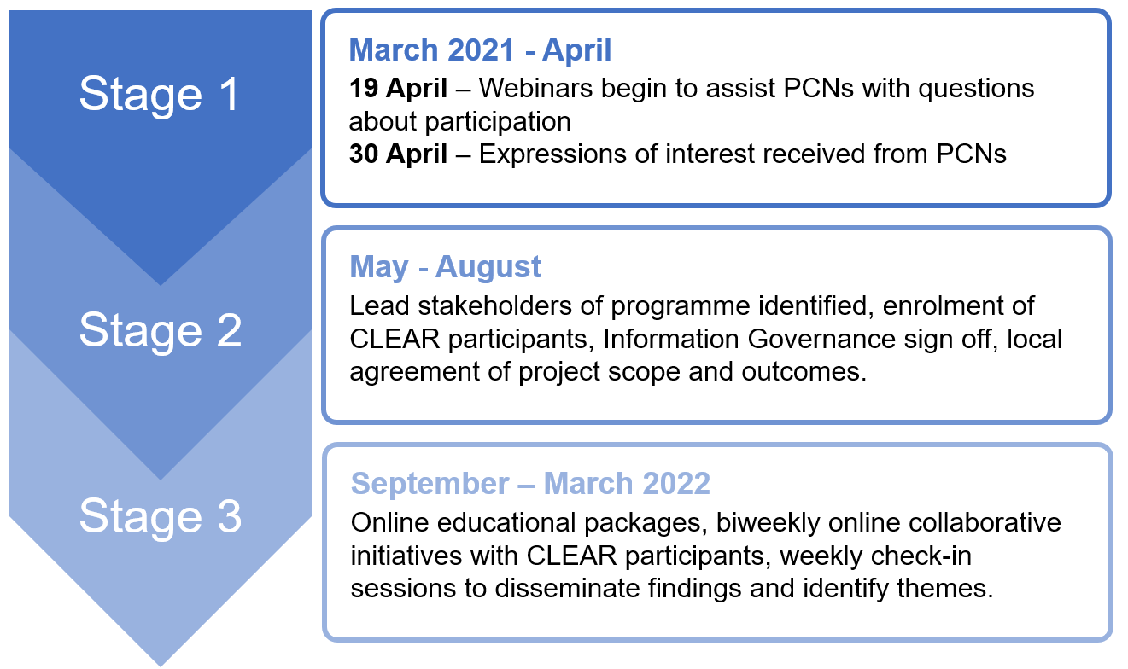
Minimum requirements
Participants in the programme must meet the following requirements and EOIs (Appendix 6) will need to demonstrate the following factors:
- Agreement from their commissioner/ICS to participate in the programme, and an agreed funding route for backfill which will be used for CLEAR participants to engage in the programme 2.5 days a week with a CIRCE of 30k over 6 months.
- Agreement of the ICS evident within the Expression of Interest return.
- A collaboratively defined project scope within the cohorts set out in appendix 6, which is agreed by any local partners involved in the programme.
- To engage with the National CLEAR Faculty in planning the project scope and allow the National CLEAR Faculty and NHSE/I Anticipatory Care programme team to provide direction.
- Commitment to support dissemination of information, both before and after project initiation / finalisation, i.e., participants may be asked to share learnings at national Communities of practice. Provision of resource for projects - see below list of required participants in Roles and Responsibilities section.
- Primary care networks (PCNs) must use the same electronic patient record e.g., all practices are on EMIS or SystmOne to release pooled GP data.
- A primary care network (PCN) and its constituent GP practices must sign an information governance (IG) agreement to provide internal assurance for data sharing, support the CLEAR provider engaging with local IG personnel and, where appropriate, provide approval on sharing agreements and sign off risks on data processing impact assessments.
- PCNs that are using the same patient record system will score more highly on the EOI scoring matrix and its constituent PCN / integrated team must show willingness to sign IG arrangements with the CLEAR team acting as data controller.

Roles and Responsibilities
To ensure the best possible outcome from the programme, we would request the participants are selected from a multidisciplinary model across medical, nursing, and allied health professionals. The experience of the programme is that this variety in background generates the most innovative types of workforce redesign. PCNs must be committed to providing:

Role | Responsibility | Time
Executive sponsor | - An Executive sponsor for the PCN. This is usually a senior manager of a CCG or from the PCN executive board. A description of the support required is attached in the (Appendix 4) | .5 hours per week
Clinical sponsor | - A clinical sponsor to collaborate) with each team from the project site. This is usually a senior clinician of at least a senior GP, matron or a band 8 level. A brief job description is attached in (Appendix 5) | 5 hours per week
CLEAR participant | - A minimum of 2 CLEAR participants who will be trained to deliver the projects, the person specification for the CLEAR participants is described in the proforma (Appendix 3)  - Participants can be from any professional background on the MDT and will need to be released for 2.5 days per week for the duration of the project.  - These participants will be trained and supported by the existing CLEAR national faculty.  - From any discipline or service area provided they meet the person specification | Part time (2.5 days per week) for 6 months to perform this project.
Practice Management | - An identified practice manager of each PCN to assist with commitment of signing IG agreement and systematic problem solving.  - The PCN to identify IT/BI leads to support in appropriate data extraction, as well as resource knowledgeable re. GDPR / existing information sharing agreements | 1 hour per week

Next steps
If you are interested in participating in the programme, please fill out the following template in Appendix 6 and send to clear.team@hee.nhs.uk before the 30th of April 2021.

Yours sincerely,
Dr, John Jeans, CLEAR programme Director

APPENDIX 1 -

To find out more about the National CLEAR Programme:
Visit the CLEAR website at www.clear-uk.org.uk
Visit the CLEAR web pages at HEE at https://www.hee.nhs.uk/our-work/workforce-transformation/clinically-led-workforce-activity-redesign-clear

What will CLEAR do for Anticipatory Care?
CLEAR will work with seven PCNs, one from each NHSEI region, on 14 Anticipatory Care projects. Each PCN will focus on one Covid-19 related project, and one other from the below list:
- Dementia.
- Housebound people.
- Long term conditions (multi-morbidity).
- Respiratory (including those recovering from COVID-19 infection).
- Cardiology.
- Patients/the public who suffer from challenges due to the impact of wider determinants of health e.g., homelessness.
- Mental health in primary care.
- End of Life.
The CLEAR programme will support PCNs to embed the five core components of Anticipatory Care:
- Identifying cohorts most at risk of unwarranted health outcomes.
- Undertaking Proactive Care Needs Assessments (PCNAs) to ensure that the needs of those identified are supported in a personalised, holistic manner.
- Robust personalised care and support planning, which focusses on what matters to the person as well as their clinical and support needs.
- Proactive management of need through digitally enabled multi-disciplinary teams and,
- Care coordination which brings together all the information into a single personalised care and support plan, based on what matters to the person.
The CLEAR programme will train clinicians (see below section on participants) in each of the PCNs in the CLEAR methodology. Using the CLEAR methodology, clinicians will draw on data from the PCNs they work within and, where possible, from the community service providers they work closely with. They will use this to identify patients who meet the above project criteria and are at risk of adverse health outcomes. The programme will then support clinicians in identifying interventions that will enhance the care delivered to these populations, using the core components of Anticipatory Care outlined above. This will support the PCN’s workforce to deliver Anticipatory Care which enhances existing local ways of working, meets patient needs in a proactive way, and aligns with the anticipated service requirements and metrics of the PCN. Projects will commence by September 2021. Training and project delivery will be done virtually where possible given the pandemic; if face to face work is required it will be fully compliant with social distancing rules.

How a CLEAR project works:

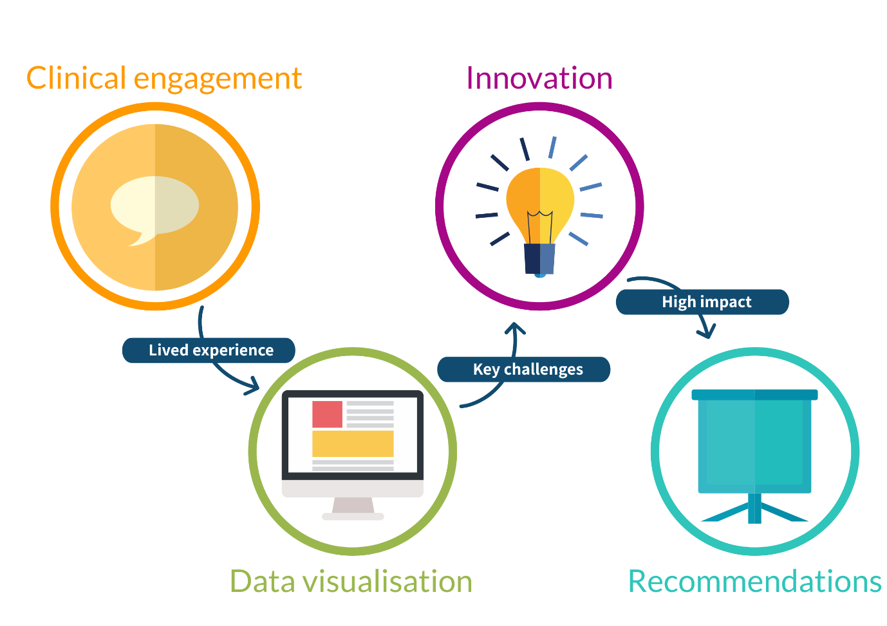
Outputs:
The outputs from the CLEAR anticipatory care programme will be:
- 14 projects across 7 PCNs – these will be undertaken during September 21 to March 22 and learning and innovation from the projects will be shared nationally and in future NHSE/I publications.
- Clinicians trained in the CLEAR methodology and capable of a data-driven approach to designing models of Anticipatory Care, and the workforce required to deliver these models. The clinicians will have the opportunity to join the national CLEAR faculty and support the wider community of practice.
- The development of an MDT workforce model in each participating PCN that meets the complex needs of the different patient populations.
- Improved partnership working between the health system and community providers to deliver proactive personalised care in the community.
- An enhanced capability to perform workforce redesign using a standardised approach to support wider system redesign.
- As part of the project, CLEAR teams at each PCN will interact with each other to share learning between PCN’s and support each other’s projects. These shared-learning forums will be referred to as “kaleidoscopes” used on CLEAR’s online learning platform.
- A bespoke CLEAR anticipatory care education and training package with the relevant virtual and/or face to face learning materials/resources.
- Case studies and learnings from the CLEAR projects that can be shared regionally and nationally.
- An independent evaluation of the projects to ensure learning is disseminated widely from the process of delivering the CLEAR projects.

Data Requirements
CLEAR relies on interrogation and visualisation of data to produce models of care and workforce. Therefore, IG data sharing agreements are an essential part of the projects and we request assistance to make sure these can be safely and swiftly signed.

APPENDIX 2: Timeline requirements for the expression of interest:
Delivery of the programme will be in 3 stages:

Stage 1:
March 2021 to April -- Expressions of interest for interested PCNs will open:
- As well as this document, there will be a webinar for PCNs to answer any questions about participation. Potential webinar dates will be on the week of the 19th of April.
- Expressions of Interest will need to be received by the week ending the 30th of April (see Appendix 6 for the EOI form).

Stage 2:
May 2021 to August 2021—Organisational readiness will include:
- Identification of lead stakeholders of the program and enrolment of the CLEAR participants (see Appendix 3-4 for more information about roles and responsibilities)
- Local agreement of project scope, requirements, and anticipated outcomes
- Confirmation of Information Governance
- Installation of the analytics (the CLEAR data team to be able to automate the data) Understanding the key pressures and stresses on staff workload in primary care. Support the development of the anticipatory care model that align the most appropriate roles, Determining the volume of different staff groups required based on understanding the new skills and activities required by patients.

Stage 3:
September 2021 to March 2021—project delivery over 6 months
- The CLEAR program will provide on -line educational packages which can be accessed through our Blackboard portal to assist with qualitative and quantitative data analysis.
- Weekly check ins on- line and weekly webinars will be held on- line during the process, along with on- line kaleidoscopes to enhance learning.

(Appendix 3) - CLEAR Participant *For the purposes of this document, “clinical” and “clinician” refer to any member of the multidisciplinary team, including, but not limited to, nurses, midwives, allied health professionals, pharmacists, theatre practitioners, surgeons, and doctors.

Clinical | Essential | Desirable
Practicing MDT clinician with valid professional registrations | X
Willing to be participate for a minimum of 6 months | X
Minimum of 4 years recent experience as an NHS clinician |  | X
No major professional commitments in the next 6 months (e.g. postgraduate examinations) |  | X
Previous experience of QI or transformation work |  | X
Data
Strong interest in data | X
Proficient in excel or willing to learn | X
Interest in new technologies or willing to learn | X
Communication skills
Excellent verbal and written communication skills | X
Experience of engaging a variety of stakeholders |  | X
Able to adapt and effectively use new communication methods including virtual platforms to develop productive and collaborative working. | X
Education
Strong interest in education | X
Experience in clinical teaching and/or working with or within clinical education teams | X
Post graduate qualification in education or previous substantive post in a clinical or academic education role |  | X
Interest in new and innovative methods, or willing to learn | X
Has been active in novel education design and provision and or creation of new education initiatives |  | X
Personal attributes
Patient-centred thinking with a commitment to high quality of care outcomes | X
Resilience under pressure to deliver high quality work to deadline, using effective task and time management skills | X
Self-motivated and proactively seeks out learning opportunities and able to utilise online learning resources | X
Effective team-working through acting as a team-player by driving toward a common goal, showing respect and support for colleagues and assuming accountability for work and actions appropriately | X
Preference for collaborative approach to working with others | X
Adaptability to a variety of situations and environments | X
Engages effectively with others as a situation requires, and applies knowledge learnt in one field to novel environments | X
Values – commitment to improving NHS from within. | X

NB Feedback from previous CLEAR participants.

A Consultant’s View
“Training is provided through e-learning; didactic teaching from experienced NHS clinicians, managers and data analysts; and close supervision from experienced mentors. In this way the fellows are able to…understand NHS and local trust processes…[and] analyse patient flow and workforce data to put forward innovative ideas and suggest new ways of working.
The CLEAR programme also delivers the essential generic skills required by the GMC’s professional capabilities framework to provide safe, effective, high quality care…allowing the fellows to develop into effective, motivated leaders in their fields in the future.”
Dr. Michelle Hayes, CLEAR Mentor, ICU and Anaesthetic Consultant;
Chelsea and Westminster NHS Foundation Trust

A Speciality Doctor View
“Working with the CLEAR team, I received genuine and constructive feedback on my presentations…. I had individual practice sessions with the team to help me with my skills which helped my confidence and improved my delivery skills…after working with the CLEAR team and it’s mentors, each presentation I make is now just a bit easier and better .”
Dr James Anish, CLEAR Fellow and ED registrar; Oxford University Hospital NHS Foundation Trust

A Senior Nurse’s View
“I've been a Senior Nurse in the NHS for 20 years, during this time I've been involved in change management, reconfiguration, project work and staffing issues. Within the NHS we often encounter the same frustrating problems and adapt to change after or during a crisis and 'hope' solutions are found to improve care for patient…
…I joined the CLEAR programme in September 2019 and it has given me a completely different approach to current and future challenges within healthcare. The CLEAR programme has revolutionised my thinking, and approach to challenges and given me the space to engage with staff on the frontline, something that we haven't been able to do before. Working alongside other 'hubs' nationally with the support from Health Education England and the CLEAR team has given us the credibility to work strategically and to produce some excellent analysis and provide actual evidence of what is and isn’t working, while learning to use data to influence change is very powerful and engages everyone. I have learnt many new skills related to CLEAR such as being able to visualise, interpret data and apply it to a clinical setting to explain the challenges we face. I have also learnt many skills that are transferable to my clinical work. I have gained invaluable communication skills especially in presentations and engaging with others. I have an increased awareness of strategic issues for the NHS as well as individual Trusts and department. I have been working in a team with new people from different disciplines/ areas and learnt from them as well as how to work with them. I have had the opportunity to experience organisational meetings, discussion with managers and speaking to a whole range of people within NHS organisations. The results of the projects and feedback from the local teams, so far have been amazing and I look forward to continuing this work with CLEAR in the future!”
Claire Brewster, CLEAR Fellow and Frailty Specialist Nurse;
Calderdale and Huddersfield NHS Foundation Trust

Appendix 4 – CLEAR Project Site Executive Sponsor role

The Executive sponsor lead for the CLEAR project site has responsibility for ensuing the CLEAR team are welcomed within the PCN and can function within the organisation.
Key responsibilities include:
- Ensuring the Executive team area aware of the scope, and limitations of the CLEAR project.
- Ensuring that key personnel within CCG/ICS Finance, Human Resources and Business Intelligence are aware of their expectations with regards to the CLEAR project and are accessible by the CLEAR team so that project outputs can be reviewed and disseminated effectively in line with the strategic priorities of the CCG/ICS.
- Liaise with relevant clinical leadership in PCNs and integrated community teams to agree the scope of the CLEAR project as well as identifying key individuals for engagement.
- Providing a point of escalation for the CLEAR team when operational issues within the host PCN cannot be addressed by the Directorate Lead.
- Implementation plans following CLEAR recommendations will be the responsibility of participating organisations.

Appendix 5 –CLEAR Clinical Sponsor role

The role of Clinical Sponsor aligns the work produced by the CLEAR project with the strategic priorities of the PCN. They will ensure that the project is engaged with locally and made visible to the right people so that it can have a positive impact. This individual must be involved in the leadership within the clinical area in which the project is being performed and should have one day a week to support this work for the duration of the project.

Key responsibilities include:
- Facilitating IG, data extraction and data transfer from the project site.
- Working with the CLEAR team to outline the key issues and scope of the project, including challenges to addressing this previously.
- Supporting data validation and mapping exercises.
- Working with the CLEAR team to outline the key issues and scope of the project, including challenges to addressing this previously.
- Explaining local clinical context to the CLEAR team.
- Ensuring the project site is aware of the scope and limitations of the CLEAR project.
- Providing an insight into the culture within the project site and the local context.
- Identifying key stakeholders within the project site and ensuring that they are accessible to the CLEAR team.
- Providing guidance to the CLEAR team around foreseeable challenges to the implementation of new ways of working.
- Supporting the organisation of focus groups with key stakeholders or other appropriate arena for discussing new ways of working.
- Engaging with the CLEAR participants to support analysis of the local data and innovation on the key themes.
- Reviewing project recommendations and outputs of interim and final reports.
- Supporting the communication of outputs to key stakeholders.
- Project governance.
- Providing pastoral care for the CLEAR Associates on site.

Appendix 6 - Anticipatory Care Initial Expression of interest Proforma

Please complete the proforma below if you are keen to take part in the CLEAR programme. Once you have completed this proforma, or if you have any questions, please email clear.team@hee.nhs.uk. We look forward to hearing from you.

Question | Response | Scoring (Essential, Desirable)
PCN name, along with CCG and region |  | Essential 5 points
Contact details for System Executive Champion | Name:  Email: | Essential 5 points
Contact details for PCN Clinical Director/ Clinical Sponsor | Name:  Email: | Essential 5 points
Contact details for PCN managerial lead | Name:  Email: | Essential 5 points
Contact details for the individual practice managers | Name:  Email:  Name:  Email:  Name:  Email:  Name:  Email:  Name:  Email: | Essential 5 points
Areas of interest for CLEAR projects. Please mark these in red | Each PCN will perform a project in COVID and please rank the following preferences as 1-8  - COVID-19.  Please select a minimum of 2 from:  - Housebound people.  - Long term conditions (multi-morbidity).  - Respiratory (including those recovering from COVID-19 infection).  - Cardiology.  - Patients/the public who suffer from challenges due to the impact of wider determinants of health e.g., homelessness.  - Mental health in primary care.  - End of Life  - Dementia | Essential 5 points to mark at least 2 preferences.
What the benefits of doing a project would be for your system? |  | Desirable (response graded from 1-10 depending on alignment to LTP)
Are there any risks that may impact the successful delivery of the project? |  | Desirable (response graded from 1-10 depending upon realistic articulation of risks)
Are there similiar projects that the organisation is currently or have been recently involved in?  NHSEI’s Population Health Management Development Programme |  | Desirable – not used for scoring but for information only
What is your approximate PCN population size? |  | This is for information only for monitoring and evaluation
How many practices are there in your PCN? |  | This is for information only for monitoring and evaluation
Is your PCN within one ICS? |  | This is for information only for monitoring and evaluation
Clinical system (s) used primary care e.g., system1/EMIS/Vision or other |  | PCNs will need to all use the same system to be considered for CLEAR
Potential dates for meetings with key stakeholders above |  | More potential dates generate a higher score. 2 points per date. Please suggest dates between 10th and 20th May
Why is the clinical area relevant?  See the example below: |  | Desirable (response graded from 1-10 depending on alignment to STP)

A short paragraph detailing three issues below:
- Context of Community and organisational challenges,
- Particular area/pathway/cohort of patients of interest within the specific team,
- Intended outcome and focus of model of care solutions.
An example is listed below:
Context: The GP practice and the Community Integrated Teams are undergoing system wide reconfiguration which involves the reorganisation of processes and pathways, especially with recent challenges from the COVID pandemic.
Patient cohort: The Community Rapid Response Team has identified a surge of house bound patients as priority on their case load who are complicated with long term conditions with high hospital admission rates.
Focus of new model of care; The PCN seeks to understand further the impact of this cohort of patients and co-develop nursing and Allied health professional workforce models that improve workforce retention and care for these high-risk patients in the community.

