# Reporting and/or Escalating Education Quality Concerns Guidance



First published 2023

Updated July 2024 (rebranded to reflect transition to new NHS England)

Contents

Reporting and/or Escalating Education Quality Concerns Guidence 1

Introduction 3

Principles 3

Scope 3

The Education Quality Framework 4

Notification (or escalation) of concerns 5

Learners and educators 5

Placement and education providers 5

How NHS England WT&E will use the information 8

Associated documentation 9

## Introduction

NHS England, Workforce, Training and Education (WT&E) is responsible for ensuring that there are high quality learning environments for all healthcare learners.

There are times when concerns may be raised about a healthcare education and training programme or an approved learning environment. It is important that NHS England WT&E and our partners work together to ensure regulatory and education and training standards for education and training continue to be met. This policy provides the overarching approach and principles for escalating, de-escalating and sharing of issues, risks and concerns relating to the quality of education and training and to the clinical or practice learning environment.

This policy should be read in conjunction with the [NHS England Education Quality Strategy and Framework and supporting documents](https://www.hee.nhs.uk/our-work/quality).

## Principles

The principles that underpin this policy are:

* To ensure a safe and suitable learning environment for all healthcare learners.
* To promote the values of the NHS Constitution through collaboration and respect for each other.
* To support openness and transparency between organisations with a commitment to work together to drive improvements.
* To have a duty of candour and to share information and concerns in a timely manner.
* To use the NHS England Education Quality Strategy and Framework when describing issues, concerns and risks. Specifically reporting against the six grouped domains/themes articulated in the education quality framework.

## Scope

NHS England WT&E has a statutory responsibility to work with partners to plan, recruit, educate and train the future workforce to produce the highest quality healthcare professionals in the right numbers to meet the needs of patients and NHS services.

This policy applies to all clinical and practice learning environments in which learners are placed regardless of funding arrangements.

This policy applies to all providers of healthcare education programmes and health and care practice placements, including:

* Higher Education Institutions (HEIs)
* NHS health and care Providers
* Independent health and care Providers

This policy does not replace the following existing policies, protocols, or processes:

* Policies which organisations may already have in place for their own role in escalating concerns to NHS partner organisations for example, to a professional regulator. NHS England WT&E must be informed of any escalation of this kind, where there is an impact on education and training.
* Local policies for the sharing and escalation of concerns between local placement providers and education providers. At a local level, provider organisations and those responsible for education and training must have processes in place to manage concerns raised by learners.
* Local and/or regional WT&E polices for the sharing and escalation of concerns between providers and WT&E education quality teams, this policy provides the principles to support a consistent approach across England.

It is important that learners and educators utilise local mechanisms within the learning environment initially. This process does not replace serious incident reporting procedures in trusts and local processes should be followed for serious incidents.

## The Education Quality Framework

The NHS England Education Quality Framework articulates NHS England’s expectations of the quality of the clinical and practice learning environment as a whole system, complementing the other regulatory and professional frameworks and requirements where relevant.

Robust monitoring and reporting processes are essential to the continuous improvement of education and training, with patient safety and quality, central to all activities. The [NHS Education Contract](https://www.hee.nhs.uk/our-work/new-nhs-education-contract) sets out the expectations for all providers in respect of the application and monitoring of quality through the Quality Framework and associated quality and performance requirements.

NHS England exists within a wider system, working in partnership with, and across, healthcare and professional regulators, service and education providers, other arms-length bodies, and key stakeholders. We occupy a unique space where we can view quality through a multi-professional and cross-disciplinary lens and have an overview and understanding of the clinical education and training landscape, which reaches across sectors and organisations.

## Notification (or escalation) of concerns

### Learners and educators

Learners and educators in any clinical learning environment (or healthcare related education placement) are well placed to provide valuable information about the quality of their educational experience, but also about the supportive nature of each workplace, both in terms of patient safety and interpersonal/inter-professional behaviours and culture.

Since learners commonly rotate between different placements, their feedback can often be an early warning for potential quality or patient safety concerns.

**Raising quality concerns**

NHS England WT&E has a pathway for learners and educators to raise, and where appropriate, escalate concerns regarding the learning environment. The pathway and supporting information can be found on the website [here](https://www.hee.nhs.uk/our-work/quality/raising-concerns-0).

### Placement and education providers

When a concern arises regarding an education and training programme and/or an approved learning environment, NHS England regional education quality Teams, education providers and placement providers must work together to ensure regulatory and educational standards for education and training continue to be met. Education institutions and those responsible for the management of approved training programmes are required to report concerns to NHS England WT&E, particularly where an issue affects the clinical learning environment or where the concern may pose a risk to patient and/or learner safety.

It is important to recognise that the education or placement provider will remain responsible for the management and mitigation of the concern.  NHS England WT&E will be able to offer support and will require providers to share progress updates and confirmation of resolution.  This information will enable the triangulation of concerns geographically and professionally to identify any emerging and/or escalating concerns.  Providing regular updates to the regional NHS England WT&E office will support the collation of mitigating actions and good practice to support other providers to resolve similar concerns.

**Sharing and escalating quality concerns**

Reporting to NHS England WT&E should take place where there is a risk of, or evidence that, one or more of the Education Quality Framework standards for education quality are not being met, and should especially be considered where there are:

* Persistent issues that are not resolved through actions with providers / stakeholders. These may include persistent minor concerns over a longer period of time.
* Major and serious quality issues that may require immediate escalation / action. For example, a lack of supervision/support because of educator absence.
* Professional and system regulator concerns.

A concern that may impact on one or more of the Education Quality Framework standards should be reported.  The table below (figure 2) provides examples of concerns that should be reported to regional NHS England education quality teams (please note that this list is not exhaustive).

Figure 2

|  |  |
| --- | --- |
| NHS England Education Quality Framework domain | Examples of concerns, relating to the learner experience, that should be reported and/or escalated to NHS England |
| Learning environment and culture | * A trend of reported bullying and undermining behaviours in a clinical learning environment that has not improved or where feedback regarding concerns has not been acted upon. * Significant patient safety risk as a result of insufficient staff to cope with workload pressures. * Patient dignity concerns, for example instances of patients being spoken to in a derogatory manner or failing to protect a patient’s dignity. * Unsupportive environment and/or unsupportive behaviours. * Patient safety concerns. * Governance issues including supervision and mentoring. |
| Educational governance and commitment to quality | * Poor governance including reporting or poor engagement with the trust senior education team or leads. * Concerns that are about a specific ward or department or organisation wide issues. * Trends or patterns from complaints, feedback, data, visits, meetings, and committees. * Conditions or requirements and actions following regulators visits which have a link to or an impact on education and training/quality of experience. |
| Developing and supporting learners | * A lack of supervision (named supervisors/mentors) because of staffing shortages. * Emerging themes from learner feedback that highlight concerns. This may include more than one learner describing the same concern, or consecutive feedback from individual learners in a small programme/placement. |
| Developing and supporting supervisors | * Supervisors/educators not given adequate time for the role. |
| Delivering programmes and curricula | * Access to clinics or procedures reported as mixed and sometimes difficult, but with a plan in place to monitor and resolve. * Workforce issues affecting the ability of learners in the clinical learning environment to achieve curriculum requirements. * Curriculum delivery failure/ability to achieve learning objectives. |
| Developing a sustainable workforce | * Service reconfiguration which has the potential to impact on placement quality and capacity. * Insufficient placement capacity. * Services identified at risk due to significant non-training workforce gaps that have not been resolved and which impact on educational opportunities, supervision and experience. |

**How to report and escalate quality concerns**

This is a live quality reporting process, and concerns should be reported and/or escalated as they arise.  To report a concern, please contact the regional quality team, details are available on our [website](https://www.hee.nhs.uk/our-work/quality/raising-concerns/who-contact-resources-links).

When reporting the quality issue or concern, the following should be considered:

* Be clear what the issue/concern is and which learner groups it affects.
* Be clear what the desired improvements, and any actions to achieve these are.
* Consider and define what a successful outcome looks like.
* That the pace and timings of actions /monitoring are clearly described.
* That the next steps and potential end points, including escalation, are clearly described.
* Is there potential for impact on other professional or learner groups?

De-escalation by the provider is considered when sustained and triangulated progress has been made.

## How NHS England WT&E will use the information

Reported concerns will feed into NHS England’s national and regional education quality management processes. This will include the triangulation of concerns with other sources of data and intelligence. In accordance with our [Intensive Support Framework](https://www.hee.nhs.uk/sites/default/files/documents/Intensive%20Support%20Framework%20Guide%20-%20June%2018.pdf), concerns may be shared with professional and system regulators and other system partners. NHS England WT&E will involve providers if concerns are shared.

We will consider the sharing and escalation of quality concerns through a categorised structure; this supports individuals managing concerns as well as ensuring appropriate and fair actions or next steps.  The National Intensive Support Framework (figure 3) is designed to enable both categorisation of concerns and provide local support to address them. It facilitates a graded approach to this reporting and support. To promote consistency regional offices, apply the same language and categories for all learners in order to classify and describe the escalation level.

Figure 3

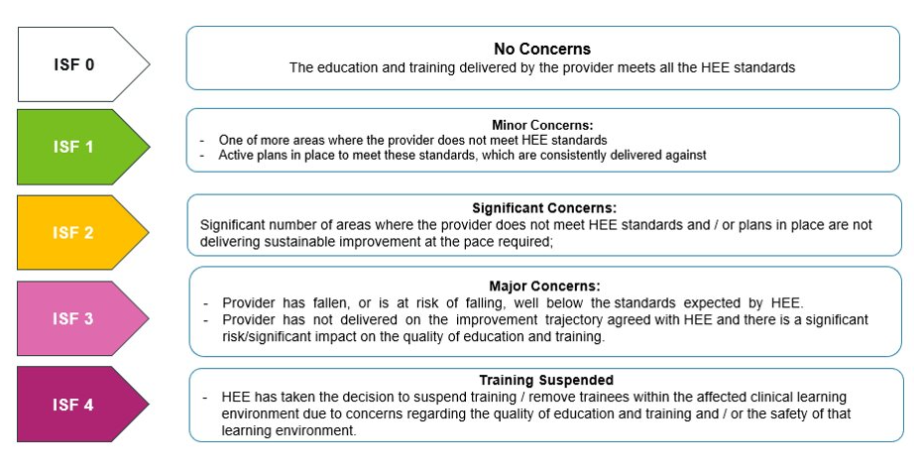

## Associated documentation

Documents available at <https://www.hee.nhs.uk/our-work/quality>

* NHS England Education Intensive Support Framework
* NHS England Education Quality Framework
* Emerging Concerns Protocol
* NHS England Education Quality Strategy