Maternity Support Worker

Level 3 Apprenticeship
Training and Competency Manual
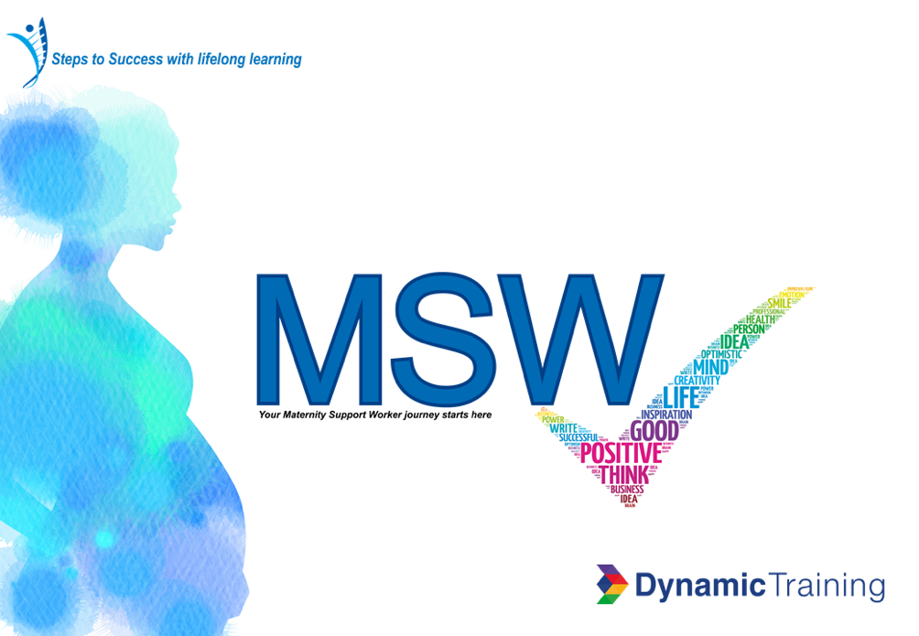

In collaboration with:
London North West University Healthcare NHS Trust
Imperial College Healthcare NHS Trust
The Hillingdon Hospitals NHS Foundation Trust
Chelsea and Westminster Hospital NHS Foundation Trust

Version | Reviewed by | Date
Final Pilot version 1 | MSW working group/JM/RG | Jan 2020

Contents
Topic | Page number
Contents | 3
Welcome | 6
How to use Skills Passport and Competency Book | 8-17
Assessors Signature Sheet | 18
MODULE: Supporting women and families
Consent and Confidentiality | 20
Documentation | 22
MODULE: Public Health, Prevention and Promotion
Making Every Contact Count (MECC) | 44
Postnatal Care | 48
Wound care and perineal care | 50
Bladder Care | 45
Infant Feeding | 66
Loss/Bereavement
MODULE: Personal and Clinical Skills
Physiological Assessment
Maternal Observations | 25
Obstetric Emergencies | 24
Phlebotomy | 27
Newborn Blood Spot Test | 52
Neonatal Blood Glucose Monitoring | 55
Serum Bilirubin Ratio Screening | 58
Neonatal Observations & Check | 60
Care of the Neonate | 64
Labour Ward and Theatre | 34
CS set Instruments | 40
MODULE: Creating a Safe Environment

ANTT (Aseptic non touch techniques) | 32
Infection control | 31
Equipment | 68
Core and Additional skills achieved | 70
Summary Education | 74

Welcome to your Apprenticeship Training and Competency framework Booklet

This will be your guide through the healthcare system within North West London Trust Hospitals and will be where your competency accreditation skills will be recorded.
NORTH WEST LONDON VISION
Our vision is to lead the way in providing first class, safe maternity care that offers choice, individualised continuity and that has the family at the heart of everything we do.
We will do this by working in partnership to provide outstanding maternity services that are evidenced based and in line with the recommendations of the national maternity review ‘Better Births’.
Working as a collaborative Local Maternity System, we will build trust and breakdown boundaries across our area. By doing this we aim to improve the clinical outcomes and care experience for women and families using our services. LMS 2018
Better Births Objectives in conjunction with maternity workforce
Our vision for maternity services across England is: for them to become safer, more personalised, kinder, professional more family friendly; where every woman has access to information to enable her to make decisions about her care and where she and her baby can access support that is centred on their individual needs and circumstances.
All staff to be supported to deliver care which is women centred, working in high performing teams, in organisations which are well led and in cultures which promote innovation, continuous learning, and break down organisational and professional boundaries. NHSE 2016
https://www.england.nhs.uk/wp-content/uploads/2016/02/national-maternity-review-report.pdf

How to use the Skills Passport and Competency Booklet

This document will follow on from the skills for health Care Certificate where you either are currently completing or have already demonstrated successfully completion of the 15 standards, including Functional skills 1+ 2. It will be your maternity passport of competency and will link into the apprenticeship programme at level 3. To be completed within the programme timeline structure.

http://www.skillsforhealth.org.uk/standards/item/216-the-care-certificate

https://www.dynamictraining.org.uk/apprenticeships/learners/our-apprenticeships/maternity-support-worker-shcsw/

The maternity support worker (MSW) will be responsible for completing and maintaining a professional and personal portfolio. This will include details of your orientation to xxxxxxxxxxx Hospital and the community setting and training relevant to the role.

The portfolio will contain specific core competencies that you must achieve (with documented evidence) and expected competencies that you will achieve within a given timescale (dependant your clinical area of work). Your manager may indicate further skills and training for you to fulfil in order to carry out the role as an MSW to enable you to meet service needs and for your own personal development. This document should be used to collate evidence and certification of training days, conferences and academic qualifications. It is designed to guide you and promote reflection upon your learning.

Your portfolio and competency book will enable you and your manager to clearly identify your skills and strengths, as well as areas where there is scope for improvement; prior to the end point assessment (EPA). At the end of your apprenticeship you will continue development with a yearly appraisal, a professional development plan (PDP) and review of yearly trust objectives (specific to your current role) will take place. This may highlight personal or professional areas that the trust can support you to develop and progress towards a higher level of achievement.

APPRAISAL, TRUST OBJECTIVES AND PERSONAL DEVELOPMENT REVIEW (PDR)

Your annual appraisal and PDR will enable you and your manager (or nominated senior person) to re visit the expectations of your job role and the trust objectives. You will be required to provide evidence of achievement or progress towards achievement of competencies specific to your role. This portfolio will be used to facilitate this.

Mentors are expected to support MSW through there learning within the clinical area and give feedback. Take overall responsibility for facilitating and monitoring learning and achievement of skills during the given timescale.

Definition of a Maternity Support Worker

“Maternity support workers assist with caring for women, babies, and their families throughout their maternity journey, working under direct supervision and within agreed guidelines and protocols when providing care to women and their families” HEE 2019
.

Further Definitions

“Competence is the bringing together of general attributes – knowledge, skills and attitudes. Skill without knowledge, understanding and the appropriate attitude does not equate with competent practice (NMC, 2008). Thus, competence equals the “skills and the ability to practice safely and effectively without the need for direct supervision” (UKCC, 1999, Watson et al, 2002).

“Delegation is defined as the transfer to a competent individual, the authority to perform a specific task in a specified situation that can be carried out in the absence of that midwife and without direct supervision.” (NMC, 2008).

Accountability and Responsibility
Delegation & Supervision Principles

As a maternity support worker you work as part of a team of midwives, doctors and other health professionals. You require a wide range of competencies including – communication skills, problem solving, recognising and responding appropriately to any situation as well as emergency situations, demonstrating awareness of equality and diversity issues as well as a range of clinical skills.

This competency record is largely focused on clinical tasks but will have set reflective sections and will link with the apprenticeship workbook. Its aim is to ensure that you have received the necessary formal training and been assessed as competent, to carry out these tasks safely and to a high standard. It is important to recognise you are responsible for any tasks that are delegated to you and that you accept and as such are accountable for your actions.

https://www.rcm.org.uk/media/2338/role-responsibilities-maternity-support-workers.pdf

The decision to delegate is either made by the midwife, nurse or the employer and it is the decision maker, who is accountable for the appropriate delegation (NMC, 2008).

A midwife who delegates aspects of care to others remains accountable to the NMC and employer for the appropriateness of that delegation and for providing the appropriate level of supervision to ensure the MSW competent in carrying out the delegated task. Employers are responsible for ensuring that this is facilitated by working practices.

The midwife is also responsible for reassessing the condition of the person under their care at appropriate intervals and determining that the person’s condition remains stable and predictable (NMC, 2008/ RCM, 2014).

Where the decision to delegate care has been made, this has to be supported by clear written records. Communication channels between midwives and support workers have to be in place to enable the MSW to report clinical findings to the midwife.
Parameters of care given by MSW’s

Remember as a Maternity Support Worker you:
Undertake tasks that have been delegated to you by a midwife or other registered practitioner
Observe
Inform (Midwives & Women and their Families)
With appropriate training and supervision, provide information, guidance, reassurance and support
Report findings back to midwives verbally and through documentation

You cannot assess, initiate an intervention, or make a clinical judgement or plan of care.
DO NOT INITIATE COMMENCING ELECTRONIC FETAL MONITORING IN ANY CIRCUMSTANCE
It should be noted that the competencies and tasks in this record are not an exhaustive list of what the MSW undertakes, but are some of the clinical tasks that require an assessment of competency to ensure high and consistent levels of care.

Competency Framework for MSWs for North West London Local Maternity System
The framework for North West London Local Maternity System Maternity Support Workers should be used alongside the Band 3 North West London Local Maternity System Job description, and the Maternity Support Worker Competency, Education and Career Development Framework. The employer is responsible for identifying the range of skills and tasks suitable for delegation to an MSW and this document will clarify activities, tasks and skills that can be delegated following assessment of competence and also highlight those NOT to be carried out by the MSW.
The purpose of the framework is to standardize care by providing clarity and guidance to both the employee (MSW) and their colleagues. This will enable the MSW to develop the skills and competence safely to fulfill the current and evolving role.
http://www.rcm.org.uk/learning-and-career/learning-support/msw-roles-and-responsibilities
NOT TO BE UNDERTAKEN
BY MATERNITY CARE SUPPORT WORKERS

- Maternal history taking/booking
- Diagnose pregnancy
- Monitor progress of pregnancy
- Provide primary advice
- Give advice / information on pain relief
- Diagnose onset of labour
- Supervise student midwives
- Second person attending a home birth
- Obtain consent for any invasive procedures
- Assisted delivery
- Fetal blood sampling
- Antenatal assessment of a woman
- Abdominal examination of a woman
- Speculum examination of a woman
- Vaginal examination of a woman
- Assessment of uterine activity
- Suscultation of fetal heart
- Drawing up of an injection

- Care for the woman and her baby
- Monitor labour progress including maternal and fetal wellbeing
- Run through an intravenous infusion
- Administer any medication
- insertion of a nasogastric tube
- Attachment of a fetal monitor
- Interpretation of a cardiotocograph (ctg)
- Delivery of a baby
- Episiotomy
- Perineal repair
- Initial examination of the newborn
- Apgar score
- Supra pubic pressure during shoulder dystocia
- Rubbing up a contraction during post-partum haemorrhage
- Manual removal of placenta

In an extreme emergency and following training on a recognised obstetric emergency course, the MSW may be asked to perform emergency procedures under direct instruction and supervision of a midwife. Responsibility and accountability remain with the delegating qualified member of the Multi-Professional team.

Role Descriptor: Level 3 Maternity Support Worker

Level 3 Maternity Support Worker
Uses additional skills within focused aspects of service delivery to enhance the service offered to
women and their families; working alongside, but under the guidance of, practitioners at all levels
from across the multidisciplinary team including, but not limited to: obstetricians; midwives; ultrasonographers;
physiotherapists and advanced nurse practitioners Band 5 and above.

Scope of role

Level 3 MSWs provide direct delivery of clinical care to all women and babies accessing maternity
services and may be based within specialist and integrated teams such as in theatre, fetal medicine
units and community hubs. Level 3 MSWs may serve as a point of contact/support for women and
their families and provide clinical, physical, psychological and emotional care and support; they
provide appropriate information and, where necessary, signpost to wider support organisations.
They report to registered practitioners where planned delegated care has been provided.

Leadership
The role holder reflects on and actively seeks ways to improve their own performance.
They demonstrate qualities of leadership, supporting change management, as well as offering
comments and suggestions for improvements to procedures or service development. They prioritise
own workload to ensure timely completion of tasks delegated to them, for reporting to registered
practitioners and documenting outcomes of care offered and/or provided.

Contextual knowledge: the role holder possesses generalised knowledge to inform

Contextual knowledge
The role holder possess generalised knowledge to inform their understanding of the job role and specific knowledge related to tasks or activities within their scope of role.
This may include cross professional knowledge. Through their practice, they must
demonstrate an awareness of contemporary public health and health promotion initiatives, policy
and legislation, including where legal and ethical issues are relevant to their scope of role.

Process knowledge
The role holder is able to make fact-based judgements requiring a comparison of options to effectively perform tasks and activities.
The role holder will undertake well defined, familiar tasks. In some instances, workload is likely to include some complexity but supervision and guidance should be available to assure safety. The role holder will demonstrate
effective application of problem solving and planning skills and a broad skill base related to their
practice. They will be required to document care appropriately, detailing actions taken, where
support has been sought from suitably qualified practitioners or where concerns have been
escalated. They engage in, promote and support others to undertake routine audits or surveys
relevant to their work.

Personal and professional values and behaviours
The role holder is able to independently plan
tasks and workload activities whilst ensuring that their practice is guided by standard operating
procedures and established protocols. Their practice will reflect the principles of woman and
family centred care. They will demonstrate self-directed development, recognising own limitations,
and work within the scope of their role at all times. They will prioritise own workload and may
be responsible for planned care and tasks delegated from a registered or Level 4 practitioner.
Depending upon the level of complexity and risk present, the role holder may exercise an appropriate
degree of autonomy, ensuring they present themselves in a credible and competent manner at all times.

Activities include
In addition to that of the (Level 2 maternity housekeeper) routine maternal and
neonatal observations including BP, temperature, respirations, urinalysis, weighing, maternal and
neonatal phlebotomy, infant feeding support, leading and supporting routine clinics e.g. GTT, public
health promotion and education either as a group or on a one to one basis, including antenatal classes

https://www.hee.nhs.uk/sites/default/files/document/MSW_Framework_Final.pdf

Assessor Signatories’ Sheet
This MUST be completed by all assessors whose signatures appear in this document.

Name  (Please Print) | Job Title | Place of Work | Initials | Signature

When signing supervised practice, it is acceptable for the MSW to have further supervision and supervised practice as necessary to practice and improve their skill before being finally signed off as competent. When signing off as competent, both you and the MSW are agreeing that the MSW is capable to perform these tasks safely.
In some skills, the MSW will need to have demonstrated their ability with supervised practice for a set number of times prior to being signed off as competent (e.g. venepuncture, Neonatal Blood Spot Screening, Serum Bilirubin ratio test, manual blood pressure).

Consent and Confidentiality
Learning Competency | Theory  completed | Assessment  complete | Date  Sign off | Signature of Assessor

Demonstrates an understanding of the ethical principal of valid consent and refusal as outlined in the Data Protection Act (1988)

Consistently ensures consent is obtained before any care is initiated

Consistently treats information as confidential except where sharing information is required for the purposes of safeguarding and/or public protection

Learning Competency | Theory  completed | Assessment complete | Date  Sign off | Signature of Assessor
Demonstrates an understanding of what the scope of MSW practice entails
Understands when it is appropriate and when it is not appropriate to give advice to women
Consistently demonstrates that any advice given is:
- Within the scope of the MSW role at their particular banding
- Having had appropriate training
- Is given under direction from a midwife
Consistently refers appropriately when encounters a task or situation that is not appropriate for an MSW to undertake
Demonstrates consistently working as an active team member, supporting and assisting others appropriately
Consistently takes active responsibility for any tasks that have been delegated to them and communicates to midwife if they encounter any problems with completing the tasks in a timely manner.

Documentation and Communication
Learning Competency | Theory  completed | Assessment complete | Date Achieved | Signature of Assessor

Has attended a training session regarding documentation in maternity, including training on the use of the charts used, including the MEWS chart and computer system

Has demonstrated why clear, accurate and timely documentation is important and understands the impact that poor documentation can have

Consistently keeps clear, accurate and timely records of all care given to women and/or their babies in accordance with Trust Guidelines

Is able to complete all necessary charts in the patients notes as required (MEWS, NEWS, Fluid Balance, VIP, Catheter care)

Understands the need, and demonstrates the ability to treat individuals with respect and dignity at all times and is sensitive to cultural and social factors

Communicates effectively and sensitively with women and their families

Communicates the needs and wishes of women to other professionals

Communicates effectively with other

Colleagues, verbally and written.

Obstetric Emergencies
Learning Competency | Theory  completed | Assessment complete | Date Achieved | Signature of Assessor

Has attended a training session on obstetric emergencies (PROMPT, MOMS)

Demonstrates a basic understanding of the emergencies that can occur when looking after women in antenatal and postnatal

Understands the role of the MSW when dealing with obstetric and neonatal emergencies

Is able to communicate and respond appropriately to the needs of the emergency team (SBAR/TROLLEYS)

Demonstrates the ability to put out an appropriate emergency call with clear instructions

EMERGENCY CONTACT INFORMATION

Dial
2222
State
THE CALL
(See trust guidance)

State: Name of location- ward and room number

Remain online and wait for operator to confirm call details

Ensure any locked doors are opened for team to enter

Obtain the relevant emergency trolley

Return and confirm call has been done

Maternal Observations
Learning outcomes
- Understands why accurate observations are important in assessing maternal well-being
- Demonstrates ability to take maternal observations, including performing manual blood pressures
- Demonstrates understanding of importance of escalating results to midwife

Learning Competency | Theory completed | Assessment complete | Date Achieved | Signature of Assessor
Understands the anatomy +physiology related to pregnancy, birth and postnatal period
Attendance at a study session regarding recording maternal observations
Understands and demonstrates knowledge of taking observations and gaining consent
Demonstrates competence in the use of equipment required to take observations
Understands the potential hazards of poor recording and none referral of observations
Consistently records all observations correctly on MEWS chart
Consistently escalates results to midwife as appropriate

Record of manual blood pressure readings performed under supervision
Demonstrates ability to take a manual blood pressure in a safe and effective manner.
*must have taken a minimum of 5 correct readings prior to being signed as competent.*
No | Date | Clinical area supervised practice | Signature
1.
2.
3.
4.
5.
6.
7.
8.
9
10

I can confirm that the assessed has successfully demonstrated competency and safe practice through by completion of all the performance standards and criteria required.

Name of MSW: | Signature: | Date:
Name of Assessor: | Signature: | Date:

Phlebotomy
MSW’s are ONLY permitted to carry out venepuncture once they have successfully completed the Trust approved training and have passed the practical assessment. They must also be ANTT competent.
Learning Competency | Theory  completed | Date Achieved | Signature of Assessor
Attendance at a study session regarding venepuncture
Consistently ensures consent is obtained before any care is initiated
Venepuncture Assessment  Clinical Area | Safely performs skill and considered competent
 | MSW |  | Assessor
 | Date | Signature | Date | Signature of Assessor

Demonstrates safe practice according to trust’s values (CARES) in identifying patient to obtain consent and assessing risk before attempting venepuncture

Understands how to select the correct vein for procedure, and collecting the appropriate equipment needed.

Demonstrates awareness of the risks to contamination and the prevention of labelling errors of sample obtained

Demonstrates an awareness of the potential complications and plans to minimise risk including (ANTT, Sharps& splashes)

To perform the procedure according to the local policy and guidelines

Accurately completes the documentation required for sample, including labelling and completely woman’s hospital notes

I can confirm that the assessed has successfully demonstrated competency and safe practice through by completion of all the performance standards and criteria required.
Name of MSW: | Signature: | Date:
Name of Assessor | Signature | Date:
Physiological Assessment  Clinical | Safely performs skill and considered competent
 | MSW |  | Assessor
 | Date | Signature | Date | Signature

Interpret vital signs in relation to normal ranges

Appropriate use and completion of Early Warning Score tool relevant to area

Identify, document and report abnormal findings appropriately

Appropriate use of fluid balance chart

Accurately measure and record respiratory rate (RR)

Accurately measure and record pulse oximetry (SpO₂)

Accurately measure and record radial pulse

Accurately measure and record electronic blood pressure (BP) including MAP

Accurately measure and record oral temperature

Accurately measure and record height

Accurately measure and record weight

Accurately perform and record urinalysis – dipstick

Accurately perform and record urinalysis - Machine
I can confirm that the assessed has successfully demonstrated competency and safe practice through by completion of all the performance standards and criteria required.

Name of MSW: | Signature: | Date:
Name of Assessor: | Signature: | Date:

Infection Control
Learning Competency | Theory completed | Assessment  completed | Date Achieved | Signature of Assessor
Understand the causes of infection
Understand the transmission of infection
Understand own and others roles and responsibilities in the prevention and control of infections
Awareness of the legislation and policies relating to prevention and control of infections

I can confirm that the assessed has successfully demonstrated competency and safe practice through by completion of all the performance standards and criteria required.

Name of MSW: | Signature: | Date:
Name of Assessor: | Signature: | Date:

Aseptic Non Touch Technique (ANTT) | Theory  completed | Date Achieved | Signature of Assessor
Training
Assessment Passed
Infection Prevention and Control  Clinical assessment | Safe demonstration of skill and considered competent
 | MSW |  | Assessor
 | Date | Signature | Date | Signature

Demonstrates effective hand hygiene

Demonstrates appropriate use of personal protective equipment (PPE)

Demonstrates an understanding of general infection control of the environment

Demonstrates appropriate decontamination and maintenance of care equipment

Demonstrates safe management of used linen, including potentially contaminated

Demonstrates safe use and disposal of sharps

Demonstrates safe construction of sharps bins

Demonstrates safe closure, labeling and disposal of sharps bins

Demonstrates safe management of blood and body fluid spillages

Demonstrates safe disposal of waste, including that which is potentially contaminated

Demonstrates safe collection, labelling and processing of specimens

Demonstrates an understanding of their role in safeguarding the spread of infection and isolating infectious patients as per Trust guidelines

I can confirm that the assessed has successfully demonstrated competency and safe practice through by completion of all the performance standards and criteria required.

Name of MSW: | Signature: | Date:
Name of Assessor: | Signature: | Date:

Labour Ward and Theatre Tasks
Labour Ward  Clinical assessment | Safe demonstration of skill and considered competent
 | MSW |  | Assessor
 | Date | Signature | Date | Signature

Can assist in preparing the birthing room and any necessary equipment for the birth( including the birthing pool)

Demonstrates awareness of stock control and guidance for ordering

Can assist the Midwife with to orientate woman on arrival to ward

Can assist with early labour care under direct supervision of the midwife (supporting hydration &nutrition needs as appropriate

Can assist in placing women in lithotomy position in preparation for an instrumental delivery or theatre procedure

Is able to support mothers with personal hygiene after the birth

Demonstrates ability to promote skin to skin contact with healthy babies and their mothers or fathers straight after the birth

Knows how to disassemble and assemble the delivery beds in a safe manner

Is competent at thoroughly cleaning the delivery beds, using appropriate cleaning materials and then remaking

Awareness that the above competencies are linked with the theatre skills

I can confirm that the assessed has successfully demonstrated competency and safe practice through by completion of all the performance standards and criteria required.

Name of MSW: | Signature: | Date:
Name of Assessor: | Signature: | Date:
Theatre Tasks  Clinical assessment | Safe demonstration of skill and considered competent
 | MSW |  | Assessor
 | Date | Signature | Date | Signature
Is able to assist with preparation for theatre; daily clean ; theatre lights and stock theatre (including checking expiry dates of all sterile packs and equipment)
Demonstrates how to use the controls for the operating table
Demonstrates ability to use the theatre lights, including positioning and how to turn on and off
Is able to fit lithotomy poles
Is able to remove the end of the operating table
Demonstrates ability to report faulty equipment
Is able to answer all bleeps and telephone calls as requested
Is able to activate the emergency call bell and is able to put out a ‘2222’ emergency call
Understands the importance of maintaining a sterile environment
Is able to set up the trolley for each procedure, including opening the sterile packs and checking the expiry date on chlorhexidine and all sterile equipment
Knows which instrument set is relevant for different procedures
Ensures accurate and timely documentation, including documenting times and personnel present in theatre records
Is able to assist with the positioning of the patient including for the anaesthetic procedure and catheter insertion
Can support and reassure the woman and birth partner during the procedure
Is able to assist the surgeon and scrub nurse with tying up the sterile gown
Knows how to connect and use the diathermy pad
Is able to fit the patient with flowtrons and is able to use appropriately and safely
Is able to use the suction machine correctly and appropriately
Is able to process foetal scalp/umbilical cord pH using the blood gas analyser

I can confirm that the assessed has successfully demonstrated competency and safe practice through by completion of all the performance standards and criteria required.

Name of MSW: | Signature: | Date:
Name of Assessor: | Signature: | Date:

Theatre Tasks Continued | Safe demonstration of skill and considered competent
 | MSW |  | Assessor
 | Date | Signature | Date | Signature

Is able to carry out and document all swabs, instruments and sharps counts

Is able to check and identify instruments with scrub ODP/Nurse against checklist and complete necessary paperwork

Is able to anticipate the needs of the scrub team and provide extra equipment when required

Is able to communicate and respond appropriately to the needs of the scrub team

Is able to carry out baby blood gas analysing when requested

Is able to calculate blood loss by weighing swabs and subtracting the dry weight from the wet weight

Is able to note contents of suction container and subtracts any irrigation or wash used

Can assist in transferring patient to recovery bed

Demonstrates ability to clean the theatre following the procedure, including removing all soiled linen and clinical waste, cleaning the lithotomy poles, equipment and trolleys, using appropriate cleaning products

Is able to prepare the trolleys for the next procedure

I can confirm that the assessed has successfully demonstrated competency and safe practice through by completion of all the performance standards and criteria required.

Name of MSW: | Signature: | Date:
Name of Assessor: | Signature: | Date:

Caesarean Section instruments
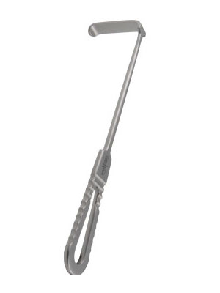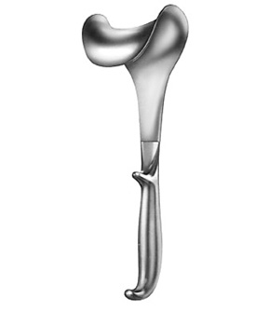
LAGENBECK RESTRACTOR X1 DOYENS RETRACTOR X1
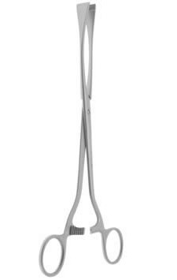
WRIGLEYS FORCEPS X1 GREEN ARMITAGE X5
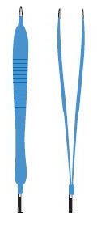
DIATHERMY FORCEPS X1 DIATHERMY LEAD X1

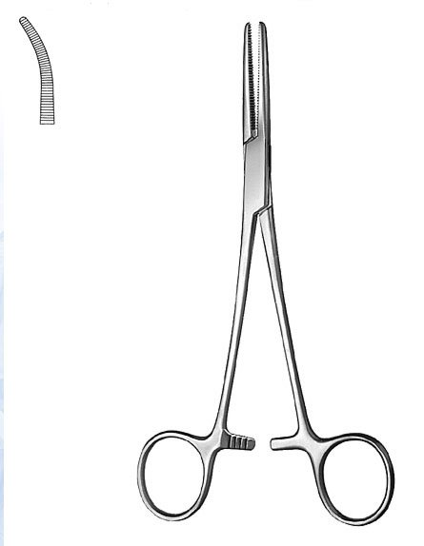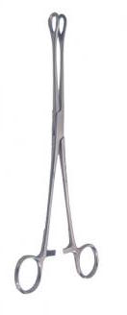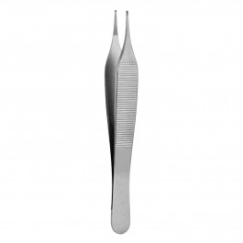
ARTERY FORCEPS SPONGE HOLDERS TOOTHED X1 /
SPENCER WELLS X5 X4 NON-TOOTHED X1
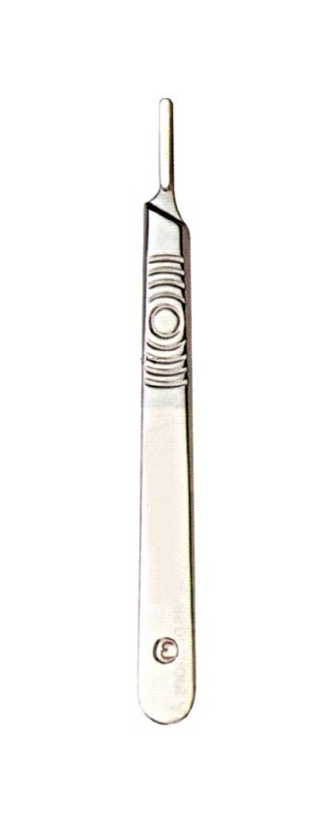
MAYO SCISSORS STRAIGHT X1 BLADE HANDLE SMALL ARTERY
& CURVED X1 X1 FORCEPS X5
_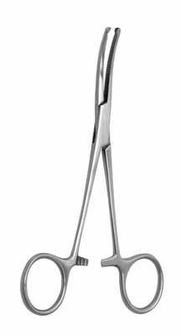 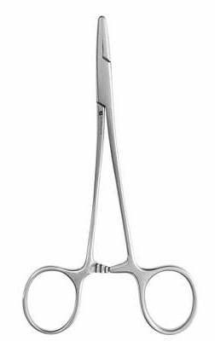 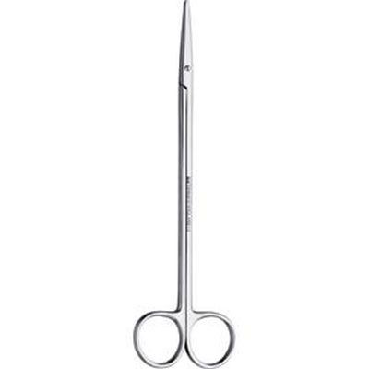 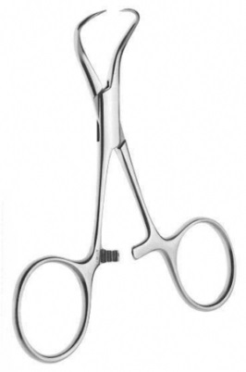
CURVED KOCHERS NEEDLE HOLDER McINDOE TOWEL CLIPS
X2 X1 SCISSORS X1 X2

I can confirm that the assessed has successfully demonstrated competency and safe practice through by completion of all the performance standards and criteria required.

Name of MSW: | Signature: | Date:
Name of Assessor: | Signature: | Date:

Making Every Contact Count –MECC
- To enable you to Make Every Contact Count (MECC) in your day to day work
- Understand MECC and the potential impact of influencing health and wellbeing changes during pregnancy
- Understand the key lifestyle messages for expectant mothers (healthy eating, physical activity, stopping smoking, alcohol consumption and mental wellbeing)
- Be able to identify opportunities and understand how to make effective approaches in promoting health and wellbeing

Learning Competency | Theory  completed | Assessment  completed | Date  Sign off | Signature of Assessor
Has attended a study session regarding MECC
Understands and demonstrates knowledge of the importance of having conversations with women and their families
Understand the key lifestyle messages for expectant mothers (healthy eating, physical activity, stopping smoking, alcohol consumption and mental wellbeing
Be able to identify opportunities and understand how to make effective approaches in promoting health and wellbeing

Bladder Care

- Demonstrates understanding of importance of bladder care in pregnant and postnatal women
- Has the ability to assist women with catheter care
- Can remove a urinary catheter safely
- Is able to document accurate fluid balance appropriately and escalate the results to Midwife

Learning Competency | Theory  completed | Assessment  completed | Date  Sign off | Signature of Assessor
Has attended a study session regarding bladder care in pregnant and postnatal women
Understand and demonstrates knowledge of importance of bladder care in pregnant and postnatal women
Understands the potential hazards of poor recording of fluid balance and of non-escalation.
Understands and demonstrates knowledge of gaining consent prior to undertaking any procedure.

Bladder Care | Safe demonstration of skill and considered competent
 | MSW |  | Assessor
 | Date | Signature | Date | Signature

Is able to assist women with urinary catheter care and hygiene

Can safely empty, change and fit a catheter bag in a sterile manner

Is able to safely obtain a urine specimen from indwelling catheter

Is able to safely remove an indwelling urinary catheter

Can accurately record fluid balance – input and output, including totals at midnight or end of shift

Consistently disposes of equipment according to trust policy

Ensures privacy and dignity maintained throughout procedure

Accurately documents care given in woman maternity records

Demonstrates infection control precautions are maintained throughout
Give accurate instructions to women regarding care after removal of catheter, following Trust guidelines.

I can confirm that the assessed has successfully demonstrated competency and safe practice through by completion of all the performance standards and criteria required.

Name of MSW: | Signature: | Date:
Name of Assessor: | Signature: | Date:

Postnatal Care

Learning Competency | Theory  completed | Assessment completed | Date  Sign off | Signature of Assessor
Understand the anatomy and physiology of women related to postnatal period
Has attended a study session regarding all aspects of the postnatal information discharge discussion
Understands that any clinical guidance required following on from the basic postnatal talk should be escalated to a midwife

Postnatal Care | Safe demonstration of skill and considered competent
 | MSW |  | Assessor
 | Date | Signature | Date | Signature

Is able to assist women who have just given birth to maintain personal hygiene

Demonstrates sound knowledge to give information to women regarding Sudden Infant Death Syndrome( SIDS)

Demonstrates sound knowledge to give information to women regarding pelvic flood exercises

Demonstrates sound knowledge to give information to women regarding contraception choices following birth

Demonstrates sound knowledge to give information to women regarding the birth registration process

Demonstrates sound knowledge to give information to women regarding emergency contact numbers once discharged home

Demonstrates sound knowledge to give information to women regarding community midwife check ups

I can confirm that the assessed has successfully demonstrated competency and safe practice through by completion of all the performance standards and criteria required.

Name of MSW: | Signature: | Date:
Name of Assessor: | Signature: | Date:
Wound Care – abdominal and perineal
- Be able to recognise a healthy healing abdominal wound and refer appropriately when not normal.
- Be able to safely remove wound clips / sutures
- Be able to give accurate, evidence-based guidance of basic wound care to women.
- Be able to give accurate, evidence based guidance of basic perineal care to women.
- Be able to recognise a healthy healing perineal wound and refer appropriately when not normal.

Learning Competency | Theory completed | Assessment  complete | Date  Sign off | Signature of Assessor
Has received basic training about the anatomy and physiology of wound healing
Has received evidence-based training on basic abdominal wound care
Has received evidence-based training on perineal care
Awareness of pressure areas and contribution to wound care
Has received training on pelvic floor exercises

Wound and Perineal Care | Safe demonstration of skill and considered competent
 | MSW |  | Assessor
 | Date | Signature | Date | Signature

Is able to give guidance to women about how to care for their abdominal wound

Is able to give guidance to women about how to care for their perineum

Demonstrates the ability to explain to women the importance of pelvic floor exercises and how to perform them.

I can confirm that the assessed has successfully demonstrated competency and safe practice through by completion of all the performance standards and criteria required.

Name of MSW: | Signature: | Date:
Name of Assessor: | Signature: | Date:

New Born Blood Spot Sample
Learning outcomes
- Is able to take a new born capillary sample
- Understands why the NBSS is offered to babies
- Understands which tests are offered in the screening and explain this to women and their families
- Understands the importance of gaining consent prior to undertaking any neonatal care
- Is able to take a NBSS in a safe and effective manner
- Is able to complete all relevant paperwork associated with this test

Taking a New Born Capillary Sample
Learning Competency | Theory completed | Assessment completed | Date  Sign off | Signature of Assessor
Received training about the anatomy and physiology of taking a new born capillary blood spot sample

Completed and passed online training:
(http://cpd.screening.nhs.uk/bloodspot-elearning)
Has had teaching in, and demonstrates an understanding of the specific tests
that NBSS is testing for.

New Born Blood Spot Screening | Safe demonstration of skill and considered competent
 | MSW |  | Assessor
 | Date | Signature | Date | Signature

Is able to explain to women and their families what the NBSS is testing for in a manner they can understand.

Demonstrates understanding that parental consent is always sought and understood prior to undertaking any neonatal care.

Is able to complete of the NBSS card correctly and all other relevant documentation and understands the potential hazards of poor record keeping.

Consistently disposes of equipment according to Trust Policy

Record of New Born Blood Spot Samples taken under supervision
 |  | Demonstrates ability to take a NBSS in a safe and effective manner. * must have taken a minimum of 10 effective samples prior to being signed as competent.*
 | Date | Signature, Printed Name and Status of Assessor | Comments
1.
2.
3.
4.
5.
6.
7.
8.
9.
10.

I can confirm that the assessed has successfully demonstrated competency and safe practice through by completion of all the performance standards and criteria required.

Name of MSW: | Signature: | Date:
Name of Assessor: | Signature: | Date:

Neonatal Blood Glucose Monitoring
Learning outcomes
- Is able to take a new born capillary sample
- Has an understanding why some babies require blood glucose monitoring
- Understands the importance of gaining consent prior to undertaking any neonatal care
- Is able to take a capillary blood sample in a safe and effective manner
- Is able to complete all relevant paperwork associated with this test

Taking a New Born Capillary Sample
Learning Competency | Theory completed | Assessment completed | Date  Sign off | Signature of Assessor
Received training about the anatomy and physiology of taking a new born capillary blood spot sample
Has had teaching in and demonstrates an understanding of the neonatal hypoglycaemia guideline and why this test is carried out.

Neonatal Capillary Sampling  Clinical assessment | Safe demonstration of skill and considered competent
 | MSW |  | Assessor
 | Date | Signature | Date | Signature

Is able to explain to women and their families what the test is for

Demonstrates understanding that parental consent is always sought and understood prior to undertaking any neonatal care.

Is able to complete of the hypoglycaemia proforma correctly and all other relevant documentation, and understands the potential hazards of poor record keeping

Always communicates the results directly to the midwife or paediatrician for them to make a plan of care
Record of taking neonatal capillary sample under supervision
 |  | Demonstrates ability to take a capillary sample for blood glucose monitoring in a safe and effective manner. . * must have taken a minimum of 10 effective samples prior to being signed as competent.*
 | Date | Signature, Printed Name and Status of Assessor | Comments –
1.
2.
3.
4.
5.
6.
7.
8.
9.
10.

I can confirm that the assessed has successfully demonstrated competency and safe practice through by completion of all the performance standards and criteria required.

Name of MSW: | Signature: | Date:
Name of Assessor: | Signature: | Date:

Serum Bilirubin Ration Screening
Learning outcomes
- Is able to take a Serum Bilirubin Ration (SBR) sample
- Has an understanding why some babies require monitoring
- Understands the importance of gaining consent prior to undertaking any neonatal care
- Is able to take a capillary blood sample in a safe and effective manner
- Is able to complete all relevant paperwork associated with this test

Taking a Serum Bilirubin Capillary Sample
Learning Competency | Theory completed | Assessment completed | Date  Sign off | Signature of Assessor
Received training about the anatomy and physiology of taking a Serum Bilirubin Ratio blood sample
Has had teaching in, and demonstrates an understanding of neonatal Jaundice/SBR guideline and why this test is carried out.

Serum Bilirubin Ratio Sampling  Clinical assessment | Safe demonstration of skill and considered competent
 | MSW |  | Assessor
 | Date | Signature | Date | Signature

Is able to explain to women and their families what the test is for

Demonstrates understanding that parental consent is always sought and understood prior to undertaking any neonatal care.

Is able to complete of Serum Bilirubin pro-forma correctly and all other relevant documentation, and understands the potential hazards of poor record keeping

Always communicates the results directly to the midwife or paediatrician for them to make a plan of care

I can confirm that the assessed has successfully demonstrated competency and safe practice through by completion of all the performance standards and criteria required.

Name of MSW: | Signature: | Date:
Name of Assessor: | Signature: | Date:
Neonatal Observations Learning outcomes
- Understands why the normal parameters for neonatal observations.
- Understands appropriate referral procedures when neonatal observations fall out of the normal range or if there are any concerns.
- Understands the importance of gaining consent prior to undertaking any neonatal care
- Is able to take undertake neonatal observations in a safe and effective manner
- Is able to complete all relevant paperwork associated with this skill
- Is able to understand what a healthy baby looks like, including tone, colour, skin, cord, eyes and mouth

Learning Competency | Theory  completed | Assessment  completed | Date sign off | Signature of Assessor
Attendance at a study session regarding the anatomy and physiology of neonatal observations.
Attendance at a study session regarding signs of a well- baby and signs of an unwell baby
Demonstrates competence in the use of equipment required to take observations
Understands the potential hazards of poor recording and non- referral of observations
Is able to complete the BEWS chart correctly and all other relevant documentation
Consistently recognises when neonatal observations fall outside the normal parameters and refers appropriately.

Demonstrates understanding that parental consent is always sought and understood prior to undertaking any neonatal care.

Is able to recognise healthy and unhealthy umbilical cords, and give appropriate cord care information

Is able to recognise external signs of a healthy and unhealthy baby – tone, colour, skin, hydration, nutrition

Is able to recognise and report to a midwife potential signs of neonatal jaundice and to give initial standard guidance to parents

Record of neonatal observations completed under supervision
 |  | Demonstrates ability to take neonatal observations in a safe and effective manner. This includes heart rate, respiration rate, temperature and oxygen saturations, as well as an assessment of overall well-being (tone, colour, cord, eyes, skin, bowel and bladder function). All documentation to be completed correctly. * must have completed a minimum of ten sets of observations prior to being signed as competent.*
 | Date | Signature, Printed Name and Status of Assessor | Comments
1.
2.
3.
4.
5.
6.
7.
8.
9.
10.

I can confirm that the assessed has successfully demonstrated competency and safe practice through by completion of all the performance standards and criteria required.

Name of MSW: | Signature: | Date:
Name of Assessor: | Signature: | Date:

Care of the Neonate
- Understands basic cord care
- Is able to assist new parents with nappy care and basic hygiene
- Is able to assist the midwife in aftercare immediately after birth, including baby weight and labelling
Care of the Neonate  Clinical assessment | Safe demonstration of skill and considered competent
 | MSW |  | Assessor
 | Date | Signature | Date | Signature

Is able to weight the baby accurately and safely

Is able to carry out identification and security of baby as per Trust guidance

Is able to give parents basic baby skin care guidance in a healthy neonate

Demonstrates ability to undertake daily hygiene needs of baby

Can safely give eye care of baby and give appropriate care guidance to parents

Is able to demonstrate to new parents how to undertake a nappy change

Demonstrates an understanding of cord care and recognition of abnormalities and reporting these to a midwife

Is able to recognise and report to a midwife potential signs of neonatal jaundice

Is able to competently demonstrate baby care to women, including baby bathing and nappy changes

I can confirm that the assessed has successfully demonstrated competency and safe practice through by completion of all the performance standards and criteria required.

Name of MSW: | Signature: | Date:
Name of Assessor: | Signature: | Date:
Infant Feeding
MSW’s are ONLY permitted to assist with any form of Infant Feeding advice and support after successful completion of all the learning outcomes outlined below.
Learning Outcome | Theory  completed | Assessment completed | Date  Sign off | Signature of Assessor
Have attended the Baby Friendly Initiative (BFI) 2 day study day
Have completed and passed the assessment following the 2 day study day
Know where to locate, and have accessed and read the Trust Infant Feeding Policy
Demonstrates competence in the use of equipment required to express breast milk
Has attended a study session regarding the correct methods to prepare formula feeds and correct sterilisation of equipment

Infant Feeding  Clinical assessment | Safe demonstration of skill and considered competent
 | MSW |  | Assessor
 | Date | Signature | Date | Signature

Actively promotes skin to skin contact with healthy babies and their mothers

Can inform parents about the benefits of breastfeeding

Knows how to use the electronic breast pump and can assist mothers

Is able to support women who choose to artificially feed

Is able to explain to women who choose to formula feed correct methods for sterilisation of bottles

Is able to explain to women who choose to formula feeds correct methods for preparing artificial feeds using up to date evidence

I can confirm that the assessed has successfully demonstrated competency and safe practice through by completion of all the performance standards and criteria required.

Name of MSW: | Signature: | Date:
Name of Assessor: | Signature: | Date:

Equipment
Learning Competency | Theory/ Demonstration  completed | Assessment completed | Date  Sign  Off | Signature of Assessor
Has been fully trained in the use of the blood glucose monitor
Has been fully trained in the use of the ventouse machine
Has been fully trained in the use of the blood gas analyser
Has been fully trained in how to set up the phototherapy unit
Has been fully trained in the use of the urinalysis machine
Has been fully trained in the use of the electronic breast pump

Has been fully trained in the use of the bladder scanner

Has been fully trained on how to remove tubing from the’ Baxter pump’, (ONLY once it has been disconnected form the patient by a registered professional)

Has been fully trained in the use of the theatre bed

Has been fully trained in the use of the diathermy

Has been fully trained in the use of labour ward beds

I can confirm that the assessed has successfully demonstrated competency and safe practice through by completion of all the performance standards and criteria required.

Name of MSW: | Signature: | Date:
Name of Assessor: | Signature: | Date:

Other Core Skills
Learning Competency | Theory completed | Assessment completed | Date sign  Off | Signature of Assessor
Has attended additional training session for new skills required to update knowledge and meet clinical area need

Core Skills  Clinical assessment | Safe demonstration of skill and considered competent
 | MSW |  | Assessor
 | Date | Signature | Date | Signature

Demonstrates safe measurement and application of anti-embolism socks/stockings

Is able to safely remove and dispose of an intravenous cannula, demonstrating appropriate infection control techniques, and document appropriately

Is able to obtain capillary sample of maternal blood for glucose analysis

Demonstrates ability to carry out the Glucose Tolerance Tests correctly

Is able to test and interpret a dip-stick urinalysis

Aware of how to obtain stock for the Adult Resus Trolley and complete checklist (under supervision by midwife)

Additional Skills
Learning Competency | Theory/Clinical  completed | Assessment completed | Signature of Assessor
(Attach mandatory training schedule)

Additional Skills | Safe demonstration of skill and considered competent
 | MSW |  | Assessor
 | Date | Signature | Date | Signature

Summary of Educational Activities
(Workshops, Conferences, Study and Focus Days)
Date | Activity Presented | Venue | Topic | Duration (hrs)

