HEEDs Equality, Diversity and Inclusion Committee Good Practice

Local Office/ Deans Submission: Good Practice Form for the 2023 National Report 2022/23

What was implemented and why? | The past decade has witnessed a wide range of technology assisted delivery of learning and teaching across most public and private sectors. Until recently, within health care setting, there has been a guarded approach in the adoption of technology. Although there has been wider acceptance of virtual learning and teaching over the last few years, the pandemic has brought upon this approach as a necessity due to circumstances rather than being a planned and a managed process. The proposal here explores a possible way of improving training experience by using technology-based platform for a proactive approach to support PGDiT and trainers for training needs and well-being needs.  It is increasingly evident, often the problems faced by PGDiT are brought up late to PSW. Moreover, often some of the issues identified could be better addressed if we have the ability to support our trainers and supervisors in a timely manner.  Despite having regular faculty development sessions across all schools and programme, it is not uncommon to see referrals that requires supervisor input and guidance rather than referral. It is often seeking for the extra information and support. Often similar themes of issues arise in different schools.  Our recent experience from having virtual weekly/fortnightly forum for DME/HOS and AD, it was evident that most of them found these virtual fora extremely helpful and useful to raise any pressing concerns, share challenges and good practice with ability to rapidly disseminate information and for signposting.  Given the rapid pace of changes happening around various aspects of postgraduate and undergraduate training including recruitment, work force changes, assessment, guidance around shielding PGDiT, impact of lost training opportunity, career progression, OOP, it is essential we have a more transparent and swift process of disseminating information that keeps all stakeholders up to date of the changes.  More often than not, dissemination of information across organisational boundaries and within an organisation is very poor.  The virtual café concept will provide an opportunity for trainers from different specialities, varying seniority and experience to meet in the virtual platform to ask questions, seek advice and learn from others to share good practice. This provides an increased access for networking and peer consultation in the group format These sessions will be underpinned by the basic principles of maintaining confidentiality, professionalism ensuring valuing and respecting colleagues.  What this is not about?  - The purpose is not to air personal PGDiT or trainer issues during the forum  ➢ This is not a referral system process to PSW or a complaint registering session or service  ➢ This is not a career support or counselling service  Purpose  Trainer  - A greater need to provide support to our trainers and supervisors, who are often left on their own with no immediate support when faced with a challenging situation  - A range of supervisors with variability in the quality of supervision and degree of supervisory experience and skills  - Often there is very little opportunity to share skills and techniques that can be across specialities  - In an often busy and time constraint situation where our trainers work, these sessions would enable to have a shorter “bite-size” session for supervisors to gain insight and techniques from others  - Ability to reflect on own practice on how supervision time is effectively utilised and supporting PGDiT for exams  - Opportunity for panel to identify the unmet needs and pressing issues and challenges for placement providers/trainers, provide support and sign posting  - Opportunity for providing a quick update and upcoming changes and Horizon scanning  - Opportunity for trainers to share experience from other HEE regions (those who have moved regions)  PGDiT  - A forum to air their queries  - Concerns or good practice around Cyber-supervision in the new virtual learning and clinical environment  - Potential way of an inclusive approach to involve PGDiT from different background and protected characteristics  - Opportunity for panel to identify the unmet needs and pressing issues and challenges for PGDiT, provide support and sign posting  - Opportunity for PGDiT to share experience from other HEE regions (those who have moved regions)  - Opportunity for peer support and networking across speciality and within speciality  The Format  The virtual café was delivered twice each month for a one hour period on Teams; one session was for PGDiT and the other for educators.  The session was facilitated by the Associate Dean for PSW/Revalidation, the Associate Dean for SuppoRTT and DA, the PSW Manager and where appropriate subject matter experts were invited for particular themes. Admin support was available to monitor the chat and for technical support.  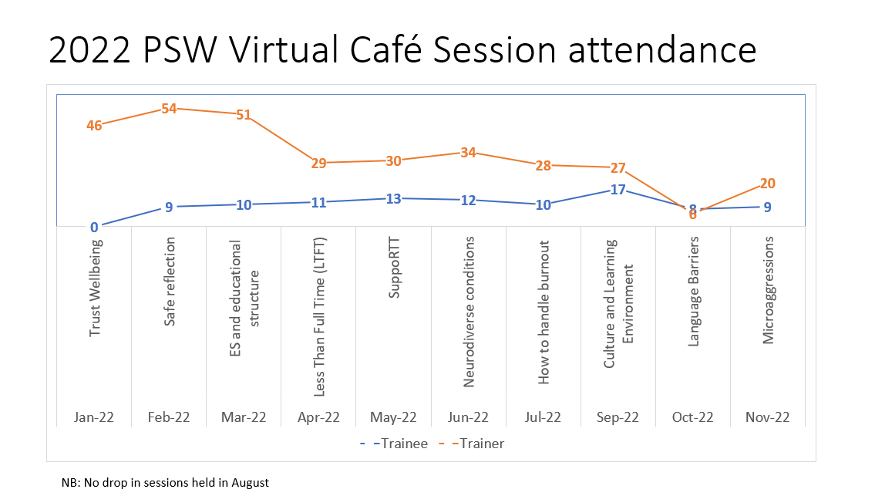
Profession(s) it relates to | Postgraduate Doctors in Training, Educators, Primary and Secondary Care
HEE domain(s),standard(s) and EDI themes it relates to | Developing and Supporting Learners  Educator Support  Supporting Wellbeing
Benefits or positive impact? | The sessions were informal and provided a safe space for educators and PGDiT to collaborate together. There was lots of shared learning and learning from experience.
Lessons learned and difficulties encountered | The format and timing of the sessions worked well. Informal feedback has been excellent, and we plan to continue with delivering virtual sessions next year.  Attendance numbers for PGDiT sessions were low, possible reasons for this are challenges in PGDiT accessing a suitable device and space to join the virtual sessions. To mitigate this, we will liaise with colleagues in Postgraduate Centres to see if they can facilitate streaming the sessions live so that a group of PGDiT can join together. Even when there were fewer attendees, it was extremely helpful session to gain insight in to challenges and improve visibility of HEE.
Contact for further information (name, role, email, telephone number) | Professor Sailesh Sankar  Associate Dean for Differential Attainment and SuppoRTT  Sailesh.sankar@hee.nhs.uk

