Workforce Stress and the Supportive Organisation
.

A systemic approach to workforce wellbeing Applying the Framework
The National Workforce Skills Development Unit

Contents
You may not wish to read this document in order from start to finish. The document has been designed to be flexible in use allowing you to flip between sections as and when you feel they are particularly relevant to you. We do suggest that you take the time to read through the first three sections before diving in further as this will frame your thinking as you work your way through.
The importance of staff wellbeing  An overview of the wellbeing challenge facing NHS organisations | 3
A systemic approach to psychological wellbeing  A brief introduction setting out the context and aims of this document | 5
Using this document  A guide on how to get the most out of this document | 6
The organisational wellbeing framework  An introduction to the model | 7
Applying the organisational wellbeing framework  A structured approach to thinking about your experience of your organisation in three phases | 9
Creating a supportive organisation  Some suggested interventions and approaches when working with groups and organisations. | 27
Evaluating workforce wellbeing  A methodology for evaluating workforce wellbeing and the Organisational Wellbeing Framework | 30

The importance of staff wellbeing

Facts and figures
- In 2020, 44% of NHS Staff reported feeling unwell as a result of work related stress in the last 12 months an increase from 40.3% in 2019
- There are over 100,000 vacancies across NHS trusts
- The annual cost per employee of poor mental health varies from £1,500 to £2,400
- A meta-analysis of 61 studies of the psychological impacts of viral pandemics on healthcare workers found 45% experienced anxiety, 38% experienced depression and 31% experienced acute stress disorder
- More than 7800 doctors responded to the questions around mental health; 41% of the doctors surveyed said that they were currently suffering from anxiety, stress, burnout or other mental health conditions relating to or made worse by their work.
- Inclusivity felt by employees with disabilities / differently abled employees has decreased by 7% due to the impacts of COVID-19 on the workplace.
- Overall 74% of staff felt they were well supported but this falls to 56% among those from socially disadvantaged backgrounds
- Black Africans are 50% more likely to be a key worker than a white British working age person and nearly three times as likely to be a health and social care worker. Reported COVID-19 related deaths of the Black Caribbean population was three times those of the British majority.

https://assets.publishing.service.gov.uk/government/uploads/system/uploads/attachment_data/file/908434/Disparities_in_the_risk_and_outcomes_of_COVID_August_2020_update.pdf

One of the biggest challenges facing the NHS is workforce resilience, capacity and wellbeing. Key issues such as recruitment and retention of staff have been reflected in publications such as the Health Education England draft health and care workforce strategy; ‘Facing the Facts, Shaping the Future’.
With this in mind Health Education England commissioned the Unit to bring together an Expert Reference Group (ERG) to think differently about the problems facing the NHS workforce.
It is important to acknowledge the nature of the work done by any caring profession can be challenging to psychological wellbeing. This framework recognises that being able to recognise the vulnerability and anxiety this might prompt can make the work more rewarding and promote empathy and compassion.

It was recognised that insufficient attention had been paid to the impact poor psychological wellbeing and stress can have on organisational success. In addition, the ERG concluded that the organisation has a substantial role to play in supporting the workforce to undertake what is an inherently psychologically demanding role; that is caring for and treating people. The psychological wellbeing of staff impacts patient care, staff retention and our ability to meet the broader workforce challenges facing the NHS.

The focus of this framework is on taking the time and making the space to carefully consider the elements of the organisational experience that can impact on staff psychological wellbeing, and to recognise the differing experiences of staff across role, ethnicity, gender and other aspects of staff identity. This is founded on key theoretical and philosophical principles that underpin the Tavistock and Portman NHS Foundation Trust’s work while incorporating other approaches and ideas. We have built on these foundations to create the Organisational Wellbeing Framework, a way of thinking in depth about psychological wellbeing within organisations.

There are of course a wide range of approaches and interventions available within the NHS and beyond. This framework is not intended to replace them but instead to complement, understand any barriers that may have previously prevented effective implementation, and to help NHS organisations and their leaders to adopt a different approach to workforce wellbeing.

“The psychological wellbeing of staff impacts patient care, staff retention and our ability to meet the broader workforce challenges facing the NHS”

A systemic approach to psychological wellbeing
People are the most important resource in the NHS, yet in some situations and organisations staff can feel undervalued, powerless and invisible. This leads to burnout, increased time off work, low productivity, and reduced empathy and compassion - prompting many to leave the NHS and putting some off from joining it in the first place.
The NWSDU commissioned the Mental Health Foundation to review the literature and evidence around the impact on staff psychological wellbeing and approaches and interventions available (https://tinyurl.com/yau46ctx).

The ERG noted that one traditional way of tackling these problems has been to promote the idea of individual resilience. To varying degrees, the individual is considered responsible for how much they can take and the organisation around them has been largely absolved of responsibility for supporting them.

It is clear there is a place for personal resilience and it is important to recognise that the nature of the work undertaken by the NHS does require large reserves of it. However, organisations and indeed the wider system have a duty to support people who are doing very difficult jobs in challenging circumstances. In short, an organisation should maintain a culture and operate in such a way that the need for personal resilience is minimised as much as possible, allowing people to maintain the compassion and empathy that led them to choose careers in the health service.

This framework for thinking is intended to provide organisations and their leaders and managers with a structured process and space to think through and understand the issues confronting their people.

In describing this as a systemic approach we are using the term in its broadest sense to emphasize the importance of thinking about wellbeing as a product of organisational factors as well as individual ones, and of considering those factors as complex and interconnected. For more detail see ‘Ways of Thinking’ on p22-p25 of the Framework Overview.

“Supportive organisations reduce the reliance on individual resilience and instead create the conditions for staff to flourish and thrive”

Using this document
Though it can be used for individual reflection, the Organisational Wellbeing Framework is intended to be applied within a group setting, and most effectively when supported by a facilitator. It will help you to develop a deeper understanding of your organisation, department or team and the extent to which its ‘five pillars’ support you and your colleagues to work effectively in your roles.
This approach can be used at different levels of an organisation and you may choose to focus on a team or department rather than the whole organisation. We expect that working through the framework will bring about a deeper understanding of you and your colleagues’ experiences of work. It is likely that, particularly if you’re intending to work across the organisation, your priority will be to gain board sign-up to go through this process. Note: It is also extremely important to ensure you include perspectives from across the whole organisation and that a plan is developed for how to do this from the very beginning.

The key focus is on creating time and space to reflect properly on your organisation, your team and your place within it. This document is purposively structured to encourage this and necessarily does not skip straight to ‘solutions’. We want you to take time to think about what is really going on in your organisation, what factors might be having an impact on this and where you would like to get to.

The framework has been developed as an interactive PDF and you will see a number of popup boxes throughout. This is intended to make information more accessible and easily digestible, but care has been taken to ensure it works as a printed document too.

There are two separate documents:
- The Framework Overview, which should be read first, contains information about the development of the Organisational Wellbeing Framework, explains the underlying concepts in detail and provides a bibliography for further reading.
- This document, Applying the Framework explains how to use the framework to gain a deeper understanding of organisational experience and to frame an overall approach to wellbeing.

It is important to recognise that working through the framework might create some discomfort, require people to expose some of their vulnerability and bring different, and perhaps strong, emotions to the surface. Effective planning and facilitation are particularly key to ensure this is done in a helpful way that allows space for sense-making and insight. For this reason, it is also important to ensure that the whole process is undertaken so that issues arising during the reflection phase can be explored in more depth and addressed in the later phases.

Please remember, this approach deliberately shifts the focus away from immediately jumping to solutions at an individual level to thinking more systemically. In this way the outcome should be an organisation that enables people to work, treat, and care for patients, and each other, while taking in to account the realities of the work you do and the context you are in.

The organisational wellbeing framework
The Organisational Wellbeing Framework is specifically designed to enable a group of people to consider wellbeing at an organisational or departmental level in a more systemic way. This is particularly true for those in leadership or management roles, though the framework can also be useful for others interested to think about wellbeing in a more systemic way, for example in the formation of a Reference Group (see Implementing a Systemic Approach to Wellbeing on page 9).
The model shows a way for you to think about your organisation, your place in it and the organisational elements that can support or hinder the people it comprises.

There are five interconnected pillars, all of equal importance. These pillars are intended to structure your thinking when reflecting on your organisation and the things that are being done well, not so well, or perhaps not at all to reduce stress and support staff wellbeing.

If all of these pillars are regularly engaged with, discussed, and taken seriously, you can use them to find ways of supporting people to provide the best care possible and contribute to achieving your organisational aims.

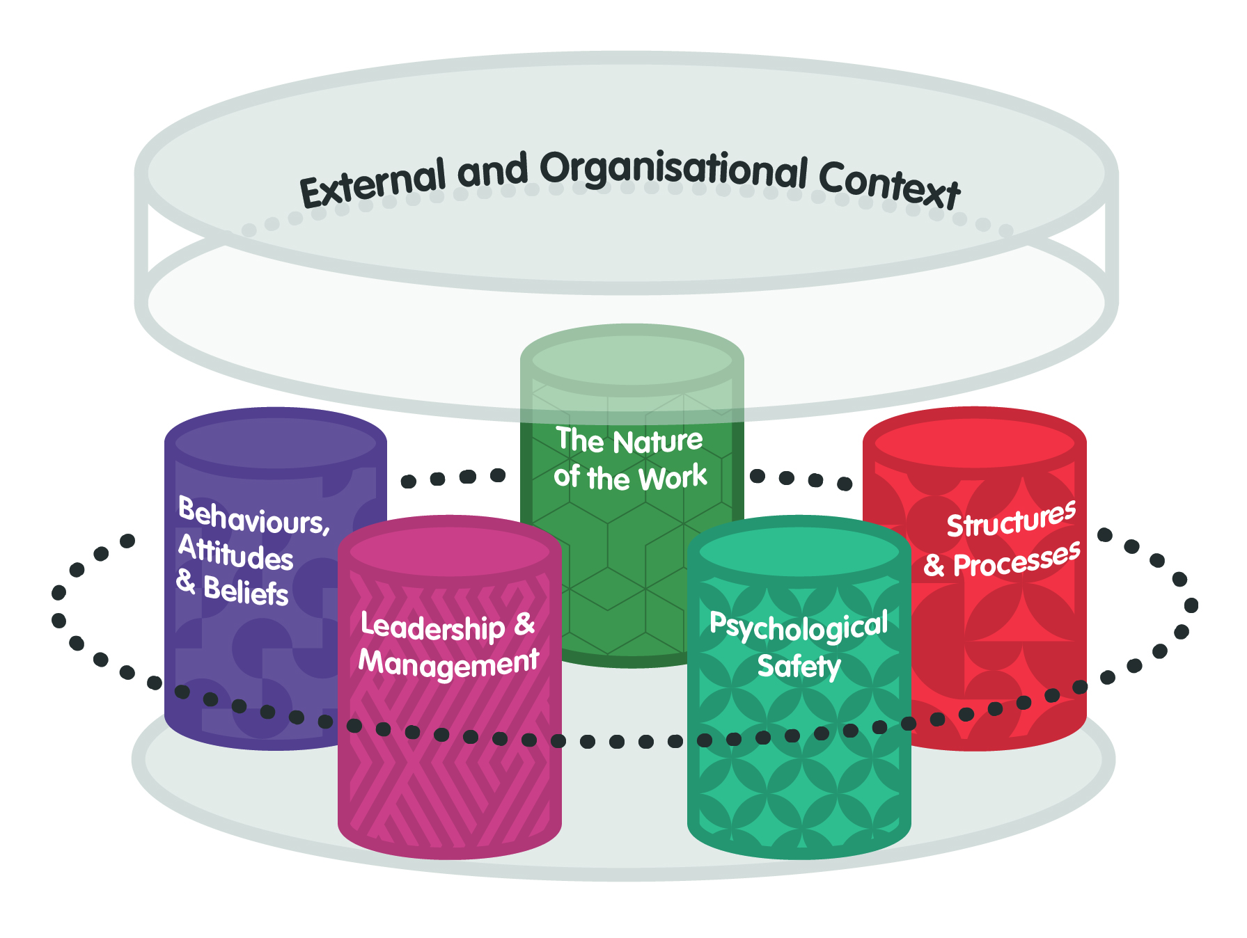
No organisation exists in a vacuum and this is especially true in the NHS where the external context or system will be exerting multiple pressures that cannot always be controlled or predicted.

The stronger the pillars within your organisation, the better equipped the people who make up your organisation can manage and respond to external pressures while providing or supporting care and treatment.

A brief overview of each pillar is listed below and you can find more information by visiting the Framework Overview document.

An interconnected framework
The pillars interconnect to create an organisational experience which can be more or less supportive

Behaviours, Attitudes & Beliefs
The particular mix of these which are (consciously and unconsciously) encouraged and reinforced in a team or organisation

Leadership & Management
The ways in which those in formal authority at all levels take up and carry out their role

External and Organisational Context
External structures, trends and events as well as conditions particular to the organisation

The Nature of the Work
The particular aspects of the work that people in health and care organisations carry out

Structures & Processes
The environmental, structural and technological aspects of an organisation, from basic fixtures and equipment to complex systems and processes

Psychological Safety
A climate of trust and respect within teams across an organisation, where people feel valued and their psychological wellbeing is prioritised by management

Ways of thinking
The model is informed by a number of concepts and theories, which we believe are helpful as ways of thinking about your organisation and going through the five pillars. See the Framework Overview for more details.

Applying the organisational wellbeing framework

Implementing a systemic approach to wellbeing
There are strategic, structural, cultural and process dimensions to this systemic approach, which, when implemented in an aligned and sustained way, will deliver improved workforce wellbeing and lead to improved workforce metrics and organisational performance.
As with any significant organisational shift, implementing a systemic approach to wellbeing will require sponsorship, leadership, resources and commitment. The senior management team and your Organisational Development (OD) team should be involved from start and throughout the process.

Good wellbeing governance is key to this approach. This means that:
- Wellbeing is at the top of the organisation’s agenda and a headline in its strategy.
- Wellbeing principles and metrics are an explicit part of executive decision-making.
- Wellbeing is led by a dedicated network of well-resourced, inter-professional roles.
- Team managers have the support they need to prioritise and respond to the wellbeing issues in their part of the organisation.
- Wellbeing is a valid and prioritised workplace activity.

(See pages 12-13 for more details of each principle.)

The first part of engaging with the Framework is for the organisation to review and understand its existing state of wellbeing governance in terms of these five principles and to address those areas that fall short. This can be undertaken by the Organisational Development (OD Team) with external support as required.

A Sponsor Group should be formed at the start of implementing the framework to ensure that the work aligns with and augments, rather than duplicates, existing wellbeing initiatives and activity. The Sponsor Group should have representation from the organisation’s Executive, HR and OD Teams.

Impact can be evaluated using an organisation’s own in-house wellbeing survey if one exists, or by using a selection of measures from the NHS Staff Survey, or by using the evaluation tool on page 30).

The next part of the engagement phase is to form a Reference Group who will be meeting to share and reflect on their organisational experiences and sense-check those experiences with other qualitative and quantitative data.

This Reference Group is made up of 10 to 15 people and is intended to represent, and be representative of, the different perspectives and experiences across the organisation. Membership should be made up of staff members from different levels, services, teams and professions and should also be diverse in terms of background and identity, for example in terms of race, gender, sexuality and disability.

The Reference Group will then use this shared understanding to develop a picture of the organisation in relation to the Organisational Wellbeing Framework, highlighting which of the pillars, and aspects of the organisational and external context will need to change in order to create a more supportive environment for staff (see pages 16 to 26 for details of this process).

The Reference Group’s work can also be used by the OD Team to assess where, existing or planned, wellbeing and wider organisational initiatives can be reinforced, adapted or connected to amplify their impact.

The Reference Group continue to meet on an ongoing basis throughout the engaging and sustaining phases of implementation to develop and maintain a live sense of overall organisational experience. This understanding will continue to inform and support wellbeing governance and organisational initiatives including leadership development. The Reference Group can also be valuable in providing an organisational ‘sense-check’ for the Executive or Senior Management Teams.

The final element of implementing the framework is ensuring that its philosophy and key elements are represented in the organisation’s development of leaders and managers. This is particularly true of the pillar of psychological safety which, as a group level phenomenon, will be most directly impacted by the capabilities of individual leaders and managers.

The overall implementation of the Organisational Wellbeing Framework is likely to take at least 18 months.

The core philosophy of the Organisational Wellbeing Framework
- The psychological wellbeing of staff is a priority and should not be secondary to their work and performance.
- Organisations have a responsibility to support the wellbeing of their staff.
- While there is a place for personal resilience a systemic approach to wellbeing is essential.

Implementing a systemic approach to wellbeing

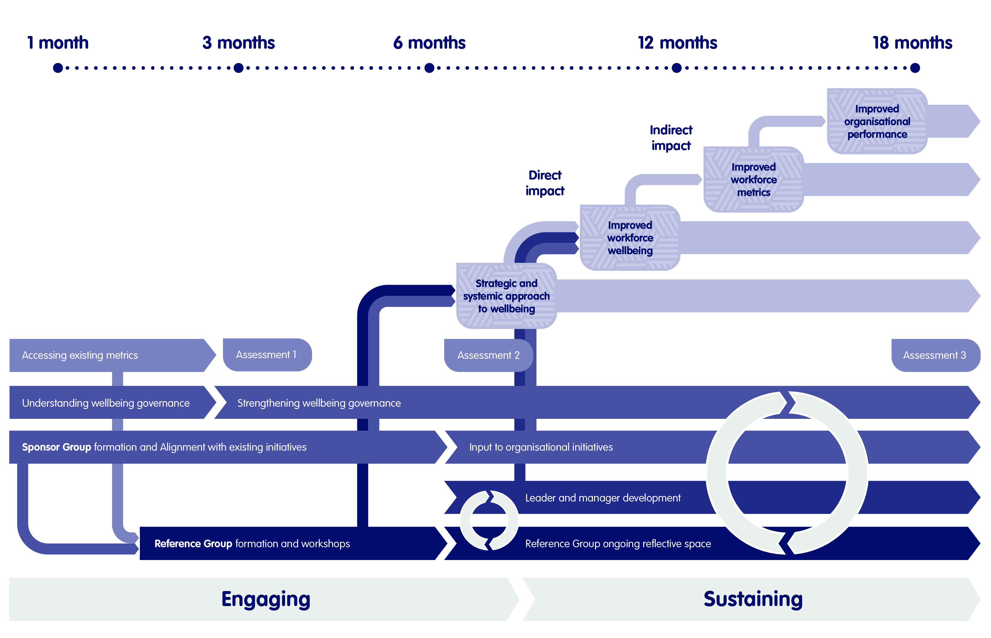

Good governance for systemic wellbeing
NHS Organisations have a substantial role to play in supporting the workforce to undertake what is an inherently psychologically demanding role; that is caring for and treating people. The psychological wellbeing of staff impacts patient care, staff retention and our ability to meet the broader workforce challenges facing the NHS.
Particularly given the impact of the COVID-19 pandemic, staff wellbeing is increasingly recognised as a strategic priority, equal to patient outcomes and financial sustainability.

NHS organisations should maintain a culture and operate in such a way that the need for personal resilience is minimised as much as possible, allowing people to maintain the compassion and empathy that led them to choose careers in the health service.

The Organisational Wellbeing Framework provides a way for you to think about your organisation, your place in it and the organisational elements that can support or hinder the people who work there.

There are five equally important and interconnected pillars:
- The Nature of the Work
- Structures & Processes
- Psychological Safety
- Leadership & Management
- Behaviours, Attitudes & Beliefs

Regularly engaging with, discussing, and including these pillars as part of strategic and operational planning will help your organisation highlight ways of supporting people to provide the best care possible and contribute to achieving your organisational aims.

For this approach to be sustainable, however, wellbeing must be actively emphasised as a strategic priority and embedded as part of organisational governance.

It is also important to recognise that good wellbeing governance is both an enabler of the supportive organisation, and a possible improvement outcome from adopting the Organisational Wellbeing Framework.

given the impact of the COVID-19 pandemic, staff wellbeing is increasingly recognised as a strategic priority

What does good wellbeing governance look like?
NHS organisations are clear about the need for good governance in relation to patient care, finances and decision making. Our work in developing the Organisational Wellbeing Framework has shown that a systemic approach to wellbeing needs to be underpinned with good wellbeing governance, summarised by the following principles.

Wellbeing is at the top of the organisation’s agenda and a headline in its strategy
It should be understood as strategic and integral to performing effectively rather than a ‘nice to have’ that can be dealt with ‘when there’s time’.

Wellbeing principles and metrics are an explicit part of executive decision-making
Staff wellbeing has an impact on patient outcomes and organisational performance, and can be measured and tracked using existing data, such as the NHS staff survey, or tracking indicators such as absence or retention as well as through simple additional data gathering using for example, the ONS 4 survey. This data should be as important as financial and clinical targets and be given the same weight when making strategic decisions.

Wellbeing is led by a dedicated network of well-resourced, inter-professional roles
Sometimes wellbeing activities are one-off activities organised in response to crises, at times by volunteers working in spare time they don’t have, and with little formal authority or resourcing. A systemic approach to wellbeing calls for a sustained network of formal roles with the authority, resources and sponsorship to ensure that wellbeing is treated as a priority across the organisation. This network is responsive and ensures that issues are identified and attended to before they impact performance. Its members should be drawn from different departments, teams, professions and backgrounds.

Team managers have the support they need to prioritise and respond to the wellbeing issues in their part of the organisation.
Team managers have a key role to play in creating a supportive work environment, both in terms of emphasising the importance of wellbeing and also in putting into practice models such as containment and psychological safety. This requirement shouldn’t be yet another initiative checklist to fit into their day but a genuine aspect of their role, enabled through support from their own managers, ongoing training and development for themselves and role modelling from senior leaders.

Wellbeing is a valid and prioritised workplace activity
A supportive organisation is one where attention to wellbeing is not something that people fit into their spare time, lunch break or after work but rather something that is a normal and integral part of work and the time spent at work. Managers and their teams should see wellbeing as something that they ‘have permission’ to make space and time to think about, discuss and work on. Taking time to reflect on and process the nature and experience of the work that they do is valued and encouraged – it ‘counts as work’.

There are three phases to using the Organisational Wellbeing Framework. By working through these phases in order you will develop a rich and in depth understanding of your department or organisation as an environment that supports staff wellbeing.
The process deliberately begins with reflection and curiosity, rather than solution building. Connecting to the different perspectives and experiences of colleagues across your organisation or department, and taking time to understand and appreciate them, is a crucial part of developing a systemic perspective.

Phase 1:
Engaging with this approach; exploring your organisational experience
This phase encourages you to reflect on your individual or group experience of your organisation; be curious about which of the pillars you think might impact on you and others the most and to think about what positive change might look like. A series of questions has been included to frame each of the sessions in this stage.

Phase 2:
Using information; sense checking your organisational experience
In the second phase of the process you will use existing data sources and other sources of information to sense-check the picture of the organisation that you have developed in Phase 1. It is important to stress that this phase is not about jumping to solutions, rather you should be using the process to further your understanding of the organisational experience.

Phase 3:
Taking action; changing your organisational experience
This phase encourages you to assess the systemic understanding of your organisation. With a clear picture of priority areas to address, you will consider which existing initiatives may already be tackling these and where additional activity may be required. If changes are to be made, use your experience of previous organisational initiatives to inform the best approach to take.

Working with the framework
The following pages describe a process for working through the Organisational Wellbeing Framework in order to create an in depth understanding of your organisational environment and the extent to which it supports staff wellbeing.

Phase 1: Exploring
Reflection
Curiosity
Review

Phase 2: Sense-making
Curiosity
Reflection

Phase 3: Changing
Focus

Who is the process for?
It is intended to be used in a series of group sessions carried out by a small group (8 to 10 people) with a consistent membership. This group could be the Executive or Senior Management Team of an organisation or department, using the process as part of their strategic planning. It could be the Reference Group for an organisational implementation of the framework (see page 9-10). It could also be used by senior managers in the same role across different parts of the organisation.

How does the process work?
The process can be carried out face-to-face or online, and it is worth considering either or
using a blend, as either format may be more or less accessible for staff in different parts of
the organisation.

There is a deliberate emphasis on slowing down and taking a more reflective approach. It is important to go through each element of the framework, thinking about context and about each of the pillars in turn.

The process should take place over a series of sessions with enough time to work through the questions for each phase and enough space to hear from the different experiences and perspectives in the group.

Running the sessions over several weeks, with a gap in between each one can help in building up the organisational picture and also with applying insight and learning gained by the group members as part of the process.
Work with pairs and breakout groups during the sessions, to allow for more sensitive conversations and perspectives, to build connections across the group, and to develop trust as the sessions continue.

You may find it helpful to check-in as a group each time you meet to hear how each person is arriving at the session. Also to take time at the end of each session for personal reflections on the experience in that session and what each individual is taking away to apply for themselves. The process should be of individual as well as organisational benefit.

Does running the process need any additional support?
The nature of the framework, and the themes that will be covered might make for difficult conversations at times. For this reason we would advise a dedicated facilitator for the session, preferably an external facilitator and certainly one with substantial experience of working with groups.

It’s important to clarify ground rules, especially if using the process with a Reference Group as confidentiality won’t be total as the themes that emerge will be shared with the Sponsor Group and OD team.

For each pillar we recommend using key readings, perhaps a paper, book chapter, video or podcast, to provide a common starting point and framework for the discussion e.g., Amy Edmondson’s book for the session on Psychological Safety.

For the implementation discussion, encourage members to present changes they have been part of, whether successful or not, as a foundation for a conversation about ‘how change happens here’ and highlighting critical success factors for implementing the Framework.

Phase 1: Exploring your organisational experience

Reflection
Reflection on all the pillars will develop an overall sense of your organisation as a more, or less, supportive workplace – See sections below for more details.

Curiosity
Curiosity encourages you to be curious by investigating each of the five pillars in more depth - you may wish to prioritise these depending upon your own circumstances - See sections below for more details.

Review
A pause to take stock of the overall picture of organisational experience that has emerged. - See sections below for more details.

Phase 1: Reflection
The aim of reflection is to develop an overall sense of your organisation as a more, or less, supportive place. Use these questions individually or in a group to think about your experience of your organisation.
- What three words come to mind when you think about your experience of working in your organisation?
- Do you think this experience would be different in different parts of the organisation? How?
- Which external factors are having the biggest influence on your organisation at the moment? How are these external factors felt and understood by people in your organisation?
- What is your sense of your organisation’s relationship with external organisations e.g. commissioners, Care Quality Commission (CQC)? What impact do these organisations have?
- What’s going on at the moment in your organisational context that might be having an impact in terms of wellbeing, stress and resilience?
- If you drew a version of the model to illustrate your organisation as an image, what would that look like?
  - How would you draw the different pillars?
  - What size and shape would each one be?
  - How stable, solid (or not) would they be?
  - What would the resulting picture tell you about your experience of your organisation? (If you do this exercise in a group, what is different and similar about the different pictures people have drawn?)
- Do any of the five pillars strike you as particularly influential in forming your current experience of your organisation as a more or less supportive place?
- Which pillar would it be most helpful to focus on first?

“Develop a sense of your organisation as a more, or less, supportive place”

Phase 1: Curiosity
The aim of this phase of the process is to explore the five different pillars in depth to develop a more detailed understanding of each, and the impact that they might be having on your organisation’s capacity to support you and colleagues in your work.
Answer these questions for each pillar in turn. Based on your initial reflection, you may already have a clear sense of which pillar(s) it would be most helpful to explore in more detail – perhaps the least stable one, or perhaps the one you are least certain about. Detailed descriptions of each pillar can be found in the Framework Overview document.
- In a few words, how would you describe this aspect of your organisation – what does it currently look like?
- How would you describe the impact that this pillar has on you and your colleagues’ everyday experience of work?
- What are the strongest and weakest aspects of this pillar in your organisation? The most and least helpful aspects?
- How consciously does your organisation engage with this pillar? Does it feel like a priority? Are there any specific projects and initiatives currently underway that are relevant to this pillar?
- If this pillar was changed for the better, what difference would that make to your experience of work?
- Are there more conversations to have about this pillar? Are there any specific questions or issues that need to be responded to by your department or organisation?

explore the five different pillars in depth to develop a more detailed understanding

Phase 1: Review
The aim of this phase of the process is to bring together the main themes from your exploration of organisational experience, and highlight any clear issues that have emerged. You will also identify the pillars that might be a focus for changes that would make your organisation a more supportive place for you and your colleagues.
- Think about the overall picture that you have developed of your organisational experience. Which of the five pillars in your organisation, if strengthened, would have the most immediate effect on stress and wellbeing?
- What are the main themes across the organisational picture you have developed?
- What impact might each of these themes be having on the wellbeing and resilience of staff? Will this be equally felt in each service or team across the organisation?
- Are there any positive or negative connections between the different pillars?
- What best practice have you identified during the reflection and curiosity phases that could be a basis for wider improvement?
- Are there any current or planned initiatives that are or will be addressing any of the key themes or issues that you have identified?
- Are there any issues that will need new activity or initiatives to be addressed?

“identify changes that would make your organisation a more supportive place”

Phase 2: Sense checking your organisational experience

Curiosity
What existing sources of data do you have access to that will help provide a complete picture of stress, resilience and wellbeing in your organisation or department?

Reflection
How do these sources of data support or challenge the overall experience of the organisation that you developed in Phase 1?

Phase 2
There is a large amount of quantitative data available to the NHS that will help you understand things like retention, sickness and absence and staff experience. There may also be additional qualitative data available from recent consultations or organisational development initiatives. http://www.nhsemployers.org/staffengagement.
The first part of this phase is to collate some existing data sources related to the themes that you have been exploring. This could be the NHS Staff Survey or other internal surveys. Some possible sources are listed on the next two pages.

NHS Staff Survey: This collects data on the views of NHS staff to improve working conditions and ultimately patient care. The data is collected annually which provides a better understanding of staff conditions and views over time. The data is used at a national level to and feedback reports are produced each year. NHS organisations can access the data via the NHS staff survey website. Pointers and support for analysing NHS staff survey data can be found here: https://www.nhsstaffsurveys.com/survey-documents/

Internal staff survey: NHS organisations may choose to run additional internal surveys to obtain staff feedback. Data obtained from staff surveys can be both quantitative, in form of additional surveys, or qualitative such as through focus groups.

Patient surveys: National patient surveys are carried out by the CQC and can be downloaded from their website. Additionally, organisations may choose to conduct local patient surveys to obtain feedback from patients on issues such as communication, involvement, dignity and respect, quality of care etc. These can be qualitative or quantitative.

Support for analysing quantitative data is provided by NHSEI: https://www.england.nhs.uk/publication/making-data-count/

Phase 2
Qualitative data will often help you flesh out quantitative data and uncover things that figures and statistics only suggest. It may also form part of any staff engagement plan or strategy you plan to undertake and this is key.
Exit interviews/staying interviews: These can provide a information on workforce issues. Some organisations also choose to conduct staying interviews to gain an understanding of their existing staff’s motivation.

CEO question time/roadshows: Organisations may choose to organise regular or occasional opportunities for staff to directly engage with the organisation’s CEO to provide feedback or ask questions.

Appraisals: Staff appraisals can be a useful source of information on workforce issues. These can be collected via ESR.

Unions: Unions can provide useful feedback on staff issues and priorities and the NHS as a whole is heavily unionised. Organisations should regularly engage with Unions for this purpose.

Internal Staff Survey: Various qualitative staff feedback options are available. Organisations may choose to conduct focus groups to ask people about their experience and beliefs in a structured way. Another example are cross sectional reference groups where people of all levels of the organisation are brought together for feedback.

CQC: Inspections will gather evidence from different sources including speaking to people individually or in groups and information from complaints and concerns, reviewing records. They will provide feedback at the end of the inspection which can be used as a source of information.

Analysis of past interventions: Organisations should conduct reviews and evaluations of previous action taken. This can help build a picture of what has worked in the past.

Benchmarking data: Organisations may choose to benchmark themselves against other organisations. This supports understanding of areas for improvement and of areas that are working well compared to other organisations. iView and iViewPlus might be useful in this regard: https://digital.nhs.uk/services/iview-and-iviewplus

Use the quantitative and qualitative data that you access to sense-check the picture of the organisation that you developed in Phase 1.
To what extent do the other sources of data support, contradict or supplement the picture of organisational experience that you have developed?
Is there enough alignment for the picture that you have developed to be a good enough model of how your organisation impacts on staff stress, resilience and wellbeing?
Which themes or issues does this combined picture of reflection and data confirm as priorities that should be tackled to create a more supportive organisation?
Are any of the framework pillars in need of change to create a more supportive organisation?

Phase 3: Changing your organisational experience

Focus
What approaches, interventions and actions should I take? Is the culture management strategy currently in place working?

Phase 3
With an in-depth understanding of organisational experience and key sources of data to support your priorities, this phase of the process is about deciding where and how to focus effort and resources to create change.

- Given your role in the organisation and the resources you have access to, what level of change would it be reasonable for you to aim for in relation to this pillar? Local, organisation-wide, or something in between?
- What specific changes – if any - come to mind that could make a difference at the level you have chosen to affect?
- Thinking about the particular pillar that you want to change - Are there any people who would be effective allies, advocates or advisors? How could you engage them in the help you need to make the changes?
- What structures and processes supporting wellbeing are already in place in your organisation that you could link on these changes?
- Are there any existing or recent initiatives that could connect to and amplify your effort in relation to a particular pillar?
- Has change been successfully implemented in your organisation recently? What can you learn from this success, and those involved in it, before you begin your own process of change?
- Are there any parts of the organisation likely to be concerned about making changes? Why? How can you address their concerns?
- What barriers or resistance might you encounter as you try to make this change happen? What will help you to persevere in the face of these?
- What initial signs would you expect to see if your change was making a difference?

Decide on a clear focus for these changes depending on your role and resources.
Implementing a systemic approach to wellbeing across an organisation or department will need the longer term, aligned approach as described on pages 9-10 and using established change management processes and tools.
There may also be quick wins that can be implemented using existing structures and processes.
There may also be changes that can be made at a team level, for example by focusing on Psychological Safety.
For any change to be sustained though, it will need to take place as part of a shift to a systemic approach to wellbeing, with good wellbeing governance in place, and aligned with wider strategic and organisational developments.

Phase 3
Once you have gathered the information you think you need, understood elements of the pillars that might be weakening your organisational experience and engaged fully with people you will be thinking about moving on to implementation.
There is a list of actions or interventions in ‘Further Information’ but please remember, applying these in an ad-hoc manner will not yield the best results.

The King’s Fund have collated a suite of tools that will help you to develop a plan and undergo cultural change - https://www.kingsfund.org.uk/projects/culture. They also emphasise the idea of ‘collective leadership’. This is a helpful model for thinking about staff engagement and culture change:

’everyone taking responsibility for the success of the organisation as a whole – not just for their own jobs. It requires organisations to distribute leadership power to wherever expertise, capability and motivation sit within organisations.’

NHS Improvement also have helpful case examples of organisations that have gone through culture change programmes - https://www.england.nhs.uk/culture/culture-leadership-programme/ and go on to collate another series of helpful tools, concepts and diagnostics.

You will find all of these helpful when creating your plan for change and implementing it but we would like you to bear several key things in mind while doing this:

- Taking the time and making the space to reflect and properly understand what is happening within your organisation using the information and data you have gathered.
- Psychological wellbeing will directly contribute to achieving your organisational aims - What elements of the organisational experience will contribute most to the psychological wellbeing of the people in your organisation? How can you minimise those that may be doing harm and make the most of those that might help with this?
- Personal resilience should not be the focus, although it is important given the nature of the work we do - what elements of the organisational experience can you improve to minimise the need for this? Refer back to the pillars to help you do this.
- Listen to the people in your organisation, engage properly with them and act on what you have learned. There is nothing worse than giving people a voice and then not acting on what it is saying.

Creating a supportive organisation
We have put together suggestions on possible actions or interventions. They have been categorised by level of intervention (individual/group/organisation) or processes. This is to support you in finding the type of intervention that is needed.
It is important to emphasise at this point that the actions listed here should be carefully considered as part of an overall package following significant reflection and processing of the approach already described. The focus should be on taking time and space to consider your organisation, your place in it and the impact you can have rather than simply jumping to specific actions in an attempt to resolve particular issues without taking the time to fully understand them.

The interventions below are intended as a starting point for further reflection and are by no means exhaustive. It also includes links with further information or specific interventions. Many of these were identified in the Mental Health Foundation Report commissioned as part of this work - https://tinyurl.com/yau46ctx.

Organisational approaches
Organisational approaches are often focussed on culture change and leadership. It is likely that your organisation will already be using one or more of these approaches. It is worth investigating which ones are being used and to reflect on the impact they may be having.

Inclusive Leadership
Inclusive leaders are empathic and self aware. They value the competitive advantage that diversity brings and actively seek out and include different perspectives and experiences in their thinking and decision-making. Inclusive Leadership aims at empowering people in all areas and at all levels to lead and take decisions. The link below provides practical support and resources to help providers improve their culture and to run their own culture and leadership programme. https://www.england.nhs.uk/culture/culture-leadership-programme/

https://www.kingsfund.org.uk/topics/organisational-culture/compassionate-inclusive

Transformational leadership
Here, “a leader works with their staff or followers to identify where change is needed, serving to motivate, boost morale and job performance of staff by connecting with their sense of identity, the collective identity of the organisation and being a role model.” The NHS leadership academy provides further information and programmes on the topic: https://www.leadershipacademy.nhs.uk/

Appreciative enquiry
Appreciative inquiry is a type of approach and a way of thinking. Rather than focusing on the negative, appreciative inquiry asks what is working well within an organisation and how to build on that. This can help with looking at an issue from a different perspective and opening up new ways of thinking. There are usually several steps to the process. The Scottish Social Services Council provides an appreciative inquiry resource pack at: http://learningzone.workforcesolutions.sssc.uk.com/course/view.php?id=67

Creating healthy workplaces
Health and wellbeing are essential to an organisation’s culture. The toolkit below aims to support NHS organisations to improve the health, wellbeing as well as effectiveness and productivity of its workforce. It is a useful reference to think about the topic and take further actions. https://www.nhsemployers.org/publications/nhs-health-and-wellbeing-framework

Groups

Reflective supervision
This refers to the creation of a space to explore emotional responses and reactions to trauma. In practice, this could be a regular meeting between a supervisor and a supervisee to discuss cases. The space allows the health professional to reflect on the differences between their worldview and that of the patient they are caring for to prevent secondary trauma and other negative consequences such as burnout, desensitisation or dysfunctional coping.

Balint Group
Balint Groups are a type of reflective group practice and refer to “a type of clinical supervision in which doctors are able to present and discuss a case and the emotional aspects of the patient-doctor relationship.” More detailed descriptions can be found on the Balint Society’s website: https://balint.co.uk/about/introduction/

Schwartz Rounds
“Schwartz Rounds provide a structured forum where all staff, clinical and non-clinical, come together regularly to discuss the emotional and social aspects of working in healthcare.” They are part of reflective practices. https://www.pointofcarefoundation.org.uk/our-work/schwartz-rounds/about-schwartz-rounds/

Team building
Team building and team working encompasses a wide range of tools and interventions from team away days to team consultations. As a starting point, MindTools provides a tool to assess team effectiveness and proposes further interventions: https://www.mindtools.com/pages/article/newTMM_84.htm

Evaluating workforce wellbeing

Evaluating workforce wellbeing and the Organisational Wellbeing Framework
The framework provides a structured process for thinking and talking about staff wellbeing. Going through the process of implementing the framework should help organisations create the right conditions for improving staff wellbeing, to provide a way of effectively engaging staff who can influence positive change, and to provide the opportunity for staff to think in a structured (evidence based) way about what drives wellbeing in their organisation (or their team or department) and what systemic changes are needed.

Understanding the extent to which implementing the framework results in tangible improvements in staff wellbeing is crucial, both to support sustainable improvements within individual organisations that use it, and to support wider adoption and evidence gathering about the framework’s effectiveness in different contexts and for different organisations.

As part of the development of the Framework, the Unit commissioned the design of an evaluation tool that could be used both more broadly to measure workforce wellbeing and to evaluate the impact of implementing the Organisational Wellbeing Framework.

This evaluation tool measures five domains of impact:
- organisational engagement & positioning
- changes in attitudes and behaviours
- changes in how staff feel
- measurable workforce impacts
- measurable organisational impacts

A number of indicators are included in each domain and can be measured using a combination of existing data sources and specifically commissioned surveys and interviews. There are three levels of evaluation, increasing in detail and complexity: core, enhanced and complete. Available resources and the extent to which the Organisational Wellbeing Framework is being explicitly implemented will be factors in deciding the appropriate level to use.

Level 1: core
This is based on existing data (selected NHS Staff Survey questions, workforce data, ONS4 wellbeing survey) and is a comprehensive way of providing a snapshot of organisational wellbeing. This can be used by NHS organisations as a standalone tool, whether or not the Organisational Wellbeing Framework is being used.

Level 2: enhanced
In addition to the level 1 metrics, level 2 also uses a bespoke framework survey and a wellbeing governance audit to gain a deeper understanding of commitment, decision-making, and feedback processes in relation to workforce wellbeing.

Level 3: complete
The complete evaluation methodology includes a series of semi-structured interviews and group discussions across the organisation in order to understand and assess attitudes and behaviours in relation to wellbeing and the impact of wellbeing is on organisational performance.
For more details on the overall approach ‘Evaluating the Organisational Wellbeing Framework – evaluation framework and data collection tools’ please contact the National Workforce Skills Development Unit (NWSDU) via email Workforce@tavi-port.nhs.uk.

Using the Level 1: core as a way of measuring workforce wellbeing
The core level of evaluation uses existing metrics to create a snapshot of workforce wellbeing and can be used as a standalone process. These metrics are:
- The NHS Staff survey questions (and relation to specific wellbeing indicators) are as follows:

Evaluation indicator | Relevant NHS Staff Survey questions
Staff feel able to speak up about their wellbeing at work | Survey question 18f
Staff feel listened to by leaders / managers who then act on what they hear | Survey questions 4b and 4c
Staff feel that the work they do is understood and valued | Survey questions 5a, 5f and 8g
Staff feel that there is a consistent and coherent / co-ordinated approach to wellbeing across the organisation | Survey question 11a
Staff feel better physically and mentally | Survey questions 11b, 11c, and 11d
Staff feel safe (from threats and hazards) in their work environment | Survey questions 12 and 13 (parts a - c), and 18
Self-reported work-related stress | Survey question 11c
Job satisfaction | Survey questions 2 (all parts), 18c, 19a

- The ONS4 Wellbeing survey is a simple survey of four questions focused on personal wellbeing:
- Overall, how satisfied are you with your life nowadays?
- Overall, to what extent do you feel that the things you do in your life are worthwhile?
- Overall, how happy did you feel yesterday?
- On a scale where 0 is “not at all anxious” and 10 is “completely anxious”, overall, how anxious did you feel yesterday?

For information on using the ONS4 see: https://www.ons.gov.uk/peoplepopulationandcommunity/wellbeing/methodologies/personalwellbeingsurveyuserguide

- Staff vacancy rate, staff turnover and staff sickness absence rates.

Contact
If you would like to comment on the document or discuss the framework please contact the National Workforce Skills Development Unit at workforce@tavi-port.nhs.uk.

Facebook: @NWDSU
Twitter: @NWDSU
LinkedIn: linkedin.com/company/nwsdu

The National Workforce Skills Development Unit
The National Workforce Skills Development Unit is situated within the Tavistock and Portman NHS Foundation Trust. The Trust has a history of delivering psychologically minded training and clinical services. The work of the Trust is founded on a commitment to the value of time to think and reflect on practice.

https://tavistockandportman.nhs.uk/training/workforce-development/national-workforce-skills-development-unit/

This work was commissioned by Health Education England (HEE):
https://www.hee.nhs.uk

