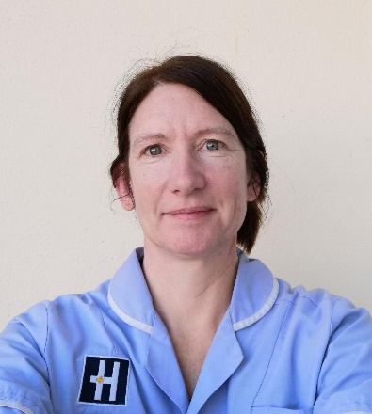
Your Name:
Lindsey Eldridge
Your Employer / Trust:
Hilton Nursing Partners
What is your current role and what does it involve?
I am a Personal Nursing Assistant and my role involves supporting with personal care, some aspects of daily living such as food and hydration, medication, referrals to services for physiotherapy, equipment and medical treatment. Most importantly, we are also here to chat and listen to the patients!

How did you get into your current role?
I saw the job advert on Facebook and I contacted Hilton the same day. I would be interested in some career progression

What kind of support do you give to staff undertaking the Care Certificate?
I have partnered up with new staff during patient rounds out in the community and I have supported them by answering any questions they may have and they have also watched me during the course of my work when needed.

How do you think the Care Certificate benefits the organisation?
The Care Certificate is laid out so clearly and is well organised, that it is easy to understand. Learning the sections within the training certificates ensures that we, as personal nursing assistants, conduct our role well, and with professionalism. We work safely and become excellent listeners to our patients. The care certificate training plan ensures that we do not become open to litigation, and avoid putting our organisation into disrepute. We protect the business and build up trust between patients and other services.

What have been biggest successes?
Completing my Care Certificate, I really enjoyed doing that. I also really enjoyed the training I was given in the classroom and out in the field. The training that was given was top notch!

I was so pleased when I passed my mentoring and was let loose out in the community to work with our patients.

