HEEDs Equality, Diversity and Inclusion Committee Good Practice

Local Office/ Deans Submission: Good Practice Form for the 2023 National Report 2022/23

What was implemented and why? | As part of Health Education England’s commitment to addressing Differential Attainment (DA), in the West Midlands an Enhanced Induction was held on 7th September 2022, to provide additional support and resources to International Medical Graduates (IMGs) and those new to the region. The objectives of the Enhanced Induction workshop were to:  - Inform those new to the NHS about systems and structures  - Provide opportunities for networking  - Supplement support given within existing Trust Inductions  - Remove stigma in seeking support  - Acknowledge additional barriers IMGs faced
Profession(s) it relates to | Postgraduate Doctors in Training (PGDiT)
HEE domain(s),standard(s) and EDI themes it relates to | Enhanced Programme of Induction  Developing and Supporting Learners
Benefits or positive impact? | A short electronic survey on MS Forms was sent to all registered attendees on the morning of the event prior to commencement. The purpose was to capture the demographics of attendees as well as the expectations about the content of the event to understand expectations and to use a post-event survey to determine whether these expectations were met.  The morning session of the induction was attended by 33 Postgraduate (PG) doctors in  training, with 27 attending the full day. 20 PG doctors in training completed the pre-event questionnaire with some responses highlighted in the table below.  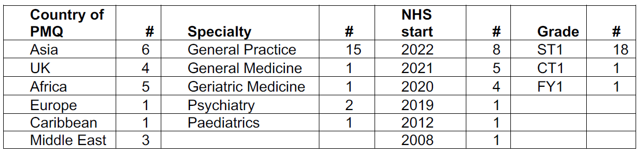
Lessons learned and difficulties encountered | The responses to the pre-event questionnaire indicated PG doctors in training wanted to enhance understanding in NHS systems, Training programme requirements and expectations, and to improve communication, leadership, and time management skills.A short survey on MS Forms was sent electronically to attendees who attended the full event. Attendees were incentivised with a  participation certificate to complete the feedback survey, 24 out of 27 responses were received.  The results of the post event survey indicated 94% found the presentation, content, and relevance of each topic covered in the event to be ‘good’ or ‘excellent’. The overall feedback on the event was positive, with 62% of respondents saying the event was ‘extremely useful’, and 33% found it ‘somewhat useful’.  Enhanced Induction met and exceeded the expectations of the attendees which was made up of majority IMGs who are at risk of Differential Attainment. This feedback will be used to inform the planning and design of future Enhanced Induction events to ensure that the content and presentation meets the expectations and needs of the attendees. Regular and more frequent events to involve and integrate IMG’s in addition to induction will also be helpful involving wider  group of postgraduate doctors in training and trainers.
Contact for further information (name, role, email, telephone number) | Professor Sailesh Sankar  Associate Dean for Differential Attainment and SuppoRTT  Sailesh.sankar@hee.nhs.uk

