HEEDs Equality, Diversity, and Inclusion Committee Good Practice

Local Office/ Deans Submission: Good Practice Form for the 2023 National Report 2022/23

What was implemented and why? | Differential Attainment (DA) is the term for the differences in average  achievement between different groups of doctors who do or do not share a certain characteristic. Differences because of different abilities are expected and appropriate, differences connected solely to a group’s shared characteristic, such as age, gender or ethnicity are unfair. The Equality Act (2010) outlines nine protected characteristics which confer statutory protection from discrimination on this basis.  General trends indicating that poor average performances are seen amongst male, older, BME and International medical graduate (IMG) groups. The largest differences in outcome are seen when looking at doctors’ ethnicity or their country of primary medical qualification.  There is little evidence to support that any single intervention alone will alter differential attainment and most likely a variety of interventions will be needed to reduce the attainment gaps seen in postgraduate education.  We sought to better understand support and opportunities available for IMG doctors  and other groups of postgraduate doctors in training affected by DA in the West-Midlands.  Thirty-minute virtual interviews were undertaken with Directors of Medical Education (or equivalent) at NHS Trusts in the West-Midlands. A questionnaire was circulated prior to the interview.
Profession(s) it relates to | Postgraduate Doctors in Training, Nurses, SAS and LEDs
HEE domain(s),standard(s) and EDI themes it relates to | Learning environment and culture, Educational governance and commitment to quality – sharing good practice across organisations and multi-disciplinary specialisms. Differential Attainment
Benefits or positive impact? | There was a 55% response rate (12/22) from NHS Trusts across the West Midlands, which included the largest trusts in the region. The results are summarised below:  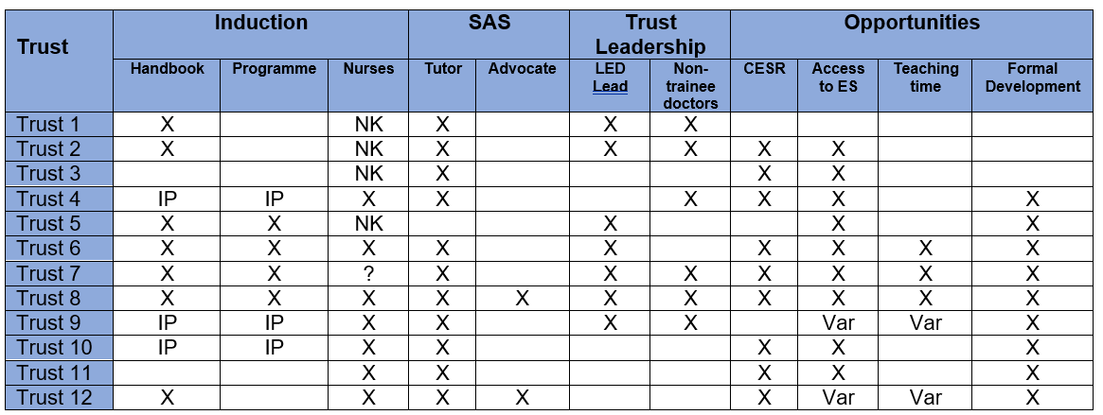  Key:  X Activity Undertaken  IP – Activity ‘In Progress’  Var – Variable  NK – Not Known  This piece of work allowed an opportunity to share good practice across different organisations and embed this within the existing educational governance process.
Lessons learned and difficulties encountered | Although it was evident a significant number of Trust are taking steps to address the issues around narrowing the attainment gap, however, there is still a need for further work and engage organisations and key individuals more widely.
Contact for further information (name, role, email, telephone number) | Professor Sailesh Sankar  Associate Dean for Differential Attainment and SuppoRTT  Sailesh.sankar@hee.nhs.uk

