The Service improvement project is an important part of the Higher Development Award giving the delegate an opportunity to apply their newly-learned skills to the workplace and implement an improvement project.
The best projects are usually small changes that make an impact in terms of improved patient experience, better care, time and financial efficiencies or improved ways of working.
Delegates should discuss their choice of service improvement project with their manager prior to writing their 200-word summary at application stage. During the programme delegates will be taught how to work through the problem-solving process and implement a change in the workplace and will be given the opportunity to work on their own particular project.
The Project will be presented to peers and form one of the assignments required to pass the ILM.
At the end of the programme, delegates will be asked to distil the main project title and outcomes in a A4 poster to be shared with colleagues from the other participating cohorts and Managers from the sector at a showcasing event.
Below is a sample of recent service improvement projects:
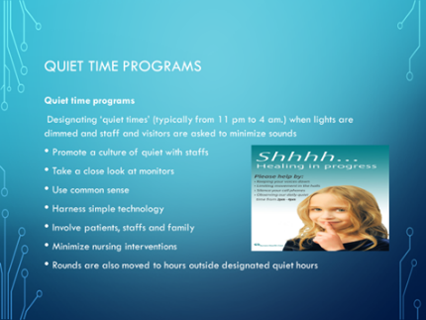
A guide to prepare patients for an ECG in a GP surgery to help patients understand what is expected and to save time in clinic. Dealing with fundamental issues of preparedness of both the surgery and patient attending

Quiet time and keeping noise levels down at night – range of aids and agreed practices to reduce noise at night time

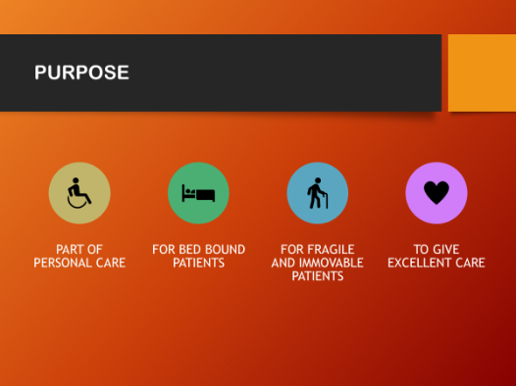
Use of a ‘shower-cap’ to wash residents’ hair to help them feel better and aid their recovery

Provide range of activities within service (rather than external) to encourage all users in a residential home to be able to take part
Implementation of a laminated card for all staff to provide information in a RAG rating format on hydration and eating pre-procedure for patients to avoid unnecessary discomfort for patients
Introduction of a chart to monitor fluid and food intake for patients to reduce risk of dehydration
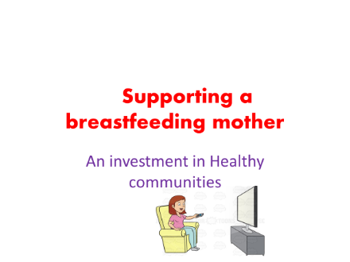
Investing in Breastfeeding – variety of approaches for all women in a non-judgemental way

- Introduction of a monthly checklist to avoid expiration of products resulting in unnecessary waste and cost
