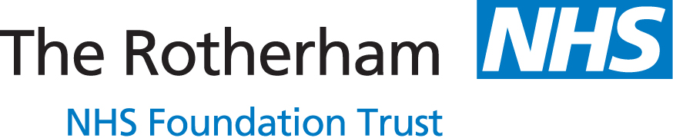

A Student Placement model for Speech and Language Therapy Students in The Rotherham NHS Foundation Trust

A model for remote placement delivery to supplement face-to-face clinical placement activity

The flowchart on the next page outlines the Trust, departmental and student requirements to ensure successful remote access for students to Practice Educators (PE), peers and patients. Remote activities are outlined including direct remote patient contact and indirect remote clinical learning activities. Hyperlinks to documents are included within the chart and in the document below. Current Royal College of Speech and Language Therapists (RCSLT) Guidance states that a minimum of 25% of practice-based learning should be direct client-centred care. The aim is to create a model that can be adapted to a variety of clinical placement settings and professions with reference to our experience.

Model for Remote Student Placements in Speech and Language Therapy Flowchart
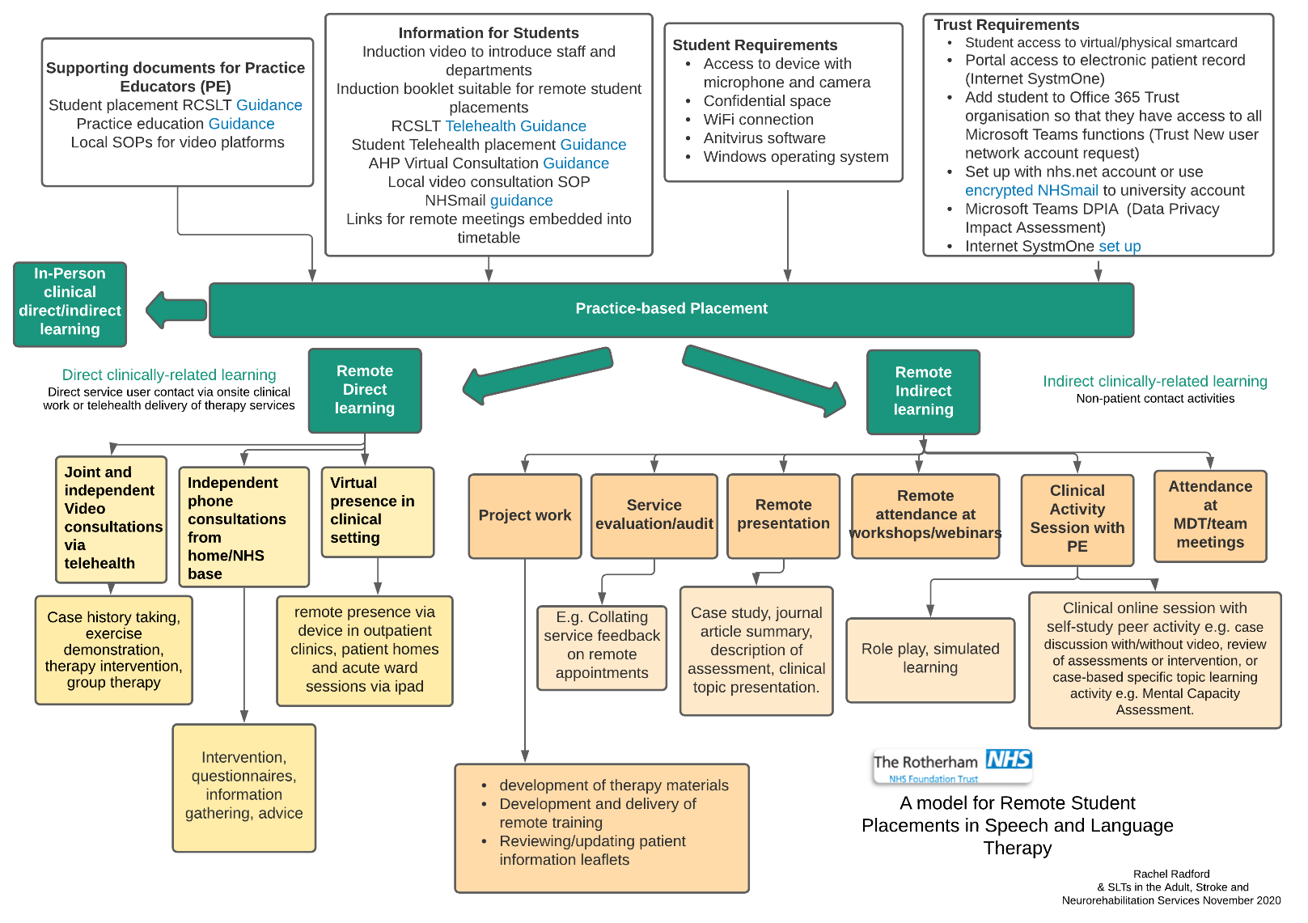

Outline of the Model for Remote Student Placements in Speech and Language Therapy Flowchart

Definitions -
- Direct clinically – related learning is direct service user contact via onsite clinical work or telehealth delivery of therapy services
- Indirect clinically-related learning is non-patient contact activities

The top of the flowchart has four headings: Supporting documents for Practice Educators, Information for Students, Student Requirements and Trust Requirements.

- Supporting Documents for Practice Educators (PE) - Student Placement RCSLT Guidance, Practice Education Guidance, Local SOPs for video platforms. Links to Practice-Based Placement’.
- Information for Students – Induction video to introduce staff and departments, Induction booklet suitable for remote student placements, RCSLT Telehealth Guidance, Student Telehealth Placement Guidance, AHP Virtual Consultation Guidance, Local Video Consultation SOP, NHSmail Guidance, Links for remote meetings embedded into timetable. Links to Practice-Based Placement’.
- Student Requirements – Access to device with microphone and camera, Confidential space, WiFi connection, Antivirus software, Windows operating system. Links to Practice-Based Placement’.
- Trust Requirements – Student access to virtual/physical smartcard, Potal Access to electronic patient record Internet SystemOne, Add student to Office 365 Trust organisation so that they have access to all Microsoft teams functions (Trust New user network account request), Set up with nhs.net account or use encrypted NHSmail to university account, Microsoft Teams DPIA (Data Privacy Impact Assessment), Internet SystmOne set up. Links to Practice-Based Placement’.

Practice Based Assessment
- In-Person clinical direct/indirect learning
- Remote Direct learning
  - ‘Joint and independent video consultations via telehealth’ to ‘Case history taking, exercise demonstration, therapy intervention, group therapy’.
  - ‘Independent phone consultations from home/NHS base’ to ‘Intervention, questionnaires, information gathering, advice’
  - ‘Virtual presence in clinical setting’ to ‘Remote presence via device in outpatient clinics, patient homes and acute ward sessions via ipad.’
- Remote Indirect learning
  - ‘Project work’ to ‘Development of therapy materials, development and delivery of remote training and reviewing/updating patient information leaflets’.
  - ‘Service Evaluation/audit’ to ‘e.g. collating service feedback on remote appointments’
  - ‘Remote presentation’ to ‘Case study, journal article summary, description of assessment, clinical topic presentation.’
  - ‘Remote attendance at workshops/webinars’
  - ‘Clinical Activity Session with PE’ to ‘Role play, stimulated learning’ and ‘Clinical online session with self-study peer activity e.g., case discussion with/without video, review of assessments or intervention, or care-based specific topic learning activity e.g. Mental Capacity Assessment.’

Background information relevant to remote placements

- Profession-specific placement guidance such as the Royal College of Speech and Language Therapists Telehealth Placement Guidance

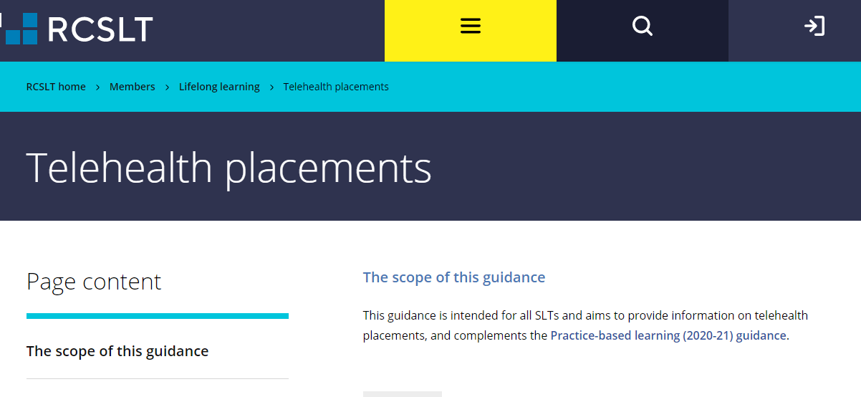
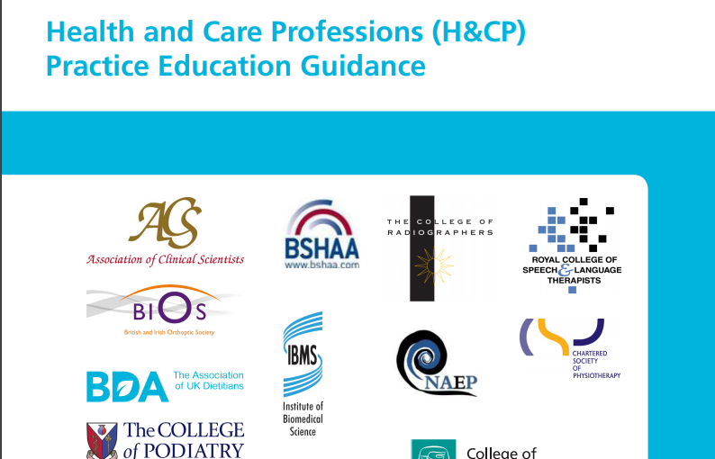
Health and Care Professions (H&CP) Practice Education Guidance
- Local Standard Operating Procedures for Trust video platforms (e.g. Microsoft Teams, Attend Anywhere, AccuRx)

Student requirements
- In order to access internet SystmOne for access to patient records, Information Governance have recommended that Students can use their own devices as long as they have:
  - A windows operating system
  - Antivirus software
  - Secure Wi-Fi connection
They also need:
- A confidential space
- Access to a device with microphone and camera (Microsoft Teams can be accessed from smartphone, laptop of tablet)
- University ID/usual uniform

Trust requirements
- Trust network account
In order to make sure that information can be transferred securely between student and placement provider, and that Students can access everything that they would access on site, they are set up with a Trust login for Windows. This enables access to Microsoft Teams, Office 365 and shared drives.
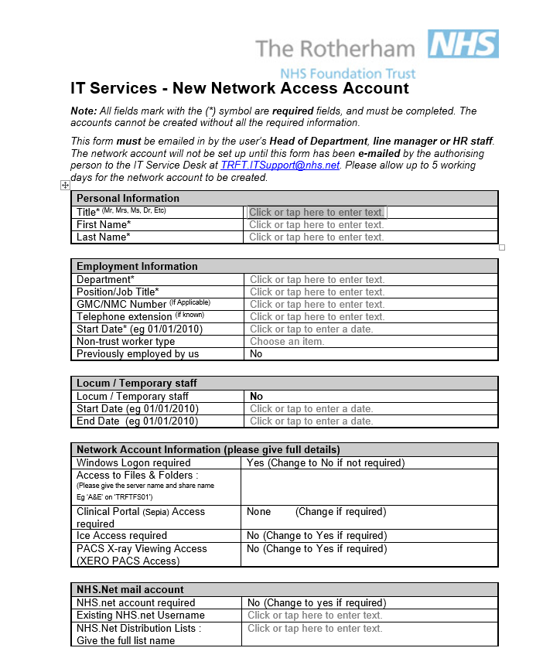
- Each student can be set up with an nhs.net account that they can then use for future placements.

- Internet SystmOne Guidance Student access to Internet SystmOne with virtual/physical smartcard to access electronic patient record.
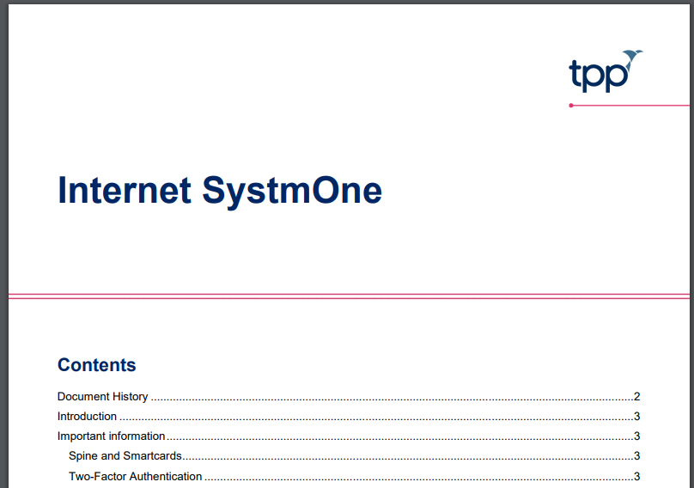

Introductory Student information
- Induction video to introduce staff and orientate within the Trust (put onto Teams channel for students to access before their placement)
- Induction booklet including Student telehealth advice (see below)
- RCSLT Guidance on Telehealth 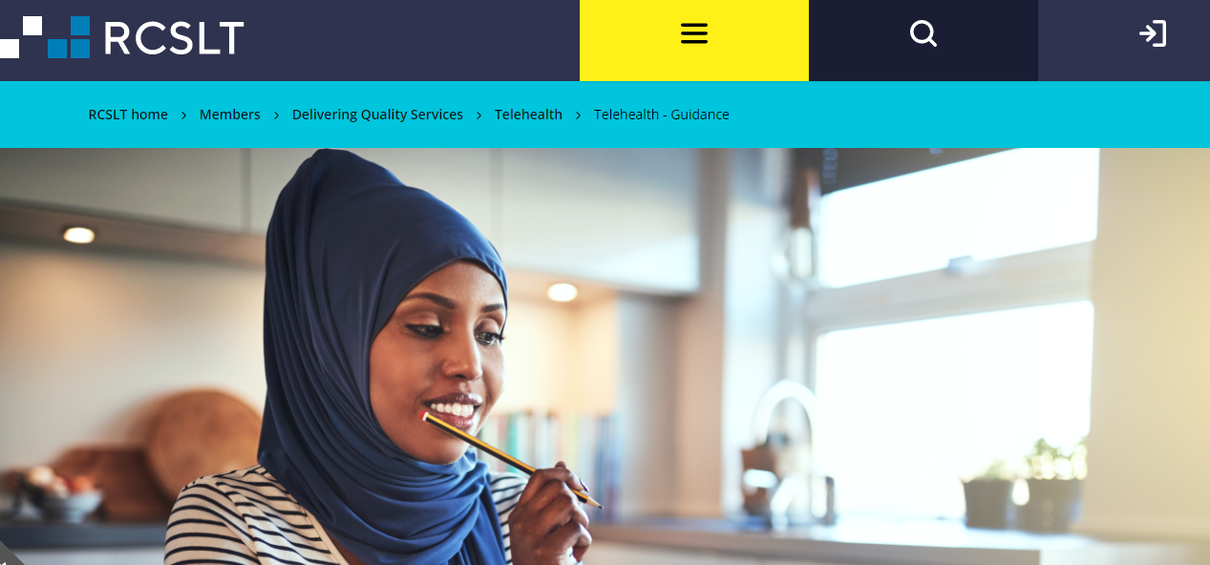

- Student Telehealth Guidance (University of Sheffield Human Communication Science Department) 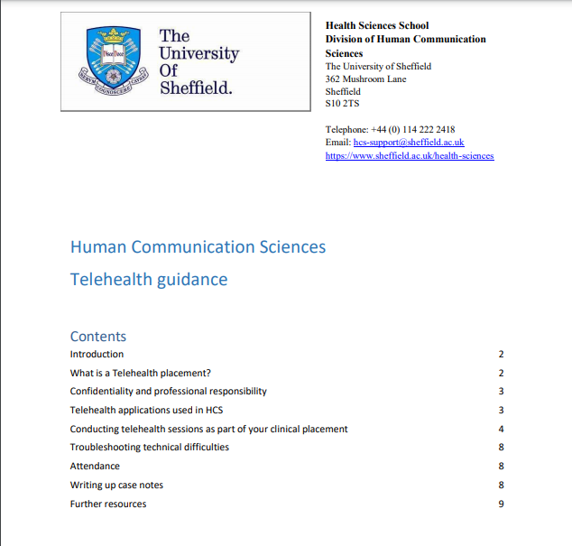
- AHP virtual Consultation Guidance
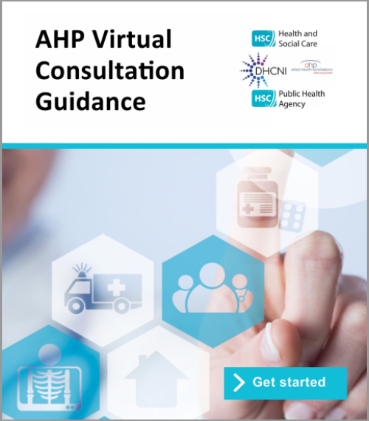
- Department-specific Standard Operating Procedure (SOP) for arranging and conducting video appointments.
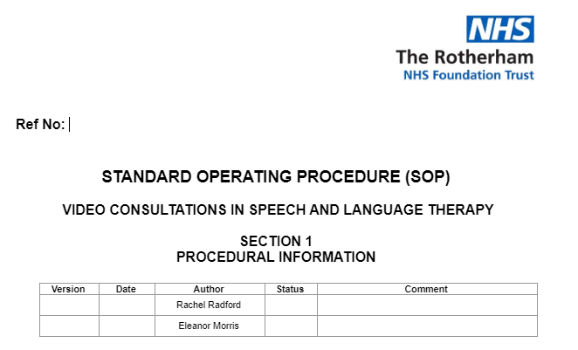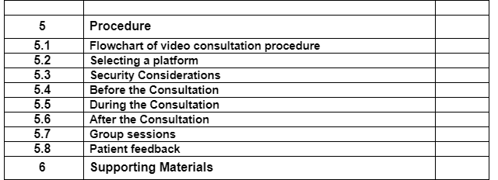
- Information on sending and receiving NHS mail encrypted email.
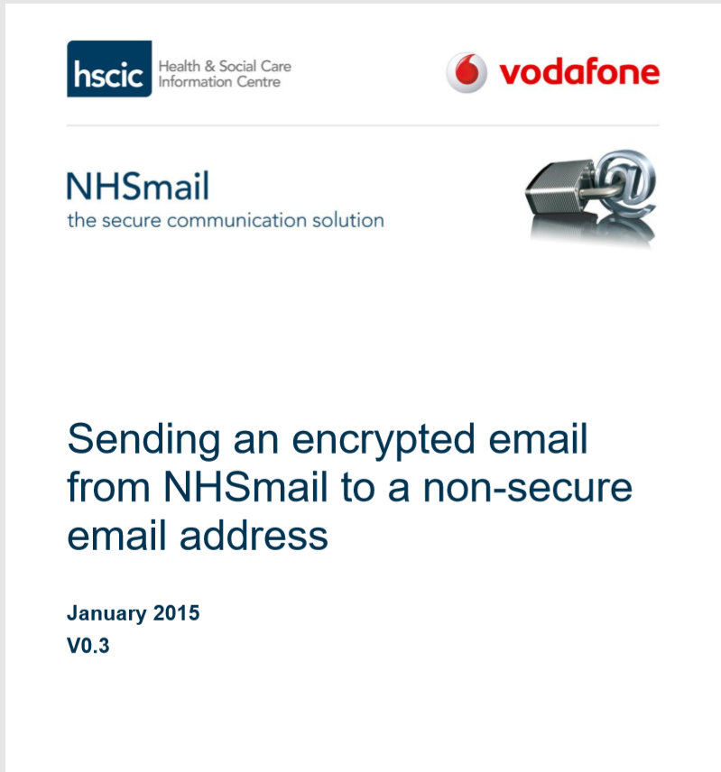

- Timetable including embedded meeting links
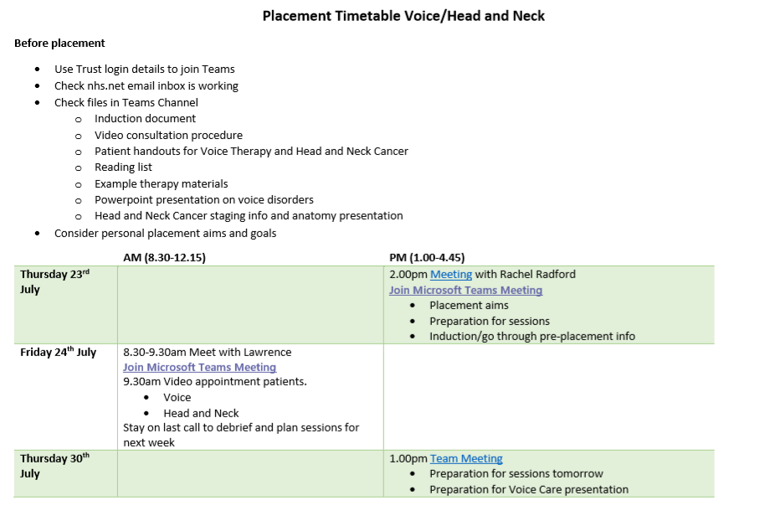
Example timetable

Use of Microsoft Teams

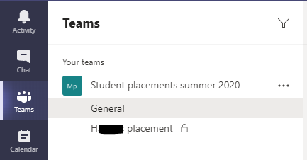

- Student placement Team created within Microsoft Teams with all students and practice educators as members for file sharing and information required for all students on placement
- Private channel for each student with their own practice educator(s)
- Potential to create group chat for student peer support
- Use of file sharing for pre-placement reading and information, resources required during placement and student presentations
- Sharing links for webinars, outcome forms and key patient information for upcoming therapy sessions
- Video calling for supervision sessions and clinical activity sessions is done via Teams
- Chat channels are used for one-to-one queries/questions as an alternative to email and used to start video calls with students
- Screen sharing of electronic patient record and remote participant control for student to input notes with supervision (internet SystmOne will mean this isn’t necessary but screen sharing can be useful for immediate feedback before the record is saved).

New ways of working

Remote placements have enabled us to explore new ways of creating learning experiences that we will take forward. This has included Clinical Activity Sessions facilitated by one Practice Educator for multiple students over a half day. This frees up clinician time as students are in groups and clinical teaching can be recorded for future use. This complements the direct patient work because the topic areas are embedded in our practice.
- 1 hour taught session by clinician around a topic e.g.
  - Specialist clinical area
  - Mental Capacity Act
  - Clinical record keeping
  - Mouthcare
- Self-study peer activity

Remote Student Placements 2020

Example activities and feedback

Direct Practice-based learning
e.g. Direct service user contact via onsite clinical work or telehealth delivery of therapy services

Activity Type | Examples | Learning
Video consultations via teletherapy | Case history taking, exercise demonstration | Familiarisation with evidence base surrounding practice, practice of key clinical skills, opportunity to receive feedback on practice.
Independent phone reviews from home | Mid-radiotherapy checklists and advice, information gathering | Familiarisation with swallowing advice given to patients, opportunity to engage with patients independently, familiarisation with SLT processes.
Virtual presence in clinical setting | Remote presence in joint head and neck cancer clinics, virtual ward session | Opportunity to observe MDT working, opportunity to hear about patient experience regarding cancer recovery, familiarisation with cancer recovery process.
Day in the life of an SLT | Student present via iPad on Teams for the day.  Introduction to physical clinical area and the trust.  Therapy huddle.  Ward session (3 ward patients observed via iPad, history given before session)  Debrief of clinical session  Time for student to practice writing clinical notes.  MDT meeting  PE feedback on notes. | Practice writing medical notes in risk free environment with time for PE feedback.  Clinical note writing skills.  Observational skills.

Indirect Practice-based learning
e.g. simulated learning, case study with/without video, clinical and professional scenarios, role play, expert service users, project work, attending CPD activities (webinars, workshops..)

Activity Type | Examples | Learning
Project work | Development of a voice care workshop delivered in a video team meeting. | Familiarisation with voice care advice for patients, presentation skills, development of material to deliver more widely across the service.
 | Development of presentation using Viscgo sticks (new product for testing fluid thickness) | Experience using thickener and testing Viscgo sticks for the benefit of the SLT team, presentation skills.
Outcomes form development | Assessment and outcomes turned into Microsoft forms that can be sent as links to patients. | Familiarisation with assessments
Case Study presentation and discussion via Teams | Case studies across neuro, stroke and mental capacity with peer discussion with specialist therapist followed by independent peer learning activity. Sessions by therapist recorded for future use. | Peer learning.  Access to specialist therapist by multiple students.  Exposure to different clinical areas.
Attendance at workshops | Attendance at zoom dietetic student workshop delivered by SLT | Appreciation of MDT working using remote access to other professions
Webinars | Watching RCSLT Telehealth Webinar | Overview of telehealth delivery of therapy to apply to clinical practice on placement

Student experiences and feedback

- “Teletherapy appointments allowed for students to practice key clinical skills and gain insight into patient experience without being in the same room.”
- “Opportunity to understand MDT working remotely was valuable (i.e. with clinical nursing)”
- “Being on an iPad during a face-to-face consultation was appropriate and insightful, with the patients appearing happy to engage.”
- “Conducting mid-radiotherapy phone reviews was a really valuable experience that helped develop interpersonal skills and working with clients independently. This was an appropriate activity to do and I would recommend including this in the future.”
- “It was especially beneficial to be given the opportunity to carry out therapy independently – e.g. voice exercises, assessments as this really helps to build on confidence.”
- “Working through case studies was really helpful – e.g. Mental Capacity case study. It allowed detailed discussion and application of learning from readings.”
- “Being able to experience the flow of the day in the day in the life of an SLT was great; it’s something you don’t get just sitting in on individual video calls, and it was important to see transitions between patients, how SLTs interact with other professionals, get a true feel of the ward; hearing all the sounds etc.”
- “It was really beneficial being able to see the structure of an SLT day remotely; I sat in on the morning huddle and saw 3 patients in the ward, and then sat in on an MDT meeting before discussing patients and writing up notes with SLT”.
- “It was beneficial seeing assessments first-hand; it’s hard to truly get to grips with an assessment without seeing it first-hand”.
- “Overall I really enjoyed my ‘day in the life’, I felt like I learned a lot from it and would happily do it again! It was definitely the most challenging, but most enjoyable part of the placement so far- one I won’t forget!”

Negative comments
- “Sometimes I felt a bit awkward being on the iPad, particularly when a patient became distressed or didn’t seem to understand what the iPad was for, however I think this feeling is similar when you are a student, sometimes you feel a bit awkward sitting in!”
- “It was a shame that I wasn’t able to be more involved, i.e. actually talking to patients. I think this was due to the ability of the patients who were being seen and also just the difficulty of talking over video call in a busy ward; I still found observing really useful.”
- “MDT meetings on zoom are preferable as interacting virtually with a predominantly face-to-face meeting is difficult and tiring, although it is beneficial to see the setup of a face-to-face meeting.”
- “Having a few students on the same call would be beneficial so we could use ‘in between’ time to discuss patients.”
- “MDT meeting was useful to be able to see the flow of the day and see how all the different professionals interacted, however, I couldn’t hear much and I wasn’t aware of the patients so it was a bit difficult to concentrate.”
- “The video calls did get tiring! Although it was really beneficial (and I would probably be a bit tired after a full day’s placement anyway; I think having multiple days of video shadowing one after the other would be too much, but one day was okay).”

Therapist experience and feedback

Positive comments
- “No concerns from patients on wards.”
- “Presence via iPad placed to one side was possibly less disruptive to the patient than if they were physically in the room.”
- “Patients in an outpatient setting were very happy to interact with the student on the iPad, she could hear everything that was going on.”
- “It worked really well to observe a student doing a video consultation with myself, student and patient on one call.”
- “Microsoft Teams channels work really well for file sharing and supervision. Video calls were easy to do for feedback and introducing the day.”
- “Clinical activity sessions have been a really good use of therapist time as one PE can have multiple students.”
- “Great student presentations in our Microsoft Teams department meeting. We all learnt lots!”

Negative comments
- “Limited opportunity for students to get any practical experience conducting assessments or therapy on an acute ward.”
- “Limit to interaction between student and patient in acute setting with patients with language difficulties.”
- “Sound and picture can be compromised depending on Wi-Fi connection.”
- “Difficulty getting iPad into optimum position so that student could see SLT and patient and it was close enough to hear what was happening.”
- “Video calls can be tiring and the student and therapist need breaks. Students can consolidate their learning in this time and consider any questions they want to raise later.”

Barriers to overcome

- Difficulty with remote access to the electronic patient record
- Issues with tech support to get students onto Teams and logged into nhs.net
- Equipment needed for iPad positioning

Opportunities/solutions

- Nhs.net account for students so confidential information is secure and can be used for future placements
- Shared online timetable via teams with relevant meeting links in advance
- Access to S1 via virtual smartcard
- Remote peer student attendance at in-person clinics and ward sessions for peer discussion without numbers in the room overwhelming the patient but giving access to more students.
- Multiple students in one session without heavy physical presence in clinic room or on the wards. This also reduced any perceived burden on practice educator time.
- Video consultation SOP sent to student before the session
- Students could develop online therapy materials and work independently creating learning experience with reduced therapist time.
- Other technology could be used e.g. flexible stand for screens, head camera, improved microphones.
- Recorded clinical activity presentations delivered by therapist for use in future placements.

