

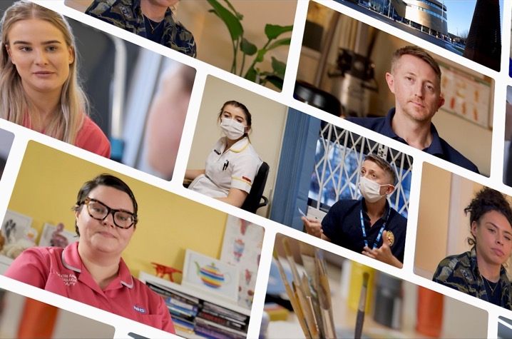A practical toolkit on maximising the contribution of Allied Health Professions (AHPs) within mental health, learning disability and autism settings

.

­

# Foreword

Mental health support has never been more important and the same is true in services for people with learning disability and autistic people. Allied Health Professionals (AHPs) have a significant role to play to provide services at every stage of life and across settings.

As the third largest clinical workforce group in health and care in England, AHPs have an incredible potential to transform our current and future services. I have seen first-hand how AHPs are leading change to create innovative and efficient services, that significantly improve people’s lives and wellbeing in mental health, learning disabilities, and autism services. This toolkit has been curated to include many of these examples.

The toolkit is intended as a guide for commissioners of mental health, learning disability, and autism service settings about the opportunities that AHPs present to this workforce. It can be used to support local and regional workforce decision-making. The document gives examples about the services the AHP community offers, and how they can be most efficiently and effectively utilised across primary and secondary care.

I anticipate that this toolkit will inspire readers to create innovative solutions to the workforce challenges they are facing by expanding and developing their AHP workforce. I am confident that this action will support the transformation of care for and with patients, service users and their carers.

Picture of Suzanne Rastrick OBE, Chief Allied Health Professions Officer (England)


Suzanne Rastrick OBE  
Chief Allied Health Professions Officer (England)

# Introduction

Allied Health Professionals (AHPs) are the third largest clinical workforce in the NHS. AHPs also provide system-wide care to assess, diagnose, treat, and discharge patients across social care, housing, education, criminal justice, and the independent and voluntary sectors. On a weekly basis, the AHP workforce of over 170,000 have contact with over 4 million patients and service users (Royal Society for Public Health, 2015).

The time to focus on AHPs in mental health, learning disabilities, and autism services is now. The NHS Long Term Plan describes AHPs as playing a central role in the delivery of person-centred care to children, adults, and older adults to help meet the changing demands the NHS is facing. The Mental Health Workforce Plan for England’ (2017) also highlights the vital and varied role of AHPs as first responders, in diagnosis, self-management, rehabilitation, and recovery of everyday life.

There are 14 disciplines under the AHP umbrella and in September 2021, there were over 233,000 registered numbers making up AHPs in Britian: England, Wales, Scotland and Northern Ireland.

13 of the 14 AHPs are regulated by the Health and Care Professions Council (HCPC), with Osteopaths regulated by the General Osteopathic Council (GOC).

### Registered numbers of AHPs

|  |  |
| --- | --- |
| Profession | Total |
| Arts therapists (art, music and drama) | 4,904 |
| Chiropodists / podiatrists | 12,472 |
| Dietitians | 10,407 |
| Occupational therapists | 41,762 |
| Operating department practitioners | 14,559 |
| Orthoptists | 1,516 |
| Osteopaths | 5,483 |
| Paramedics | 31,470 |
| Physiotherapists | 59,717 |
| Prosthetists / orthotists | 1,154 |
| Radiographers | 38,168 |
| Speech and language therapists | 17,413 |
| Total | 233,542 |

(Source: [HCPC](https://www.hcpc-uk.org/about-us/insights-and-data/the-register/registrant-snapshot-sept-2021/) 2021/GOC 2022)

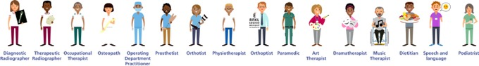

AHPs are key to transforming health, care, and wellbeing. Working at the top of their competencies and skills, AHPs lead mental health, learning disability and autism teams to new ways of working. Their expertise in rehabilitation and enablement is vital to moving away from over-reliance on hospital-based care. AHPs can provide professional and tailored interventions in local communities, primary, secondary, specialist, and community care in addition to across health and social care settings.

The pressure on the NHS is increasing and the demand on nurses and medical staff to deliver care is growing but using the AHP workforce to support mental health, learning disability, and autism is an opportunity yet to be realised.

With the help of this toolkit, we are bringing together an outline of some AHP roles and their contribution to mental health, learning disability and autism settings. This toolkit highlights evidence to enable growth in AHP potential in clinical settings and to celebrate and showcase the role of AHPs within mental health, learning disability and autism services and to refresh and reframe perceptions of the professions.

## Where did this toolkit come from?

This toolkit is the result of our bold AHP workforce development ambition and discussions which stemmed from the HEE AHP Mental Health, Learning Disability and Autism Observatory. We want to ensure that AHPs are in the right place, at the right time, with the right skills to deliver the first point of contact and advanced pathways of rehabilitation and recovery across sectors and age groups in mental health, learning disability, and autism services.

To achieve this, we have several interconnected developments to progress, which are represented in the ABCDE plan overleaf. This toolkit reflects work undertaken in each aspect of our plan to provide information and support the visionary leadership developments required.

This toolkit also contributes to a wider goal of HEE: to ensure the skills of AHP’s are recognised and understood as key contributors to the mental health, learning disability and autism workforce.

Our ABCDE of Advancing AHP Mental Health & Learning Disability Workforce Development

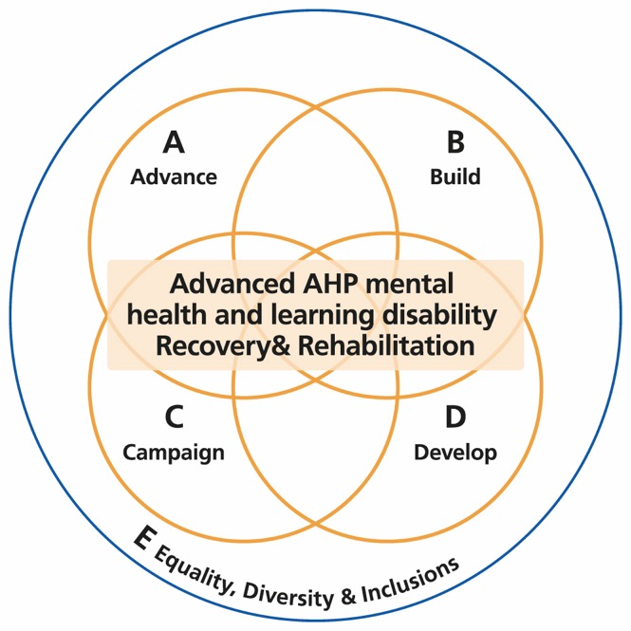

**Advance Engagement** with a wide range of stakeholders to build understanding, energy, and capacity

**Build Capacity** for student / apprenticeship / preceptorship / First Contact Practitioner in MH LD practice

**Campaign to Inspire** understanding and ambition

**Develop Capability** for advanced & consultant AHP practice through education

**Equality**, Diversity, Inclusion

## Who is this toolkit for?

This document is primarily aimed at commissioners, mental health, learning disability and autism service leads, Integrated Care Systems (ICS) workforce planners, and any senior leaders who are involved in workforce development who want to be able to identify and gather information on AHPs and how they can utilise their skills in finding solutions and supporting workforce development.

The toolkit is also designed to be easily accessible and useful for the AHP professionals themselves who are interested in developing their careers within mental health, learning disability and autism setting, in addition to the newly formed AHP Faculties within Integrated Care Systems, to influence decision-making about transformational workforce developments for mental health and learning disabilities services for the future.

We encourage you to read and share the toolkit within your systems and organisations and discuss how the AHP workforce in mental health, learning disability and autism can be expanded to ensure service users and patients get the right support and care at the right time.

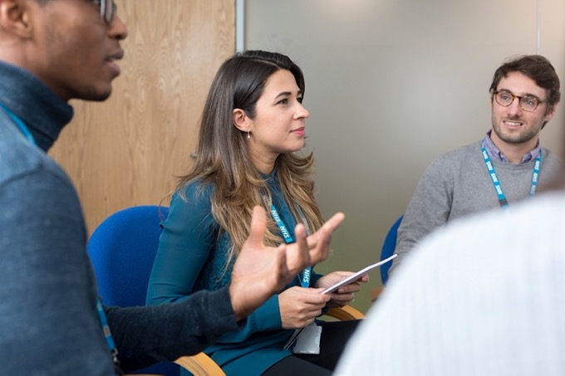

# Contents

|  |  |
| --- | --- |
| Introduction to AHPs AHPs in primary care  AHPs in secondary care | P8  P8  P9 |
| Role of AHPs within mental health, learning disability and autism Highlighting AHPs contribution to the mental health, learning disabilities and autism workforce  The imperative of expanding AHP student placements in mental health and learning disability practice | P10  P23  P25 |
| Career development and pathways for the AHP community Non-registered career pathways  Registered career pathways  Careers in mental health, learning disability and autism  Training and career planning resources | P26  P26  P28  P34  P42 |
| Action for change Investing in AHPs: why is there a need for it  Checklist for system leaders and commissioners  Collection of case studies – real life examples of AHPs making a difference in mental health and learning disability settings | P44  P46  P50  P51 |

# An introduction to AHPs and their role within mental health, learning disability and autism services

AHPs are the third largest clinical workforce in the NHS and include 14 distinct professional groups. In the main they are degree level professions and are professionally autonomous practitioners.

## AHPs in primary mental health care

Some AHPs have a unique primary care superpower: <https://www.hee.nhs.uk/our-work/allied-health-professions/ahp-superpowers>. They bring a new and beneficial skillset to the primary care setting and skill-mix. As first contact practitioners, AHPs provide innovative expertise and enable increased capacity to general practice. In addition, AHPs in primary care can provide patients with faster access to the right care.

For example, evidence suggests that two sessions with a primary care occupational therapist for a person with a mental health condition can lead to a 66% increase in confidence and a 50% reduction in GP appointments.

<https://www.youtube.com/playlist?list=PLrVQaAxyJE3c0LRqrjq1-OR4JQ5AG6u2W>



One in 4 adults experiences a mental health condition in any given year, and mental health conditions are the largest single cause of disability in the UK.

[NHS England and NHS Improvement, 2017](https://www.england.nhs.uk/mental-health/about/#:~:text=One%2Din%2Dfour%20adults%20and,of%20all%20ages%20and%20backgrounds)

1 kingsfund.org.uk/projects/mental-health-and-long-term-conditions-cost-co-morbidity

## AHPs in secondary care

Across their life span, people with mental illness, learning disabilities, and autism can have complex needs that significantly impact on the quality and length of their lives. These require diverse and creative approaches which AHPs are well placed to deliver.

It is evident that all AHPs will work with people experiencing mental illness and learning disabilities and so require particular skills. For example in engagement techniques, reasonable adjustments to the way they deliver care, and mental health first aid to support individuals and their families as well.

Some of the AHP groups working in mental health services are regarded as core mental health practitioners and as such have further developed expertise and skills that can lead to advanced practice and leadership roles.

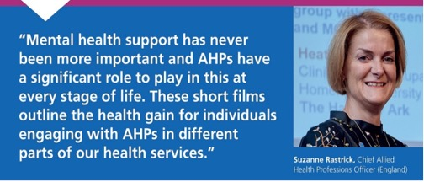

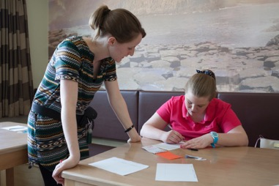

Approximately 1.5 million people with a learning disability in the UK.

[Mencap, 2020](https://www.mencap.org.uk/learning-disability-explained/research-and-statistics/how-common-learning-disability#:~:text=There%20are%20approximately%201.5%20million,learning%20disability%20are%20in%20England)

# Roles of AHPs in mental health

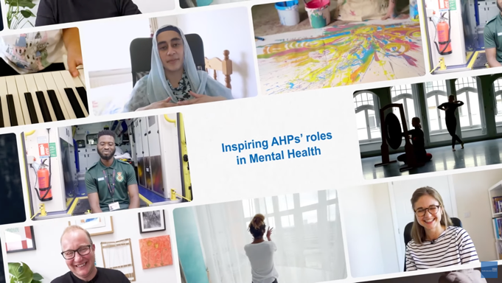

Meet Eshmit, Jed, Jess, Jon, Matondo and Donvé and learn how AHPs can play an important role in mental health. This suite of films focus on the roles of AHPs’ in mental health. The films cover the following roles: Dramatherapist, Music therapist, Art psychotherapist, Dietitian, Paramedic and Occupational Therapist.



[Dramatherapist](https://www.youtube.com/watch?v=uRrYeM-x9IA&list=PLrVQaAxyJE3c7jrG88eFGm88LQ86k2epl&index=1)

<https://www.youtube.com/watch?v=uRrYeM-x9IA&list=PLrVQaAxyJE3c7jrG88eFGm88LQ86k2epl&index=1>

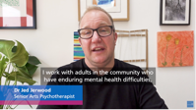

[Art Psychotherapist](https://www.youtube.com/watch?v=YUrz5WJTkA0&list=PLrVQaAxyJE3c7jrG88eFGm88LQ86k2epl&index=2)

<https://www.youtube.com/watch?v=YUrz5WJTkA0&list=PLrVQaAxyJE3c7jrG88eFGm88LQ86k2epl&index=2>

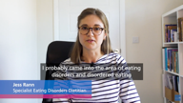

[Dietitian](https://www.youtube.com/watch?v=om3kPJ8FYww&list=PLrVQaAxyJE3c7jrG88eFGm88LQ86k2epl&index=3)

<https://www.youtube.com/watch?v=om3kPJ8FYww&list=PLrVQaAxyJE3c7jrG88eFGm88LQ86k2epl&index=3>

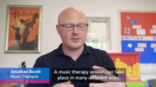

[Music Therapist](https://www.youtube.com/watch?v=mxC98bxo1n4&list=PLrVQaAxyJE3c7jrG88eFGm88LQ86k2epl&index=4)

<https://www.youtube.com/watch?v=mxC98bxo1n4&list=PLrVQaAxyJE3c7jrG88eFGm88LQ86k2epl&index=4>

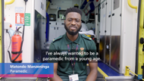

[Paramedic](https://www.youtube.com/watch?v=0vtHYDEm-e4&list=PLrVQaAxyJE3c7jrG88eFGm88LQ86k2epl&index=5)

<https://www.youtube.com/watch?v=uRrYeM-x9IA&list=PLrVQaAxyJE3c7jrG88eFGm88LQ86k2epl&index=1>

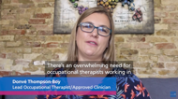

[Occupational Therapist](https://www.youtube.com/watch?v=jltLbRhZ2Dc&list=PLrVQaAxyJE3c7jrG88eFGm88LQ86k2epl&index=6)

<https://www.youtube.com/watch?v=jltLbRhZ2Dc&list=PLrVQaAxyJE3c7jrG88eFGm88LQ86k2epl&index=6>

## Introduction to AHPs

### Core profession relating to mental health and learning disability – Art therapists

Art therapists use the medium of art and art-making as part of a skilled psychotherapeutic approach. Their intervention helps to develop communication through expression with people whose illness has prevented them from connecting with others or aspects of themselves. Within this context, art is not used as a diagnostic tool but as a medium to address emotional issues that may be confusing and distressing.

Nicki Power, art therapist talks about role of arts therapies in a learning disability team: <https://www.baat.org/About-BAAT/Blog/163/Art-Therapists-and-their-AHP-colleagues-highlighted-on-World-of-Work-WoW-careers-TV>

#### Service user stories

In this short film, C shares her experience of group and individual art therapy for adults. The film illustrates her therapeutic process and how art making enabled C to express herself and reflect upon her eating disorder: <https://www.youtube.com/watch?v=00R6zv5vPw0>

“Art therapy is a form of psychotherapy that uses art media as its primary mode of expression and communication. Art therapists work with children, young people, adults, and the elderly. Clients may have a wide range of difficulties, disabilities, or diagnoses. These include emotional, behavioural, or mental health problems, learning or physical disabilities, life-limiting conditions, neurological conditions and physical illnesses”.

“Arts Therapists (art, music, and drama therapists) have a unique role in successfully engaging people who are too overwhelmed by their illness to take part in talking-based therapy.”



### Chiropodists / podiatrists

A podiatrist’s primary aim is to improve mobility, independence, and quality of life for their patients. Podiatrists specialise in the foot, ankle, and leg, leading the patient care through the whole journey including prevention, diagnosis and treatment. Podiatrists work in a variety of places and can work with a team of people including doctors and nurses or on their own running their own business.

Source: <https://rcpod.org.uk/become-a-podiatrist/what-is-a-podiatrist>

Podiatrists are experts in all aspects of the foot and lower limb. Working across all health and care settings, their primary aim is to manage people’s health, mobility, and independence. Podiatrists support people with learning disabilities with foot complications, often resulting from structural, joint, or gait conditions that can result in reduced or restricted mobility.

Source: <https://cdev3.hee.nhs.uk/learning-disability/careers/find-a-role-to-suit-you/allied-health-professions-ahps/podiatrist/>



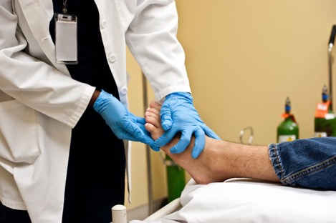

### Core profession relating to mental health and learning disability – Dramatherapists

There is a strong connection between dramatherapy and learning disabilities; a two-way relationship in which both have learnt and developed from each other. For the clients dramatherapy offers a space in which they can leave their ‘disability’; their ‘label’ at the door and be seen as an individual in order to develop their own sense of self. The nature of dramatherapy is to acknowledge the individual and through offering a safe, client-led space. Clients with learning disabilities are able to explore autonomy, self-expression and creativity.

Source: <https://www.badth.org.uk/dramatherapy/how-dramatherapy-can-help>

“Dramatherapy has many benefits for people with a range of mental health conditions such as anxiety, depression, psychosis, borderline personality disorder and bipolar. It can offer a different way of looking at things using a creative platform, rather than only the thinking and discussing method of addressing problems. Not relying on words can help a person who is struggling to express themselves cognitively or for people who have found the talking therapies difficult to engage with. Dramatherapist may use stories, drama, movement, role-play, music, and play in combination or isolation to help meet the goals, aims, needs of an individual and/or group. This creative way of working can help people to share their thoughts and emotions and work through what they are experiencing to help improve their mental well-being.”

Jane Bourne, Dramatherapist, Cumbria, Northumberland, Tyne and Wear NHS Foundation Trust, Learning Disability and Mental Health, BADth Vice Chair.

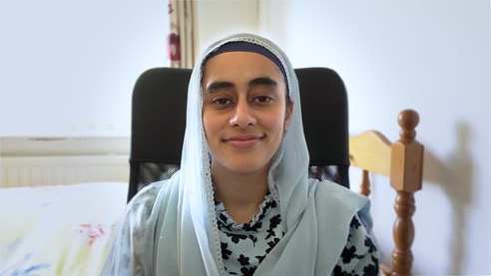

Eshmit Kaur,

Dramatherapist

](https://www.youtube.com/watch?v=c7ahcgGP3BY) 

<https://www.youtube.com/watch?v=c7ahcgGP3BY>

### Core profession relating to mental health and learning disability – Dietitians

Dietitians are qualified and regulated health professionals that assess, diagnose, and treat dietary and nutritional problems at an individual and wider public-health level. They use the most up-to-date public health and scientific research on food, health, and disease which they translate into practical guidance to enable people to make appropriate lifestyle and food choices.

Mental health dietitians can help you to eat well and develop a positive relationship with food. Good nutrition is important for both your mental and physical health. Mental health dietitians also work to improve catering and menu planning within mental health settings, such as psychiatric units. Mental health dietitians work with people of all ages who have a mental health condition(s). These can include anxiety, autism, bipolar disorder, dementia, depression, drug and/or alcohol problems, eating disorders, learning disabilities, personality disorders, and schizophrenia.

Source: <https://www.bda.uk.com/specialist-groups-and-branches/mental-health-specialist-group/what-do-mental-health-dietitians-do.html>

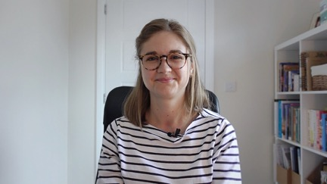

Jess Rann, specialist eating disorders dietitian

](https://www.youtube.com/watch?v=om3kPJ8FYww&list=PLrVQaAxyJE3c7jrG88eFGm88LQ86k2epl&index=4) 

<https://www.youtube.com/watch?v=om3kPJ8FYww&list=PLrVQaAxyJE3c7jrG88eFGm88LQ86k2epl&index=4>

### Core profession relating to mental health and learning disability – Music therapist

Music therapists are highly trained allied health professionals (AHPs), providing treatment that can help to transform people’s lives. Music therapists work in hospitals, schools, pupil referral units, day centres, hospices, care homes, therapy centres, prisons and in private practice across the UK.

Music can be a social process involving others and it can also provide the sanctuary of a more private experience. Depending on the individual needs of the clients, music therapists offer individual or group sessions. For a child with autism, this could be helping them to find a way to communicate with others. For a learning-disabled adult, this could be helping them to find a way in which to express their emotions in a safe and supported environment. For a person with dementia, this could be helping them to feel valued and heard.

Source: <https://www.bamt.org/music-therapy/what-is-a-music-therapist>

### Service user and patient stories

Music therapy and mental health – making positive, safe connections: <https://www.bamt.org/content/5075/Live/document/Mental%20Health.pdf>

Read some of the service user stories to find out how music therapy has enabled patients to be creative, expressive and musical in a time of need: <https://www.nordoff-robbins.org.uk/music-therapy-and-mental-health-challenges/>

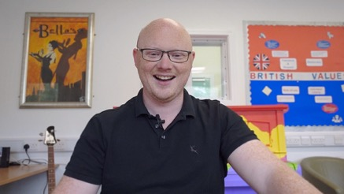

Jon Booth, music therapist

](https://www.youtube.com/watch?v=mxC98bxo1n4&list=PLrVQaAxyJE3c7jrG88eFGm88LQ86k2epl&index=5) 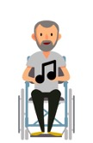

<https://www.youtube.com/watch?v=mxC98bxo1n4&list=PLrVQaAxyJE3c7jrG88eFGm88LQ86k2epl&index=5>

### Core profession relating to mental health and learning disability – Occupational therapists

Occupational therapy provides practical support to empower people to facilitate recovery and overcome barriers preventing them from doing the activities (or occupations) that matter to them. This support increases people’s independence and satisfaction in all aspects of life.

Occupational therapists work with adults and children of all ages with a wide range of conditions; most commonly those who have difficulties due to a mental health illness, physical or learning disabilities. They can work in a variety of settings including health organisations, social care services, housing, education, voluntary organisations, or as independent practitioners.

Occupational therapists support people with all types of learning disabilities to help them continue with life skills, work, and leisure activities as independently as possible.

Source: <https://www.rcot.co.uk/about-occupational-therapy/what-is-occupational-therapy>

Royal College of Occupational Therapists (RCOT) has produced a resource about occupational therapy with people with learning disabilities: <https://www.rcot.co.uk/sites/default/files/Resource-OT-and-Learning-Disabilities_0.pdf>

RCOT has also produced a resource outlining evidence to how occupational therapy benefits those with mental health: <https://www.rcot.co.uk/file/1805/download?token=dA7ez-G9>

The 2007 amendments to the Mental Health Act 1983 expanded the existing roles of approved clinician and responsible clinician, enabling occupational therapists and other mental health professionals other than psychiatrists to carry out duties previously performed by psychiatrists.

There are a further two roles available to occupational therapists under the Mental Capacity Act which are the best interest assessor role (BIA) and the second is the approved mental health professional (AMHP).

Michelle Mason, occupational therapist talks about her current role and career journey within mental health services:

](https://www.youtube.com/watch?v=DDQRGmJxolQ) 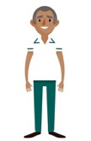

<https://www.youtube.com/watch?v=DDQRGmJxolQ>

### Osteopaths

Osteopaths are highly trained AHPs who are well known for expertise in the evaluation, diagnosis, and management of the entire musculoskeletal system (MSK) and its relationship with other systems in the body.

Osteopaths provide a patient-centred package of care which will vary depending on the needs of the person being treated. This will often include manual therapy where indicated, as well as rehabilitation exercises, screening, and general health advice. In addition to MSK health, osteopaths can contribute to other specialist areas of practice including paediatrics, occupational health, chronic pain management, sports care, woman’s health, and others. These are usually supported by additional postgraduate training.

Source: <https://www.iosteopathy.org/the-io/>

Jonathan Hearsey, osteopath talks about his role:

<https://www.youtube.com/watch?v=QF0VLW14PYc>

](https://www.youtube.com/watch?v=QF0VLW14PYc) 

<https://www.youtube.com/watch?v=QF0VLW14PYc>

### Orthoptists

Orthoptists are the experts in diagnosing and treating defects in eye movement and problems with how the eyes work together, called binocular vision. These can be caused by issues with the muscles around the eyes or defects in the nerves enabling the brain to communicate with the eyes.

They see patients with a wide range of conditions affecting their vision. They are trained to offer a range of treatments, including eye patches, eye exercises, prisms, or glasses. They also commonly work with patients with neurological conditions, such as stroke, brain tumours or multiple sclerosis.

Orthoptists are highly skilled in the assessment of vision and have particular expertise in the assessment of children and patients with special educational needs or learning disability.

Source: <https://www.orthoptics.org.uk/patients-and-public/orthoptist-optometrist-or-ophthalmologist/>

Jo Adeoye, orthoptist discusses the learning, obstacles, and greatest achievements from their career journey to date: <https://www.youtube.com/watch?v=Uz7zRqgaLK0>

](https://www.youtube.com/watch?v=Uz7zRqgaLK0) 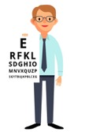

<https://www.youtube.com/watch?v=Uz7zRqgaLK0>

### Orthotists / prosthetists

Prosthetists are autonomous registered practitioners who provide gait analysis and engineering solutions to patients with limb loss. They are extensively trained at undergraduate level in mechanics, biomechanics, and material science along with anatomy, physiology and pathophysiology.

Orthotists are autonomous registered practitioners who provide gait analysis and engineering solutions to patients with problems of the neuro, muscular and skeletal systems. They are extensively trained at undergraduate level in mechanics, biomechanics, and material science along with anatomy, physiology and pathophysiology. Their qualifications make them competent to design and provide orthoses that modify the structural or functional characteristics of the patients’ neuro-muscular and skeletal systems enabling patients to mobilise, eliminate gait deviations, reduce falls, reduce pain, prevent, and facilitate healing of ulcers.

Source: <https://www.bapo.com/about-us/who-are-prosthetists-and-orthotists/>





### Operating department practitioners

The ODP role has evolved significantly and includes increased practice outside the operating theatre environment and as such the scope of ODP practice encompasses the totality of the patient pathway and ODPs routinely practice within pre-assessment, admissions units, and post-operative care, including critical care units.

Increasing numbers of ODPs are further developing their careers into advanced roles, for example Advanced Clinical Practitioners, where they have increased responsibility and practice beyond the perioperative environment. These roles include ODP endoscopists and acute pain practitioners as examples.

Source: <https://cpoc.org.uk/vision-college-operating-department-practitioners-and-cpoc>



### Core profession relating to mental health and learning disability – Paramedics

Paramedics are registered healthcare professionals who have a unique role that crosses healthcare, public health, social care, and public safety, they work autonomously providing care in a range of situations.

Paramedics are educated and trained to make decisions in complex and high-pressure situations in unfamiliar and often unpredictable environments. Paramedics are skilled at history taking, consultation skills and examination, judgement in diagnosis and management of a wide range of illness and injury from new-borns and babies to the elderly and those at the end of their life. Paramedics have expertise in dealing with critically ill and injured patients using complex equipment and a range of medications whilst getting the patient to the right hospital for their ongoing treatment.

Source: <https://www.collegeofparamedics.co.uk/COP/Become_a_Paramedic/COP/BecomeAParamedic/Become_a_Paramedic.aspx?hkey=f10838de-b67f-44a0-83b7-8140d8cdba83>

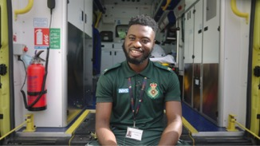

Matondo Manzeninga, paramedic

](https://www.youtube.com/watch?v=0vtHYDEm-e4&list=PLrVQaAxyJE3c7jrG88eFGm88LQ86k2epl&index=6) 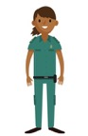

<https://www.youtube.com/watch?v=0vtHYDEm-e4&list=PLrVQaAxyJE3c7jrG88eFGm88LQ86k2epl&index=6>

### Core profession relating to mental health and learning disability – Physiotherapists

Physiotherapy has a unique role to play in the treatment of eating disorders, as a member of the multidisciplinary team using physical therapeutic interventions and education to help patients overcome their symptoms and to accept their changing body shape as they restore weight. The physiotherapy role within this field encompasses specialist assessment, advice, education, treatment and management of the various physical and psychological components of an eating disorder, and plays a vital role in the management of compulsive exercise, osteoporosis and altered body image.”

Source: <https://cpmh.csp.org.uk/content/physiotherapy-eating-disorders>

Learning disability physiotherapists provide specialist assessment, treatment and management to adults with a learning disability whose needs cannot be successfully met by mainstream services, even when reasonable adjustments are made. Physiotherapists will work in collaboration with the person, their network of care, mainstream health services, and the multidisciplinary team to enhance, optimise and maintain the person’s physical presentation, function and quality of life.”

Source: <https://acppld.csp.org.uk/content/standards-of-practice-main-document>

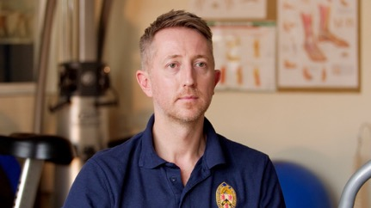

Nathan Swingewood, clinical lead physiotherapist

Naymond Campbell, physiotherapist talks about his career journey within mental health services:

](https://www.youtube.com/watch?v=YgkPWbYP2ds) 

<https://www.youtube.com/watch?v=YgkPWbYP2ds>

### Radiographers (Diagnostic & Therapeutic)

Radiographers are registered AHPs, vital for modern health care. There are two branches of radiography: Diagnostic and Therapeutic. Radiographers are clinical practitioners, managers, leaders, researchers and educators. They work as a team together with support workers, assistant practitioners, radiologists and oncologists to provide person-centred support and care for patients during screening, diagnosis, treatment and monitoring of trauma and disease processes. The profession is dynamic, developing rapidly in response to changing technological, health and patient population needs.

Source: <https://www.sor.org/about/about-radiography>

#### Diagnostic radiographers

Diagnostic radiographers use a range of techniques to produce high quality images to diagnose an injury or disease. They are responsible for providing safe and accurate imaging examinations and increasingly also the resulting report. Diagnostic imaging is a component of the majority of care pathways.



#### Therapeutic radiographers

Therapeutic radiographers play a vital role in the treatment of cancer. They are also responsible as they are the only health professionals qualified to plan and deliver radiotherapy. Radiotherapy is used either on its own or in combination with surgery and/or chemotherapy.

Also, refer to the current and future roles of diagnostic radiographers document for further information: <https://www.sor.org/getmedia/bfd03897-1a20-4b56-abc5-7463a7cc635e/Current-and-Future-Roles-of-Diagnostic-Radiographers-v1>

Stephanie and David talk about the difference between diagnostic and therapeutic radiographers: <https://www.youtube.com/watch?v=d5KnCTiUNn8>



### Core profession relating to mental health and learning disability – Speech and language therapists

Speech and language therapists (SLTs) have a unique role in identifying communication characteristics and swallowing difficulties. They can also provide therapeutic programmes to develop speech, language or communication skills. Speech and language therapists (SLTs) provide life-improving treatment, support and care for children and adults who have difficulties with communication, eating, drinking or swallowing. SLTs assess and treat speech, language and communication problems in people of all ages to help them communicate better. They also assess, treat and develop personalised plans to support people who have eating and swallowing problems.

SLTs are integral members of the multidisciplinary team supporting clients with mental health problems. They:

* identify speech, language, communication and eating, drinking and swallowing difficulties;
* support patient safety by reducing the risk of swallowing problems which can lead to malnutrition, dehydration, choking or aspiration pneumonia requiring hospital admission and in some cases causing death.

Source: <https://www.rcslt.org/speech-and-language-therapy/#section-1>

#### Speech and language therapy transforms lives

The following fact sheets detail case studies and service user stories, showing how speech and language therapy changes lives:

* Children and young people’s mental health services: <https://www.rcslt.org/wp-content/uploads/media/docs/RCSLTCYPMHSA4Digital.pdf>
* Giving voice to people with swallowing difficulties: <https://www.rcslt.org/wp-content/uploads/media/Project/RCSLT/rcslt-dysphagia-factsheet.pdf>
* Supporting people with learning disabilities: <https://www.rcslt.org/wp-content/uploads/media/docs/RCSLTCYPMHSA4Digital.pdf>
* Promoting social, emotional and mental health: <https://www.rcslt.org/wp-content/uploads/media/Project/RCSLT/rcslt-social-emotional-mental-health-factsheet.pdf>
* Giving voice – Autism: <https://www.youtube.com/watch?v=slT-pxC76Ls>

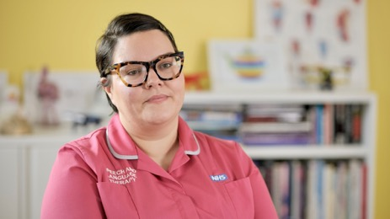 

Amy Hird, clinical lead speech and language therapist

### Highlighting AHPs contribution to the mental health, learning disabilities and autism workforce

The following two infographics can be used to demonstrate to employers and clinical workforce planners how AHPs, which are the third-largest clinical workforce in the NHS, can make a unique contribution to mental health, learning disability and autism services.

The infographic, co-designed with the HEE AHP Mental Health and Learning Disability Observatory, shows how patients, service users and families can benefit from holistic AHP support for their health and care needs.

Image of an infographic which can be used to demonstrate to employers and clinical workforce planners how AHPs can make a contribution to mental health, learning disability and autism services. The title of the infographic is "What can AHPs offer in mental health settings?"

The infographic can be downloaded via this link: <https://www.hee.nhs.uk/our-work/mental-health/new-ways-working-mental-health/allied-health-professionals-mental-health/ahps-offer-mental-health-settings-explained>

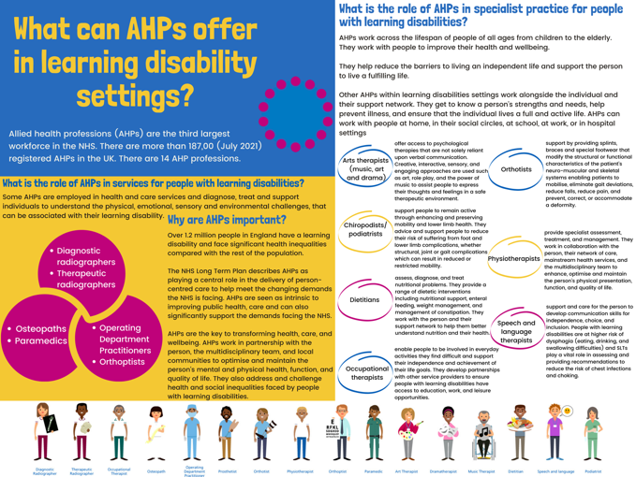

### The imperative of expanding AHP student placements in mental health and learning disability practice

A quick guide has been created that highlights the benefits and opportunities of practice-based learning (PBL) through placements in mental health and learning disability settings for AHP students, focusing particularly on the professions most common in these settings: <https://www.hee.nhs.uk/our-work/allied-health-professions/developing-practice-based-learning-mental-health-learning-disability-settings-allied-health>.

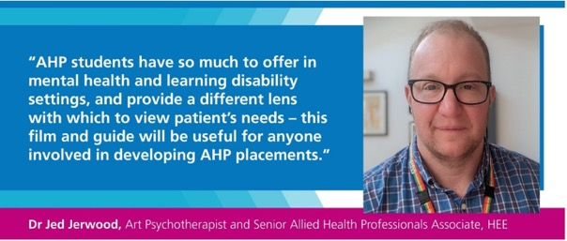

There is a focus on developing pre-registration student opportunities for AHPs in mental health and learning disability practice to drive and ensure AHP capacity for mental health and learning disability developments, to inspire careers in this area, develop further expertise and promote MDT teamworking.

The ideas and examples show how placements have been developed in these settings and highlight the benefits to students, Higher Education Institutions (HEI’s) and placement providers. Ultimately, these placements offer most benefit to patients, service users and families who receive holistic support for their health and care needs offered by the different AHPs.

PBL in mental health and learning disability settings offers students the opportunity to build their confidence, to understand their profession more broadly and to develop an essential skill set to forward into whichever professional setting they work in. The skills and knowledge gained by students when working in specialist mental health and learning disability settings will stay with them throughout their careers, shaping future career choices and ensuring transfer of these skills into different career pathways, supporting the development of the future AHP workforce across health and social care.

The following film features some passionate AHP clinicians and students talking about their work in mental health and learning disability setting:

](https://www.youtube.com/watch?v=gccTT2femfU&list=PLrVQaAxyJE3f-gRXcf3WOoy2bdCj_7OIJ&index=6)

<https://www.youtube.com/watch?v=gccTT2femfU&list=PLrVQaAxyJE3f-gRXcf3WOoy2bdCj_7OIJ&index=6>

# Career development and pathways for the AHP community

In this section, we have created a hub of information outlining career pathways for the AHP community in mental health, learning disability, and autism settings. The AHP community comprises pre-registration students and apprentices, AHP support workers, assistant practitioners, those returning to practice (RtP), and registered AHPs.

We have highlighted some inspiring career stories of AHPs working across settings to encourage others and help them pursue a career in similar areas. We hope the promotion of these roles will also aid the recruitment and retention of staff.

## Career pathways

### Non-registered AHP workforce

Support workers, senior support workers, assistants and assistant practitioners work in, with and alongside the allied health professions (AHPs), providing high quality, life changing care across a range of acute and community services.

HEE’s national AHP support workforce programme has been established to provide national leadership and support in recognising, developing, and expanding the non-registered AHP workforce. The AHP Support Worker Competency, Education and Career Development Framework enables employers, networks, integrated care systems (ICSs) and services to effectively plan, develop, and deploy their AHP support workforce: <https://www.hee.nhs.uk/our-work/allied-health-professions/enable-workforce/developing-role-ahp-support-workers/ahp-support-worker-competency-education-career-development>

AHP support worker case studies highlight how AHPs play an integral role in supporting people’s health and wellbeing: <https://www.hee.nhs.uk/our-work/allied-health-professions/enable-workforce/developing-role-ahp-support-workers/ahp-support-worker-case-studies>

## Pathway to an AHP career

This map outlines a few different ways individuals can progress towards qualifying as an AHP and advancing their career.

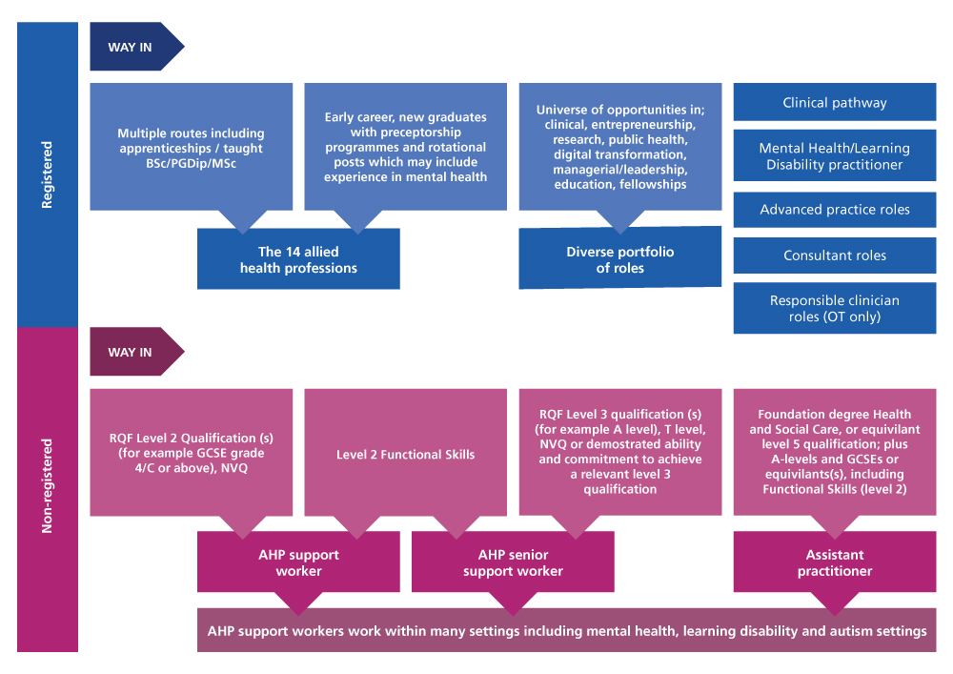

## Registered AHP workforce

The Universe of Opportunities resource outlines eight core areas in which AHPs could consider developing their career, all while potentially continuing in clinical practice: <https://www.e-lfh.org.uk/programmes/allied-health-professionals-careers/>

The AHPs Everywhere webinar showcases some diverse AHP career pathways:

<https://future.nhs.uk/SeniorAHP/view?objectID=570564>

### Multi-professional approved roles

Approved clinicians are one example of how AHPs can progress into a senior clinical role within mental health, learning disability and autism settings. The 2007 amendments to the Mental Health Act (MHA) 1983 introduced the roles of approved clinician and responsible clinician, enabling occupational therapists and other mental health professionals other than psychiatrists to carry out duties previously performed by a psychiatrist.

HEE defines the role of an approved clinician as:

“A mental health professional approved by the secretary of state or a person or body exercising the approval function of the secretary of state. Some decisions under the Mental Health Act can only be taken by people who are approved clinicians. All responsible clinicians must be approved clinicians.”

Occupational therapists are one the AHPs that are eligible to train and act as approved clinician. They are also one of the key professions in mental health practice. Mental health occupational therapists bring a valuable contribution to service users in hospitals and in the community. Their role promotes independence and encourages fully integrated living in the community.

There are many benefits that these multi-professional approved roles bring with them such as:

* ensuring capacity and capability to provide contemporary, expert rehabilitative practice for and with service users and carers
* enabling the AHP workforce to work at the top of their competencies and skills
* bringing diverse clinical leadership to the multi-disciplinary team

This Multi-Professional Approved/ Responsible Clinician: Implementation Guide provides guidance to NHS organisations and partner agencies looking to implement multi-professional approved (AC) and responsible clinician (RC) roles: <https://www.hee.nhs.uk/sites/default/files/documents/Multi%20Professional%20Approved%20Responsible%20Clinician%20Implementation%20Guide.pdf>

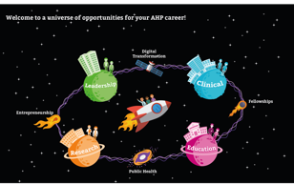

## Professional case study: Approved Clinician



### Donvé Thompson-Boy

Bromley CMHRES manager Community Mental Health Directorate, lead occupational therapist (OT) and approved clinician (AC)

#### Tell us about your career journey so far.

I have worked in mental health for more than 20 years and had at least 15 years’ experience in a senior clinical leadership role. During this time, I have worked across a range of mental health settings, including acute, inpatient rehabilitation and community mental health, although my passion always lay in rehabilitation services. While working on an inpatient rehabilitation unit, I was given the opportunity to consider the AC training. The responsible clinician on the unit was very supportive of this development and agreed to mentor me while I undertook the training. The process took about three years to complete and involved developing and demonstrating the eight core AC competencies, while compiling the evidence required for the AC portfolio. I now work in a community rehabilitation team with service users who are discharged from hospital on CTOs.

#### What have been the key enablers in you becoming an Approved Clinician?

Organisational support to undertake the training and protected time to develop the AC competencies were essential. Having the support from an AC mentor was vital in giving me the opportunity to shadow and develop my knowledge and skills, while also being able to reflect on my learning and identify gaps. Being part of an AC peer group was also an important part of my learning and support structure, and still forms an important part of my continuing professional development as an approved clinician.

#### What have been the key challenges in you becoming an Approved Clinician?

There was no clear deployment plan when I started my training, which then made it difficult to forge a role for myself once I was approved. It can also be an adjustment for other members of the multidisciplinary teams, who have traditionally worked with consultant psychiatrists as the professional leading the care and treatment, so educating others regarding the role has been important.

#### What do you most enjoy about this role?

I love using my AC role as a way of improving and enhancing my service users’ experience of mental health services, while leading the MDT in decisions regarding care, treatment, and ultimate discharge from detention, where appropriate.

#### What advice might you have for other occupational therapists aspiring to become approved clinicians?

The AC role enables OTs to consider an exciting clinical career development pathway as an alternative to a management pathway, which has traditionally been considered one of the few alternatives for OTs to break through the Band 7 ceiling. I would encourage OTs to seek out opportunities early on in your career, to learn more about the legal frameworks used by ACs, to attend mental health tribunal hearings to observe the AC role and responsibilities and to improve your knowledge and understanding of detention criteria. If you are interested in pursuing the role, I would suggest discussing this with your professional lead and/or clinical director, in order to explore potential career development opportunities within your trust. Speaking with other multi-professional approved clinicians (MPACs) about the role and the difference you can make will also be helpful.

## Becoming leaders in advanced practice

“Advanced clinical practice is delivered by experienced, registered health and care practitioners. It is a level of practice characterised by a high degree of autonomy and complex decision-making. This is underpinned by a master’s level award or equivalent that encompasses the four pillars of clinical practice, leadership and management, education, and research, with demonstration of core capabilities and area-specific clinical competence…”

(Health Education England, 2017)

Advanced practitioners’, as experienced clinicians, add significant value to teams. This enables the rethinking of how modern teams operate by:

* redistributing workload within a multi-professional team to meet the needs of populations,
* reducing temporary workforce spend and risk by investing in the value-added skills of experienced clinicians,
* supporting person-centred approaches/prevention of ill health,
* building experienced decision-making capacity and clinical continuity within teams’ advanced practice,
* upskilling team members and offering safe and effective skills sharing across traditional professional boundaries.

The role and development of advanced clinical practice within allied health professions: a mixed method study 2020 indicates that these roles are already having a positive impact on healthcare services and supporting new models of care. However, establishing the necessary infrastructure, standardisation, and governance for ACP roles across sectors, along with the career pathways, funding, sustainability, and education, could increase impact in the future: <https://www.ncbi.nlm.nih.gov/pmc/articles/PMC7701658/>



Did you know...

there are different routes to becoming recognised as an advanced practitioner AHP including via a master’s degree, an apprenticeship or the supported e-portfolio route?

Further details are available at: <https://advanced-practice.hee.nhs.uk/>

## Developing capability of AHP mental health and learning disability practitioners to achieve and be recognised as working at an advanced level

The Multi-professional framework for advanced clinical practice in England provides guidance on the possible ways of evidencing the capabilities within the four pillars of advanced clinical practice: <https://advanced-practice.hee.nhs.uk/credentials/>

Experienced allied health practitioners are well placed to deliver advanced practice roles in services for people with mental health issues, learning disabilities, and people with autism.

Making good use of these highly developed practitioners allows for increased productivity, efficiency, and team satisfaction within multi-professional teams. Finding, keeping, and developing the right staff is a particular challenge for all services and especially learning disability and autism services.

Upskilling talented staff in clinical, leadership, education and research skills is a perfect opportunity to fill the clinical and system leadership roles gaps with multi-professional advanced practitioners or consultants. Additionally, these roles provide a career pathway for the workforce, which aids the recruitment and retention of staff.

Occupational therapists, speech and language therapists, physiotherapists, dietitians, arts, drama, and music therapists are the allied health professions that most frequently work in secondary care, mental health, learning disability, and autism services. They work across all ages and settings, providing their unique expertise, to help individuals to live the best life they can and overcome barriers every day, and support their carers and loved ones with specialist advice.

As part of a multi-professional team, allied health professionals provide a coordinated approach, and often share their knowledge and expertise with the team, across organisations and providers. For example, speech and language therapists provide education and training to support inclusive communication so that communication and access to healthcare are not impeded. Occupational therapists assist providers in housing-related matters and make reasonable adjustments by educating their staff to provide an inclusive service and culture of equality of access.



Given the complex nature of mental health, learning disability and autism services, both a multi-professional and an integrated service approach spanning several organisations are needed. This requires clear leadership and management, and HEE is supporting multi-professional advancing practice and, specifically within the field of learning disability and autism, the development of:

* advanced practitioners – to provide education, leadership, and specialist advice across a team or organisation;
* consultant practitioners – to provide strategic leadership, specialist advice, and education across a healthcare system. For example, providing expert advice across an ICS.

These roles are undertaken by experienced clinicians working in a multidisciplinary manner, able to meet the needs of individuals and the system in which they work. They facilitate improved quality of care, for example by addressing key points of transition, and are increasingly supporting the implementation of new service models, e.g. The National Autism Strategy (2021).

## Things for AHPs to consider to develop as an advanced practitioner

* Explore the possibility of undertaking a master’s in advanced practice. There is variation in the course content between providers, although all are expected to deliver the content set out in the multi-professional framework for advanced clinical practice in England. Consider your specific learning needs, including for the setting in which you work, look at the content of several courses and think about which one suits your needs.
* Map yourself into the multi-professional framework for advanced clinical practice in England to identify your current level of knowledge and skills and your own areas for learning and development. If you work in a setting where there is also an area-specific credential, such as advanced practice in mental health, also map your level of knowledge and skills into this framework.
* The work of the Centre for Advancing Practice is evolving at national and regional levels, so review the leadership opportunities available at a national and local level to influence and shape advancing practice within your region.
* Seek out mentors to support you and to develop business cases to demonstrate the need for change. Look for HEE, NHSE/I, professional bodies and NHS Employers resources that can also help with the implementation of new roles or development of existing roles in practice.
* As the communities of practice are being developed, keep yourself updated on the news via the Centre for Advancing Practice.
* HEE is developing units of learning (credentials <https://advanced-practice.hee.nhs.uk/credentials/>) for priority areas such as mental health, learning disability and autism. Some education providers are integrating the credentials into their master’s programmes – Speak to your regional faculty for advancing practice, who will be able to advise you on what is offered in your area, including the funding arrangements: <https://advanced-practice.hee.nhs.uk/regional-faculties-for-advancing-practice/>
* Advocate for and educate students in mental health and learning disability settings regularly to ensure the workforce is fit for the future with an AHP workforce pipeline assured.

## Case studies

This selection of case studies demonstrates consultant AHP roles and what inspired AHPs to pursue this career pathway.

<https://advanced-practice.hee.nhs.uk/welcome/regional-faculty-for-advancing-practice-north-east-and-yorkshire/case-studies-advanced-practice-in-the-region/>

### Resources

* Advanced clinical practice toolkit: <https://advanced-practice.hee.nhs.uk/>
* Community of Advanced Practice in Mental Health: <https://www.advancedmentalhealthcommunityofpractice.co.uk/>
* Multi-professional framework for advanced clinical practice in England: <https://advanced-practice.hee.nhs.uk/multi-professional-framework-for-advanced-clinical-practice-in-england/>
* Advanced Practice Mental Health Curriculum and Capabilities Framework: <https://www.hee.nhs.uk/sites/default/files/documents/AP-MH%20Curriculum%20and%20Capabilities%20Framework%201.2.pdf>

## Careers in mental health, learning disability and autism

### Mental health careers

Mental health services and settings are the range of places where health and care services are delivered to people experiencing mental ill health or distress. This includes both NHS and other statutory services, in in-patient settings and community settings. Mental health needs are met in primary care, secondary care, specialist mental health services, in in-patient settings and residential services, education settings and in the private, voluntary and community sector. Mental health services incorporate medical/psychiatric, psychological, occupational, social and peer-led recovery interventions.

Mental health services support people experiencing a wide range of difficulties and diagnoses including depression and anxiety, psychosis, personality difficulties, trauma-oriented difficulties, addictions, eating disorders, bi-polar disorders, neurological disorders and other related conditions.

AHPs working in mental health services make a unique contribution to mental health services in the following ways:

* Specialist early intervention to users of services and their families and carers ensures patients get the right support and care at the right time.
* As champions of physical and mental health, AHPs link across care pathways and can therefore provide a strategic overview for commissioning activities.
* Mental health services provide AHPs with the settings and opportunity to maximise their skills and work at the top of their competencies and skills.

“Mental health needs are met in primary care, secondary care, specialist mental health services, in in-patient settings and residential services, education settings and in the private, voluntary and community sector.”2

#### AHP careers in mental health

](https://www.youtube.com/watch?v=YgkPWbYP2ds)

[Physiotherapy:](https://www.youtube.com/watch?v=YgkPWbYP2ds)

[https://youtu.be/YgkPWbYP2ds](https://www.youtube.com/watch?v=YgkPWbYP2ds)

](https://www.youtube.com/watch?v=DDQRGmJxolQ&feature=youtu.be)

[Occupational therapy in perinatal services:](https://www.youtube.com/watch?v=DDQRGmJxolQ&feature=youtu.be)

<https://youtu.be/DDQRGmJxolQ>

](https://www.youtube.com/watch?v=_39soSWCQTg&feature=youtu.be)

[Dietetics:](https://www.youtube.com/watch?v=_39soSWCQTg&feature=youtu.be)

<https://youtu.be/_39soSWCQTg>

2 HEE, 2022

“I chose mental health occupational therapy because it combines creativity and science. I support people to find meaning and balance within their lives whilst tackling occupational injustice and health inequalities. My role brings people into decision-making about their care and helps them, and the people who are important to them, to understand the things that support their recovery. Working in equal partnership enables me to support the people I work with to do the things they need to do, want to do and are expected to do as part of their everyday lives.”



Melissa Reed

Consultant Occupational Therapist for Recovery and Inclusion

Gloucestershire Health and Care NHS Foundation Trust

“My 30 year career as a physiotherapist for adults with learning disabilities has been varied and interesting, with no two days the same! As an AHP, I bring my in-depth knowledge of physical health to our community team. I couple this with specialist experience of emotional well-being to enable people with complex issues to achieve the lives they want to live and to reduce the health inequality that this group so often experience.”



Jackie Hempkin

Interim Lead for Physiotherapy and Health and Exercise Practice, Mental Health and LD

Gloucestershire Health and Care NHS Foundation Trust

“My role as a paramedic provides different ranges of care to people from different communities and backgrounds. We deal with mental health at the front line. We aim to get people the ultimate care they need. You know you’re successful when you know that the patient is safe and that the patient is getting the ultimate care that will potentially prevent them from self-harming and being at peace from whatever problem is causing them to have that mental health problem.”

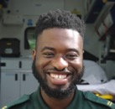

Matondo Manzeninga

Paramedic

Yorkshire Ambulance Service NHS Trust

“Dramatherapy can offer so many ways for a person to be supported. Success for me is defined when a young person tells me that they were able to use their self-soothing box instead of having the impulse to self-harm. Knowing that individuals feel more confident and loving towards themselves tells me there has been a positive outcome from the therapy.”



Eshmit Kaur

Dramatherapist

East London NHS Foundation Trust

“My current roles afford me the honour of supporting the most complex eating disorders patients, while developing the dietetic team and reviewing the service. I also have the opportunity to develop AHPs across the mental health services in Lancaster and Morecambe and the South Lakes. Coupled with my clinical and strategic roles I volunteer for the BDA where I get the opportunity to work with experts across the fields of mental health Dietetics and nationally promote and represent these roles within mental health services, whilst being the voice for mental health dietetics on the BDA England Board. I feel very fortunate to have these opportunities and am looking forward to the continued growth of dietitians within mental health.”



Christian Lee BSc (Hons) MSc RD MBDA

Consultant Eating Disorders Dietitian, Network Associate Director Allied Health Professions (AHP) – The Bay

## Learning disability careers

“People with learning disabilities receive care and support from a wide range of agencies and services both inside and outside the NHS. Specialist services offer support and care in the community, residential, in-patient and education settings. People with learning disabilities may also have autism spectrum disorders and experience other neurodiversity.

Learning disability services incorporate medical/psychiatric, psychological, occupational, social and peer-led advocacy interventions. People with learning disabilities often have physical and mental health needs and some services are integrated. However, many people with learning disabilities have unmet mental health needs.”3

There are roles in learning disability across health and social care to suit a range of skills and interests. This site explores the six professions that most commonly specialise in working with people with a learning disability: <https://learning-disability.hee.nhs.uk/careers/find-a-role-to-suit-you/allied-health-professions-ahps/>

These professions are: occupational therapists, physiotherapists, speech and language therapists, dietitians, podiatrists and art, music or drama therapists.



Occupational therapist: <https://learning-disability.hee.nhs.uk/careers/find-a-role-to-suit-you/allied-health-professions-ahps/occupational-therapist/>



Speech and language therapist: <https://learning-disability.hee.nhs.uk/careers/find-a-role-to-suit-you/allied-health-professions-ahps/speech-and-language-therapist/>

Caricature of a Podiatrist

Podiatrist: <https://learning-disability.hee.nhs.uk/careers/find-a-role-to-suit-you/allied-health-professions-ahps/podiatrist/>



Physiotherapist: <https://learning-disability.hee.nhs.uk/careers/find-a-role-to-suit-you/allied-health-professions-ahps/physiotherapist/>



Dietitian: <https://learning-disability.hee.nhs.uk/careers/find-a-role-to-suit-you/allied-health-professions-ahps/dietician/>

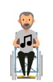

Art, music, or dramatherapist: <https://learning-disability.hee.nhs.uk/careers/find-a-role-to-suit-you/allied-health-professions-ahps/art-music-or-drama-therapist/>

3 HEE, 2022

## Career stories

We have showcased a small collection of career stories of AHPs working in mental health and learning disability settings, to inspire other AHPs to consider a career in similar settings. These stories also offer an insight to others into the life of an AHP in mental health and learning disability settings.

### Case Study: Paramedic

#### Name – Dr Ursula Rolfe

Mental Health Lead for College of Paramedics; deputy head of department midwifery and health sciences; faculty simulation lead

Bournemouth University

##### 1. How did you get into your role within mental health/learning disability?

The College of Paramedics was developing a strategy around mental health and, due to my PhD research and passion in mental health, I became one of the national leads for mental health – in post since 2015. Initially my plan was to remain clinical, but I became an academic through opportunity and support, not only from my ambulance service line manager but also the university I was seconded to. Having completed a PhD was also a huge advantage as it was considered unusual at that time.

##### 2. What made you decide to choose a career within mental health/learning disability services?

Because my research interest was in mental health and delivery of services, this became imbedded into my career pathway too. As my career is academic (although I still maintain clinical practice through bank work as an advanced clinical practitioner) there are many opportunities to support curriculum development and research into this very important area. I have also taken some of the lessons learned through research and have been able to apply it to my practice. My role has really been about accepting and creating opportunities that have come my way.

##### 3. How does your role make an impact on a service user within mental health/learning disability services?

As my primary area of interest is in how paramedics manage patients experiencing mental health issues, the results of my PhD and associated research as well as the work around curriculum development have a direct impact on service users. Paramedics have an excellent opportunity and desire to make a positive contribution to the care of these patients, but they need more support from their NHS trusts and a more standardised curriculum to support their development in this field. My role involves supporting paramedics in this specialist area, finding new avenues to develop paramedics depending on their needs and their roles.

##### What are the best bits you face in your role?

Working for the College of Paramedics has always been more of a vocation than a role. I feel honoured to be able to contribute to this workstream and to continue to highlight and develop managing mental health with a focus on the paramedic role.

### Case study: Dramatherapist

#### Image of Clare Hubbard, Professional Lead for Dramatherapy, Adult Mental Health Hertfordshire Partnership University NHS Foundation Trust (HPFT).

#### Name – Clare Hubbard

Professional lead for dramatherapy, adult mental health

Hertfordshire Partnership University NHS Foundation Trust (HPFT)

##### 1. How did you get into your role within mental health/learning disability?

At the time I qualified as a dramatherapist, I was working as a residential support worker for people who have a learning disability. I had done one of my placements in older adult mental health at the Maudsley and I was volunteering as a dramatherapist for Mind in North London. I approached the local NHS mental health trust about running a pilot for them. I was lucky that they had a head of art therapy, and a bit of occupational therapist underspend. They accepted my offer. By this time, I had secured a senior dramatherapist post in another part of the trust two days a week, which over time extended to five days. I took secondment opportunities for management roles, and became the substantive head of dramatherapy across adult mental health services in 2014, when services were redesigned.

##### 2. What made you decide to choose a career within mental health/learning disability services?

Although I did a drama degree in order to act, I had become interested in psychology when I took it for A Level and discovered there was something called dramatherapy, which was a perfect marriage of my two interests. I read about dramatherapy whilst doing my degree. I volunteered with dramatherapists where I lived in Cardiff, both in mental health and learning disability. I was sure I wanted to train.

I had really enjoyed my training placement at the Maudsley with older adults who experienced mental health difficulties and was keen to work more in the NHS mental health area. However, it was difficult to find work in the NHS as a dramatherapist, most work being freelance within education or charities, so I worked to create a role.

##### 3. How does your role make an impact on a service user within mental health/learning disability services?

My role is 40 per cent clinical and 60 per cent leadership. This means I see service users for one-to-one and group dramatherapy, and I hope the therapy makes a positive impact on their mental health. Individuals are often referred for dramatherapy because they find traditional talking therapies difficult and it is hoped that they can benefit from an approach that enables them to express and work through their difficulties through the distance of creativity and metaphor, or perhaps work with what they are experiencing in their bodies.

As a leader and supervisor, I aim to have a positive impact on service users, by ensuring that the dramatherapy they receive is of high quality, through supporting staff to develop their skills, setting standards of practice, and evaluating the provision through outcome measures and service user feedback. I also aim to improve the accessibility of dramatherapy for service users, through advocating its use in other/new services and building the evidence base.

##### What are the best bits you face in your role?

I love the variety in my role. It keeps it interesting, with a healthy level of challenge. My job is rewarding when service users feel they are supported or have taken some steps forward. It is rewarding when staff feel supported, and I see them grow in their confidence and skills. It has been really rewarding this year, as we have had new permanent posts and some short-term projects funded.

“Many dramatherapists study either drama or psychology for undergraduate. The dramatherapy training is a master’s level training course. It includes training on human development, mental health and emotional regulation using embodied, creative and active methods. The courses include assessed practice sessions within the training cohort. Students also have clinically supervised placements in different settings to apply their skills with real clients. Following qualification, graduates must register with the Health and Care Professions Council prior to commencing employment. Dramatherapists must maintain their continuing professional development to continue their registration.”

### Case study: Occupational therapist



#### Name – Kosiwa Lokosu

#### Mental health occupational therapist (OT)

#### Mid Hampshire Healthcare/Winchester Primary Care Network

##### How did you get into your role within mental health?

Prior to starting my degree, I volunteered to support young people with additional needs. Through this role, I developed a passion for working with and supporting others and started to take on additional roles that helped me to develop my skills. I knew as a student and prior to starting my degree that I always wanted to work in mental health, mainly due to experiences I had supporting loved ones who were suffering from their own mental health issues. I was also very aware of the stigma associated with mental health and wanted to work hard on breaking down these prejudices and stereotypes.

On qualifying, my first role was in acute adult mental health. I worked in an acute mixed ward and also in the community supporting people with functional-based goals as part of their recovery. I absolutely loved this role and it was the perfect start to my career. Although challenging, and initially quite scary supporting people generally at their lowest times, I felt I was really able to flourish and develop as an OT, learning valuable skills that I would take forwards in my role.

After two-and-a-half years, I decided to change my career path slightly and work in a more physical-based role. This was a big challenge for me. Although OTs are dual-trained, a lot of people tend to choose an area, such as physical, mental health, or learning disabilities, and stick with it. I wanted to develop my skills as a practitioner. I also wanted to demonstrate that we need to work with individuals holistically, taking into account both their physical and mental health needs and breaking away from the siloed way of thinking.

##### How does your role make an impact on a service user within mental health services?

My current role sees me working in primary care as part of the Additional Roles Reimbursement Scheme. Before I started in January 2020, there was no OT service. However, within a year the service has come on leaps and bounds. We support people with enduring mental health problems, some of whom also suffer from multiple comorbidities and chronic physical health conditions. This role has been an eye-opener, helping to build understanding of the differences between primary and secondary care, and enabling work on breaking down barriers between siloed ways of working in services.

##### What are the best bits you face in your role?

I love working with people, I always have. I knew from a young age that I wanted a job working with and supporting people. We have a really special role to play in people’s lives, supporting them through some of their hardest moments and hopefully supporting them through this to something better. This is something we cannot take lightly; compassion and empathy are imperative, and we need to recognise how our time, voice, and approach can be used to either improve or negatively affect someone else’s life. As occupational therapists, we enable people to access the tools to help them live a better and more fulfilling life. I think this is a special time to be a part of.

## Training and career planning resources

We have compiled some career planning resources to help AHPs map their professional growth. We also recommend using career frameworks published by professional bodies to assist with this.

There is also a list of training programmes that are available and would be suitable for those AHPs who do not necessarily work in mental health, learning disability or autism environments but might come across patients with these conditions in their day-to-day working life.

### Career planning resources

* HEE has developed an AHP Careers Toolkit to provide profession-specific and combined AHP career resources and events: <https://www.hee.nhs.uk/our-work/allied-health-professions/stimulate-demand/ahp-careers-toolkit>
* A Careers Resource for Qualified Allied Health Professionals: <http://cs1.e-learningforhealthcare.org.uk/public/AHP/AHP_01_001/index.html#/>
* If you want to return to the HCPC register, HEE can provide the help and information you need to return to practice: <https://www.hee.nhs.uk/our-work/return-practice-allied-health-professionals-healthcare-scientists>
* Developing AHP Leaders. This is a guide for trust boards and clinicians to support professional development opportunities and possibilities for allied health professionals: <https://www.england.nhs.uk/wp-content/uploads/2021/04/nhsi-developing-ahp-leaders-print.pdf>
* Allied Health Professionals Retention Bite-Size Learning Webinars. These online interactive webinars provide a platform to share the latest data and evidence on AHP retention, as well as a forum for providers to share their experiences and innovative solutions to factors that impact staff retention: <https://future.nhs.uk/SeniorAHP/view?objectID=570564>
* Allied Health Professionals Job Planning: A Best Practice Guide: <https://www.england.nhs.uk/ahp/allied-health-professionals-job-planning-a-best-practice-guide/>
* A Roadmap to Practice is a supportive document that offers a clear pathway to advanced practice: <https://www.hee.nhs.uk/our-work/allied-health-professions/enable-workforce/roadmaps-practice-0>
* Allied health professionals promote their careers and provide a better understanding of what it is like to work in mental health, learning disabilities & autism services: <https://www.youtube.com/watch?v=KZyVcnLtrJE>
* Late career AHPs supporting practice-based learning resource: <https://www.hee.nhs.uk/our-work/allied-health-professions/increase-capacity/ahp-pre-registration-student-practice-based-learning-programme/practice-based-learning-8>
* Leadership academy help the NHS to discover its full leadership potential and achieve the highest standards in health and care: <https://www.leadershipacademy.nhs.uk/>

### Training resources

* Autism Awareness programme: <https://www.e-lfh.org.uk/programmes/autism-awareness/>
* Autism resources and training: <https://www.england.nhs.uk/learning-disabilities/about/useful-autism-resources-and-training/>
* Disability Awareness: <https://www.e-lfh.org.uk/programmes/disability-matters/>
* Mental Health Awareness Programme: <https://www.e-lfh.org.uk/programmes/mental-health-awareness-programme/>
* Dysphagia Guide e-learning resource: <https://www.e-lfh.org.uk/programmes/dysphagiaguide/>
* Mental Capacity Act programme: <https://www.e-lfh.org.uk/programmes/mental-capacity-act/>
* Mental Health Training resources: <https://www.e-lfh.org.uk/programmes/mental-health-training-resources/>
* Suicide Prevention programme: <https://www.e-lfh.org.uk/programmes/suicide-prevention/>
* So your next patient has a mental health condition: a guide for physiotherapists not specialising in mental health – <https://www.csp.org.uk/system/files/publication_files/Guide%20to%20treating%20patients%20with%20a%20mental%20health%20condition.pdf>
* What do dietitians need to know when seeing a patient with a learning disability? <https://www.bda.uk.com/resource/what-do-dietitians-need-to-know-when-seeing-a-patient-with-a-learning-disability.html>
* Mencap provides handy guides and information about learning disabilities if you work in the health services: <https://www.mencap.org.uk/learning-disability-explained/resources-healthcare-professionals>

# Action for change

This section of the toolkit argues a case for why there is a need for commissioners to invest in AHPs and provides tips to system leaders, commissioners, employers, and workforce planners on how they can take much-needed action in maximising the contribution of AHPs in mental health, learning disability, and autism settings.

The skills that AHPs possess within mental health, learning disabilities and autism are invaluable but are often less understood and undervalued. Throughout the toolkit, we have informed the reader of the various skills AHPs bring to the table and this section shines a light on some innovative practical examples of how AHPs are strengthening services, transforming care, and making a valuable contribution to positive patient outcomes.

We have also underlined key strategic plans that have been placed to highlight the importance of utilising AHP skills within services to make appropriate changes, which would then ease the pressure the NHS and social care is under. The contribution of AHPs needs to be recognised in order to meet the ambitions of the NHS Long Term Plan and deliver high-quality care across England.

## The current picture

As of September 2021,

* 1.49 million people were in contact with mental health services, at the end of September. The majority of these (1,019,305) were in contact with adult services.
* 178,242 people were in contact with learning disabilities and autism services, at the end of September.
* 366,560 new referrals were received, and 2.02 million care contacts were attended, during September.
* There were 2,085 learning disabilities and/or autism inpatients at the end of the month. 1,150 (55 per cent) of these have had a total length of stay over two years.*

*Total length of stay is the time since the date of first admission to any hospital as part of this continuous period of inpatient care.

In September 2021, the workforce for AHPs working in Mental Health services in England was 26,863 (Nuffield Health).

Since 2017, the number of such staff has increased by over 7,500 – exceeding the initial target to recruit an additional 4,200 allied health professionals by 2021.

## Strategic context

* The NHS Long Term Plan provides evidence that suggests AHPs should be viewed as intrinsic to improving care. With leadership and support from AHPs around the country, we will maximise the benefit for our patients and populations. The NHS Long Term Plan will provide a range of opportunities for AHP roles, in both the registered and support workforce, to support the system. <https://www.longtermplan.nhs.uk/publication/interim-nhs-people-plan/>
* The interim NHS plan highlights AHPs are central to meeting the changing demand the NHS faces from our growing and ageing population, long term conditions and the expanding frontiers of science and innovation. <https://www.longtermplan.nhs.uk/publication/interim-nhs-people-plan/>
* Delivering sustainable growth in the AHP workforce was listed as vital to addressing the ambitions of the NHS Interim People Plan to support the Long Term Plan, here AHPs are described as being instrumental in delivering person-centred, evidence-based care as clinical leaders and practitioners. <https://www.longtermplan.nhs.uk/wp-content/uploads/2019/05/Interim-NHS-People-Plan_June2019.pdf>.
* Health Education England (HEE) is supporting the national AHP workforce programme by setting out the action needed to improve supply and retention of AHPs, and their deployment and development across professions and geography. This will ensure that, by 2024, the right AHP workforce with the right skills is in the right place to deliver high-quality care. <https://www.england.nhs.uk/ournhspeople/online-version/lfaop/our-nhs-people-promise/>
* The AHP Strategy for England: AHPs Deliver (2022-2027) has been developed to provide strategic direction to the AHP community across England, to help the AHP community and those they work with maximise their contribution to the aim of improving health outcomes for all, providing better quality care, and improving sustainability of health and care services. <https://www.england.nhs.uk/publication/the-allied-health-professions-ahps-strategy-for-england>

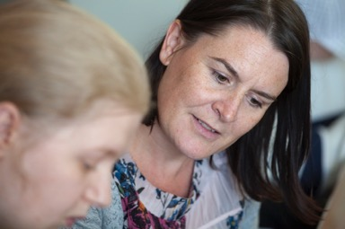

## Investing in AHPs: why is there a need for it

AHPs are core mental health practitioners whose knowledge and key skills enhance the quality and capacity of the mental health and learning disabilities workforce.

AHPs are registered practitioners and possess a wide area of expertise and some are dual trained in mental health, learning disability, and physical health (such as occupational therapists). In general, it takes AHPs up to three years to be trained up to registration level.

There is an aspiration to increase the availability of AHP careers in mental health, learning disabilities and autism services. This toolkit will support the development of new roles and ensure a holistic service for and with people and their carers.

AHPs are also the key to transforming health, care, and wellbeing as they work every day with people who are experiencing mental health difficulties or are diagnosed with a mental illness. Therefore, all AHPs also have skills that support the health and wellbeing of people experiencing challenges with their mental health.

Working at the top of their competencies and skills, AHPs lead mental health teams to new ways of working. Their expertise in rehabilitation and enablement is vital to the move away from over-reliance on hospitals and towards professional interventions across health and social care settings. They use their skills to provide assessments and interventions that are specifically aimed at improving a person’s mental health and working with people who have been diagnosed with a mental illness.

AHPs working in learning disability settings work alongside the individual and their support network to get to know their strengths and needs, to help prevent illness, and to ensure that the individual lives a full and active life in all aspects of their life, whether that is at home, in their social circles, at school, hospital or at work.

AHPs have a real opportunity for transformation and advancing practice development that will enhance the care offered for people with mental health, learning disabilities and autism and their families. However, AHPs are currently underutilised and are underrepresented in senior leadership positions. Investing in Chief Allied Health Professionals: Insights from Trust Executives Guide4 highlights many key benefits of investing in AHP leadership, such as early discharge, rapid response, user satisfaction, patient-reported outcome measures, and reduced length of stay. The AHP Strategy for England: AHPs Deliver also highlights how diverse AHP leadership can transform an organisation and system by focusing the engaged, productive and visible AHP workforce on trust, local authority and system priorities. By thinking differently about how leadership is developed and managed, systems and providers will maximise the contribution of the NHS’s third largest clinical workforce.



AHPs are the third largest workforce in the NHS, with over 4 million client contacts every week

Royal Society for Public Health, 2015

4 https://www.england.nhs.uk/wp-content/uploads/2021/08/investing-in-chief-ahp-leadership.pdf

## Examples of AHP skills:

AHPs work with people of all ages, from children to the elderly, and can work in and across areas of practice such as primary care, secondary care, community, hospital, and in people’s own homes. They work with people to improve their health and wellbeing. Some examples include:

The value of AHPs in mental health services: <https://youtu.be/2yYDTAHov5Y>

“Podiatrists play an important role in supporting people with a learning disability to remain active through enhancing and preserving mobility and lower limb health. Podiatrists support people with learning disabilities to reduce their risk of suffering from foot and lower limb complications.”

“Occupational therapists have the skills to support and enable, and promote the independence of, people who wish to develop their participation and achieve their life goals. They develop partnerships with others so people with learning disabilities can access universal services such as health, social care, education, work, and leisure opportunities.”

“Arts therapists (music therapists, art psychotherapists, dramatherapists) offer adults and children with learning disabilities access to psychological therapies that are not solely reliant upon verbal communication. Creative, interactive, sensory, and engaging approaches are used to assist people in expressing their thoughts and feelings in a safe, therapeutic environment.”

AHPs play a massive role in positive patient outcomes, such as:

* diagnosing and therapeutics in primary care,
* delivering rehabilitation and enabling recovery for and with people with serious mental illness,
* supporting people who are unable to express themselves verbally (e.g. art psychotherapy),
* habilitation to achieving everyday life goals (e.g. occupational therapy for people with learning disability),
* supporting people with managing sensory challenges.

AHP faculties have been developed around England in recent years to support workforce developments in Integrated Care Systems (ICS). Most ICS areas will have a chief AHP who will lead the AHP faculty locally, drawing in expert support and leadership from chief AHPs in NHS trusts and local authorities. The faculties will typically report to the local people board and be key to realising the potential of the AHP workforce in mental health, learning disabilities and other areas of practice.

The faculty structure is a great opportunity to inspire energy for action as well as momentum for development and change. Faculty members provide visibility of AHP workforce matters, can challenge the norm, and can offer expert advice and support to initiate and evaluate

new developments.

Health Education England has also developed support structures for AHPs in mental health and learning disabilities services in some regional areas. For example, a pioneering ‘Clinical Fellowship’ role in the southwest region has provided specific championship to AHP workforce developments, as well as developing leadership capacity for the future.

“Paramedics are involved with providing care to children and adults with learning disabilities in medical and trauma situations in a range of care settings. Paramedics are aware of the communications challenges when interacting with people with learning difficulties.”

“A dietitian can improve your health and lifestyle, but can also treat a range of conditions such as: diabetes, malnutrition including enteral feeding and dysphagia, food intolerances and allergy, weight management and gastrointestinal issues such as IBS.”

[The value of AHPs in mental health recovery- Martha's story:](https://www.youtube.com/watch?v=NW7dulxNDMc) <https://www.youtube.com/watch?v=NW7dulxNDMc>

## Working well together: example of Nurses and AHPs working together collaboratively

“As an Autism specialist nurse working in an eating disorder specialist inpatient hospital, I have the privilege of working with several AHPs including dietitians, art therapists, occupational therapists, and speech and language therapists.

“Each brings professionalism and expertise in their field, allowing a collaborative approach to this complex patient group. Often a co-morbid diagnosis of anorexia nervosa and autism is a gateway to lengthy inpatient stays and poor long-term outcomes but working as a multi-disciplinary team allows us to devise specialised dietary pathways based on clear sensory assessments.

“We utilise the same sensory assessments to ensure that naso-gastric feeding incidents are less traumatic, and that the environment is supportive of recovery. An understanding of communication difficulties and differences allows staff to communicate effectively and with sensitivity to the differences in communication required with this patient group. Taking a different approach to therapy, such as art therapy, can be less intrusive and more appropriate to the communication styles identified.

“Without a rich but balanced multidisciplinary team, inclusive of a range of AHPs, there would be a significant detrimental effect on the progress and recovery of this complex patient group. As a specialist nurse, I would be unable to complete my role with any significant efficacy. The AHPs I work with are equally as important as every other member of staff on the patient journey to recovery.”

James Harrison, ASD Lead Nurse

Ellern Mede Group

### Checklist

System leaders, commissioners, employers, and workforce planners who want to maximise the contribution of AHPs in mental health, learning disability and autism settings can refer to some of the suggestions below:

* Identify who the 14 AHPs in your mental health and learning disability services are,
* Find out if their skills and talents are being utilised to the best effect in your services,
* Understand the range of AHP skills and the contribution that they make to the management of mental health, learning disabilities and autism as part of the multi-professional team ,
* Review practical case studies which have examples to enhance outcomes and value-for-money,
* Collaborate with local [AHP faculty](https://future.nhs.uk/system/login?nextURL=%2Fconnect%2Eti%2FSeniorAHP%2Fview%3FobjectId%3D20343312) to facilitate system-wide working,
* Ensure that the AHP workforce is representative of the communities that are served and that development opportunities for colleagues from diverse backgrounds are encouraged and supported,
* Advance the education of your AHP workforce in identifying and supporting people with mental health, learning disability and autism,
* Collaborate with professional bodies to understand how each profession can deliver quality and effective services,
* Invest in AHP posts for new registrants and ensure robust preceptorship arrangements to maximise mental health practice,
* Be assured that AHP student placements in mental health and learning disability settings have been expanded in your locality.
* Enable AHP rotational posts across physical and mental health, primary and secondary care,
* Support development of advance practice and consultant level practice roles for AHPs in mental health and learning disability,
* Maximise the benefits of AHP practice for primary care,
* Support leadership development for AHPs in mental health and learning disability practice.

## Collection of case studies:

This section consists of a collection of case studies that shine a light on how AHPs are making a difference in mental health and learning disability settings.

These case studies showcase AHPs supporting wellbeing and recovery in mental health and may be useful for anyone who is involved in decision-making for mental health services – whether this be providers of services (including NHS, charity/third sector and local authorities) looking to innovate and become increasingly effective, or commissioners seeking to enhance outcomes and value-for-money for their mental health spend: <https://www.ahpnw.nhs.uk/media/1160/ahp_mental_health_case_studies_finalv2.pdf>

This quick guide showcases services that provide care to autistic people and people with learning disabilities, and has a wide range of impactful practices including improving people’s access to mainstream services, the strengthening of specialist services such as reducing autism diagnostic waiting times, and the designing of suitable housing. This document is useful for everyone who is looking to transform learning disability and autism services by utilising the AHP workforce: <https://www.ahpnw.nhs.uk/media/1169/ld_autism_case_study_collection_finalv3.pdf>

My role in tackling health inequalities: A framework for allied health professionals can be accessed here and provides many practical examples of the critical work AHPs are doing: <https://www.kingsfund.org.uk/publications/tackling-health-inequalities-framework-allied-health-professionals>

### Occupational therapists

Leading fulfilled lives: occupational therapy supporting people with learning disabilities:

<https://www.rcot.co.uk/file/3763/download?token=ddtSi1dz>

* Support community integration
* Improve and support mental health and wellbeing
* Positive patient outcome

RCOT has published series of small changes occupational therapists have made that have had a big impact on the people they support. There are many examples relating to mental health and learning disability services, which can be found here:

<https://www.rcot.co.uk/small-change-big-impact>

* Cost-saving
* Positive patient outcome
* Support community integration
* Improve and support mental health and wellbeing
* Practical recommendations

Getting my life back: occupational therapy promoting mental health and wellbeing:

<https://www.rcot.co.uk/sites/default/files/Getting-my-life-back_WalesENG.pdf#:~:text=Early%20access%20to%20the%20right%20support%20when%20people,good%20mental%20health%20and%20central%20to%20occupational%20therapy>

* Cost-saving
* Positive patient outcome
* Practical recommendations

Roots of recovery: Occupational therapy at the heart of health equity:

<https://www.rcot.co.uk/roots-recovery-occupational-therapy-heart-health-equity-6?hash=YEAqWDfFicAaEJoOfg5Gotn43Z9_Su8TraWguz-KaCE>

* Positive patient outcome
* Improve and support mental health and wellbeing
* Improve and establish health equity

Key messages for commissioners and service providers regarding occupational therapy evidence in mental health:

<https://www.rcot.co.uk/file/1805/download?token=dA7ez-G9>

* Cost-saving
* Positive patient outcome
* Improve and support mental health and wellbeing
* Practical recommendations

“Occupational therapists are a significant part of the mental health workforce in the UK. Approximately a third of all occupational therapists are embedded in statutory mental health services across the lifespan. By focusing on social justice, lived experience, access and joining up services, meaningful change can be created”

Vanessa Pinfold, 2021

### Dietitians

Eating Well for Adults with a Learning Disability – a dietitian-led training course for support workers in addressing the nutritional needs of the people they support:

<https://www.rsph.org.uk/static/uploaded/e72febf1-c8c5-4ee4-99b14e5d5dfa3850.pdf>

* Positive patient outcome
* Improve and support mental health and wellbeing
* Prevention and health promotion

Pages 8-9 of the Action from Learning Report, a result of LeDeR reviews into premature deaths of people with learning disabilities, provides a real-world example of the value of nutritional support, including dietitians sitting in specialist LD community teams, in improving patient outcomes:

<https://www.england.nhs.uk/wp-content/uploads/2020/07/Action-from-learning-report-2020-1.pdf>

* Prevention and health promotion
* Practical recommendations

### Speech and Language Therapists

Enabling adults with learning disabilities to understand their health recommendations:

<https://www.rsph.org.uk/static/uploaded/f95556c0-9d3f-4d4c-b06f6e8ec5b77b9c.pdf>

* Positive patient outcome
* Improve and support wellbeing
* Prevention and health promotion

Reducing the risk of negative health outcomes associated with dysphagia:

<https://link.hee.nhs.uk/mental-health-ahp>

* Positive patient outcome
* Prevention and health promotion
* Practical recommendations

“Social and environmental factors also influence communication, with many relying on the people they interact with. A key role for speech and language therapists is to develop others’ knowledge and expertise to provide meaningful interaction and make reasonable adjustments”

Dr Della Money  
Associate Director  
Allied Health Professionals  
Nottinghamshire Healthcare Foundation Trust

### Podiatrist

Inpatient case study highlighting how podiatrists can help patients improve both their physical and mental health:

<https://link.hee.nhs.uk/mental-health-podiatry>

* Positive patient outcome
* Prevention and health promotion
* Practical recommendations

A commentary on the role of podiatry in supporting mental wellbeing:

<https://link.hee.nhs.uk/mental-health-podiatry2>

* Positive patient outcome
* Improve and support mental health and wellbeing
* Practical recommendations
* Prevention and health promotion

### Physiotherapist

Collaborative cross-agency service delivery to address public health issues within an MSK setting: evaluation of the ‘Healthy Mind, Health Body’ project:

<https://www.rsph.org.uk/static/uploaded/1861ba53-cb2b-4283-bde53797112d57cd.pdf>

* Cost-saving
* Positive patient outcome
* Improve and support mental health and wellbeing
* Practical recommendations

“Specialist Learning disability physiotherapists make the adjustments required to provide successful physiotherapy to people with a learning disability that go beyond what is reasonable and for mainstream services”

Commissioning Mental Health Services: the contribution of physiotherapy to integrated services for health and wellbeing –

<https://cpmh.csp.org.uk/system/files/csp_mental_health_commision.pdf>

* Cost-saving
* Positive patient outcome
* Support community integration
* Improve and support mental health and wellbeing
* Practical recommendations
* Prevention and health promotion

Arts therapists (Art, drama and music therapist)

Building resilience: a pilot study of an art therapy and mindfulness group in a community learning disability team:

<https://link.hee.nhs.uk/mental-health-art>

* Positive patient outcome
* Improve and support mental health and wellbeing

Supporting recovery within and beyond mental health services: Arts therapy leadership activates creative resources which promote individual, team, and community growth:

<https://link.hee.nhs.uk/mental-health-art2>

* Positive patient outcome
* Support community integration
* Improve and support mental health and wellbeing
* Improve and establish health equity

Dramatherapy group for adults living with psychosis:

<https://www.nice.org.uk/sharedlearning/dramatherapy-group-for-adults-living-with-psychosis#results>

* Positive patient outcome
* Improve and support mental health and wellbeing

The Get Going Group: dramatherapy for people with learning disabilities and mental ill health

<https://www.researchgate.net/publication/270746759_The_Get_Going_Group_Dramatherapy_with_Adults_who_have_Learning_Disabilities_and_Mental_Health_Difficulties>

* Positive patient outcome
* Support community integration
* Improve and support mental health and wellbeing

“There are many ways that dramatherapy can support mental health. Currently we are not very embedded in the NICE guidelines, so other approaches such as CBT are often preferred to dramatherapy. This can impact on jobs and treatments offered. The British Association of Dramatherapists is proactively working to increase the evidence base, through case studies, posters and systematic reviews. Currently the NICE guidelines show treatments in a ranked order; it would be helpful if this ranking could be removed to reflect that different approaches work for different people.”

Amy Willshire

Acting vice chair – The British Association of Dramatherapists

### Conclusion:

The AHP agenda is massive for mental health, learning disability, and autism services. To significantly support the demands facing the NHS, investment in AHPs needs to be made now. Their skills need to be utilised, and collaborative working with medical and nursing colleagues should be encouraged.

We refer you to our checklist which can be used by system leaders, commissioners, employers, and workforce planners to maximise the contribution of AHPs in mental health, learning disability, and autism settings.

We encourage you to share this toolkit to promote the further deployment of AHPs into mental health, learning disability and autism settings as AHPs can lead health promotion, provide early intervention, deliver expert rehabilitation, tackle health inequalities, and support recovery.

“From the conversations, we have to support the Advanced Mental Health Community of Practice, AHPs appear to be an untapped resource. Part of this is the ongoing narrative that primarily focuses on the NHS as a place for doctors and nurses but the main block is a blind spot within operational and strategic management.

I do not think all employers know what AHPs can offer services across career levels, particularly within multi-professional advanced practice roles. The tendency is to think about medical substitution or widening current advanced nurse practitioner posts to include applications from AHPs, but without thinking about their unique contributions too.”

Dr Stephanie Tempest

Project Lead for the HEE Advanced Mental Health Community of Practice

## Acknowledgements

We would like to thank the following people for their contributions to this work: all the members of the HEE AHP in Mental health and Learning Disability Observatory:

Alison Bullock, Trust wide professional head of occupational therapy

Amy Daniels, AHP workforce lead

Anita Atwal, Associate professor in higher education

Anna Prygodzicz, Mental health programme lead across the Southeast

Brendan Stubbs, Physiotherapist

Carly Atkinson, Southwest region AHP clinical fellow for mental health, learning disabilities and autism

Carrie Biddle, AHP workforce director (Southwest)

Catherine Schofield, AHP lead

Christian Lee, Consultant eating disorders dietitian, Network associate director AHP

Claire Arditto, regional head of AHP Northeast & Yorkshire

Claire Moser, policy adviser

Claire Grant, Trust head of arts psychotherapy & operational lead arts psychotherapist, adult services

Clare Hubbard, Dramatherapy lead

Donvé Thompson-Boy Bromley, CMHRES manager/directorate lead occupational therapist

Dr Ursula, Rolfe mental health lead for college of paramedics, deputy head of department midwifery and health sciences, faculty simulation lead

Erin Byrd, Senior lecturer in sport and exercise science

Genevieve Smith, Professional adviser

Glenn Westrop, AHP lead

Helen Beaumont-Waters, Head of clinical development

Helen Lycett, Associate director for AHPs

Helen Marriott, AHP workforce director (Midlands)

Jane Moses, Southwest regional adv practice supervision and assessment lead for mental health, learning disability & autism, and occupational therapy

Jane Bourne, BADth vice chair

Jane Melton, National adviser: mental health

Janet Folland, Associate director for AHPs and professional lead for occupational therapy, North Cumbria locality

Jed Jerwood, Principal lead art psychotherapist for community services

arts psychotherapies service

Jess Rann, specialist eating disorders dietitian

Jo Brook, Perinatal mental health training and service development lead & London perinatal mental health clinical lead

Jonathan Booth, Music therapist

Julia Wilson, Strategic lead for AHPs

Karen Forbes, Workforce transformation lead (Midlands) UEC & transformation hub

Kathryn Moyse, Outcomes and informatics manager

Kawori Iguchi, Music therapist

Laura Akers, Advanced practitioner occupational therapist/professional lead for CMHT occupational therapists

Laura Leadsford, AHP workforce director (London)

Lawrence Ambrose, Head of policy & public affairs

Lucy Locks, Director of AHPs/clinical advisor – Southeast region advancing practice faculty

Mahdiyah Bandali, lead diversity

Naomi McVey, AHP workforce director (Northwest)

Paula Hedderly, Music therapist

Phoene Cave, Music therapist

Rebecca Tyrrell, AHP workforce director (Southeast)

Reena Patel, CSP education adviser

Sally Judges, AHP leads (East of England)

Samantha Mclver, Clinical lead physiotherapist & NIHR clinical academic intern

Sara Ennew, Regional head of AHPs (East of England)

Sharon Greenshill, Trust lead for mortality and suicide prevention and trust physiotherapy lead

Stephanie Tempest, Project lead for the HEE advanced mental health community of practice

Stephen Sanford, Music therapist

Suhailah Mohamed, AHP clinical fellow

Tina Judson, Lead occupational therapist/sensory integration practitioner

Toni King, Consultant occupational therapist trainee, mental health pathway

Victoria Apparicio, AHP workforce lead for HEE (Midlands) and speech and language therapist

We would also like to thank the following people for their contributions to this work:

Amy Hird, Clinical lead speech and language therapist

Claire Hubbard, Dramatherapy Lead

Dr Della Money, Associate director AHPs

Dr Tracy O’Regan, Professional officer clinical imaging and research at the Society and College of Radiographers

Dr Ursula Rolfe, Advanced paramedic prescriber

Genevieve Smyth, Professional adviser at Royal college of occupational therapists

James Harrison, ASD lead nurse

Jason Bourne, Senior arts psychotherapist

Kosiwa Lokosu, Occupational therapist

Marie Lancett, Workforce specialist - national learning disability & autism programme (London & South of England)

Melissa Reed, Consultant occupational therapist for recovery and inclusion

Nicki Power, Art therapist





## Contact:

### Health Education England

[www.hee.nhs.uk](http://www.hee.nhs.uk/)

<mailto:mentalhealth@hee.nhs.uk>

@NHS_HealthEdEng

[www.facebook.com/nhshee](http://www.facebook.com/nhshee)