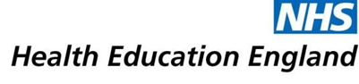

Alice Page - Nursing Assistant

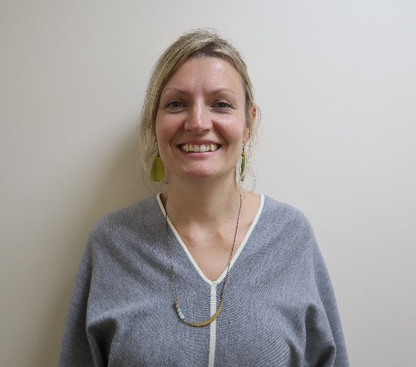

While working towards the Care Certificate I gained lots of new knowledge - I have always worked in jobs supporting people but never in the healthcare sector so there was lots of new information and understanding which I found really helpful.
I enjoyed learning about aspects of the role such as helping people with fluid and nutrition intake and I enjoyed learning from colleagues during my training. I especially valued learning how to do each task in a person-centred way, e.g. assisting patients with washing. I also learnt valuable knowledge like how to reduce the risk of pressure ulcers.
I think my Care Certificate will help me in the future especially as it is a nationally recognised. It will show people what my base level of skills and knowledge was when I started my Nursing Assistant role and illustrate my competencies.
I love my job as a Nursing Assistant on the Stroke Unit in the hospital. I love being with the patients and being able to offer them care and make a difference to their hospital experience and sense of wellbeing. I love working within a wide-ranging team and feeling as though we are all working towards a common goal. I genuinely see my role as a privilege - caring for people when they are at their most vulnerable and being able to offer them empathy and kindness. I can see myself doing this job for a long time.

