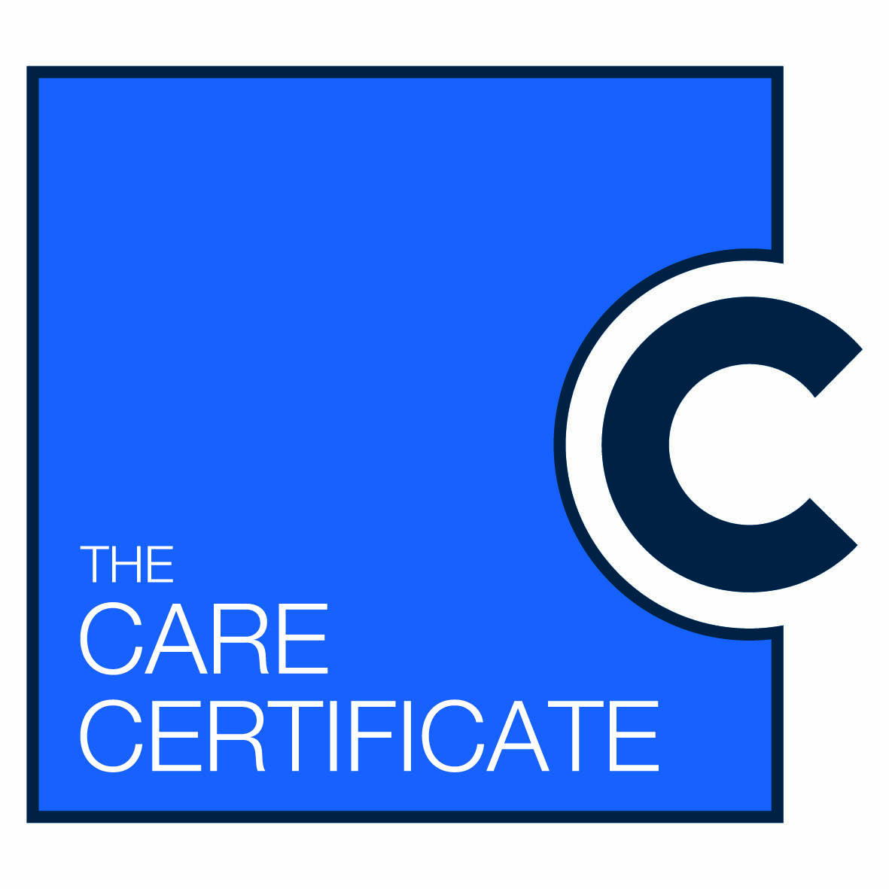
Care Certificate Assessor Guidelines
This is an optional guide for any type of assessor to help with planning to assess the Support Worker in achieving the Care Certificate. This may be customised by individual Employers
The Care Certificate is the start of the career journey for Support Workers and is only one element of training and education that will make them ready to practice within their workplace.
The assessment of the Care Certificate is part of people management and the induction period over 12 weeks. The assessment process has to be rigorous, as an assessor every opportunity should be taken to assess the support worker holistically when working alongside of them and supporting them in the workplace. All performance required to meet the standards must have knowledge demonstrated and be assessed.
National Guidance can be found here http://hee.nhs.uk/wp-content/blogs.dir/321/files/2015/01/Care-Certificate-Guidance-final-Feb-2015.pdf
If you need to refresh knowledge on assessing learners, the National Occupational Standard LSILADD09 - Assess learner achievement is the recommended standard to follow:
http://webarchive.nationalarchives.gov.uk/20110414152025/http:/www.lluk.org/standards-and-qualifications/standards/learning-and-development-national-occupational-standards/

Who can be an assessor for the learners who are undertaking the Care Certificate?
- All occupationally competent registered professionals (i.e. Matrons, Specialist Nurses Physiotherapists, OT’s, Doctors)
- Established experienced support workers in the future who have received training to assess in practice
- Need for Lead Assessor and Co-Assessors (similar format to Student Nurse Assessment)

How do assessors support the learners?
- Assessors should have protected time
- Working alongside and with the support workers try and follow shift pattern of their assessor
- Minimum of 3 hours of supervised working time per week (suggestion only – each Trust to formulate assessment plan for achievement)

Methods of Assessment
- Adopting the ‘student nurse’ PAD approach i.e. strict timeframes and mid-point meetings, action plans
- Self-reflection
- Observation in practice
- Oral discussions with Support Worker
- In classroom based training through tests and quizzes
How often should meetings with the learner take place?
- Initial start to introduce the Care Certificate and how it will be assessed, midpoint (6wks) and final (penultimate week) with informal discussions re. feedback in-between
- Assigning more time in relation to individual needs
- Ensure working together is factored in at all times not only around these key milestones
What should happen at these meetings?
- Review of progress
- Action planning (identifying strengths and weaknesses, objective setting)
- Trouble shooting
What should I do if a learner fails to complete the work?*
- Speak to learner
- Set action plan (using SMART)
- Review
- Discuss with lead Assessor involve L&D Team
- Effective Line Management and commence on Capability Process after discussing with HR

What should happen at the final meeting?
- Review progress and feedback to learner
- Identify any further development areas and future career aspirations
- Evaluate own performance and reflect on own practice
- Final sign off- explanation to learner of what this means and positively reinforce their achievement

*The learner must complete all 15 standards to be suitable to work in this frontline caring role. Completion of this should be specified on the Job Description & Person Specification. If the employer has a probationary period the Care Certificate will be a requirement to meet this, if no probationary period then a 3 month initial appraisal where performance and capability can be discussed.
Make yourself aware of the process your employer has in place.

