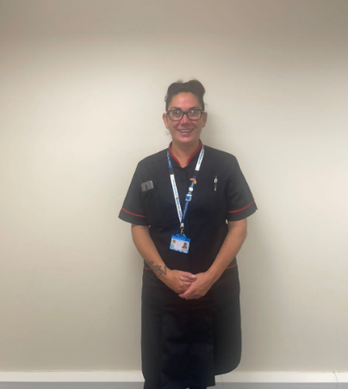
What is your current role and what does it involve?
I am an Associate Clinical Practice Educator. My role is to work closely with HCSW (Healthcare Support Worker) staff in clinical practice. Providing clinical support and education in their roles. Working closely with managers, directors, and other multi-disciplinary teams. Supporting staff through the care certificate. I provide pastoral support and advice when needed. And I provide peer support and training sessions to all HCSWs.
How did you get into your current role?
I got into the role through the trust I work for, I have always been keen to pass on my knowledge to others.
I am a qualified Assistant Practitioner, I was seconded to complete a 2-year Foundation Degree from the trust. I feel that this has given me the confidence to support others in practice.
What kind of support do you give to staff undertaking the care certificate?
I am part of the introduction to the care certificate; I am part of workshops that we do face to face around fluids and nutrition. I provide clinical and pastoral support, if needed, covering the standards and how the staff member can meet the standards. I provide support on completing the care in practice document.
What have been biggest successes?
My biggest success has been working with a cohort of 13 apprentices who I managed to get through the Care Certificate all together within 12 weeks, that was a massive achievement.
What have been your biggest challenges?
My biggest challenges have been trying to encourage established HCSW staff to complete the Care Certificate if they haven’t done so already.
How do you think the care certificate benefits the organisation?
The Care Certificate is very beneficial to the trust I work in. It gives the HCSW staff a greater understanding of the basic standards of care which is implemented in their day to day working life. This is seen in practice daily as all the HCSW staff in the trust provide a very high standard of care to the people within our communities.

