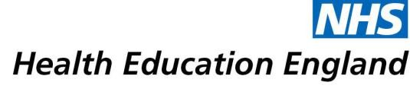

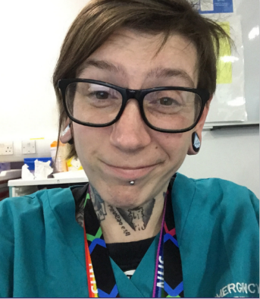

Clare Fowler – Registered Nurse Degree Apprentice and A and E Technician
What is your current role?
I am currently an RNDA / A&E Technician and in my final year of my nursing degree.
How did you get into your current role?
I started my career as a Phlebotomist after completing a phlebotomy training course.
Do you feel that completing the Care Certificate and HDA helped with your career progression?
Definitely, there has been such an overlap of skills that I learned on the Care Certificate and Higher Development Award (HDA) that have been essential and transferable to the nursing degree apprenticeship programme. The Care Certificate offered a great foundation and introduction to studying. The Higher Development Award built on that knowledge. I remember the leadership and management aspect of the course clearly and this really helped with my third year leadership and management essay. The study skills I learnt whilst doing the Higher Development Award have proved so valuable especially when it came to time management and balancing studying and working.

