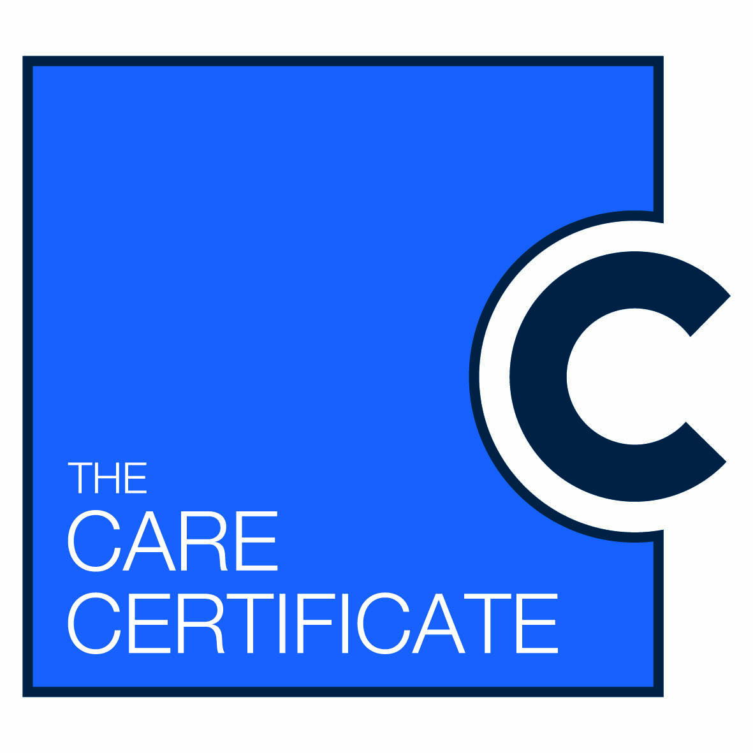
Care Certificate Communications/ Implementation plan

Action | Who | When | Status
Daily Noticeboard/electronic messages
Posters for staff/ward areas with names for contact
HENWL posters, leaflets and pocket guides
Intranet folder (internal access)
Internet (External access)
Multi –disciplinary meetings; on everyone’s agenda linking with timescales and Comms plan

Website story about Care Certificate – from a support worker and Assessor perspective
Desktop – info caption on desktop when first logging on
Electronic Patient record – reminder when logging on front page
Blog – written by HCA on the pilot and published on Trust website
Trust News/ or similar in house news letter

