Easy
Read

The Oliver McGowan Mandatory Training on Learning Disability and Autism
Answers to your questions

Contents
Introduction 4

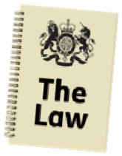About the law 6

About The Oliver McGowan Mandatory Training on Learning Disability and Autism 7

Getting the training 8

Information about the training 14

Getting involved 23

The Oliver McGowan Mandatory Training and other training 28

The law 32

For more information 41

In this Easy Read document, hard words are in bold. We explain what these words mean in the sentence after we have used them.

Some words are blue and underlined.

links
These are links that will go to another website which has more information.

Introduction

This is an easy read version of the most common questions from people about the new law and The Oliver McGowan Mandatory Training.

The Oliver McGowan Mandatory Training will be used to train all health and care staff on how to care for people with a learning disability and autistic people.

Learning disabilities and autism

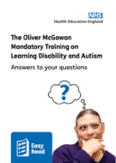The questions were last checked by Health Education England on 23 December 2022.

These questions will be useful to:
- People who look after training in health and care organisations
- People in charge of health and care services
- People who want to be trainers.

The questions give information about:
- The training
- How staff can get the training
- How people can get involved

About the law

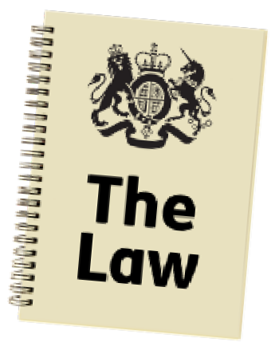The law says that all staff working in Care Quality Commission (CQC) regulated services should be trained in how to care for people with a learning disability and autistic people.

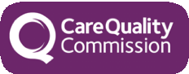The Care Quality Commission checks how good health and care services in England are, like hospitals and care homes.

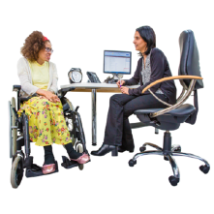Regulated means controlled or checked.
Regulated health or social care services are services that are controlled and checked by the Care Quality Commission.

About The Oliver McGowan Mandatory Training on Learning Disability and Autism

The Oliver McGowan Mandatory Training has been created by Health Education England, NHS England, Skills for Care, people with a learning disability and autistic people.

Oliver McGowan was a young man with autism and a learning disability. Oliver sadly died because staff who cared for him did not have the skills and knowledge to look after him.

The government says The Oliver McGowan Mandatory Training is very good training.

Getting the training

This section gives information for organisations and their staff.

How can staff get the training?
There are 2 parts to the training:
  - Training on the computer, called elearning. Everyone will need to do this.
People can do this now.

  - A training session with experts.

This might be 1 hour or 1 day, depending on how much training is needed.

You will be able to do this training from early 2023.

2023

Can health and care organisations use their own experts to give training to staff?
Yes, but they will need to be trained to give The Oliver McGowan Mandatory Training.

Organisations should work with
Integrated Care Boards to do this.
Integrated Care Boards are in charge of NHS services in your local area.

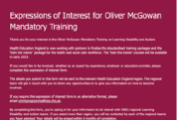Health and care organisations can find out more by filling out this form online:
expression of interest form

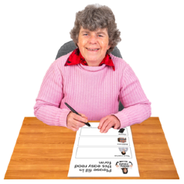An easy read version of the form is also available:
Click here for PDF version Click here for a Word version

Can health and care organisations give the elearning using their own computer system?
Yes, organisations can do this using a computer link to the elearning.

This is the only way to make sure the elearning is right.

If organisations need help to do this, they can email:
support@e-lfh.org.uk

Can everyone use the elearning?
The Oliver McGowan Mandatory Training is for everyone.

There are different ways to get The Oliver McGowan Mandatory Training elearning:

- NHS and care staff can use their work email address.

- Organisations can set it up for their staff.

- Organisations can include a link to it on their own computer systems.

link

- People can use an OpenAthens account to sign in - OpenAthens is a
way of signing into websites.

- People can use their own email address.

For support to get the elearning, email:
support@e-lfh.org.uk

Information about the training

This section is to answer questions from health and care employers and staff.

What does the training talk about?

Learning disabilities and autism
The training gives staff the skills to care for people with a learning disability and autistic people in the best way.

There are two levels of the training, called Tiers:
- Tier 1 is for anyone working in health and care.
It helps staff understand the care that autistic people and people with a learning disability need.

- 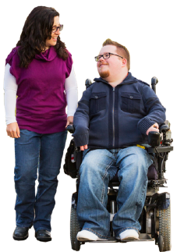Tier 2 is for staff who may give care to autistic people or people with a
learning disability.
It gives more detail about how to care for and support autistic people and people with a learning disability.

Tier 2 skills include:
- Not missing important illnesses.

- Knowing about health conditions that people with a learning
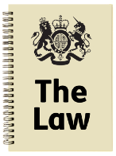disability and autistic people might have.

- Knowing about the law to do with caring for people with a learning
disability and autistic people.

- 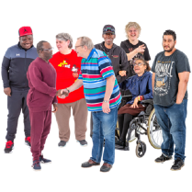Changes they can make to support people with a learning disability and

Change
autistic people.

- How they should behave.

- How to talk to people in a way that everyone can understand.

- 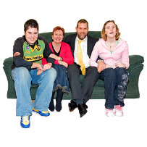How to understand what the person and their family are saying.

- Ask Listen Do - this is a project that supports health and care
organisations to learn from what autistic people, people with learning disabilities and their families and carers say.

- Learning from LeDeR - these are reports about people with a learning
disability and autistic people who have died.

- Checking people's health every year.

Some staff might need to know more.
Their organisations should make sure they get the training they need.

After people have done the elearning, when should they take part in a training session?
People should do the 2 parts of the training within a few days of each other.

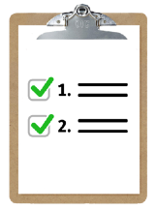If the training session is more than 6 months after the elearning, people will need to do the elearning again.
6

Staff must do both parts of the training.

People can watch the elearning again before their training session.

Why can staff do the elearning, but not the training session?

Today

The elearning is ready and useful for people now.

The elearning can help them understand learning disability and autism better.

It might also make people with a learning disability and autistic people want to be trainers for The Oliver McGowan Mandatory Training.
Training

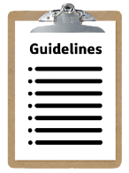How often should I do the training?
The government will write a Code of Practice for health and care services. A Code of Practice is a set of guidelines for how an organisation or service should work.

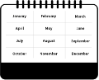The Code of Practice will say how often staff should do the training.
practice
Code of

The government will send out a draft
Change
practice
Code of
of the Code of Practice in 2023.
A draft means it is not finished and could be changed.

People will be able to tell the government what they think about the draft.

Will there be enough experts to give everyone training?

We think there will be more experts next year.

There will be chances for experts with lived experience of autism or learning disability to work as trainers.
Lived experience means that you know about it from your own life.

Will the training be part of the Core Skills Training Framework?
The Core Skills Training Framework are the skills that all health and care staff should have.

The Oliver McGowan Mandatory Training might become part of the Core Skills Training Framework.

Getting involved

This section answers questions from

- People with lived experience of learning disability and autism.

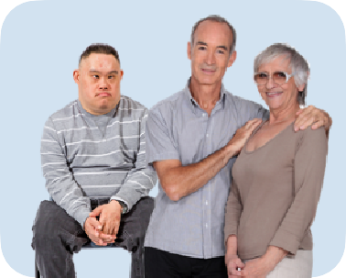 • Carers and families.
- Health and care organisations and staff.

Who can get involved in The Oliver McGowan Mandatory Training?

The training is given by 3 people.

There will be 2 trainers with lived experience:
- 1 autistic person
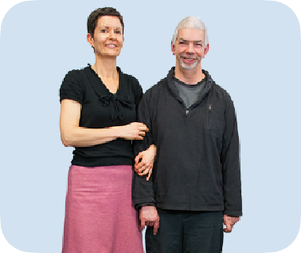
- 1 person with a learning disability

The trainers with lived experience can also have support workers or carers with them.

The third trainer will be called a facilitating trainer.

The facilitating trainer will have given training before and will know a lot about autism and learning disability.

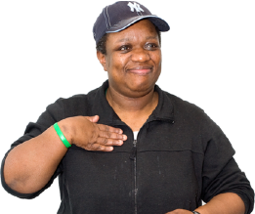The experts have to have lived experience of autism or learning disability.

Organisations will soon be looking for experts to work as trainers.

If you would like to be involved, you can fill in this form online: expression of interest form

Or you can fill in the easy read version of the form:
Click here for PDF version Click here for a Word version

How can training providers get involved?
Training providers are organisations that give training.

They should work with their local Integrated Care Boards to get involved.

If they are not already working with Integrated Care Boards, they can fill in this form to get involved:
expression of interest form

The Oliver McGowan Mandatory Training and other training

This section gives information for health and care organisations.

Can organisations use different training instead?
The law says that Care Quality Commission (CQC) regulated organisations must make sure their staff get training on learning disability and autism.

The government's Code of Practice will say what training health and care organisations should get.
practice
Code of

The government prefers The Oliver McGowan Mandatory Training.

It is recommended by Skills for Care, NHS England and Health Education England.

The CQC has given advice about how to train staff to support autistic people and people with a learning disability.

You can read what they said by following this link: www.cqc.org.uk/guidance-providers/ training-staff-support-autistic-people- and-people-learning-disability

Can my organisation use the Oliver's Story video?
Oliver's Story is a video about Oliver McGowan, told by his mother, Paula McGowan.

Organisations need to ask Paula McGowan if they want to use it.

Please can I use the Oliver’s Story video?

You can find out more on the Oliver's Campaign website: www.olivermcgowan.org

If my organisation is giving autism training for mental health services, do we also need to do this training?
The autism training for mental health services helps those organisations support autistic people using their services.

It talks about different things from this training.
Your organisation should do The Oliver McGowan Mandatory Training as well.

The law

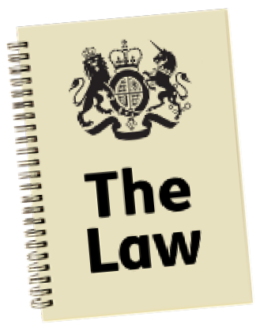This section answers questions sent in by lots of different people who want to know more about the law.

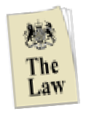What does the law say about training health and care staff on learning disability and autism?
The law says that all staff working in Care Quality Commission regulated health and care services must be trained on how to care for people with a learning disability and autistic people.
Practice
Code of

The government's Code of Practice will explain how training should be carried out and what health and care services need to do.

The Care Quality Commission has written statutory guidance. This will help health and care services know what they need to do now.

Statutory guidance explains how organisations can follow rules that say how good their work should be.

Who must have the training about learning disability and autism?
The training is for staff working in all Care Quality Commission regulated health or social care services in England.

These services will include services like care homes, dentists, GP surgeries and hospitals.

The sort of training that staff have will depends on what job they do.

But all staff should have training.

What will the Code of Practice say about learning disability and autism training?
The Code of Practice will explain:
- What should be in the training.

- How the training should be run.

- How services should check that the training is working.

When will the Code of Practice be available?
The government is still writing the Code of Practice for health and care services.

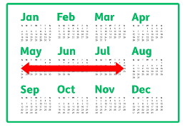After the Code of Practice is written, the government must ask everyone what they think of it.

What do you think?

This usually takes about 3 months.

The government will listen to what services and people have said and make some changes to the Code of Practice if needed.
Change

Then the Code of Practice will have to go to Parliament - this is where political parties meet to talk about making changes to laws.
Practice
Code of

Parliament will look at the Code of Practice. This takes at least 40 days.
Days
40

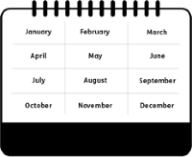It will probably take at least a year until Parliament has finished looking at the Code of Practice.

We expect the Code of Practice may be finished in June 2023, but it might take longer.
June 2023

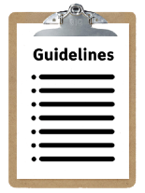For now, health and care services should follow the statutory guidance that has been written by the Care Quality Commission.

Statutory Guidance

Who will make sure health and care services train their staff on learning disability and autism?
The Care Quality Commission will check that staff are being trained on how to care for people with a learning disability and autistic people.

The Care Quality Commission checks the work of different regulated health and care services in England.

Do health and care services provide their staff with the right level of training for their job roles already?
Yes, all health and care staff have to complete training to do their jobs.

The law now says that staff must also have training on how to care for people with a learning disability and autistic people.

If a service is not regulated by the Care Quality Commission, does this mean their staff do not have to do the training?
The law says that services that ae regulated by the Care Quality Commission have to do the training.

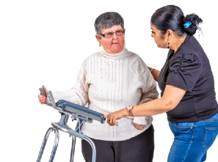But the government wants all health and care organisations to give their staff some training on how to care for autistic people and people with a learning disability.

This training should be the right level for their job.

Organisations that use The Oliver McGowan Mandatory Training will know that it is the right training and has been checked.

For more information

You can find out more about the Oliver McGowan Mandatory Training on the Health Education England website:
www.hee.nhs.uk/our-work/learning- disability/oliver-mcgowan- mandatory-training-learning- disability-autism

This Easy Read information has been produced by easy-read-online.co.uk

