Ellie McLoughlin - Health Care Assistant, Stockport NHS Foundation Trust

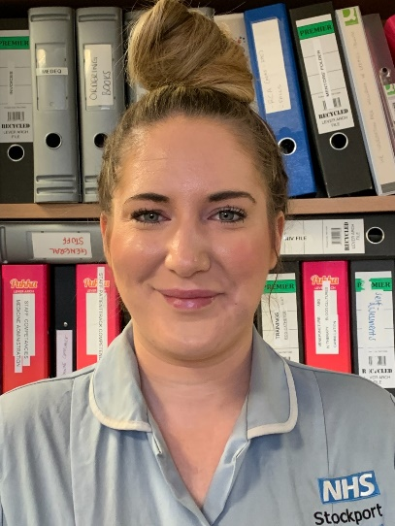

The Care Certificate has introduced the person centered approach which I think is such a great tool to us day to day in my role. I can feel myself being much more empathetic and patient with patients. It has also made me much more aware of my surroundings and what to look out for in vulnerable situations, not just with patients but with a work environment and to keep my eyes peeled for things that I see which don’t feel right.

Overall, the Care Certificate has and continues to make me feel more confident within my role and comfortable in speaking with my managers when I need to. It has been a fantastic base and learning tool.

