

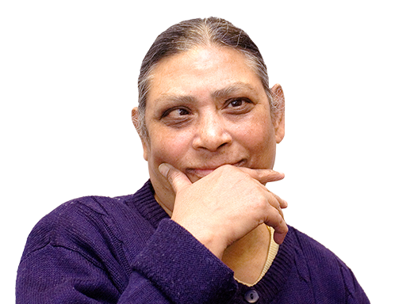
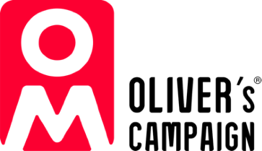
May 2024
Easy
Read

The Oliver McGowan Mandatory Training on Learning Disability and Autism

Answers to your questions

Easy Read

This is an Easy Read version of some information. It may not include all of the information but it will tell you about the important parts.

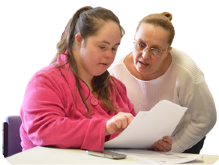
This Easy Read booklet uses easier words and pictures. Some people may still want help to read it.

Some words are in bold - this means the writing is thicker and darker.
Bold
words

These are important words in the booklet.

This word
means….

Sometimes if a bold word is hard to understand, we will explain what it means.



Blue and underlined words show links to websites and email addresses. You can click on these links on a computer.

links

What is in this booklet
About this booklet 4
About how to do Oliver’s Training 6
About what Oliver’s Training is about 21
About how organisations need to do Oliver’s Training 26
About how you can take part in giving Oliver’s Training 42
About other learning disability and autism training 49
About what the law says 52

About this booklet



This is an Easy Read version of questions about The Oliver McGowan Mandatory Training on Learning Disability and Autism.

Oliver’s Training is for all staff who work in health and care services.


The answers to the questions will tell you:
- How to do Oliver’s Training.


- How to take part in giving Oliver’s Training.

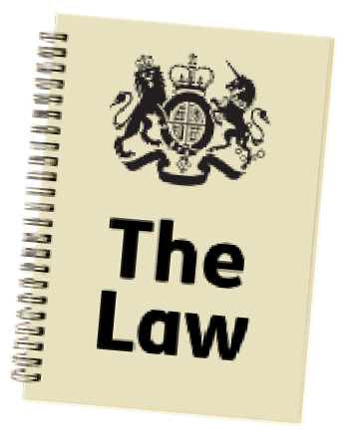
- What the law says about training.

The answers to the questions will also tell you:

- What the training is about.


- How organisations can do the training.

About how to do Oliver’s Training

Question 1. What is The Oliver McGowan Mandatory Training?
Oliver’s Training is the government’s preferred training that health and social care staff need to do to meet the law.


There are 2 levels of Oliver’s Training, called Tiers.
2
Tiers


Tier 1 is for staff who need to be aware of what autistic people and people with a learning disability might need.


Tier 2 is for staff who may give care and support to autistic people and people with a learning disability.


Each Tier has 2 parts.

2
parts



Part 1 is online learning - everyone needs to do the online learning.


Part 2 of Oliver’s Training is:

- A 1 hour online training session for Tier 1.


- A 1 day in person training day for Tier 2.



Autistic people and people with a learning disability will help to give Oliver’s Training in part 2.


Question 2: How do I do part 2 of Oliver’s Training?

If you are a staff member, please speak to your manager to find out.




If you are an employer who is deciding how to give your staff the part 2 training, you have some choices. You could:

- Give Oliver’s Training using trainers in your own organisation.



Remember that anyone giving Oliver’s Training will need to be trained themselves first and approved.

- Work together with organisations in your area to give Oliver’s Training.


Employers could also ask other people or organisations to come in and give Oliver’s Training for them. You can see a list online of approved trainers NHS England have said can do this: www.hee.nhs.uk/our-work/learning- disability/current-projects/oliver- mcgowan-mandatory-training- learning-disability-autism/training- providers-approved-trainers


Question 3: Can employers put the online part of Oliver’s Training on their own online learning systems?

Yes, but it has to be done in a certain way.


To find out how, please email support@e-lfh.org.uk

Question 4: Can everyone do the online training on the elearning for healthcare website?


Yes, anyone can do the online learning on this website, it is open to everyone.

If you need help with doing Oliver’s Training on the website, you can get support by:

- Emailing support@e-lfh.org.uk


Using the chat box on the website: www.e-lfh.org.uk/support
•


Question 5: How can my organisation see which staff have looked at the online learning?

It depends on how your staff are using the online learning.


You should be able to see who has done the online learning.

For help with this please email support@e-lfh.org.uk

Question 6: I have done the online learning but the system says I have not, what should I do?

You need to watch all of the videos fully for the system to record that you have finished them.

You can see how far you are through the learning by looking at the grey striped bar at the top of the screen.

If you click on the grey bar, a box will show on the right hand side of the screen. This will tell you which parts you still need to complete.

To save what you have done, you need to click the grey close button at the top right of the screen.
CLOSE


Question 7: Can my organisation give the online learning to a group of staff?

You can give the online learning to a group of staff.

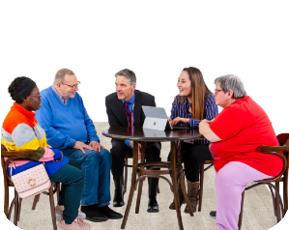
If you do this, you will need to treat it as a learning session with a trainer.
The group will talk to each other and think about Oliver’s Training together.

Organisations will need to record which staff have done part 1 of Oliver’s Training (the eLearning).

Record


Question 8: How can I find the online learning handbook?

It depends on what system you are doing Oliver’s Training on.

You can see the handbook on the elearning for healthcare website here: portal.e-lfh.org.uk/Component/ Details/781416

Once you click play, the handbook will download to your computer.

Play


If you are using another system, you will need to ask your learning team how to get the handbook.

Question 9: How can I get part 2 of Oliver’s Training from another training provider?


Only people who have been trained to give Oliver’s Training can be approved trainers.

You can see a list of approved trainers and training providers online at: www.hee.nhs.uk/our-work/learning- disability/current-projects/oliver- mcgowan-mandatory-training- learning-disability-autism/training- providers-approved-trainers

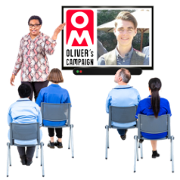
Question 10: How can I make sure Oliver’s Training from another provider is The Oliver McGowan Mandatory Training on Learning Disability and Autism?

Only trainers that we have trained can call their training “The Oliver McGowan Mandatory Training.”

You can see a list of approved trainers and training providers online at: www.hee.nhs.uk/our-work/learning- disability/current-projects/oliver- mcgowan-mandatory-training- learning-disability-autism/training- providers-approved-trainers

If you have any questions about trainers or training providers, you can email us:
england.ommt@nhs.net

Question 11: We are not an organisation that provides services that the CQC checks. Can we still do Oliver’s Training?




The CQC is the Care Quality Commission - an organisation that checks how good health and care services are.


The government wants all staff to get training about learning disability and autism.


All employers can use the online learning on the elearning for healthcare website for free.


Employers will need to give their staff part 2 of Oliver’s Training.

Part 2

They can contact approved training providers online at: www.hee.nhs.uk/ our-work/learning-disability/current- projects/oliver-mcgowan-mandatory- training-learning-disability-autism/ training-providers-approved-trainers


Question 12: If we do not provide health and care services, can we still do Oliver’s Training?

Oliver’s Training has been set up for health and care staff.


But staff in other jobs might find it helpful too.

While we are finding enough trainers to give part 2 of Oliver’s Training, we might need to give Oliver’s Training to health and care staff first.

First

Question 13: Can people outside the UK do Oliver’s Training?


Part 1 of Oliver’s Training is available online for anyone outside the UK. You can find it on this website: www.eintegrity.org

About what Oliver’s Training is about

Question 14: What does Oliver’s Training tell people about?


Oliver’s Training tells people about what they need to know to support autistic people and people with a learning disability.


The different parts of Oliver’s Training will tell staff what they need to know in the jobs that they do, like how to talk and listen to people.

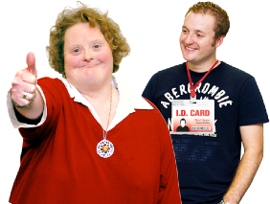
Staff who support autistic people and people with a learning disability should do Tier 2 of Oliver’s Training which gives more information about how to support them.


Question 15: Will Oliver’s Training be added to or changed over time?

Yes. NHS England will check that Oliver’s Training is still correct and good for staff, and they will add any new information that will be helpful.


Question 16: How will Oliver’s Training be checked to see if it is good?

NHS England are looking for an organisation that can say that trainers are giving Oliver’s Training correctly.



Until then, they are working with other organisations to:
Training

- Train the trainers.


- Make sure Oliver’s Training is good.


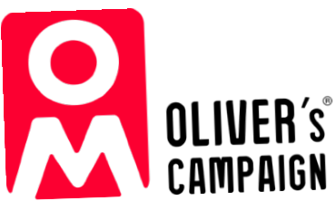
Question 17: How can Oliver’s Training be suitable for all staff in health and care workplaces?

Oliver’s Training tells all health and care staff about learning disability and autism.
Learning
disability
and
autism

This will be suitable for all health and care staff.



Trainers may match different case studies and information in Oliver’s Training to suit different staff and organisations.



Case studies are real life stories used to learn how things happen and what to do.

My Story



Question 18: Will Oliver’s Training be part of the Core Skills Training Framework?

The Core Skills Training Framework is a list of the main skills that all health staff need to know.


The Core Skills Training Framework is being checked to see if anything else should be included.


The Oliver McGowan Mandatory Training is being checked to see if it should be part of the Core Skills Training Framework.


Question 19: Has Oliver’s Training been checked to see if it works?

3

The government tested Oliver’s Training out with 3 training providers in 2021.


We used what we learned from the tests to improve Oliver’s Training.

Improve

The National Institute for Health and Care Research is finding an organisation to check how well Oliver’s Training is working.

About how organisations need to do Oliver’s Training

Question 20: How much does Oliver’s Training cost?

Free

The part 1 online learning is free for everyone in the UK.



The part 2 training will cost some money.


How much it costs depends on how employers give Oliver’s Training.


They might choose to give Oliver’s Training themselves or use a different training provider.

Question 21: How long will it take to train all staff?

Employers will need to plan a way for all staff to get Oliver’s Training.


They will need to think about the best way to do this for their own organisation.


For large organisations, it might take up to 3 years to train all of their staff.
3

Question 22: How do I know which Tier of training I need, or my staff need?

Tier 1

Tier 1 is for staff who need some general understanding about autism and learning disability.

Tier 2 is for staff who will support or care for autistic people or people with a learning disability.

Tier 2

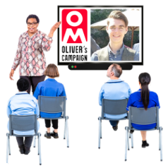
Some staff may need extra training on top of Tier 2 to do their job.

Extra

Employers can find more guidance about what Tiers staff should do online at:
www.hee.nhs.uk/our-work/learning- disability/current-projects/oliver- mcgowan-mandatory-training- learning-disability-autism/employer- resources

Question 23: I support or care for autistic people or people with a learning disability and I have done training already. Why do I need to do Oliver’s Training too?

The Oliver McGowan Mandatory Training is a standard training that everyone will do.


This is important so we know everyone understands the same things.

Staff working in learning disability or autism services might need to do extra training too.

Extra

Question 24: My organisation does not provide services for autistic people or people with a learning disability. What training do my staff need to do?


The law says that all organisations that are checked by the Care Quality Commission (CQC) must do learning disability and autism training.

Employers can use our guide to find out what training their staff need here:
www.hee.nhs.uk/our-work/learning- disability/current-projects/oliver- mcgowan-mandatory-training- learning-disability-autism/employer- resources

Question 25: Who is in charge of making sure that agency staff do Oliver’s Training?


Agency staff are not employed by any health and care organisations. They work for an agency that provides extra staff to work in health and care organisations when they are needed.



Employers are in charge of making sure the staff working for them do Oliver’s Training.


Organisations and agencies need to work together to make sure that all agency staff have done Oliver’s Training.


Question 26: Do volunteers need to do Oliver’s Training?

Volunteers are people who give their time for free to help out.


Employers need to make sure that everyone working in their organisation has the right training to do their job, including volunteers.

We think everyone should do Oliver’s Training if it is suitable for their job.


Question 27: How soon after doing part 1 of Oliver’s Training should I do part 2?

It is best if you do part 2 no more than a few days after doing
part 1.



This is because you need to know things from part 1 to do part 2.
Part 1


If it has been a while since you did part 1, we think it is best if you play the part 1 videos again to remind yourself what they said.

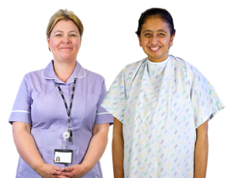
Question 28: Why was the online learning shared before most people could do the part 2 training?

We shared the online learning as soon as it was ready because it can help staff work better now.


The online learning might also help autistic people and people with a learning disability want to take part in becoming a trainer.

Training?

Question 29: How often should people do Oliver’s Training?


Oliver’s Training has been made to be taken every 3 years, or sooner if
3
needed.

Question 30: Will there be enough trainers to train everyone?

More

We need more trainers who are autistic or have a learning disability.


Becoming a trainer might help people to:

- Get more skills.


- Have a job that works for them.


There is information to help employers train people with a learning disability and autistic people to become trainers.


Question 31: What do autistic people or people with a learning disability get paid to help Oliver’s Training?

Same

Trainers for Oliver’s Training should get the same pay as any other trainer doing the same job.


It is up to employers to give fair pay to these trainers.
Fair
pay


You can see an example of what is involved with the job and how much pay trainers should get on our website:
www.hee.nhs.uk/our-work/learning- disability/current-projects/oliver- mcgowan-mandatory-training- learning-disability-autism/employer- resources


Question 32: Are there any descriptions of what a trainer should do in their job?

We have examples of these, please see the link above in question 31.


Question 33: Can I give this training in my own organisation with my own trainers?

Approved

Yes, but all trainers will need to be approved to give The Oliver McGowan Mandatory Training.

You can find out more about this on our website:
www.hee.nhs.uk/our-work/learning- disability/current-projects/oliver- mcgowan-mandatory-training- learning-disability-autism

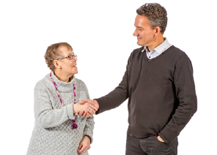
Question 34: Do autistic trainers or trainers with a learning disability need to work full time?

We expect employers to support what these trainers want and need.


We expect some trainers will work part time, but some may want full time work.

Part time

Question 35: How can I find and support autistic trainers or trainers with a learning disability?


Employers will need to make applying for these jobs accessible - that means making changes to support people’s needs.



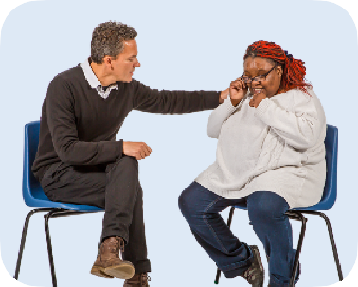
Employers must think looking after people’s feelings as well as helping them to do their jobs.


You can find out more about how to do this on the employer resource website at: https://www.hee.nhs.uk/our-work/ learning-disability/current-projects/ oliver-mcgowan-mandatory-training- learning-disability-autism

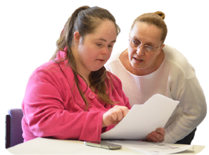
We have worked on trainer training to make sure that trainers are supported to help give Oliver’s Training to others.


Question 36: Can a trainer give the Tier 2 training online, or must they be in the room to give Oliver’s Training?

Tier 2 training is done in the same room as staff, face to face.



We found that worked best when we tested out Oliver’s Training.



Question 37: What if the autistic trainer or trainer with a learning disability is ill and cannot help give Oliver’s Training?

Training providers and organisations will need to deal with staff being ill in the same way they usually do with any other staff.


Oliver’s Training is always given by a trainer with a learning disability and an autistic trainer.


Question 38: Can children or young people help give Oliver’s Training?

This may be suitable sometimes, like when Oliver’s Training is being given to staff in children’s services.


Employers can work with young people in the way that their organisation usually does.

Question 39: What happens if I move to a new job?

Same

The Oliver McGowan Mandatory Training is the same in all places of work.


This means you do not need to do Oliver’s Training again if you move jobs.

Staff should keep a record to show they have done Oliver’s training.

Record

About how you can take part in giving Oliver’s Training


Question 40: I am someone who is autistic or has a learning disability. Can I be part of giving Oliver’s Training?

Yes, we need people like you to help give Oliver’s Training.


To find out where you can take part:

- Look out for organisations that are looking for trainers.


- Contact your local Oliver McGowan team.


You can also go to this website to find your local Oliver McGowan team: www.hee.nhs.uk/our-work/learning- disability/current-projects/oliver- mcgowan-mandatory-training- learning-disability-autism/express- interest-olivers-training


Question 41: Can I volunteer to give Oliver’s Training, instead of being paid?

We want as many people as possible to become trainers for Oliver’s Training.



Volunteers can help with Oliver’s Training.



Employers cannot discriminate by using people who volunteer instead of trainers.

Discriminate means treating someone better or worse than others because of who they are.
Better
Worse


Volunteering can still impact benefits. You can find out more about volunteering if you get benefits on this website: www.gov.uk/guidance/volunteering- and-claiming-benefits


Question 42: I am a carer or family member of someone who is autistic or has a learning disability. Can I take part in giving Oliver’s Training?

Yes, you can take part as trainers or supporters of other trainers.


But you cannot take the place of a trainer who is autistic or has a learning disability if you are not autistic or do not have a learning disability.



Question 43: How can training providers take part in giving Oliver’s Training?

Training providers that understand how to train people about learning disability and autism can take part.

Training providers can use the contact details on this website to say that they would like to take part: www.hee.nhs.uk/our-work/learning- disability/current-projects/oliver- mcgowan-mandatory-training- learning-disability-autism/express- interest-olivers-training



Question 44: I have told you that I want to take part in giving Oliver’s Training, when will I hear from you?

Many organisations are still planning how they give Oliver’s Training.


It might take a bit of time before they start looking for people to be trainers.


Please do not worry if you have not heard anything yet.

You can check that you have sent your correct contact details to us by using the contact details on this website: www.hee.nhs.uk/our-work/learning- disability/current-projects/oliver- mcgowan-mandatory-training- learning-disability-autism/express- interest-olivers-training

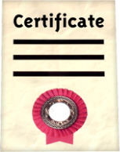
Question 45: I have finished the trainer training but I have not got my certificate yet. Can I start giving Oliver’s Training to others?

It is important to wait for your certificate and trainer number before you start training others.


Your employer will be able to check online that you are an Oliver McGowan Trainer.


Question 46: How long does it take to get the certificate after finishing the trainer training?
14

The NHS will send a letter within 14 days after the trainer training is complete.


The letter will ask you to fill in a form with your details.


Once the NHS has got your form back, they will send you your certificate and trainer number.

It may take another 14 days but the team will try to send out the letter to you in less time than this.

Less

Question 47: How can we support The Oliver McGowan Mandatory Training?


We want to work with other organisations to let health and care staff know about The Oliver McGowan’s Mandatory Training.

We will share an employer’s pack soon, with ways they can tell staff about The Oliver McGowan Mandatory Training.

Employer’s pack

About other learning disability and autism training

Question 48: Can employers use different training about autism and learning disability instead of The Oliver McGowan Mandatory Training?
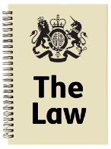
Employers will need to show the Care Quality Commission (CQC) how they have followed the law, which might include doing The Oliver McGowan Mandatory Training.

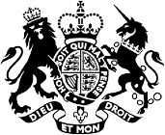

The Oliver McGowan Mandatory Training is what the government prefers employers to use.


You can find out more about this on the CQC’s website: www.cqc.org.uk/guidance-providers/ training-staff-support-autistic-people- and-people-learning-disability


Question 49: Can we use our own online learning and then do part 2 of The Oliver McGowan’s Mandatory Training?

No, you cannot.

The Oliver McGowan Mandatory Training includes doing the online learning, which all health and care staff need to do.


Question 50: Can my organisation use the Oliver’s Story video in our own training?

No, you cannot.


The video can only be used as part of The Oliver McGowan Mandatory Training.

Question 51: How does The Oliver McGowan Mandatory Training link with other training in the NHS?


The Oliver McGowan Mandatory Training has been made to give all staff an understanding of autism and learning disability.


The Oliver McGowan Mandatory Training will make sure all health and care staff understand the same things.

Same


Other training on autism and learning disability should be used to give more information on top of The Oliver McGowan’s Mandatory Training.

More


The extra training may come from lots of different places.

About what the law says

Question 52: What does the law say about what training staff need to do on autism and learning disability?

The law says that every person working in CQC regulated services should get training on autism and learning disability, that is suitable for their job.

Same

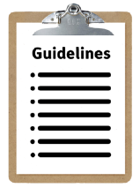
The government is working on guidelines for how organisations can follow this law. The guidelines will be called the Oliver McGowan Code of Practice.


You can see more about the guidelines on this website: www.gov.uk/government/ consultations/oliver-mcgowan-draft- code-of-practice

Question 53: Which organisations need to train their staff by law?

Any organisation that is checked by the Care Quality Commission (CQC) needs to train its staff on autism and learning disability.


This includes staff who are part of the organisation but work in an office and not directly with people using health and social care services.

There is guidance from the CQC about this on their website: www.cqc.org.uk/guidance-providers/ regulations/regulation-18- staffing#guidance

Question 54: What will the Oliver McGowan Code of Practice say about following the law?

The guidelines will explain how organisations can follow the law about training their staff.

It will explain:

- What training on learning disability and autism should be about.


- How it should be done.

- How to check that staff understand the training.


Question 55: When will the government share the Code of Practice with the public?
What do you think?

The government has asked people what they think of the Code of Practice.


They are now looking at what people said about the Code of Practice.


You can find out more about when the Code of Practice will be shared on the government’s website: www.gov.uk/government/ consultations/oliver-mcgowan-draft- code-of-practice

Question 56: How will organisations be checked to see if they are training their staff?

The Care Quality Commission (CQC) checks that organisations are training their staff in the right way.



The CQC will look into any organisations that it thinks are not training staff in the right way.


Question 57: Did providers have to make sure that staff had the right training before this new law came in?

Yes, they had to make sure staff had the right training to do their job.





But the new law says that all staff should get training on autism and learning disability.


Organisations might not have given training on this before, but now they have to.

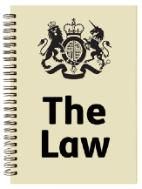
Question 58: If an organisation is not checked by the CQC, do their staff have to do Oliver’s Training?

The law does not say that these staff have to do Oliver’s Training.

But the government would like all health and care organisations to give their staff training on learning disability and autism.
All staff


Some health and care services that are not checked by the CQC have already done Oliver’s Training. All organisations can take part in Oliver’s Training.

This Easy Read booklet was produced by easy-read-online.co.uk
The booklet includes images licensed from Photosymbols & Shutterstock.

