Diagnostic Radiographer (Integrated Degree) (Level 6) Apprenticeship Completion – Case Study

Gill Kite
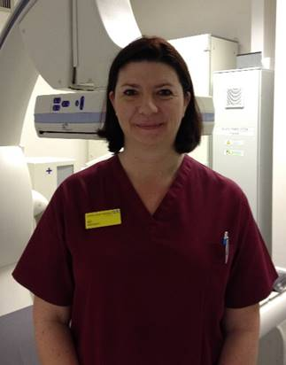

Superintendent Radiographer, Royal Devon University Healthcare NHS Foundation Trust; Northern Services, NDDH

Why is it important to have Degree Apprentices?
Radiographer recruitment has been challenging for several years now and more departments have needed to think creatively about their workforce and how we provide the service. The Diagnostic Radiographer Apprenticeship came along at just the right time, and we were very appreciative that the University of Exeter took this on where other HEI’s wouldn’t initially, due to financial implications.

We had support workers who wanted to train to be radiographers, who we happily wanted to support to upskill, however due to family commitments they would not have been able to train to be a radiographer via the traditional undergraduate route, and so the apprenticeship has been perfect.

Our first radiographer apprentices started at the start of the pandemic in March 2020, which probably wasn’t the most ideal time to start a course. However, they were very enthusiastic and soon became very useful members of the imaging team; there were weeks during 2021 where our imaging service would have been compromised had we not had the apprentices bolstering the radiographic workforce. Our first three apprentices qualified in March 2023 and already it’s easy to see they will be confident, professional, and very competent radiographers from the outset.

It’s important that we have given this opportunity to our existing staff as retention has also been an issue in the past, however our apprentices have firm roots in the area, are very thankful for the opportunity and so are more likely to remain in our employment.

We have also recruited externally to apprentice roles in subsequent years, this has become a very competitive process, as it’s such a good opportunity for the area, with lots of applicants and the calibre of applicants is always high; our main problem being not enough posts to offer and difficult decisions to make between preferred candidates.

How do you accommodate Degree Apprentices, in addition to ‘traditional’ undergraduate radiography students on placement?

We were very conscious that there might be some difficulties having both undergraduates and apprentices at different levels in the department. However, one of the first things that we did was re-brand them all as ‘Diagnostic Radiography Learners’, giving them a separate learners rota so they were all on the same rota, getting the same amount of experience and working the same shift patterns.

We also set up weekly combined clinical supervision sessions which have been a great success as they have been able to learn so much from, and support each other, especially now we have a full mix of all three years studying in the department.

Are there any challenges for the clinical workplace?

There have been challenges, such as the amount of assessments that need to be completed, with increased learners, and only a certain number of available assessors in the department, especially where staffing levels have been difficult; however, we have faced those challenges together and because the learners have felt supported they have been happy to reschedule assessments knowing that we will get them done before the end of their placement or end of required modules. We have also increased the number of trained assessors for both undergraduates and apprentices.

The Apprentices have found the remote learning and workload challenging at times, but again we have faced that challenge together and supported them when they have needed extra time, academic help, guidance, or time to contact the university for more specific guidance.

Ensuring that they have pastoral support in the department has been essential making sure that there is always someone available should they need it. It’s been important to make sure that the apprentices take their annual leave and have important downtime rather than keep working and studying without break; we found that the first-year apprentices seem to be afraid they would miss something important if they took time off, however this has been easier to manage as the apprentices relax more through the later years of their apprenticeship and something we look out for now in the first years ensuring they book leave at regular intervals.

What are the benefits of the Degree Apprentice route?

The benefit for the department has been high, not only have we been able to upskill staff who were at a level that they were unable to go any further in the department and so job satisfaction was low, we have also managed to bolster the imaging service significantly.

It has also benefitted other staff in the department as the support staff have seen that there are interesting options for future progression, and it has provided CPD opportunities and new skills for radiographers who have become SOAP assessors, mentors, supervisors, and trainers.

It has highlighted radiography in the trust and community as our apprentices have actively participated in the national apprentice week activities within the trust and career day talks with school and college students; we have never had so many requests for information about becoming a radiographer and work experience as we have now which can only be a good thing for the future work force.

It has given the individuals just the career boost that they needed and a wonderful opportunity to train to become a registered professional whilst being paid, have the benefits of employment, be able to live and study at home and have a relatively normal family life.

