Pre-employment management platform Discovery
Health Education England

Version: 1.0
Recipients: Rachel Wright, Oli.Colbourne-Laight and Megan Wright - Health Education England
Authors: Adam Spencer, Dr John Gribbin and Rico Farina - Lagom Strategy
Issued: 16 December 2022

Contents
Contents
1 Discovery overview
1.1 Executive summary
1.2 Discovery phase goals
1.3 The scope of the Discovery
1.4 Project team
1.5 Discovery phase activities
1.6 Key associated documents
1.7 Background to this Discovery
1.8 Overview / method
2 Findings
2.1 Defining the problem and scope
2.2 Context
2.3 User experience
2.4 Fairness and equity of access
3 Validating user needs
3.1 Analysis method and outputs
4 Concept development
4.1 Overview
4.2 Concept feedback summary
5 Landscape analysis
5.1 Lincolnshire Talent Academy
5.2 Digital Marketplace
5.3 Get School Experience
6 Inclusivity and accessibility assessment
6.1 Digital skills
6.2 Connectivity
6.3 Accessibility
7 Recommendations
7.1 Context for the recommendations
7.2 Overarching recommendations
7.3 Steps towards a pre-employment service
7.4 Technical recommendations
7.5 Service management and governance
7.6 Suggested roadmap
Annex 1: Discovery research
Annex 2: Discovery outputs
Annex 3: Surveys

1 Discovery overview

1.1 Executive summary
This Discovery was conducted by Lagom Strategy and between October and December 2022.
The Discovery focussed on building upon previous research to determine if having a pre-employment management service would meet the needs of young learners, providers and coordinators of pre-employment opportunities.
The research activities were conducted in line with the definition and guidance of a digital service Discovery phase mandated by the Government’s Digital Service Service Manual..
Publicly funded digital services are subject to such a Discovery phase before proceeding to the next phase of technical development and design, and passing subsequent service assessments.
The Discovery has concluded with a prioritised user needs backlog and a set of recommendations for Health Education England (HEE) to consider.

The context for the recommendations
- There are assumptions surrounding the effectiveness of pre-employment activities
- Some pre-employment processes are unfair
- There is an administrative burden involved in facilitating pre-employment activity
- There are a multitude of local systems operating in this space
- Stakeholders see overlap with other ongoing initiatives
- A pre-employment service alone won’t solve systemic issues

Overarching recommendations
- Be clear about the specific problem(s) that you are trying to solve
- Understand the pre-employment space in more detail
- Break the service down into manageable parts
- Proceed with the pursuit of an application tracking system
- Agreed the scope of a minimum viable product (MVP)
- Develop a roadmap for the service

Steps towards a pre-employment service
- Aim for a service capable of facilitating a strategic journey through pre-employment opportunities
- Differentiate between finite and infinite opportunities
- Adopt a set of overarching principles that underpin the service
- Work closely with Health Careers to create the optimal journey for young learners
- Place data at the heart of the service design

Technical recommendations
- Technology options analysis
- Meet minimum viable product functionality with an application tracking system
- Explore simpler tools to achieve functionality not supported by an application tracking system

Service management and governance
- Decide where service ownership should sit within the organisation
- Select a product manager and ensure they have capacity to deliver the next phase of work
- Prepare for the communications challenge
- Create and enforce standards for the new service
- Create national policy around the fair distribution of pre-employment opportunities
- Develop KPIs to measure the performance of the service

Suggested roadmap
- Prepare for an Alpha
- (Cautiously) proceed to Alpha

1.2 Discovery phase goals
At the start of the Discovery we used the kick off workshop to prioritise a set of goals to explore in the Discovery:
- Build on previous work and fully understand the context
- Better understand how young learners/attendees access pre-employment opportunities, and how pre-employment providers/coordinators promote and process them
- Quantify the scale and nature of pre-employment opportunities that a digital service would need to support
- Better understand how to solve the whole problem for users, and to ensure the NHS gets most value from providing pre-employment opportunities
- Validate the user needs
- Validate that a platform service will be ‘fair, equitable, transparent and consistent’ and ‘reduce workload and improve data collection and monitoring’
- Assess development options for a pre-employment management platform that meets priority user needs
- Develop a clear plan to progress the service, and build consensus

1.3 The scope of the Discovery
The scope of the Discovery was limited to pre-employment opportunities for young learners aged between 14-18 years old who were in school, college or not in education, employment or training (NEET).
The Discovery included participants who had not yet undertaken work experience and who did not have family or friends already working within healthcare.
The original scope of the Discovery was to focus on the whole pre-employment service journey. Work on the Discovery revealed that the current landscape is made up of several elements including marketing and promotion, applying for opportunities, processing applications, and the work experience delivery itself.
The findings and recommendations in this report are largely based on marketing and promoting opportunities, applying for opportunities and processing applications.
The Discovery phase has been extended to allow time to undertake further research into online pre-employment learning content to confidently articulate the user needs for this element of a service.

1.4 Project team

Discovery team
- Dr John Gribbin, Service designer
- Adam Spencer, Lead user researcher
- Dr Hannah Fletcher-Poole, Support user researcher
- Rico Farina, Technical architect
- Victoria Garnett, Senior delivery manager
- Rachel Wright, National Programme Manager, Widening Access and Participation team
- Katie Adams, Head of Widening Access and Participation team
- Megan Wright, National Senior Programme Officer - Volunteering Unit - Talent for Care
- Oli Colbourne-Laight, Technical Digital Architect & National Programme Manager - Volunteering

1.5 Discovery phase activities
The Discovery was conducted between October and December 2022.
These activities allowed us to generate the insights and recommendations in this report and the other Discovery outputs:
- Kick off workshop with key project stakeholders.
- Reviewed 18 online and documentary sources.
- Conducted 11 stakeholder interviews.
- Conducted 28 one-to-one user interviews.
- Analysis of a user experience survey for providers and coordinators with 50 responses.
- Analysis of 3 user needs survey for providers, teachers and young learners with 149 responses in total.
- Ran a user needs workshop with 1 user representative and ran 4 1-2-1 user needs sessions.
- Developed 6 user proto-personas.
- Created and prioritised 89 user needs with the Widening Access and Participation team.
- Presented a project findings and recommendations show-and-tell.
- Performed a landscape analysis.
- Ran a co-design workshop with 1 user along with 3 1-2-1 co-design user sessions.
- Developed a set of concept prototypes and tested these with 9 users.

1.5.1 User research participation levels
Participation from young learners and teachers/careers advisors across all research activities was to a satisfactory level required for a robust Discovery.
The number of providers that volunteered to participate in research activities was also satisfactory.
However, it is worth noting that provider engagement was not as significant as anticipated at the beginning of the project. The cause of this is unclear, however there is some evidence of inconsistencies in the way that HEE regions cascaded communications about this Discovery.
It is important to consider the Discovery as the start and not the end of ongoing user research.

1.6 Key associated documents
- Proto-persona profiles
- User needs backlog
- Concept prototypes
- Service blueprint
Note: all project documentation has been gathered and shared. A full list of outputs is available in Annex 2.

1.7 Background to this Discovery
In 2020, HEE undertook research to explore the NHS work experience landscape, and this resulted in The HEE Future of HealthCare Work Experience: Research Report (2021). That Discovery made several recommendations for improving NHS work experience and recommended that HEE pursues the development of an end-to-end digital service to coordinate work experience.
The 2021 report was not specific as to the user needs of a centralised web based pre-employment management platform. Therefore the HEE Widening Access and Participation Team required a Discovery to understand the needs of young learners and their support networks, when accessing pre-employment opportunities, work experience and work-related learning in the NHS.
The team also wanted to understand the needs of providers and coordinators who would be advertising and promoting pre-employment opportunities through such a service.

1.8 Overview / method

1.8.1 Stakeholder overview
We conducted semi-structured interviews with stakeholders to ensure that their needs and views were understood and accounted for in the research process.
We completed 11 interviews with stakeholders, including ​speaking to the Health Careers Product Owner and other key stakeholders across digital roles in Health Education England.
We also engaged with HEE people in strategic roles, for example directors and deputy directors.
Our analysis of stakeholder perspectives is presented alongside our analysis from the user research in the findings section of this report (Section 2).
The stakeholder interviews took place in October 2022 and November 2022.
See Annex 1 for a full list of participants.

1.8.2 User research
We conducted 28 semi-structured one to one interviews with a range of participants including:
- 18 young learners across England, aged between 14 and 18, who were either in school or college, in part-time employment or not in employment, education or training (NEET)
- 10 providers of pre-employment opportunities across a range of trusts
- 6 people from young learners support networks such as parents, teachers and careers advisors

Qualitative research
- 28 one-to-one interviews
- User workshop with 1 user participant
- 4 user experience one-to-one sessions
- Co-design workshop with 2 user participants
- 3 user co-design one-to-one sessions
- 10 concept feedback sessions

Quantitative research
- 149 respondents to the online user needs validation survey
- 50 respondents to an online provider experience survey

1.8.3 User roles
Our research addressed the following user roles, as defined in a user research planning call at the inception of the Discovery:
- Young learners aged between 14 and 18
- Co-ordinators and providers of pre-employment opportunities
- Young learners support networks including parents, teachers and careers advisors

1.8.4 Prioritising the user needs backlog
A user need is something that a person has to get done.
This need is present regardless of any existing products or services in place that they might have to interact with.
User needs are written using the syntax below:
As a... [the type of person/role that the user is]
I need to… [the task that the user wants to do]
So that... [the end goal that the user wants to reach]
The HEE team were invited to a session to prioritise the user needs on 15 November 2022.
The team used research evidence to inform their initial round of prioritisation of user needs using the MoSCoW (Must, Should, Could, or Won’t) method.
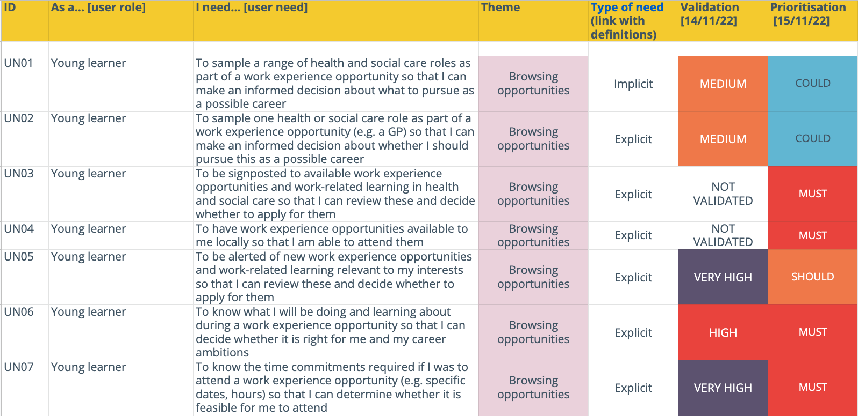
Image: Screenshot from the backlog of prioritised user needs. The backlog is available as an output.

1.8.5 Service blueprint
A service blueprint describes a hypothetical, optimal journey through a service.
It is not restricted by the boundaries of the current service and represents an ideal that a new service can aim towards.
For this Discovery, we created a blueprint based on an end-to-end journey for a young learner, through the following phases of a ‘find work experience’ service:
- Awareness of potential careers
- Considering a career
- Searching and applying to pre-employment opportunities
- Pre-attendance activities
- Attending an opportunity
- Post-attendance activities
- Post-qualification activities
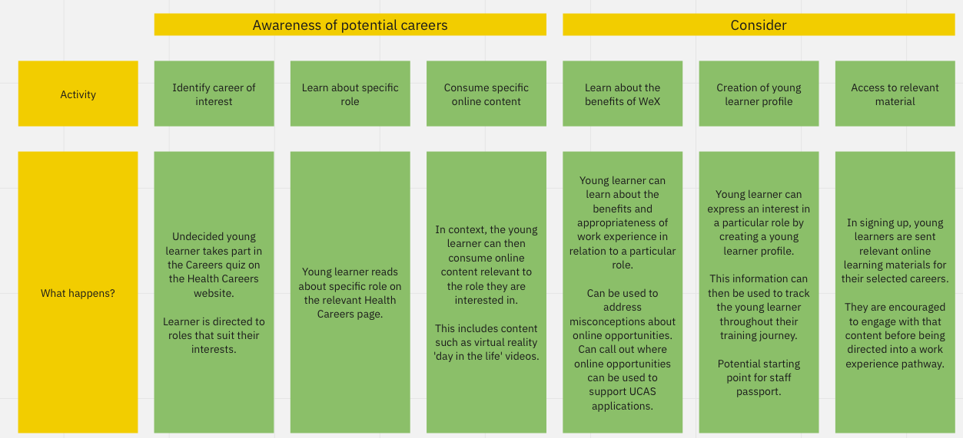
Image: A partial screenshot of the completed service blueprint.

2 Findings

2.1 Defining the problem and scope

2.1.1 Stakeholders articulate a range of problems that they hope a platform will solve
There is little consensus about the specific problem that this work is seeking to address.
Most of the problems that we have heard are a subset of a national challenge surrounding the capacity of the health and care workforce.
Some stakeholders have suggested that this challenge is the core problem that this work is trying to address.
“There is a huge push to get people into healthcare roles because the workforce is lacking numbers, therefore something needs to be done.” Stakeholder
“The work is being framed as something that will drive a future workforce.” Stakeholder
“The problem is about access to opportunities, but it is also about the desperate need to grow the workforce because there are constantly insufficient numbers of staff.” Stakeholder
Others have suggested similarly large national problems that this work is trying to solve, including reducing staff turnover, improving diversity of the workforce and improving future workforce planning.
“The turnover of staff is an issue, in part because people aren’t told about the realities of jobs.” Stakeholder
“There is also a responsibility to adequately prepare young people for a career in the NHS. People should get the opportunity to test out what they want to do and step foot in a placement before they sign up to a self funded degree for three years.” Stakeholder
“The other problem is how can we attract and engage a hidden talent pool. NHS diversity figures need to improve so that the NHS better reflects the communities that we serve.” Stakeholder
“There is also a need to increase and diversify the workforce, particularly in areas where there are huge amounts of inequality.” Stakeholder
“Nationally, there are issues around workforce planning. Seeing where the level of interest is in particular roles is helpful to detect trends. It is also important to map these trends against the needs of the future workforce.” Stakeholder
As well as recognising national problems, we have also heard reflections on problems that are specific to pre-employment.
Notably there were suggestions that the platform approach is attempting to resolve a lack of in-person work experience placements.
“There is a need for consistency across the country in terms of how work experience is delivered. It’s a postcode lottery at the moment in terms of what is available to a young person and that’s unfair. A more consistent national approach is needed.” Stakeholder
Stakeholders also discussed problems relating to awareness of existing opportunities, as well as awareness of the full range of roles available across the NHS.
“From a student perspective, access to real world industry placements is an issue. This includes knowing where placements are and engaging with them.” Stakeholder
“There is a significant challenge around promoting careers in schools so that young people have a view of wider careers that are available in the NHS, beyond being a nurse or doctor.” Stakeholder
“There is also a challenge in that young people do not understand the range of opportunities that are available in the NHS.” Stakeholder
For other stakeholders, this work is attempting to improve fairness and equity of access to opportunities.
“Currently, all pre-employment work is devolved to regions. This means that there is no equity of service and it varies based on region. Some are more successful than others.” Stakeholder
“The issue is that there is a need for end-to-end digital services to coordinate pre-employment activity. There are pockets of this happening at the moment on smaller platforms, which are in use at the local level. This is an opportunity to have one standard approach for everyone to access.” Stakeholder
“The problem we are trying to solve is the disparity of opportunity across the country for young people to engage with work experience.” Stakeholder
“There is a lot of nepotism in the NHS, the goal is to widen access and participation for marginalised and disadvantaged groups who don’t have connections in the NHS to see what it is like to work in the NHS.” Stakeholder
Finally, the problem has been expressed as a challenge of maximising economies of scale and creating consistency across existing digital processes.
“The role of the national team is to maximise economies of scale and make sure that there is no duplication.” Stakeholder
“The option is to allow this to happen 260 times across the country at a significant cost, or 42 times by ICS’, or 7 times at the regional level, or once nationally.” Stakeholder
“There needs to be consistency across the board in terms of the digital tools that are facilitating this process. At the very least there needs to be compliance with NHS service design standards.” Stakeholder
“The issue is that there is a need for end-to-end digital services to coordinate pre-employment activity. There are pockets of this happening at the moment on smaller platforms, which are in use at the local level. This is an opportunity to have one standard approach for everyone to access.” Stakeholder

2.1.2 There are some concerns surrounding the scale and scope of these problems
Some stakeholders have expressed caution when discussing the problem space surrounding this work.
In particular, some stakeholders were keen to stress the dangers of creating a digital platform without sufficiently giving thought to the underpinning large scale strategic issues.
“Some kind of platform and supporting strategy will be needed. IT on its own without the supporting strategy will be useless.” Stakeholder
Interestingly, this was echoed by users who highlight that making opportunities easier to access might only succeed in increasing demand for limited opportunities even further.
“It might not help for employers because they might see an increase in requests because everyone’s going to that one place and we’re promoting it.” Pre-employment opportunity provider
Stakeholders with digital product experience were also keen to express caution about the size and scope of this work.
“You can’t solve the whole problem from the outset and it feels like pre-employment is trying to solve too big a problem.” Stakeholder

2.1.3 Stakeholders reflected differently on the perceived scope of a pre-employment platform
Most stakeholders view work experience as the most important component of any future platform. Previous work has focused on work experience exclusively.
“Stakeholder engagement was carried out to better understand the landscape of work experience. A National Work Experience network was created to help manage this work, the network now has 460+ people on there, mostly NHS employers.” Stakeholder
We have also heard strong arguments for including T-levels in any such platform, and in some cases stakeholders have even suggested prioritising them over other opportunities.
“This provides a convincing argument to focus on T-levels over other elements of pre-employment. The way that industry placements are approached for T-levels could influence work experience or other industry placements.” Stakeholder
Most stakeholders identified volunteering as out of scope for any future platform, however some stressed that volunteering is closely related to pre-employment.
“Volunteering should be outside the scope of this work, but it is likely to come up in conversations. Some people might do work experience and then go on to volunteering or the other way around.” Stakeholder
Apprenticeships also fall under the definition of pre-employment, however stakeholders stress that any potential platform does not need to include apprenticeships within its scope.
“This work shouldn’t include apprenticeships because support for these is already well established.” Stakeholder
2.1.4 The potential end-to-end journey of a pre-employment platform also represents a significant scope
Whilst pre-employment itself represents a large scope of activity, the proposed journey through a pre-employment platform is also significant.
Taking a person interested in a NHS career from applications to opportunities through to online learning elements is a sizeable service. For some, this scope is too big.
“A service that includes a learning management system makes it more difficult to launch. Putting this into one Discovery and scope is a challenge.” Stakeholder
“The learning management system and the application element makes it sound like a hybrid of two things.” Stakeholder

2.1.4 Stakeholders have reflected on the inclusion of social care in this scope of this service
Almost unanimously, stakeholders suggested that social care should be included in this work.
“Including social care is important. Amending the Care Certificate to be more transferable between health and care might be central to this. The goal is to create an interchangeable group of people thinking about roles across health and care” Stakeholder
“Social care should be included in something like this. Social care is bigger and the problem is bigger as a result. At ICB level, conversations are about delivering interventions in health and care.” Stakeholder
“Containing social care is a good thing. From an end user point of view, getting work experience to support a job application doesn’t really matter if that experience is in health or social care.” Stakeholder
This research has also heard limited anecdotal evidence that social care is facing similar challenges in the pre-employment space, however further research would need to be carried out to confidently confirm this.
“There is no visibility of work experience across the [social care] sector. People will only be able to find out about opportunities through connections.” Stakeholder

2.2 Context

2.2.1 Stakeholders are fairly clear about what pre-employment encompasses
We heard consistent definitions of the term ‘pre-employment’ from stakeholders. Amongst these definitions was a focus on young learners, but also a recognition that it is not exclusively about opportunities for young learners.
“People who are considering options relating to health and care careers. It could be young people coming into their career or career changers. It could also include work placements, work experience, school taster days from Year 10 upwards, as well as work based schemes such as traineeships and apprenticeships.” Stakeholder
“Pre-employment should include people who are armed forces leavers, prison leavers, people looking at retraining. It is an opportunity that you create for someone who is transitioning from a much different life than they might have had before.” Stakeholder
It is also clear that a mixture of activities are used to deliver pre-employment opportunities. Notably, these can be delivered through online or offline channels.
“It could be online work related learning from a webinar or face-to-face careers events or work experience opportunities.” Stakeholder

2.2.2 The term pre-employment is poorly understood by young learners and support networks
Although there appears to be consensus within HEE about a definition of pre-employment, it is a term that is not well understood by young learners or teachers.
“Pre-employment? I don’t know what that means, I’ve never heard of that before.” Young learner
“Pre-employment? I’ve never heard of that but I guess it’s a trial to see if you’re fit for a job or not?” Young learner
“Pre-employment? What is that? Like getting employed? It sounds like training to guarantee you a place.” Young learner
“We don’t ever see that phrase in any literature that I’ve ever seen related to work experience.” Careers advisor

2.2.3 The current scale of pre-employment activity is significant and difficult to quantify
Historical data has shown that there have been approximately 20-25k pre-employment activities (online or in-person) delivered annually, dating back to 2017.
Whilst this minimum figure is known, there is little granularity to suggest the nature of these pre-employment opportunities.
Upcoming Widening Access and Participation data collection in 2023 will go some way to addressing the lack of data in this space.
It is worth noting, however, that the breadth of these opportunities is particularly large. Taking into account factors such as type of opportunity, region, time duration, discipline and delivery method highlights that there are comfortably thousands of combinations of pre-employment activity happening across the NHS.
Each opportunity will have a person who is responsible for it. At some level these people will need to be engaged throughout the progression of this work.

2.2.4 Stakeholders desire both national consistency and local innovation
We have heard a desire from stakeholders to achieve national consistency and standardisation in the way that pre-employment opportunities are advertised to young learners.
“There needs to be consistency across the board in terms of the digital tools that are facilitating this process. At the very least there needs to be compliance with NHS service design standards.” Stakeholder
“The approach may be to say that if someone is looking for work experience in the NHS, their expectation is to have the same look and feel as the rest of the NHS to provide a level of trust that the experience isn’t completely different.” Stakeholder
Contrastingly, stakeholders have simultaneously been keen to highlight the importance of local initiatives in this space.
“It is important to build on the expertise of people who have these systems in place at the moment. A lot of learning has already happened in this space.” Stakeholder
“Lots of things start off locally and that isn’t a bad thing. Often that is where innovation happens.” Stakeholder

2.2.5 There is a wide landscape of existing initiatives that overlap with this work
Throughout our research, several existing and past initiatives and teams have been mentioned, both across HEE and the wider NHS landscape.
These initiatives have been talked about as things that the HEE project team could learn from, integrate with or build on going forward.

2.2.5.1 HEE National Website Platform
“It might be moving towards some sort of centralised hub on the [HEE] National Website Platform. Either as a pre-employment hub or a natural extension of Health Careers.” Stakeholder
“Integrations between an applications management service and the NWP will be important, you don’t want applicants to be jumping around between different websites.” Stakeholder
“This will also have to fit into the National Website Platform. There also needs to be a link with Health Careers.” Stakeholder

2.2.5.2 Health Careers Website
“NHS Health Careers is usually the first place where people will go online to find out about careers in the NHS so it is logical that people will be looking on there to find out about work experience and have questions.” Stakeholder
“The other element of the work is how this fits into the journey of Health Careers and feeds into other opportunities for people. That whole journey needs to be considered as part of this piece of work.” Stakeholder

2.2.5.3 National Volunteering Platform
“NHS Volunteering is an ongoing strand of work in this space. It is a national platform that is in Alpha at the moment. People use NHS Jobs to advertise volunteering at the moment but it’s not a good fit. This work is looking at a dedicated space to advertise these opportunities.” Stakeholder
“The national volunteering platform is potentially serving similar needs to work experience and pre-employment.” Stakeholder

2.2.5.4 Digital Staff Passports
“The sensible approach might be to build this service onto the work that has already been done through staff passports.” Stakeholder
“On the NHS England level there are schemes such as staff passports and ePortfolios. There is an important question to consider, which is: are work experience students considered to be staff or not?” Stakeholder

2.2.5.5 Technology Enhanced Learning (TEL)
“[The] Learning Hub might not have the capability to do it but eLearning for Healthcare might. eLearning for Healthcare is a siloed system however, which might make an end-to-end journey difficult.” Stakeholder
“TEL has that team currently supporting the Learning Hub. In the future, there is a need to understand where this element of any work will sit. It makes sense for this to sit within the TEL team and take a partnership approach.” Stakeholder

2.2.5.6 NHS Jobs
“It is likely that this kind of [pre-employment opportunities] platform doesn’t exist at the moment, however NHS Jobs is achieving some of these objectives. So questions will be asked about whether work experience and volunteering should fall under the remit of NHS Jobs.” Stakeholder
“If NHS jobs can do it that would be a big box ticked; it makes sense to do it there rather than procuring something else.” Stakeholder

2.2.5.7 Adult Social Care Jobs Board
Adult Social Care Jobs Board was also mentioned, although it is worth noting this work didn’t progress beyond an Alpha phase.
“Adult Social Care jobs board was another area of similar work. A Discovery was carried out and an Alpha phase.” Stakeholder

2.2.6 Stakeholders have reflected on the potential ownership of this type of service
Most of the stakeholders we engaged with suggested that the Widening Access and Participation team should be responsible for this service.
“The ownership should sit with the Widening Access and Participation team. Their remit is about growing the appeal of working within the NHS. This does seem to fit within that scope of work.” Stakeholder
“Within HEE, the responsibility for work experience sits with the Widening Access and Participation team, who work closely with Health Careers.” Stakeholder
We did also hear views that ownership should be more collaborative, involving Widening Access and Participation, but also other teams across HEE.
“Responsibility for this suite of work is also important, there is a massive overlap between Health Careers, TEL and Widening Access and Participation. It should be a collaborative approach across these departments so some partnership would be important.” Stakeholder
Outside of the Widening Access and Participation team, other views on the ownership of the work significantly increased in seniority, ranging from the Executive Team within HEE up to the Department for Health and Social Care.
“Ownership needs to sit with the Exec Team. The Director and SRO leads nursing and midwifery, as well as Talent for Care. This looks at widening access and participation, but also technical reform, so T-levels and apprenticeships. Volunteering is under this remit as well. This is a useful place for this work to sit because the exec director has the key view over all of these areas.” Stakeholder
“This should sit with DHSC because the national recruitment campaign is owned there. Things are disparate at the moment because there aren’t many national bodies that can host a thing like this.” Stakeholder

2.2.7 The merger with NHS England is causing uncertainty
Stakeholders have highlighted a broad sense of uncertainty that is brought about by the current merger.
Interestingly, some have reflected that the merger is making it difficult to understand the appetite for this work at the senior level of the organisation. This is perhaps underpinned by the difficulties in engaging senior stakeholders as part of the interview process in this Discovery research.
“Currently the merger is ongoing and HEE is becoming part of a bigger organisation. It’s impossible to say what the appetite is for this service in the future state, however there is no evidence to suggest that there isn’t an appetite for this.” Stakeholder
“The merger is presenting challenges as senior stakeholders are taking on multiple roles. It's a challenging time so it’s hard to determine if people are just busy with the merger or people are displaying a lack of appetite for this work.” Stakeholder

2.2.8 Data around work experience is lacking, although there are plans to address this
This Discovery has highlighted a lack of data around work experience. Stakeholders recognise that this makes it difficult to track people after they have engaged with pre-employment activities.
“It is difficult to track young people after work experience. Often they go off to do A-levels and university so the follow through between Year 10 and 12 is clunky.” Stakeholder
“It is a struggle to know where staff go once they are qualified. There is also a lack of intelligence about the impact of work experience on factors such as retention longer term.” Stakeholder
“Destination data is really interesting because no one has it. If a 16 year old does work experience, and that inspires them to get a job in the NHS after going to university, no one can tell you about that journey.” Stakeholder
Interestingly, stakeholders also have ambitions that centre around better data collection in this space.
“A goal of the project should be to say how many people started in roles because of pre-employment activities.” Stakeholder
“Opening the service to the Staff Passport service means that it would be possible to track people from work experience to their first job application, where they’d already be registered. This is helpful from the employer perspective as they could see that someone had work experience, alongside potentially how well someone has performed.” Stakeholder

2.3 User experience

2.3.1 There are a range of systems in use to coordinate pre-employment activities
Some providers discussed the use of a website to promote pre-employment opportunities for young learners.
“Young people come to our front-facing website. There’s a section there on work experience which gives our open and shut times for applications.” Pre-employment opportunity provider
11 out of 61 survey respondents to our provider experience survey mentioned a website as part of the tools to coordinate pre-employment opportunities.
13 out of 61 survey respondents referred to a bespoke system of some sort, e.g. a website to promote opportunities or a more comprehensive platform for processing applications.
“Bespoke-developed automated application form and placement tool.” Pre-employment opportunity provider
Providers also discussed the use of NHS Jobs and Trac for promoting some opportunities and processing applications.
While some providers mentioned SurveyMonkey and Google Forms, 33 providers discussed using MS Forms as an application form for young learners to complete online.
Other tools mentioned included Mentimeter, Canva, Eventbrite, different social media platforms and video-calling tools including Zoom and Microsoft Teams.
Some young learners and careers advisors also discussed the tools being used in schools and colleges to help coordinate work experience and careers-related learning.
This included Springpod, as a platform for careers guidance and work experience, but also Unifrog which helps to reduce the administrative burden for schools and colleges.
“With Unifrog, you record it but also the employer and the parent or guardian gets a letter. It’s the full process. We’re hoping it will reduce the workload that can go into some of the in-person placements.” Careers advisor
The majority of providers who responded to our experience survey (55 of 61) discussed the use of spreadsheets to help with their administration of pre-employment opportunities.
“I log every request on a spreadsheet and we look at those and work out which ones we can facilitate.” Pre-employment opportunity provider
And also for reporting purposes.
“It’s just a spreadsheet. It’s not even Access. It’s not that complicated. We don’t even use PowerBI or anything like that. We just use a pivot table to tell us this many were white, this many were female, this many were under 19. Whatever they ask us for, I can pull it out from that.” Pre-employment opportunity provider
The dominance of spreadsheets and Microsoft tools is likely a reaction to the fact that these are perceived as ‘free’ tools, because they are already paid for at an organisational level.
“We’ve got Office 365 which I don’t have to pay for at a department level. Everyone in our organisation has got access so we must have an organisational licence.” Pre-employment opportunity provider
Additionally, most of the providers we interviewed indicated that they have limited funding available to them to help their administration of pre-employment activities.
“Do I have a dedicated annual allowance added to my budget? No. If I didn’t income-generate, we wouldn’t have anything which itself is problematic but is just a reality in my trust.” Pre-employment opportunity provider
“Virtual is something I’ve been considering, but the costs involved with that are prohibitive for the trust. We’re looking at ways we can finance that.” Pre-employment opportunity provider
The stages and processes involved with procurement are also a barrier for them to bring about change in tools.
“Finance is the biggest hurdle. At the moment, we have no budgets. If we want funding, we have to bid into pots - so we’d go to places like HEE for that but a lot of that is one-off funding, so it’s making that sustainable and how do we fund that year-on-year.” Pre-employment opportunity provider
“If I had to go internally, cap in hand, it takes ages. It takes a really long time. If you stick at it, you’ll get there, but it’s onerous and I have to write in triplicate why it’s a good idea.” Pre-employment opportunity provider

2.3.2 There are issues around capacity and resourcing when coordinating pre-employment opportunities
Most providers discussed working in small teams or, in some cases, by themselves when managing opportunities.
"It’s just me that manages work experience.”
Pre-employment opportunity provider
32 of 61 survey respondents indicated that their teams consist of three or fewer staff members.
43 of the same 61 survey respondents scored their level of burden as 5 out of 10 or higher when planning, promoting and/or managing pre-employment opportunities.
For some, this limited resourcing means they are unable to process the volume of young learner applications they receive.
“There’s just me. [...] I could definitely do with more people.” Pre-employment opportunity provider
“In the period from September when we opened, we had so many applications that we had to close within a week because we were just swamped with requests.” Pre-employment opportunity provider
More importantly, providers also highlighted that there are not enough opportunities available to meet demand for placements. This is because there are insufficient departments or professionals with capacity to supervise young learners.
Put simply, there are not enough placements to meet the volume of applications.
“It’s not complicated. I have a lot of requests, but not enough placements.” Pre-employment opportunity provider
“The biggest issue we have is that there are no placements in departments. Even if we go to a careers event and seven people say they want to do work experience, there’s nothing we can send them to.” Pre-employment opportunity provider
Young learners also expressed a hope that the individuals supervising their work experience or some other pre-employment opportunity would have the capacity to support them properly.
“I’d hope that they’re prepared for me to be there and I’m not just sat there doing nothing.” Young learner

2.3.3 There is a perceived reluctance to provide and deliver pre-employment opportunities
Some providers discussed how they often find departments and professionals within their organisation unwilling to offer work experience to young learners.
“I’ve got those fantastic people who see the value of providing work experience and they would be providing it on an ongoing basis and then you’ve got some who say why should I bother and why should I have this additional pressure?” Pre-employment opportunity provider
Providers also told us about situations where a placement has been arranged and then a department or individual drops out.
“They could turn around to me and say ‘no sorry, it’s just not a good time’ and I’m being told by my boss to be prepared for this. Which is marvellous. I’ll have just got to the point where I’ve got placements sorted and I’ll have to go back and say we’re really sorry but we can’t have you.” Pre-employment opportunity provider
Some providers are particularly frustrated about how staff are concerned around vacancies, yet do not think engaging with young learners will benefit them in terms of improving workforce capacity in the long term.
“What we get back is that it’s never a good time to do these extra-curricular activities. But if you don’t do that and you don’t build your pipeline and engage with young people, they’re not going to want to come and work with you and you’ll continue to hold those vacancies.” Pre-employment opportunity provider
Those in schools and colleges have also noticed a reluctance in healthcare providers to take on young learners, particularly since the pandemic.
“The pressures of staff and some of them have a lot of the covid restrictions in place and obviously don’t want to tempt fate by having a student in even if they have PPE on, they could still risk infection.” Careers advisor

2.3.4 Some young learners describe work experience as a tick-box exercise for university and/or employment
The following participant discussed in great detail how interesting and valuable they found the activities they had previously participated in, but also admitted that they were something to add onto their CV.
“As horrible as it sounds, often you do work experience just to get that tick on the CV because at the end of the day, that’s all you need.” Young learner
We asked each young learner what they wanted to know about an opportunity before applying for it. While some discussed wanting to confirm the subject matter or the time and travel commitments, some said that they wanted to know whether it would have a positive impact on their university application.
“I want to know whether if I did something, would it contribute to my [university] application?” Young learner
Providers were also concerned about this perception.
“A lot of it comes down to a UCAS issue where if they’re applying for medical school, they have to show that they’ve had all this work experience. That needs to be addressed, but I don’t know where you or I are going to get with that.” Pre-employment opportunity provider

2.3.5 Some young learners felt that there are a lack of local opportunities
We have heard interesting evidence of young learners attempting to find opportunities and either not getting replies from providers or finding a lack of suitable opportunities.
“I emailed all the GPs, pharmacies and hospitals in my local area. [..] All of them either didn’t respond, couldn’t facilitate it because of insurance reasons or they were all booked up cos it’s like a three years in advance waiting list. Or they wanted university students instead of sixth form students.” Young learner
“I did look online for health ones but couldn’t find any. I went to my careers advisor and did ask about healthcare specifically but they couldn’t find one, so that’s why I went to Nando’s.” Young learner
And for some young learners, limited opportunities will mean an increased competition to get a space - which can be a daunting experience.
“The sheer amount of students applying is daunting for me. There’ll be hundreds of students maybe going for five opportunities. That’s why school tells us to get started now.” Young learner
This feeling is also shared by those supporting young learners in schools and colleges.
“Lack of opportunities is the biggest factor [...] I know that our hospital closest to us is now only offering one placement for the whole cohort and I’ve got 240 Year 10 students.” Careers advisor

2.3.6 There is a fatigue of online pre-employment opportunities
Providers have noticed a decline in online participation and a desire for young learners to attend more in-person activities since lockdown restrictions have eased.
“There is an increased interest in face-to-face placements and the feedback we get from schools is that they’re a little bit over virtual learning.” Pre-employment opportunity provider
We do still offer virtual, but we don’t really get much take-up. [...] the schools want us to physically send the person there. The virtual stuff has died down.” Pre-employment opportunity provider
As have those supporting young learners in school and college.
“Virtual experiences can be amazing, but there is a reluctance because students have spent so much time online and they really want to get those experiences in-person. Whether that’s in the workplace or getting someone to see them.” Careers advisor
Some young learners consider online participation to be less authentic and credible.
“There were some virtual courses that we took part in, but it wasn’t like proper work experience. It was just like webinars, it wasn’t hands on kind of things.” Young learner
“With a virtual thing, it feels like a cop-out if that makes sense. You’re just sat on your computer and you could be on your phone the whole time.” Young learner
Two of the user needs validated in this Discovery (Section 3) encompassed the scenarios of either in-person experiences or access to online work-related materials. Of these two needs, in-person exposure validated as Very High and access to online resources scored as Medium by 64 young learners.

2.3.7 Opportunities do not seem to be promoted well enough
Some providers suggested that the NHS can often be too tribal and trusts enjoy their own sovereignty more than promoting the wider organisation as an ideal employer for young learners.
“I’ve always had an opinion that the NHS doesn’t promote itself well enough. Some of that is because trusts like their sovereignty and they like to promote themselves as an employer of choice rather than working as a system or under the NHS umbrella.” Pre-employment opportunity provider
Some young learners have also picked up on these inconsistencies in how opportunities are promoted and how they are expected to apply.
“When I do a search for work experience in hospitals, there’s not really a clear process for how you apply to it. It’s kind of each trust to their own.” Young learner
Nearly all young learners engaged as part of this Discovery suggested that more could be done to promote opportunities.
For example, increased advertising in locations that young learners will be exposed to, e.g. when commuting to school.
“On transportation and stuff like buses. We’re on buses a lot and we do read the notices on those. At the bus stops. And the trains too.” Young learner
Participants also emphasised that the NHS should improve its presence on social media and use this as a powerful medium to promote opportunities to young learners.
“On your phone, definitely. It’s all technology now. Get on your phone, get on Facebook - oh look there’s something about being a paramedic, I’ll take a look at that. Put it on adverts on YouTube and stuff like that.” Young learner
Particularly, newer forms of social media such as TikTok. Some providers acknowledged that they feel their organisations are behind with the times when it comes to harnessing social media as a tool, but this is also challenging to keep on top of.
“Last minute it was Snapchat, then it was WhatsApp, now it’s TikTok. Tomorrow it will be something else. We don’t have a driver to be at the cutting-edge of things.” Pre-employment opportunity provider
But both young learners and careers advisors emphasised how essential it is for the NHS to promote itself and its opportunities using the platforms that will actually be used by young learners.
“It’s promotion rather than production. I think it’s also an acknowledgement that students access things in a very different way. We were talking about a government campaign around misogyny and I asked if they’d seen the TV advert and they said they don’t watch TV - they stream everything. They don’t listen to the radio, they have Spotify. You need to use the platforms that they’re using.” Careers advisor

2.4 Fairness and equity of access

2.4.1 There is evidence that some processes are not fair or equitable to young learners
In Section 2.1.1, one stakeholder described young learners’ access to opportunities being like a postcode lottery.
Both young learners and careers advisors discussed how there can be disparity in opportunities based on location.
“If you lived somewhere central with more hospitals as opposed to being rural, then you’d be an advantage.” Young learner
“Rurality is a big issue for us. Students are so spread out around the county and our transport links aren’t great. There are barriers for the kids to get into college and so I think that can be an issue for them as there are only so many opportunities and not every student can get to them.” Careers advisor
School grades, education and the financial circumstances of young learners’ families were also raised as issues.
“We have kids who have never left Towcester in their entire lives and then we’ve got kids who are jetting off to the Maldives this Christmas.” Careers advisor
And while some providers discussed mechanisms they have in place to ensure a fairer and more equitable application process.
“I do try and keep it as fair as possible. Everyone has to apply through the same route. They all have to go on our waiting list. I feel it’s a fair process from that point of view.” Pre-employment opportunity provider
There have definitely been incidents where young learners have been less convinced. For example, one young learner indicated that they felt uncomfortable sharing information about where they lived in case it detrimentally affected their application.
“[With] them knowing that I lived local, I wasn’t sure if that would affect my chances. I thought they might have a misconception of me as an individual like I’d be late every day.” Young learner
Another young learner also spoke about their experiences of discrimination. After being asked to submit a photo as part of their application and receiving generic feedback which didn’t seem to match the information they supplied, they were led to assume that they had been unfairly judged based on their age and gender.
“I went over and above with my application, but then you have a picture at the top of it and I’m pretty sure that went against me. I had some feedback and thought ‘she definitely didn’t read my statement’ because if she did, she’d have known that I wrote it in my statement. It was about me not being capable enough with this work and I was like - woah, what do you mean? I feel it was about gender.” Young learner

2.4.2 Incidences of nepotism are particularly common for some providers
Nearly every research participant in this Discovery referred to nepotistic links as an advantage to accessing opportunities.
“If you know people in the field or you have a family history of doctors and healthcare professionals, then you’d be at an advantage.” Young learner
"My friend’s mum is the head of the physio department at some hospital and she said she’s going to get her work experience at 16, but I wouldn’t have access to anything like that.” Young learner
Providers are also frustrated by the current status quo.
“It is 100% nepotism. While I was organising this event, I had a paediatrician contact me with a family contact who wanted to do work experience. If you know someone - you’re in, and if you don’t - you’re out. It’s not acceptable. How do we target everyone and make it fair? It’s hard.” Pre-employment opportunity provider
“Some members of staff will only offer work experience to people they know because of that assurance that they know them. That will always happen, but at least now we’re capturing more of it and logging it so we know how many there are and they’re not going under the radar.” Pre-employment opportunity provider
One provider also recounted a situation where a young girl had approached them and mentioned that they didn’t feel that they could become a doctor as they did not have any existing family members already working in healthcare.
“A young girl came up to me [...] and said ‘oh, I don’t think I can be a doctor because no one in my family is one’ and I just thought that has nothing to do with it. You forget that that is an attitude out there. That is really problematic.” Pre-employment opportunity provider
They were also particularly irritated by their limited abilities to challenge incidences of nepotism going on in their organisation.
“It shocks me how many consultants are bringing in their own children or friends’ children and I’m not allowed to stop it.” Pre-employment opportunity provider
Interestingly however, one stakeholder discussed how having family and friends working in the adult social care sector can often be perceived as a positive indicator as it can help to recruit people with the right values into their organisations.
“One of the most effective methods of recruitment across adult social care is word of mouth. [...] Having a family member or friend in the sector is a similar word of mouth opportunity and will lead to the recruitment of people with similar values.” Stakeholder

2.4.3 Some providers are working proactively to reduce these imbalances
Some providers discussed where they introduced measures to reduce the imbalances of nepotism and preferential access.
For example, some discussed how if they know a professional took on someone they knew (e.g. a family member or friend), then they will encourage them and departments generally to supervise additional young learners that meet specific priority criteria as a way of widening participation.
“It would be great for me to say that the Chief Exec’s daughter cannot come on work experience because you don’t meet the criteria. I’d probably get sacked for saying that. Our balance to that is to say that anybody who takes on a student that doesn’t meet the priority criteria, must take a student from another area.” Pre-employment opportunity provider
“I am going to go back to those particular consultants and say ‘you know that you supported X, Y and Z over the summer, I’ve got four people who want to do your department, could you take them for me?’, so I’m going to put that pressure back on them.” Pre-employment opportunity provider
Some providers discussed altering their application process to make it easier for young learners to apply.
“The kids whose mums and dads are consultants and they go to nice schools, they’ll be better at writing a paragraph about why they want work experience. So that’s not making our process more fair, it’s making it more unfair so we’ve taken that out.” Pre-employment opportunity provider
Other providers have also removed other potential barriers such as a uniform policy to encourage those from different backgrounds to apply and attend opportunities.
“They might not have a suit. They might feel that they don’t have what they need to fit in. We don’t have a uniform policy - they just need black shoes and if in a ward area, they’ve got to wear short sleeves.” Pre-employment opportunity provider
And in some cases, providers seek guidance from schools and colleges to help ensure young learners from deprived or disadvantaged backgrounds apply and attend opportunities.
“We ask the tutor to tell us whether they’re in receipt of FSM or in an area of deprivation or if they would be the first generation to go to university. [...] We did it that way because they either don’t know or they might be embarrassed and not want to fill that out on a form.” Pre-employment opportunity provider
This particular example helped a provider to better understand a young learner’s circumstances without being intrusive - a feeling that one young learner did experience when declaring it themselves as part of an application.
“My school did encourage me to mention that I was on free school meals when I was applying for it, so it was a bit awkward at times.” Young learner
While providers are seeking to improve access, they are also aware that further work is needed and are keen to improve.
“We need to look at how we target other populations because at the moment, they don’t appear to be accessing placements. Why is that and do we need to offer alternative channels?” Pre-employment opportunity provider

2.4.4 Some providers want to prioritise their opportunities for local young learners
When discussing how to ensure a fairer access to opportunities, some providers specified the need to reserve local opportunities only to young learners within their locality.
“Our eligibility criteria is that they have to live and study in the two local authorities that we cover, because if they don’t then there’s another hospital closer to them.” Pre-employment opportunity provider
However, some providers also emphasised an organisational need to grow and train their local workforce, and therefore want to prioritise their opportunities only to local young learners for this reason, rather than accept applications from those from different regions who have more capacity to travel and stay away from home, e.g. with family relatives.
“We want that ring-fencing for students in our local area so you don’t get so-and-so saying ‘oh, right well I’m going to stay with my aunt in North Yorkshire and have that placement there which looks really good’ because the chances are they won’t relocate here. We want to train people and keep them local. We have a problem with our geography and keeping people local.” Pre-employment opportunity provider
Interestingly, some young learners did mention that they would be willing to travel and stay with relatives if the right opportunity was available - conflicting with attitudes mentioned by some providers around the allocation of opportunities.
"If I had to look nationwide, then I’d want to be close to family or friends who I could stay with or have somewhere to live chosen for me and included as part of the work experience.” Young learner
While some providers may seek to maintain a local supply of young talent to build their workforce, other providers did emphasise that this would be difficult to achieve, as young learners are less committed to staying in one location, particularly as they embark on their higher education.
“The problem is once when you’re doing placements for local schools and colleges, those young people may well go to university and study medicine or whatever, but they’ll end up in a different trust.” Pre-employment opportunity provider

3 Validating user needs
In total, 89 user needs were identified from user interviews, workshops, journey mapping sessions and surveys. Of these, 80 were validated in an online survey to their respective user roles.

3.1 Analysis method and outputs
The level of user need was scored by participants on a scale from 0 - I have no need... to 4 - I definitely need to…
Each need was then categorised into Very High, High, Medium and Low priority user needs depending on the average score of the responses.
Please refer to the full data contained within the user needs validation survey analysis spreadsheets for more detail about the scoring of the user needs.
The following summaries are categorised by the three user roles: young learners, providers of pre-employment opportunities and teachers/careers advisors.
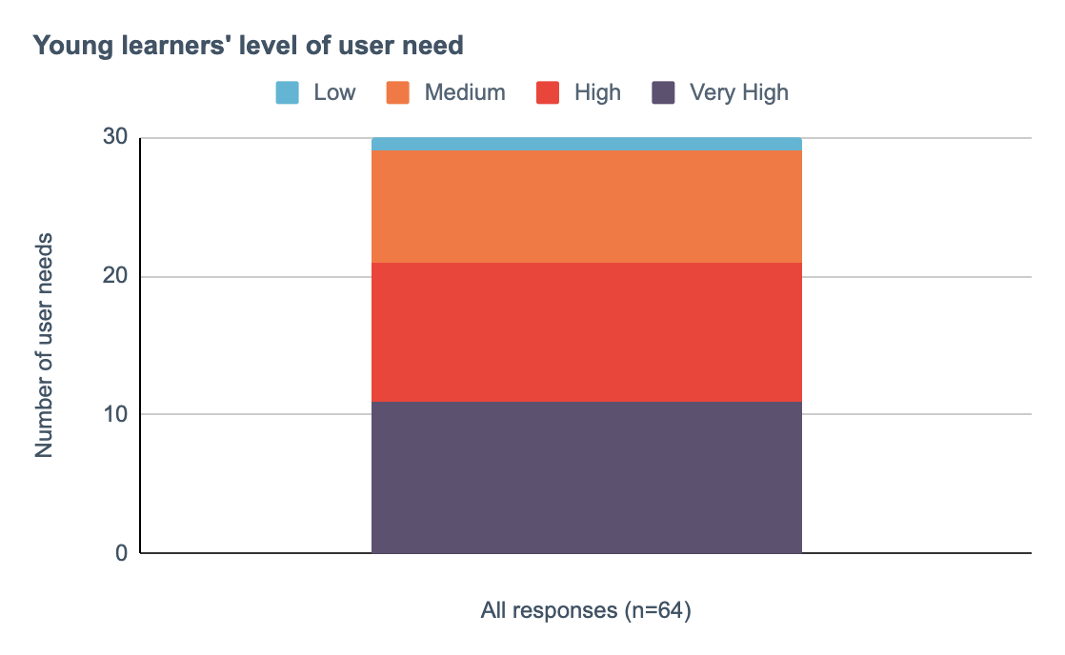
The level of young learners’ needs are shown in this chart:
Stacked bar chart: Young learners’ level of user need.
These 30 user needs were also themed and the level of validated need across these categories are shown in this chart:
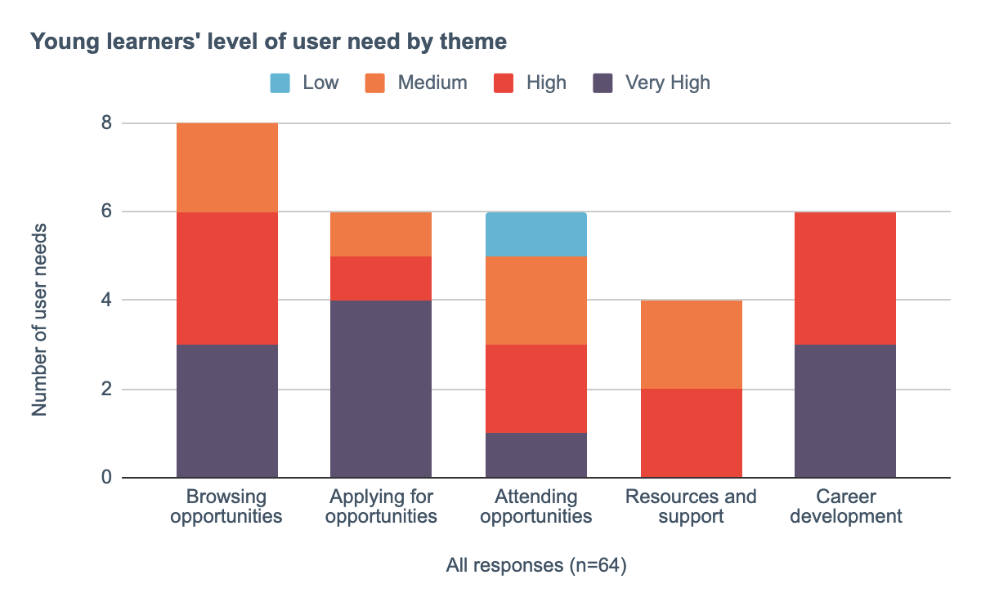
Stacked bar chart: Young learners’ level of user need by theme.
The level of providers’ needs are shown in this chart:
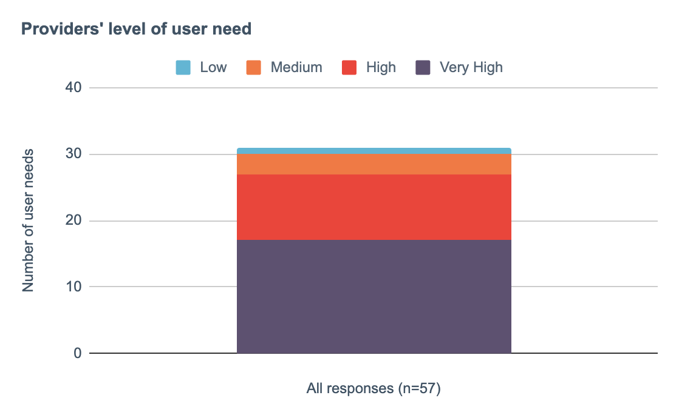
Stacked bar chart: Providers’ level of user need
These 31 user needs were also themed and the level of validated need across these categories, shown in the following chart:
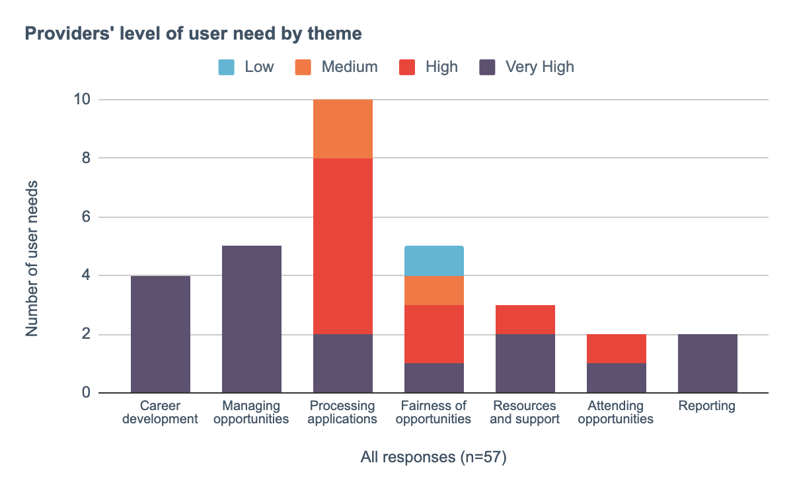

Stacked bar chart: Providers’ level of user need by theme.
The level of teachers/careers advisors’ needs are shown in this chart:
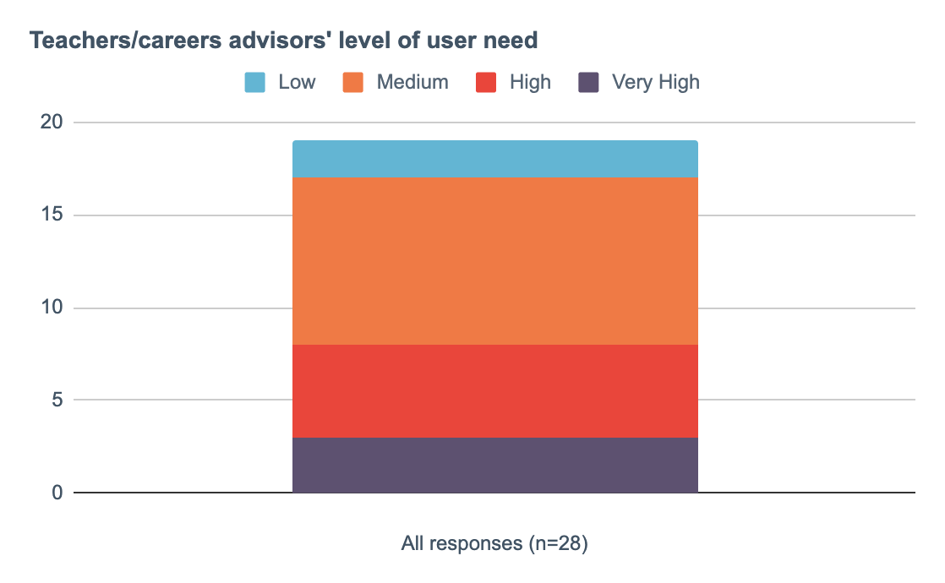
Stacked bar chart: Teachers/careers advisors’ level of user need
These 19 user needs were also themed and the level of
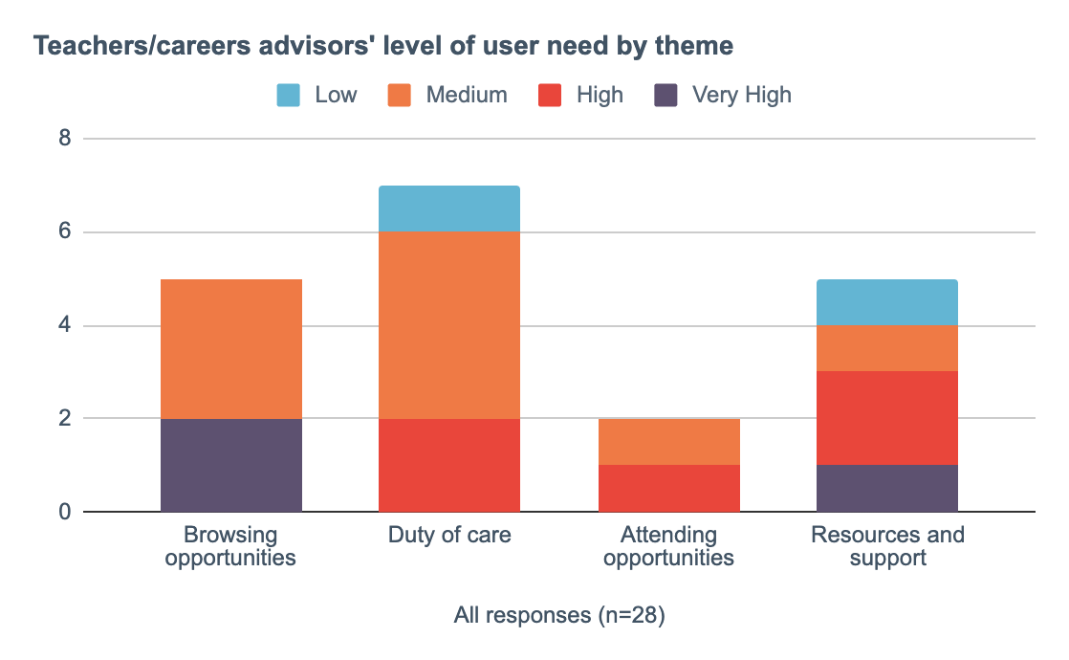
validated need across these categories are shown in this chart:

Stacked bar chart: Teachers/careers advisors’ level of user need by theme.

3.1.1 The level of young learners’ needs around browsing opportunities, applying for opportunities and career development are predominantly High
Of the eight validated user needs relating to browsing opportunities, three ranked as Very High, three as High and two as Medium.
Of the six validated user needs relating to applying for opportunities, four ranked as Very High, one as High and one as Medium.
Of the six validated user needs relating to career development, three ranked as Very High and three as High.
The following need, ranked as Medium:
UN01: As a young learner, I need to sample a range of health and social care roles as part of a work experience opportunity so that I can make an informed decision about what to pursue as a possible career.
Whereas, this need ranked as Very High:
UN23: As a young learner, I need to verify that I have attended a work experience opportunity so that I can use this as evidence in the future (e.g. for UCAS applications).
These levels of validation also support our qualitative findings around how some young learners place very high value on work experience and pre-employment opportunities as a way of evidence to support their applications and employment pathways (Section 2.3.4).

3.1.2 The level of most providers’ needs around managing opportunities, processing applications, career development, resources and reporting are predominantly High
Of the five validated user needs relating to managing opportunities, all five ranked as Very High.
Of the ten validated user needs relating to processing applications, two ranked as Very High, six as High, and two as Medium.
Of the four validated user needs relating to career development (of young learners), all four ranked as Very High.
Of the three validated user needs relating to resources, two ranked as Very High, and the other as High.
Of the two validated user needs relating to reporting, both ranked as Very High.
These levels of validation support our qualitative findings around providers’ issues with capacity and resourcing (Section 2.3.2) and reporting (Section 2.2.8).

4 Concept development

4.1 Overview
We developed a set of low-fidelity concept prototypes informed by the Discovery’s research and user needs.
The concepts explored:
- Finding a work experience opportunity
- Submitting an application [form] for an opportunity
- Exploring an online work experience opportunity
- Back-end processing for pre-employment providers
Four young learners, five pre-employment providers and one careers advisor were invited to participate in concept feedback sessions.
Each participant was asked to assess the viability of these concepts and suggest where further improvement could be made for designs to better fulfil their user needs.
An exported Miro board of collated feedback from these sessions is included as an output of this Discovery.
Below is a summary of important feedback worth reflecting on and to potentially explore further as part of an Alpha phase.

4.2 Concept feedback summary

4.2.1 Combining the promotion of online and in-person opportunities together tested well with most participants
Participants were asked for their feedback on whether both online and in-person types of work experience opportunities should be combined or separated on a prospective platform.

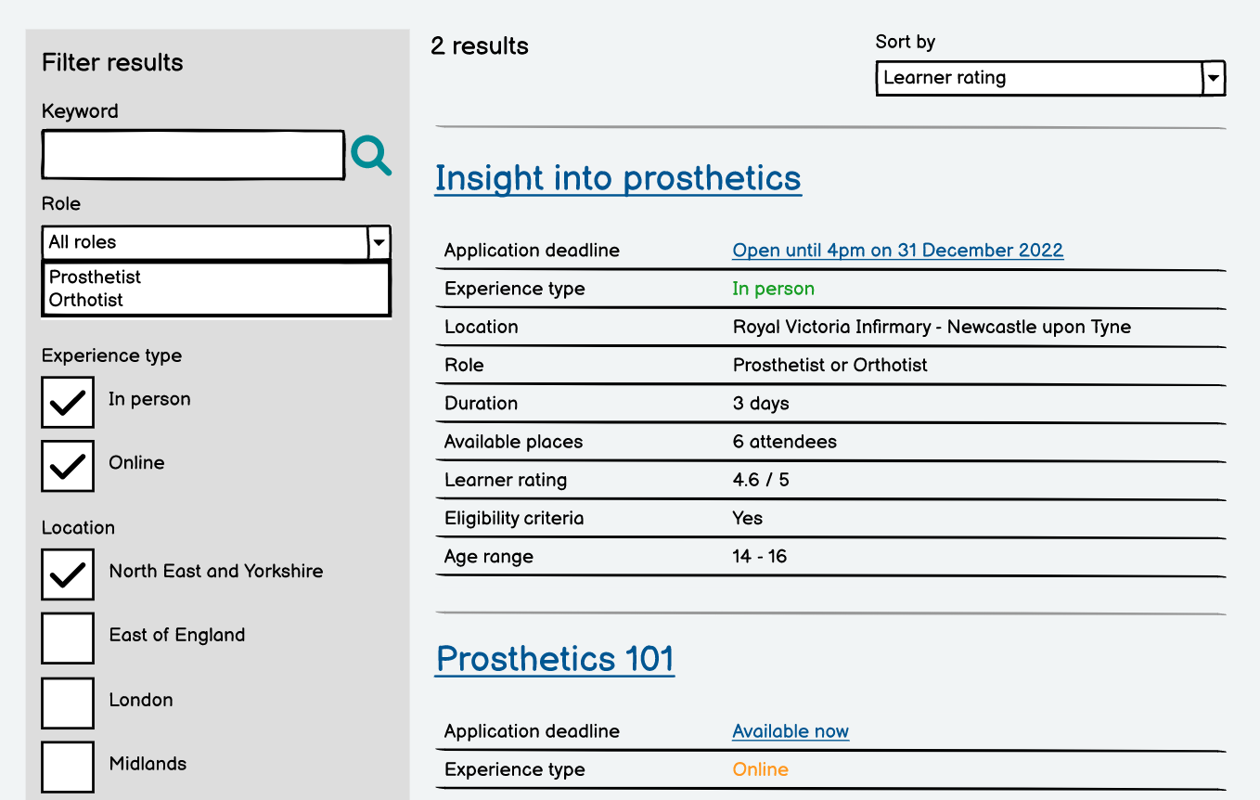

In most cases, this was considered a positive step forward and could help to provide balance between the two mediums and early exposure to hybrid working which has become more common in recent years for some health and care roles.
“I think it would work really well because it would give a balance between working online, meeting face-to-face.” Careers advisor
One young learner also articulated that despite the difference in delivery, in-person and online opportunities are both still valuable experiences for a young person to attend and so there shouldn’t be a sense of hierarchy or priority in their promotion.
“I think they're still probably considered work experience because you're looking at the work from a different point of view.” Young learner
Although another young learner did suggest that although they’d explore both, they would prefer there to be clear separation between the two types still.
“I'd maybe separate them. I'd look at both but it would be helpful if I could see which is which are online opportunities versus in-person activities.” Young learner
When testing this concept with providers, some shared similar feedback heard in the Discovery’s earlier research activities.
Notably, a strong suggestion to avoid the term ‘pre-employment’ when presenting opportunities to young learners.
“Why are you using the term pre-employment rather than work experience? Simply calling it work experience would be more understood by young people and schools.” Pre-employment opportunity provider
And also the recurring issue of capacity and resourcing. While the provider valued the idea of a platform, they also shared concerns around an increase in application numbers for them to still have to process.
“We've been reluctant to join platforms because we've been a victim of our success. Demand has always outweighed capacity and we've started receiving applications from way outside our region.” Pre-employment opportunity provider

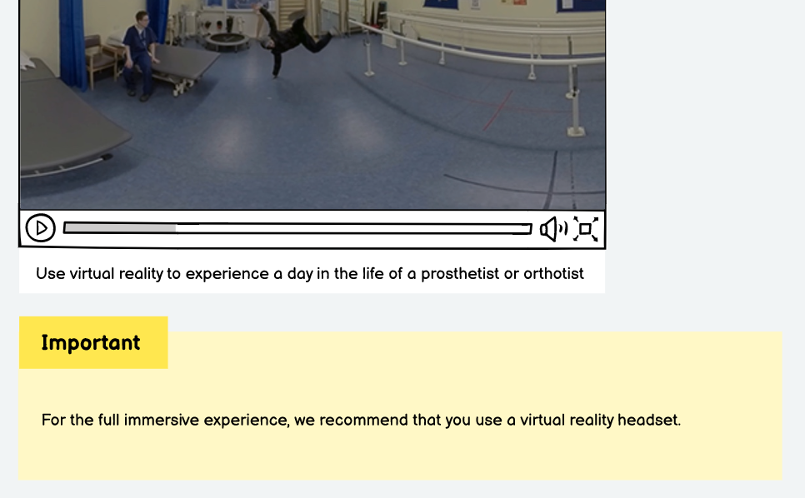
4.2.2 While virtual reality experiences are powerful tools, they may exclude some young learners from accessing them

One of the online opportunities included in the concept prototypes is based on an existing virtual reality experience provided by HEE.
While this could be an exciting and novel way of promoting health and social care roles and their experiences:
“This can give a real benefit to giving hands-on experience.” Careers advisor
The majority of participants raised concerns around whether young learners would have access to the equipment needed for a virtual reality experience.
“We do have one [a virtual reality headset] but in the scheme of things it is quite hard to get one.” Young learner
“They're [a virtual reality headset] not cheap and there might be some pressure to go out and buy one.” Young learner
Or whether schools and colleges would have the infrastructure to help support young learners, e.g. allowing them to borrow a VR headset to attend one of these opportunities.
“Some schools will invest in that [virtual reality headsets] quite heavily, so they will have that opportunity, but otherwise not.” Parent of a young learner
“I think depending on the school, I know my friend's school has these [a virtual reality headset] but mine personally doesn't.” Young learner

4.2.3 Undertaking an online opportunity before progressing to in-person work experience tested well as a pathway

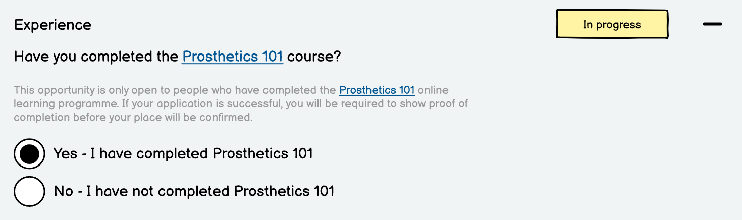
One of the in-person work experience opportunities presented to participants included some eligibility criteria. This stipulated that a young learner could only attend the activity if they had also enrolled and completed some specific online learning.
This tested well with the majority of participants.
For providers, it could help to ensure that the most suitable applicants attend the in-person experiences.
“I like that because sometimes you get a student coming through with no real interest in nursing, but I turned away umpteen other people that could have taken that space.” Pre-employment opportunity provider
“It gives a good idea of if the student wants to do it or the school wants them to do it.” Pre-employment opportunity provider
And some providers already operate a similar process:
“We do have a progression route that we encourage. We keep a list of students who've participated before and we tell them about further opportunities.” Pre-employment opportunity provider
Young learners also valued this potential pathway as it could ensure that they’re better prepared and informed before starting an in-person activity.
“I think that'd be fine, it might be better to be honest because you'd get to know more about it.” Young learner
“I think it's useful if it will help you in-person and so you then get more from your experience.” Young learner
At least then you won't be confused and constantly asking what's going on.” Young learner

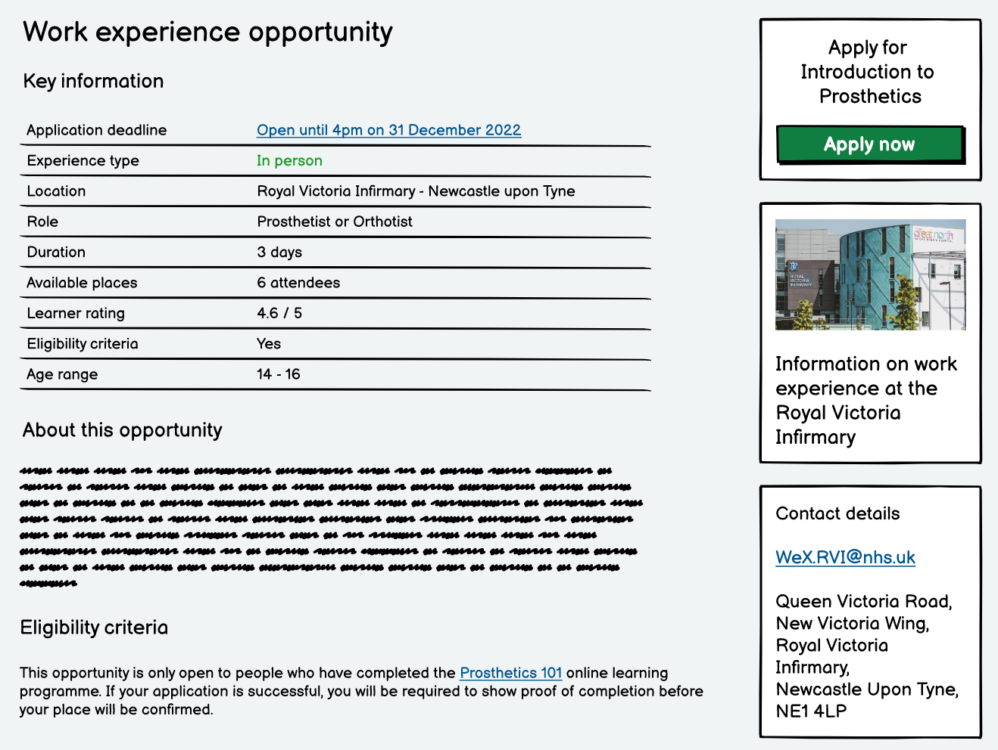
4.2.4 Useful information to know about a work experience opportunity

Participants were presented with a prototype design that simulated how a young learner might browse and filter work experience opportunities, e.g. by age, location, experience type.
This tested well with the majority of participants and they provided useful feedback on their preferences.
“I'd probably look by the experience type, the location and the duration.” Young learner
“I think the subject, but also age and all that kind of stuff that's already on there cos you wouldn't want to be going to a WE place that's two hours down the road.” Young learner
“I think you've covered the good things to search. What I thought was really useful was ‘virtual’ and ‘in-person’, and area.” Pre-employment opportunity provider
Some also suggested where further work is needed to make categories more useful or realistic for young learners seeking an opportunity, e.g. more granular location options.
“I think location-wise, I'm not sure how many people would know South East as a region, it would be quite big to get to.” Pre-employment opportunity provider
“Maybe the location actually going down further than just East of England. Drill down to local hospitals.” Careers advisor
One young learner and one provider also indicated that any age breakdowns should also be more specific. For example, 18+ being too vague and ambiguous as a category:
“I feel like 18+ is a very large age category.” Young learner
And also options for those aged around 16, as this is typically a watershed age bracket determining what a young learner can attend in health and social care environments.
“The age would need to be more specific. If they're under 16, they can't go into a clinical environment.” Careers advisor
This concept prototype also presented some search results of work experience opportunities with a series of specific attributes next to them. Notably: available places, whether it was in-person or online and a learner rating (feedback score).
The available places label was understood by most participants.
“That's how many people you'd be doing it with.” Young learner
However, one provider suggested that some opportunities are more flexible in terms of total vacancies and so this may not be a useful attribute to include for every opportunity.
“By putting something like there might be six available spaces, we might be giving an unrealistic expectation. It's always more fluid and flexible than that.” Pre-employment opportunity provider
Some interpreted the learner rating as a metric or score around how much they would learn, rather than its intended use as a feedback score from previous young learners who completed the opportunity.
“Is that how much you'll learn from the experience?” Young learner
“Is that about the experience, how much of a hands on it is compared to reality?” Young learner
Providers had a better understanding of the concept and some were enthusiastic about the idea:
“It is good. We all like reviews and it does give valuable feedback to the host organisation cos if you've got a 1.5 out of 5, you're gonna want to do something about that.” Pre-employment opportunity provider
But some providers suggested that the scoring could very quickly become warped depending on who and how many provide feedback and further moderation would be required if this was to become part of an actual online solution.
“It's good but that number can be affected by a small number. One person could bring that rating down quite significantly. It could be quite misleading.” Pre-employment opportunity provider

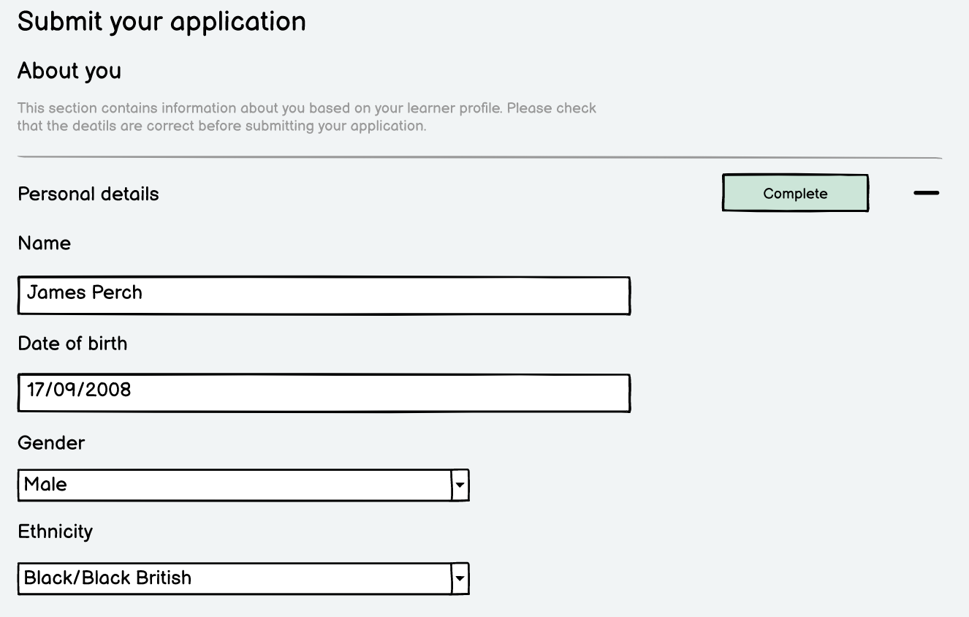
4.2.5 Feedback on the suggested data required with an online application form

The concept design for an online application form included some questions to help determine how feasible it would be for a young learner to retrieve and populate by themselves.
In most cases, the information required would be easy to input.
“I think that would be pretty easy to fill in. Most of this is common knowledge.” Young learner
However, some were less obvious. For example, the form asks for a ‘designated contact’ from their school or college such as their tutor, but some participants were unclear about this.
“How you'd like them to contact you? So by email or telephone.” Young learner
“We would put next of kin, or parent / guardian.” Careers advisor
One provider suggested this could be an unnecessary piece of data to ask for, as some young learners apply for work experience opportunities and without support from school or college.
“If it's a 15 or 16 year old doing it independently, it would be the parents' consent we need, nothing to do with the school.” Pre-employment opportunity provider
Similarly, some providers had reservations when part of the form asked for a young learner to supply school grades.
“I've got mixed feelings on school grades because we want to inspire them and if we're dealing with Year 10s, they won't have any meaningful grades.” Pre-employment opportunity provider
“They might not know their school grades and does it really matter? They might be starting really at entry level and finding their own career pathway. I wouldn't want those under-achieving to think they need really good grades.” Pre-employment opportunity provider
Further down the application form prototype, participants were presented with some free-text fields so that a young learner could demonstrate why they would be most suitable for a specific work experience opportunity.
This tested well with some young learners and providers as it would help determine who is most appropriate.
“I think that's pretty reasonable 'cos obviously they're gonna want to find something out about you that will set you out from other candidates applying.” Young learner
“It'll take longer to do, but they need to choose the right people to take part and they can't do that randomly.” Young learner
“I absolutely want to know why they want it cos that will let me determine whether we want to pursue with them or not.” Pre-employment opportunity provider
And it can help with improving their employability skills.
“I think it's also really good practice [to have to write a bit about yourself] because it's useful for when they go onto university.” Pre-employment opportunity provider
But some others did also raise concerns:
“I feel this isn't the most necessary, but if there's limited places then a word count would be good.” Pre-employment opportunity provider
“If people don't know what they want to do [in the future] would they be disadvantaged?” Pre-employment opportunity provider
The last section of this prototype presented participants with a confirmation of their submitted application and a time-window on when to expect a decision about it.
This tested well with young learners.
“I like that because you always question whether they've seen in.” Young learner
“They do this sort of thing on UCAS.” Young learner
Some young learners suggested they would regularly check the status of their application, but others would be happy to wait for some form of notification.
”I probably would check it. I always get really nervous checking whether I've got in.” Young learner
“I'd probably just wait and it'll come when it comes.” Young learner
The suggested 10-day waiting period also tested well with young learners and one provider.
“That's quite reasonable. Just as long as it’s not too close to when the experience starts.” Young learner
“We would have to have systems in place, as the person applying you wouldn't want to wait longer than 10 days so I think that's quite reasonable.” Pre-employment opportunity provider
However, most providers were concerned that it would set a high expectation on them and potential burden, particularly with the difficulties in capacity and resourcing (Section 2.3.2) and so the idea of a time-window is worth further exploration.
“For a reply, yes but not a confirmation. We can't do a confirmation until they've had their clearances. They can take 10 to 12 weeks. Occupational health for example.” Pre-employment opportunity provider
“You're relying on health professionals to get back to you and that often doesn't happen very quickly. In the grand scheme of things, you're quite low priority.” Pre-employment opportunity provider
“Most don't have a dedicated work experience lead, they're doing it as part of a day job. You'd want them to reply in a timely manner, but if they don't - what then?” Pre-employment opportunity provider

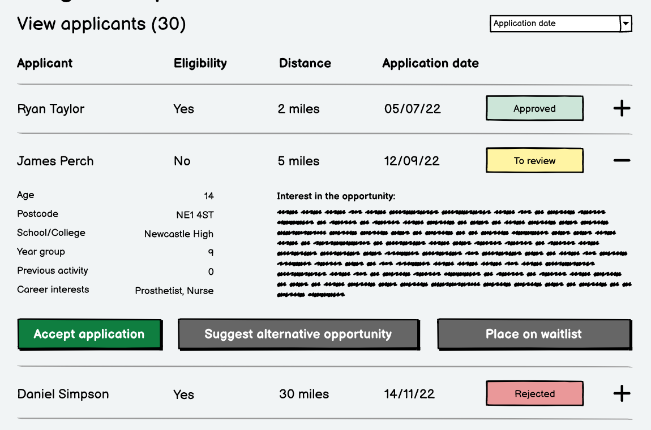
4.2.6 Providers’ feedback on a suggested back-end admin experience

The last concept prototype explored how providers could manage applications from a back-end admin perspective.
Particular focus was directed towards accepting applicants, moving them to a waiting list or to suggest an alternative opportunity for them if they had limited availability.
Suggesting alternatives tested well with all provider participants.
“I like the idea of being able to suggest something else or place them on a waiting list.” Pre-employment opportunity provider
“I almost feel we need to give young people a choice, so we can suggest an alternative but some young people have got their career mapped.” Pre-employment opportunity provider
“I like that. It's not just a blunt no - you're still offering them opportunities to explore.” Pre-employment opportunity provider
Although some suggested that not all providers might have other opportunities to offer.
“We have the capacity to suggest alternatives. Others don't.” Pre-employment opportunity provider
“Would national things be alternatives? Then we're not saying no to someone, we're signposting them to other things which may be of interest.” Pre-employment opportunity provider
Providers also provided feedback on the information they’d value to help determine whether they’d accept an applicant.
At this point, it was flagged by one participant that additional checks would be essential with their decision-making and not something that would necessarily be collected as part of an initial application form.
“It would be hard for me to accept an application based on what you've shown me. There's no occupational health check information on there.” Pre-employment opportunity provider

5 Landscape analysis
We took a detailed look at three comparable services, at various stages of their development to see what lessons could be learned.

5.1 Lincolnshire Talent Academy
The Lincolnshire Talent Academy has overseen the development of a platform to facilitate pre-employment opportunities.
This case study is based on a conversation with Claire Flavell, Strategic Lead - Lincolnshire Talent Academy.

5.1.1 Context
- Aimed to set up an in-house service to engage directly with students, facilitating work experience opportunities
- In 2016, this was expanded to the wider Lincolnshire system
- Contracts are in place with 3-4 other Integrated Care Systems (ICS) to manage the service around work experience
- Intention was to create something that could be used as a national platform
- Also supporting some GPs and social care where necessary within Lincolnshire
- ICS’ have been contacting the Talent Academy about using the service more widely
- Service deals with between 800 and 1,000 placements per year. Some of these placements moved to e-placements over Covid

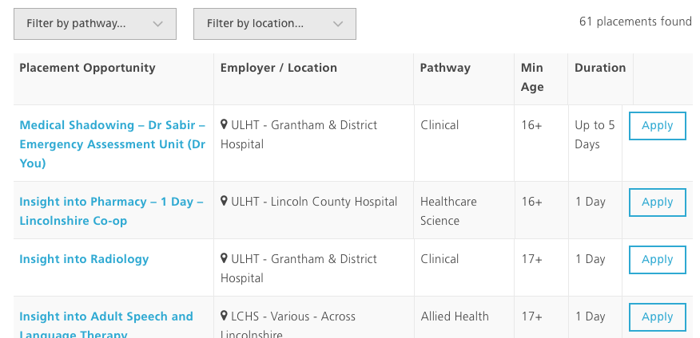
Image: A screenshot of opportunities posted on the Talent Academy website

5.1.2 System journeys
- The system allows the tracking of elements such as health and safety, risk assessment, employers liability information
- The software contains booking parameters so students can see what they can take part in. For example if a student is under the required age, the system will recognise this and stop as student from registering for an opportunity
- The system will notify parents or guardians when consent is needed
- Every placement has the same look and feel in terms of the information that is provided to students
- The system will automatically email appropriate information to students once they have been confirmed on a placement
- Students can find opportunities based on pathway or county
- Students are asked to log in to the system in order to see information on appropriate opportunities
- Students are asked to complete an application form for an opportunity. Any eligibility criteria is dictated by the host organisation. The application form mirrors the questions that are asked on NHS jobs
- Hosts then manage their own applications and make selection decisions
- The service will also collect contact information within the boundaries of GDPR to contact students about future opportunities that may be of interest to them
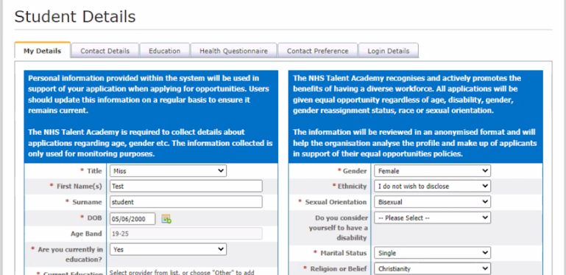
Image: A screenshot of student details captured by the system to inform applications
Image: A screenshot of information providers are expected to provide to advertise an opportunity

5.1.3 Managing the service
- The same data is captured across different placements to ensure consistency
- A central record is used to capture this data
- Each placement will complete the central record with appropriate information. The central record is updated by the service team, providers can only view this information on the system
- Documentation mirrors the elements that are asked for by the software
- The Talent Academy Team will enter information into the system based on the central record being sent over by a provider
- One person works on the service full time with others working at periods of higher demand
- A licence fee is paid every year for the platform, based on the number of students. The previous annual licence cost £8,640 for the general platform. Costs are then paid per user, so adding an employer host would cost £100 per licence
- Further development is paid for, making the system bespoke. Over the past 7 years, approximately £25-30k has been spent on the development of the system

5.2 Digital Marketplace
The Digital Marketplace is an online service for public sector organisations to find specialists and technology for digital projects.
This case study is based on a conversation with David Elsley, Associate Commercial Lead for Digital Outcomes Specialists/Digital Futures and Megan Barradell, Digital Directory Services Team

5.2.1 Context
- Since 2016, the Digital Marketplace has advertised approximately 5,300 opportunities, ranging from 500 to 1,100 per year
- The G-Cloud framework also runs at the same time, hosting thousands of prospective technology suppliers
- The platform is self-serviced. Buyers post their opportunities and companies [suppliers] are able to submit bids when necessary
- There is a light touch tech team which manages the service, including: a product manager, 1.5FTE developers, and a 0.5FTE tester
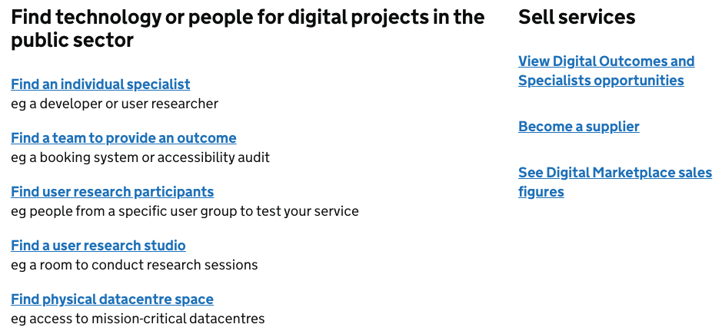
Image: A screenshot of the actions available on the Digital Marketplace

5.2.2 Ensuring consistency of opportunities
- When users reach the Digital Marketplace, the service guides them through the journey of creating an opportunity in a structured way. This enables opportunities to be displayed in a consistent way
- There is guidance around content that should inform opportunities
- The service also uses limitations such as field lengths and formatting to ensure that people adhere to standards within the actual service
- Opportunities are not policed, as the platform is self-service. The Team can encourage suppliers to remove opportunities if they don’t meet criteria but suppliers are under no obligation to remove the opportunities
- Involvement is often before an opportunity is posted in the first place, but this depends on the buyer
- Often buyers or suppliers will highlight opportunities that do not meet the standard
- Education of suppliers can take approximately one day per week, with that time spread across members of the product team

5.2.3 Reflections on the scale of the service
- Issues may arise if there is an influx of users to the system for any reason, for instance comms being sent on a particular day
- The potential applicants [suppliers] for an opportunity are limited by having to register for the service in the first instance
- Otherwise, there are no mechanisms to restrict the number of applicants for an opportunity
- Covid involved a larger number of applicants applying to opportunities which caused issues for procurement processes. This resulted in 100s of applicants for opportunities, whereas the average number is approximately 12 per opportunity

5.2.4 Advice for the project team
- Pre-filtering doesn’t exist on the platform currently so opportunities have to have enough information in the criteria so that suppliers can deselect themselves. Questions need to be very clear so that people can rule themselves in or out of an opportunity in the absence of filters
- As a self-serve platform, It is important to think about how the platform guides user behaviour so that there is a higher probability that the opportunity will be advertised correctly
- The filter functionality of the service could be used to help students filter opportunities, for example the right location or profession. Categorisation might help to stop people seeing irrelevant opportunities, which might help to reduce the number of applications
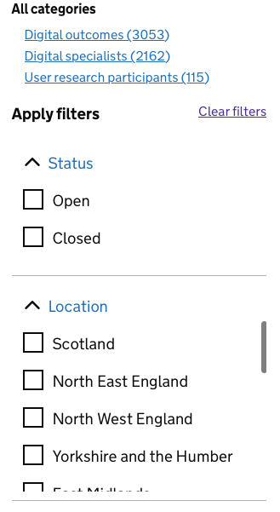
Image: A screenshot of filtering options on the Digital Marketplace

5.2.5 Ensuring fairness and equity of access
- Every supplier can apply to any opportunity. If they feel like they have sufficient capability to do a piece of work, they can bid for it
- Buyers shouldn't be putting out any opportunities that have pre-conditions that exclude anyone in a discriminatory way
- People can challenge outcomes if they feel like they have been unfairly treated. This is rare. If the supplier can justify their decisions then the challenge usually goes away
- Anonymity is also important. Any interaction between suppliers and buyers is completely anonymous

5.3 Get School Experience
Get School Experience is a service where prospective teachers can find work experience within schools.
This case study is based on a conversation with Miles Jarvis, Product Manager for the Get School Experience service.

5.3.1 Context
- Get School Experience sits within Get into Teaching
- The service aims to guide candidates from searching for work experience to completion within a school
- Candidates can search for opportunities, find local schools and apply for opportunities within the context of the service
- The service aims to allow a dialogue between both providers and candidates. The aim is to reduce interactions that happen informally without oversight, for example cold emails
- If a candidate decides they don’t want to get into teaching after an experience, that is seen as a good outcome
- The majority of applicants are graduates or postgraduates
- There have been approximately 9,000 applicants in the past year
- External factors drive interest in teaching, e.g. it is perceived as a safe job in a recession. This might drive engagement from end uses but is outside of the control of the project team
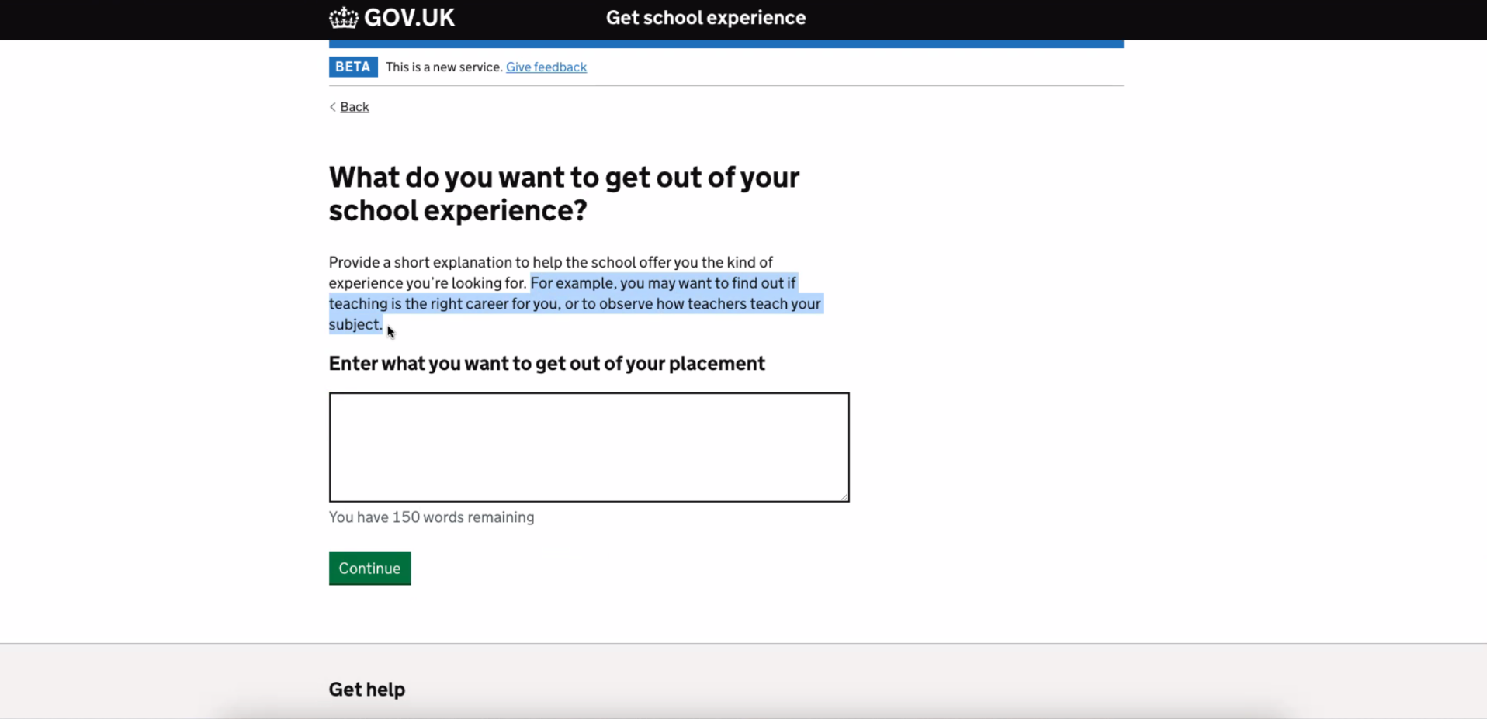
Image: A screenshot of a question asked as part of the application process

5.3.2 Driving conversion
- Gov Notify is used to generate SMS messages to encourage attendance at opportunities
- Certain schools struggle with getting candidates to attend opportunities
- Interest in teaching is declining generally, therefore there is a pressure to convert more people who engage with the service
- The Get School Experience team exists to get people into work experience. A separate element of the service exists to help candidates with further applications beyond work experience
- This part of the service is free and paid for by the Department of Education. Candidates can get help to write a personal statement to enhance their applications in the next phase of their journey
- The service has 50-60 teacher training advisors across the country. Agents are also hired to handle online chat and calls to a call centre. The advisors are typically ex-teachers
- This levels the playing field but only to people who know about it

5.3.3 Engagement with providers
- Altruism is a significant factor in onboarding schools to the service. Some schools view the service as a way to give back to the system, whereas others won’t participate without a guarantee that they will get a person as a trainee further down the line
- There is a disparity between providers; academy systems can have people responsible for coordinating data across multiple schools
- There is a risk of disengagement if too many people are applying to opportunities and it becomes too hard to administer
- Onboarding and awareness is really difficult. Schools aren’t aware of the service and disseminating the message about benefits across the whole of England is really difficult
- It is difficult to grow the service beyond proof of concept. It can take a nine month lead time to onboard people and the onboarding process is relatively straightforward
- Changing roles can be difficult. Administrators might leave which means that a school won’t have anyone managing applications if there hasn’t been a handover

5.3.4 Data collection
- Data specialists and performance analysts are used to connect data between all services
- Data is stored in a MS Dynamics CRM
- The service aims to join up data from different products in order to enable end-to-end data collection
- This has evidenced that Get School Experience leads to an uptake in people going on to teaching roles
- It isn’t possible yet to know if someone does experience at a particular school and then returns once they complete training
- There is no data on the completion of support services that people use to the point of applying or what increases commitment

5.3.5 Branding
- The apply experience is handled by GOV.UK, whereas information is handled on other Get Into Teaching sites
- This experience can be jarring for users, it has received negative feedback
- People associate GOV.UK.uk with trustworthiness, but the teaching brands are also seen as trustworthy so this isn’t a huge benefit
- It would be worthwhile considering how to skin the work experience on the current branding if it is recognised and people trust it
- GOV.UK can also make it difficult to browse opportunities so may not be a good alternative depending on needs
- An alternative option might be to add some branding to the GOV.UK style of work. Finding teacher vacancies is a good example of this, where creative liberties have been taken
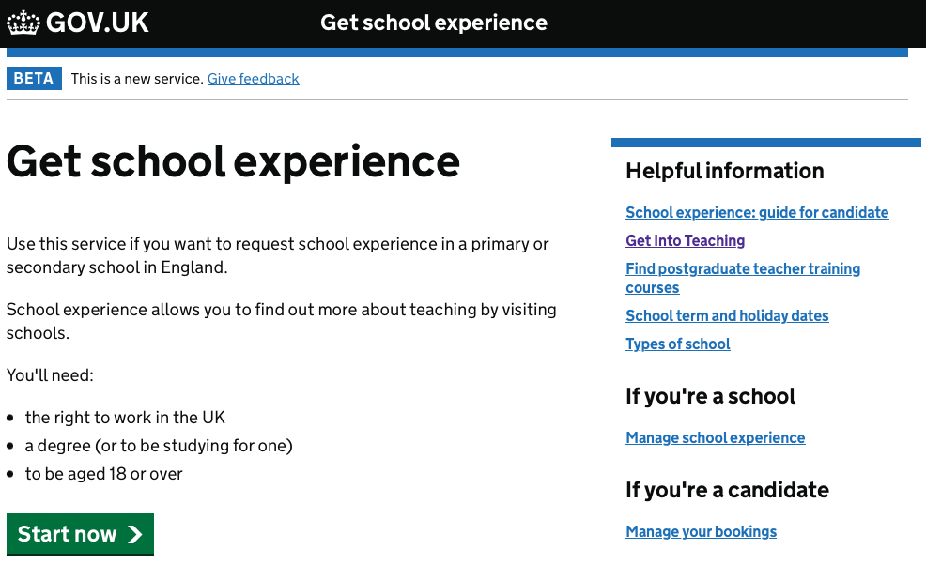
Image: The get school experience application element of the service, hosted on GOV.UK
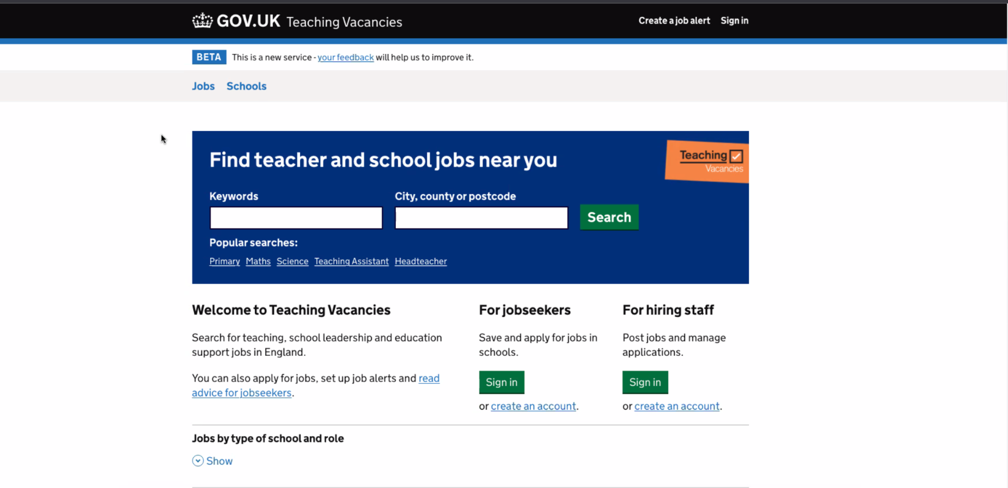
Image: Find teacher vacancies site, which builds on the GOV.UK style guide

6 Inclusivity and accessibility assessment

6.1 Digital skills
User research was conducted with all key roles identified by the HEE Widening Access and Participation Team during this Discovery’s inception phase (Section 1.8.3).
Respondents to the recruitment surveys were asked to self-assess their digital skills using the 9-point GDS Digital Inclusion Scale. Respondents were also provided the options of Prefer not to say and Don’t know.
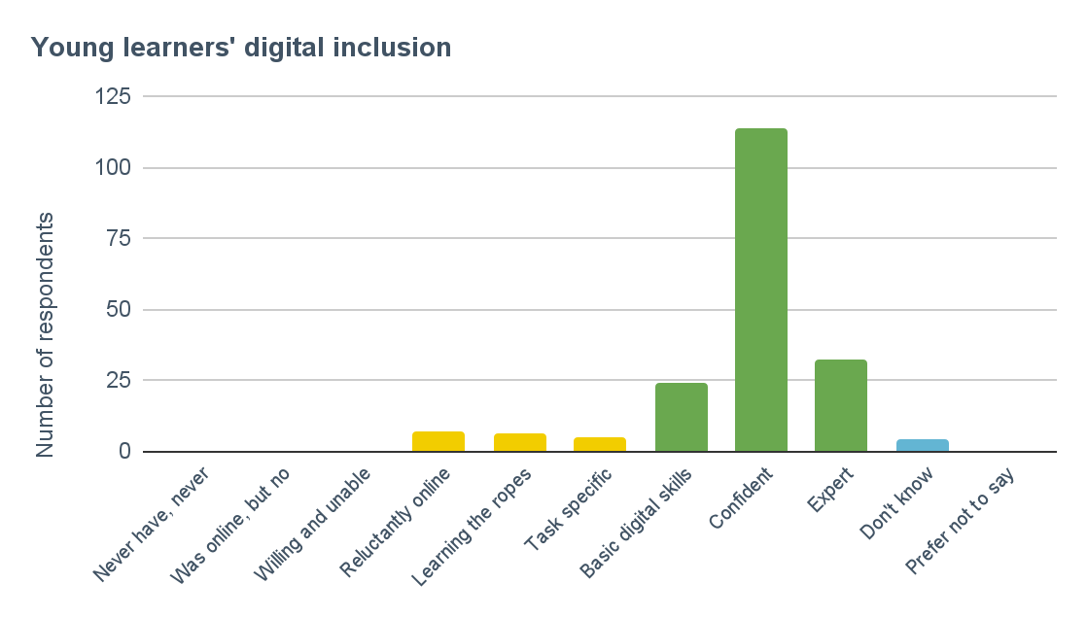
Their responses are presented in the charts below where ~88% of young learners and ~86% of providers and teachers/careers advisors identified themselves as either having basic digital skills, being confident or an expert online.

Bar chart: Young learners’ (n=197) self-assessed level of digital skills.

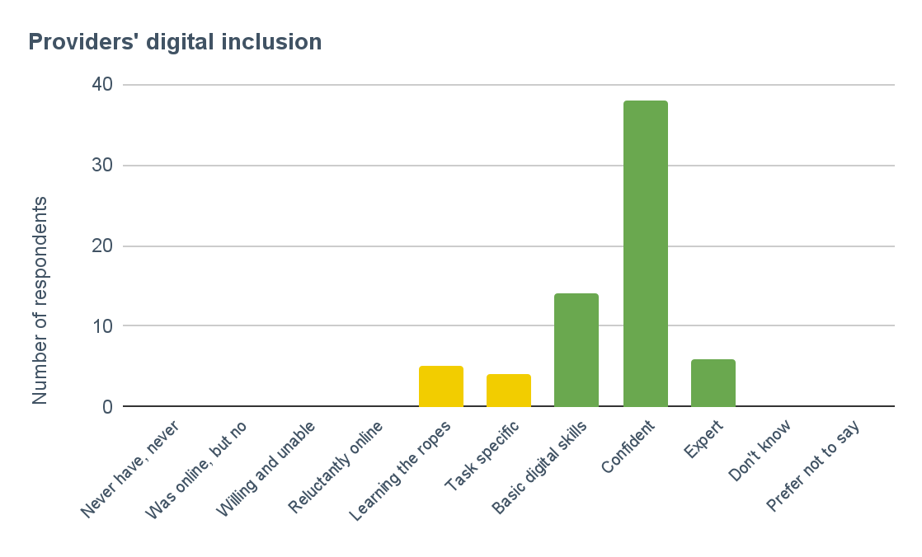

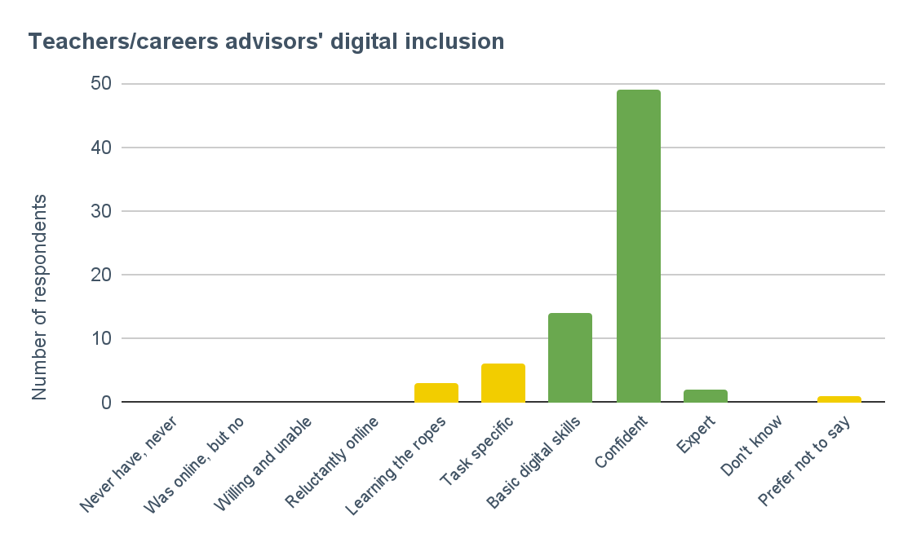
Bar chart: Providers’ (n=67) self-assessed level of digital skills.

Bar chart: Teachers/careers advisors’ (n=75) self-assessed level of digital skills.

Important: all surveys were online surveys shared to email addresses. It is appreciated that this is likely to risk a bias towards users with a higher level of digital literacy.
This has been considered when interpreting results, however there is no reason to suggest that the individuals recruited to participate in user research were not representative of users in terms of digital skills.
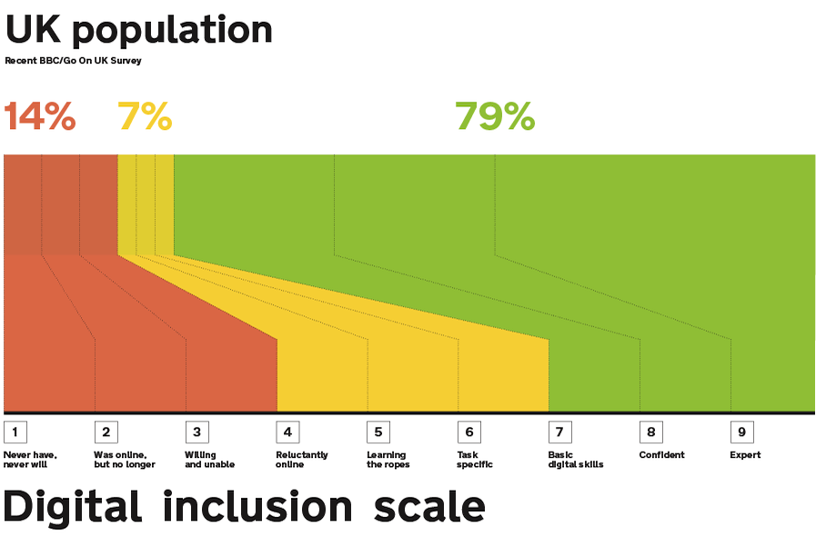
To give some idea of what the digital skills of the general population are, the latest Digital Inclusion Scale figures on the UK population are taken from the Government Digital Inclusion Strategy, updated in December 2014 and presented in this visual:

Image: The Government Digital Service’s digital inclusion scale
Basic digital skills to Expert
79% of the UK population are a 7 (Basic digital skills), 8 (Confident) or 9 (Expert). This segmentation should be capable of using any Service Standard level digital service offered to them if they have internet access.
~88% of the young learners identified within this group, which is higher in comparison to the average UK population.
~86% of providers and teachers/careers advisors identified within this group, which is also higher in comparison to the average UK population.
Never have, never will to Willing and unable
14% of the UK population are a 1 (Never have, never will), 2 (Was online, but no longer) or 3 (Willing and unable). This segment of the UK average population will have an assisted digital need.
No survey respondents and no qualitative user research participants identified within this group. However, 4 young learners selected Don’t know as an option and one teacher/careers advisor opted to Prefer not to say.
While this user research did not identify those lower on the digital inclusion scale on this occasion, there will be individuals who do require assisted digital support and must be catered for with any current or prospective digital services.
Reluctantly online to Task specific
- 7% of the UK population are a 4 (Reluctantly online), 5 (Learning the ropes) or 6 (Task specific).
- ~13% of the young learners identified within this group, which is higher in comparison to the average UK population.
- ~34% of providers identified within this group, which is considerably higher in comparison to the average UK population.
- ~12% of teachers/careers advisors identified within this group, which is higher in comparison to the average UK population.
As some survey respondents identified as Learning the ropes and Task specific, this indicates that there are individuals who may have a level of assisted digital need.
Next steps
We recommend that future research be carried out with users who identify at the lower end of the digital inclusion scale, to further explore their needs and to help confirm requirements for effective assisted digital support.

6.2 Connectivity

Internet access
No participants mentioned internet access as a current barrier to them applying for pre-employment opportunities.
However, issues around travel infrastructure and rurality were discussed as an issue in terms of the availability and accessibility of opportunities for young learners.
“The area I live in is very derelict.” Young learner
“Travel is a really big barrier. Some of our students get bussed in from lots of different places and some of the villages have one bus a day.” Careers advisor
While not a direct correlation, rural places often experience weaker internet speeds and connectivity which may therefore impact some young learners’ abilities to find and apply for opportunities if they are promoted online.

Mobile devices
All research activities with young learners, providers and teachers/careers advisors were conducted online via Zoom or by telephone.
For telephone interviews, all young learners had access to a smartphone and the majority of young learners who attended a Zoom call joined the session by their mobile device too.
As discussed in Section 2.3.7, young learners, providers and teachers/careers advisors discussed the value of social media for promoting pre-employment opportunities and none suggested this medium or the use of mobile devices as a possible barrier.

Next steps
We recommend that user research continues and specifically focusses on testing out potential mobile user experiences to identify potential issues for young learners, providers and teachers/careers advisors.
This should be conducted with a range of smartphones, tablet devices and operating systems (e.g. iOS, Android) to ensure that any future services are accessible to as many users as possible.
Additionally, we recommend that user research is conducted to further explore the impact of specific technology choices, their related connectivity issues and how to resolve these for affected users, e.g. how to ensure optimal broadband conditions.

6.3 Accessibility
According to The Big Hack, 19% of working age adults in the UK have a disability.
Their research also shows that disabled people are more likely to encounter barriers to accessing digital services and lack the skills they need to get online.
The NHS also specifies that a similar proportion of the UK population: 1 in 5 people, have a disability of some kind.
As part of the user research participant recruitment process and the three user needs validation surveys, respondents were provided with the opportunity to disclose whether they had any access needs.
The following accessibility conditions were disclosed:
“Hearing impaired.” Survey response (provider)
“Concentration and adaptability.” Survey response (young learner)
“I am short sighted and this affects seeing screens and my reading. this is fixed by glasses.”
Survey response (young learner)
“Dyslexia.” Survey response (provider)
5 survey respondents also opted to Prefer not to say.
People for Research also helped us to engage with young learners with disabilities as part of our qualitative user research.
One participant had scoliosis and another described themselves as having slow processing speeds.

Next steps
While the volume of survey respondents and research participants who disclosed having a disability or access need was less than the approximate UK average, it should be assumed that a sizeable proportion of users (e.g. ~20%) will have some form of access need.
NHS digital services are expected to meet at least level AA of the Web Content Accessibility Guidelines (WCAG 2.1) - and aim for AAA where possible, therefore the future iteration of this service must also comply and meet the access needs of its users.
We recommend that future research be carried out with individuals who identify as having an access need, to further explore their circumstances and to help confirm requirements for effective accessibility support. This includes those with:
- Visual impairments
- Auditory impairments
- Motor impairments
- Cognitive impairments
This should be achieved through qualitative, in-depth studies with users, as well as testing prototype designs with individuals who use different types of assistive technologies (e.g. screen readers, voice recognition software) to ensure that a future service is accessible.

7 Recommendations
Our recommendations cover six broad themes:
- Context for the recommendations
- Overarching recommendations
- Steps towards a pre-employment service
- Technical recommendations
- Service management and governance
- Suggested roadmap

7.1 Context for the recommendations

7.1.1 There are assumptions surrounding the effectiveness of pre-employment activities
Throughout this Discovery, participants have made assumptions about the effectiveness of pre-employment activities.
This is reflected in the wide range of problems that stakeholders believe a pre-employment service can contribute towards solving. Notably, participants talk about pre-employment as a way of increasing workforce supply by encouraging more entrants into the workforce as well as reducing the number of people leaving to other sectors.
However, we have not seen sufficient evidence to confidently support some of these assumptions. Primarily, this can be attributed to a lack of data around pre-employment and work experience activities (Section 2.2.8).
There does appear to be some evidence to suggest that taking part in work experience will lead to an increase in people applying for further study in a particular career. However, beyond this, there is little evidence to highlight the effectiveness of pre-employment at reducing attrition in either education or employment.

7.1.2 Some pre-employment processes are unfair
Our research has found evidence to suggest that pre-employment activities are unfairly distributed. The availability of opportunities for young people has been described as a postcode lottery, with the availability of opportunities depending on where people live.
We have also heard that some activities aren’t well advertised, which can favour young people who find out about them through word of mouth.
We have also heard about nepotism (in various forms) leading to work experience opportunities for young people.

7.1.3 There is an administrative burden involved in facilitating pre-employment activity
Providers have reported large volumes of applicants for work experience opportunities, and small teams of people required to process these applications (Section 2.3.2).
Whilst some providers are using systems to help facilitate the processing of these applications, others still use paper based application processes.
These processes can compound the sense of burden associated with facilitating pre-employment activities.
The burden is also compounded by the scale of opportunities happening annually across the country. A minimum of 20-25k placements are taking place each year, with any administrative burden being stretched across the facilitation of each opportunity.

7.1.4 There are a multitude of local systems operating in this space
There are various local approaches to facilitating pre-employment opportunities. These approaches vary in terms of cost, quality and compliance with national standards.
Lower cost options include providers using Excel and similar products to coordinate placements.
We have also heard about higher cost tools that have specifically been developed with the goal of facilitating pre-employment activity.
A variance in cost, quality and compliance with standards across the landscape of this work brings about several risks. Most notably, the biggest risk surrounds compliance with information governance regulations.
A national service would provide the opportunity to make financial efficiencies and also ensure compliance with information governance standards, as well as NHS Digital Service standards.

7.1.5 Stakeholders see overlap with other ongoing initiatives
Stakeholders have highlighted several ongoing initiatives that overlap with this work (Section 2.2.5). Some of these initiatives are driven by HEE (National Website Platform, Health Careers), whilst the responsibility of others sits wider in the NHS (NHS Jobs).
Some of these initiatives may represent a natural starting point for this work, whilst others may represent an opportunity to learn best practices.

7.1.6 A pre-employment service alone won’t solve systemic issues
In defining the problem space, stakeholders talked about systemic, national issues.
A pre-employment service alone won’t solve these issues.
Increasing workforce supply or reducing attrition throughout education and employment are important issues to solve. However, access to pre-employment opportunities won’t solve issues surrounding the pay and conditions of particular roles.
Work experience or pre-employment will expose people to these conditions before they commit to a career, but it won’t fix them.

7.2 Overarching recommendations

7.2.1 Be clear about the specific problem(s) that you are trying to solve
Section 2.1.1 highlighted a range of problems that stakeholders believe this work can address. The scale and scope of these problem statements varied significantly, from national workforce supply issues to the inefficiency and administrative burden of facilitating pre-employment opportunities.
Clearly, these are all problems currently facing the NHS. However, a pre-employment service will only go some way to solving all of these issues (Section 7.1.6).
As this work proceeds, we recommend being clearer about the specific problems that the service is best placed to address.
Based on our research, we recommend the following problem statement as a reasonable anchor for future work:
Pre-employment opportunities in the NHS are not as open and transparent as they should be, potentially disenfranchising marginalised groups of young learners.
Section 2.4 outlines evidence to underpin this problem statement. Our research has found evidence that some pre-employment processes are not fair or equitable to young learners.
Taking these Discovery findings into account, this seems like a worthy problem to solve and is one that is underpinned by sufficient evidence.
If the NHS aims to be a diverse and inclusive employer, this philosophy should extend to pre-employment opportunities that the NHS offers.
This is the problem space that a pre-employment service can contribute towards solving, by putting opportunities out in the open and making them transparent.

7.2.2 Understand the pre-employment space in more detail
To inform strategic thinking about this work, there are still fundamental questions that need to be answered.
Some of these questions are about the effectiveness of pre-employment activities, others are around the downstream implications of this work.
Specific recommendations will highlight instances where improved data will better support decision making as the work proceeds.
From the outset, however, we recommend carrying out research with current NHS staff to understand the impact that work experience has on some of the wider problems that stakeholders have identified.
This evidence can then begin to support policy that will underpin a pre-employment service as it develops.
Pre-employment opportunities should be optimally designed to make the best use of time for both young learners and NHS employees.
The success of a pre-employment service is largely only worthwhile if pre-employment activities are effective at attracting young learners towards health careers and into training pathways.
Therefore it is worth investigating the answers to the following questions:
- Is a person more likely to enter training towards a health career having done work experience than having not done work experience?
- Is the attrition rate higher for people without work experience than people with? (in apprenticeships, at university, post qualification, over the longer term of a career)
- To what extent do current staff value their ‘work experience’ experience?
Without understanding the answers to these questions, there is a risk that this work will make inefficient or suboptimal work experience opportunities fair and accessible to all, increasing the burden on the NHS without reaping workforce supply rewards.

7.2.3 Break the service down into manageable parts
The scope of this Discovery encompassed a large end-to-end journey, from the promotion of opportunities to the delivery of online experiences for young people.
Some stakeholders were keen to stress that this scope was too big to incorporate into a single platform.
Our suggested approach to proceeding with the work is to think of the solution as one service, underpinned by separate, distinct products: an application tracking tool, a learning management system and a reporting function.

7.2.4 Proceed with the pursuit of an application tracking system
Our Discovery has evidenced sufficient user need to suggest that there is a need for a digital tool that can act as a marketplace for pre-employment opportunities.
Such a system would allow providers to openly publicise pre-employment opportunities in a consistent way. Openly publicising these opportunities would go some way towards making them fairer and accessible to all young learners.
The system would also help to reduce the provider burden associated with promoting pre-employment opportunities.
*N.B there is a risk that the tool would also increase the burden of processing applications if the number of applicants significantly increases. This is further explored in Section 7.6.2.
A national applicant tracking system will also provide benefits that contribute to a convincing business case.
The work represents an opportunity to maximise on economies of scale to reduce the cost and effort that is currently driving local initiatives in the same space.
Similarly, the work represents an opportunity to reduce the risks associated with numerous local systems. In particular a national system would ensure compliance with NHS design standards as well as information governance standards. This is essential when processing the personal details of young learners.

7.2.5 Agree the scope of a minimum viable product (MVP)
Whilst we have suggested proceeding towards a new applicant tracking system, it is unlikely that any system will meet all of the user requirements immediately.
As a result, the scope and features become an important set of criteria for an MVP.

7.2.5.1 Scope of an MVP
The scope for a pre-employment service is particularly large. For an MVP, we recommend narrowing the scope to make the immediate phases of work more achievable.
It appears that access to work experience is the most valuable part of a future service, therefore this should be the central focus for an MVP, as opposed to a full suite of pre-employment activity.
Further, the focus should be on young learners as the primary users who would need to access a work experience service.
Depending on the scale of future phases, it may be necessary to break down the scope even further. If this is the case, it would be reasonable to break down work experience by discipline.
A strategic approach to this would be to identify areas of workforce supply issues and start with these disciplines before rolling the service out to others with smaller supply challenges.

7.2.5.2 Features on an MVP
The suggested focus of the MVP should be about enabling the consistent promotion of work experience opportunities for young learners, as well as a seamless application process that can fit into the wider journey of a user with the Health Careers ecosystem.
We also recommend that the team consider which features are not within the scope of an MVP, to form a longer term roadmap for the new service.
Based on the backlog of prioritised user needs and the service blueprint, we recommend working towards and testing concepts for an MVP that:
- Enables providers to advertise opportunities in a consistent way
- Enables young learners to apply to these opportunities
- Enables young learners to track the progress of their application
- Provides notifications of new opportunities
- Can be embedded within Health Careers (on HEE’s National Website Platform)
Once the scope of an MVP has been agreed, it can be used to further inform a decision about which technical option to proceed with.

7.2.6 Develop a roadmap for the service
Over the course of this Discovery, we have heard about a range of aspirations for the service. Some are relatively straightforward, whilst others are particularly ambitious.
To progress the service, it will be important to develop a roadmap beyond a minimum viable product (Section 7.2.5).
Some of our recommendations will help to achieve this. In Section 7.6.1, we set out some things to do now, in advance of an Alpha, as well as some things to focus on in an Alpha phase.
Some of our recommendations are for things to do later.
The team needs to take these recommendations into account and begin to own the service’s roadmap.

7.3 Steps towards a pre-employment service

7.3.1 Aim for a service capable of facilitating a strategic journey through pre-employment opportunities
The real opportunity here is a strategic journey that supports end users as they make critical early decisions about their careers, in a way that is fair and equitable.
Our service blueprint documents what we think this service can aspire to be and is available as an output of this research.
The blueprint recommends a user journey that guides young learners from the point of learning about careers, through to finding and applying for pre-employment opportunities, and then making best use of them as they take early steps in their career.
The goal of the service is to make sure that the most committed students are accessing in-person opportunities, in a fair and consistent way, so that the return on investment of the most valuable experiences can be maximised.

7.3.2 Differentiate between finite and infinite opportunities
There are two overarching categories of pre-employment opportunities that this service needs to cater for: finite and infinite.
Infinite opportunities are those that can be repeated an unlimited number of times once they are created. Predominantly, these activities will be delivered online, for example: webinars or day in the life videos. There is an initial cost to create content here and some minimal upkeep costs.
Finite opportunities are limited in number, more costly to facilitate, but also the most valuable to younger people. This would typically include in-person work experience, but could also include online elements such as a live question and answer session.
We recommend that these types of opportunities are treated as different from each other.
Supply of finite opportunities is vastly outstripped by the demand. A good service, therefore, should consider how to ensure that finite opportunities are delivered to people who would get the most benefit.

7.3.3 Adopt a set of overarching principles that underpin the service
The service blueprint takes into account three overarching principles that are a useful anchor for future phases of this work:
- Finite opportunities are more valuable to young learners, but also more costly to deliver
- Each stage should represent a mental checkpoint for young learners to see if they are interested in a role
- The most committed students should be applying to in-person opportunities
Sense checking decisions against these principles will be important as the work progresses. If the service is not delivering on these principles, then it risks being inefficient for both end users and the providers of pre-employment opportunities.

7.3.4 Work closely with Health Careers to create the optimal journey for young learners
This Discovery has resulted in a set of needs that show some considerable overlap with the user needs of the NHS Health Careers website.
Health Careers is the website that people go to in order to find information about careers in the NHS, and by extension, work experience.
Between April 2021 and March 2022, over 1,700 actively contacted the Health Careers team for information about work experience.
It is also the top ranked Google search for ‘work experience in the NHS’. Subsequently, from a user journey standpoint, Health Careers represents the natural starting point for any pre-employment service.
We therefore recommend considering the relationship between a pre-employment service, Health Careers and Widening Access and Participation.
In part, this should be thought about with the goal of identifying the boundaries of responsibility for this work. For example, we have seen similar ‘day in the life’ content commissioned by Health Careers and other aspects of HEE, representing a duplication of effort.
Differentiating online materials between learning and marketing may be helpful here. Marketing should be available routinely through Health Careers, with no need for a user to engage in a wider pre-employment service to access materials.

7.3.5 Place data at the heart of the service design
In the long run, there is an opportunity for this service to support aspirations surrounding workforce planning.
For example, if there is a national workforce shortage in a particular role, the service design can be used to encourage people into those careers.
This may involve increasing the number of opportunities in a particular discipline (or reducing them if a career is oversubscribed).
This would require both a coordinated national approach and sufficient data to evidence these decisions.
The team should start to think about this data collection now.

7.4 Technical recommendations

7.4.1 Technology options analysis
Based on the prioritised user needs backlog and the service blueprint, an extensive list of desired functionality for a possible technology solution was produced.
This functionality was reviewed by the entire Discovery team to ensure all insights from the research were captured.
This process resulted in a technology matrix, containing rows of functionality and columns for identified tools.
The tools in the matrix consist of the three most viable options to meet the required functionality.
Each tool was evaluated to determine how they deliver (or not) on the desired functionality, based on market research and stakeholder interviews.
A screenshot of the matrix is shown below and the full matrix is available as an output of this research.
Image: A partial screenshot of the completed technology options matrix.

7.4.2 Meet minimum viable product functionality with an application tracking system
Based on the prioritised user needs, service blueprint and MVP criteria (outlined in Section 7.2.5), application tracking functionality was identified as the core area.
Three potential approaches to delivering this functionality were identified: NHS Jobs, The Talent Academy’s work experience tool, and the development of a bespoke tool.

7.4.2.1 NHS Jobs
The NHS Jobs platform is advantageous because it is at an advanced stage of development, having been developed from the start in full compliance with the NHS Digital Service Standard and other best practices.
NHS Jobs meets a significant amount of the application tracking functionality identified in the technology matrix.
Some of the remaining functionality that is not yet readily available (e.g. saving searches, creating alerts and securely sharing documents) is on the platform’s roadmap for the future.
The NHS Jobs platform was also developed on open source technologies. The implication of this is that it could potentially allow for differing levels of customisation and ownership to meet the needs of this service. This is reflected in the technology matrix.
The level of customisation and change required will result in different setup and maintenance costs (with more customisation and change from NHS Jobs leading to higher costs).

7.4.2.2 Lincolnshire Talent Academy work experience tool
The Talent Academy work experience tool is also a viable option to explore.
The main benefits of this tool are that:
- It relies on years of expertise from third party developers and on years of use by the Talent Academy and some ICSs.
- It offers a more mature tool with nearly all application tracking features covered and with technical support available.
- The time to set up would be considerably shorter than other options.
- The provider of the tool (Nicholas Associates Software) has a Learning Management System (LMS) that could be easily integrated with it in the future if desired.
Whilst these benefits are significant, further clarification is needed in several areas before this option is taken further.
Notably, it will be important to complete a deeper assessment of compliance with the NHS Digital Service Standard and Technology Code of Practice. This is of particular significance as the service will be public facing and of national importance.
Further, practical considerations need to be discussed. Amongst these, it will be important to understand the service ownership in more detail, the ownership of the tool itself, the running costs and contractual terms.

7.4.2.3 Bespoke solution
Of these three options, a bespoke tool is the only one that would deliver all of the required functionality within a single application.
If a bespoke solution is pursued, core application tracking functionality should be the first development priority to meet the suggested MVP criteria.
Beyond this, non-applicant tracking functionality could be included later in the development roadmap. It would be worthwhile at this point to individually assess the benefits of adding further functionality compared to using available off-the-shelf tools for those specific features (e.g. learning management, email newsletter, survey).
Costs for this option are considerably higher than the other two options due to bespoke development costs.
The time to implement a bespoke solution will also be considerably longer than the other options given that it will be necessary to start from scratch.

7.4.3 Explore simpler tools to achieve functionality not supported by an application tracking system
We identified that some of the additional required functionality could be delivered with simpler tools that could be used in conjunction with an application tracking system.
These tools are documented in the technology matrix, namely an email marketing tool and a video streaming service.
An email marketing tool (e.g. Benchmark Email, Mailchimp and Omnisend) can provide the delivery of curated emails sent to different audiences.
This would allow the building of different email newsletters and promotion of specific content to people interested in different professions and work experiences.
When used in conjunction with a survey tool (e.g. SurveyMonkey, Microsoft Forms) it could also provide a better understanding of the users, their interests and stages that they are at in the journey.
Furthermore, a video streaming service (e.g. Vimeo, YouTube) can provide the functionality to share curated video content at accessible prices, including learning paths (playlists), a wide variety of video formats and qualities, 360 videos, and some commenting interactivity.
N.B. This approach would require some level of moderation at a later date.

7.5 Service management and governance

7.5.1 Decide where service ownership should sit within the organisation
A service owner is accountable for the quality of an entire service.
For this work to progress, we recommend that the service is owned by someone at the executive level of the organisation, who can fulfil the following criteria:
- Strategic oversight, knowledge and perspective of the whole user journey, from awareness to applications
- Insight into the wider NHS recruitment and retention strategy
- Insight into ongoing strategic initiatives (placements, staff passports, etc)
- Strong links to the senior leadership team and able to drive the project in line with overarching NHS Strategy
The ongoing merger will impact who this person is. We recommend immediately doing some ground work to explore the strategy of the merged organisation to help understand which people meet the criteria for service owner.
Time and capacity is essential to being a service owner. This role will need to be added to the job responsibilities of whoever takes it on, with appropriate time carved out to influence the direction of the work.

7.5.2 Select a product manager and ensure they have capacity to deliver the next phase of work
A product manager is another critical role, and is responsible for the day-to-day management of the service. This will be a person who has knowledge of user needs and business goals and can use this knowledge to shape the direction of the service.
Based on the user journey identified as part of the service blueprint, we recommend that a product manager sits between the Health Careers and Widening Access and Participation teams.
The product manager will again need capacity to deliver the work. This is likely to be a full time role given the scale of the service and responsibilities involved in the position.

7.5.3 Prepare for the communications challenge
There is an important communications challenge upcoming as part of this work and there are several layers to consider to ensure that this is carried out correctly.

7.5.3.1 Ensure that key decision makers are clear about the specific problem that this work is solving
Our findings revealed a large range of problems that stakeholders thought this work was setting out to address.
Whilst each of the problems had merit, there is a risk to key decision makers having different opinions about the purpose of the work. Mostly, this is because the work cannot solve all of the problems we have heard about.
Therefore, whatever the solution becomes, it will be failing to live up to the expectations of some key people.
It is important to make sure that decision makers view the purpose of the work in the same way to reduce the risk of disagreements in later phases of the work.
We recommend using the problem statement outlined in Section 7.2.1 as a starting point for these conversations.

7.5.3.2 Explore and test potential names for the future service
Another key finding from the research was a lack of understanding about the term ‘pre-employment’ from end users.
This is problematic for several reasons. Most importantly, it makes it difficult for the service team to communicate about the new service in a way that is understandable and consistent to everyone involved.
Users should be able to understand what the service is and does by its name. The naming convention of good services are verbs, bad services are nouns, is a principle advocated by GDS when naming public sector digital services.
In the short-term, this might be achieved by using the name ‘find a work experience opportunity’, which adequately describes the MVP service criteria.
This will need to be tested with users in the next phase of the work.
Longer term, we recommend further testing the name of the service in subsequent phases of this work, particularly names which explore different language relating to all of the pre-employment offerings.

7.5.3.3 Develop a communications strategy to encourage providers onto the new service
Key to the success of this work will also be the way in which providers of pre-employment are informed about progress towards the new service.
Messages will need to be delivered across different channels over a sustained period to ensure adequate engagement with providers activities.
The goal is to encourage engagement in subsequent phases of the work, towards an end goal of providers advertising their opportunities through the new service.
To achieve this, we recommend that people are made aware of what is happening and when, as early as possible.
There will be three key phases to this engagement:
- Before the new service is in place
- During the implementation
- After the new service is live for ongoing training and support
What has been described here is strategic communications work and would benefit from the input of people with professional comms experience.

7.5.4 Create and enforce standards for the new service
If one of the goals of the new service is to create a consistent experience for young learners who are seeking pre-employment opportunities, there is a need to create standards to ensure that opportunities are posted in a consistent manner.
At a minimum, these standards should consider what information a provider needs to include in any posting to ensure that a young learner has sufficient information to make an informed decision about an opportunity.
The application process should also be explored to understand whether it is feasible for the application process to be the same across any pre-employment opportunity, no matter the provider.

7.5.4.1 Co-create standards with young learners and providers
In creating standards for the service, it is a sensible approach to engage with both young learners and providers through co-design and by getting regular feedback.
Engaging with providers is particularly important here, as those who have engaged will become advocates for the process and support communication efforts surrounding the service as it develops.

7.5.4.2 Encourage compliance with standards through the design of the service
Whilst creating standards is an important first step towards ensuring consistency in the way that pre-employment opportunities are advertised, it is just as important to ensure that these standards are adhered to across the service.
Our landscape interview with the Digital Marketplace (Section 5.2) is helpful here.
The design of the Digital Marketplace service encourages compliance as people are posting opportunities.
Tactics such as mandated field lengths can help to focus descriptions, whilst specific questions are used to encourage buyers to think about aspects of their work that otherwise may not be described.
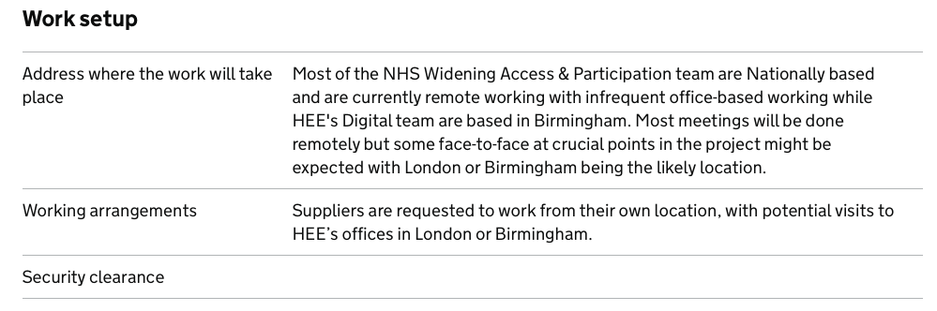
Image: By asking questions about elements such as security clearance, the Digital Marketplace is ensuring compliance with its standards without having to oversee every opportunity
Along with this approach, buyers are educated before they post opportunities. This education piece takes up one day per week.
As a result, most opportunities that are posted on the Marketplace comply with standards.
A similar approach would be beneficial for a pre-employment service. The design of the information required by providers as they post opportunities can be used to encourage compliance, alongside an education strand of work to further encourage consistency.
This approach takes the Digital Marketplace team approximately one day per week to achieve. This can act as a useful benchmark for the pre-employment service.

7.5.5 Create national policy around the fair distribution of pre-employment opportunities
Whilst a pre-employment service will go some way towards ensuring that opportunities are open and accessible to all, it won’t entirely solve the problems we have heard about unfairness.
Process and policy is needed here to both encourage and support providers to make fairer decisions about the distribution of opportunities.
Eventually, this may centre on policy whereby people can only take part in opportunities through this service. This will reduce instances of people being given opportunities because of family or friends.
The extent of this policy effort should be dictated by further research.
We have heard about the benefits of word of mouth in relation to social care recruitment. Notably, those who enter jobs through channels of word of mouth are strongly correlated to the highest retention rates.
If the same can be said for healthcare roles, then it may not be optimal to workforce supply to actively reduce opportunities enabled via family or friends.

7.5.6 Develop KPIs to measure the performance of the service
We recommend using subsequent phases of this work to develop KPIs and targets that will focus performance reporting on the strategic objectives of the service.
We recommend prioritising this work post-Discovery, however some useful KPIs might include:
- Tracking the diversity of applicants through the service
- Measuring the proportion of opportunities facilitated through the service (as opposed to on other platforms)
- Measuring drop outs through the application process
- The number of people carrying out in-person activities after engaging with online activities
In addition to service specific KPIs, we recommend you measure and set targets for three of the mandatory KPIs for government digital services:
- Cost per transaction
- User satisfaction
- Completion rate
See the Government Service Manual for further detail on these KPIs.
Importantly we recommend taking full responsibility for this process within the service team.
N.B. The NHS Digital Service Manual refers to the Government Service Manual for guidance relating to measuring the performance of the service

7.6 Suggested roadmap
At this point, it is too early to decide on a technical solution for applicant tracking. The technology options review (Section 7.4) has highlighted three viable options that would be worthwhile exploring going forwards.
Further work needs to be carried out to narrow down these choices to select the ones which best meet the needs of users.
This can be achieved by progressing to an Alpha phase.
The Alpha phase will help the team to quickly learn which of the technology options are most appropriate to the user needs identified throughout our research.

7.6.1 Prepare for an Alpha
Before beginning an Alpha, we recommend carrying out three distinct activities to answer some fundamental questions that will shape the direction of any Alpha work.
Important: failing to complete these activities before the start of an Alpha will greatly increase the risk of choosing an inappropriate solution.

7.6.1.1 Start to collect more pre-employment data
Our recommendations have mentioned several areas where data can better support strategic decision making as the work progresses.
It would be beneficial to start this data collection process as soon as possible so that it can start to feed decision making.
N.B. The Talent for Care Team is starting an annual data collection process in 2023 which will collect some, but not all, of this data.

7.6.1.2 Consider the organisational challenges to implementing both NHS Jobs and Lincolnshire Talent Academy tool
Our technical recommendations (Section 7.4) highlight three potential technical solutions for the application tracking element of this work: NHS Jobs, the Lincolnshire Talent Academy tool or a bespoke solution.
Whilst NHS Jobs and the Talent Academy tool appear to be the best options, there are several factors that need to be considered before an Alpha phase, which will influence the viability of each option.
From a technical standpoint, exploring the feasibility of these platforms is likely to be relatively straightforward, whereas understanding the organisational challenges may be more difficult.
Notably work needs to be done to understand the ownership structure, underpinning service and costs of the two technologies to better understand their suitability.
Whilst NHS Jobs is perhaps the obvious technological choice, the team need to consider what an ideal relationship would be with NHS Business Services Authority to deliver on an application tracking system for work experience opportunities.
The team needs to be confident that their user needs can be prioritised and met satisfactorily within the roadmap of NHS Jobs.
In the case of the Talent Academy tool, we have been unable to articulate the exact costs involved. It appears that there is a cost per placement on this tool, but we do not know the exact amount.
For a national service, catering for 25,000 opportunities, this cost could be substantial and therefore prohibitive.
This cost is on top of other costs to scale and run the service.
Whilst NHS Jobs is perhaps the most obvious technical solution, service management challenges may prove insurmountable when mapped against the needs and wants of the project team.
Similarly, the approach to costs may rule out the Talent Academy tool.
It is important to understand this in advance of an Alpha to help prioritise your resources.

7.6.1.3 Planning for Alpha
Section 7.6.2 sets out a series of potential Alpha experiments that will help to quickly learn which options will meet the user needs identified and prioritised throughout our research.
To reach the point of being ready to begin an Alpha, the project team will need to consider and own a number of decisions to shape this work.
Doing this as early as possible will ensure that the HEE team is prepared for the Alpha phase.

7.6.1.3.1 Service and product ownership
Decide who will be your service owner and product manager and ensure that these people have sufficient time to dedicate to an Alpha phase.
Leading and delivering an Alpha can be more intensive and time-consuming than carrying out a Discovery.
This is particularly important for the product manager, who will be responsible for the day-to-day elements of the work.

7.6.1.3.2 Service standards
Familiarise yourself with any service standards you will need to meet throughout the delivery of the work. The NHS Digital Service Standard, Technology Code of Practice and Alpha phase in particular.
It is also important to identify who will be assessing the service as part of the service assessment process.

7.6.1.3.3 Identify a set of Alpha experiments
Section 7.6.2 documents a set of potential Alpha experiments that could be used to inform an Alpha phase of work.
The team should consider these experiments, alongside the technical options and agree on a finalised set of experiments for the Alpha phase.
It may be necessary to devise new experiments at this stage, taking into account work carried out as part of Section 7.6.1.2.
Experiments should allow the team to answer questions needed to be confident that a technical option will meet the needs of end users.

7.6.1.3.4 Plan for a multidisciplinary team
Having agreed on a set of Alpha experiments there is a need to consider the technical and specialist skills that will be required to build proof of concepts for each option.
It is also important to consider other roles and skills that will be needed to form a multidisciplinary team for the Alpha phase.
Subsequently, the resourcing of technical and non-technical roles needs to be considered.
Based on the experiments outlined in Section 7.6.2, an indicative Alpha team would need to be comprised of:
- Product manager
- Delivery manager
- User researcher/s
- User experience designer
- Service designer
- Technical architect
- Full stack developer (with hands on experience in Node if NHS Jobs is a preferred option)
- An accessibility and assisted digital lead
You should also consider having access to:
- Performance analyst
- Content designer
- Quality assurance and testing skills
These roles can be occupied by members of the HEE service team , other HEE colleagues, or external contractors.

7.6.1.3.5 Devise a research plan
Good quality user research will underpin the success of any Alpha phase.
It is important to plan for how user research will be carried out during Alpha.
An important element will be having a user researcher within the Alpha team, however it will be equally important to identify a plan for recruiting research participants.
Starting the process of identifying research participants as early as possible will streamline the user research process, which can be particularly important during the pressures of fast-moving Alpha sprints.

7.6.1.3.6 Identify an appropriate route through assurance processes
It is prudent to engage with the Assurance Team who will be assessing your Alpha at this stage to share any plans for the Alpha.
This provides an early opportunity to gather feedback which can be used to refine the Alpha plan, to deliver the best work possible.

7.6.1.3.7 Produce a brief and plan procurement (if necessary)
Each of the subsequent stages have described a set of activities that will ultimately form a brief for an Alpha phase.
It will document the problem, the experiments that will be undertaken and what roles are needed to achieve success.
This brief can be used to prepare for planned procurement at this stage, if it is necessary to involve external parties in order to recruit the roles needed to carry out the work.

7.6.2 (Cautiously) proceed to Alpha
Only once you have completed the activities outlined in Section 7.6.1, we recommend proceeding to an Alpha phase.
The Alpha is largely an experiment or proof of concept for the potential service.
We strongly recommend that the service delivery team approaches the Alpha with a shared set of questions designed to explore the existing and alternative solutions outlined in Section 7.4
This approach will be heavily influenced by the pre-Alpha work outlined in Section 7.6.1.
For example, you might discount some of the options based on conversations around ownership, risks and costs before reaching this stage of the project.
Depending on the recommendations you adopt and prioritise for Alpha, a reasonable set of experiments could include:
- Explore whether a single marketplace can cover all in-person work experience opportunities
- Explore whether this service will make it easier for providers to facilitate pre-employment opportunities
- Understand how the service can work for a range of disciplines, including social care
- Explore potential options surrounding the roll out of a new platform
- Explore the branding and entry point surrounding a potential service
These are in addition to the standard set of NHS Service Standard recommendations to use the experience of building prototypes in the alpha to:
- Find the problems with the design of your service and decide how you’ll solve them
- Make some estimates about how much your service will cost
- Identify the biggest risks for the Beta stage, as early as possible
We would expect an Alpha of this size to take approximately 12 weeks.

Annex 1: Discovery research

Research sources
The following materials have been reviewed during the Discovery phase:
- Previous research provider workshop outputs
- BSA volunteering recruitment Discovery
- National work experience platform documentation including overview and specification
- Talent for Care data collection
- Talent for Care definitions
- Learning Hub online materials
- Springpod online supported internship
- Early careers survey 2021
- Movement to work youth voice census
- NHS BSA Strategy 2022-2025
- DFE, Employability programmes and work placements in UK higher education
- HEE Employability programme ROI validation
- The value of work experience literature review
- Work experience deep dive survey
- Access to medicine overview
- Prince’s Trust outcomes data
- Improving the evaluation of work experience report
- HEE online work related learning toolkits

Stakeholder interviews
A range of stakeholders were interviewed during the Discovery phase, including:
- Elisa Lakhan-Hector, Head of Enterprise Architecture, Health Education England
- Jon Bowlas, Senior Communications Manager Digital, Health Education England
- Darren Aldrich, Strategy and Communications Lead Health Careers, Health Education England
- Katie Adams, Head of Widening Access Team, Health Education England
- Rachel Wright, National Programme Manager, Widening Access and Participation team, Health Education England
- Patrick Mitchell, Director of Innovation, Digital and Transformation, Health Education England
- Jane Hadfield, National Lead, Talent for Care and Senior Programme Manager – Apprenticeships, Health Education England
- Lynn Scott, Senior Service Delivery Manager - NHS Jobs, NHS Business Services
- Amanda Ashworth, Project Manager Workforce Capacity and Transformation, Skills for Care
- Teresa Hewitt-Moran, Interim Regional Deputy Director South West, Health Education England
- Callum Pallister, Director of Finance, Health Education England

Landscape stakeholder interviewees
- Claire Flavell, Head of Service / Strategic Lead, Lincolnshire Talent Academy
- Miles Jarvis, Product Manager, Get School Experience service
- David Elsley, Associate Commercial Lead for Digital Outcomes Specialists/Digital Futures and Megan Barradell, Digital Directory Services Team

User participants
All the users below were involved in one-to-one interviews, the user needs workshop, user needs sessions, co-design workshop, co-design sessions or concept feedback sessions.

User interviews
- Young learner, aged 16 in school
- Young learner, aged 18 working towards a qualification or completing an apprenticeship / traineeship
- Young learner, aged 17 in college
- Young learner, aged 18 not in education, employment or training (NEET)
- Young learner, aged 16 in school or college
- Young learner, aged 15 in school
- Young learner, aged 15 in school
- Young learner, aged 15 in school
- Young learner, aged 14 in school
- Young learner, aged 14 in school
- Young learner, aged 16 in school or college
- Young learner, aged 17 in school or college
- Young learner, aged 15 in school
- Young learner, aged 17 in school or college
- Young learner, aged 16 in school or college
- Young learner, aged 18, part time employed
- Young learner, aged 14 in school
- Young learner, aged 15 in school
- Support network, Careers advisor, academy
- Support network, Careers advisor, state comprehensive
- Support network, Careers advisor, college
- Support network, Teacher, Academy
- Support network, Careers advisor, college
- Support network, Teacher, academy
- Provider/coordinator, Programme manager, Barts Health NHS Trust
- Provider/coordinator Work Based Learning Manager, Mid and South Essex NHS Foundation Trust
- Provider/coordinator, Head of Widening Participation Manchester university Foundation Trust
- Provider/coordinator, Widening Participation Lead, The Shrewsbury and Telford Hospital NHS Trust
- Provider/coordinator, Head of their hospital’s Apprenticeships and Development Centre, University Hospitals of Leicester
- Provider/coordinator, Apprenticeships and Widening Participation Lead, Nottingham University Hospitals NHS Trust
- Provider/coordinator, Work Experience coordinator, Sherwood Forest Hospitals NHS Foundation Trust
- Provider/coordinator, Project Manager, Humber and North Yorkshire integrated care board
- Provider/coordinator, Early Career and Volunteer Coordinator, Devon Partnership Trust
- Provider/coordinator, GP, Training Hub

User needs workshop
- Provider/coordinator, Widening Participation Lead, Shrewsbury and Telford Hospital NHS Trust

User needs sessions
- Young learner, aged 18, University student
- Young learner, aged 17 in college
- Support network, Parent of child aged 17, at school/college
- Support network, Teacher, college

Co-design workshop
- Provider/coordinator, Business Support Manager/ NHS Futures Co-ordinator, The Royal Wolverhampton NHS Trust

Co-design sessions
- Young learner, aged 18, NEET
- Young learner, aged 16, school or college
- Support network, Careers advisor, college

Concept feedback sessions
- Young learner, aged 15, school
- Young learner, aged 16, school or college
- Young learner, aged 14, school
- Young learner, aged 17, school or college
- Support network, Careers advisor, college
- Provider/coordinator, Health and Care Academy Programme Manager, Herts and West Essex Integrated Care System
- Provider/coordinator, Development Manager, HEE South West
- Provider/coordinator, Vocational Education Manager, Doncaster and Bassetlaw Teaching Hospitals NHS Foundation Trust
- Provider/coordinator, Project Manager - Improving AHP careers awareness, Herefordshire and Worcestershire Integrated Care System

Annex 2: Discovery outputs
These artefacts have been delivered in accordance with the project proposal:
- Notes from stakeholder interviews
- User research notes and analysis from user interviews
- Survey results and analysis
- User proto-persona profiles
- User journey maps
- Service journey maps
- User needs backlog
- Service blueprint
- Market options analysis
- Findings show and tell presentation
- Handover show and tell presentation
- Discovery report (this document)
- Executive summary
These other distinct outputs have also been delivered in accordance with the project proposal but captured elsewhere:
- Discovery concept development (Section 4)
- Landscape analysis case studies (Section 5)

Annex 3: Surveys

Young learners user needs validation survey data
64 young learners completed the survey and further data about their responses have been included in the summaries below.

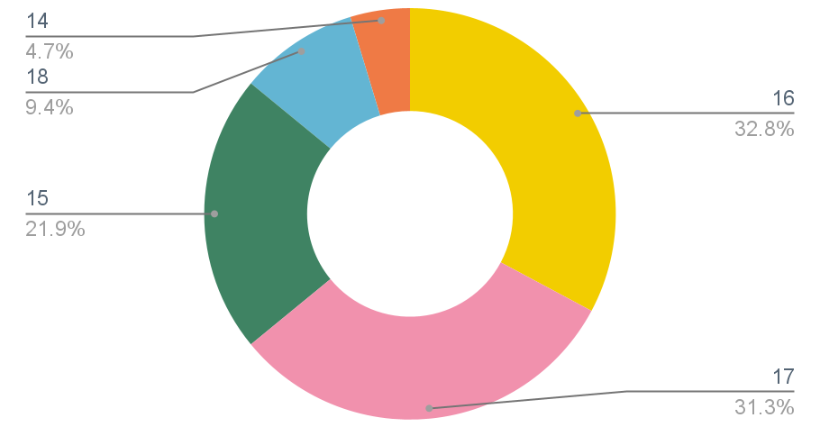
How old are you?

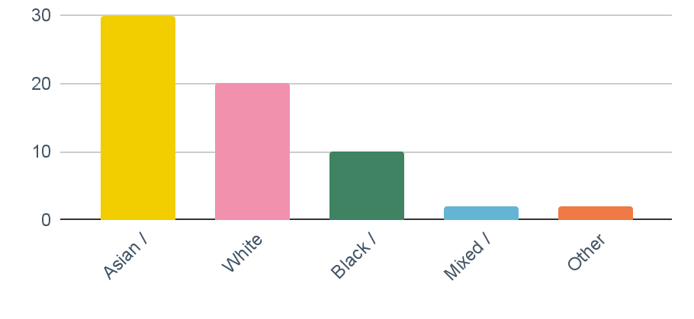
What is your ethnic group?

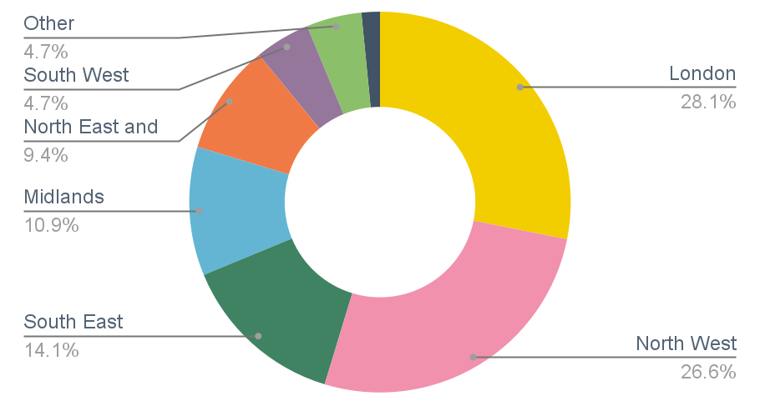
What region in England do you live in?

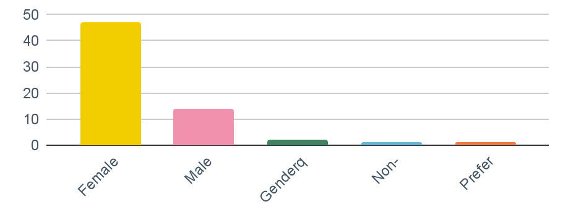
Regarding your sex and gender, how do you currently identify?

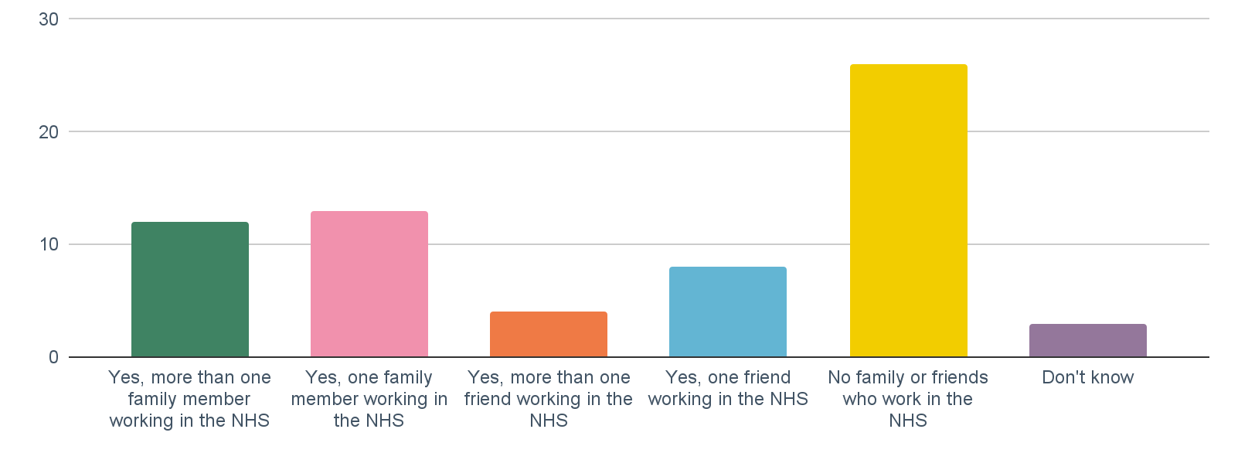
Do you have any family members or friends who already work in the NHS?

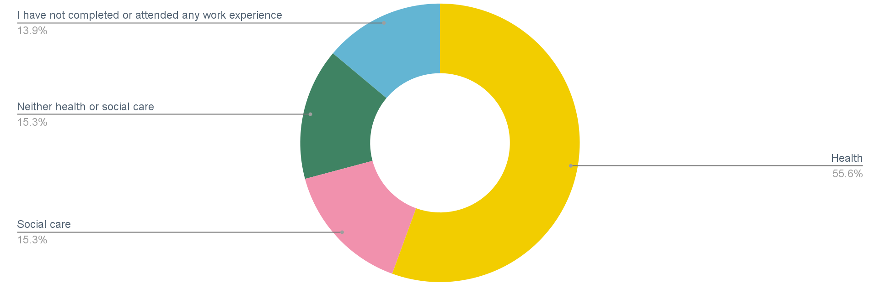
Which of the following sectors have you completed or attended some form of work experience or work-related activity in?

Providers user needs validation survey data
57 pre-employment opportunity providers completed the survey and further data about their responses have been included in the summaries below.

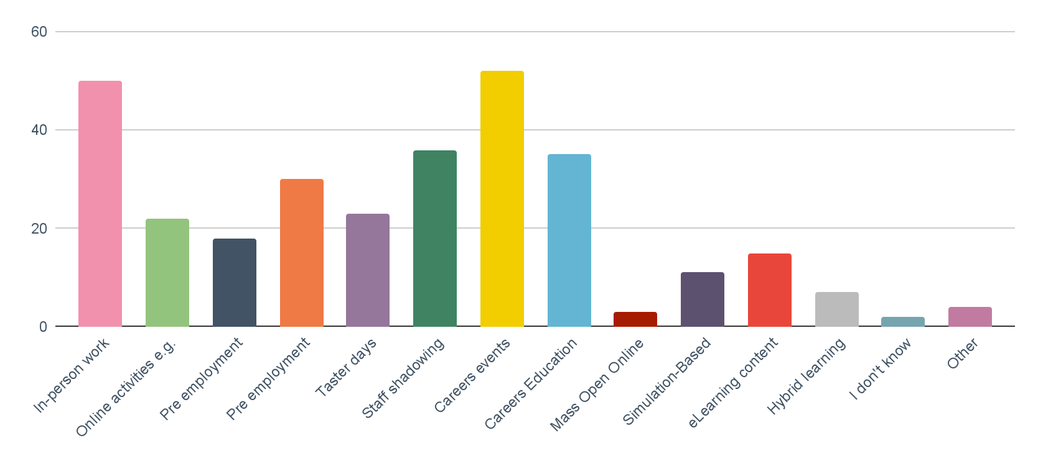
What types of pre-employment opportunities does your organisation provide?

Which of the following professions do your pre-employment opportunities relate to?
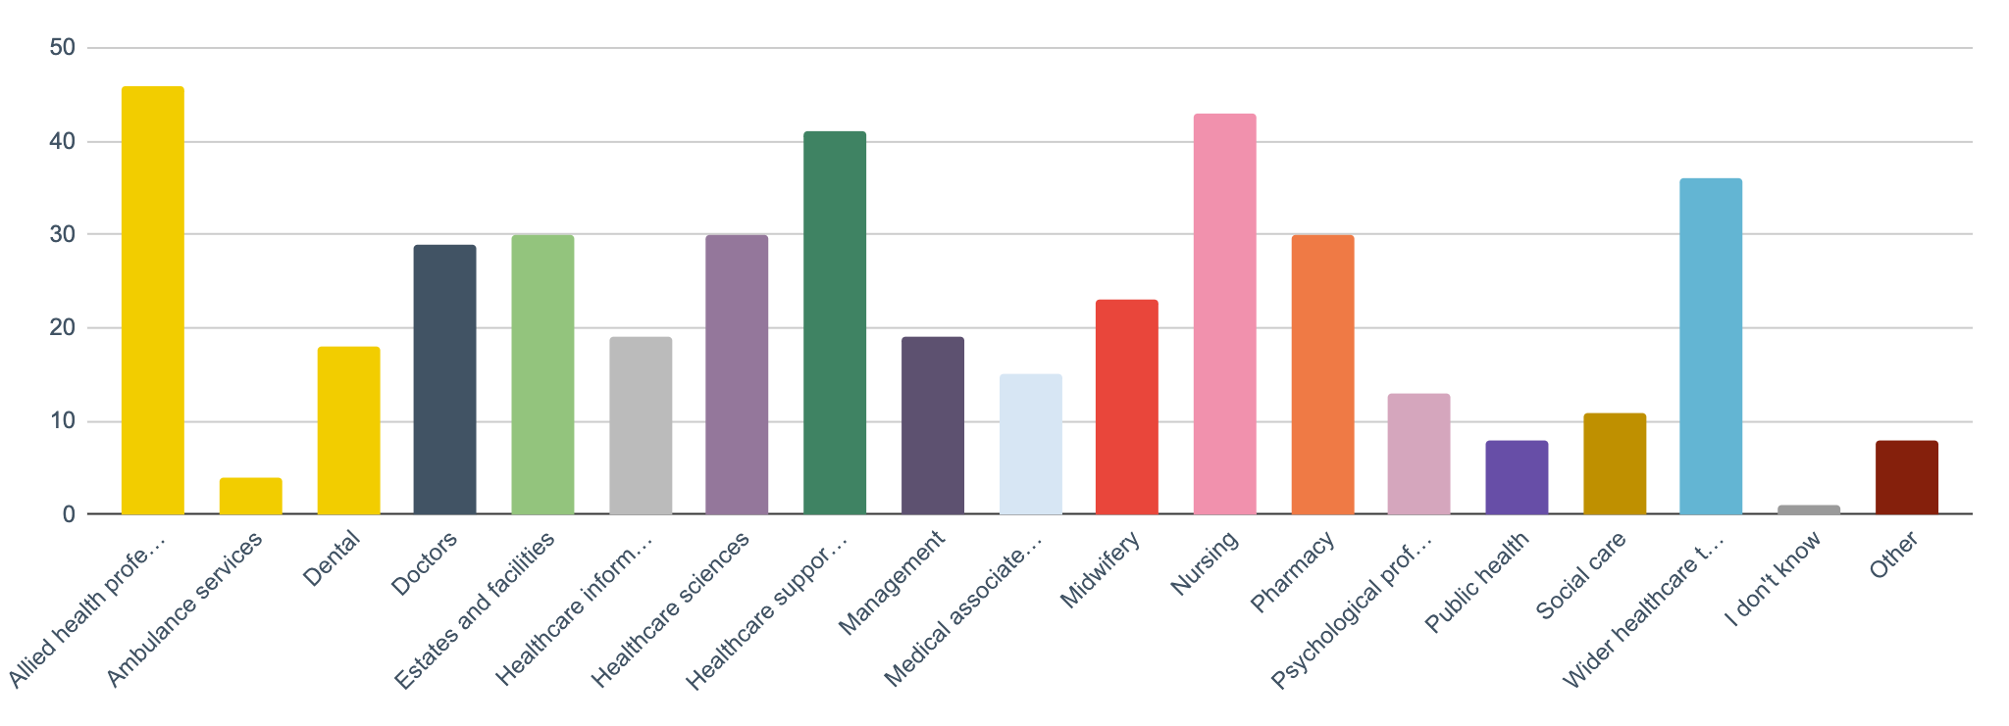

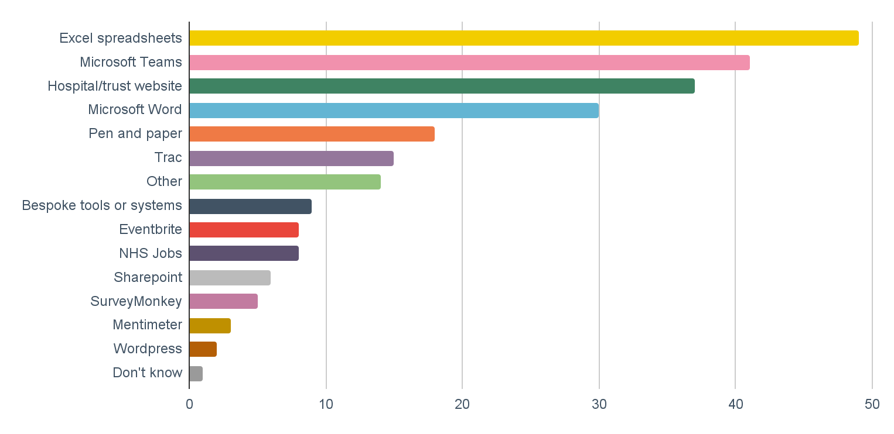
What tools do you currently use to plan, promote, review and manage pre-employment opportunities?

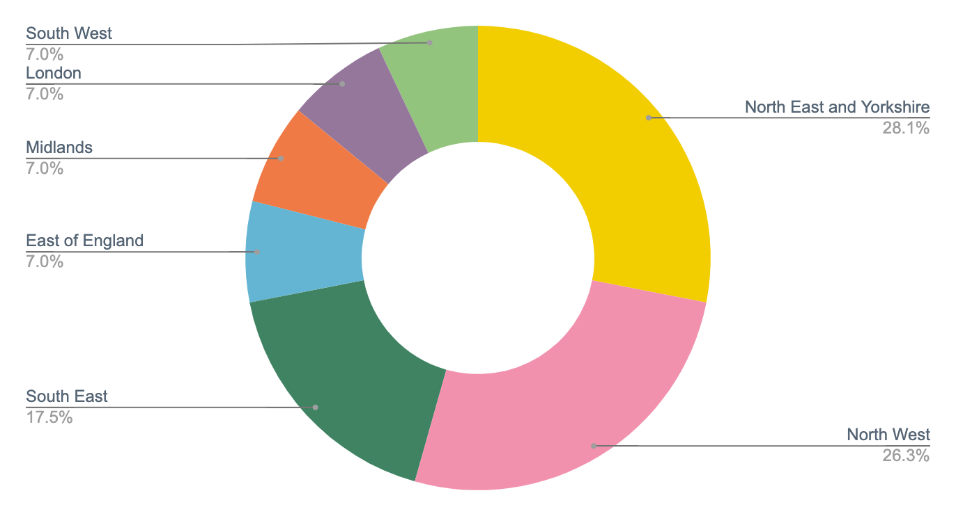
What region in England do you work in?

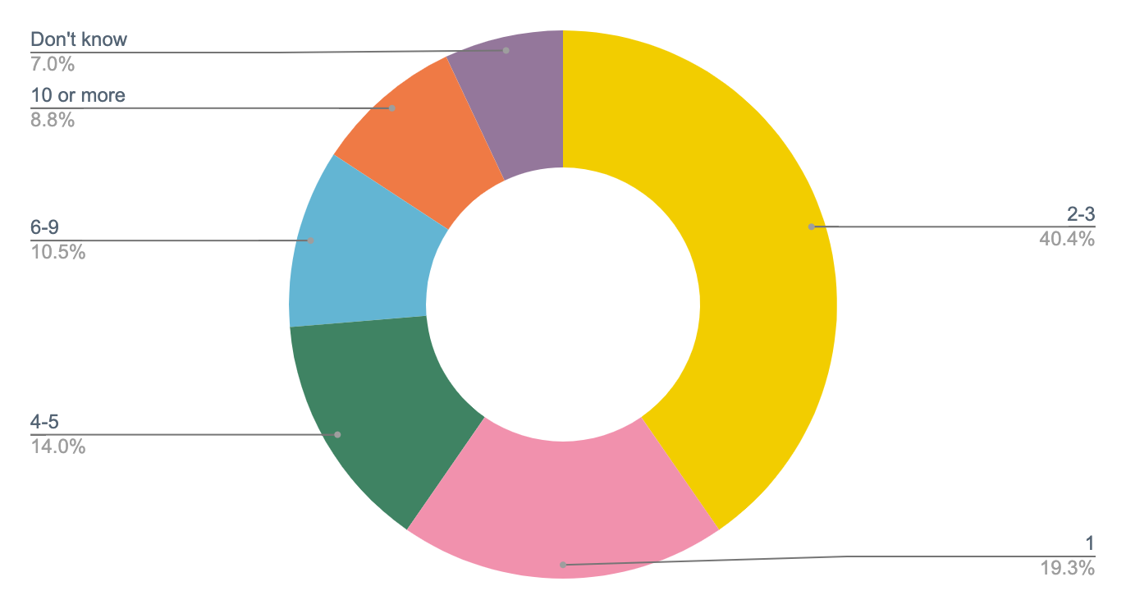
Approximately how many people in your organisation are involved with the planning, promoting and managing of pre-employment opportunities?

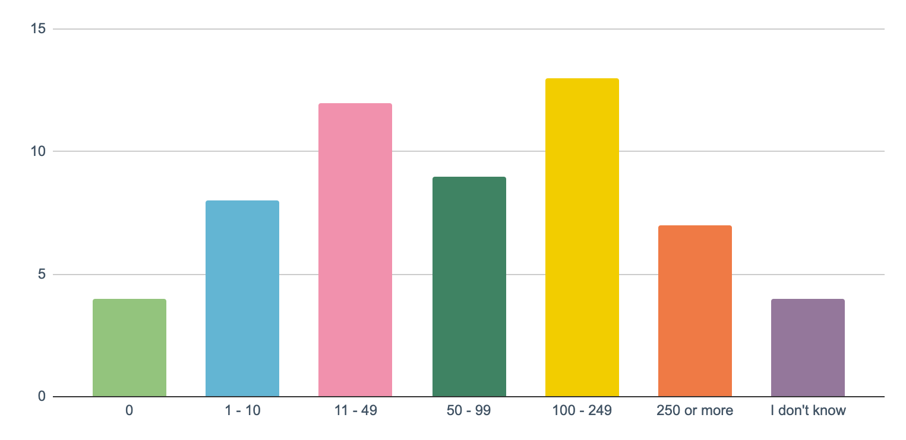
In the last year, approximately how many young people attend in-person pre-employment opportunities provided by your organisation each year?

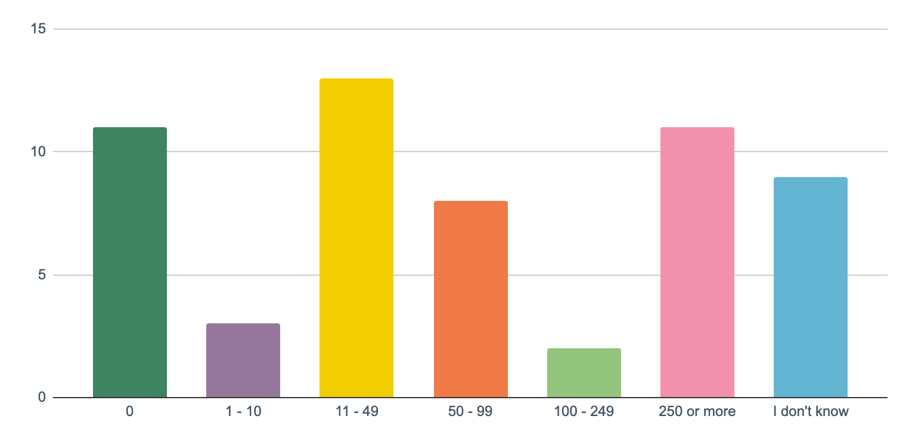
In the last year, approximately how many young people attend in-person pre-employment opportunities provided by your organisation each year?

Teachers/careers advisors user needs validation survey data
28 teachers/careers advisors completed the survey and further data about their responses have been included in the summaries below.

What region in England do you work in?
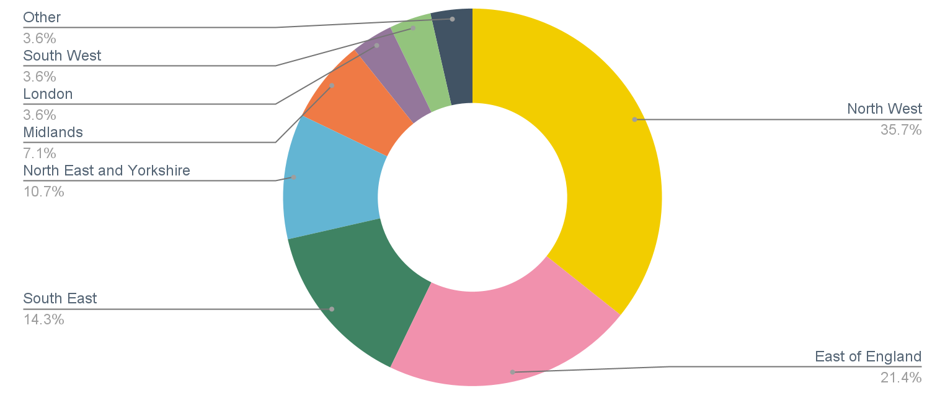

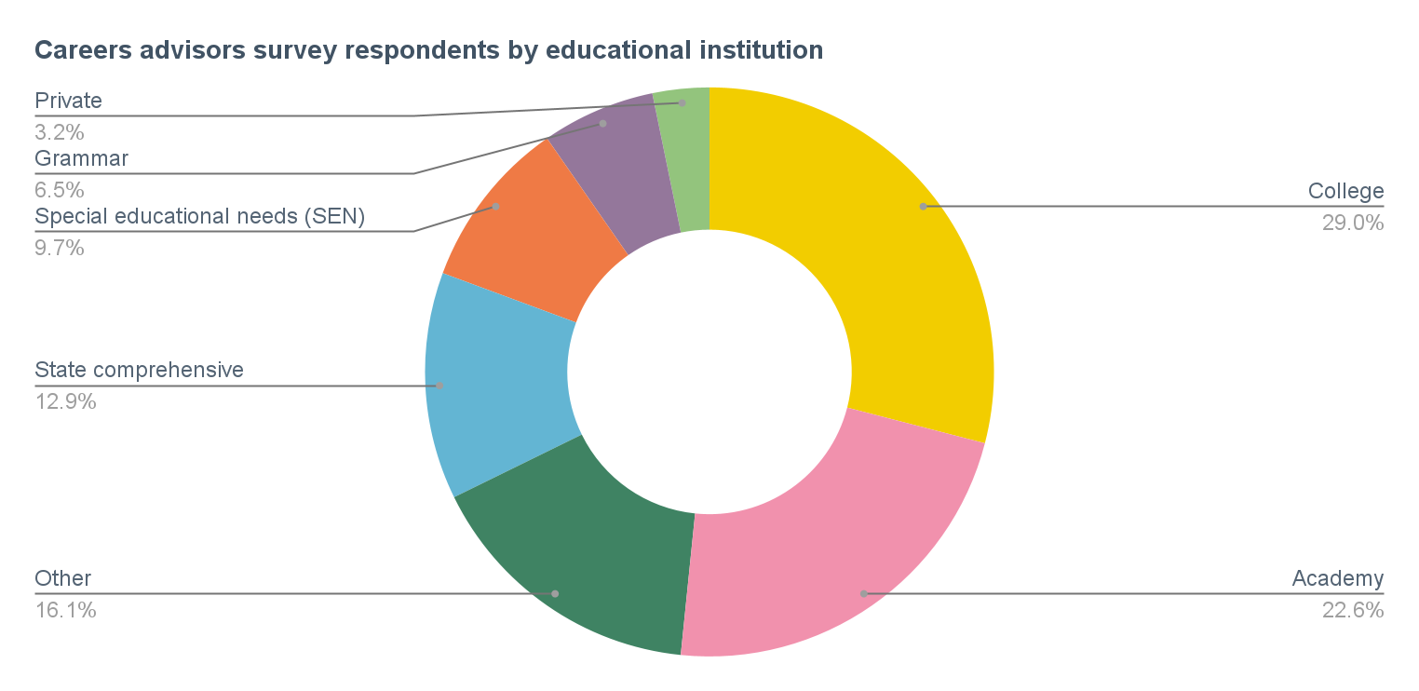
What type of school or educational institution do you work for?

