# **Developing advanced practice in pharmacy – why and how (FAQs)**

|  |
| --- |
| **What is advanced clinical practice?** Advanced clinical practice is:   * delivered by **experienced**, registered health and care practitioners * a level of practice characterised by a **high degree of autonomy** and **complex decision making** * underpinned by a **master’s level** award or equivalent that encompasses the **four pillars** of clinical practice, leadership and management, education and research, with **demonstration of core capabilities and area-specific clinical competence**   It sits on pharmacist career continuum as shown below: |

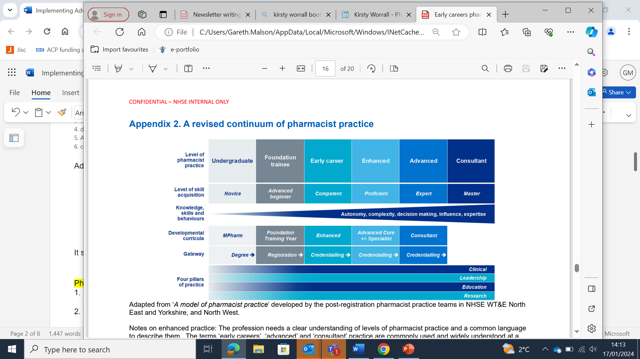

# **Why should employers embrace advanced practice development?**

Working towards advanced practice accreditation encourages:

* Structure to personal development that can be recognised across all sectors of the profession, and alongside a roadmap for working towards consultant-level practice
* Broad development across all four pillars of practice, often resulting in a more varied role or breadth of professional activities
* Assurance for employers and patients about standard of practice
* A consistent approach to career transition from foundation to consultant through a process of accreditation
* Experienced pharmacists to build educator skills to support the development of undergraduates, trainee pharmacists and foundation-level pharmacists
* The development of professional skills, including decision making, team working and resilience

|  |  |  |  |  |  |
| --- | --- | --- | --- | --- | --- |
| **How to become credentialed** | | | | | |
| **Provider** | **Framework** | **Route** | **Evidence Required** | **Available to** | **Successful Outcome** |
| **Royal Pharmaceutical Society (supported)** | [Core Advanced Curriculum](https://www.rpharms.com/development/credentialing/core-advanced-pharmacist-curriculum) | [RPS Advanced Credentialing Support Programme](https://www.cppe.ac.uk/career/rps-adv-credential)* | [RPS e-portfolio](https://www.rpharms.com/development/credentialing/core-advanced-pharmacist-curriculum/core-advanced-pharmacist-e-portfolio) | All pharmacists** | Receive RPS Core Advanced Practice Credential*** and Centre for Advancing Practice digital badge |
| **Royal Pharmaceutical Society (self-directed)** | [Core Advanced Curriculum](https://www.rpharms.com/development/credentialing/core-advanced-pharmacist-curriculum) | Self-directed portfolio | [RPS e-portfolio](https://www.rpharms.com/development/credentialing/core-advanced-pharmacist-curriculum/core-advanced-pharmacist-e-portfolio) | All pharmacists** | Receive RPS Core Advanced Practice Credential*** |
| **NHS England (formerly HEE)** | [Multi-professional framework for advanced practice in England](https://advanced-practice.hee.nhs.uk/multi-professional-framework-for-advanced-practice/) | [Accredited ACP 3 year master's degree](https://advanced-practice.hee.nhs.uk/our-work/programme-accreditation/accredited-programmes/) | ACP course requirements | Registered healthcare professionals (including pharmacists) | Centre for Advancing Practice digital badge and listed on NHS England Directory of Advanced Practitioners**** |
| * Expressions of interest to join a supported eportfolio route can be made [**here**](https://advanced-practice.hee.nhs.uk/our-work/eportfolio-route/)  ** Pharmacists can start collecting evidence at any time and can submit their portfolio as per RPS submission deadlines. They do not need to be an RPS member to access the portfolio, collect evidence and submit for assessment.  *** Members of the RPS can use the post-nominal MRPharmS (Advanced Practice)  **** Directory not currently available to the public. | | | | | |

# **What is the difference between an advanced clinical practitioner and an advanced pharmacist practitioner?**

* Both ACPs and APPs deliver complex patient care autonomously, while leading and educating others and being research active
* Arguably, due to the training provided on the ACP masters course, ACPs tend to have a significant amount of their time apportioned to clinical assessment of acutely unwell patients, or those needing advanced diagnostic assessment. APPs may also do this but may not necessarily been taught to do so at a higher education institute (e.g. a university).

# **How have some hospital trusts already embedded advanced practice development?**

***Definition****: An Advanced Practice Development Programme (APDP) is a structured programme of learning based on an analysis of the learning needs of a given cohort of pharmacists.*

**Key features of an APDP** (Appendix 1 for example)

1. Identify a group of pharmacists who are keen to develop to an advanced level of practice
   1. For example, this is likely to suit band 7/8a pharmacists
2. Discuss the options for accreditation (ACP masters or RPS portfolio)
3. Pharmacists self-assess themselves against the [RPS Core Advanced Curriculum](https://www.rpharms.com/Portals/0/Credentialing/RPS%20-%20Core%20Advanced%20curriculumFINAL.pdf?ver=iR3AZBxZA79vddgs6a6wUQ%3d%3d) (a self-assessment form is provided in Appendix 2)
4. Review the gaps in curriculum achievement identified by your workforce and tailor a programme of learning and development activities to support this development
5. Agree capacity and a timetable to run specified learning events or modules
6. Agree a time commitment from staff and supervisors for both teaching and discussing evidence

**Other considerations:**

* Can time for research activities be built into individual job plans and working patterns? (This is the domain often cited as the most challenging to complete)
* Consider the use of [action learning sets](https://library.hee.nhs.uk/knowledge-mobilisation/knowledge-mobilisation-toolkit/action-learning-sets) to solve problems or fill gaps identified by pharmacists in their self-assessment
* Encourage a mentorship programme (see below), whereby all pharmacists are offered a more experienced mentor and offer to support those less experienced than themselves
* For the education pillar, consider how your existing pharmacists can support trainee pharmacists after 2025 when they register with a prescribing qualification
* Consider whether and how advanced practice accreditation could be linked with the existing appraisal system
* For those who are doing the RPS core advanced curriculum:
  + Set realistic expectations on time to complete portfolios
    - 6-12 months for those who are credential ready
    - 1-5 years for those who are not ready, depending on how many gaps they have in their self-assessment
  + Consider breaking up the domains into small groups and focus on each one until sufficient evidence is gathered, before moving on to the next
  + Ensure collaborator duties are spread widely among appropriate members of staff

|  |  |
| --- | --- |
| **Core Principles of an APDP** | |
| Supervision | Portfolio |
| Resources | Curriculum |

This programme is intended to support workplace learning and enable quality assurance but offer individual organisations the freedom to build a programme around their own needs and capacity. Such a programme can also help to meet the tenets of the [NHS Long Term Workforce Plan](https://www.england.nhs.uk/publication/nhs-long-term-workforce-plan/) by upskilling pharmacists and placing them in a stronger position to assume innovative roles.

# **Where can I find more information on the ACP Masters Course?**

Liaise with your advanced practice lead (if you have one) and seek clarification from your regional Faculty of Advanced Practice website on application processes and deadlines

* [North East and Yorkshire](https://advanced-practice.hee.nhs.uk/welcome/regional-faculty-for-advancing-practice-north-east-and-yorkshire/guidance-and-resources/)
* [North West](https://advanced-practice.hee.nhs.uk/regional-faculties-for-advancing-practice/regional-faculty-for-advancing-practice-north-west/)

Ensure that appropriate clinical supervision arrangements will be in place when submitting funding applications, and rewrite job plans to allow 1 day a week for off-the-job training and 1 day a week of classroom learning

# **Where can I find more information on completing an advanced practice portfolio**

More information can be found on the [RPS website](https://www.rpharms.com/development/credentialing/core-advanced-pharmacist-curriculum).

If you would like any advice, contact your NHS England advanced practice training programme director:

* + North East and Yorkshire: Hazel Jamieson ([hazel.jamieson2@nhs.net](mailto:hazel.jamieson2@nhs.net))
  + North West: Gareth Malson ([gareth.malson1@nhs.net](mailto:gareth.malson1@nhs.net))

# **How and why can pharmacists be supported to supervise and mentor others?**

All pharmacists should be encouraged to get involved with supervising more junior pharmacists, those in training, or undergraduate students. Do you have the skills and experience to be an educational supervisor or mentor? These include:

|  |  |
| --- | --- |
| Empathy | Leadership |
| Active listening | Observation |
| Well organised | Creativity |
| Strong relationship builder | Conflict management |
| Ability to give constructive feedback | Problem solving |

Several options can be found to help developing these skills or the confidence to use them, for example:

1. Complete educational supervisor training if needed
2. Consider watching [RPS webinars on mentoring](https://www.rpharms.com/development/mentoring/webinars)

When being a mentor, ensure you:

* Understand the curriculum being undertaken by the pharmacist
* Provide support through regular planned meetings
* Identify experiential learning opportunities that are mutually beneficial to the directorate and the trainee
* Oversee the progress of the pharmacist and facilitate additional support where needed

# **Appendix 1 - The Sheffield model**

In 2019, Sheffield Teaching Hospitals Pharmacy department created an in-house training programme to support the development of pharmacists at band 7 level to transition from early careers to advanced practice. This programme included teaching, reflective practice and documenting of evidence (portfolio building) with an emphasis on self-directed learning and peer support. It also seeks to develop autonomy and sphere of influence, along with decision making and skills to deal with complexity.

Pharmacists self-assessed their development against the six clusters of the RPS Advanced Practice Framework (now superseded by the core advanced curriculum) to identify their personal learning needs and then attended face-to-face teaching sessions on one of the domains. Module content consisted mostly of in-house teaching sessions, plus some external learning resources (e.g. via the NHS Leadership Academy).

Pharmacists could attend up to four sessions each year most beneficial for their personal development, which could span different curriculum domains. This flexible approach aimed to provide a programme tailored to the needs of the individual and their clinical role and has been retained for subsequent iterations (Fig 1).

Since its launch the STH APDP has been generally very well received by those attending. Feedback from participants indicates that most feel the APDP has supported them in their development towards the curriculum learning outcomes. A future aim of the APDP is to maintain interest and momentum for learning over the whole year using potential initiatives such as an electronic newsletter, online space for sharing learning and ideas, peer support meetings and incorporation of the APF into annual appraisals.

# **Appendix 2: Self-assessment for RPS Core Advanced Curriculum**

For further advice on generating evidence for each learning outcome, see the descriptors listed against each outcome in the [RPS core advanced curriculum document](https://www.rpharms.com/Portals/0/Credentialing/RPS%20-%20Core%20Advanced%20curriculumFINAL.pdf?ver=8gc3s2aE9t1nZN37CSU7Lw%3d%3d)

|  |  |
| --- | --- |
| **Competent** | I already have the necessary knowledge, skills, and behaviours to fully meet this specific statement and can provide evidence for this. No action required. |
| **Development required** | I have some knowledge, skills, and behaviours in this area, but these need to be developed further. I will create an action plan to address this. |
| **No previous experience** | This is new to me. I need to prioritise my action plan to develop my competence in this area. |

## **Person-centred care and collaboration**

|  |  |  |  |  |
| --- | --- | --- | --- | --- |
| **Learning outcome** | **Competent** | **Development required** | **No previous experience** | **Comments on evidence – either already available or required** |
| 1.1 Communicates complex, sensitive and/or contentious information effectively with people receiving care and senior decision makers. |  |  |  |  |
| 1.2 Demonstrates cultural effectiveness through action; values and respects others, creating an inclusive environment in the delivery of care and with colleagues. |  |  |  |  |
| 1.3 Always keeps the person at the centre of their approach to care when managing challenging situations; empowers individuals and, where necessary, appropriately advocates for those who are unable to effectively advocate for themselves. |  |  |  |  |
| 1.4 Builds strong relationships with colleagues working as part of multidisciplinary teams, influencing the delivery of positive healthcare outcomes at a team and/or organisational level. |  |  |  |  |
| 1.5 Gains co-operation from senior stakeholders through effective influencing, persuasion, and negotiation. |  |  |  |  |
| 1.6 Recognises, and respects, the role of others in the wide pharmacy and multidisciplinary team; optimises the care delivered for individuals and groups through appropriate delegation and referral. |  |  |  |  |

## **Professional practice**

|  |  |  |  |  |
| --- | --- | --- | --- | --- |
| **Learning outcome** | **Competent** | **Development required** | **No previous experience** | **Comments on evidence – either already available or required** |
| 2.1 Delivers care using advanced pharmaceutical knowledge and skills for individuals and/or groups with highly complex needs, including where evidence is limited or ambiguous. |  |  |  |  |
| 2.2 Undertakes a holistic clinical review of individuals with complex needs, using a range of assessment methods, appropriately adapting assessments and communication style based on the individual. |  |  |  |  |
| 2.3 Demonstrates effective clinical reasoning skills, making autonomous, evidence informed, person-centred decisions about treatment for individuals or groups with complex clinical needs, managing risk in the presence of significant uncertainty. |  |  |  |  |
| 2.4 Acts to improve the health of the population and reduce health inequalities. |  |  |  |  |
| 2.5 Makes, and is accountable for, own decisions and takes responsibility for performance at a team and/or service level. |  |  |  |  |
| 2.6 Defines and articulates own advanced scope of practice to others; uses professional judgement to appropriately seek help when needed for complex and/or high-stakes decisions. |  |  |  |  |

## **Leadership and management**

|  |  |  |  |  |
| --- | --- | --- | --- | --- |
| **Learning outcome** | **Competent** | **Development required** | **No previous experience** | **Comments on evidence – either already available or required** |
| 3.1 Pro-actively contributes to defining a strategic vision for their team and/or service in collaboration with other senior stakeholders; engages others to support the delivery of the strategic vision. |  |  |  |  |
| 3.2 Motivates and supports individuals and/or teams to improve performance |  |  |  |  |
| 3.3 Demonstrates team leadership, resilience and determination, managing situations that are unfamiliar, complex and/or unpredictable to deliver positive outcomes at a team and/ or service level. |  |  |  |  |
| 3.4 Critically analyses data as part of quality improvement and/ or innovation in the development and delivery of services, the identification and mitigation of medicines-related risks, and the management of resources. |  |  |  |  |
| 3.5 Works collaboratively with multi-disciplinary resources across care settings to develop and implement strategies to manage risk and improve safety and outcomes from medicines and care delivery. |  |  |  |  |
| 3.6 Demonstrates emotional intelligence when managing challenging and complex situations; remains composed and de-escalates potential and actual conflict situations. |  |  |  |  |

## **Education**

|  |  |  |  |  |
| --- | --- | --- | --- | --- |
| **Learning outcome** | **Competent** | **Development required** | **No previous experience** | **Comments on evidence – either already available or required** |
| 4.1 Reflects on practice to critically assess own learning needs and pro-actively engages in professional development |  |  |  |  |
| 4.2 Supervises others’ performance and development; provides high quality feedback, mentorship and support. |  |  |  |  |
| 4.3 Designs and delivers educational interventions that impact at a team and/or organisational level, supporting members of the pharmacy team, wider multidisciplinary team, and/or service users, to safely and effectively use medicines |  |  |  |  |

## **Research**

|  |  |  |  |  |
| --- | --- | --- | --- | --- |
| **Learning outcome** | **Competent** | **Development required** | **No previous experience** | **Comments on evidence – either already available or required** |
| 5.1 Interprets and critically appraises the evidence base to inform practice and care delivery at a team and/or service level. |  |  |  |  |
| 5.2 Identifies gaps in the evidence base; uses appropriate methods for addressing the identified gap(s), generating new evidence. |  |  |  |  |
| 5.3 Implements changes at a team and/or service level based on the outputs of their research and/or quality improvement activity and disseminates findings. |  |  |  |  |
| 5.4 Collaborates with others in undertaking research and supports others to engage with research and improvement activities. |  |  |  |  |