Workforce, Training and Education (WT&E) Directorate

Inclusive Educational Faculty Recruitment:
Ensuring best practice

Using this document

A recent significant event has helped to crystallise a developing view that as NHSE WT&E we needed to review our recruitment practices for faculty staff, identifying some areas of focus.

Some drivers for this:
- There is a need to broaden the diversity of our education faculty to better represent the trainee cohort and the wider population we serve.
- In some areas, recruitment practices for Clinical Educator posts have been largely devolved to faculty members and have potentially become disconnected from what has now been developed in NHSE WT&E as best inclusive recruitment practices by HR and Diversity and Inclusion professionals in collaboration with a range of stakeholders.
- There is recognition that if we “do what we always do, we get what we always get”. In particular, we have placed greater value historically on local over general knowledge, including knowledge relating to NHSE WT&E strategy, and to educational training needs, and on postgraduate training and development experience over equivalent transferable (including undergraduate) experience.
- There were no clear national guidance/standards on recruiting educator staff. There has not been a well-understood shared view of “what good looks like” when recruiting suitable educator candidates, and what minimum skills and experience are required to gain entry to these roles.
- The understanding required for possible opportunities appears potentially to be restricted by existing networks, power dynamics and relationships, perhaps denying the ability for new entrants to the talent pool.
- The UK and international labour market is tightening, and we need to respond to this by accessing and drawing from the widest possible talent pool. That means thinking differently about those skills and experience we require and recruit for, and those skills that might be developed in the role.
- Recognition that ‘lived experience’ should be considered an important and valid criterion for recruitment, rather than solely the more traditional perspective of favouring previous positional experience, which may perpetuate anticipatory discrimination, and deter candidates from applying for roles at all.
- Significant numbers of educators working in NHS healthcare do so in seconded positions from their substantive employer. These individuals require the support of their departmental leads, who sit outwith the influence of this document. Specific consideration is needed to ensure secondment opportunities are available to everyone.
This is not about altering our standards but in rethinking our talent attraction and selection strategy to support a more inclusive approach.

This document seeks to establish a fresh approach to faculty recruitment, enabling simpler access to the many excellent resources already available to colleagues responsible for recruiting new talent to the educational faculty. Providing a deeper understanding of the vital importance of following Inclusive Recruitment principles, we can ensure we are building the best possible teams to support our learners as they develop their skills to become the clinicians, and the future faculty, themselves.

By following best practice, we will ensure we are demonstrating that we are acting transparently, fairly and inclusively to recruit the best possible talent, and by doing so we will improve the diversity which is proven to enable the highest performing organisations to flourish.

Where to start?

Senior educators often find themselves responsible for recruitment to their faculty without much prior experience of HR or interview processes. Compared to most professions, medics often have relatively few interviews in their careers.

NHSE WT&E has a range of existing documents which are enormously helpful in defining the standards expected in recruitment to all roles, and to clinical faculty in particular:

The following document may be useful to clinical faculty members from all professional backgrounds:

- NHSE WT&E Standard Operating Framework for Recruitment of clinical faculty

This essential brief document includes a number of notable mandatory requirements specific to medical faculty recruitment. These principles may also be useful for other profession faculties:

- It is mandatory that all interview panel members undergo Recruitment and Selection and Equality and Diversity training.
- The interview panel will normally consist of a minimum of three personnel from the following list; Postgraduate Dean/Deputy, Head of School, Associate Dean, Business Manager, School Manager, Specialty representatives which may be STC Chair or Specialty administrative staff, lay representatives.
- Medical Royal College or specialist society representation will be considered if relevant, appropriate and required. Head of School recruitment should include a representative from the relevant Royal College.

Why Inclusive Recruitment?

• It’s an approach to the hiring process that considers inclusivity and diversity for the whole recruitment process, from writing job descriptions to making an offer to a candidate.

“It’s not about recruiting people from underrepresented backgrounds to tick a box, but rather aims to level the playing field for all applicants to offer equal opportunity. (...) Taking steps to enhance our recruitment practices, we help open doors to people who may previously have found them locked.”*
*Dr Navina Evans, CEO NHSE WT&E, 8 Nov 21

• It aims to level the playing field by uncovering and tackling systemic and individual bias (that can be experienced and perpetuated by anyone).

• It is about small changes that can have a big impact.

“This will mean we are recruiting the very best talent out there into NHSE WT&E which will help us produce the best outcomes in our work and reduce inequalities in our own workforce.”*

Inclusive recruitment aims for widening access, fairness and equity – diversity is an outcome of that.
Summary: Key Principles of Inclusive Recruitment
- Concise job descriptions that have inclusive language, promote wider audiences
- Recruitment panel members have consistent training, guidance and support.
- Assessment and selection process does not unfairly discriminate.
- Upholding organisational commitments and charters (i.e. Disability Confident Scheme, etc).
- Reducing space for bias in each stage of the process.
- Giving constructive and supportive feedback to unsuccessful candidates, demonstrating a fair and objective process.
- Inductions are tailored and welcoming.
- Equitable support and a positive experience.
Small changes with big impact

Job descriptions

- Separating your essential and desirable criteria
- Use inclusive, clear and concise language to describe the role in the advert.
- Be clear that on-the-job development will be available.
- Assessing candidates before interview – including validated skills assessments where appropriate
- Ensure that panel members are clear on the criteria and weight of each criteria, so this can objectively and fairly be applied consistently throughout the assessment and selection process.
- Ensure that any colleague who indicates they have a disability on TRAC, who meets the essential criteria is invited to interview and is asked whether they require any adjustments for the assessment and/or interview (Disability Confident Scheme).

Shortlisting and Interviewing

- Give careful consideration when setting shortlisting criteria. This should be led by lead interviewers rather than left with the support team.
- Ensure your panel has at least one person from a diverse group who understands the role (i.e. colleagues from outside your immediate team or colleagues from a different region, and/or colleagues from under-represented group(s) where possible. This could include someone with a disability and/or BAME background and/or LGBTQ+ or any other protected characteristic).
- Introduce yourself with your personal pronouns (e.g., She/her)
- Include a mix of technical, competency-based and values-based questions in the interview. Scenario-based questions can potentially disadvantage neurodiverse candidates.
- Refrain from conversation with the panel between interviews.
- Be clear as a panel about what constitutes as good answers ahead of interviews against the set criteria and being open to new approaches from the candidates.
Take the time to highlight the benefits of working at NHSE WT&E (i.e. flexible working, etc).

The following inclusive recruitment checklist and guidance available here provides further detail.

NHSE WT&E's Inclusive Recruitment Checklist: Educational Faculty Edition

Original IR checklist also available independently here.

Thank you for using NHSE WT&E's Inclusive Recruitment Checklist for Education Faculty. The document has been created as a ‘checklist’ in an attempt to clarify the actions and thinking required by those professionals involved in the recruitment process.

This guidance has been produced as part of NHSE WT&E's Inclusive Recruitment Project and has been developed in collaboration with several hiring managers and staff networks.

This version has been adjusted to reflect specific best practice in recruitment of educational faculty.

The aim of this resource is to promote inclusive practice in recruitment across NHSE WT&E and to provide managers with a resource that empowers them to carry out inclusive practice.

Throughout the document, you will see 'Bias Checks' to highlight where bias can unconsciously creep into the recruitment process.

We recommend that you use this checklist to ensure you’ve considered inclusivity at each stage of the recruitment process.

Please note that much of the practice in the checklist is reflective and supportive of the NHSE
If Your Face Fits practitioner guide and NHSE No More Tick boxes research paper on inclusive recruitment and talent progression.

If you have any questions about this document, please get in touch

Job Description and Advertising

Job description and advertising

Essential and desirable criteria

- I have clearly identified the essential and desirable criteria of the role on the job description AND reflected this in the 'role requirements' section on TRAC.

Please note that job descriptions must be evaluated in line with national terms and conditions to determine the grade of a role. Where managers wish to amend an existing job description that has already undergone the job evaluation process, suggested changes should be discussed with People and Culture directorate. For further information, please contact your local HR Team.

- Unless qualifications are mandatory, I have stated the equivalent level of skill or experience that would be considered equally valid for the role.

- If I am creating a new role, I have based the essential and desirable criteria on what is required to do the job, rather than basing the criteria on historic factors (i.e. the skills or experience the outgoing person who filled a similar role had).

- If I am creating a new role, I have only introduced desirable criteria if there is an anticipation that a high number of applications will be submitted (i.e. >30).

Bias Check: If the essential criteria includes a qualification, managers should ensure equivalent experience is also included, to avoid limiting the diversity of your talent pool. Consider what skills or experience you believe comes with having that qualification and set criteria scores (functional; requirements on TRAC) to ensure an equitable approach to shortlisting.

For example, if the requirement is, 'Educated to Masters level', what might be more effective is, 'Educated to Masters level or equivalent specialised knowledge and experience in XX subject'.

Bias Check: Desirable criteria can in some cases reduce or limit the chances of attracting a diverse range of candidates. Further, what is considered desirable is subjective to the manager drafting the job description which allows for unconscious bias to creep into the recruitment process.

Useful resources: NHS Employer International Recruitment Toolkit

Guide to writing a job advert

Language

- I have reviewed the language used in the job description and role advert, and ensured there is a balance between 'male' and 'female' coded words, and considered which words can be replaced or removed using the gender decoder tool.
- I have removed any language that indicates '‘minimum number of years' experience’ from the job description, and instead, describe the kind of experience you need the candidate to have, e.g. in-depth knowledge.
- I have explained any NHS or NHSE WT&E abbreviations, for example, instead of writing DEQ, I have written, 'Directorate of Education and Quality (DEQ).
- If I am creating a new role, I have tested the contents of the job description with colleagues who are unfamiliar with the role.

- I have used plain English, removed any jargon and kept the job advert concise.

Bias Check: Years of experience is not an indicator of success or competence. Instead, managers should focus on the outcomes and achievements within the experience. For example, a candidate could have 15 years’ experience being a senior leader, this doesn't equate to leadership skills, strategic thinking, etc.

Useful resources: Plain writing resources

Dates and deadlines

- Where possible, I have included an estimate date/week of when the interviews are due to take place. This will ensure that individuals with caring or childcare responsibilities, and with particular disabilities can determine their availability and plan ahead.

It is strongly advised that managers contact their potential interview panel members at this stage, or as early as possible, to determine their availability.

Promoting the role

- I have advertised the vacancy with my professional networks and asked my team/relevant colleagues to do the same. Sharing the advert on LinkedIn is a great way of doing this. If you don't have a LinkedIn account, consider speaking to your team members about posting the job on their LinkedIn accounts or their professional networks.

Please note that this is a suggestion, you are not required to re-share jobs on LinkedIn or on any other platform.

Posting on LinkedIn

Step 1: Find the post on NHSE WT&E's LinkedIn page, and select the 'share' button or the arrow. Select the 'Share in a post' option.

Step 2: Select the 'Who can see your post' button, then select 'Anyone on or off LinkedIn' (this is optional, choose the option you feel comfortable with) and save the changes.

Step 3: In the 'What do you want to talk about section?', enter the message you want to share about the post. A suggested message is detailed below.

"A wonderful opportunity has arisen in our [enter your team's name] team. Please do apply or share across your networks if you or someone you know would be suited to this role. We encourage applications from all backgrounds, communities, and industries, and are committed to employing a team that has diverse skills, experiences and abilities."

Step 1

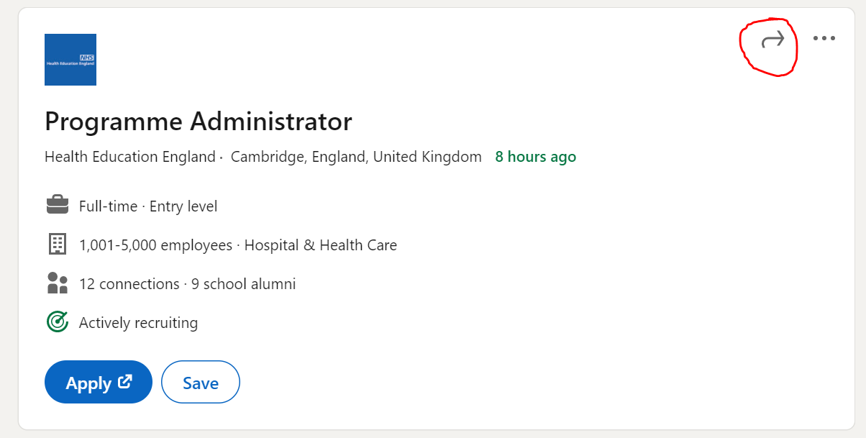

Step 2

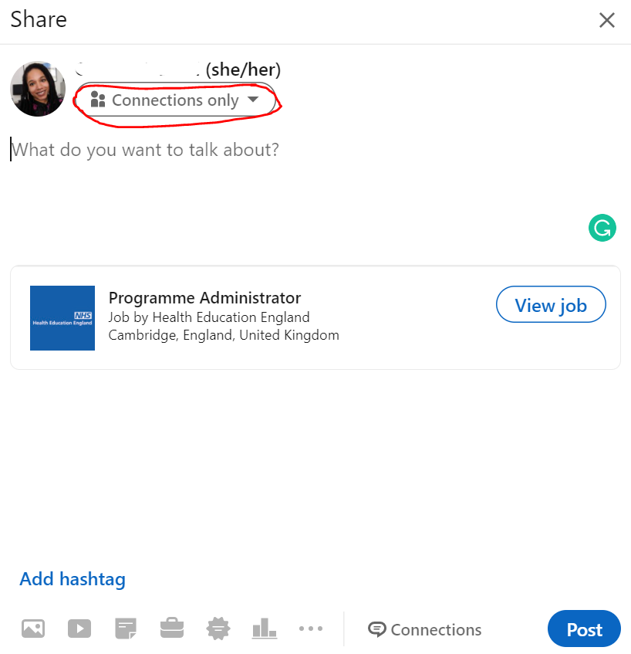

Step 3

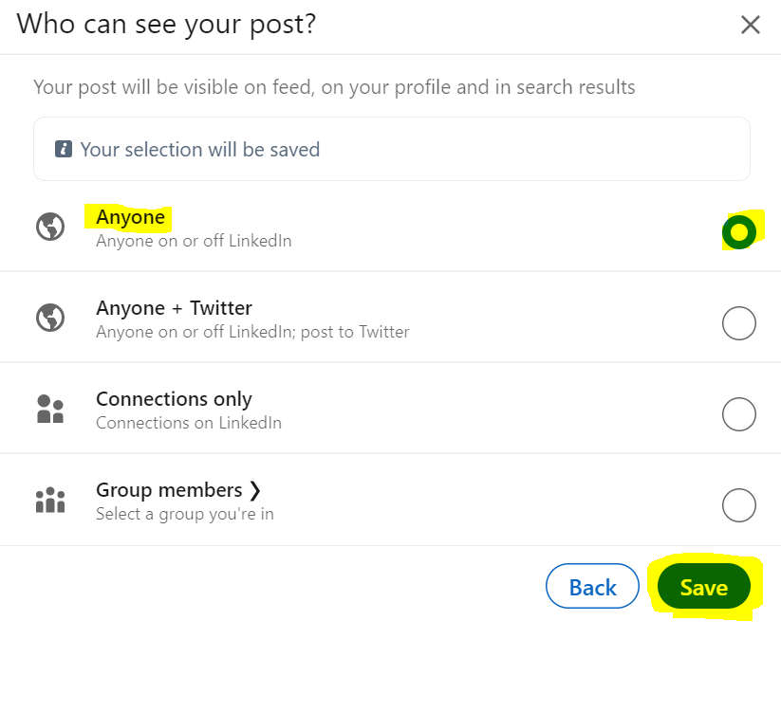
Step 4

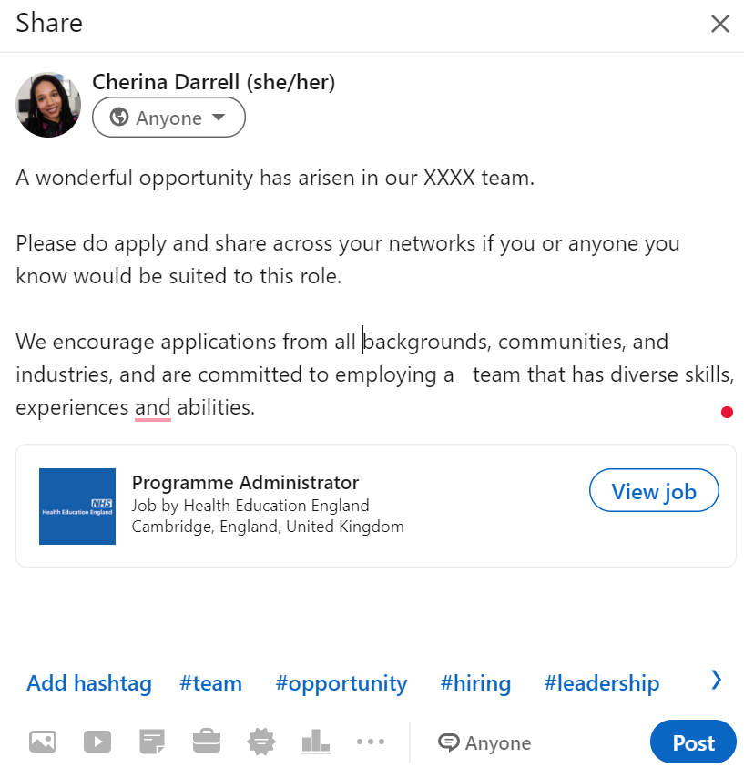

Longlisting and Shortlisting

Longlisting and Shortlisting

Longlisting Tips

Longlisting is particularly useful if you have a vacancy that attracts a high number of applications. It is a way of sorting candidates based on certain essential (and if many applicants met all the essential you could also use desirable) criteria and moving the most suitable candidates through to the shortlisting stage.

It works by allocating applications to ‘piles’ of application forms. Here's an example, if 'project management' was an essential criteria, you could set up two ‘piles’ as follows:

Pile 1 – Applicant has experience project management

Pile 2 – No experience of project management

As applications arrive, managers can go into TRAC and move the applications into one of the piles. This can be done while the vacancy is live. Once the vacancy has closed, only applications from pile 1 will moved through to the shortlisting stage.

If you want to use the longlisting function, you can enter your piles in the longlisting tab of the vacancy in TRAC. You can create up to five piles, but we would recommend using only two or three. If you have any further questions, please contact your local recruitment team.
Useful Resources: TRAC Longlisting guidance

Shortlisting panel make-up

- My shortlisting panel is made up of at least myself and one other person who understands what is required for the role, and is available to participate in the interview and assessment panel, where possible.

- I have ensured that my panel is made up of mixed gender composition, or other underrepresented groups, where possible.

- I have considered reaching out to colleagues in another region (perhaps the same team in a different region) to ensure that there is full objectivity on the shortlisting panel, especially if there are internal applicants.
Bias check: By introducing an objective member into your recruitment process, you can increase the likelihood of objectivity and decrease the likelihood of group think. Ensure that they have a full understanding of the role, and the essential and desirable criteria that you are scoring candidates against.

Useful resources: An article about the concept of group think.

Decrease the likelihood of group think. Ensure that they have a full understanding of the role, and the essential and desirable criteria that you are scoring candidates against.

Click for More ideas about best practice shortlisting.
Preparing your panel

- I have clarified the following with the panel:

• which essential criteria they should score applications against,
• the scoring criteria,
- the criteria advertised should be applied when assessing candidates throughout the recruitment process
• and, that they should leave comments on TRAC to support the scores they give.

You can use the following key to score during shortlisting.

0= Fails to meet criteria, 1= Partially meets criteria, 2= Meets criteria

- I have allowed time for the panel to review applications independently.

Bias Check: Without providing clarity, panel members can be left to rely on their assumptions and interpretations about skills, experience and qualities required to be considered suitable for the role, particularly when the role is internally advertised. This allows space for unconscious bias to creep into the shortlisting process.

Disability Confident Scheme

- I have ensured that any candidates who have indicated they have a disability on TRAC and who have met all of the essential criteria, meaning scoring at least 2 points for each essential criteria, have been offered an interview for the role.

You can use the following matrix to score during shortlisting.

0= Fails to meet criteria, 1= Partially meets criteria, 2= Meets criteria.

Applicants who have declared they have a disability can be identified by the lead short lister on TRAC, once all shortlisting panel members have completed the shortlisting stage. A ‘Two Ticks’ symbol will show against the left side of the name of the applicant or candidate.

Useful resource: Further information about the Disability Confident Scheme and our organisational responsibility, is here on NHSE WT&E Connect.

Providing feedback

- I have provided, or have scheduled time to provide, feedback to unsuccessful applicants who were not shortlisted.

Preparation for the interview
Preparation for the interview

Preparing your talent assessment tools

- I have drafted 6-7 interview questions to assess the candidates’ suitability against the essential criteria required for the role, ensuring that each candidate is asked the same questions.

These should include questions to explore applicants knowledge and previous experience, and scenario based questions to explore how applicants would behave in role-relevant situations.

- I have considered using an additional talent assessment tool to get a better understanding of the values, qualities, technical skills and experience of the candidate. These assessments must be relevant to the role. Additional assessments can include work samples, job-simulations or scenario-based questions and presentations. Some examples include:

- A short presentation on a topic related to their role, or what they might prioritise in the first three months of the role.
- A scenario-based assessment during which candidates are asked how they would approach a common scenario likely to be faced in the role.
- A timed test based on one of the essential criteria. For example, if 'Proficient in Microsoft Excel' is an essential criterion, you may consider an Excel-focussed test.

- I have included at least one interview question to assess the individual’s commitment to and experience of supporting inclusion in the workplace.
Bias check: All talent assessment tools should be asked of all candidates to limit bias in the assessment process.

Useful resource: NHSE/I ICS Board Appointments on Interviews and Equality, Diversity and Inclusion.

If you have questions about drafting interview questions and talent assessment tools, please contact your local Resourcing Specialists.

If you want support with drafting interview questions about inclusion specifically, please email diversityandinclusion@hee.nhs.uk

Planning interview questions

This section is also available as planning interview questions and scoring methodology.

Different type of questions
There are three main types of interview questions that you may want to use - competency-based, values-based, and scenario-based questions.

Competency-based questions assess a candidate’s suitability for the role based on the skills and abilities that they have demonstrated in past performance. You can use competency questions to assess criteria in the skills and abilities section of the job description. For example, if you want to test a candidate’s ability to communicate with difficult stakeholders, you can ask them to describe a time in the past they have had to communicate with a difficult stakeholder. Interviews can be made more valid by using structured competency questions, that relate to competencies needed to do the job.

Unstructured Interview | Structured but hypothetical question | Structured, competency question  Recommended
Are you a good team player? | What do you think makes a good team player? | Tell me about a time you’ve worked in a team. What was your role and what did you do?
Would you say you are persuasive? | How would you persuade me to your point of view? | Tell me about a time when you’ve had to persuade someone to a course of action. What was the situation? what did you do? and what was the outcome?
You’ve got to be able to communicate well in this job, can you do that? | How would you communicate with your team to ensure they are up to date. | How do you ensure all your team members are kept up to date with their objectives? What tools, techniques or shortcuts have you used?

Here are further guidance on competency-based interviews and examples of competency-based questions.

Values based questions are designed to assess how a candidate’s values are aligned to those of the organisation or the team in which they will be placed. For example, if one of your values is ‘customer service’ then you would wish to assess whether ‘customer service’ is a value that is important to your candidates. You could ask your candidates to describe a time when they have dealt with a difficult customer, giving an introduction about the values of the team regarding customer service. The candidates are expected to describe how they were motivated to do what was best for the customer and went above and beyond to deliver excellent customer service because they believe in excellent customer service.

In a competency-based question you could also ask a candidate about a time that they dealt with a difficult customer, but the focus would be on what they did and what the outcome was, rather than the values that motivated them.

It is recommended for all interviews to use at least one values based question to assess the candidates’ commitment to and experience of supporting inclusion in the workplace. Further support can be provided by emailing diversityandinclusion@hee.nhs.uk. If you have any general questions about drafting interview questions and talent assessment tools, please contact your local Resourcing Specialist.

Scenario (or situational) based questions ask candidates how they would respond to a hypothetical situation in the future. By using these types of questions, it provides an understanding of how each candidate is likely to approach situations and how they will deal with them. Whilst competency-based questions require the candidates to reflect on past work experiences, scenario questions require the candidates to explain how they would approach and handle future work-related scenarios.

Example scenario-based questions:

Let say you lost track of a deadline. How would you recover to ensure that you completed your project on time?

How would you manage a situation where a customer asked you about a service and you were unsure of the answer?

How would you explain a complex idea to a stakeholder who was already frustrated?

Deciding on your questions
With all interview questions, you should consider carefully so you are clear that the question asked relates to the actual competency you are looking for, and that you know what a “good” answer looks like. This should be recorded on the interview assessment form. Doing this will ensure that you use the limited time that you have with the candidates as efficiently as possible and do not waste time with questions that do not help you to reach a decision. This will also help to protect you if your decision is challenged.

Questions must be aligned to the criteria you have advertised from the outset in the advertisement for the role aligned to the job description of the role. Focus your questions on those areas that you don’t already know about and that can only be meaningful assessed by speaking to the applicant. For example, it would not be helpful to ask about qualifications, as these would have been identified for each candidate at shortlisting stage.

It is good practice for the panel members to meet in advance of the interview to agree on the questions and what you are looking for in an answer. You need to remain open minded when you consider what you expect from a model answer. A candidate may have different approach to what you are used to, but it could be equally valid.

Remember all candidates must be asked the same questions in an interview, but you may vary your probing questions as a result of the responses given by a candidate. You need to be careful not to unfairly advantage candidates in this by offering leading questions or even answering the question yourself.

Here is an example when planning an interview assessment form, including what a good answer could look like. Also bearing in mind, the importance of being open to new approaches:

Questions related to service improvement | Success factors when assessing answers | Score/notes of answer  (0 = no evidence, 1= some evidence, 2= most competencies evidenced, 3 = excellent response – all competencies evidenced)
Intro by panel member – explain briefly how service improvement fits into the role they are applying for.  1a. Tell us a time when you have identified the need to improve either a process or procedure?  1b. What was the outcome and impact?  2. How do you sell processes to the business to add value and not simply introduce what they may see as bureaucracy? | - Good diagnostic review of need to change  - Aware of options – pro’s and con’s  - Appropriate consideration afforded to identify most suitable approach, with a clear recommendation  - Good understanding of new issue and foresight to manage any possible resistance  - Aware of levers to effect change  - Identification of possible allies / key blockers  - Coaching  - Ability to determine the appropriate course of action where judgement and analysis of complex information is required.

You can use context to frame a question. Give the candidate some background on why you are asking a specific question as it will help them to deliver an answer that focusses in on what you are looking for.

When assessing an answer, you should refer to the criteria from the job description that you are testing. Based on the evidence that the candidate has presented in their answer, are you satisfied that the candidate meets the criteria to the level required to carry out the role effectively?

How to score candidates’ responses?
This aspect is crucial to mitigate bias. It needs to be done objectively against what the candidate said (evidenced by your interview notes). Each interviewer should independently score each competency for the candidate on the evidence collected.

This framework and four-point scoring scale is suggested, as outlined here:

0 = no evidence | - Some evidence | - most competencies evidenced | - Excellent answer – all competencies evidenced
Limited level of behavioural / technical indicators demonstrated and limited demonstration of experience or awareness / knowledge of key issues | Some but still limited behavioural / technical indicators demonstrated and adequate demonstration of experience or awareness / understanding or knowledge of key issues | Good level of behavioural / technical indicators demonstrated and good demonstration of experience or awareness / understanding or knowledge of key issues | Full range of behavioural / technical indicators demonstrated and excellent demonstration of experience or awareness / understanding or knowledge of key issues

You are not expected to record verbatim what a candidate says, this would be impractical and would break the natural rapport in an interview. But you are expected to take a sufficient level of detail to meaningful score each question to justify and objectively score after the interview is complete.

An extensive list of competency-based questions suitable for faculty interviews is available here.

Preparing your candidates

- I have given the candidate at least one week's notice of the interview.

- I have added on TRAC details to be communicated to the candidates - any additional talent assessment exercises and the interview, and who will be on the panel, including their job title.

- If a candidate has indicated on TRAC that they have a disability, I have checked whether these applicants have been asked via TRAC communications whether they require adjustments.

Disability Confident Scheme

There is a range of adjustments that may be required or given to a candidate, most of which cost little to nothing. Managers should consider how the adjustment prevents disadvantage, the practicality of adjustment and the financial implications of the adjustments.

Adjustments can include:

- Hiring a British Sign Language interpreter if the candidate has a hearing disability.
- Sending or giving questions to the candidate 10 minutes ahead of the interview if someone has Auditory Processing Disorder.
- Hosting the interview on the ground floor if the candidate has mobility related disabilities and there is no wheelchair access.
- Giving additional time to complete a written test or assessment if the candidate has dyslexia or dyspraxia, ADHD or other neurodiversity or disabilities.

Each adjustment should be applied based on the need of the individual. However, managers are advised to contact your Resourcing Specialist team for more information and clarity. To learn more about Disability Confidence, managers can sign up to one of the corporately funded Disability Confidence sessions, here.

British Sign Language Interpreter (BSL)

If you will need a BSL interpreter or one is required for an employee or applicant, there are approved signers for NHSE WT&E nationally that managers should search for and contact. An interpreter can be found on The National Registers of Communications Professionals working with Deaf and Deafblind People (NRCPD) website, here.

You can use the search function and enter a postcode to find the nearest signer. These interpreters are already registered on NHSE WT&E finance systems which means they can invoice NHSE WT&E directly.

Please note that many of the interpreters may need 2-3 weeks notice. For further support on this, managers should contact your local Resourcing Specialist for more information and clarity.

Selecting and preparing your interview panel

Selecting and preparing your interview panel

- I have scheduled meetings into the diaries of the recruitment panel for scheduled interviews and discussions.

- I have checked that all panel members have accessed and downloaded all applications from TRAC and has any relevant paperwork. Also, they are clear that they should score candidates independently. At this stage, useful to also ensure there is no conflict of interest if candidate(s) are known to panel member(s). It’s the panel members responsibility to declare this.

- I have sent the interview questions to the panel and invited feedback on the questions.

- I have taken time to discuss and agree with panel members the criteria for what is an acceptable or good response and what key points or themes that should be included in candidate responses. The themes of an acceptable response must be clear with the panel, however not so prescriptive that there is a verbatim 'model' answer you are all looking for.

For example, if the question is, "Tell us about a time that you made a mistake at work or didn't deliver to the expectation of customers. How did you resolve the situation?". You and your panel should be clear on the key themes of a good answer. In this example, the themes panel members may look out for are:

- Candidate shows a demonstrates honesty and takes personal responsibility.
- Candidate explains the outcome and resolution and shows commitment to service improvement.
- Candidate shows care and commitment for meeting customer expectations

- My interview panel is made up of a minimum of 2 additional interview panel members in addition to myself. Interview panels should be made up of:

- mixed composition of gender, and where possible other underrepresented groups,
- a colleague who does not sit directly within the team, either from another department or region and has a firm understanding of the job description and criteria.
- Should ideally include Inclusive Recruitment Specilaist or trained Cultural Ambassador (CA) – increasingly valid for more senbior roles.
- Must comply with the relevant Standard Operating Procedure, where applicable

Bias check: Ensuring that your panel make-up is demographically diverse, does not necessarily remove bias from your interview panel and should not be seen as a 'silver bullet' to diversity and inclusion in recruitment. However, an independent panel member may make Black, Asian and Minority ethnic (BAME), Disabled or female candidates more comfortable in interview. Without ensuring that all panel members have an equal voice and equal influence over the final decision, diverse panels can be viewed as a tokenistic approach to diversity and inclusion in recruitment.

- I have circulated the final version of the scoring sheet to the panel members with the questions and included the agreed themes of an acceptable response.

Useful resource: The NHSE WT&E template interview score sheet, If Your Face Fits Guide

The interview

The interview

Panel support and conduct before and during the interview

- I have scheduled short breaks between interviews and if applicable, I have scheduled a 30-minute lunch break between interviews on a full day of interviewing.

- I have informed the panel that they must take notes during the interview and return them to me after the interviews are over.

- I have agreed with the panel that we will refrain from conversations between interviews and only discuss candidates during our scheduled de-brief at the end of interviewing.

- Before the interviews, I have completed a bias check with panel members. You can try the following script:

'Before we get started I just wanted to run through a quick bias check with you all. This is just a point to note that we, including myself, must be aware of our biases throughout interviewing and scoring. We all have biases, whether conscious or unconscious, and this can creep into how we score a candidate. This is not to meant to single anyone out. I only want to highlight how bias can manifest in interviewing, including but not limited to:

- Judging different groups of people more harshly using the same criteria,
- Using past work as a potential for future performance (especially with internal candidates who we may be familiar with),
- Making judgements about career breaks, awarding institutions, and those who can ‘hit the ground’ running,
- Belief in merit; this can manifest in a belief that someone should have achieved better or more at their current stage in life.

Bias Check: We all have a different bias, and these can manifest in the interview process. You and/or panel might consider completing or revisiting unconscious bias training before interviewing. You can find NHSE WT&E's in-house Unconscious Bias training on NHSE WT&E Connect or you can source funded Unconscious bias training for your team through the L&D hub.

Useful resources: Page 13-16 in the If Your Face Fits recruitment and talent progression practitioner guide from NHSE.

- Special considerations for Remote Interviews

- Using MS Teams, a separate meeting for each interview rather than one big meeting has been set up

- A colleague not on the panel will co-ordinate
- I have reminded the panel to be aware of their screen presence at all times during the interview, maintaining an open and engaged posture

- I have ensured any adjustments are in place

- I have ensured cameras of the panel and candidate are on

- I will rearrange if any insurmountable technical difficulties

- I have ensured all interview MS Team invites are set as 'private appointments'

- I will admit candidates via the lobby to ensure panel is in attendance first

Engaging with candidates

Engaging with candidates

- I have introduced myself using my personal pronouns. For example, “Good afternoon [candidate name]. My name is Tomi, and my pronouns are she/her or he/him or they/them”.

- I have ensured that panel members have introduced themselves.

- I have explained the agenda / order of the interview.

- If facilitated virtually, I have assured the candidate that unforeseen noises in the background are normal when working from home and that they should continue with the interview if this happens.

- I have checked that the candidate has water or a beverage to hand.

Useful resources: A suggested interview script for managers; a NHSE WT&E article on pronouns

After the interview

- I have asked the candidate if they have any questions.

- I have talked to the candidate about the team they will work in and how the team contributes to the wider organisation.

- I have highlighted the benefits of working for NHSE WT&E including flexible working options, professional development opportunities, potential job sharing opportunities, staff networks and support groups, etc., following any questions the candidate asks.

- I have given a timeframe for when I will get back to them with an answer; managers should aim to give a response within a few days.

Useful resources: A list of NHSE WT&E staff networks

Making a decision
Making a decision

Discussion with panellists

- I have reminded the panel that we're scoring the candidate's suitability based on the criteria listed in the job description, and how they have met this criteria in their application, additional talent assessment (if applicable) and interview.

- I have asked for the panel for the candidate's score before beginning the discussion about the candidates responses; The panel and I have gone through our discussion question by question to discuss the candidates competencies.

- I have checked or challenged any panel members pushing for one candidate, particularly one with medium to low scoring, and asked for their reasons why they support their chosen candidate. There should be a discussion about any significant variation in scoring of responses to any of the questions between panel members, and the reasons for the variation recorded.

- I have chaired the discussion in an inclusive way, taking on the opinions of panel members.

- I have given the candidate an average overall score for each candidate based on the scoring of all panellists and made a note of this in the scoring paperwork, in the event I am asked about the final decision.

- Recruiting panel members have sent in their written feedback which I have collated and saved in a digital folder. The panel has agreed the feedback that could be offered to each of the applicants.

Bias check: There are several factors that can impact on how we perceive a candidate which heightens our propensity for bias. This includes:

- Perceiving the confidence, a particular accent or diction of candidate as competence,

- Exploring other panellists’ opinions before fully forming our own opinions,

- Forming an opinion of a candidate based on candidates’ non-verbal cues,

- Rushing to discuss candidates and make a decision, due to other end-of-day commitments (meetings, childcare, etc.)

- Relying on the opinions of, and following the lead of 'the expert'- or in many cases, the manager chairing the panel

Useful resources: Page 17-19 of If Your Face Fits

Post-interview activities

Appointment

- After the panel has agreed on a candidate, I have contacted the candidate to offer the role and informed them of the salary range.

If potentially a higher salary than entry point of relevant pay band/grade is appropriate, this cannot be offered at this stage. You will need to check with the recruitment hub, as possibly an application for consideration will be required align to the starting salary policy.

Next steps

- Once the candidate has accepted the role, I have scheduled a follow up phone call to discuss:

- Their available start date,
- arrangements including flexible working, home-working and condensed hours,
- relevant workplace adjustments or necessary equipment including applying to the government’s Access to Work scheme for colleagues with physical and mental disabilities.

- I have looked through the NHSE WT&E Induction checklist, and worked with the local administration team to instigate an appropriate induction for the successful candidate. Please note that it is a requirement for managers to complete this checklist with every new starter within three months of their start date. A completed document should be emailed over to your local HR team, once it is completed.

Unsuccessful candidates

- During communications with unsuccessful candidates, either over the phone or by email, I have offered to give feedback to unsuccessful candidates who interviewed. I have offered for this feedback to be delivered at a later date and time, advising the candidate that normal practice is for feedback to be provided at l;east 24 hours after the outcome has been communicated.

- If the unsuccessful candidates are within my current team, I have offered them a meeting at a later stage to give them feedback and discuss what actions or development opportunities they may consider in future.

Useful resources: NHSE WT&E Learning and Development Hub

