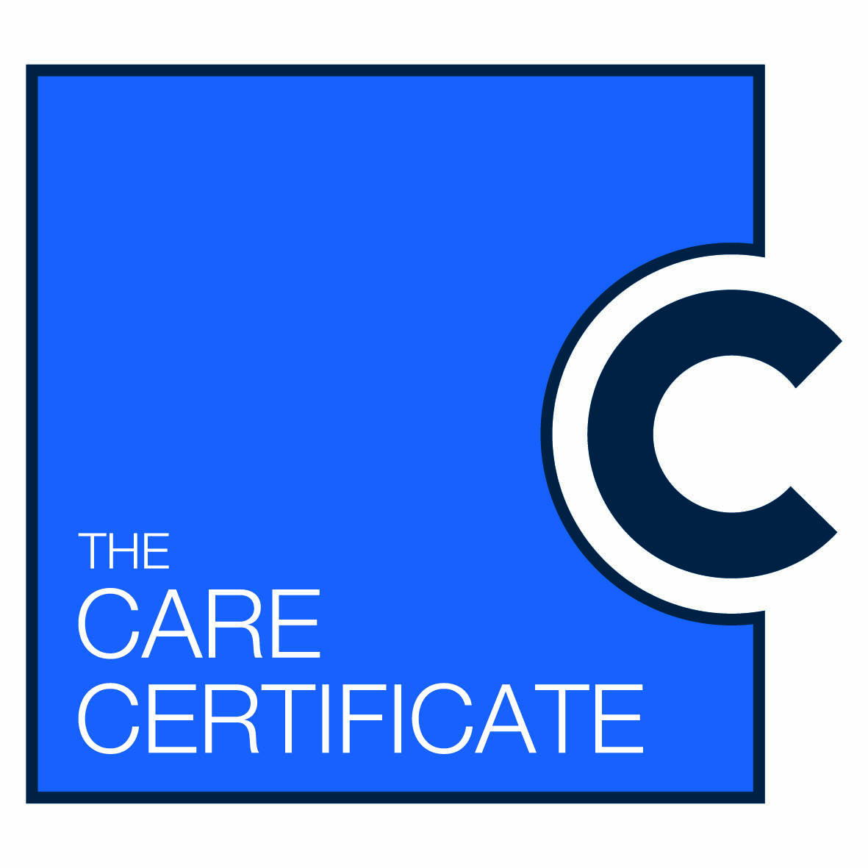
Care certificate mapping to current induction training
From 1 April 2015 all new health and social care support staff that directly care for patients and clients will need to complete the fifteen standard Care Certificate and demonstrate knowledge which is assessed both in the workplace and during Induction.
National mapping guidance can be found here: http://hee.nhs.uk/wp-content/blogs.dir/321/files/2015/01/2015-01-14-Care-Certificate-Mapping-FINAL.pdf
The purpose of this form is to gather information on current training provision so it can be identified how much of the certificate is already covered in induction training. Please complete one of these forms for each training session you provide which links to the standards.
Name of session which links to standard
Frequency of session (if part of induction please state)
Aim of session
Learning Outcomes of your session
Study Mode (E learning, Face to face etc)
Who provides this session

Specialist equipment required for the training event
Length of session
Any additional hours of self-direct study required (if yes, how many)
Method of assessing learning (if learning is not assessed please state this)

Are there any associated competencies to be assessed in practice?

Time frame allowed to achieve any competencies

Having read the Care Certificate standard, are there any outcomes which this session does not cover? Please list the numbers.
Name of person completing this form

Please return to Education/ Training Dept:

