HEE Maternity Programme e-LfH Guide

Overview
The guide is designed to provide an overview of all the e-learning packages that are related to Pregnancy, Maternity and Newborn. There are a broad range of programmes, modules and individual courses available. The guide is designed to collate these in one place for easy reference. Some modules and courses are contained within a programme that applies to a number of care pathways but elements of the programme are related to Maternity. Some programmes are specific to Maternity. The following are grouped under a programme called Maternity and Newborn and can be found here.

Maternity and Newborn e-learning programmes
The following are programmes directly relating to Maternity care.

Avoiding Term Admissions into Neonatal Units

This e-learning programme will help healthcare professionals involved in care of newborns, both in the hospital and community settings, to improve outcomes for babies, mothers and families through the safer delivery of care.

It is one of the outputs from the Atain programme (an acronym for ‘avoiding term admissions into neonatal units’) to reduce avoidable causes of harm that can lead to infants born at term (i.e. ≥ 37+0 weeks gestation) being admitted to a neonatal unit.
The e-learning programme addresses the key learning needs identified through Atain, with a focus on four key clinical areas:
- respiratory conditions
- hypoglycaemia
- jaundice
- asphyxia (perinatal hypoxia–ischaemia)

https://www.e-lfh.org.uk/programmes/avoiding-term-admissions-into-neonatal-units/

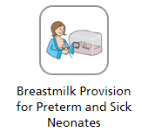
Breastmilk Provision for Preterm and Sick Neonates

This learning resource has been designed to improve education and training of all relevant staff in the support of breast milk provision for preterm and sick infants. The e-learning programme will also enable healthcare professionals to improve breastmilk provision rates at discharge from neonatal units. According to the National Neonatal Audit Programme statistics based on 2015-2016 data, 58% of eligible babies were receiving mother’s milk, exclusively or with another form of feeding, at the time of their discharge from neonatal care.
The content is suitable for all professionals who work to support/contribute to improving breastmilk provision:
- Nurses and healthcare assistants
- Midwives and maternity healthcare support workers
- Medical trainees
- All medical staff
https://portal.e-lfh.org.uk/Component/Details/478987

Close Relative Marriage

Close relative (consanguineous) marriage is widely practised globally. However, it is linked to an increased risk of recessive genetic disorders. Improving understanding about genetic inheritance can empower affected families and reduce unexpected, affected births and infant deaths. Healthcare professionals can do more to ensure equitable access to genetic information and services for affected families.

Cultural Competence

The Cultural Competence e-learning tool is designed to support clinicians in the NHS to gain knowledge and understanding of the issues around culture and health and how this might influence healthcare outcomes.
Being Culturally Competent is not only about respecting and appreciating the cultural contexts of patients’ lives. Neither is it a one-size-fits-all approach – it’s about understanding the way we deliver health care and respond to the needs of our diverse population.
Cultural competence is a key aspect of providing both quality and safety care. This is why health professionals need to be aware and gain understanding of the key issues relating to culture and how this may influence the uptake of health care and treatment options. Developing this knowledge and understanding will influence the way we give care and could have an impact on reducing disparities in health care outcomes.

https://portal.e-lfh.org.uk/Component/Details/438949

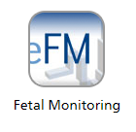
Fetal Monitoring
eFM is a comprehensive web-based resource developed by the Royal College of Obstetricians and Gynaecologists and the Royal College of Midwives in partnership with Health Education England e-Learning for Healthcare.
eFM will teach and assess learners in all aspects of intrapartum fetal monitoring and is directed at both obstetricians and midwives in training as well as those who have completed their training. eFM is split into three sections:
- A knowledge-based, interactive tutorial section.
- An assessment section which formally tests what knowledge the learner has acquired
- A case study section.

https://portal.e-lfh.org.uk/Component/Details/390938

Growth Assessment Protocol (GAP)

The GAP e-learning modules have been developed to support midwives, obstetricians and sonographers in the delivery of safe fetal growth surveillance during pregnancy.
It is part of the Perinatal Institute’s award-winning GAP programme, a licensed and supported service which includes training, e-learning, customised growth charts, care pathways and tools for rolling audit, benchmarking and reporting.
The need for a standardised, evidence-based protocol has arisen from findings that many adverse outcomes in maternal and perinatal care are associated with unrecognised fetal growth problems. These can be prevented by improved awareness and identification of the pregnancies affected. GAP is aligned with key elements of NHS England Saving Babies Lives v2 and RCOG SGA guidelines.
https://www.e-lfh.org.uk/programmes/growth-assessment-protocol/

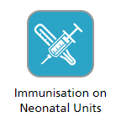
Immunisation on Neonatal Units

The session aims to support newly qualified/novice nurses, neonatal nurses, and other members of multi-professional teams to achieve knowledge and competence in the administration and management of neonatal immunisations, including vaccination for Respiratory Syncytial Virus (RSV). The e-learning session will be used as part of a blended learning approach as an adjunct to face-to-face teaching sessions, simulation and scenarios to facilitate reflection and real time feedback.
This session will discuss and review the issues surrounding vaccination of pre-term infants while resident on a neonatal unit. It will discuss issues around who can give consent while the baby is still resident on a neonatal unit, why it is important to administer routine immunisations at the appropriate time and within the schedule and when a delay in vaccination timing may be appropriate.

https://portal.e-lfh.org.uk/Component/Details/442064

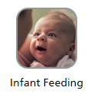
Infant Feeding

This programme is for healthcare professionals who have contact with pregnant women and new mothers. It aims to provide information about the importance of building close and loving relationships with baby during pregnancy and following birth, as well as information around breast and bottle feeding. This programme isn’t intended to replace existing training. Instead it is intended to complement training for those in facilities which are implementing Baby Friendly standards.

https://portal.e-lfh.org.uk/Component/Details/523000

Intelligent Intermittent Ausculation in Labour (IAA)

Intelligent Intermittent Auscultation (IIA) of the fetal heart is the recommended method of fetal monitoring for all women who are considered at low risk of fetal hypoxia during labour. It is therefore a fundamental skill of all midwives in any birth setting.
This programme aims to improve safety for mothers and babies in low risk labour and birth by improving the knowledge, skills and confidence of midwives to undertake intermittent auscultation of the fetal heart in an intelligent manner (IIA). This will ensure early recognition of deterioration or abnormalities in the fetal heart rate and that situations requiring escalation and a move to continuous electronic fetal monitoring are recognised in a timely manner.
https://www.e-lfh.org.uk/programmes/intelligent-intermittent-auscultation-in-labour/

Introduction to the Pelvic Floor During Pregnancy

The intention for this module is to provide those working closely with new and expectant mums with a basic understanding of the pelvic floor, its function and how pregnancy affects it. It is hoped that with this basic knowledge you will feel comfortable to initiate conversations about the importance of looking after their pelvic floor throughout the pre and post-natal period, the exercises they can do, what to expect in the weeks after birth and when and whom to ask for help if problems persist.
This module will cover:
- the structure and anatomy of the pelvic floor
- the mechanism and function of the pelvic floor, with reference to the ante-natal, intrapartum, and post-natal period
- the effects of pregnancy and childbirth on the pelvic floor mechanism during the ante-natal, intrapartum, and post-natal period
- the principles of teaching pelvic floor exercises
- the importance of maintaining maternal levels of general fitness
- when to seek help
https://www.e-lfh.org.uk/programmes/introduction-to-the-pelvic-floor-during-pregnancy/

Maternal Anaemia

This resource has been developed for healthcare workers to gain an understanding of the prevalence of maternal anaemia and the wider health and social consequences and understand the benefits of health promotion (diet) during pregnancy, in maternal and fetal health, and the value of specific screening. It also aims to identify the current recommenndations for identification and management of maternal anaemia and promote the adoption of best practice guidelines.

https://portal.e-lfh.org.uk/Catalogue/Index?HierarchyId=0_48135&programmeId=48135

Maternity Resources: Ockenden Immediate and Essential Actions

Health Education England elearning for healthcare (HEE elfh) has worked with HEE Maternity Team to develop a catalogue of resources for maternity staff to easily access key elearning to support the delivery of care for women and families.
Maternity Support Workers

These modules have been developed following a short mapping exercise and review of resources against the Maternity Support Worker Competency, Education and Career Development Framework. We have identified that there is a need to develop 4 e-learning modules: Screening, Immunisations in pregnancy and post natal period, Anatomy and Physiology and Legal and Ethical Frameworks.
This programme has been written with MSWs in mind, however, it will be useful for anyone that deals with expectant mums.
https://www.e-lfh.org.uk/programmes/maternity-support-worker/

Medical Problems in Pregnancy

Every year a small number of women in the UK die in pregnancy or the puerperium. Previously, the main causes of maternal death were obstetric problems such as postpartum haemorrhage. Now, however, the main causes of maternal death are medical complications rather than obstetric and include cardiac disease, neurological disease and sepsis.

This programme is primarily designed for trainees in Internal Medicine Trainees, but will also be of use to others in ACCS (Acute Care Common Stem), Obstetrics and Anaesthesia and allied health professionals. The programme has been updated to represent current knowledge and guidelines.

https://www.e-lfh.org.uk/programmes/medical-problems-in-pregnancy/

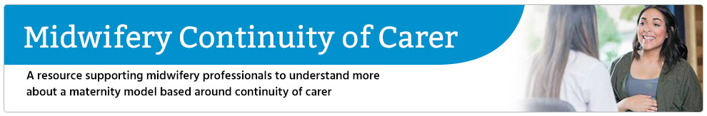

Midwifery Continuity of Carer

This programme provides participants with an overview of the underpinning policy changes which have informed both the development of Midwifery Continuity of Carer (MCoC) models and proposed changes of midwifery care in England.

https://www.e-lfh.org.uk/programmes/midwifery-continuity-of-carer/

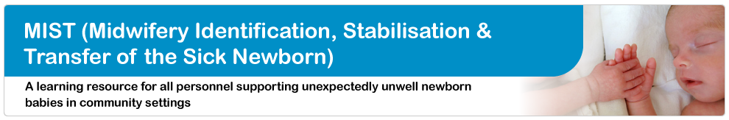

Midwifery Identification, Stabilisation and Transfer of the Sick Newborn (MIST)

This e-learning programme is aimed at midwifery and ambulance personnel to support the treatment plan for newborn babies who are, or have the potential to become, unwell following delivery in a community setting. The resources are designed to equip maternity and emergency teams with the knowledge required to extend care beyond the first minutes after birth, up to and including handover to the neonatal team.

https://www.e-lfh.org.uk/programmes/midwifery-identification-stabilisation-and-transfer-of-the-sick-newborn/

Midwifery Supervision
Midwifery supervision has changed: A-EQUIP – Advocating and educating for quality improvement.
This e-learning session, supporting the A-EQUIP model, is both important and timely. It’s designed to provide further information and links into the A-EQUIP Operational Guidance for midwives, leaders, managers, maternity providers, commissioners and higher education institutions requiring NHS maternity services to have the A-EQUIP model in place.
This e-learning session will enable you to gain a greater understanding by exploring the A-EQUIP model from a conceptual and practical perspective. The e-learning will enable you to embrace and reflect on the opportunities for the future; a model that supports and empowers midwives to provide safe, high quality, kind, compassionate, care to women and their families.
https://portal.e-lfh.org.uk/Component/Details/473243
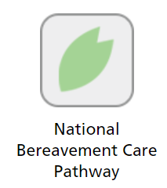
National Bereavement Care Pathway

National Bereavement Care Pathway training sessions have been designed to provide support when talking to bereaved individuals. The course focuses on bereavement Care after Pregnancy Loss or Baby Death.

https://portal.e-lfh.org.uk/Component/Details/589351

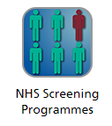
NHS Screening Programmes

These e-learning modules support the training of healthcare professionals involved in the delivery of the NHS Screening Programmes in England.

The Antenatal and Newborn Screening e-learning Module is a flexible cross-programme training resource for all health care professionals and students involved in antenatal and newborn screening in the NHS in England. It allows learning to be evidenced and promotes informed choice for women and their families regarding screening.

https://portal.e-lfh.org.uk/Component/Details/458987

NHS Fetal Anomaly Screening Programme (FASP)

The NHS Fetal Anomaly Screening Programme (FASP) offers screening to all eligible pregnant women in England to assess the risk of the baby being born with Down’s, or Edwards’/Patau’s syndromes or a number of fetal anomalies (structural abnormalities of the developing fetus).
NHS FASP aims to ensure there is equal access to uniform and quality-assured screening across England and women are provided with high quality information so they can make an informed choice about their screening and pregnancy options.

https://portal.e-lfh.org.uk/Component/Details/456823

NHS Newborn Blood Spot (NBS) Screening Programme

The NHS Newborn Blood Spot Screening Programme screens newborn babies for nine rare but serious conditions:

- sickle cell disease (SCD)
- cystic fibrosis (CF)
- congenital hypothyroidism (CHT)
- phenylketonuria (PKU)
- medium-chain acyl-CoA dehydrogenase deficiency (MCADD)
- maple syrup urine disease (MSUD)
- isovaleric acidaemia (IVA)
- glutaric aciduria type 1 (GA1)
- homocystinuria (HCU).

The programme uses a heel prick test to collect spots of blood which are tested to find babies who have one of the conditions. Babies who test positive can then be treated early, improving their health and, in some cases, preventing severe disability or even death.

https://portal.e-lfh.org.uk/Component/Details/444913

NHS Newborn Hearing Screening Programme (NHSP)

The newborn hearing screening test helps to identify babies who have permanent hearing loss as soon as early as possible. This means that parents can get the advice and support they need as soon as possible.
https://portal.e-lfh.org.uk/Component/Details/446082

NHS Newborn Infant Physical Examination (NIPE) Programme

The NHS Newborn and Infant Physical Examination e-learning course is a free training resource and is aimed at health care professionals who undertake newborn and infant physical examination (NIPE) screening in the NHS in England. It covers the 4 screening elements of the physical examination: eyes, heart, hips, and testes. As a useful addition to formal training, the module uses film and animation to illustrate robust screening pathways and best practice.

https://portal.e-lfh.org.uk/Component/Details/458974

Sickle Cell and Thalassaemia Screening e-learning module

This e-learning resource supports the Sickle Cell and Thalassaemia Screening Programme. It identifies the specific conditions screened for and explains how they may impact on individuals and their families. These 10 standalone units are aimed at practitioners involved in the screening pathway, to enable them to understand and explain results, in order to assist women and their partners to make informed decisions throughout their pregnancy, and following the birth of their baby.

https://portal.e-lfh.org.uk/Component/Details/449905

Screening and informed choice

This unit describes principles of screening and offering informed choice to women and parents considering antenatal and/ or newborn screening.

https://portal.e-lfh.org.uk/Component/Details/551291

Screening for Trisomy 21, 18 and 13 (Down's Edwards's and Patau's syndromes)

This unit describes screening for Trisomy 21, 18 and 13 (Down's Edwards's and Patau's syndrome) including aims, key points and up to date policies and clinical guidance.

https://portal.e-lfh.org.uk/Component/Details/551300

Fetal Anomaly 18+0 to 20+6 weeks ultrasound Scan

This unit describes the fetal anomaly 18+0 to 20+6 weeks ultrasound scan including aims, key points and up to date policies and clinical guidance.

https://portal.e-lfh.org.uk/Component/Details/551303

Pelvic Health VBA
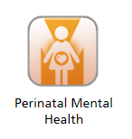
Perinatal Mental Health
The Perinatal Mental Health programme has been designed to help educate and increase awareness of issues arising from mental health.
This programme deals with two small projects, Perinatal Mental Health for Health Visitors, and Perinatal Mental Health. The latter project has recently been added as a result of the Mental Health Awareness Programme, which includes e-learning from several projects.
https://portal.e-lfh.org.uk/Component/Details/391659

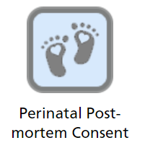
Perinatal Post-mortem Consent

This interactive e-learning package has been developed to support healthcare professionals who are required to discuss perinatal post-mortem consent with bereaved families.

Other healthcare professionals who come into contact with bereaved parents and are involved in supporting them in this difficult time may also find it useful.

https://portal.e-lfh.org.uk/Component/Details/663528

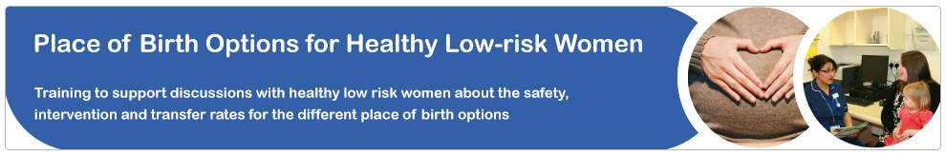

Place of Birth

‘Discussing Place of Birth Options with Healthy Low-risk Women’, and ‘Becoming a Place of Birth Lead’ are e-learning sessions developed by midwives, for midwives, to support women in their birth place decisions. They are also suitable for others working with pregnant women, such as obstetricians, maternity support workers and GPs.

https://www.e-lfh.org.uk/programmes/place-of-birth/

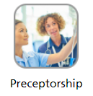
Preceptorship

This e-learning programme is designed to develop the knowledge and skills needed to act as a preceptor to guide a newly qualified healthcare professional.

https://portal.e-lfh.org.uk/Component/Details/511661
Preterm Birth

Children born preterm (before 37 weeks of gestation) are at increased risk of a range of cognitive, social, emotional and learning difficulties, compared with children born at term. These difficulties may persist throughout childhood and adolescence and can have a negative impact on children’s attainment at school. This e-learning programme is designed to improve users’ knowledge of the long term consequences of preterm birth on children’s development and to improve professionals’ competence in supporting preterm children’s learning. Although designed for education professionals, the programme will also be of interest to health and care professionals involved in the care of children and young people born preterm.

https://www.e-lfh.org.uk/programmes/preterm-birth/

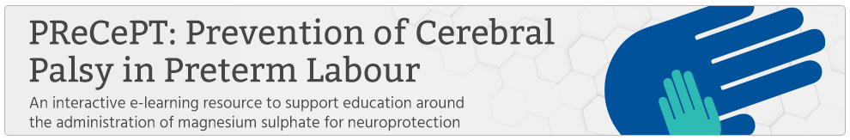

Preventing Cerebral Palsy in Preterm Babies (PRECEPT)

This interactive e-learning resource has been designed for perinatal healthcare professionals to support education around the administration of magnesium sulphate for neuroprotection to mothers in preterm labour. Building on current NICE guidance, and the successful roll out of the national PReCePT programme, this module will guide clinicians through the clinical benefits of administering magnesium sulphate (MgSO4) to mothers who go into labour before 30 weeks gestation. It will provide information on the neuroprotective qualities of this cost-effective and readily available drug, the detail of how it is administered and the positive impact it can have on the lives of neonates and their families.

https://www.e-lfh.org.uk/programmes/prevention-of-cerebral-palsy-in-preterm-labour/

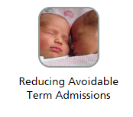
Reducing Avoidable Term Admissions
The aim of this interactive multiprofessional e-learning tool is to facilitate development of skills and knowledge that are needed to make informed decisions to avoid term babies being unnecessarily separated from their mothers and admitted to neonatal units. The target users of the e-learning module are:
- Midwives
- Neonatal nurses/ Advanced neo-natal nurse practitioners (ANNPs)
- Middle grade paediatricians in both training & non-training posts
- Health Care Support Workers (HCSWs)/ Nursery nurses/ Midwifery support nurses
- Post registration child branch students
- Pre registration child branch students
- Midwifery students

https://portal.e-lfh.org.uk/Component/Details/473623

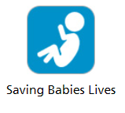
Saving Babies Lives

The Saving Babies’ Lives e-learning programme has been developed to support the delivery of the Saving Babies’ Lives Care Bundle Version Two (SBLCBv2) in maternity units across the NHS. SBLCBv2 has been produced to build on the achievements of version one and address the issues identified in the SPiRE evaluation. It aims to provide detailed information for providers and commissioners of maternity care on how to reduce perinatal mortality across England.

https://portal.e-lfh.org.uk/Component/Details/602276
https://portal.e-lfh.org.uk/Component/Details/602845
https://portal.e-lfh.org.uk/Component/Details/602855
https://portal.e-lfh.org.uk/Component/Details/602516
https://portal.e-lfh.org.uk/Component/Details/602514
https://portal.e-lfh.org.uk/Component/Details/733656

Sexual and Reproductive Health for Health Visitors

This programme comprises 3 sections to support health visitors with promoting sexual and reproductive health to all families they work with. As part of this programme you will first complete Health Education England e-Learning for Healthcare (e-LfH)’s All Our Health: Sexual and Reproductive Health and HIV e-learning, which will be referred to during the session.

https://www.e-lfh.org.uk/programmes/sexual-and-reproductive-health-for-health-visitors/

Small Wonders

Small Wonders e-learning programme comprises seven succinct sessions developed for neonatal health care professionals and anyone coming into contact with neonates and their families. The programme is designed to optimise professional competencies by enhancing your understanding of the neonatal journey from a parent’s perspective. This includes: a review of the role of lactation physiology in expressing and getting to volume in neonatal care; how to involve parents as partners in care in the neonatal journey; how to support the transition to babies’ feeding independently; how to support parents as they transition to a new unit or home; and how to support neonatal baby loss with its unique challenges in bereavement. This learning reflects best practice and is consistent with an increased awareness of the positive impact that good family-centred neonatal care can have on the mental health and wellbeing of entire families, not solely the physical wellbeing of the baby.

https://www.e-lfh.org.uk/programmes/small-wonders/

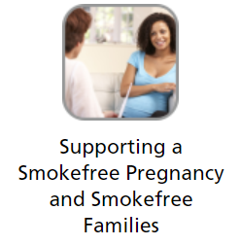
Supporting a Smokefree Pregnancy and Smokefree Families in Pregnancy

This e-learning programme focuses on the delivery of very brief advice (VBA) on smoking to pregnant women or those who have recently given birth, including carbon monoxide monitoring. There are specific films and PowerPoint resources for both midwives and health visitors, but all are relevant across the whole midwifery and early years team.

NICE guidance recommends that all women are offered CO testing at antenatal appointments, with those having elevated levels referred for specialist support to stop smoking. Health visitors should also be supporting women and families to be smokefree, during, after and before future pregnancy.

Smoking during pregnancy is the largest modifiable risk factor for a range of adverse pregnancy outcomes and VBA is a proven intervention that has the potential to improve the health, and even save the life, of both mother and baby. Exposure to secondhand smoke is also a risks to the health of women, foetus and new born baby.

All staff coming into contact with pregnant women, new mothers and their families have a role to play in triggering quit attempts and delivering very brief advice on smoking. These resources are aimed at helping members of midwifery, health visiting and early years teams to deliver very brief advice (VBA) on smoking to their patients.

Consisting of an on-line training programme, some short films demonstrating the intervention in practice and two sets of powerpoint slides providing detailed background and references, this suite of resource should be used as an introduction to delivering advice on smoking, as a refresher for more experienced practitioners or to supplement local face to face training.

https://portal.e-lfh.org.uk/Component/Details/531936

Working with Families to transition from neonatal units to home

This session aims to raise awareness of the health visitor’s role in supporting sick and preterm babies. It is intended to complement existing e-Learning for Healthcare training programmes, which will be referred to during the session.

https://www.e-lfh.org.uk/programmes/working-with-families-to-transition-from-neonatal-units-to-home/

e-Learning programmes that contain courses or modules associated with Maternity care
The following are courses/modules are part of larger programmes that apply to multi-professional care pathways. There are elements that are associated with a Maternity care pathway but can be also applicable to other care pathways.

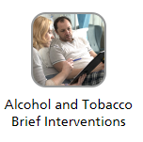
Alcohol and Tobacco Brief Interventions
This e-learning programme focuses on two brief interventions that are recommended by the National Institute for Health and Care Excellence for delivery in secondary care:
Alcohol misuse and smoking are among the most significant risk factors contributing to ill health. In England, more than one in four people drink alcohol at levels that increase their risk of health harm, and about 16% of people smoke (Public Health England). Many of these people are frequent users of hospitals, which provides a great opportunity for healthcare professionals to talk to them about their drinking and smoking, and how their health could benefit from making changes.
The programme is intended to provide healthcare professionals with the minimum level of knowledge and skill needed to confidently and effectively identify risk and provide brief advice to patients who smoke or who are drinking at a level that could be harming them.
https://portal.e-lfh.org.uk/Component/Details/515190

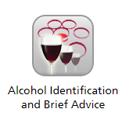
Alcohol Identification and Brief Advice
The Alcohol Identification and Brief Advice e-learning project (Alcohol IBA) helps professionals to identify those individuals whose drinking might impact their health, now or in the future and to deliver simple, structured advice aimed at reducing this risk. Courses available include delivering alcohol IBA in four settings:
- Primary Care https://portal.e-lfh.org.uk/Component/Details/454070
- Community Pharmacy https://portal.e-lfh.org.uk/Component/Details/454072
- Hospitals https://portal.e-lfh.org.uk/Component/Details/456154
- Dental Teams https://portal.e-lfh.org.uk/Component/Details/456156
All four pathways were developed in collaboration with Public Health England. NICE public health guideline PH24: Alcohol-use disorders: prevention, recommends that health and social care, criminal justice and community and voluntary sector professionals should routinely carry out alcohol risk identification and deliver brief advice as an integral part of practice.

https://portal.e-lfh.org.uk/Component/Details/391471

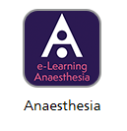
Anaesthesia

This module provides knowledge based sessions on the provision of analgesia and anaesthesia during labour and pregnancy together with the physiological changes associated with a normal pregnancy. The topic areas covered are:

- Pregnancy and labour
- Assessment and consent
- Labour analgesia
- Regional analgesia and anaesthesia
- General anaesthesia in obstetrics
- Choice of anaesthetic technique
- Serious problems in obstetric anaesthesia
- Postnatal issues
- Anaesthesia during pregnancy outside the delivery suite

https://portal.e-lfh.org.uk/Component/Details/459772

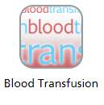
Blood Transfusion
The Anti-D Clinical course covers pathophysiology, management of routine and non-routine care during pregnancy, informed decision making and administration of anti-D immunoglobulin. On completion of the course you will be able to:

- Explain the significance of the RhD factor during pregnancy, the pathophysiology of antibody formation following fetomaternal haemorrhage and how anti-D immunoglobulin prevents sensitisation.
- Describe the impact that anti-D prophylaxis has on maternal, fetal and neonatal outcomes.
- Discuss the management of potentially sensitising events during pregnancy and the care of women already sensitised to the RhD antigen.
- Identify national guidance for anti-D prophylaxis.
- Recognise the need to facilitate informed decision making in relation to anti-D immunoglobulin.
- Describe the safe storage and administration of anti-D immunoglobulin.

https://portal.e-lfh.org.uk/Component/Details/392092

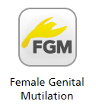
Female Genital Mutilation

The FGM course is designed to improve the knowledge and awareness of FGM amongst healthcare professionals. The e-learning resource focuses on issues related to health, legal status and referral pathways. The sessions are knowledge based and will provide practical support to healthcare professionals facing challenges such as how to approach a conversation about FGM with patients.

https://portal.e-lfh.org.uk/Component/Details/390864

General Practice

Children and Young People: Neonates and Infants and Women's Health: Conception and Pregnancy

Most care of children is delivered by Primary Care professionals. The care of children in General Practice is concerned with the health of infants and children, their growth and development and their opportunity to achieve full potential as adults. GPs need to be effective at recognising and dealing with any safeguarding issues. This module looks at the issues facing neonates and infants including common neonatal problems. It also deals with neonatal assessment and examination.

https://portal.e-lfh.org.uk/Component/Details/457637
https://portal.e-lfh.org.uk/Component/Details/392845

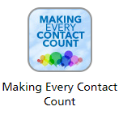
Making Every Contact Count
Making Every Contact Count is an approach to behaviour change that utilises the millions of day-to-day interactions that organisations and people have with other people to support them in making positive changes to their physical and mental health and wellbeing.
Making Every Contact Count enables the opportunistic delivery of consistent and concise healthy lifestyle information and enables individuals to engage in conversations about their health at scale across organisations and populations. Drawing on behaviour change evidence, the approach maximises the opportunity within routine health and care interactions for a brief or very brief discussion on health and wellbeing factors.
https://portal.e-lfh.org.uk/Component/Details/432821

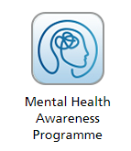
Mental Health Awareness Programme
Mental health problems are very common and NHS staff would benefit from greater awareness, as people with poor physical health are more likely to experience mental health difficulties. Equally, people with poor mental health often also have poor physical health.
This short programme aims to raise the awareness of mental health amongst health care staff. It is designed to give a broad overview of what encompasses mental illness, the link between mental and physical health diagnoses and outline some possible treatment options. These sessions provide all staff working within health care with some general strategies to help support individuals who are worried about their mental health, and advice about where to find extra support.
Mental Health Awareness for Healthcare professionals https://portal.e-lfh.org.uk/Component/Details/421625
Mental Health Awareness for Emergency Medicine https://portal.e-lfh.org.uk/Component/Details/422031
Mental Health Awareness for Practice Nurses https://portal.e-lfh.org.uk/Component/Details/443402

Revalidation

Revalidation is the new process that all nurses and midwives in the UK need to follow to maintain their registration with the Nursing and Midwifery Council (which took effect from April 2016). Revalidation enables nurses and midwives to demonstrate that they practise safely and effectively. This e-learning package has been designed to support and provide tools to NMC registrants in order to hold an effective professional discussion as part of the revalidation process.

https://portal.e-lfh.org.uk/Component/Details/478549

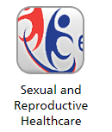
Sexual and Reproductive Healthcare

The e-SRH programme has been developed by the Faculty of Sexual and Reproductive Healthcare (FSRH) in partnership with Health Education England e-Learning for Healthcare (HEE e-LfH).

The programme supports a range of healthcare professionals to gain the necessary knowledge to successfully support patients with their SRH needs.

The e-SRH programme has been updated to be more relevant to current practice and complement the redesigned FSRH Diploma (DFSRH) as well as other FSRH qualifications. It is an excellent learning resource to build SRH knowledge.

The updated e-SRH programme comprises of 30 sessions organised around 13 different topics. Sessions are 20-30 minutes in duration and are interactive and accessible.
Learners can access information, read articles, undertake self-assessments, view video clips and animation, along with real-life case studies to support learning.

https://portal.e-lfh.org.uk/Component/Details/628669

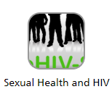
Sexual Health and HIV
eHIV-STI is an engaging and extensive e-learning programme supporting specialist training in Sexual Health & HIV.
It has been developed by the British Association for Sexual Health and HIV (BASHH) and the Federation of Royal Colleges of Physicians in partnership with Health Education England e-Learning for Healthcare.
Around 140 session incorporating video clips and case studies cover large parts of the knowledge components of the sexual health and HIV curriculum for trainees.
https://www.e-lfh.org.uk/programmes/sexual-health-and-hiv/

Standards for Student Supervision and Assessment (SSSA) update

This update provides a refresher of the knowledge, skills and behaviours needed to support learners to become outstanding nurses and midwives.
In this module, you will learn how to:
• Employ strong interpersonal skills to have productive and inclusive conversations with learners and colleagues
• Create a safe, engaging, and inclusive learning environment for your learners
• Effectively manage learner performance by setting clear objectives, providing feedback, supporting struggling learners, and escalating where appropriate.
This module should take around 30 - 45 minutes to complete.
There are interactive activities and reflection activities throughout this module to check your understanding.

https://portal.e-lfh.org.uk/Component/Details/733576

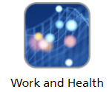
Work and Health

This session will offer some practical guidance to healthcare professionals on how they can look after themselves and do it well.

https://portal.e-lfh.org.uk/Component/Details/546169

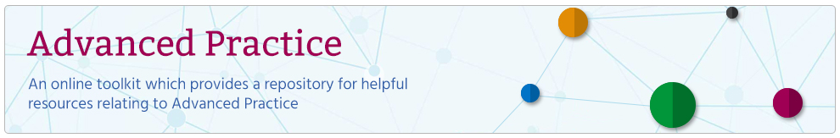

The Advanced Practice Toolkit supports ongoing work to enhance the understanding of Advanced Practice (AP). The toolkit aims to benchmark this level of practice and its application to specific roles across clinical practice, leadership and management, education and research.
The toolkit provides general information about the AP role as well as specific information aimed at the following groups of people: practitioners, educators, employers, commissioners, those planning the workforce across systems and patients/service users.
https://www.e-lfh.org.uk/programmes/advanced-practice-toolkit/

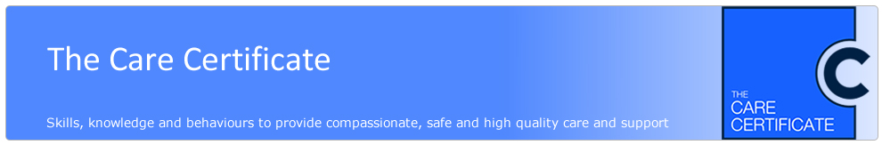

Developed following the review of health and social care support workers by Camilla Cavendish (2013), the Care Certificate is an identified set of standards that health and social care workers adhere to in their daily working life. Designed with the unregistered workforce in mind, the Care Certificate was developed to provide structured and consistent learning to ensure that care workers have the same introductory skills, knowledge and behaviours to provide compassionate, safe, quality care and support.

https://www.e-lfh.org.uk/programmes/care-certificate/

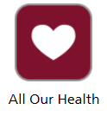
All Our Health

This is a bite-sized session to give health and care professionals an overview of sexual and reproductive health and HIV - including key evidence, data and signposting to trusted resources to help prevent illness, protect health and promote wellbeing.

https://portal.e-lfh.org.uk/Component/Details/596373

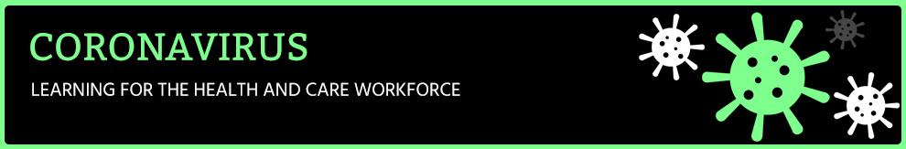

Accessing the Coronavirus programme

Available to all
The programme is freely available to colleagues working in the NHS, independent sector and social care. We have removed the requirement to register and log in: https://portal.e-lfh.org.uk/Component/Details/604722
Please note that if you do not log in, then your activity will not be tracked and you will not create a learning record. For example, if you are returning to work and need to complete your Statutory and Mandatory training, then you will need to be logged in so that the system knows who you are.
So if you need to create a learning record but don’t have an account, then you will need to register. Please note this is not restricted and you can submit any email address: https://portal.e-lfh.org.uk/Register
https://www.e-lfh.org.uk/programmes/coronavirus/

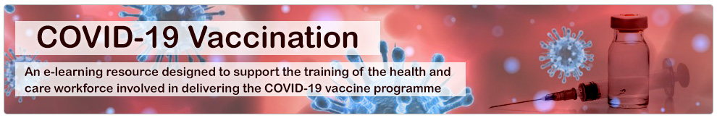

The COVID-19 pandemic has caused millions of infections and over a million deaths across the world. Numerous measures have been taken to try to contain the virus and prevent infection but ultimately, the most effective way to stop the pandemic will be the introduction of an efficacious vaccine. Scientists across the world have worked rapidly to develop an effective vaccine. Now it is crucial that the COVID-19 vaccine is safely delivered to as many of those eligible as possible.
This COVID-19 Vaccination e-learning programme is designed to provide the health and care workforce involved in the national COVID-19 vaccination programme with the knowledge they need to confidently promote high uptake of the vaccine and deliver the vaccine programme effectively.
https://www.e-lfh.org.uk/programmes/covid-19-vaccination/

Explore genomics in midwifery
Genomics is fundamental to midwifery practice. It allows midwives to predict and prepare for situations in pregnancy to better protect and care for the parent and child.
To help midwives recognise the significance of genomics in their practice, the Genomics Education Programme (GEP) has created a new resource in the Genomics in Healthcare series: Genomics in Midwifery. The webpage brings together tips and tools to support midwives at any point of their career and at any stage of their genomics learning journey.
The resource brings together a variety of learning opportunities, including an introductory animation highlighting the importance of genomics in midwifery practice, a pregnancy touchpoint walkthrough with good practice tips and a case study that explores why early information about family history can have such a big impact on care.
View the resource on our website.

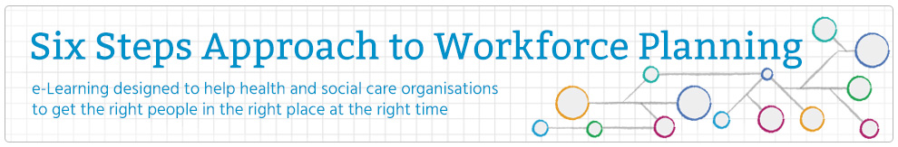

The six steps have, for several years, been widely regarded as the method used to support workforce planning in health and social care.
This e-learning programme can be used as a tool to support health and social care organisations with workforce planning. The programme is made up of six steps which will guide the health and social care professional through the principles and activities of planning.
It is aimed at anyone who engages in service redesign, restructures and reorganisations but can be appropriately scaled to suite the users’ need dependant on the size of the change.
It also is supported by a case study illustrating the steps that should be followed as part of the workforce planning process.
https://www.e-lfh.org.uk/programmes/six-steps-approach-to-workforce-planning/
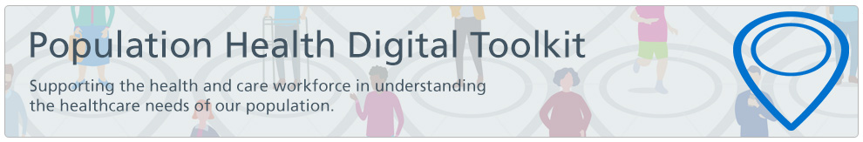

Population Health Digital Toolkit
Population health is an approach aimed at improving the health of an entire population. It is about improving the physical and mental health outcomes and wellbeing of people, whilst reducing health inequalities within and across a defined population. It includes action to reduce the occurrence of ill-health, including addressing wider determinants of health, and requires working with communities and partner agencies.

Population Health Digital Toolkit
Paediatric Early Warning Scores (PEWS)
Enhanced Paediatric Nursing Skills
Obesity
Down syndrome: Improving the Maternity Experience
National Continuity of Carer (Part of the continuity of the Midwifery Continuity of Carer programme)

