Evaluation of the Oliver McGowan Mandatory Training Trial in Learning Disabilities and Autism

Project Report
NDTi June 2022

Easy read report written by My Life My Choice

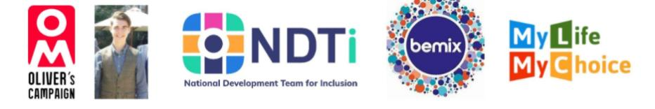

 | Oliver McGowan was a young man who had a learning disability and autism.
 | Sadly, Oliver died because he was given anti-psychotic medication when he was in hospital.
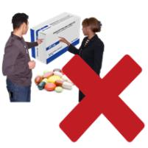 | Oliver and his family told the doctors that he did not want or need the medication, but the doctors gave it to him anyway.
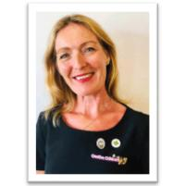 | After Oliver died, his mum, Paula McGowan led a campaign for more training for health and social care staff.
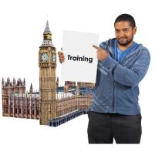 | In 2019, the Government said there should be training for staff who work with people with a learning disability and or autism.
This training must be given to health and social care staff.

This is called Mandatory Training.

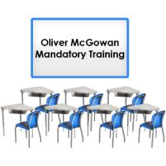 | The training is named after Oliver and is called the Oliver McGowan Mandatory Training.
 | This training had to be written by people with a learning disability, autistic people and their families.
 | In June 2020, 4 organisations were chosen to deliver and test this training.
 | To read more about the Trial Partners and how The National Development Team for Inclusion (NDTi), Bemix and My Life My Choice (MLMC) worked together, please read our mid-project report here.

Evaluating the Training
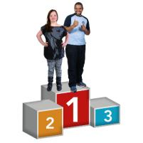 | The aim of the training is to make sure health and social care staff know how to best support autistic people and people with a learning disability.
 | The training is to help stop people from dying from getting poor care.
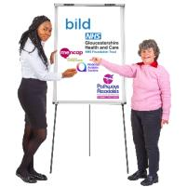 | In 2020, 4 Trial Partners were chosen to co-produce and co-deliver training to health and social care staff in England.
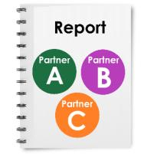 | In this report we will tell you what we found about the training that was delivered. We will talk about:  - Training Partner A  - Training Partner B  - Training Partner C
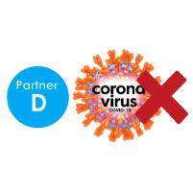 | In August 2021, Training Partner D had to stop being involved in the project because of Covid 19.
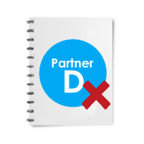 | We have not looked at any information from Partner D in this report.
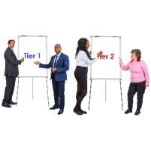 | There were 2 levels of training to be delivered.  Level 1, known as Tier 1 and level 2 was known as Tier 2.
 | Some of the Trial Partners wanted to deliver their training face-to-face.
 | Others wanted to do some learning online that people did in their own time and then had discussions together face-to-face.
 | Some groups did a separate training session for Tier 1 and Tier 2.
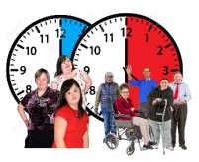 | Other organisations did shorter learning sessions that people could do at different times.
 | Some partners worked with people with lived experience to make films for the training.
 | Others worked with people with lived experience to deliver the training.
 | Training Partner A started delivering Tier 1 training in December 2020 and Tier 2 training in August 2021.
 | Training Partner B started both Tier 1 and Tier 2 at the same time in May 2021.
 | Training Partner C started both Tier 1 and Tier 2 at the same time in August 2021.
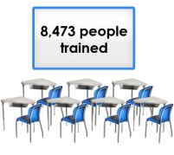 | In total, 8,374 people have had the training.
What we wanted to find out about the training
 | The most important thing we wanted to know was what made the best training course.
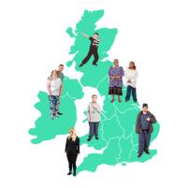 | We thought about these questions:  - What was the best way to deliver the training to lots of different staff in different places?
 | - What training made the staff feel the most confident with working with autistic people and people with a learning disability?
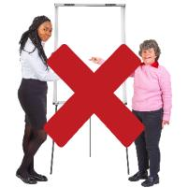 | - What might make it hard to deliver this training?
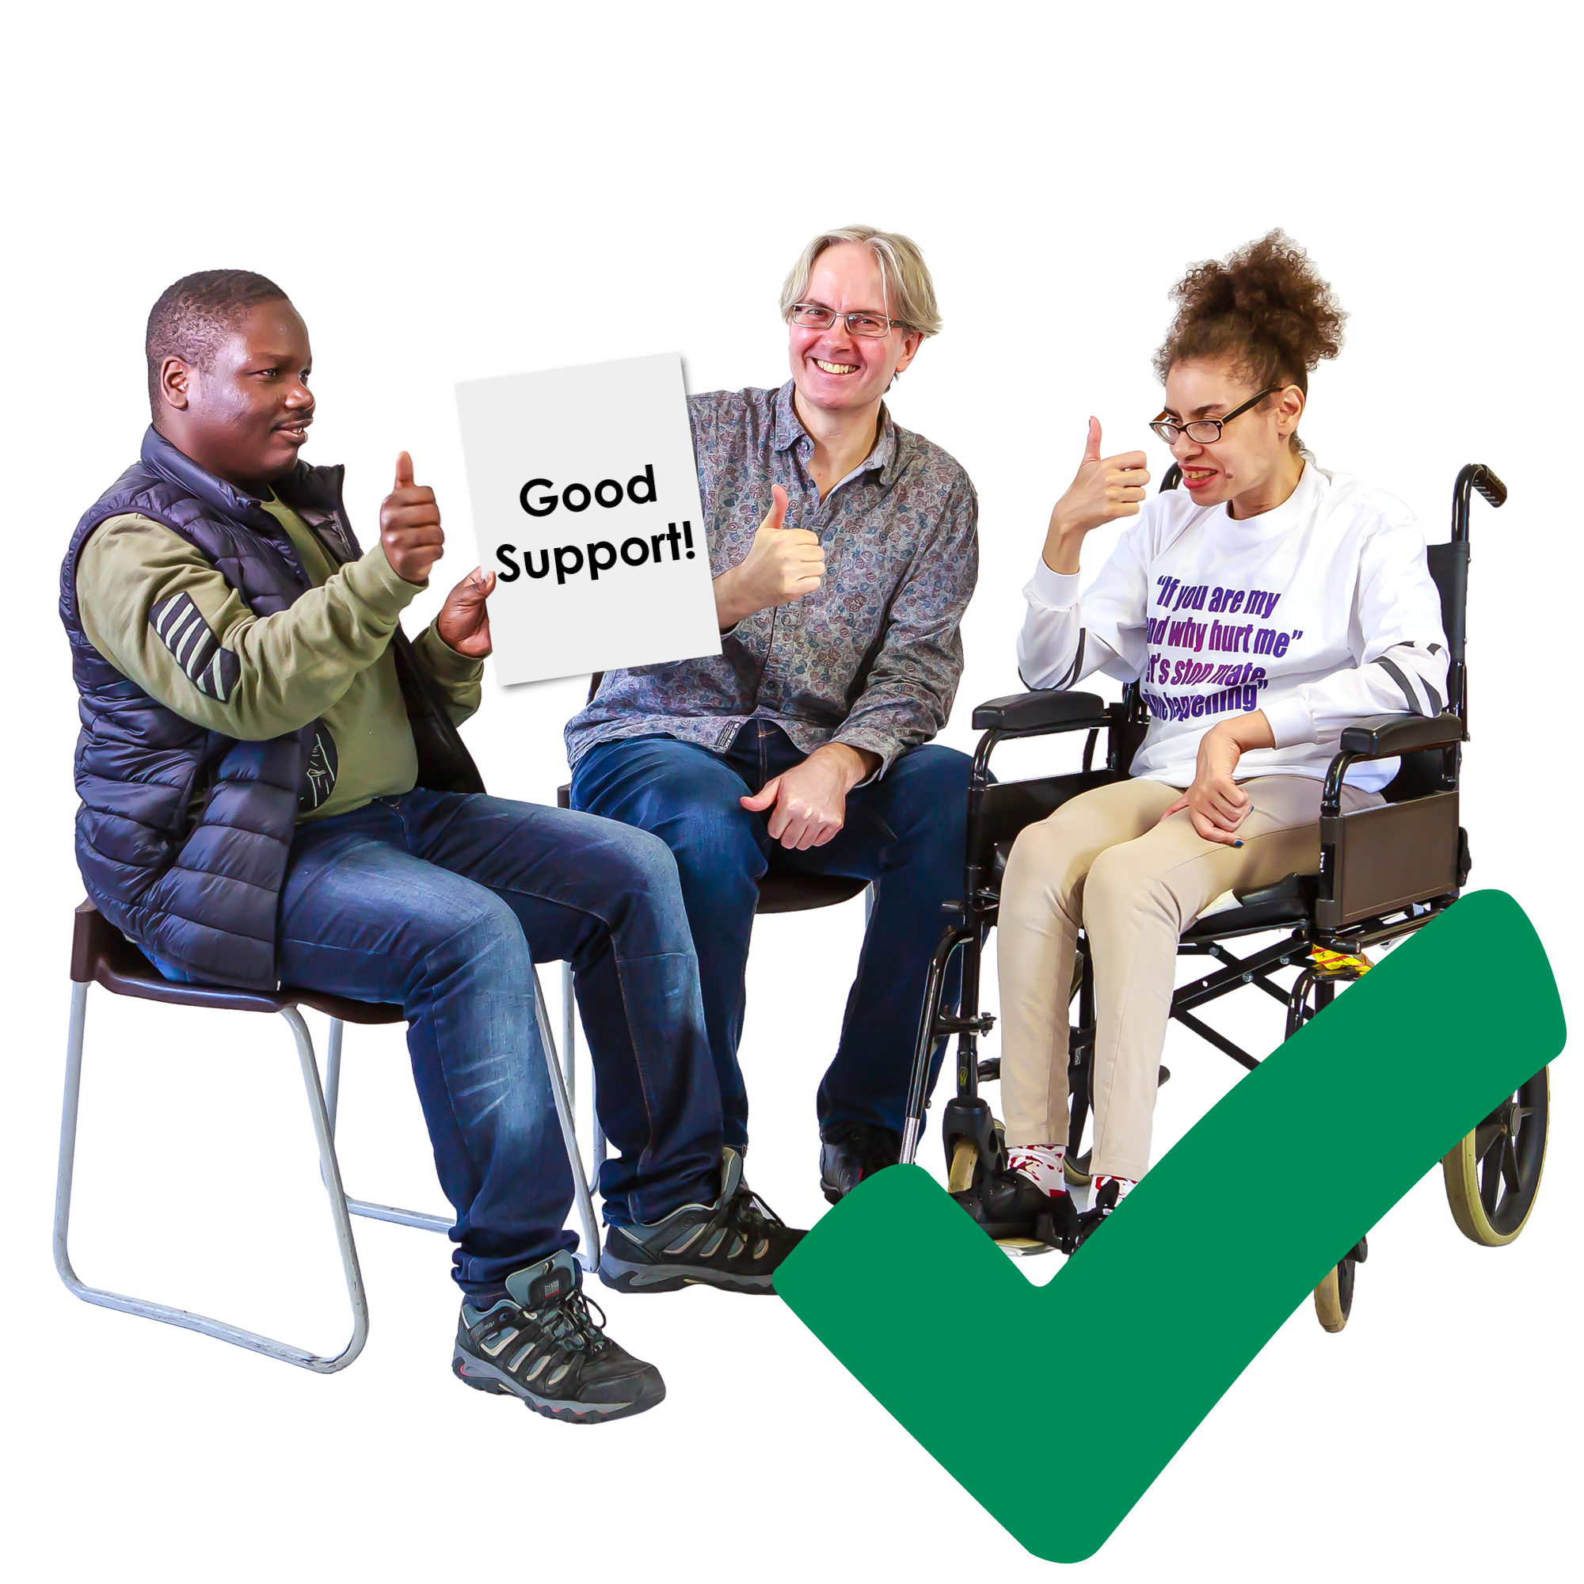 | - How can we know if autistic people and people with a learning disability are getting better care and support because of the training
Why we did the evaluation
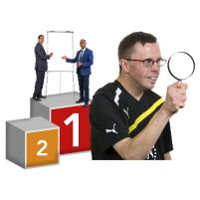 | We needed to do some research so we could decide which Trial Partner made the best training course.
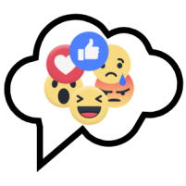 | We wanted to look at 4 main things:  - How did people feel once they had the training?
 | - Had people learnt something and gained new skills because of the training?
 | - Has the training helped people to do their jobs differently and give people better care and support?
 | - Did the training deliver what it said it would or needed to?
 | As well as looking at the training courses, we also wanted to know how people with personal experience of a learning disability or autism were included in creating and delivering the training.

How we did the evaluation
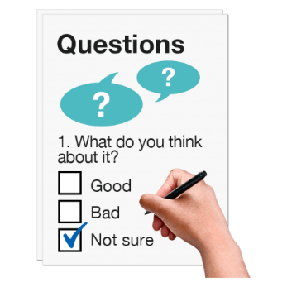 | To find the answers to the evaluation questions, we did different things.
Observation

The Evaluation Team worked together to look closely at how the training was delivered to staff.

This is called an observation.

Experts by experience and the NDTi worked together to come up with a checklist for the training.

These were things that they all thought were important to look out for.

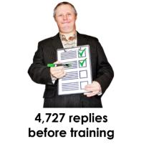 | Survey  We asked staff who were trained what they know about learning disabilities and autism.  We asked them before and again after the training to see what they have learnt.  This is called a survey.  There were 4,272 replies to our survey before people had the training.
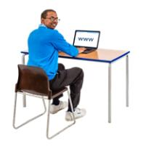 | Follow up Survey  The team sent out some questions to staff online 3 months after they had the training.  We wanted to know if the training has helped them to do their jobs better.
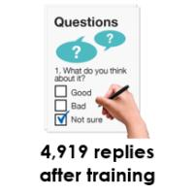 | There were 4,919 replies to the follow up survey.
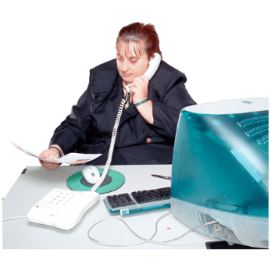 | Telephone Interviews  The team called staff on the phone after they had the training to see if it helped them to work with people with a learning disability or autism better.
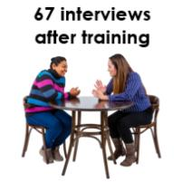 | There were 67 interviews with people after they had done the training.
Focus Groups

The Evaluation Team asked a group of people about the training they delivered.

The focus group was for people to share their stories with each other and say what worked and what could have been done better.

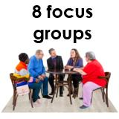 | There were 8 focus groups with people who were involved in making and delivering the training courses.
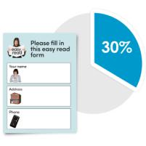 | Data Review  As well as asking people how the training went, we also looked at the numbers.  When there is a set of numbers or information this is called data.  We looked at all our data to help write this report.

Tier 1 Training
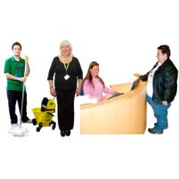 | Tier 1 training was for all people who might come into contact with an autistic person or person with a learning disability at work but who do not work closely with them every day.
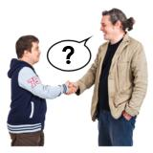 | There were key things that the training had to include. These were:  - What is a learning disability?  - What is autism?  - How do they affect people?  - How can you see an invisible disability?  - What are reasonable adjustments and how do you make them?  - What are your own thoughts and opinions about autistic people and people with a learning disability?
 | All training courses must also include a video about Oliver’s story.

Trial Partner A – Tier 1
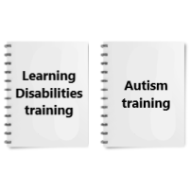 | They ran their training as two separate courses.  They had one course for understanding autism and one course for understanding learning disability.
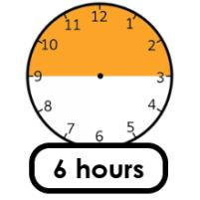 | Their course was 6 hours long in total.
 | They had two lots of lessons online where people had to do their own learning. This is called e-learning.
They had to learn about:

- Understanding autism and learning disability

- What words to use when speaking about someone autistic or with a learning disability

- What the law says about autism and people with a learning disability

- How they have been treated throughout history

- How best to communicate with autistic people or people with a learning disability

They then had 2 long (1.5 hours each) online meetings with experts by experience to talk about what they had learnt.

They had 1 session for each of their courses.

Trial Partner B – Tier 1
 | They asked people to do some online e-learning in their own time.
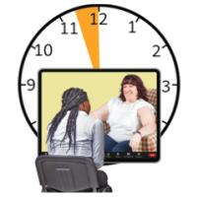 | They followed this up with an online meeting with someone with an expert by experience for 30 minutes.
 | Their course was 2 hours long.
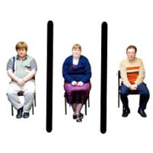 | Their online learning lessons were divided into autistic people, people with a learning disability and then people with a learning disability who also had autism.
They learnt about:

- Health issues

- Getting a diagnosis

- How to communicate well

- How you can improve someone’s experience of care

- What people think about autistic people and people with a learning disability

 | They also included videos made by experts by experience.
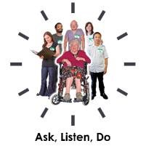 | There was a section for people to think about their own work and what they could change, called ‘Ask, Listen, Do’.
Trial Partner C – Tier 1
 | They also decided to separate courses. 1 was on autism and 1 on learning disability.
The courses were run face-to-face and lasted for 3.5 hours each.

It would take 7 hours to do the whole Tier 1 course.

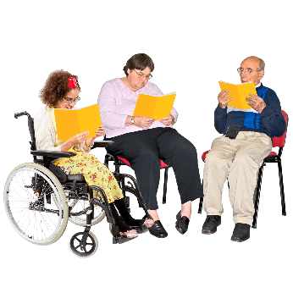 | People learned about:  - Health conditions that people may have  - Challenges in health and social care  - Ideas on how to change things in health and social care
What people thought about the Tier 1 training
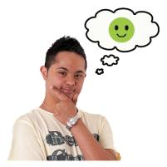 | Most people who had Tier 1 training thought the training was at the right level for them.
Some people thought they had the right amount of training.

Others thought the training was a bit too short, but some thought it was too long.
 | One person said, “I am a back officer worker with no interaction. The training was far too much for my role.”
 | However, most people said that there was nothing they would change to make the training better.
 | Nearly all the people who told us what they thought of the training said it was really good to have a mix of online learning and speaking to people in real life.
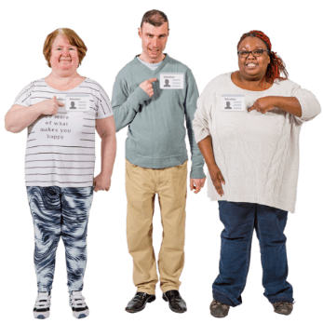 | Lots of people liked that experts by experience were included in the training.
 | They also liked watching the videos made by experts by experience and they liked the video about Oliver’s story.

What people learnt from the Tier 1 training
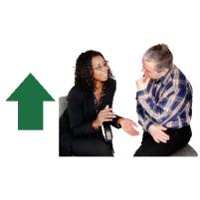 | The data shows that people felt they were more confident to communicate with autistic people or a person with a learning disability after having the training.
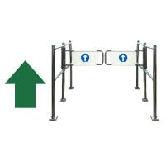 | They also felt like they had learnt more about autistic people and people with a learning disability and the challenges that face them.
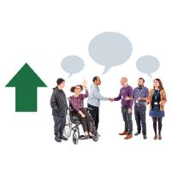 | Some people thought they had learnt new skills or tips to work better together.
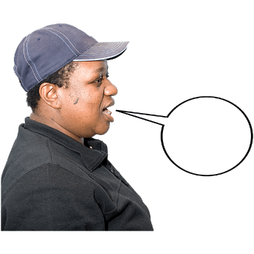 | One person said, “The course has made me think more about listening and watching at a personal level.”
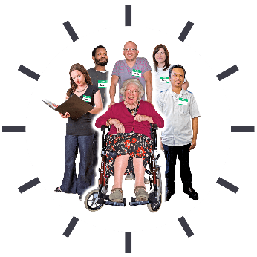 | Lots of people said that they had started doing things differently in their jobs after they had the training.  For example, one person told us that they had recently arranged a home visit rather than meeting someone at the doctor’s surgery which the person finds more stressful.

Our final thoughts on the Tier 1 Training
 | Each course had parts that people liked and parts they did not like.
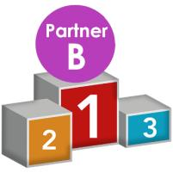 | Based on the feedback that we got, we think Trial Partner B’s training would be the best.
 | We think it is important to have a mix of doing training online and being able to talk to someone in person.
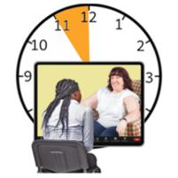 | We think that people doing the training should talk to someone autistic and someone with a learning disability.  This would mean the online meeting with experts by experience should be for 1 hour.

Tier 2 Training
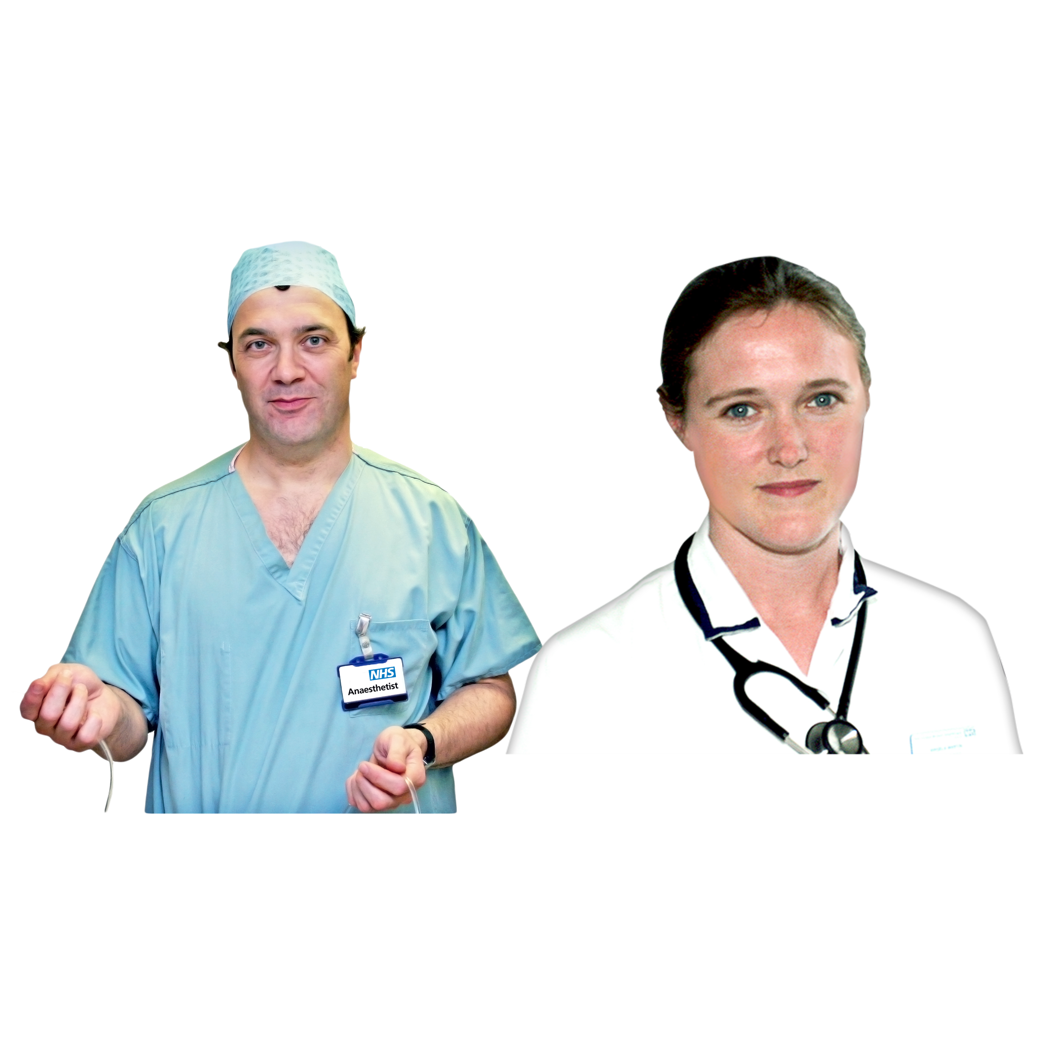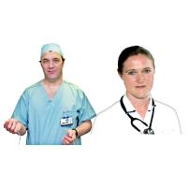 | Tier 2 training was given to people who sometimes work with autistic people or people with a learning disability in their jobs.
Tier 2 training looked at what people learnt in Tier 1 and added more information to help people work better together.

The training also had to teach people about:

- Different medical conditions people can have

- The laws around autism and learning disability

- What reasonable adjustments are and how to make them

- How to communicate in an accessible way

- Annual Health Checks

Trial Partner A – Tier 2
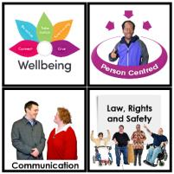 | Trial partner A divided their training up into 4 main areas including:  - Health and Wellbeing  - Person Centred Support  - Communication  - Law, Rights and Safety
 | They asked people to do this online at a time that suited them.
 | There were follow up sessions that were face-to-face with autistic people and people with a learning disability.
 | This training took 1 full day but could have been done online or in person.

Trial Partner B – Tier 2
 | Trial Partner B wanted to deliver all of their training face-to-face.
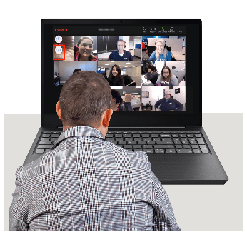 | Sadly, because of Covid 19, they also had to do some training online.  This training was different because it was done live, and people could join in.
 | Experts by experience were asked to deliver the training.
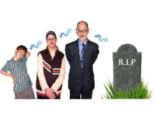 | The training was about someone’s life from when they are born to when they die.
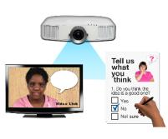 | There were different presentations, videos and quizzes to help explain the training.
 | This training takes 1 full day to deliver.
Trial Partner C – Tier 2
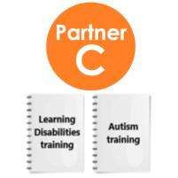 | Trial Partner C did one training session on autism and one on learning disability.
They did all their training face-to-face.
The autism training was delivered by 2 people, one with autism and one without.

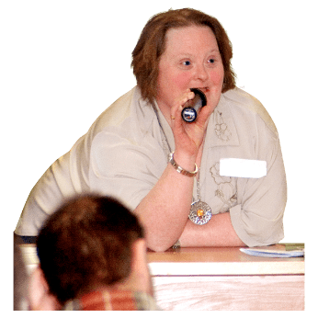 | An expert by experience with a learning disability was invited to share their stories at the learning disability training.
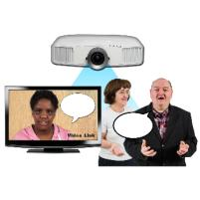 | They used presentations, films and conversations to help people to understand their training.
 | This training takes 2 full days to deliver.

What People thought about the Tier 2 training
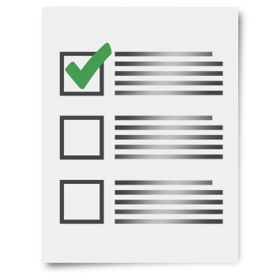 | Most people who had Tier 2 training thought it had the right information.
It was hard to know how long the training should be.

Some people thought it was too long and some people thought it was too short.

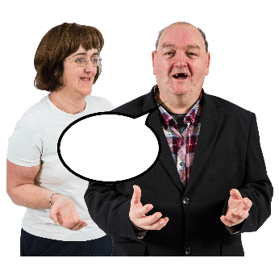 | 1 person said, “It is impossible to cover that much in one day.”  Another person said, “I would have loved this training to be longer.”
What people learnt from the Tier 2 training
 | The data shows that people felt they were more confident to communicate with autistic people or a person with a learning disability after having the training.
 | They also felt like they had learnt more about autistic people and people with a learning disability and the challenges that face them.
 | Some people thought they had learnt new skills or tips to work better together.
One person said, “Before the course I might not have reported it but now I could highlight if something went wrong."

Another person said, “I felt way more confident to question practice and felt empowered.”

Most people who had Tier 2 training told us that they started doing things differently in their jobs since having the training.

Someone told us that when a child with a learning disability was getting upset in a busy waiting area they moved them to a quieter area.

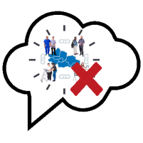 | Some people on the training said they did not feel they were allowed to make changes to the ‘system.’

Our final thoughts on the Tier 2 Training
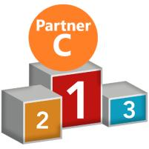 | If a decision is made to go with one of the Trial Partners to deliver this training, we think it should be Partner C.
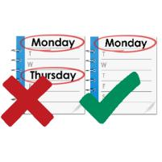 | However, we think it would be better to deliver the training in 1 full day and not 2 days.
From all the information we have looked at, we think Tier 2 training should include:

- Oliver’s Film

- videos that talk more about social care

- videos that have been made by experts by experience about their care

- people with a profound learning disability and autistic people who do not use speech.

- Top Tips for what they can do in their jobs

- time for people to think about what they have learnt and what they could do differently in their jobs.

 | From all the feedback we had, we think doing the training in person would be best for everyone.
 | However, some people did like that the training could be spread out if it was done online.

