# NHS England Wider Workforce Mental Health Training

Final Evaluation Report November 2023

# 

Contents

1

1. Introduction 4

Principles Underpinning the Training 5

2. Summary of Findings 6

3. Methodology & Approach 7

3.1 Collation and Analysis of Training Registration and Attendance Data 7

3.2 Pre-Training and Post-Training Evaluation Surveys 8

3.3 Linkage of Registration, Attendance and Pre/Post-Training Evaluation Data 8

3.4 Online Focus Groups with Training Attendees 9

4. Profile of Attendees Attending Training 9

Figure 1: Number of attendees per module. % of total registered 9

Table 2: All attendees who attended at least one session, by sector 10

Table 3: All attendees who attended at least one session, by level of direct contact with CYP and families 11

Table 4: All attendees who attended at least one session, by ethnicity 11

5. Session Scheduling and Attendance 12

6. Evaluation Findings 15

6.1 Attendees’ motivations for taking part in the training 15

Figure 4: Attendees’ pre-evaluation open-text responses on their motivations for taking part in the training. 17

6.2 The role of practitioners in supporting children and young people with their mental health 18

Table 5: Attendees role in supporting the mental health of CYP and families 18

6.3 Knowledge, skills and confidence to support children and young people with their mental health 19

Table 6: Attendees’ self-rated knowledge, skills and confidence to support children and young people with their mental health pre- and post-training 20

Table 7: Attendees’ self-reported understanding of the impact of the environment and relationships on CYP’s mental health and wellbeing 21

6.4 Differences in attendees’ understanding, knowledge, and confidence to support CYP pre- and post-training by pilot area and sector 22

6.5 Implementation of the training in practice 23

Table 8: Attendees’ intended implementation of training in their practice 25

6.6 Satisfaction with the training 27

Figure 5: Attendees’ satisfaction with training content, facilitation quality, and opportunity to ask questions 28

6.7 Suggestions for improvements to the delivery, format, and content of the training 30

Table 9: Focus group participants’ suggested improvements for future training delivery 31

7. Conclusion 36

8. Appendix 37

Appendix Figure A: Objectives of each training workshop 37

Appendix Figure B: All attendees who attended at least one session, by sector 38

Appendix Figure C: Number of attendees who attended Module 1, 2 and 3 by sector 39

Appendix Figure D1: Differences in attendees’ understanding, knowledge, and confidence to support CYP pre- and post-training by pilot area 40

Appendix Figure D2: Differences in attendees’ understanding, knowledge, and confidence to support CYP pre- and post-training by sector 41

Appendix Figure D3: Differences in attendees’ understanding, knowledge, and confidence to support CYP pre- and post-training by Pilot area 41

Appendix Figure E: Summary of how the Lundy Model of Participation was used for the development of the training 42

## Introduction

In November 2022, Anna Freud, in partnership with Charlie Waller Trust and the National Children’s Bureau (NCB) (henceforth, the partnership), were commissioned by NHS England (formerly Health Education England) to develop and deliver a mental health training for the wider children’s workforce in three pilot areas: Norfolk, Portsmouth, and Southampton. The intention was to design and test the impact of a training that positioned mental wellbeing as “everyone’s business” in a similar way to safeguarding, in order to maximise the role that those in the wider children’s workforce can play in supporting the mental health of children, young people and their families.

The training was developed through an iterative process of participation and feedback (see diagram). The partnership undertook extensive consultation with children and young people (CYP), parents and carers, and staff members from a range of sectors in the three pilot areas. Via workshops, focus groups and surveys, the partnership sought to understand CYP and parents and carers’ experiences of the workforce and what qualities and skills they would most value, workers’ perception of training needs and worker confidence in key knowledge and skills. Data captured was combined with learning from existing local CYP and parent/carer participation work from the pilot areas and the existing evidence base around important knowledge, skills and values, to design a training curriculum and materials. Both the content and method of the training was influenced by the combined existing expertise from the three partnership organisations. Throughout training design, feedback was sought from key stakeholders and fed back into the design.

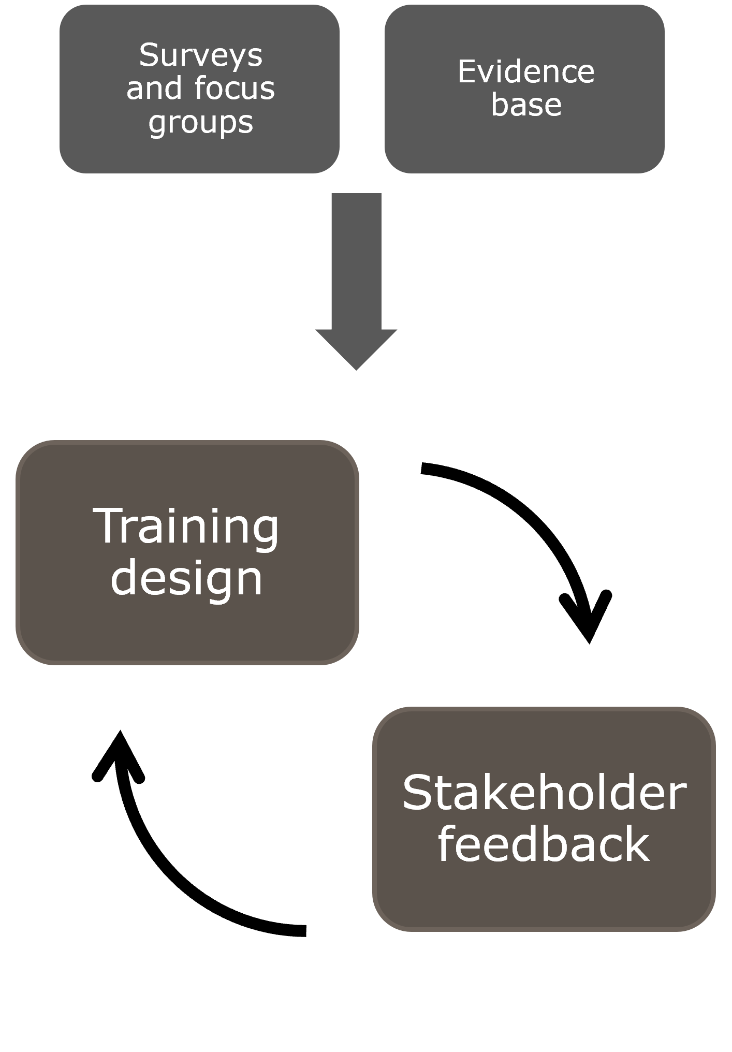

In some areas, the participation data revealed a discrepancy between the experiences of CYP and families and the confidence expressed by workers. For example, 87% of workers said they were somewhat, very or extremely confident in speaking about mental health concerns and offering support, yet significant numbers of CYP, parents and carers described feeling unheard, or invalidated, by workers when they spoke about their mental wellbeing or that of their child. Examples provided were of workers offering advice, onwards referral or signposting, when the CYP, parents or carers would have preferred a listening conversation with the person they had initially approached. For this reason, the training focussed not only on knowledge, skills and values, but also a) how to apply those knowledge, skills and values – many of which workers already possess - in practice and b) how to establish *which* knowledge, skill or value to apply in any given interaction, based on a shared understanding of the need of the CYP, parent or carer. To support this, the training was influenced by AMBIT (adaptive mentalization based integrative treatment[1]), an approach developed at Anna Freud which foregrounds the impact that working in stressful real-world contexts has on worker behaviour, including their ability to listen, understand and adapt their offer of help accordingly.

The participation work influenced not only the training content, but the principles that should underpin it, which were threaded throughout.

### Principles Underpinning the Training

Mental health is everyone’s business - we can all play a part in positively influencing children and young people’s emotional and mental wellbeing.

* Children and young people’s emotional wellbeing can be understood and addressed by paying attention to relationships and context.
* Parents and carers play a key role in supporting children and young people with their mental health.
* We must meaningfully promote child, young person, parent and carer participation in our work and respect their rights.
* Help needs to be adapted to each person and their unique circumstances.
* We must pay attention to equity, diversity and inclusion in how we offer help.
* Services are doing their best to respond in a context of high demand and increasing societal pressures.

The training was jointly delivered by trainers from all three organisations across the pilot areas. It comprised three separate modules delivered in three formats to cater for different schedules (all day, one module per day for three days, two twilight sessions) between March 2023 to September 2023:

1. Supporting positive mental health and identifying early signs of mental health challenges
2. Qualities and skills for helping conversation for children, young people and families
3. Access more help for children, young people and families

This evaluation draws on the objectives from each training workshop (see Appendix Figure A). The overarching aim of this evaluation was to assess the impact of the training on attendees’ knowledge of mental health and wellbeing in CYP, their skills and confidence to support CYP who are experiencing problems with their mental health, and how they have implemented what they have learnt throughout the training within their practice. The evaluation also examined the overall reach of the training in terms of registration and attendance levels.

Additionally, a key aim of this evaluation was to gather feedback from attendees to assess their levels of satisfaction with the training and understand any potential improvements for future training delivery.

## Summary of Findings

* High levels of attendance throughout the training programme: 740 individuals (63% of those registered) attended at least one training module, with 567 attending all three modules[2].
* Qualitative findings from the focus groups supported data from pre-training and post-training questionnaires: Participants expressed a variety of reasons motivating them to take part in the training, mainly to improve their overall knowledge of mental health in CYP, to learn how to better communicate with CYP and their families, and to improve their confidence to effectively support CYP experiencing problems with their mental health and wellbeing.
* Very high levels of satisfaction with the training programme overall: The vast majority of attendees reported being either satisfied or very satisfied with the content (96%), the facilitation (97%) and the opportunity to engage and ask questions (95%).
* Focus group participants also reported very high levels of satisfaction with the training programme, supporting the findings from the post-training evaluation questionnaire: The relevance of the training, as well as the opportunity to learn from, and collaborate with, other professionals were identified as key aspects of the training delivery that participants were most satisfied with. Participants also expressed that the training had helped to solidify a lot of their previous learning and helped enhance their practice.
* Attendees’ knowledge and confidence in their ability to support children and young people with their mental health and wellbeing improved substantially: Attendees’ self-rated knowledge, skills and confidence to support CYP with their mental health increased by up to 51 percentage points following participation in the training.
* In terms of potential enhancements for future training, attendees would value the opportunity to interact and discuss the content of the training in more detail: From over 200 responses regarding improvements to future training delivery, almost a quarter of respondents expressed wanting more opportunities for engaging and interacting with other attendees (e.g., through the use of breakout discussions).

## Methodology & Approach

The evaluation comprised the following four discrete research activities which are further described below:

1. Collation of training registration and attendance data;
2. Design and administration of online pre- and post-training evaluation questionnaires for training attendees;
3. Data linkage of registration, attendance, and pre/post training evaluation data; and
4. Design, facilitation and analysis of three online focus groups with training attendees.

### 3.1 Collation and Analysis of Training Registration and Attendance Data

To facilitate the collection of registration data, NCB created an Excel template for each pilot site to complete and return data to NCB. NCB consulted with those overseeing the training registration process in the three pilot areas of Norfolk, Portsmouth and Southampton to agree the information that each would collect from trainees at the point of registration. Examples of data fields included in the template included first name, last name and email address of trainee as these were common fields in evaluation forms to enable data linkage (see below).

### 3.2 Pre-Training and Post-Training Evaluation Surveys

Two online surveys were designed, focused on assessing the impact of the training on target learning outcomes (e.g., knowledge, skills and confidence).

The pre-training survey captured the following information:

* Profile information on attendee (job title, role, sector, level of contact with CYP)
* Levels of confidence, knowledge and skills in training content areas; and
* Expectations and hopes for training.

The post-training survey captured the following information:

* Profile information;
* Levels of confidence knowledge and skills in training content areas;
* Satisfaction levels with training content and delivery;
* Relevance of training to role and direct work with CYP and families;
* Accessibility of training; and
* Willingness to take part in a future focus group discussion.

To enable the linkage of registration data to the pre/post survey data, other data were also collected (first name, last name, work email address) in the pre/post evaluation forms. Respondents also provided detail of the sector they worked in, their level of contact with children, young people, and/or parents in their role, and their ethnicity.

### 3.3 Linkage of Registration, Attendance and Pre/Post-Training Evaluation Data

Following submission of the registration data from the three pilot areas, an initial data cleaning exercise was carried out. Following this, an extensive data linkage exercise was undertaken where attendance data and data from the pre- and post-training evaluation questionnaires were linked in with registration data for each individual who was registered to take part in the training. This linkage exercise enabled one complete dataset to be compiled and subsequently analysed. Linking the registration and evaluation data further allowed for the analysis of attendees’ outcomes (e.g., changes in knowledge, skills and confidence following the training) by sector, role, and pilot area.

This evaluation report does not include data related to training sessions scheduled to run after the 13th of September 2023 (n=5). In addition, data related to those who attended the training from 12th September 2023 onwards from one pilot site (Portsmouth) was unavailable for analysis.

### 3.4 Online Focus Groups with Training Attendees

Online focus group discussions with training attendees were facilitated by NCB. Three focus groups were facilitated (one group per pilot area). The purpose of these discussions was to explore the initial impact and application of the training in practice, as well as attendees’ thoughts on any potential improvements to future delivery of the training.

The focus groups took place in September 2023 to allow sufficient time for attendees to use the training in their practice and consider any feedback. A topic guide was developed and this included questions on attendees’ motivations for taking part in the training, barriers and facilitators to implementing the training in their practice, perceptions on the format, delivery, and content of the training, and suggestions for improving future training delivery. Each focus group was conducted online via Microsoft Teams and recorded for transcription purposes.

All attendees who had completed the training prior to the 5th of September 2023 and who had consented to being recontacted were invited to attend a focus group. Attendees were invited to attend each focus group session based on their pilot site. The target for the total number of attendees to join the focus groups was 30, and 25 attended.

## Profile of Attendees Attending Training

In total, 1,174 individuals registered to take part in the training. Of those, 740 (63%) attended at least one module. 697 individuals attended Module 1 and completed the pre-training evaluation questionnaire, 670 individuals attended Module 2, and 642 individuals attended Module 3 and completed the post-training evaluation questionnaire (see Figure 1).

### Figure 1: Number of attendees per module. % of total registered

The number of individuals who registered and attended the training varied by pilot area. The pilot area with the highest proportion of attendance versus those registered was in Norfolk (71%), with Portsmouth having just over half (54%)[3] registering for training attending at least one session (Table 1).

**Table 1: Number of attendees who registered for and attended at least one module by Pilot Area**

|  |  |  |  |
| --- | --- | --- | --- |
| Pilot Area | Registered to attend at least 1 module (n) | Attending at least 1 module (n) | % |
| Southampton | 550 | 328 | 60% |
| Norfolk | 436 | 311 | 71% |
| Portsmouth | 188 | 101 | 54% |
| Total | 1,174 | 740 | 63% |

Note: Above figures may be an underestimate due to missing data from one pilot area and training delivery continuing beyond the start of data analysis.

Combined, over half of the attendees who attended one module or more work across the education (22.8%), social care (22.4%), and health sectors (16.5%). A small proportion (7%) of attendees work across more than 1 sector. The ‘other’ category accounts for 3.8% of attendees (see Table 2 and Appendix Figure B).

The ethnicity of training attendees was largely homogenous (see Table 4), with the majority (90.6%) of attendees who attended at least one session being White. The next largest ethnic group was Mixed or Multiple ethnic groups: White and Black Caribbean (1.4%), followed by Black, Black British, Black Welsh, Caribbean or African: African (1.2%).

### Table 2: All attendees who attended at least one session, by sector

|  |  |  |
| --- | --- | --- |
| Sector | Number of Attendees | % of Attendees |
| Education | 169 | 23% |
| Social care | 166 | 22% |
| Health | 122 | 16% |
| Family & youth support | 109 | 15% |
| I work across more than 1 sector | 52 | 7% |
| Sports and culture | 32 | 4% |
| Voluntary, community or faith support | 29 | 4% |
| Other | 28 | 4% |
| Justice and crime prevention | 14 | 2% |
| Housing or transport | 12 | 2% |
| Local Government | 7 | 1% |
| Grand Total | 740 | 100.0% |

Note: Family support (n= 77) and youth support (n= 32) have been combined to create one sector group.

In terms of the level of contact that those who attended the training have with CYP and families, more than three-quarters of attendees reported having regular contact (78%), with fewer having occasional (19%) or irregular but intensive contact (3%) (Table 3).

### Table 3: All attendees who attended at least one session, by level of direct contact with CYP and families

|  |  |  |
| --- | --- | --- |
| Contact with CYP | Attendees (n) | % |
| Regular contact (e.g., weekly) | 567 | 77% |
| Occasional contact | 139 | 19% |
| Irregular but intensive contact | 22 | 3% |
| No response | 12 | 2% |
| Total | 740 | 100% |

### Table 4: All attendees who attended at least one session, by ethnicity

|  |  |  |
| --- | --- | --- |
| Ethnicity | Attendees (n) | % |
| White - English / Welsh / Scottish / Northern Irish / British | 644 | 87% |
| White: Other White | 27 | 4% |
| Unknown | 13 | 2% |
| Mixed or Multiple ethnic groups: White and Black Caribbean | 10 | 1% |
| Black, Black British, Black Welsh, Caribbean or African: African | 9 | 1% |
| Asian, Asian British or Asian Welsh: Indian | 6 | 1% |
| Mixed or Multiple ethnic groups: White and Black African | 6 | 1% |
| White: Irish | 5 | 1% |
| Asian, Asian British or Asian Welsh: Bangladeshi | 5 | 1% |
| Mixed or Multiple ethnic groups: Other Mixed or Multiple ethnic groups | 4 | 1% |
| Mixed or Multiple ethnic groups: White and Asian | 4 | 1% |
| Black, Black British, Black Welsh, Caribbean or African: Caribbean | 3 | 0% |
| Asian, Asian British or Asian Welsh: Chinese | 2 | 0% |
| Asian, Asian British or Asian Welsh: Other Asian | 1 | 0% |
| Asian, Asian British or Asian Welsh: Pakistani | 1 | 0% |
| Total | 740 | 100% |

## Session Scheduling and Attendance

Of the 70 planned training sessions, 61 (87%) sessions were delivered, and 9 sessions were cancelled due to low uptake from potential attendees and facilitator illness. The analysis presented below was based on the data for 52 sessions in total. Data was not available for all sessions delivered for a variety of reasons (e.g., training scheduled to take place beyond the period of this evaluation) [4].

* 740 individuals (63% of those registered) attended at least one training module
* The session with the highest attendance included 41[5] attendees (Figure 3)
* The average attendance across all sessions was 14.2 attendees (Figure 3)

Attendance for the training varied based on session type. Training sessions were delivered in one of three formats: all day, standalone module delivery, and twilight delivery. Individuals taking part in the ‘all-day’ session completed all three training modules in one day, with the session lasting 7 hours. Individuals taking part in the ‘standalone module’ delivery completed one training module per day across multiple days, with each session running for 2 hours. ‘Twilight’ sessions were delivered over two consecutive evenings, with each session lasting 3 hours. All-day sessions were the most popular, with 66% of all attendees attending this type of session. (Figure 2).

Of the 740 individuals who attended at least one module, 576 (78%) attendees attended all 3 modules. Of the attendees who attended every training module, the majority work across the education (24.1%), social care (22.2%), and health (16.3%) sectors (see Appendix Figure C).

**Figure 2: Session attendance by session type**

**Figure 3: Number of attendees per session**

P = Portsmouth, S = Southampton, N = Norfolk. Please note, the above figure is based on available evaluation data only. The number of attendees per session could be higher in cases where individuals have attended the session but not completed the registration form or where they have incorrectly recorded their session number.

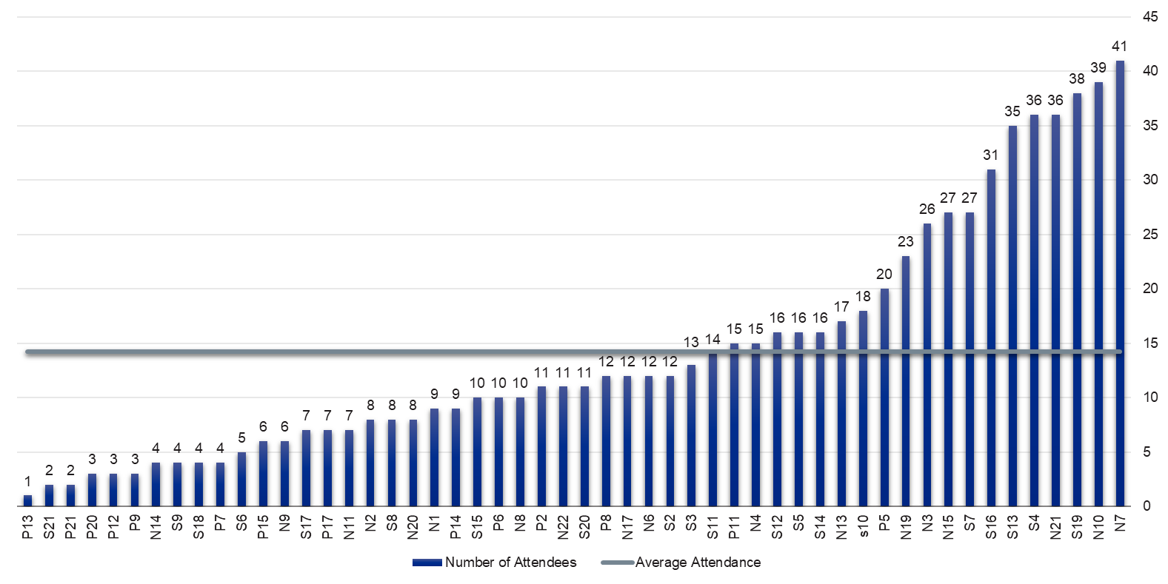

## Evaluation Findings

### 6.1 Attendees’ motivations for taking part in the training

Prior to completing the training, attendees were asked to report their motivations for attending the training. Attendees’ free-text responses from the pre-training evaluation form were analysed. Although responses were generally varied, the following reasons were most commonly reported:

* To improve their overall knowledge of mental health and wellbeing in CYP;
* To improve their communication with CYP and families;
* To improve their ability to identify mental health problems in CYP;
* To improve their knowledge of available resources and tools;
* To improve their confidence to effectively support CYP and their families.

A selection of attendees’ responses from the pre-evaluation questionnaire reflecting the themes outlined above are shown inFigure 4below.

Attendees’ motivations for taking part in the training were further explored in the focus groups. Several focus group participants expressed developing their knowledge and awareness of tools to support CYP as a key motivator for attending the training:

**“I work with children and families and often children who are looked after who have had a lot of developmental trauma in their life […]. For me, it was just developing my knowledge and skills around […] any new ideas, new tools I could carry around with me in my work with children and families.”**

**“I don't think you can ever have enough knowledge or skills in this area because there's, you know, home life, things happening on an everyday basis, especially with some of the children and within our school and […] I'm always [wanting] to gain more knowledge.”**

One participant expressed the significance of continued professional development and staying up to date with new information, citing this as a key reason for attending the training:

**“It's important for us to stay up to date with information, reflect on the knowledge that we already have, to look at anything new that's coming forward. In my role I talk to a lot of professionals, we are having reflective conversations about those vulnerable families and children and what is happening with mental health. The strains within settings […] I think it's really important for us to be on top of things and to make sure that we're giving the right advice.”**

Improving awareness of signposting opportunities and available resources for CYP and their families also emerged as a key reason for those who took part in the training:

**“I realised I had gaps in knowledge of where to signpost. There's an awful lot of services out there and just that knowledge around where to signpost and to refer onwards.”**

One participant reported a desire to attend this training to understand how this training offer compared with other similar training programmes available to professionals in their local area:

**“I attended looking for a refresher for sure, but also to have a think about how this training complement the offer that's already available in [the local area] because there are quite a few different training offers available. I was really interested to see how this would complement the current offer and any new bits and bobs that would be really interesting to hear about.”**

### Figure 4: Attendees’ pre-evaluation open-text responses on their motivations for taking part in the training.

“To know how to talk to a child who is dealing with mental health issues of their own.”

“To understand more about the signs of mental health and how best to talk to someone using the right words and understand their situation better.”

“Learn how to support children with mental health difficulties, how to communicate with them and where to signpost them to.”

“Feeling better able to speak about mental health concerns and knowing what to say and knowing when more specialist support is needed.”

“To increase my knowledge and ability to respond appropriately professionally with the families I support whilst feeling confident in my responses. To be fully aware of the options myself and service users have around support for MH.”

“I would like to gain more knowledge about mental health and how I can help the young people I look after.”

“I am wanting to build and expand my knowledge around children’s mental health and want to be confident when a child confides and know how to help them.”

“I feel that I have limited information and resources to use to help families. I am hoping that the training will empower me and make me feel more confident.”

“A greater sense of confidence with managing mental health challenges in CYP.”

“I would like to feel confident with supporting young people who struggle with their mental health on any level. How to respond to their wishes and feelings and being aware of what support is out there for young people other than CAMHS.”

“To increase awareness of resources and confidence in supporting young people with mental health difficulties.”

“Where to go for support ourselves, and where and who we can signpost staff, families and children to.”

“More understanding of child mental health and services who can support especially if children/young people are already waiting to be seen by CAMHS.”

“[Understand] how the wider workforce can identify and support CYP, signpost appropriately and minimise escalation and pressure on specialist services.”

“Understand when emotional difficulties become more than usual childhood worries.”

“To be confident in identifying early signs of mental health challenges and respond to them effectively.”

“To be able to spot early signs of someone struggling with mental health difficulties.”

“To be more aware about mental health challenges among young people and how to better identify them.”

“[To be] able to put into practice skills and ability to support positive mental health and be confident in identifying early signs of mental health challenges effectively.”

### 6.2 The role of practitioners in supporting children and young people with their mental health

To establish whether the training influenced any changes in attendees’ self-perception of their role in supporting CYP with their mental health, attendees were asked to rate the extent of their agreement with statements about their role in supporting CYP and families with their mental health and wellbeing before, and after, completing the training (Table 5).

* Prior to completing the training, 93% of respondents agreed/strongly agreed that **it is part of their job to contribute to the development of positive mental health and wellbeing amongst children**. After completing the training, a higher proportion of respondents (95%) agreed/strongly agreed with these statements.
* Prior to completing the training, 92% of respondents agreed/strongly agreed that **there are things they could do within their current role to provide support when someone is struggling with their mental health**. After completing the training, a higher proportion of respondents (96%) agreed/strongly agreed with these statements.
* Prior to the beginning of the training, 88% of respondents agreed/strongly agreed that there were things they could do within their current role to support children, young people and families to access additional help should they need. After the training was complete, 94% agreed/strongly agreed with this statement.

### Table 5: Attendees role in supporting the mental health of CYP and families

|  |  |  |  |
| --- | --- | --- | --- |
| Statement | % of attendees who agree or strongly agree with the statement | | |
| Pre-training | Post-training | Difference (PP[6]) |
| It is part of my job to contribute to the development of positive mental health and well-being amongst the children, young people and families that I come into contact with as part of my job. | 93% | 95% | +2 PP |
| There are things I can do within my role to help support children, young people and families who are beginning to struggle with their mental health. | 92% | 96% | +4 PP |
| There are things I can do in my current role to support children, young people and families to access additional help should they need it. | 88% | 94% | +5 PP |

Based on responses from pre- (total n= 697) and post-training (total n= 642) evaluation questionnaires.

### 6.3 Knowledge, skills and confidence to support children and young people with their mental health

A core aim of this evaluation is to establish the impact of the training programme on attendees’ knowledge of mental health and wellbeing in CYP, as well as identify any changes in their confidence to support CYP and their families.

Attendees were asked to rate their level of agreement with a number of statements in relation to their knowledge, skills and confidence in identifying when CYP are potentially struggling with their mental health and providing support to them.

Prior to the training, 75% of attendees reported a good level of **knowledge of the range of factors that influence mental wellbeing in children and young people**. However, lower proportions of attendees agreed with the other statements concerning their ability to recognise early signs of mental wellbeing struggles in CYP and signpost CYP effectively (Table 6).

Following participation in the training, attendees’ self-rated level of knowledge, skills and confidence in recognising signs of mental health problems in CYP and their ability to support CYP increased substantially (Table 6). Improvements of between +13 percentage points (PP) and +51 PP were registered for the statements below. The largest improvement was in relation to attendees’ **knowledge of what children, young people and families might find helpful when talking about mental wellbeing** with 45% of attendees agreeing/strongly agreeing with this statement prior to the delivery of the training, and 96% after attending the training.

In addition, attendees also reported on their understanding of the impact of the environment and relationships around CYP and how this can impact their health and wellbeing (Table 7). The pre-training baseline was already high in terms of agreement with the following statements, and encouragingly, there were even higher proportions of attendees who agreed/strongly agreed with these statements following participation in the training.

Although the majority (87%) of attendees agreed or strongly agreed that they already had **a good understanding of how the quality of the environment and relationships around a child can impact on their development and mental wellbeing** prior to completing the training, this increased by 12 percentage points (PP), resulting in almost all (99%) attendees agreeing or strongly agreeing with this statement after the training. Similarly, attendees’ confidence in their **ability to adapt conversations for individuals taking into account aspects of social difference (such as gender, race, ethnicity, religion)** also improved from an already high baseline of 92% to 96%.

In particular, a substantial improvement in attendees’ self-reported **knowledge of what they can do within their role to address the inequalities that limit access to help for CYP and their families** emerged, as indicated by an increase of 36 PP from pre- to post-training.

### Table 6: Attendees’ self-rated knowledge, skills and confidence to support children and young people with their mental health pre- and post-training

|  |  |  |  |
| --- | --- | --- | --- |
| Statement | % of attendees who agree or strongly agree with the statement | | |
| Pre-training | Post-training | Difference (PP) |
| I have a good level of knowledge of the range of factors that influence mental wellbeing in children and young people | 75% | 88% | +13 PP |
| I can recognise the early signs of mental wellbeing struggles in children, young people and families | 59% | 96% | +37 PP |
| I have a good knowledge of what children, young people and families might find helpful when talking about mental wellbeing | 45% | 96% | +51 PP |
| I am confident in my ability to have helping conversations with children, young people or families | 44% | 92% | +48 PP |
| I have a good knowledge of the principles underpinning effective signposting/referral | 44% | 94% | +50 PP |
| I am confident in having conversations that support children, young people and families to access additional help if they need it | 55% | 93% | +38 PP |

Based on responses from pre- (total n= 697) and post-training (total n= 642) evaluation questionnaires.

### Table 7: Attendees’ self-reported understanding of the impact of the environment and relationships on CYP’s mental health and wellbeing

|  |  |  |  |
| --- | --- | --- | --- |
| Statement | % of attendees who agree or strongly agree with the statement | | |
| Pre-training | Post-training | Difference (PP) |
| I have a good understanding of how the quality of the environment and relationships around a child can impact on their development and mental wellbeing | 87% | 99% | +12 PP |
| I feel confident in my ability to adapt conversations for individuals taking into account aspects of social difference (such as gender, race, ethnicity, religion) | 92% | 96% | +4 PP |
| I know what I can do within my role where I see there are inequalities that make it hard for children, young people and families to seek and access additional help | 58% | 94% | +36 PP |

Based on responses from pre- (total n= 697) and post-training (total n= 642) evaluation questionnaires.

Attendees’ knowledge, skills and confidence to support CYP with their mental health were also further explored during the focus groups.

Participants expressed that the training had solidified a lot of their previous learning. Reflecting on their experience of the training, several participants conveyed that the training often included familiar content which they had not been frequently using in their practice, but the inclusion of particular information and strategies served as a useful reminder to begin to use these in their practice going forward.

**"Every session had takeaways for me, whether it just be that I knew that and it just brought it back to the front, but also gave me confidence to use those skills with our children and young people and the families."**

Another attendee shared that the training had encouraged them to consider how to effectively listen to CYP when supporting them with their mental health and wellbeing.

**“I think out of the training one of the important things I thought about was to be reflective in my conversations with [CYP] and to consider our own body language and [show] that we're actively listening. I think that really came out in the training, to reflect on how you present as a person when you are physically listening. [Making sure] you’re presenting in a way to produce that security for them and that can enable that opportunity to talk.”**

### 6.4 Differences in attendees’ understanding, knowledge, and confidence to support CYP pre- and post-training by pilot area and sector

Changes in attendees’ self-rated understanding of mental health and wellbeing, as well as their knowledge, skills and confidence to support CYP were further analysed to identify if there were any differences between the three pilot areas and the sectors that attendees work in (see **Appendix D**).

72% of attendees from Southampton agreed/strongly agreed that **they had a good level of knowledge of the range of factors that influence mental wellbeing in CYP** prior to the training, increasing to 81% after the training, indicating a +9 PP difference. In Norfolk however, 76% of attendees agreed/strongly agreed with this statement prior to the training, increasing to 90%, indicating a +14 PP difference.

Likewise, a +41 PP difference between attendees’ **knowledge of the principles underpinning effective signposting/referral** emerged for attendees in Portsmouth, with the proportion of attendees agreeing/strongly agreeing increasing from 45% to 86% following the training. Whereas for those in Norfolk, a +49 PP difference was identified, with 45% of attendees agreeing/strongly agreeing prior to the training, in comparison to 94% after the training.

Differences in attendees’ understanding of the impact of the environment and relationships on CYP’s mental health and wellbeing between the pilot areas were also evident. Following the training, 93% of attendees in Norfolk agreed/strongly agreed that they **know what they can do within their role where they see there are inequalities that make it hard for CYP and families to seek and access additional help**, an increase of +30 PP from 63% prior to the training. Similarly, analysis of Portsmouth attendees’ responses indicated a smaller PP difference of +24 PP, with those agreeing/strongly agreeing increasing from 58% prior to the training to 82% after they had completed the training.

Some differences were also identified between the various sectors represented in the sample of attendees. Prior to the training, 28% of those working in sports and culture agreed/strongly agreed that they **have good knowledge of the principles underpinning effective signposting/referral**, increasing to 93% following the training (+65 PP), indicating a substantial improvement for those attending from this sector. However, analyses revealed a +33 PP difference for those working in voluntary, community or faith support, with 93% of attendees agreeing/strongly agreeing with the statement following the training, increasing from 59% prior to the training.

Similarly, for those working in justice and crime prevention, there was an overall difference of +62 PP concerning attendees’ confidence in **having conversations that support children, young people and families to access additional help**, in comparison to those working in social care, where an overall difference of +31 PP was identified.

Overall, despite some differences between pilot areas and sectors, there was nonetheless an improvement in attendees’ understanding, knowledge and confidence to support CYP with their mental health and wellbeing.

### 6.5 Implementation of the training in practice

Understanding the ways in which attendees intend to use the training in their practice was a key aim of this evaluation. In the post-training questionnaire, attendees were asked how they planned on incorporating the training into their work with CYP and families in the future.

Based on attendees’ responses, several themes emerged:

* Listening to and communicating with CYP and their families about mental health and wellbeing;
* Utilising strategies and tools to better support CYP and their families;
* Sharing knowledge and resources with colleagues; and
* Signposting CYP and their families to appropriate services and resources

Table 8 highlights several examples of comments from attendees relating to each of the themes outlined above.

Additionally, similar findings emerged during the focus groups. Given that in some cases many attendees participated in the focus groups months following their participation in the training, this presented an opportunity to delve into the elements of the training that attendees had actually been able to apply in their practice.

One participant shared how they had incorporated one particular element of the training – the Lundy model of participation – in their work as a social worker.

**“I think the new thing that I'd not seen before was Lundy's model of participation. That was quite new to me, but it is very relevant to what we do as social workers in terms of making sure that young people have a voice. I think that's certainly something that I'm trying to do […] and something that I planned to kind of talk to my colleagues about. […] I find it a really good model in terms of reflecting on where we incorporate like the young person’s or child's voice in the work we do really.”**

Likewise, another participant explained how seeing the Iceberg model - a tool familiar to them - explained in the training gave them confidence to use this even more in their practice, affirming the use of methods they were already aware of but had not consistently been using.

**“We use the iceberg to kind of talk to families about what you see above and what's going on underneath. And it was really nice to see that in [the training] as well. I've been using it a bit more with parents to help them kind of unpick why their child might be doing something or why behaviours might be coming out.”**

### Table 8: Attendees’ intended implementation of training in their practice

|  |  |
| --- | --- |
| Theme | Attendee comment |
| Listening to and communicating with CYP and their families about mental health and wellbeing | “I will definitely try to be a bit more creative with how I offer those opportunities for a young person to connect with me, as well as view all those signs and body language and other forms of communication - purely as 'talking' to me.” |
| “Listen more intently, look at the whole picture and try not to 'fix' the issue presented straight away.” |
| “I will be developing a new wellbeing traffic light system of signs and behaviours for our non-verbal service users. I am going to prepare a booklet with helpful tips and strategies as well as useful points of contact. This can be handed to staff, families and other service users. I think this will be less intimidating for some than a face-to-face discussion.” |
| Utilising strategies and tools to better support CYP and their families | “The Ecological mapping tool and suggestions for how this has been utilised by practitioners as well as the well-being wheel offer fantastic takeaways to base discussions on with children, young people and families to ensure their perspectives are at the heart of decision making.” |
| “I aim to discuss with parents how their children’s behaviour is another way of them communicating and use the analogy of the iceberg to try and help them understand why they are displaying certain behaviours and how to support their emotional wellbeing.” |
| “I will take some of the tools shared and use them immediately with young people and families supported by my team, like the wellbeing wheel. I will use some of the tools to do some reflective work with my team to build their capability.” |
| “[The training] help[ed me to] to create a sense of belonging for the YPs I work with and build a trusted relationship that allows openness. [It also helped me to] think about the serve and return model and if it was present in the early years of a YP and how this may be impacting them now.” |
| Sharing knowledge and resources with colleagues | “Sharing the information with colleagues to build into our ethos and values to ensure consistency of approach” |
| “[I will use the training to facilitate] discussions among the wider team on how we can best support young people that we see, and perhaps implementing new systems, seeking further training for other individuals.” |
| "I will give feedback to my unit, including resources given in this training to help all my colleagues and I to give more support to CYP and their families when they ask/need it.” |
| Signpost CYP and their families to appropriate services and resources | “This training has given me more knowledge on what support I can signpost them to and help explain what they are offering. It has been helpful to understand the tips on questions not best to ask CYP when trying to engage and communicate, giving them more chance to open up and express their concerns, not just for Mental Health but also concerns regarding their family.” |
| “I plan to be able to offer families and children more support, by being able to signpost to other services, whilst also having a greater understanding of what help is available and how we can support the CYP or family.” |
| “I work in an adult service but am sometimes asked to support those who are around 17.5 years [old] and transitioning from child to adult services. I now understand more about supporting them and services I can signpost to. It will also help me liaise with GPs when they ask questions about younger individuals with mental health problems.” |

Examples included in the table above are based on 499 open-text responses on the post-training evaluation questionnaire.

### 6.6 Satisfaction with the training

Overall, attendees provided positive written feedback in their post-training evaluation questionnaire, with respondents reporting that they found the training to be relevant, enjoyable, and informative.

Almost all attendees (96%[7]) reported that the training had met - or exceeded - their expectations.

*“***This training exceeded my expectations, so much valuable, relevant and relatable content was made available and clearly communicated.”**

**“It actually exceeded my expectations. There has been so much covered and most of it was really helpful and can be put into action immediately.”**

**“The training gave me something different to my expectations. I had hoped for strategies, it actually reinforced the things I'm doing right in my role. It helped me reflect on what I might miss or view as less important.”**

The vast majority of attendees reported to be either satisfied or very satisfied with the content of the training (96%, n= 614), the facilitation (97%, n= 621), and the opportunity to ask questions and voice opinions (95%, n= 612) (see Figure 5).

Attendance data were further analysed to establish whether there was any difference in attendees’ satisfaction based on the number of people who attended the training session. The overall dataset was split into two groups to represent larger training sessions where the attendance was higher than average (15 or more attendees) and smaller training sessions where the attendance was lower than average (14 or less attendees).

Satisfaction levels did not differ by subgroup, with both groups reporting very high satisfaction (95%) regardless of the number of attendees attending the session.

Additionally, almost all (98%[8]) attendees who completed the post-training evaluation questionnaire reported that they would recommend the training to others.

### A graph of different sizes and colors Description automatically generated with medium confidenceFigure 5: Attendees’ satisfaction with training content, facilitation quality, and opportunity to ask questions

Attendees’ satisfaction with the training was further explored in the focus groups with a subsample of attendees. The relevance of the training to current role and the opportunity to learn from, and collaborate with, other professionals were identified as aspects of the training delivery that participants were most satisfied with.

**“I think for my role, everything was covered that we would cover with our young people […].So I think that's very relevant for us and would definitely recommend it to any new members of the team that join us.”**

**“[the training] was really useful in that it fitted into other training we receive and it complemented the training we receiving as part of our new role. […] It's all quite central to both sides of what we do at [pilot site].”**

**"It was a brilliant […] training course and I thought it was delivered incredibly well. […] for me it was more around the sign posting and resources that I was really looking forward to […] hearing more about. And I think I think it was really positive having so many people from like different areas of work […] and I think that really enhanced the training programme."**

However, some participants expressed that the training was not relevant to their role, particularly those working in roles with little to no direct contact with CYP.

**“I really enjoyed the session, but it wasn't as relevant because I don't work directly with children. However, I really enjoyed the first two sessions and the reminders of the things that I've learned. I taught for many years [and some of the training] I would have found very useful when I was in the classroom. I was thinking, well, how do I get them across to the teachers that I work with? …] I think I can use what I've learned, but I probably am one step too far away in some ways.”**

Another participant, commenting on the impact of the size of the group attending the session, expressed that attending the training alongside professionals from other sectors added value to the training.

**“The number of people really helped the differences of opinions and the different stories and it helped I think it helped us to look at the, you know, the details in a different way. And on other courses I've been to, it was all just all teachers in a room. […] It was interesting to hear different people's views.”**

Reflecting on their experience of attending the training, one focus group participant reported positive feedback regarding the inclusive nature of the content and identified that this was a gap in other training programmes they have attended previously.

**"I liked the way that the training picked up on kind of the external factors that are often not talked about and that can influence a young person's mental health. I think there was a section on fathers and their relationship and also kind of thinking about the diversity of families and the different aspects in which a young person might grow up and the culture that they grow up in can affect their mental health, and I think that that was something that I haven't seen across other training offers. So that was really interesting to hear about."**

### 6.7 Suggestions for improvements to the delivery, format, and content of the training

Following participation in the training, attendees were invited to suggest ways in which the training could be further enhanced and improved. Responses were received from 213 respondents. 37 (17%) respondents commented that they would not make any changes or improvements to the training programme, providing positive feedback on the training including its relevance to their role, quality of the content and how it was delivered by the facilitator(s).

The most common suggestion for improving the training was in relation to increasing opportunities for engagement through greater use of interactive activities and/or breakout room discussions, with 52 respondents (24%) suggesting at least one of these improvements.

21 (10%) respondents advocated for future training to be delivered face-to-face in addition to other delivery methods, with many suggesting that this delivery method would improve attendee engagement throughout the session.

Other recommendations for future improvements included:

* Rationalising the content (e.g., slides) and reducing the amount of information shared in the session;
* Including more examples and case studies;
* Reducing the overall pace of the sessions;
* Improving the language and terminology used regarding neurodiversity;
* Including more age-specific content for pre-school aged children.

Focus groups with attendees from each pilot site allowed a further opportunity for some attendees to offer suggestions for ways of improving future training delivery. The themes that emerged throughout the focus groups generally mirrored those in the post-training evaluation questionnaire, described above. However, more detailed analysis of attendees’ thoughts related to possible training improvements is presented in **Table 9**.

### Table 9: Focus group participants’ suggested improvements for future training delivery

|  |  |
| --- | --- |
| Suggested improvement | Responses collected during focus group discussions |
| Breakout rooms, and more opportunity for collaborative group discussions | “The opportunity to have more breakout I think would have been good […] There wasn't a lot of time to share thoughts […] Sometimes I find it quite difficult with a lot of people to kind of speak up, and I think being able to go into smaller groups and have that time to kind of really unpick things would have been useful.” |
| "The chat box was really used really effectively and it's always you know incredibly valuable to hear colleagues’ experiences. I think from memory there wasn't many sort of breakout discussions. Sometimes [breakout discussions] can be quite useful to sort of solidify your learning and to sort of unpicking and pull the research and talk through it and everything as well” |
| “I think there could have been a lot more interaction […] a little bit more interaction probably with these and breakout rooms have been useful. I think [there were] around 20 to 30 people in our group and I think that was that was quite a nice amount of people that people could chat and talk and things like that.” |
| “Our session was mainly conversations in the chat. I would have preferred more interaction in breakout rooms” |
| “I do quite like when you have like a little task to discuss or something and you do go into breakout rooms and you can then talk to relevant people on the course and discuss what you're doing. […] I think it takes your mind away from the fact that you're staring at slides and listening because […] I do find myself switching off a little bit. Having that little break in between and then you can kind of have a little chat, a discussion and then it brings your brain back into what you're doing and what you're discussing. […] I think you almost revive yourself for the next bit of information you’re given.” |
| Changes to the format and delivery of the training | “There was an awful lot of information on the slides. […] I get the value that there's a lot of useful content in there but does it need to be all part of the PowerPoint? Could it not be linked to resources or something so that you're not overwhelmed but you could go back and reflect on that? I think that might free up a little bit more space for when you're giving case study examples […] and the ability to discuss further. And that's when those more important questions come out, and hopefully solutions or support as to how best help those families. I think sometimes until you literally dig into a situation and start reflecting as individuals and then linking it to your personal experiences, you don't necessarily get the value out of it as much. I just think that's quite important. So that content not necessarily has to be condensed, but whether it could just be given in a different format, so it's still there, but then it gives you more opportunities to kind of look more in depth at some of the case studies and specific areas.” |
| “Although personally I didn't find it an issue doing the [all-day session], there was a lot of information. There's a lot to take on board. […] There is a lot of stuff to take in, a lot of reading, a lot of PowerPoint slides, really good for backup and using at a later date to refresh you. However, on the day when you're engrossed, you're having those communications, those conversations, some of it is probably challenging on a personal level for some people. I think sticking to the shorter sessions and having them separated would be the way forward.” |
| “[The session] was 9 until 5 and it was sitting at the computer all day and there were so many [attendees], I don't think they could fit all the pictures of people on the screen and it was more typing so you would sort of like that, discuss something and then you might type, you know, a scenario or an answer or question. And yeah, I do feel that there was a lot of people on there. So not many people apart from the people delivering the course actually spoke.” |
| More in-depth and new information | “I think it was a really good overview, but I think it would have been nice to have [some] new research, like really fresh, something that we've not heard before and to have techniques or strategies. […] you can normally tell if training is effective because you'll remember strategies.” |
| “I really like hearing about what's in our area and I think that could be potentially developed a little bit more.” |
| “It was very foundational, which is obviously very, very useful and very practical. But if you are a more experienced practitioner, you might go on this expecting I guess a bit more and find it is more of a refresh than new knowledge. And I'm not sure that was that explicit.” |
| Delivering the training to one local area | “I just think if it is more local, I suppose then if you've got professionals from all different areas that obviously bring a lot that you've got a lot more to relate to, I suppose going on and learning from their experiences. The other pilots might have a completely different system, so if a lot of that learning is coming from other professionals actually attending the training I think it will be a lot more useful in general if it is kept more to a specific area.” |
| “When it's localised, sort of within your area, I do think sometimes that's good in that you can actually build relationships with some of those other professionals and build a network so you've got other people that you can link in with. You might also learn about their particular roles if they come from a slightly different directive or service provider and you can start to link in and really increase that holistic approach for the family and also for yourself as professionals to have a backup.” |
| Expanding the content of the training to include infant mental health | “I am coming from an Early Years background and sometimes you go on the training and it says, you know, it's nought to 25 or its children and young people and actually it doesn't cover early years, […] but actually early years is obviously much more specialised in terms of what practitioners do, obviously what we do as a service and you know the kinds of training that we do. […] There are issues around all sorts of things and particularly around young children and behaviour, young children and their emotional wellbeing, but whenever you sort of go on [training] and it says nought to 25, it is actually not.” |

## Conclusion

This evaluation provided an opportunity to explore the impact of mental health and wellbeing training for those working in the wider children’s workforce. Attendees’ motivations for taking part in the training highlight the wider workforce’s demand for further knowledge and opportunities for professional development to improve their confidence in, and ability to support, CYP experiencing mental health problems.

Based on the findings presented throughout this evaluation report, it is evident that attendees consider the training programme to be relevant and beneficial to their role, and overall, a valuable training experience.

Attendees reported the training to be informative, enjoyable, and have generally reported an improvement in their knowledge, awareness, and confidence in their ability to identify and support children and young people’s mental health and wellbeing. The training has reportedly encouraged attendees to consider the role of mental health and wellbeing for the children that they work with and encouraged further learning for many.

Additionally, this evaluation explored the ways in which attendees have actually implemented the training in their practice. In particular, attendees reported that they had been utilising the various strategies and tools which were shared in the training, such as the Iceberg model, and the Lundy model of participation, to better communicate with and support CYP with their mental health and wellbeing.

Attendees provided valuable feedback on their training experience, and suggestions for possible improvements to future training delivery. Strategies for improving future delivery and attendee satisfaction could include more interactive learning and opportunities to collaborate with other attendees, altering the session structure to include a more varied range of activities and reduce the overall session pace, and maintaining flexibility of the training format by presenting attendees with a choice of training formats.

## Appendix

### Appendix Figure A: Objectives of each training workshop

1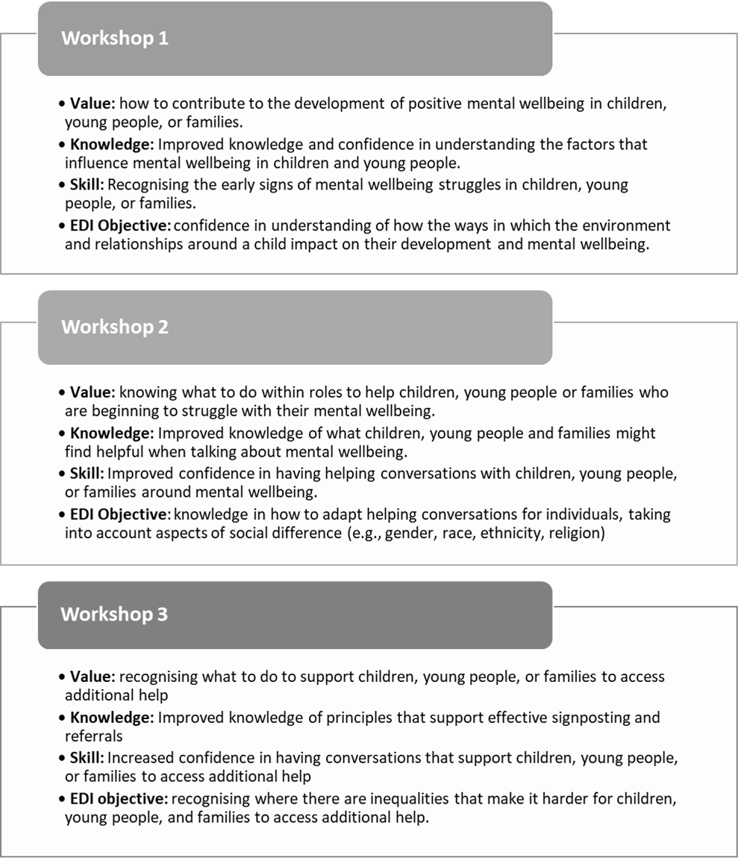

### Appendix Figure B: All attendees who attended at least one session, by sector

### Appendix Figure C: Number of attendees who attended Module 1, 2 and 3 by sector

|  |  |  |
| --- | --- | --- |
| Sector | Attendees (n) | % |
| Education | 139 | 24.1% |
| Social care | 128 | 22.2% |
| Health | 94 | 16.3% |
| Family & youth support | 81 | 14.1% |
| I work across more than 1 sector | 43 | 7.5% |
| Voluntary, community or faith support | 25 | 4.3% |
| Sports and culture | 23 | 4.0% |
| Justice and crime prevention | 13 | 2.3% |
| Housing or transport | 10 | 1.7% |
| Other | 20 | 3.5% |
| Total | 576 | 100% |

### Appendix Figure D1: Differences in attendees’ understanding, knowledge, and confidence to support CYP pre- and post-training by pilot area

|  |  |  |  |  |  |  |
| --- | --- | --- | --- | --- | --- | --- |
| Item | Percentage of Attendees Agree or Strongly Agreeing (Pre-Training) | | | Percentage of Attendees Agree or Strongly Agreeing (Post-Training) | | |
| **Norfolk** | **Portsmouth** | **Southampton** | **Norfolk** | **Portsmouth** | **Southampton** |
| I have a good level of knowledge of the range of factors that influence mental wellbeing in children and young people | 76% | 79% | 72% | 90% (+14 PP) | 85% (+6 PP) | 81% (+9 PP) |
| I have a good knowledge of the principles underpinning effective signposting / referral | 45% | 45% | 43% | 94% (+49 PP) | 86% (+41 PP) | 83% (+40 PP) |
| I know what I can do within my role where I see there are inequalities that make it hard for children, young people and families to seek and access additional help | 63% | 58% | 53% | 93% (+30 PP) | 82% (+24 PP) | 81% (+28 PP) |

### Appendix Figure D2: Differences in attendees’ understanding, knowledge, and confidence to support CYP pre- and post-training by sector

|  |  |  |  |
| --- | --- | --- | --- |
| I have a good knowledge of the principles underpinning effective signposting / referral | | | |
| Sector | Percentage of Attendees Agree or Strongly Agreeing (Pre-Training) | Percentage of Attendees Agree or Strongly Agreeing (Post-Training) | Difference |
| Education | 38% | 95% | +57 PP |
| Health | 47% | 95% | +48 PP |
| Social care | 44% | 96% | +52 PP |
| Family support | 43% | 94% | +51 PP |
| Housing or transport | 55% | 100% | +45 PP |
| Justice and crime prevention | 62% | 100% | +38 PP |
| Local Government | 71% | 100% | +29 PP |
| Sports and culture | 28% | 93% | +65 PP |
| Voluntary, community or faith support | 59% | 93% | +33 PP |
| Youth support | 59% | 100% | +41 PP |
| I work across more than 1 sector | 47% | 94% | +47 PP |
| Other | 32% | 94% | +62 PP |

### Appendix Figure D3: Differences in attendees’ understanding, knowledge, and confidence to support CYP pre- and post-training by Pilot area

|  |  |  |  |
| --- | --- | --- | --- |
| I am confident in having conversations that support children, young people and families to access additional help if they need it (+39 PP overall) | | | |
| Sector | **Percentage of Attendees Agree or Strongly Agreeing (Pre-Training)** | **Percentage of Attendees Agree or Strongly Agreeing (Post-Training)** | **Difference** |
| Education | 51% | 92% | +41 PP |
| Health | 48% | 86% | +38 PP |
| Social care | 63% | 94% | +31 PP |
| Family support | 56% | 94% | +38 PP |
| Housing or transport | 45% | 91% | +45 PP |
| Justice and crime prevention | 38% | 100% | +62 PP |
| Local Government | 43% | 86% | +43 PP |
| Sports and culture | 34% | 93% | +58 PP |
| Voluntary, community or faith support | 63% | 100% | +37 PP |
| Youth support | 78% | 100% | +22 PP |
| I work across more than 1 sector | 55% | 92% | +37 PP |
| Other | 52% | 100% | +48 PP |

### Appendix Figure E: Summary of how the Lundy Model of Participation was used for the development of the training

1. Cracknell, L., & Bevington, D. (2023). An introduction to AMBIT. Ch 22 In: Fuggle, P., Talbot, L., Campbell, C., & Bevington, D. (Eds.).  *Adaptive Mentalization-Based Integrative Treatment (AMBIT) for People with Multiple Needs: Applications in Practise*. Oxford University Press.
2. This figure is based on available evaluation data only and may be an underestimate of attendance. The number of attendees per session could be higher in cases where individuals have attended the session but not completed an evaluation questionnaire. In addition, a number of training sessions were delivered beyond the period of this evaluation.
3.
4. Data presented includes data collected until the 13th of September 2023.
5. This figure is based on available evaluation data only and may be an underestimate of attendance. The number of attendees per session could be higher in cases where individuals have attended the session but not completed an evaluation questionnaire or where they have incorrectly recorded their session number in their pre- or post-training evaluation form.
6. Percentage Points.
7. Based on 642 post-training evaluation questionnaire responses.
8. Based on 642 post-training evaluation questionnaire responses.