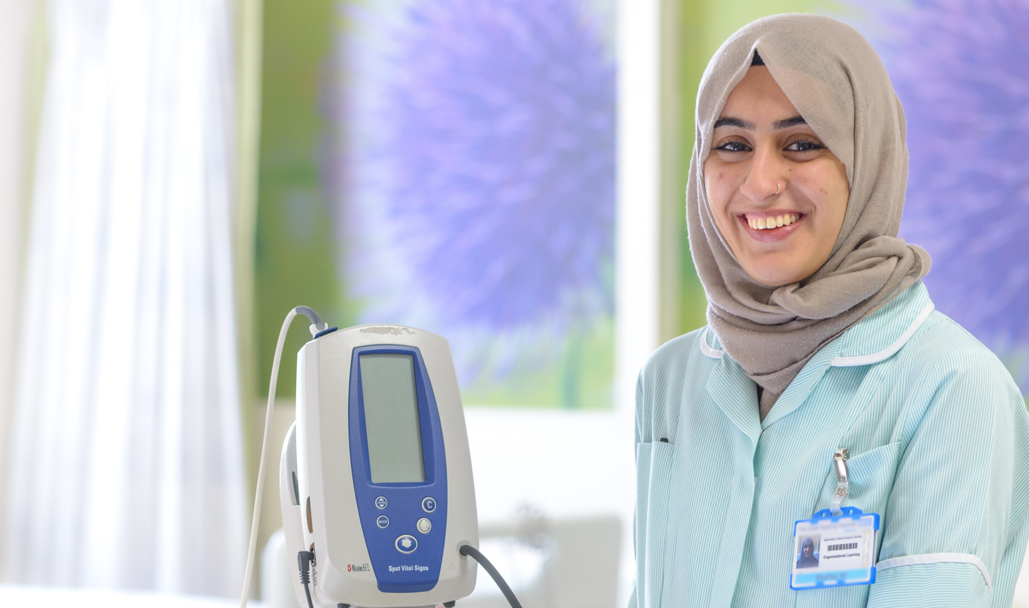

Growing your own or developing existing staff and retaining talent

Author: Caroline Clay Version: 1 Date of Publication: August 2022
If you wish to use any information from this flip-book in our own materials, please reference the author and date of publication.

Nursing Associates Background
In 2015, the UK Government created the Nursing Associate (NA) role in response to findings identified in the “Shape of Caring: Raising the Bar” review (Health Education England, 2015).
The main aim of this role creation was threefold:

- To fill the capability gap between Healthcare Assistants and Registered Nurses.
- Offer formal career progression.
- Reduce workforce shortages.

HEE launched a pre-registration nursing associate programme in 2017, with the first two waves of trainees based at 35 partnerships across England, with a gradual expansion into primary care.

As of March 2022, there are 6,874 NMC Registered Nursing Associates and growing numbers of Student Nursing Associates working across health and social care organisations in England.

This role is hugely beneficial for health and social care organisations because it offers affordable career development and university accredited learning. This approach also provides experiential learning that can then be applied within the workplace, improving patient care.

What is a Nursing Associate?
Nursing Associates (NAs) are registered healthcare professionals who work at an equivalent to an Agenda for Change Band 4. In Primary Care, they assist in expanding the capacity of nursing teams. Over time, increasing amounts of complex patient care are being transferred into primary care settings. As a result, the entire general practice workforce is required to upskill. The traditional General Practice Nurses (GPNs) are embracing more advanced responsibilities which were traditionally the role of GPs such as minor illness, managing complex, long-term conditions and travel health.

NAs are well placed to assist with some of the routine and fundamental work of GPNs.

Attending a Nursing and Midwifery Council (NMC) approved Pre-Registration Programme enables them to perform more complex care activities than those of a Healthcare Assistant (HCA).

Student and qualified NAs support, not substitute, Registered Nurses. They contribute to ongoing patient care and can recognise when it is necessary to refer to others for urgent reassessment.

ARRS funding is available to Primary Care Networks (PCNs) to establish, and salary both Student and qualified Nursing Associate roles. Furthermore, education and additional training funding is also available to equip nursing associates with the right tools for working in primary care.

For more information about ARRS, please see the later section on ARRS, and refer to ARRS and Workforce Funding in the primary care network handbook 2021-22.

What can they do?
As NMC registered, autonomous practitioners, NAs are not only able to utilize a wide variety of evidence-based skills, they are also patient-centric and are constantly looking at the wider patient picture. For example, a patient may attend for a routine dressing change, but it becomes apparent that they need a higher level of care. This may be because they have either disclosed something needing immediate attention, or the Nursing Associate identifies something in their patient assessment that requires urgent intervention. They are immediately able to adapt their practice and work with patients to address changing needs. This helps to ensure the patient remains at the centre of their care and their requirements addressed appropriately.

With appropriate training, supervision and continuing professional development, Nursing Associates can undertake a wide variety of duties. These include:

- Wound Management.
- Chronic Disease Reviews.
- NHS Health-Checks and General Health Screening.
- Sexual Health and Cervical Screening.
- Assisting in Minor Surgery.
- Immunisations.

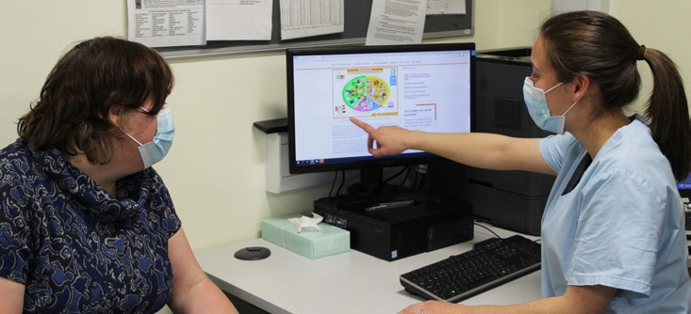

Please note that NA roles vary between organisations, the above list is designed just to give organisations insight into the work they can do in general practice. The aim of employing NAs is to free up GPN’s so that they can provide more complex patient care, offering patients a more enhanced end to end service than ever before.

The NMC (2019) table below illustrates the differences between the responsibilities of a Nursing Associate and Registered Nurse:

Nursing Associate  (6 platforms) | Registered Nurse  (7 platforms)
Be an accountable professional. | Be an accountable professional.
Promoting health and preventing ill-health. | Promoting health and preventing ill-health.
Provide and monitor care. | Provide and evaluate care.
Working in teams. | Leading and managing nursing care and working in teams.
Improving safety and quality of care. | Improving safety and quality of care.
Contributing to integrated care. | Coordinating care.
 | Assessing needs and planning care.

NAs work under supervision of Registered Nurses, GPs and other Registered Healthcare Professionals to provide holistic care. The table below provides a sample of the clinical differences between HCAs/NAs/GPNs working in primary care, as per the above NMC guidance:

Healthcare Assistant | Nursing Associate | Practice Nurse
General Patient Care - Performs specific tasks for example undertakes a blood test, checks the patient’s blood pressure and pulse, documents this factual information on the patient’s record. | Provides and monitors general patient care - drawing upon evidence-base to consider rationale behind tasks and subsequent findings.  Discusses possible causes for anything identified as ‘out of range’ with the patient and then actions next care steps. Contributes to the integrated care process by fully documenting discussion and plans next steps with the patient. This may range from requesting additional blood tests, arranging home blood pressure readings or escalating findings to a GPN or GP for action and/ or additional care guidance. | Manages and evaluates patient care - Manages and evaluates patient care, analysing all the findings from patient care activities and actions next steps.  They also coordinate care - For example, the GPN may identify some blood test findings are abnormal, blood pressure is higher than expected and then check the patient’s records for evidence as to why these findings may be abnormal. They may then book the patient in for a more in-depth review. The review may include investigating patient medications, such as identifying non- compliance and seeking to rectify any medication issues. They may also refer the patient for additional support in the community or secondary care.
Sexual Health Practitioner– Should not undertake this role | Undertakes routine contraception reviews - For example, a patient attends for a contraceptive pill review, reports no concerns and is happy to continue on their current medication regime.  During this appointment, the NA notes the patient is also extremely overdue for cervical screening. As a result they decide to ask the patient if they would like this procedure completed at this appointment.  The NAs aim is to promote health and wellbeing, informing patient of screening importance and risks of ill-health if screening is missed. The Patient agrees. | Deals with more complex patient care - For example, undertakes a contraception initiation discussion with a patient who requests information regarding the different types of contraception available to them. The GPN fully risk assesses the patient, discusses the advantages and disadvantages of each method and supports the patient in making an informed choice. The GPN arranges appropriate follow-up appointments to check the patient is happy with their contraceptive choice and offers further guidance and advice as needed

Healthcare Assistant | Nursing Associate | Practice Nurse
Immunisations - The HCA checks vaccine contra-indications check-list, administers vaccine under a Patient Specific Direction (PSD). Undertakes the task as directed by NA or GPN -  Cannot administer immunisations to children with exception of Nasal Influenza. | Administers routine immunisations to Adults and Children under a PSD - For example, an NA is about to administer a routine immunisation, but notices that the patient may have contraindications to it and identifies the patient may also be missing other vaccinations. The NA explains their concerns and seeks further guidance from their GPN. | Works to Patient Group Directions (PGD), deals with more complex immunisations and coordinates associated care needs - The GPN re-checks contraindications and advises the NA whether it is safe to administer.  The GPN then investigates the patient’s incomplete vaccine status and works out additional ones required. They contact the patient to discuss the required vaccines  in depth, explaining rationale, risks and benefits to allay patient concerns about additional vaccines. Subsequent appointments booked.
Chronic disease reviews -Relevant observations normally undertaken by an HCA, but not the subsequent review. | Undertakes routine chronic disease reviews of single diseases - Quickly identifies the patient is struggling with their condition and arranges and urgent, more in-depth review with GPN. | Provides and manages care with more complex patients with multi co-morbidities and needs - The GPN completes an in-depth review, including holistic patient assessment to try and identify causes. They also check medication adherence and identify current regime requires changing. The GPN proposes and justifies medication changes and if a non-medical prescriber, issues a prescription for new medication. They also follow up appropriately with patient to confirm whether patient’s asthma as improved.

This table illustrates how these nursing roles differ as well as their interdependencies. By working as a team they can help to provide consistent, end-to-end patient care.

For more information, please see:
- Nursing associates | Health Education England (hee.nhs.uk)
- Employer resources | Health Education England (hee.nhs.uk)
- Standards of proficiency for registered nursing associates - The Nursing and Midwifery Council (nmc.org.uk)

Recruiting a Nursing Associate sounds like a great idea! How does it work?
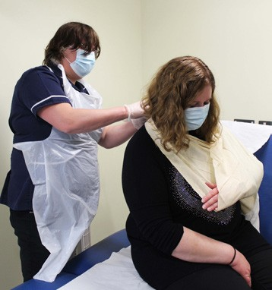
Student Nursing Associates are enrolled onto an apprenticeship programme as part of their employment. Primary Care, organisations may choose to upskill their existing healthcare assistants, or directly recruit via their Primary Care Network (PCN).

Apprenticeships are a great way for people to learn on the job, and can be used for new starters to the NHS and existing members of staff. Apprenticeships offer learners the opportunity to gain a qualification and apply their learning whilst continuing to earn a salary; namely “Earn
as you learn”. This route is extremely beneficial for people who have existing financial and family commitments.

- Paid employment with annual leave.
- Relevant work experience.
- Statutory requirement of a minimum of 20% off-the- job training including:
  - teaching theory (e.g., classroom lessons, lectures and online learning).
  - practical training (e.g., training courses, shadowing, supervised practice and insight visits).
- Formal assessment, leading to a nationally recognised qualification.

Anyone over 16 in England can apply for a workplace apprenticeship, however, they must be employed in a workplace to go on the apprenticeship.

For more general information about apprenticeships, see: What is an apprenticeship? (apprenticeships.gov.uk).

The Nursing Associate Apprenticeship is a higher-level apprenticeship offering a 2-year foundation degree at level 5. This “earn as you learn” degree typically consists of:

- 20% academic learning.
- 20% placements and insight visits in other settings – in other primary and secondary care environments, community or other health and social care settings.
- 60% work-based learning in post as a Nursing Associate Apprentice. This includes Employer provision of protected learning time.

For more information and guidance see the NMC’s Standards for pre-registration nursing associate programmes.

The Nursing Associate Pre-Registration Programme covers all nursing areas: mental health, learning disability, adult and child nursing.

A typical working week may be 3 days in workplace, 1 day in university, 1 day on placement. Please contact individual HEIs regarding this as some programmes offer placements in blocks rather than across the academic year. For more details, please see: HEE Apprenticeship Procurement Toolkit – Guidance for Employers.

Nursing Associate Apprenticeships are underpinned by Apprenticeship standards. These agreed standards illustrate the typical work an apprentice will do and skills required to undertake this role. In addition, this standard requires nursing associate apprenticeships to only be delivered by an NMC-approved approved education institution (AEI) for pre-registration nursing.

- Nursing associate (NMC 2018) / Institute for Apprenticeships and Technical Education
- Employing-an-apprentice – GOV.UK

For further information and to express an interest in recruiting a NA Apprentice to your organisation, please contact your local Training Hub using the Training Hub contact details on the HEE website.

Recruitment pathways:
NA Apprentices can be employed in two main ways:

Practice based route:
- Employed in a single practice – person may be an existing staff member wishing to upskill or a new employee.
- Supported by the practice team, with a nurse supervisor and an assessor.*
- Practice agrees to release Apprentice for study, learning and placement.
- Practice pays salary for 2 years+.
- £15,000 Education fees met through levy transfer.
- Employers also currently receive £8,000 Training Funding paid in instalments to support their Student NA.

Primary Care Network (PCN) based route:
- Employed by a PCN.
- May be “hosted” by a practice or employed across a number of practices within a PCN. Any arrangements must be agreed and signed off by all members of the PCN.
- Supported by either host practice or PCN team with shared nurse supervision and assessor support* as necessary.
- PCN agrees to release Apprentice for study, learning and placement.
- Employer currently receives £8,000 Training Funding paid in instalments to support their Student NA.
- £15,000 Education fees can be met through levy transfer.
- ARRS pays 2-year Student NA salary at Band 3.
- ARRS pays salary after qualification at Band 4.
- This route supports delivery of nursing services across the PCN.

*All Student NA Supervisors and Assessors undertake Standard for Student Supervision and Assessment (SSSA) training if they have not previously completed mentoring training or attend an SSSA conversion course if they have previously completed mentoring training such as SLAIP. Contact your local university and training hub for further guidance or complete the training online at HEE’s e-learning for healthcare hub.

The Practice Educator and Assessor (PEAP) course has been designed to prepare nurses to become Practice Educators, Practice Assessors or Practice Supervisors – dependent upon profession.

For more information, please refer to Standards for student supervision and assessment - The Nursing and Midwifery Council (nmc.org.uk).

For further information about the NA role in primary care, please see the links below:

- Case studies | Health Education England (hee.nhs.uk)
- Nursing associate case studies - The Nursing and Midwifery Council (nmc.org.uk)
- TNA case studies | HCAs and APs | Royal College of Nursing (rcn.org.uk)
- 2019.11.07-Nursing-Associate-Case-Study-Primary-Care.pdf (skillsforhealth.org.uk)

What is Additional Role Reimbursement Scheme (ARRS)?
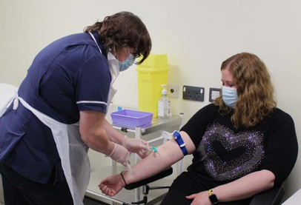
The scheme enables primary care networks (PCNs) to receive funding to help them grow their workforce, through creation and fulfilment of new primary care roles, including Student and qualified Nursing Associates. The aim of this scheme is to help resolve the workforce shortage in general practice.

There is 100% salary reimbursement for all ARRS eligible posts (including on-costs) up to the maximum reimbursable amount and within each PCNs ARRS sum.

In accordance with the Primary Care Network DES, each year, PCNs are required to complete a workforce planning template and state their recruitment intentions for any job roles which are ARRS eligible. Once this plan is agreed and signed off with the CCG, funding can then be drawn down once a Student NA has begun their employment contract. To ensure ARRS is claimable, it is advised that employers refer to the PCN DES for job description guidance prior to recruiting candidates.

For more information, please see:

- Network Contract Directed Enhanced Service: Additional Roles Reimbursement Scheme Guidance
- What do you need to know about the Additional Roles Reimbursement Scheme (ARRS)? - Primary Care Networks (PCN) | QCS Blog
- Training and funding nursing associates | NHS Employers
- Nursing associates and the apprenticeship levy

What is the eligibility criteria for this Pre-Registration Programme?
NA Apprenticeship Education Qualifications Requirement:

- A minimum of GCSE English and Mathematics Grade 4 or above (Old Grade C or above) or functional skills Level 2 in English and Mathematics.

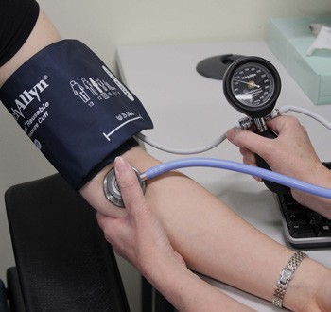
Please check with individual universities for other eligibility criteria.

It is advised that evidence of these qualifications is sought at the beginning of the application process. In normal circumstances, applicants will not be able to start their Foundation Degree without these qualifications.

Please signpost potential NA Apprentices who do not have relevant qualifications to the Functional Skills Toolkit and contact your local Training Hub for further guidance. This resource provides a useful functional skills toolkit for aspiring NA Apprentices.

What is the level of commitment required for this Apprenticeship?

Apprentice Commitment:

2 years part-time study and practice placements. All Student NAs have a minimum number of hours to complete across the 2 years.
- Able to commit to a 37.5 hours working week plus personal study time.
- Able to travel county-wide to attend practice placements, insight days and university
- Fixed holiday periods for 2 years.

Workplace Commitment:
- Requires full support of the employing practice/PCN with appropriate supervision.
- Must release the NA Apprentice for placements, insight visits and study time at university.
- Salary costs throughout programme remain with the employing practice or PCN (See ARRS funding).
- The starting salary for Student NAs is recommended to be commensurate with Agenda for Change band 3, progressing to band 4 upon qualification.

For more information, please see the nursing associates frequently asked questions (FAQs) for employers.

NA Career Development Options
Once qualified, there are lots of other career development opportunities for Nursing Associates in primary care, further extending their skill sets and enhancing primary care services:

Newly Qualified or New to General Practice Nursing Associate. | General Treatment Room Management. | Experienced Nursing Associate Chronic Disease Management.
Nursing Associate Preceptorship - supervised practice and support. | Further Development Opportunities immunisations, cytology, advanced wound care. | Available Training: level 5 and 6 modules  e.g. Asthma, COPO, Spirometry.

Other Career Development Opportunities:
Clinical Education and mentoring. | Leadership. | Registered Nurse ‘top up’ training.

As you can see from the diagram, once qualified, the opportunities for NAs are endless. They can become NA Ambassadors, raising awareness of the role to future applicants. They can also supervise and support pre-registration students and HCAs in practice and become clinical educators working across PCNs. There is also the opportunity for NAs to undergo further training to become a Registered Nurse.

Initial Recruitment Tips and Tricks
- Work with your local Training Hub and PCN to help all stakeholders increase understanding of the NA role.
- Also convey knowledge to engage the Nursing Teams who will be supporting Student NAs in practice.
- Find similar job descriptions and adverts, combine the aspects that fit best your organisation and meet with PCN DES guidelines. Training Hubs may also have resources that may be re-purposed for your needs.
- Also see How to create a job listing in NHS Jobs user guide (nhsbsa.nhs.uk).

Applicant Screening
It is advised that prior to putting applicants forward for NA Apprentice university interviews that Training Hubs and Employers screen applicants to ensure they are suitable candidates. This is to ensure that applicants are eligible to go on the programme and have full awareness of the level of commitment required to successfully complete the programme. Applicant screeners should:

- Use a standardised set of screening questions and response scoring mechanisms, this will help to ensure a fair recruitment process is undertaken during candidate shortlisting prior to sending to university interviews.
- Confirm evidence of educational qualifications, authorisation to work in UK etc..

Adopting this process will facilitate the identification of ineligible applicants much earlier and they can then be signposted sooner to get the support they need to become eligible applicants. Working in this way should enable training hubs and PCNs to only send suitable candidates for university interview, streamlining the recruitment process with less time wasted on interviews of unsuitable candidates.

Please see the English and Maths Functional Skills Guidance for Employers for further guidance.

Participating in HEI interviews
It is recommended that where possible, Training Hubs and Employers assist with HEI interviews. This participation helps to ensure candidates are academically suitable and employable within primary care. HEIs may lack primary care experience to assess candidate suitability. Being involved in this interview process not only provides an understanding of the interview process and quality of candidates, a primary care viewpoint can also be presented. This is particularly useful if applicants haven’t previously been screened for suitability prior to the HEI interview.

A prospective NA Apprentice has been identified, they’ve met the employment criteria and passed their HEI interview, what next?

Student NA On-boarding
Once a candidate has been offered a university place, it is recommended that employers swiftly apply for levy funding, their DBS and complete Occupational Health requirements. All of this preparation work should not prevent a delay between the Student NA starting on the university course and going out on placements.

Applying for Levy Funding
Each NA Apprentice Employer (or lead employer if employed on behalf of a PCN) must register for levy funding.

Training Hubs may also contact the levy fund holder with NA Apprentice and Employer details. They may also provide employers with a levy Point of Contact to assist with the levy registration process.

Please contact midlandsprimarycareschool@hee.nhs.uk if you would like a step-by-step guide for this process.

Employers must also apply for an Enhanced DBS for their NA Apprentice as soon as possible after an apprenticeship place has been offered. (Please check with individual HEI concerning validity of existing DBS’s). Please be aware that Enhanced DBS checks can take up to 8 weeks to process.

- DBS application form: guide for applicants - GOV.UK

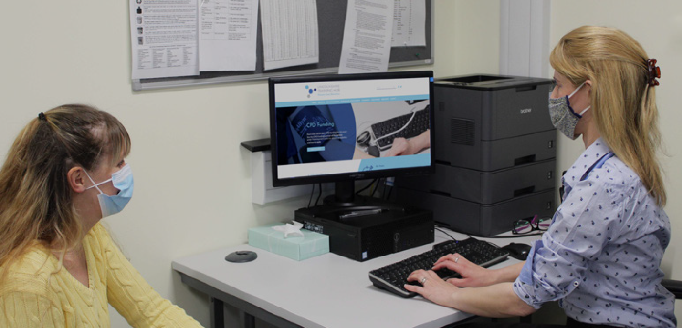

Employers must also complete Occupational Health (OH) screening with their NA Apprentice– obtain this form from the HEI. It is expected that employers will use part of their training grant to pay for OH screening with a formal OH provider (HEIs may be able to recommend an appropriate service provider) unless the employer already has access to OH services.

Please confirm with individual HEIs regards obtaining uniform for NA Apprentices. Some HEIs cover these costs, others do not.

Please note most HEIs insist that all of the above is completed prior to programme enrolment.

It is also recommended that for newly recruited NA Apprentices start in their workplaces approximately 2 weeks prior to programme start date. This helps to ensure that they are orientated to their workplace, spend time gaining understanding of clinical routines and complete all the necessary new employee paperwork.

Once the NA Apprentice has started on the programme, enrolment information will be sent to Health Education England to show eligibility for Training Grant Funding. The HEE apprentice team will then contact NA Apprentice’s employers to explain this funding process.

Other NA Apprentice Employment resources:
- It is advised that a Memorandum of Understanding (MOU) between the Training Hub, the Employer and the Apprentice is agreed and signed. This helps to ensure all parties adhere to the apprenticeship and a fully aware of their responsibilities.
- It may also be useful to create an Employment Framework document. This can be used for all NA Apprentices. This helps to standardise NA Apprentice terms and conditions, promoting equality. Adopting this approach may improve NA Apprentice retention as there is less incentive to move practices.
- HCA upskillers will also need a new employment contract when becoming an NA Apprentice.

Please contact midlandsprimarycareschool@hee.nhs.uk for sample MOU and employee framework documents.

The Benefits of Employing Nursing Associate Apprentices
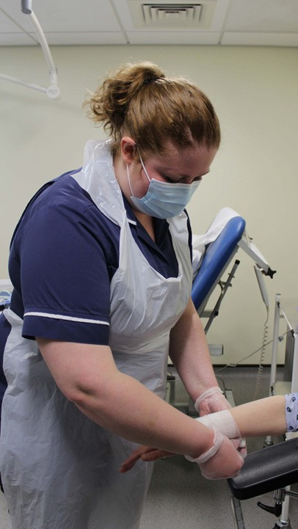
Introducing the nursing associate role into primary care, supports the delivery of safe, compassionate and effective care and offers numerous benefits:

- Enhanced patient care and communication - all apprentice and qualified nursing associates complete NMC approved pre-registration nursing associate programmes and possess a greater range of clinical skills and experience.
- Improved patient-centred care and greater awareness of the holistic needs of patients.
- Nursing Associates are better equipped to identify and escalate patients with deteriorating health.
- Improved service delivery.

Practices and Primary Care Networks Benefits
- Increased workforce retention - this route offers comprehensive nursing career progression for existing clinicians or people new to healthcare.
- Offers the opportunity for PCNs and practices “Grow Their Own,” shaping individuals to fit into developing nursing teams, to address specific practice needs.
- Provides additional nursing team capacity in areas such as cervical cytology screening, immunisations, and support management of chronic disease, aiding achievement of QOF targets.
- Improved quality and standardisation of patient care, the patient case load can be spread more widely amongst the nursing team. This will ease workforce pressures, making the team feel more valued and patients more satisfied, as they have more time to spend on patient care.
- Strengthened workforce resilience, nursing team and wider organisation able to offer more dynamic and varied clinics to meet evolving patient needs.

Nursing Associate Role - Wider Benefits
As Student NAs have moved across different placement settings, they have been able to apply and exchange skills, knowledge and good practice, which is improving the quality of services. This enables the benefits of the role to be realised immediately in Primary Care settings.

Employers particularly value the skills being exchanged between mental and physical health domains because mental health plays a key role in patient wellbeing.

