The Oliver McGowan Mandatory Training on Learning Disability and Autism

Trainer interest

form

How to be a trainer

Easy Read

Contents

How to fill in this form 3
Introduction 4
How we use the information you give us 6
Questions for you to answer 7
What next 10

In this Easy Read document, hard words are in bold. We explain what these words mean in the sentence after we have used them.

Some words are blue and underlined.

links
These are links that will go to another website which has more information.

How to fill in this form

You can fill in this Easy Read form:
- On a computer.
When you have finished the form, save it to your computer and email a copy to: ommtprogramme@hee.nhs.uk

- By printing it out and using a pen.

- Over the phone with help from someone at Health Education England (HEE).

To ask for help over the phone, send an email to: ommtprogramme@hee.nhs.uk

Introduction
The Oliver McGowan Mandatory Training has been created by Health Education England, NHS England, Skills for Care, people with a learning disability and autistic people.

Oliver McGowan was a young man with autism and a learning disability. Oliver sadly died because staff who cared for him did not have the skills and knowledge to look after him.

Learning disabilities and autism

The Oliver McGowan Mandatory Training will help staff know how to give the best care to autistic people and people with learning disabilities.

We would like others to be involved in delivering our training - this means organising and giving our training.

We are looking for:
- Experts with lived experience - this means you have a learning
disability or you are autistic.

- Employers - this means you hire other people to work at your
organisation.

- Education providers - this means you train or teach others, or you are
part of an organisation that trains or teaches others.

If you are an expert with lived experience and you are interested in delivering The Oliver McGowan Mandatory Training, please fill in this trainer interest form.

How we use the information you give us
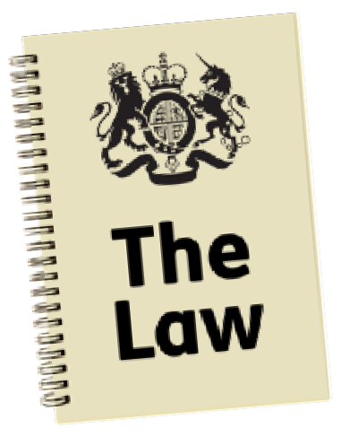The way Health Education England (HEE) use people’s personal information is covered by a law. This law is called the General Data Protection Regulation.

The information you give us is added to a list and can only be seen by the HEE teams who work on this training.

They will contact you to tell you about any opportunities they have or how you can get involved with their work.

Your information will be deleted after 6 months.
6
Months

If you would like to look at or change the information we have about you, or ask any questions, please email: ommtprogramme@hee.nhs.uk

Questions for you to answer
Question 1: Are you an autistic person or a person with a learning disability?

Yes

No

Question 2: What is your name?

Question 3: What is your email address?

Question 4: What area of England do you live or work in?
East of England

London

Midlands

North East England and Yorkshire

North West England

South East England

South West England

Question 5: What town do you live in?

Question 6: Do you have any further comments? You can write them below.
Please do not share information about another person.

What next
You can find out more about The Oliver McGowan Mandatory Training on the Health Education England website:
www.hee.nhs.uk/our-work/learning- disability/oliver-mcgowan-mandatory- training-learning-disability-autism

This Easy Read information has been produced by easy-read-online.co.uk

