**Report from the   
Peer Support Workers   
Task & Finish Group**

May 2019

**Summary from the Peer Support Workers**

**New Roles Task & Finish group**

*Health Education England is committed to a diverse and inclusive workforce which can provide person-centred care.*

**Professor Lisa Bayliss-Pratt**

**Chief Nurse and Executive Lead for Diversity & Inclusion at Health Education England**

**Executive Summary**

Peer Support Workers (PSWs) are individuals with personal lived experience of mental health challenges, built on shared experiences and empathy, who support those receiving services, working towards the individual’s wellbeing, giving hope of recovery.

We have a clear vision for the next five years to significantly increase the number of Peer Support Workers across all health and social care sectors, to complement and add value to the mental health offer within services.

While there are challenges in establishing peer support roles, the introduction of people with lived experience of mental health problems into the mental health workforce is a hugely significant step in a service becoming more recovery-focused and person-centred.

Equality, diversity and inclusion are fundamental to human rights and therefore to Peer Support Workers’ core beliefs and values. That’s why we welcome people from all ethnicities, genders, sexual orientations, socio-economic classes, religions, disabilities and ages in everything we do. This is in line with HEE’s commitment to a diverse and inclusive workforce which can provide person-centred care.

We are only at the beginning of this journey and this report draws on the conclusions, key projects to take forward, recommendations and proposed next steps, which have been gathered following a number of focused meetings by the experts in the task and finish group, additionally drawing on external reports, evidence and summaries from other sources to inform the work.

**Our Vision**

**For the Future Peer Support Workers workforce**

We have a clear vision for the next five years to significantly increase the number of Peer Support Workers across all health and social care sectors.

**Foundations of Peer Support**

**Peer support workers . . .**

* make a unique contribution by sharing their own personal lived experiences in an inspirational way, as they have experienced mental health problems either themselves, or as a carer.
* are caring, compassionate, kind, patient and supportive to assist others facing similar challenges in their recovery, to support people in finding their own ways of moving forward.
* are recruited from and reflect the diversity of the communities which the organisation they are employed by cares for.
* work in an inclusive non-judgmental way, respectful of diversity and provide honest, open conversations to understand everyone’s experiences.
* have a genuine desire to help people who find services inaccessible, alienating and frightening, to recover.
* receive training in safe working practices, goal setting, enabling and sharing stories in an appropriate way.
* strengths include supporting people especially at a time of crisis to avoid the use of restraint.
* can also benefit from the role themselves, by increasing levels of self-esteem, confidence and positive feelings that they are making a difference, which can support their own mental well-being.

**Introduction**

We are clear that this report is the start of the work we need to do, and not its conclusion. Adult services have traditionally been where Peer Support Workers (PSWs) have had roles and we wish to continue to grow these, building on the tradition of peer support in the third sector and preserving its grassroots, user-led ethos. But there are other areas we would like to focus on; for example, perinatal services and Children & Young People services. We also know that for a truly national workforce of PSWs we need to have a PSW competency and career framework. Equality, Diversity and Inclusion are foundations of PSW and for the positive impact of these workers to be realised, we have to ensure PSWs represent all communities.

Our role as a Task & Finish (T&F) group was to discover and offer clarity on how PSWs could be introduced more widely across health and social care. Now Peer support is nothing new with a long history evolving from service user (patients) movements for better care and more rights, to today where PSW are wanted and supported by the NHS. The case for peer support has already been well made, but we know there are still many challenges. Our work began by scoping these challenges with the initial aim of finding solutions. As with many other areas of workforce thinking, we uncovered many more problems than we could solve. The report highlights some of these and makes some clear recommendations for how HEE may resolve them.

This work is complex and of keen interest to multiple stakeholder groups. It is also an area of significant interest across the health and social care system. There is an overwhelmingly large number of examples of new service developments, and various schemes and awards for developing the roles of PSWs. Thus it became clear early on that we would struggle to collate information on, and include, the vast number of initiatives already happening across the country by the time this report was due.

So although we were able to identify some areas where we know good work is already happening, we know there is so much more to discover. We feel it is important to seek out more examples across the country, as well as to allow more discussion about the roles of PSWs.

We hope therefore that this initial report will prove useful both for this scoping work and to enable everyone involved to continue this important conversation. The document includes:

* an overview of PSW roles and the principles on which peer support is based
* guidance on how these principles can be put into practice
* scenarios to offer more understanding
* a vision statement
* an outline of the foundations to support peer worker development in all settings.
* a timeline infographic of peer support to show how it’s been around for many years in countless forms and its journey to where we are today.

We recommend that HEE retain national oversight of implementation and work with partners on long term and sustainable support for the growth of PSW. This will also ensure a way of providing the best training and support for organisations.

**History**

Peer Support is not new and exists in many forms. There are many ways in which peer support has been developed, some of it within grassroots community groups and some within the voluntary and community sectors. Most recently, there has been an increasing emphasis on the value of peer support in the UK within mental health services.

*Figure 1: History of Peer Support*

**Underpinning principles of peer support**

Various attempts have been made to characterise peer support work in terms of a number of core principles (NSUN, ImROC, ENRICH, SRN*). Whilst these differ somewhat from one another they share key themes:

**Non-directive**

Peer support workers offer a safe, non-judgmental relational approach, respectful of different views, values and perceptions, honest and genuine. Each person is the expert in their own experience and has responsibility for their own life. Peers are not there to give advice or direction but to listen, explore, answer questions authentically, suggest alternative interpretations and explanations without imposing them.

**Mutuality**

This includes sharing and shared experience across a range of dimensions (mental health challenges, use of services – and exclusion from services, trauma, culture, age range); empathy; camaraderie and solidarity; and challenging of prejudice and negative stereotypes.

**Reciprocity**

This refers to the mutually transformative process of peer support in which everyone learns from one another, everyone makes a contribution, all individuals are considered to have equal value. This is markedly different from a traditional professional/patient relationship in which there is a marked imbalance in power, status, role and rules.

**Focused on the self-defined Recovery goals of the person supported.**

The purpose of the peer relationship is to support the person to find a way of understanding what has happened that makes sense to them in the context of their own lives, values, beliefs and culture. By embodying the possibility of Recovery and modelling a willingness to look forwards, try different ways of helping and believe in their own potential, Peer Support Workers can support people to identify their own strengths, skills and interests to set goals and ambitions and work out the steps they can take to achieve these.

**Inclusive**

This includes ensuring that peer support is available to all and the different facets of this. To have similar experiences of mental health challenges and services is not the only important dimension of being ‘peer’: for example, faith, ethnicity, gender, class, life stage and age, and other shared life changing experiences may be equally important. Peer support can be particularly important for people who are typically marginalised/alienated within traditional services (Faulkner and Kalahill, 2012).

**Progressive and strengths based**

Peer support workers offer support and health to support a mutually transformative process; a journey of learning and growing together, recognising people’s courage, building on their strengths and skills to pursue their dreams, not what’s wrong, more what’s strong.

**Safe**

Both peer support worker and the person being supported may be in a vulnerable situation. The peer support worker may be sharing difficult and emotional life experiences and needs to do this in a way that is both safe for them and the person they are supporting. Because of the mutual nature of the relationship, the person being supported may share things with a peer support worker that they are reluctant to share with other workers. It is important that Peer Support Workers are equipped to respond appropriately and safely.

*Abbreviations: National Survivor User Network (NSUN), Implementing Recovery through Organisational Change (ImROC), Enhanced discharge from inpatient to community mental health care (ENRICH), Scottish Recovery Network (SRN).

Faulkner, A. and Kalathil, K. (2012), The Freedom to be, the Chance to Dream: Preserving User-Led Peer Support in Mental Health, Together for Mental Wellbeing, London.

**Principles into practice**

**Underpinning principles of peer support, taking the principles into practice: some scenarios**

***Non-directive***

‘Hi Sam, I’ve been told to go on the walking group today. They say it will make me feel better - should I go?’ **Sam says: ‘Well what do you think? Is that something you want to do?** **Have you been before?’**

‘Yes, a long time ago.’ **Sam says, ‘What did you think about it then? It’s up to you.’** ‘Well, I’m worried I might get too tired or stressed, so might want to come back early.’ **Sam says, ‘Well why don’t you ask the member of staff doing the walking group and tell them your concerns?’** ‘Ok… They said I can come back early if I need to, so I might go, Sam. Thanks!’

***Mutuality***

New patient on the ward says, ‘I’ve no idea what Peer Support Workers are.’ **Sam says, ‘Well I’m happy to explain! The very short version is that I’ve had experiences of mental health problems and I use these experiences to support others. Sometimes, it’s good to see how others have coped with negative things. I’m happy to sit down and share some of my experiences and story with you.’**

***Reciprocity***

‘Sam, can I talk to you about my care plan? I’m not sure of some of the things on it.’ **Sam says, ‘Yes of course you can. I’ve struggled in the past with my care plan, so maybe we could share things and perhaps I could learn things from you and you from me. I know other people with experiences of difficult times have helped me just by sharing and learning together.’**

***Focused on the self-defined Recovery goals of the person supported.***

‘Sam, can you tell me what to do, as I’m not sure?’ **Sam says, ‘Well, I can’t tell you what to do, because you’re the best person to decide. What we can do is work together to see what options and choices you have and then you might be more able to make the choice that’s best for you**.’

**Principles into practice *continued***

***Inclusive.***

New patient says to staff, ‘I don’t want a peer support worker - they don’t know any more than you!’ ‘Ok, that’s up to you, but they have experience of being detained in a mental health hospital and they are a man, as this is an all-male unit. ‘Oh, I might do then,’ says new patient. ‘**Hi, I’m Sam.’ ‘**Oh, are you from the local community? I’m surprised**.’ ‘Sam says,** '**Well as Peer Support Workers we are all from local communities, so we’re as diverse as our communities. If you want any support or just to talk, then I’m here for you - it’s always your choice.’**

***Progressive and strengths-based.***

‘Hi Sam.’ ‘**Hi! Well, here we are at the end of the course! Do you remember when you said you couldn’t do eight sessions talking about psychosis? Now it’s the last day, and I’ve learnt so much from you and everyone on the course.’** ‘But you’re the peer support worker, Sam, you must know everything by now!’ **Sam says, ‘No, I learn from everyone every day and I can build more goals knowing all the skills and strengths you all have.’**

***Safe***

“Hi Sam.” **Sam says, “Hi, how are things? We haven’t talked for a while.”** “No, Sam, I’ve not been well. I’ve known you for a year now, so I can trust you. I’m not able to carry on and want this all to end.” **Sam says, “Oh no! That’s so sad to hear. Have you talked to your support team?”** “No, it’s a secret.” **Sam says, “Do you remember when we talked first, every so often I reminded you that if I have concerns and I’m worried about you I will need to get more support and talk to the care team? I will need to tell them, but I want to support you too and talk to you about this. Is that ok? We can ask Jenny, your nurse, to join us if you want.”** “Thank you, Sam. I was scared to tell anyone else.”

**Key recommendations and areas of focus**

To support implementation, there are several areas which need much further exploration.

1. **To commission several projects to deliver the transformation needed**

Any commissioning specifications will be developed by the Peer Support Workers Task & Finish group.

**1a. Looking at ratios of Peer Support Workers per 10,000 population**

The Peer Support Work Task & Finish Group debated offering guidance on the numbers of Peer Support Workers needed within an organisation, but there was little evidence to draw from.

Work needs to be commissioned on best practice ratios to achieve the additional staff required to deliver the transformation agenda set out in Stepping Forward and NHS Long Term Plan, based on the best evidence to date.

**1b. Economic return on investment**

Much can be learned from what has been delivered so far. However, without an economic return on investment across the health and social care system, it will continue to be a challenge embedding the Peer Support Worker role.

**1c. Restraint**

Peer Support Workers should not be involved in incidents where restraint is used. There is a need for further guidance for providers.

**1d. Diversity and Inclusion**

Benchmarking and sharing good practice are key outcomes to support the diversity and inclusion agenda.

There is a need to look at how people are being recruited and developed into new roles to mental health, for example, Nursing Associates, Physician Associates and into roles such as psychiatry, nursing, etc.

**1e. Competency and Career Framework**

Development of a Peer Support Workers Competency and Career Framework should be at the heart of the next phase of implementation.

1. **Stakeholder Events**

As part of the communications and engagement strategy, four stakeholder events that include the widest spectrum of people with lived experience should be held across the country.

**Outcomes to take as a result of this report**

Peer Support Workers should not be so generic that they lose

their symbolic value, as well as their therapeutic clinical value.

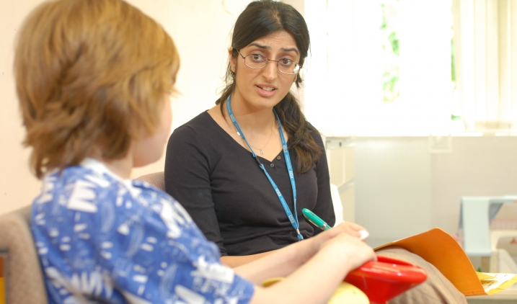

[](https://www.google.co.uk/url?sa=i&rct=j&q=&esrc=s&source=images&cd=&ved=2ahUKEwjim5r6wariAhWZBGMBHYRgDO4QjRx6BAgBEAU&url=https://www.hee.nhs.uk/our-work/nursing-associates&psig=AOvVaw3WIJDrl23ZCLPlMlGFvC1r&ust=1558455676699253)

Having a competency and career framework will help the system to provide an attractive and fulfilling career pathway if a Peer Support Worker wishes to progress into careers such as Nursing Associates, Nursing, Psychiatry, Social Care.

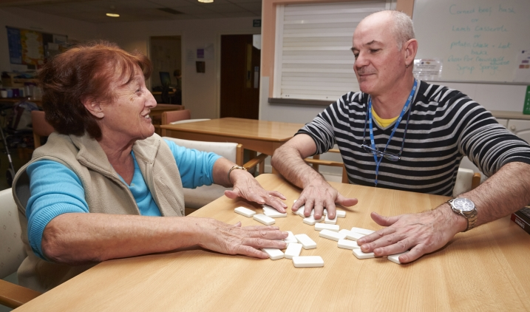

We all need to promote the value of Peer Support Workers and

support vital research to demonstrate their economic value

in improving people’s experience of care.

All Peer Support Workers that are trained should have a route into employment.

The areas in which services work truly have to value the lived experience

of those people. This means having a diverse and representative peer

workforce, ensuring it represents all aspects of all communities. Without

this people won’t have true peer support.



**Next Steps and Areas of Focus**

The vision for the group is to focus on specific subject areas that have been agreed by the co-Chairs.

Guidance will be produced after each meeting to support organisations to implement Peer Support Workers in specific areas.

Diversity and inclusion will be a common theme through all of the guidance produced.

**Areas to Focus On**

Recruiting for Peer Support Workers’ values and attributes

Peer Support Workers working in Perinatal Services

Peer Support Worker Competency and career framework

Peer Support Workers working with Children & Young people



Peer Support Workers working in adult services

Trauma informed part of the workforce

Peer Support Workers working in older adult services

Higher Education Institutions using Peer Support Workers in simulation suites and in education settings.

**Appendix 1. Peer Support Workers Task & Finish Group**

**Kick Start Workshop**

A ‘Kick Start’ workshop using the HEE Star methodology was held in November 2018 for the Peer Support Workers task and finish group, to support a coherent approach across the work of the [eight groups working on new roles in mental health.](https://www.hee.nhs.uk/our-work/mental-health/new-roles-mental-health)

**Key Projects Identified**

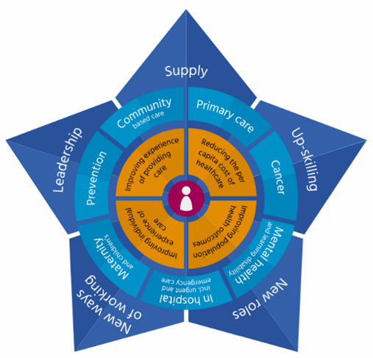The HEE Star was applied as the single OD methodology, bringing a common narrative and framework to the distinct conversations.

The HEE Star has two functions:

**1. Primarily** as an OD tool, enabling a comprehensive diagnostic of the range of workforce interventions, bringing better definition and prioritisation of solutions

**2. Secondly** as an interactive resource, showcasing the products available to providers to fulfil their chosen solutions

The HEE Star describes five key enablers of workforce transformation/improvement; Supply, Up Skilling, New Roles, New Ways of Working and Leadership and subscribes to the principle that ‘improvement happens project by project’.

The purpose of the Peer Support Workers task and finish group was to determine the list of projects under each of the named enablers of transformation, which resulted in a list of **21** possible projects for integration across all aspects of MH settings (Appendix 2).

These projects were then refined by the group and taken forward.

Work was considered in terms of timelines, prioritisation, range of workforce interventions and course of action to address the specific issues raised in relation to Peer Support Workers.

**Leadership**

* Establish the evidence base/exemplars of broader MDT working and its’ potential mitigation of nursing vacancies e.g. Pharmacists and AHP’s
* Establish national oversight of MH nurses operating as Responsible Clinicians e.g. appetite, known obstacles, exemplars and design Mythbuster
* Map known innovative nursing models to determine priorities for spread and adoption (inc. ‘Leading Change, Adding Value’)
* Undertake a stakeholder analysis of leaders/influencers required (clinical and system wide) to ensure delivery of identified projects.
* Build on existing narrative (Health Careers, NMC) to redefine the scope and purpose of MH nursing as part of an evolving MDT and make proposals to update.
* Establish national baseline of ACP’s and Nurse Consultants in MH settings to understand leadership capacity.
* Produce a communications and engagement plan to reflect the delivery requirement of improvement projects.

**New ways of working**

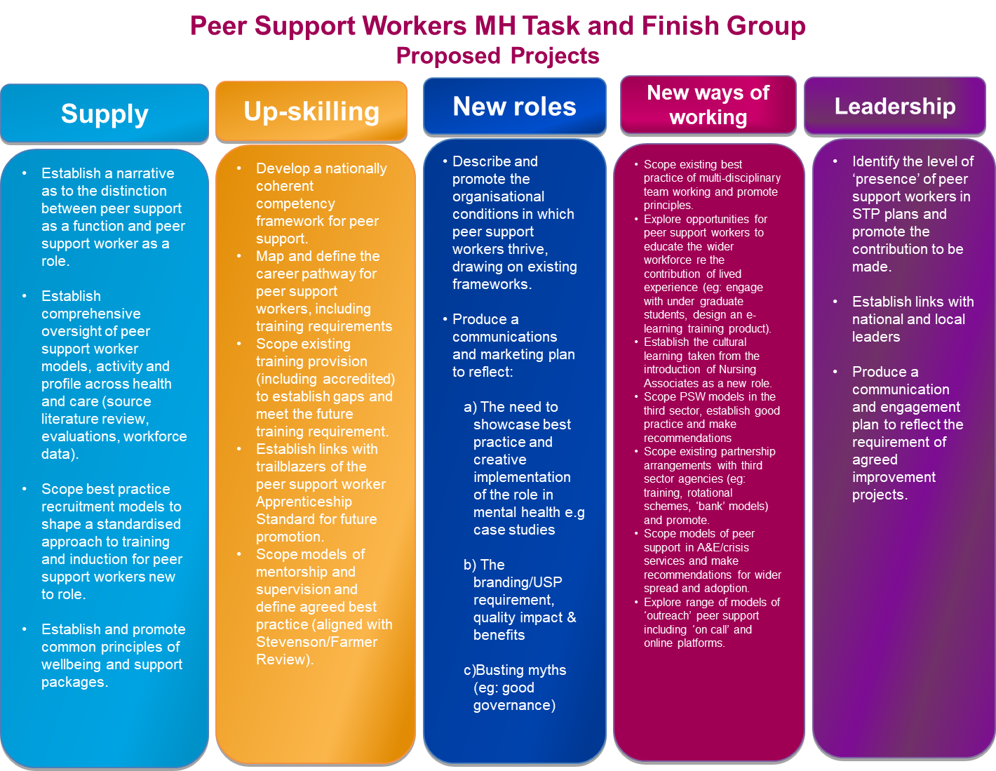





**Report from the   
Peer Support Workers   
Task & Finish Group**

May 2019

Updated March 2020