# Art, Drama and Music Therapies and Dual Identity as Allied Health Professions and Psychological Therapies

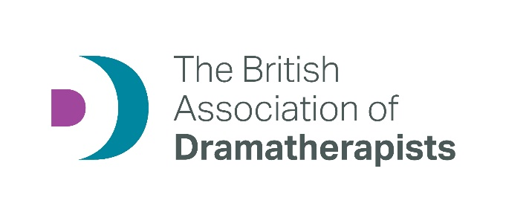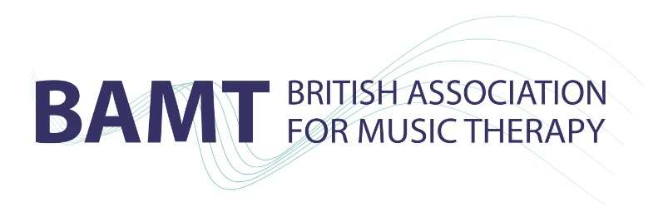

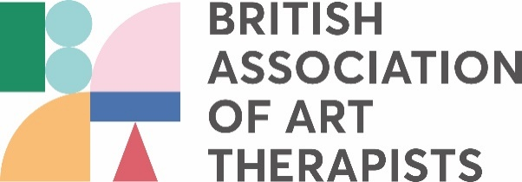

**Developed with The British Association of Dramatherapists (BADth), British Association for Music Therapy (BAMT) and British Association of Art Therapists (BAAT).** Researcher: Dr Val Huet (PhD).

Contents

Part 1: Summary of Findings 5

Introduction 5

Project Objectives 5

Measures, Data Collection and Analysis 5

Summary of quantitative data 7

Summary of Qualitative Data 7

Part 2: Data Analysis 12

Introduction 12

Section 1: Quantitative data from 14 Art, Drama and Music Therapies Service Leads and Heads 12

Section 2: Themes from individual interviews and focus groups 15

Section 3: Responses from all interviewees and focus groups on Dual Identity 22

## Part 1: Summary of Findings

### Introduction

Although Allied Health Professionals (AHPs), Art, Drama and Music Therapists are often employed within Psychological Therapies services. As AHPs, Art, Drama and Music Therapists may not be included in Psychological Therapies workforce planning even though they are employed within these services. Many are employed under generic titles (e.g., Project Worker) whilst delivering Art, Drama and Music therapies as part of their job and identifying them within the NHS workforce has been often difficult.

Art, Drama and Music Therapists have worked across this dual identity for a long time, with markedly different outcomes linked to local contexts. Some Art, Drama and Music Therapists have reported positive experiences of integrated work across AHPs and Psychological Therapies enhancing service-user choice and professional development. Others have felt poorly integrated as well as thinly spread across both, thus limiting service users’ access to Art, Drama and Music therapies, and impacting job satisfaction and staff retention.

This project, funded and supported by HEE, initially aimed to co-produce and publish a shared career framework on how best Art, Drama and Music Therapists could work across this dual identity. A separate initiative to include Art, Drama and Music Therapies within the Psychological Professions Network (PPN) has impacted positively on the initial aim of this project, as this addresses concerns of being excluded from the PPN voiced by several interviewees. Furthermore, the project objectives have yielded information that will be useful to ensure the successful integration of Art, Drama and Music Therapies within AHPs and Psychological Therapies.

### Project Objectives

* To conduct individual interviews and focus groups to understand the issues at stake locally and nationally.
* To identify and learn from areas where this dual identity works well.
* To identify and learn from challenges.

### Measures, Data Collection and Analysis

A semi-structured questionnaire was developed and used for individual interviews. This included quantifiable data (e.g. Number of years qualified) and qualitative data on experiences and opinions. The following questions were asked:

* Do you feel that Art, Drama and Music Therapists’ contribution is valued and understood by Psychological Therapies?
* Do you feel that Art, Drama and Music Therapists’ contribution is valued and understood by AHPs?
* What makes Dual Identity work and why?
* What makes Dual Identity not work and why?
* Where do you personally think Art, Drama and Music Therapists should sit?
* Anything I missed?

Additionally, 2 focus groups were conducted to expand on and explore these issues.

All interviews and group discussions with participants (N= 31) were audio-recorded. Quantifiable data were compiled and reported as percentages and charts. Thematic analysis was used to identify themes within the qualitative data.

**Individual Interviews** (n=24) included:

* 14 Art, Drama and Music Therapists (6 Art, 3 Drama and 5 Music Therapists) Service or clinical Leads/Professional Heads, Consultants, Trust Head, and Clinical Specialists.
* 3 representatives from BAAT, BADth and BAMT
* 1 AHP Lead
* 2 NHS Trust Boards Directors
* 2 Senior Lecturers and British Psychological Society (BPS) members Psychologists
* 1 AHP Chief Officer

**2 focus groups** (n=7) included:

* Focus Group 1: 3 participants (2 Art and 1 Music Therapists)
* Focus Group 2: 4 participants (2 Art, 1 Drama and 1 Music Therapists)

This report includes a summary and a full outline of the analysis of quantitative data and of themes identified in individual interviews and focus groups.

### Summary of quantitative data

The seniority and experience of respondents is an important element as all had accrued an average of 22 years of post-qualification work experience, with 9 years being the lowest and 40 the highest. Another significant aspect is that 79% had undertaken additional formal professional trainings such as Mentalization-Based Treatment (MBT), Cognitive Analytic Therapy (CAT), Cognitive Behavioural Therapy (CBT), Group Psychotherapy, Organisational Consultancy. These trainings were verbally based and extended professional skills and knowledge. They also introduced respondents to new work cultures, broadened their understanding of other professions, and challenged the usefulness of professional silos. Although the influence of local contexts needs to be factored in, these experiences may be reflected in the **majority view of 63% of respondents who prefer maintaining a dual identity as AHPs and Psychological Therapists**, rather than belonging to a single professional group (see p.5).

Furthermore, working across disciplines and integrating different approaches within their practice may enable Art, Drama and Music Therapists to navigate not only their dual identity as AHPs and Psychological Therapies, but also other professional identities and practices to benefit service users and staff. 92% of respondents supervised staff, including counsellors, psychologists and Art, Drama and Music Therapists, and trainees, making a significant contribution to their Trusts.

“Effective clinical and peer supervision has a range of benefits for the individual receiving supervision, the team and patient care, such as job satisfaction, reduced stress and better care. There were also negative effects associated with no or poor supervision.” (Health and Care Professions Council, 2020)

Another notable result is that although in senior positions, 65% of respondents manage staff, a lower percentage compared to supervising others (92%). Although this may be linked to posts and functions, this issue may also relate to Art, Drama and Music Therapists’ reluctance to take up leadership posts (see below). Leadership and management are different functions, but some management is often involved initially within professional progression toward leadership.

### Summary of Qualitative Data

**Parity of esteem with Psychological Therapies.** Art, Drama and Music Therapists’ experiences depended on local circumstances. Whilst two respondents felt valued and understood within psychological therapies services, others reported feeling marginalized: Psychological Therapies have become conflated with Psychology in many Trusts and psychology teams are high in numbers: “Psychology is hierarchical, and we are clearly not seen as at the top.”[1] This affected career progression and access to leadership positions.

**Parity of esteem with AHPs.** Although there was“not much parity still between physical and mental health,” this was more positive as Art, Drama and Music Therapists’ felt “valued at senior level.”This can still be“patchier on the ground”with colleagues, but there is “more equitable access to workforce planning with AHPs.” Several respondents noted that many Art, Drama and Music Therapists do not seem to be aware of the career opportunities accessible as AHPs: Art, Drama and Music Therapists “are missing opportunities by not being more integrated within AHPs.”

#### What makes Dual Identity work?

* **Communication and partnerships are key:** this includes learning to articulate clearly what Art, Drama and Music Therapists do (avoiding professional jargon), openness to sharing work with team members, co-working groups, extending work to providing supervision, staff support, etc. Parity of esteem must be reciprocal, and Art, Drama and Music Therapists also need to be more aware of what other professions do and contribute.
* **Properly resourced professional lead posts:** Art, Drama and Music Therapies teams tend to be smaller than other professions and this impacts on their capacity to contribute to workforce planning and development, and to build partnerships across AHPs and Psychological Therapies. Even in comparatively large teams, Lead posts are often on a one or two-day-per-week, or on a temporary secondment basis (only one respondent was in a full-time permanent Lead post). In Trusts where full-time Art, Drama and Music Therapies lead or consultant posts were implemented, the return on investment for service users’ benefit has been remarkable in terms of developing resources, partnerships with AHPs and Psychological Therapies and flexibility of services.
* **Good communication and partnership at the top:** When AHP and Psychological Therapies Leads or Directors work and communicate well with each other, having a dual identity seems to be more easily integrated.

#### What makes Dual Identity not work?

* **Dual Identity is itself a barrier and exhausting:** A respondent described“a confused picture and gaps as we are neither one thing nor the other, so we get missed. A lot of energy is needed to maintain relationships with two professional groups. This is exhausting when we are a small team.” This is amplified when there are rapid staff changes and partnerships have to be constantly rebuilt.
* **Exclusion from leadership opportunities:** “Leadership opportunities are notionally opened to all professions, but feedback is dismissive of Art, Drama and Music Therapies”and leadership posts are still mainly aimed at psychologists. Although leadership needs “to be inclusive of all professions and focused on needs of people,” respondents did not meet parity of esteem when they applied for leadership posts.
* **Art, Drama and Music Therapists exclude themselves from leadership roles:** Several respondents noted a reluctance from Art, Drama and Music Therapists to take up leadership roles. Art, Drama and Music Therapists feared “losing the creative side of practice and becoming grey” if they went into leadership posts. Furthermore, “Art, Drama and Music Therapists still want to focus on clinical work and avoid leadership roles.” However, this may be changing, and new Art, Drama and Music Therapists may be more interested in developing their leadership potential.
* **Evidence used defensively:** individual respondents and focus groups identified this issue. “Constant references to ‘evidence’ are sometimes ‘weaponised’ against Art, Drama and Music Therapists.” “Evidence and NICE[2] are used to sideline us” and make Art, Drama and Music Therapies “a last resort” to refer patients who did not engage in CBT. Other data such as patients’ experience measures that often evidence a high level of satisfaction with Art, Drama and Music Therapies are dismissed.

#### Enablers and Opportunities

* **Art, Drama and Music Therapists are the bridge between AHPs and Psychological Therapies:** Several respondents across all groups and including focus groups shared the view that Art, Drama and Music Therapists have skills and knowledge that integrate working with mental and physical health conditions and are uniquely placed to be a bridge between AHPs and Psychological Therapies services to benefit service users as this can support a more holistic approach.
* **Articulating what Art, Drama and Music Therapists do and engaging with other professions:** Art, Drama and Music Therapists need to be proactive to develop better communication skills and articulate what they do to help others understand their work. Parity of esteem between professions is a reciprocal process and Art, Drama and Music Therapies learning more about what other professions do will support mutual engagement and partnerships.
* **Thinking strategically.** Several respondents identified that local contexts and therefore, one uniform approach may not be applicable. Nevertheless, Art, Drama and Music Therapists need to develop strategic skills and share and learn from successful initiatives by Art, Drama and Music Therapists, AHPs and Psychological Therapists.
* **The NHS ‘transformation’ agenda** is important and the integration of Physical and Mental Health Care will be prioritized. As mentioned above, Art, Drama and Music Therapists bridge these two areas. The growing interest in co-production also provides opportunities as many Art, Drama and Music Therapists have already integrated a co-production approach into their work.
* **The NHS recruitment Crisis** is also opening doors and is a huge opportunity. Competency-based recruitment is open to all psychological professions, thereby opening new opportunities. Art, Drama and Music Therapists need to ‘skill-up’ to ensure that they meet generic skills criteria included in new role descriptions.
* **Better use of evidence.** Art, Drama and Music Therapies evidence has flourished over the past three to five years and there are at present several Randomised Control Trials underway. Challenges to Art, Drama and Music Therapies’ evidence need to be met with up-to-date information. Furthermore, practice-led evidence and listening to service users can lead to innovations and expansion of Art, Drama and Music Therapies services. Art, Drama and Music Therapies need to evidence clinical outcomes in a more systematic way to make their case.
* **Leadership.** Several respondents mentioned that leadership skills should be integrated into basic training. Leadership“with vision and drive that is valued-informed” is important to inspire future leaders. Art, Drama and Music Therapists need to be encouraged and supported to take up leadership training, mentoring opportunities and peer support. They also need to be ready to work generically and represent other professions: leadership progression involves going beyond one’s own professional group.

#### Where do you think Art, Drama and Music Therapies should be situated?

A majority of respondents (63%) wanted to keep their dual identity as AHPs and Psychological Therapists. 23% preferred to belong to psychological therapies, 1% to AHPs and 13% were unsure.

## Part 2: Data Analysis

### Introduction

#### Data analyses are reported in three sections:

* Section 1: Quantitative data from individual interviews
* Section 2: Themes from individual interviews and focus groups
* 2.1 Interviews with Service Leads and Heads (n=14)
* 2.2 Interviews with representatives of BAAT, BADth and BAMT (n= 3)
* 2.3 Focus groups discussions (2x groups, n= 7)
* 2.4 Interviews with Board Directors, AHP Lead, AHP Chief Officer and Psychologists (n=6)
* Section 3: Responses from all interviewees and focus groups on Dual Identity **(N=31)**

### Section 1: Quantitative data from 14 Art, Drama and Music Therapies Service Leads and Heads

**Quantitative Data Results**

#### Experience and training

Respondents (n=14) included 6 Art Therapists, 3 Dramatherapists and 5 Music Therapists. They had on average over twenty-two years of post- experience, with 9 years being the lowest and 40 the highest. 79% had completed additional professional trainings that were verbally based including CAT, MBT, CBT, Group Therapy, Organisational Consultation. One was completing a PhD. Qualification work.

#### Management and Supervision

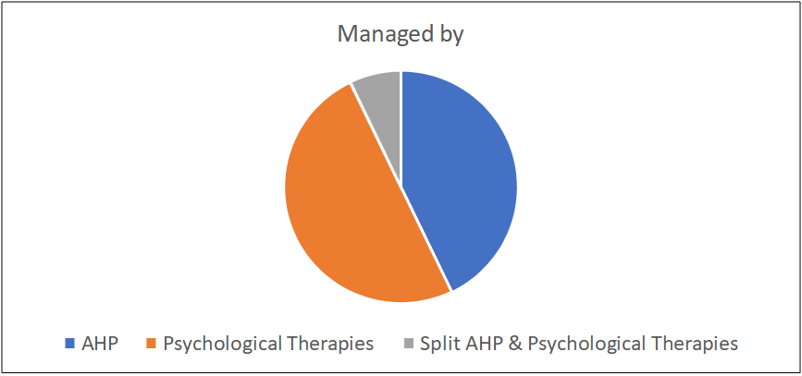

50% were managed by Psychological Therapies, 42% by AHPs, and 8% had split management.

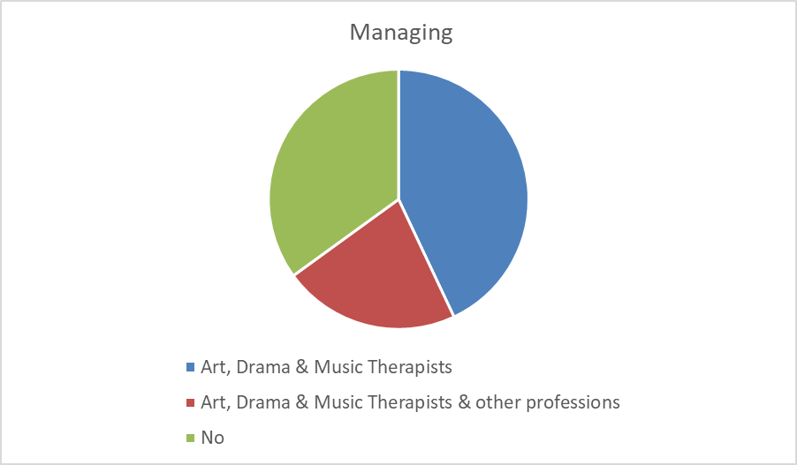

43% managed Art, Drama and Music Therapists only, 22% managed Art, Drama and Music Therapists and other professions, 35% did not manage others.

50% were supervised by an employer-funded external supervisor, 8% by self-funded external supervisor, 13% by in-house Art, Drama and Music Therapist, 13% by in-house AHP, 8% team supervision by external MBT specialist, 8% in-house Psychologist.

92% of respondents supervised others, with 64% supervising Art, Drama and Music Therapists and trainees only, and 28% supervising Art, Drama and Music Therapists and other professions (counsellors and psychologists). 8% did not supervise.

### Section 2: Themes from individual interviews and focus groups

#### 2.1 Interviews with Service Leads and Heads

##### 1. Do you feel that Art, Drama and Music Therapies contributions are valued and understood by Psychological Therapies?

Responses to this question were mixed: two respondents felt well integrated and valued within psychological therapy services, and others reported a mixed picture of feeling “invited to the party, but not as a core guest” and still being seen as marginal.

Some respondents felt “valued but not understood,” anissue linked to workforce size: although this is changing in a few Trusts, Art, Drama and Music Therapies posts are still fewer than other professions and many of these are part-time. Respondents mentioned that workforce numbers make representation and liaison work more difficult (see section on Leadership below).

Two respondents reported that they and their teams had felt marginalized following the publication of the report on the Psychological Professions Network as Art, Drama and Music Therapists were not included. This had affected team dynamics.

Parity of esteem between professions was mentioned by several respondents: psychological therapies have become conflated with Psychology in many Trusts and psychology teams are high in numbers. The hierarchical culture of psychologists was mentioned by 3 respondents: “Psychology is hierarchical, and we are clearly not seen as at the top.” This affected career progression, access to higher bandings and leadership posts.

##### 2. Do you feel that Art, Drama and Music Therapies contributions are valued and understood by AHPs?

Responses were mixed here too: 3 respondents reported positive experiences of being welcomed and valued within AHP teams and were aware that being part of an AHP group“brings access to resources and CPD funding.” One respondent stated that Art, Drama and Music Therapists“are missing opportunities by not being more integrated within AHPs.”Another respondent acted as an AHP lead for a year and found this a positive experience that increased their own knowledge of AHPs and of the opportunities Art, Drama and Music Therapists can access as AHPs. It also enabled AHPs to see that an Art, Drama and Music Therapist could take on successfully a leadership role.

Others felt little affinity with AHPs as “there was little AHP grounding in mental health” and that there was “not much parity still between physical and mental health.” This made them feel like “a fish out of water”and a respondent described how they “stifled some of their Art, Drama and Music Therapists identity” to fit in when working with AHPs. The diversity of the AHP grouping was another factor that influenced Art, Drama and Music Therapists’ sense of fitting in, although this was also seen as strategically positive as it included larger, more influential professions.

However, parity of esteem was more positive with AHPs as Art, Drama and Music Therapists feel “valued at senior level” and although this is“patchier on the ground with colleagues, there is more equitable access to workforce planning with AHPs.”

##### 3. What makes dual identity work and why?

**Good communication and partnerships** across professions were mentioned by nearly all respondents. Although being a small professional group made this a challenge in terms of time and resources, inter-discipline partnerships were cited as underpinning mutual respect and understanding. Respondents described the positive impact of co-working Art, Drama and Music Therapies groups with psychological therapies or AHP colleagues: this improved staff relationships and the quality of referrals to Art, Drama and Music Therapies. Another respondent described how facilitating Staff awayday impacted positively on their perception of Art, Drama and Music Therapies.

**Learning to use language that avoids professional jargon** and articulating clearlywhat Art, Drama and Music Therapists do was identified as key to supporting dual identity. One respondent stated: “We need to be more in line with the language of psychology to explain what we do.”

**Having full-time Art, Drama and Music Therapists Lead and Consultant posts** made a considerable difference in some Trusts, as it guaranteed time to build partnerships across AHPs and psychological therapies and to contribute to workforce planning and development. Art, Drama and Music Therapists stepping up to these leadership positions also have a positive impact on the services and on professional development and progression.

**Inclusive and equality-minded leadership from the top**, with good communication and liaison between AHPs and Psychological Therapies Directors (where these posts exist), also ensures that Art, Drama and Music Therapists feel held in mind and integrated within teams and workforce development.

##### 4. What does not work and why?

**Dual Identity is a barrier** and belonging to both AHPs and Psychological Therapies was identified by 4 respondents as a problem: “A confused picture and gaps as we are neither one thing nor the other, so we get missed.” Art, Drama and Music Therapists are “between a rock and a hard place, sitting in both camps but not fully occupying either.”One respondent described feeling like a “constant salesperson”and making a point of attending meetings to remind colleagues of her role, although “most items on the team’s agenda don’t apply to Art, Drama and Music Therapies.”

**Working across two professions is exhausting:** having to liaise across two professional groups takes additional time and effort, as one respondent explained: “A lot of energy is needed to maintain relationships. This is exhausting when we are a small team.”

**Rapid staff changes and constant restructuring** also affect communication and partnership work adversely. One respondent mentioned feeling defeated and described having spent time and energy building networks and having to start again several times: “staff changes mean culture changes and restructure isolate us.”

**The loss of Art, Drama and Music Therapists Professional Lead posts** was a detrimental factor in Art, Drama and Music Therapists’ ability to contribute to multi-disciplinary teams, and to important strategic planning and development. Four respondents were in Lead posts but only one post was full-time and permanent: others held these posts on a one- or two day per week or on a temporary secondment basis. Half of respondents identified this issue as significant.

**Leadership opportunities often exclude Art, Drama and Music Therapists:** respondents noted that leadership posts are often aimed at specific professions (e.g., psychologists) and encountered blocks to professional progression**:** “Opportunities are notionally opened to all but feedback is dismissive of Art, Drama and Music Therapies.” “Leadership roles are still aimed at Psychologists and Art, Drama and Music Therapists are not as valued as others.” “Band 8A is often the highest banding accessible to Art, Drama and Music Therapists who hit a **‘**glass ceiling’ at this point.”

**Art, Drama and Music Therapists exclude themselves from leadership roles:** However, several respondents noted a reluctance from Art, Drama and Music Therapists to take up leadership roles. “Sometimes Art, Drama and Music Therapists don’t step up to leadership but they need training. Leadership is a really important issue.” “Art, Drama and Music Therapists still want to focus on clinical work and avoid leadership roles.” However, one respondent noted: “Not many Art, Drama and Music Therapists are going for it (leadership roles) but this is changing.”

**Evidence used defensively**: Five respondents picked up this issue. “Constant references to ‘evidence’ is sometimes ‘weaponised’ against Art, Drama and Music Therapies.” A respondent felt “constantly having to make a case for our position.”Otherrespondents described how “evidence and NICE are used to sideline us” and make Art, Drama and Music Therapies “a last resort”to refer patients who did not engage in CBT. Other data such as patients’ experience measures that often evidence a high level of satisfaction with Art, Drama and Music Therapists are dismissed.

##### 5. Enablers and Opportunities

**Art, Drama and Music Therapists are the bridge between AHPs and Psychological Therapies:** Art, Drama and Music Therapists practice addresses both mind and body and can offer a useful way to bridge and integrate both to benefit service users. This could “support more holistic approaches for service users.”

**Articulate and share what we do:** Art, Drama and Music Therapists also needed to be proactive to develop better communication skills and “articulate what we do” to help others understand our work.

**Learn from others:** Some Art, Drama and Music Therapies services have managed to substantially increase, e.g., in Child and Adolescent Mental Health Services (CAMHS). Learning what made this possible and replicating these strategies would enable growth. “Art, Drama and Music Therapists need to be willing to take on generic roles and embrace the bigger picture.”

**No recruitment problems:** Other professions have recruitment problems but not Art, Drama and Music Therapies.

**Service Users’ feedback and Clinical Outcomes:** Art, Drama and Music Therapists do well with these and need to collate these more systematically.

#### 2.2: Interviews with 3 representatives from BAAT, BADth and BAMT

Professional bodies representatives’ views echoed the themes outlined above. **Dual Identity** was the preferred option for all 3.

##### 1. Do you feel that Art, Drama and Music Therapies contributions are valued and understood by Psychological Therapies?

Respondents thought that “parity of esteem depends on the situation on the ground.” However, there was not any “universal understanding” and Psychological Therapies Teams were often “dominated by psychologists offering CBT.”

2. Do you feel that Art, Drama and Music Therapies contributions are valued and understood by AHPs?

Two respondents found “more parity of esteem within AHPs than with Psychology.” However, this “situation differs regionally.”

3. What makes dual identity work and why?

Respondents felt that hearing and respecting Art, Drama and Music Therapists’ professional voice was essential. Art, Drama and Music Therapists also need to reciprocate this towards other professions.

4. What does not work and why?

Three themes identified above were strongly echoed:

* **Leadership opportunities often exclude Art, Drama and Music Therapists:** “Psychology teams are very hierarchical, blocking access to higher bandings.”
* **Art, Drama and Music Therapists exclude themselves from leadership roles:** The “mindset of some Art, Drama and Music Therapists is against leadership.”
* **Evidence used defensively:** Psychologists are “using evidence against Art, Drama and Music Therapies and we are having to prove ourselves all the time.” “Psychologists have high claims re evidence”but might need to acknowledge the limits of their efficacy of it with clients with complex needs.

5. Enablers and Opportunities

**Art, Drama and Music Therapies offer a bridge between Psychological Therapies and AHPs:** we can support a more holistic approach, integrating mind and body.

**Engaging with other professions:** “presenting our work is key as lack of interdisciplinary respect” and“reflective practice (with other professions) sets up a culture of parity.”

#### 2.3 Focus group discussions

Some themes from the focus groups (n=7) also echoed those outlined above.

**Dual Identity** was the participants’ preferred option with a “strong line to psychological therapies and another strong, but dotted line to AHPs” as there was more affinity with psychological therapies practices. Participants acknowledged that there were tensions from this duality but felt this could also be creative and productive.

**Parity of esteem with Psychological Therapies** was an issue, with Art, Drama and Music Therapists feeling marginal to some services. Furthermore, “Authoritative presence is ingrained in psychologists,” and this is not the case with most Art, Drama and Music Therapists. This was evident in leadership opportunities, where Art, Drama and Music Therapists are“still meeting prejudice against them being in leadership*.*”

**Parity of esteem with AHPs** was seen as more equal with AHPs “providing a lot of help”and “leadership opportunities within AHPs are easier to access.”

**Art, Drama and Music Therapists need to be more aware of their AHP identity.** A participant noted they had no idea about this connection until relatively recently and are now aware of the AHP’s scope of resources and career opportunities. This is relatively poorly known among Art, Drama and Music Therapists: “We need to understand what other professions do and aim for the ‘professionalisation’ of Art, Drama and Music Therapists.”

**Art, Drama and Music Therapists exclude themselves from leadership posts:** Participants acknowledged that Art, Drama and Music Therapists feared“losing the creative side of practice and becoming grey”if they went into leadership posts. Furthermore“they are not great at articulating what they do” and need to develop a “sense of authority.”

**Evidence used defensively:**“Evidence from Psychology does not always withstand close scrutiny and leads to provisions that don’t meet psychological needs of unwell Service Users.”

**Art, Drama and Music Therapists are the bridge between AHPs and Psychological Therapies** as they integrate Mind and Body in more holistically.

#### 2.4 Interviews with Board Directors, AHP Lead, AHP Chief Officer and Psychologists

Most respondents (n=6) in this grouping were linked to national strategies and offered valuable insights external to Art, Drama and Music Therapies professions. There were different, Trust-specific configurations with AHP and Psychological Therapies being separate services or merged into one.

**Parity of esteem:** the sense of integration of different professional groups varied and so did the parity of esteem between some of the professions (including, but not solely Art, Drama and Music Therapies), although some respondents noted that this sometimes “was linked more to personalities than policy.” Whilst some services were “still reluctant to include Art, Drama and Music Therapists,”there was a noticeable “renaissance of interest within the AHPs and a better integration of Art, Drama and Music Therapists’ skills was needed.”

**Leadership skills** were mentioned by most respondents as being essential to all professions. Art, Drama and Music Therapists were perceived as reluctant to develop these:“Art, Drama and Music Therapists are not coming forward for leadership roles and taking positions to access leadership opportunities. They need to feel they can lead other professions.” Art, Drama and Music Therapists should be “open to diverse roles and have the flexibility to move and lead other psychological professions.” Otherwise, for Art, Drama and Music Therapists who wish to focus on clinical work only and “want to stay in this role, there will be a ceiling’ in terms of pay and progression.”

##### Enablers/Opportunities

* **Thinking strategically.** Art, Drama and Music Therapists and Psychological Therapies need to “stop fighting the 1980s battle and adopt a shared language.”They need to “be flexible without being too uniform.”
* **The NHS ‘transformation’ agenda** is really important, and “integration of Physical and Mental Health Care could be maximised further.” The growing interest in co-production also provide opportunities as do“practice-led and service-users-led innovations.”
* **The NHS recruitment Crisis** is also opening doors and is a“huge opportunity.” “Competency-based recruitment is open to all psychological professions and job descriptions are now role descriptions rather than profession descriptions,” thereby opening new opportunities.
* **Better use of evidence.** “IAPT[3] outcomes are arguable with complex cases” and it is important to“follow the pragmatic evidence of what works and listen to service users to pick up needs.” Art, Drama and Music Therapists “need to evidence clinical outcomes in a more systematic way.”
* Leadership. Several respondents mentioned that leadership skills should be integrated into basic training. Leadership “with vision and drive that is ‘valued-informed’”is much needed and it is important to inspire future leaders. Art, Drama and Music Therapists also need to be encouraged and supported to take up leadership training, mentoring opportunities and peer support. They also need to be ready to work generically and represent other professions: leadership progression involves going beyond one’s own professional group.

### Section 3: Responses from all interviewees and focus groups on Dual Identity

#### Where do you think Art, Drama and Music Therapies should be situated?

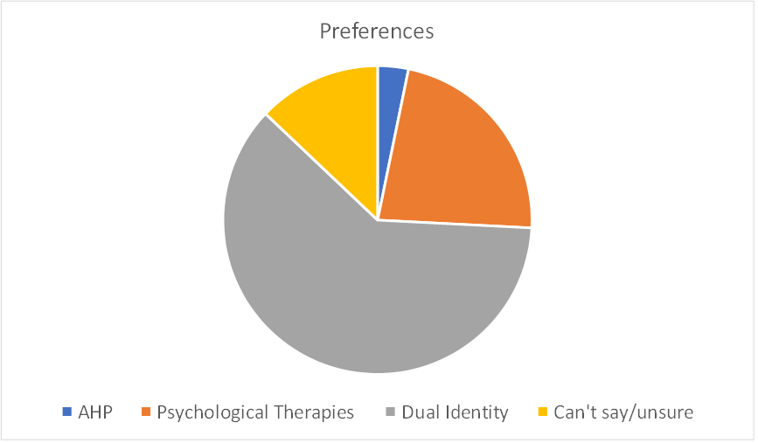

63% Dual Identity, 23% Psychological Therapies, 1% AHPs and 13% Can’t say/unsure.

1. Verbatim quotes from respondents are written “quote.”
2. The National Institute for Health and Care Excellence (NICE)
3. Improving Access to Psychological Therapies (IAPT), now known as NHS Talking Therapies for anxiety and depression programme