# 

# NHS Practice Placement Expansion Communication Strategy for Art, Drama and Music Therapists

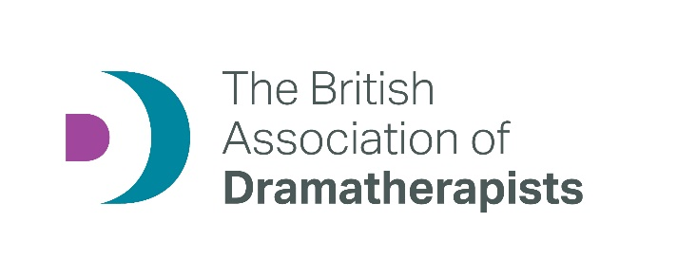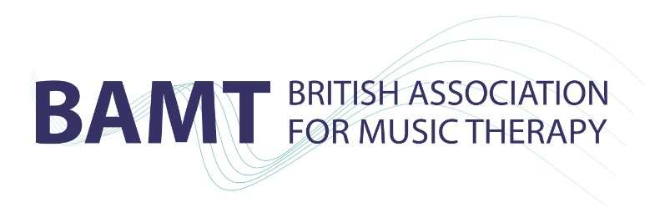

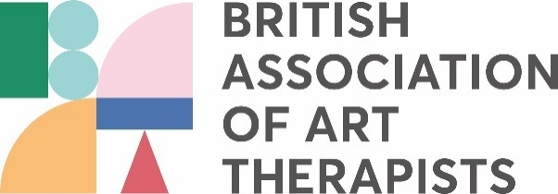

Developed with The British Association of Dramatherapists (BADth), British Association for Music Therapy (BAMT) and British Association of Art Therapists (BAAT). Researcher: Dr Val Huet (PhD).

Contents

Executive Summary 4

Introduction 4

Information for potential placement providers 4

Information for placement providers and HEE to maintain placement provision 7

In conclusion 9

FAQs NHS Practice Placements for Art, Drama and Music Therapists 10

Data Analyses 12

Introduction 12

1. Quantitative data from interviews 12

2. Qualitative data from interviews 14

3. Summary of trainees and newly qualified practitioners survey 24

4. Survey of trainees and newly qualified practitioners results 26

## Executive Summary

### Introduction

Practice placements are an essential component of health and care professional training. They work best when supported by experienced clinicians and supervisors, and properly embedded within organisations. For Art, Drama and Music Therapies trainees, job prospects mean that NHS placement experience is essential:“Each student should have at least one NHS placement experience.”[1] However, there are at present too few NHS placements to meet this demand.

NHS placements expansion for Art, Drama and Music Therapies has been supported by HEE (Clinical Placements Expansion Programme project, March 2022) and outcomes include an increase in placement numbers and a broadening of placement providers and settings. However, this trend needs to be sustained and increased. This project focused on developing a communication strategy to support NHS placements expansion, and on identifying best practices and areas needing improvement among Higher Education Institutions (HEIs) and current placement providers to maintain this growth. The summary of findings and data analysis can be found further down within this report.

### Information for potential placement providers

#### Short films

HEE funding supported the making of 3 films: one [generic film](https://youtu.be/4Ws0Af0ONW0) to highlight the benefits of providing Art, Drama and Music Therapies trainee placements and two shorter films focused on the most promising specialised practice areas for placement expansion. Following a consultation process, these two areas were identified as [Child and Adolescent Mental Health Services (CAMHS)](https://youtu.be/Yyi5AbXOUuI) and [Adult Mental Health Services (AMHS)](https://youtu.be/5HgvgaGugA8).

#### Generic film core messages (to be developed with Art, Drama and Music Therapists and Service Users)

**A short introduction to**

* Art, Drama and Music Therapies as AHPs and Psychological Therapies and Health and Care Professions Council (HCPC) registered professions.
* Art, Drama and Music Therapies as working with mental and physical health conditions and providing a holistic approach to service users.
* Art, Drama and Music Therapies as accessible to people from other cultures and with English as a second or other language (ESL) and across all ages from very young to older people (Equity, Diversity and Inclusion).

**Description of benefits of providing trainee placements:**

* Trainee placements benefit service users, as trainees bring a high level of care and attention when starting clinical work and are regularly supervised.
* Trainee placements benefit supervisors and their practice as it offers practitioners opportunities for professional development.
* Trainee placements benefit the team/service and can help to develop new resources.
* Trainees can bring fresh ideas, enthusiasm, and positivity which can benefit MDTs’ (multi-disciplinary teams) wellbeing and motivation.

**Description of mutual expectations on**

* Learning opportunities within placement and HEIs
* Provision of supervision/reflective practice groups on placement and within HEIs.
* Provision of supervision if no Art, Drama and Music Therapist is in a post to provide this.
* Trainees’ roles – an asset but not a staff member.
* Provision of referrals for clinical practice
* Support from and partnership with HEIs
* Provision of suitable space and resources for trainees (art materials, musical instruments, storage, etc.)

**Testimonies from trainees, placement providers and service users**

* Short ‘talking heads’ statements to illustrate the benefits of providing Art, Drama and Music Therapies practice placements.
* Short vignettes of Art, Drama and Music Therapists in action

#### CAMHS film core messages (to be developed with CAMHS Art, Drama and Music Therapists and Service Users)

* Reference generic film on benefits of providing trainee placements.
* Refer to the rise in Children and Young People (CYP) unmet mental health needs.
* Outline that to support CYP during these challenging times, Trusts may find that broadening their services to include Art, Drama and Music Therapies leads to better engagement and outcomes for CYP (evidenced in the Trusts that do).
* Illustrate that Art, Drama and Music Therapies work in partnerships across settings including early years provisions and schools.
* Short testimonies from trainees, placement providers and service users
* Short vignettes of Art, Drama and Music Therapists in action

#### AMHS film core messages (to be developed with CAMHS Art, Drama and Music Therapists and Service Users)

* Reference generic film on benefits of providing trainee placements.
* Refer to the rise in Adult Mental Health (AMH) unmet mental health needs.
* Outline that to support Service Users during these challenging times, Trusts may find that broadening their services to include Art, Drama and Music Therapies leads to better engagement and outcomes (evidenced in the Trusts that do).
* Illustrate that Art, Drama and Music Therapies work in partnerships across settings including community settings, outpatient, in-patient, and forensic services.
* Short testimonies from trainees, placement providers and service users
* Short vignettes of art, drama and music therapists in action

#### Downloadable information

Several pdfs will be available to be downloaded from the professional bodies, HEIs and HEE’s websites and include:

* Information from each film compiled as a ‘fact sheet’.
* Information on all Art, Drama and Music Therapies HEIs’ placement contact details.[2]

#### Blogs from Trainees and Newly Qualified Art, Drama and Music Therapists and Placement Providers

Contributors to the films will be invited to write short pieces describing their placement experience and including the following questions:

**Trainees and Newly Qualified practitioners:**

* What stays with you from your start on placement?
* What are your most important learning points?
* What would you say to encourage organisations to set up placements?

**Placement providers:**

* What motivates you to provide practice placements?
* What are your most important learning points as a supervisor/placement provider?
* What would you say to encourage organisations to set up placements?

### Information for placement providers and HEE to maintain placement provision

A detailed list of what works well and what needs improving is included in the full report.

#### The most prominent challenges included:

* Time-consuming on-boarding processes and the need for early placement allocation to mitigate this.
* Providing enhanced preparation for placement and development of a professional identity for trainees.
* Ensuring equal opportunities of access to NHS placements for first-year and overseas trainees.
* Outlining clear requirements for clinical hours and how to monitor this (logs, etc.).
* Establishing good communication and clear contracts with mutual expectations and contact details.
* Sharing the HEI’s programme and outline of the curriculum for supervisors to support learning.
* When pressure points may happen during the academic year: e.g., when deadlines for essays are or assessments scheduled, so supervisors are aware of potential stress.
* Information on governance, safeguarding of clients but also of students, e.g., whistle- blowing policy and how to raise concerns.

#### Successful strategies include:

* Partnership teaching between HEIs and Trusts, and students accessing mandatory training on statutory issues such as safeguarding, GDPR, etc.
* Preparing trainees to articulate what they do when they start on placement and first meet multi-disciplinary teams members.
* Having a central named contact person**,** with enough funded time to look after placements was identified as making a significant improvement by both placement providers and HEIs.
* Clear and timely communicationas this is key to ensuring good relationships between HEIs and placement providers.
* Regular training events and meetingsbetween HEIs and Placement providers as these were appreciated by all and helped build relationships and sustain communication.

### In conclusion

Practice placements are vital to the NHS and its future workforce, as they support the growth of confident and committed practitioners. Importantly, Art, Drama and Music Therapies NHS practice placements can introduce these modalities into new settings and support the development of posts. The dedication of Art, Drama and Music Therapists who continue to provide practice placements without receiving any financial enhancements, and often within their own time, needs to be acknowledged. Ultimately, this benefits service users through diversifying choices, ensuring equality of access to resources, and improving experiences of care.

## FAQs NHS Practice Placements for Art, Drama and Music Therapists

### Q: Who are Art, Drama and Music Therapists?

Art, Drama and Music Therapists are Psychological Therapists and Allied Health Professionals. Qualified practitioners are statutorily regulated by the Health & Care Professions Council [https://www.hcpc-uk.org](https://www.hcpc-uk.org/).

### Q: How do they work?

They work with mental and physical health conditions, and with a range of life-affecting conditions, providing a holistic approach to service users.

Art, Drama and Music Therapies are accessible to people from all cultures, including those with English as a second or other language, and across all ages from very young to older people.

Q: What can art therapy trainees contribute to your service?

* Trainee placements can help to develop new resources and improve access to treatment for service users.
* Trainees can bring fresh ideas, enthusiasm, and positivity to benefit multi-disciplinary teams’ wellbeing and motivation.
* Service users value highly their art, drama or music therapy, which enhances their experiences of the service you provide.
* Trainees undertake intensive university-based learning to get them ready for placements.
* An NHS placement provides an irreplaceable introduction to multi-disciplinary teams, and to best practice.

### Q: We don’t employ an art, drama or music therapist – can we still offer a placement?

Yes, you can but you will need to agree provision of clinical supervision for the trainee from a suitably qualified practitioner that meets the training course requirements (universities have their own guidelines on this, so do discuss this need with the placement coordinator). If no one within your staff team meets these requirements, a suitable external supervisor may need to be appointed.

### Q: There are no trainings in our area. Does this mean we can’t provide a placement?

You can still provide placements if there are no trainings in your area as although trainees often study away from home, they may live and look for a placement locally.

### Q: What practical provisions are we expected to make?

A suitable space and resources, e.g., a reasonably private space to conduct sessions and some storage space for art materials and artworks, drama props or musical instruments. Provision of basic art materials, and drama and music equipment.

### Q: How many practice hours are students expected to have?

Universities have their own guidelines and this also depends on the phase of trainings (e.g. first or final year), so do check with the placement coordinator, but generally, students will work with individual clients or in groups to fit in with the needs of your service. You will need to ensure that there are enough suitable referrals for trainees to meet the number of practice hours requirements (check with their university for details). There will also be a maximum number of practice hours or clients that trainees can take on as they are not expected to have a workload comparable to qualified staff members whilst training.

### Q: Can we expect support from the university?

Yes, universities will work collaboratively with you to ensure a positive experience for the trainee and your team. Each university has a practice placement handbook for placement providers where they outline their approach and ethos to practice and learning, mutual expectations for placements, learning objectives and supervision requirements for trainees.

### Q: Are there any other requirements?

Whenever possible, it is really helpful for students to join in the team’s learning opportunities, such as training events, seminars, etc.

The placement supervisor will also need to write a report on the trainee’s performance to be shared with the university.

### Q: How do we get started?

Please email the Art, Drama or Music Therapies Professional Bodies to request a list of trainings and contacts for placement coordinators.

British Association of Art Therapists (BAAT): [info@baat.org](mailto:info@baat.org) website: [www.baat.org](http://www.baat.org/)

British Association of Dramatherapists (BADth): [admin@badth.org.uk](mailto:admin@badth.org.uk) website: [www.badth.org.uk](http://www.badth.org.uk/)

British Association for Music Therapy (BAMT): [info@bamt.org](mailto:info@bamt.org) website: [www.bamt.org](http://www.bamt.org/)

## Data Analyses

### Introduction

**Data analyses are reported in 4 sections:**

1. Quantitative data from interviews
2. Qualitative data from interviews
3. Summary of trainees and newly qualified practitioners survey
4. Survey of trainees and newly qualified practitioners results

### 1. Quantitative data from interviews

#### NHS Practice Placements Current Trend

Data from placement providers and HEIs indicates an increase in NHS, with a 23% slight increase and a 31% significant increase.

#### Increase in placement settings/client groups

* Learning Disability (LD)
* Mentalization-Based Treatment (MBT)
* CAMHS x2

#### Decrease in placement settings/Client groups

* CAMHS x2
* AMH

#### New client groups/placement settings

* Adult LD x2
* MBT
* Paediatric care and A&E
* Elder adult and dementia care in community
* Blind CYP
* Perinatal service
* Adult autism and neurodiversity
* Neuro Rehab (strokes, accidents)
* Recovery college
* Older adults
* Community LD
* Respiratory Team
* CAMHS
* LD
* Looked After Children
* Arts in health (gallery work)

#### Preferences for NHS Placement Expansion

CAMHS and AMHS were two areas prominently mentioned by respondents.

|  |  |  |  |  |  |  |  |  |  |  |  |  |  |  |
| --- | --- | --- | --- | --- | --- | --- | --- | --- | --- | --- | --- | --- | --- | --- |
|  | Number of times mentioned | | | | | | | | | | | | | |
| Children and Adolescents Mental Health Services |  |  |  |  |  |  |  |  |  |  |  |  |  |  | |
| Adult Mental Health |  |  |  |  |  |  |  |  |  |  |  |  |  |  | |
| Older People Mental Health |  |  |  |  |  |  |  |  |  |  |  |  |  |  | |
| Learning Disability |  |  |  |  |  |  |  |  |  |  |  |  |  |  | |
| Cancer and Palliative Care |  |  |  |  |  |  |  |  |  |  |  |  |  |  | |
| Perinatal, Mother and Baby units |  |  |  |  |  |  |  |  |  |  |  |  |  |  | |
| Forensic services/Prisons/Probation |  |  |  |  |  |  |  |  |  |  |  |  |  |  | |
| Brain injuries and strokes |  |  |  |  |  |  |  |  |  |  |  |  |  |  | |
| Addiction |  |  |  |  |  |  |  |  |  |  |  |  |  |  | |
| Autism, neurodiversity |  |  |  |  |  |  |  |  |  |  |  |  |  |  | |
| GP practices and Primary Care |  |  |  |  |  |  |  |  |  |  |  |  |  |  | |
| Long COVID physical and mental health |  |  |  |  |  |  |  |  |  |  |  |  |  |  | |
| Arts in health projects |  |  |  |  |  |  |  |  |  |  |  |  |  |  | |

### 2. Qualitative data from interviews

#### Any placement settings you would prefer not to use?

Placement providers and HEIs held similar views. Several respondents felt that their “criteria are more to do with support and resource”1 and “the issue is the availability of supervisors when services carry more of a risk.”

Nonetheless, other respondents felt that forensic settings may not be suitable, especially for first-year students if addressing “trauma enmeshed with drug-related issues and sexual violence.”

Community settings and crisis pathways with higher-risk adults were also mentioned as not suitable for a practice placement setting.

#### Placement providers’ views on the benefits of providing trainee placements.

Respondents enthusiastically outlined the benefits of providing trainee placements. Four themes were identified from their responses that highlight a comprehensive range of benefits.

##### Trainee placements benefit service users.

Trainees bring a high level of care and attention when starting clinical work and approach issues “carefully and thoroughly which is helpful when more experienced clinicians may use shortcuts.”

Within CAMHS “It is nice to have someone who is new and trying to make a difference to their lives and often closer to their age.” Trainees can also contribute to practice innovations as they bring “curiosity” that can help refresh practice.

##### Trainee placements benefit supervisors and their practice.

Providing supervision offers practitioners opportunities for professional development and is “good for supervisors to provide learning and developing that role.”Trainees also bring in fresh ideas and are “a new set of eyes and asking useful questions […] that you have forgotten to ask yourself.”

Supervisors enjoy seeing trainees grow in confidence in their work: “All the theory comes alive in the practice.”

##### Trainee placements benefit the team/service

Trainees “keep both the supervisors and the team as a whole active” as “being part of a multi-disciplinary team, they bring fresh ideas, enthusiasm and positivity.”They also “broaden the profile by representing the department” and contribute to “increasing clinical work and helping waiting lists in a mutually beneficial way.” Trainees often introduce resources to “teams where there have not been any previously and contribute to the growth” of the Art, Drama and Music Therapies.

##### Providing trainee placements helps prevent cynicism and burnout.

Placement providers felt proud of “contributing to the workforce for the future and helping to build this.” Many mentioned trainees’ “enthusiasm, passion and energy,” a helpful reminder to avoid cynicism which leads to burnout. Trainees “bring new energy, insights, direction and help with teams wellbeing and motivation.”

#### Challenges of providing trainee placements

Challenges varied across respondents and the four themes identified integrate these different views and experiences. For instance, whilst HR and ‘on-boarding’ processes worked well within a few NHS Trusts, they were identified as significant barriers to placements for several respondents.

##### Complexity and intensity of setting and casework.

Respondents thought that “learning about the NHS systems takes a lot of time particularly if unfamiliar with its structures and cultures.” There is an added “challenge for students of the intensity of the setting and the work,” as mental health needs are increasingly complex, and casework can involve acute safeguarding and risk management issues. This has implications for preparedness for placement.

##### Preparedness for placement

This includes professional and emotional preparedness. “Presenting like a real professional,”aware of appropriate boundaries, able to communicate well with colleagues, and informed on protocols and policies (e.g., Safeguarding legislation) was sometimes not satisfactory. Supervisors shared concerns about some trainees’ resilience and their ability to “manage individual work with regard to psychological and personal boundaries,”especially with a rise in acute needs amongst service users. Some respondents were aware of the pressure on HEIs to increase cohort numbers and previously “trusted selection by course but numbers have had to double so selection criteria have had to be a bit looser”which may have an impact on trainees’ psychological preparedness.

##### Supervision and feedback

Some trainees struggled to take in feedback on areas needing improvement and reacted defensively:“If a trainee struggles with feedback, this highlights areas where there are challenges about their competence.”Supervision could then become difficult and a chore, rather than a positive experience for the supervisor. Trust in supervision is essential in ensuring the quality of learning and“honesty in reporting what is really going on with clients and full use of supervision is essential.”

Supervisors also shared fear that their own limitations may surface: “having a trainee can expose shortcomings in skills and knowledge.”

##### Practical obstacles

Practical obstacles included: HR and ‘on-boarding’ processes, physical space, and time pressure.

HR and ‘on-boarding’ were “a problem and dynamic administration often does lag behind” for several respondents. Processes involving identity and DBS checks, setting up honorary contracts, access to buildings and IT, arranging basic mandatory training, etc., were so slow in some Trusts that some placements had been lost. Practical adjustments such as early recruitment of students did not always work, as college and placement timetables did not necessarily synchronise.

Space was also an issue: following COVID, an increase of staff on-site meant that there was “not enough space for everybody”and supervisors may find it difficult to negotiate practice and desk spaces for trainees.

Added time pressure for supervisors can be “stressful and demanding and impacts on other work.”Providing trainee placements “takes a lot of time to prepare yourself, your team and your service.”Supervisors are expected to fit this in within an already heavy workload and it is important to note that for Art, Drama and Music Therapies, there is no payment enhancement to take in this task, unlike other AHPs.

#### Communication between placement providers and HEIs: what works well and what needs to be improved?

##### Placement providers

**What works well?**

Most placement providers felt that “having a dedicated and funded part of a post helped a huge amount”to set up and monitor placements. This had been evidenced by the Clinical Placements Expansion Programme (CPEP) project and “should be implemented across all NHS Trusts.”

Several respondents thought that “having the course curriculum for trainees would be really helpful to tailor supervision and supplementing trainees’ learning.”

Having a named HEI contact also works well but only if this person is responsive.

###### What needs improving?

HEIs’ communication is not always reliable and “sometimes trainees are the ones who manage communication which is not ideal.”Placement providers are aware that many HEIs are facing stressful issues that impact communication: “for a while there was very good communication but recently, communication has got worse because of larger cohorts, and it is getting harder to get in touch with course staff.” This creates a “deficiency model of communication, for instance with no HEI visit unless there is a problem.”Poor communication “makes the work of looking after students unrewarding. Holding the students can become very split which is not helpful on many levels: the relationship feels two-dimensional and the potential for splits is concerning.”

Sometimes placements don’t overlap with college supervision and students are not getting the level and consistency of support they need. This is particularly concerning with overseas and ESL students.

When centralised protocols are in place, “HEIs seem to prefer contacting personal contacts and bypass these processes and sometimes fly over the structures,” which can lead to confusion and conflict.

##### HEIs

**What works well?**

Early and clear communication works well, and“direct contact with the person overseeing the placement is essential to develop a shared understanding. A centralised point of contact is sometimes helpful, but it limits ability to select a placement to suit students’ need. HEIs have developed a good understanding of these.”

Developing the “relational aspects [with placement providers] works well: providing pre-placement training days was very popular and got really good feedback. Art therapists attended but also a few other professionals. Building this community is important”as HEIs try to provide **“**more support for placement providers.” This has become more possible since the pandemic “made online meetings the norm.”

Having named “link tutors and placement coordinators with contact details” also supports good communication.

**What needs improving?**

Some placement providers need“a clearer understanding of expectations”for trainees and ensure that they have adequate space, supervision, and a number of suitable referrals.

It is “essential that there is someone on both placement providers and HEIs sides with proper time to manage placements.”Issues such as on-boarding can be problematic and “quality really varies between Trusts.”

#### Quality of practice, theoretical approaches and supervision: what works well and what needs to be improved?

##### Placement providers

**What works well?**

Several placement providers felt that “this works well on the whole” and found “good synergy between some trainings and practice. Sometimes adaptations are needed which is not a problem.” “HEIs supervision groups work really well. Some HEIs have external supervisors for the placements. Generally, this has been fine.”

Supervisors were aware that added specialised knowledge was needed and were happy to provide this to the trainees: “Some extra teaching is needed but this is to be expected if they are going in a specialised area. Sometimes some models need to be introduced e.g., attachment theory, trauma- informed, and dyadic work.”

**What needs improving?**

Some HEIs need to improve preparation for placement:“Being ready for work at the coal face is mostly dependent on the trainees’ interest and previous experience. I am not sure how much HEIs are doing to prepare them.” Learning about organisations structures, policies and legal framework should be prioritised: “Students should be encouraged to get facts right about placements as this is really complex.”

In terms of practice,“students can sometimes report partially understood issues from HEIs. Sometimes, there can be contradictions between approach but mostly it is miscommunication.”

Therefore, “having a bit more structure to reflect on the supervision would help as some splitting may happen at times.”

HEIs’ expectations that trainees will do individual work may not be realistic on some placements:“HEIs would like guarantees for this and referral flows may not work with this,” and groupwork may be the main clinical experience.

##### HEIs

**What works well?**

Having increased “placement preparation module on theory into practice”has helped trainees’ readiness for placements.

Supervision “works well with good availability (of supervisor) and relationships although we are aware of pressure of [supervisors’] workloads.”

Improved communication between HEIs and NHS placement providers has been key: “there has been close liaison with college supervisors and placement supervisors […]. There is a framework and a desire to work together. The space is needed to think together, and this is better done within the NHS than within organisations where clinicians are lone workers.”

When difficult conversations are needed because of challenges with trainees, “open transparency works well and being able to meet with the clinical supervisor helps. Reports are shared with the students to have a mature dialogue with supervisors and HEI team.”

**What needs improving?**

Trainees“need a number of client sessions and this needs to be provided**.”** Placement organisations need to be able to provide appropriate referrals in sufficient numbers and this is not always reliable.

Many health and care teams and organisations are experiencing stressful issues which can have a detrimental impact on their functioning: “sometimes, the organisation culture can be a bit toxic or a bit lax. We would not approach some organisations where there are concerns about governance and boundaries.”

Additionally, some challenges may emerge“when trainees have personal issues affecting their professional conduct.” “Different opinions and perceptions between HEIs and placement supervisors can also be a problem.”

Supervisors need to “have allocated time to update their practice.” Some approaches are not in line with current evidence-based practice taught on the training and “curriculum awareness may help.” However, HEIs were aware that there was no enhanced payment to provide trainee placements and that supervisors were often adding this to an already heavy caseload.

Many placements are not available to first-year students, and this affects the quality of placement practice. Whilst some first-year students may need additional grounding before going on placement with higher-risk service users, this policy does not recognise that many have considerable pre-training experience within these settings.

#### Information that would be helpful when setting up a placement? e.g. practical and organisational issues, supervision and general expectations.

##### Placement providers

It would be helpful for HEIs to provide or ensure:

* Clear requirements for clinical hours and how to monitor this (logs, etc.).
* Programme and outline of curriculum
* When pressure points may happen during the academic year: e.g., when deadlines for essays are or assessments scheduled.
* Realistic expectations re: supervision requirements, space needs, basic idea of what Art, Drama and Music Therapies are and what clients can expect.
* More information on and preparation for trainees on the NHS
* A few health and safety issues need to be adhered to.
* Clear contracts from universities, including named contacts with emails.
* Some training for trainees to articulate Art, Drama and Music Therapies and to deliver workshops to their new teams.

##### HEIs

It would be helpful for placement providers to provide or ensure:

* Clarity re: clinical responsibility as this sits with the placement provider
* Sometimes there are high expectations that trainees are already autonomous, and at other times supervisors are over careful to let them work with clients. A happy medium would be to provide containment but not be over-controlling.
* Space and supervisor’s availability as protected space and time are getting rare. This can lead to team tensions between disciplines and impact on the trainees’ placement experience and learning.
* Steady referrals for students 1:1 or group.
* Introduction to working within a Multi-Disciplinary Team.
* Information on Safeguarding of clients but also of students, e.g., whistle-blowing policy and how to raise concerns.
* Taking some time to get to know the students.
* International students and ESL – home and EU students get offers of placements but not international ones. There may be Equity, Diversity and Inclusion (EDI) issues that placement providers need to consider.

#### Anything else?

##### Placement providers

* HEIs may need to prepare students for placement interviews and encourage them to research Trusts policies and culture.
* Supervisors need more support – untapped resource, very keen to disseminate support and information.
* Having some funding has helped expand placements.
* HEIs and NHS providers forum – where could we be?
* Having a proper post to oversee placements really works.
* New formula for placements e.g., Block placements.
* The start of the placements could be better organised, a bit earlier.
* ‘Long arm’ supervision – supervisors being in different sites and also group supervision.
* Longer placements would be helpful. One-day placements are hard.
* Communication is a massive issue.

##### HEIs

* Widening the net of Trusts.
* Leadership issue.
* The person who coordinates placements needs to be given proper time.
* AHPs and psychologists are often under recruited but some of these systems block access to these posts for years.
* Proper support from university management (for Art, Drama and Music Therapy trainings).
* Longer placements.
* Timescale for students starting placements – very long time for on boarding process.
* Positive feedback and successful event on partnership day for placement providers.
* Networking impact. Deep care shows.
* Job prospects mean NHS experience is really needed and the aim is an NHS placement for each student.

### 3. Summary of trainees and newly qualified practitioners survey

An online survey was conducted in November 2022 for 3 weeks, with BAAT, BAMT and BADth circulating a call-out to their trainee and newly qualified practitioners (up to 2 years post-qualification). Information was sought on placement settings and client groups, supervision, and views on placement experience. Respondents were also asked what information was or would have been useful for placement providers about having a trainee. 102 respondents completed the survey and included an average of modalities as follows: 75% art therapy; 20% music therapy; 5% dramatherapy.

The three main placement settings were[3]:

NHS (59%); Education (57%); Voluntary/Charitable/Independent Sector (53%). Client groups were represented as follows:

* Children and Young People services: 79%
* Adult services: 76%
* Older people service: 16%
* Family services: 9%

47% of respondents had been supervised by an Art, Drama or Music Therapist throughout their training, 6% in their first year only, 15% in their second year only, whilst 11% had not had a placement supervisor from their own modality throughout their training. Other modalities included psychotherapy, counselling, group therapy. However, a few reported being supervised by professionals with no training in psychological therapies.

When asked ‘which aspects of placement had worked well?’ respondents highly rated supervision (74%), learning opportunities (70%), suitability of referrals (69%), allocation/choice of placements (68%) and suitability of space (61%). Aspects such as ‘integration in team’ and ‘clear and consistent feedback on learning’ were rated respectively 57% and 52%. Rating lowest were ‘pre-placement checks (ID) and on-boarding (HR processes, access to IT’ (45%) and ‘communication between university and placement’ (36%).

When asked ‘which aspects of placement had not worked well?’ respondents rated highest ‘communication between university and placement’ (47%) and ‘Integration in teams’ (38%). All other aspects (listed above) were rated between 20% and 25%, apart from ‘clear and consistent feedback on learning’ which was rated at 32%. However, the ‘other’ category attracted a 45% rating and individual feedback on challenging experiences. These were mostly linked to a lack of communication between HEI and placement, lack of support when meeting challenges, on-boarding processes delaying the start of placements, poor integration in teams, conflicts between placement and HEI practice models, concerns about suitability of supervisor, and inappropriate referrals within settings with high rates of self-harm and critical incidents.

When asked ‘what information was or would have been useful for placement providers about having a trainee’, the following three points were rated highest: ‘Clear information on your modality and how it helps service users’ (35%); ‘Mutual expectations between organisation and trainee’ (17%); ‘Expectations for referrals and clinical experience’ (13%).

When asked ‘What information would you have found helpful before starting placements?’, respondents referred frequently to pre-placement preparation on note writing and other statutory protocols like Safeguarding, on learning about the specific issues linked to the client group and organisation, and on needing clear mutual expectations between trainee, placement, and HEI. Insight about how well or poorly established Art, Drama and Music Therapies are within the placement setting and preparation on how to communicate with teams and settings with no or little previous knowledge of providing a placement would also be welcome.

Additional issues included early placement allocation to avoid delays, mandatory supervision training for supervisors and the need for placements and HEIs to have a whistleblowing policy for trainees.

### 4. Survey of trainees and newly qualified practitioners results

Chart Q1 Which modality are you training in (or did you train in)? Responses showed Art 75.86%, Drama 4.31% Drama, Music 19.83%.

Chart Q2 Where are or were you on placement (tick as many as apply). Responses show: NHS 58.62%, Education 56.90%, Local Authority 9.48%, Private Practice 5.17%, Voluntary/Charitable/Independent Sector 52.59%, Other 10.34%.

Chart Q3 Please describe your client group(s) - tick more than one if appropriate. Responses show majority worked with adults and children and young people, in comparison to older people and families.

Chart Q4 Please tell us about your area(s) of practice (tick more than one category if appropriate). Highest responses were from adult mental health, school-based therapy, complex trauma/abuse, autism and learning disability.

Chart Q5: During your training were you supervised by a qualified art/drama/music therapist? Responses show: Yes throughout my training 46.55%. Yes but only in my first year 6.03%. Yes but only in my second year 14.66%. No not on my placement throughout my training 11.21%. Other 21.55%.

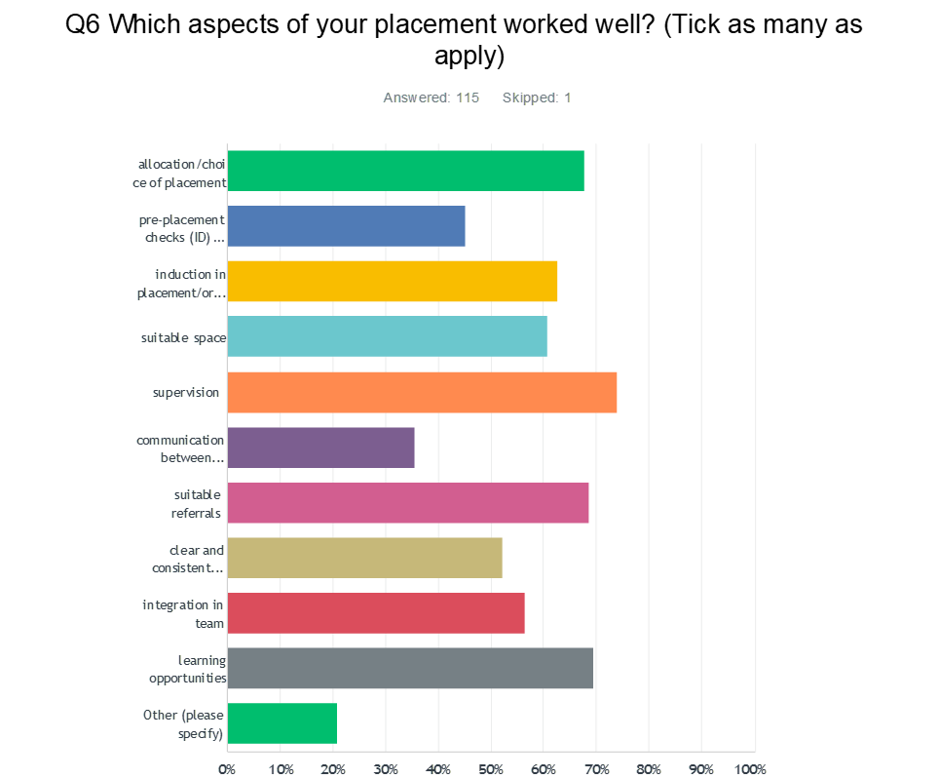

Answer choices for Chart 6, aspects of the placement that worked well. Allocation/choice of placement 67.83%. Pre-placement checks and on-boarding 45.22%. Induction in placement/organisation 62.61%. Suitable space 60.87%. Supervision 73.91%. Communication between university and placement 35.65%. Suitable referrals 68.70%. Clear and consistent feedback on learning 52.17%. Integration in team 56.52%. Learning opportunities 69.57%. Other 20.87%.

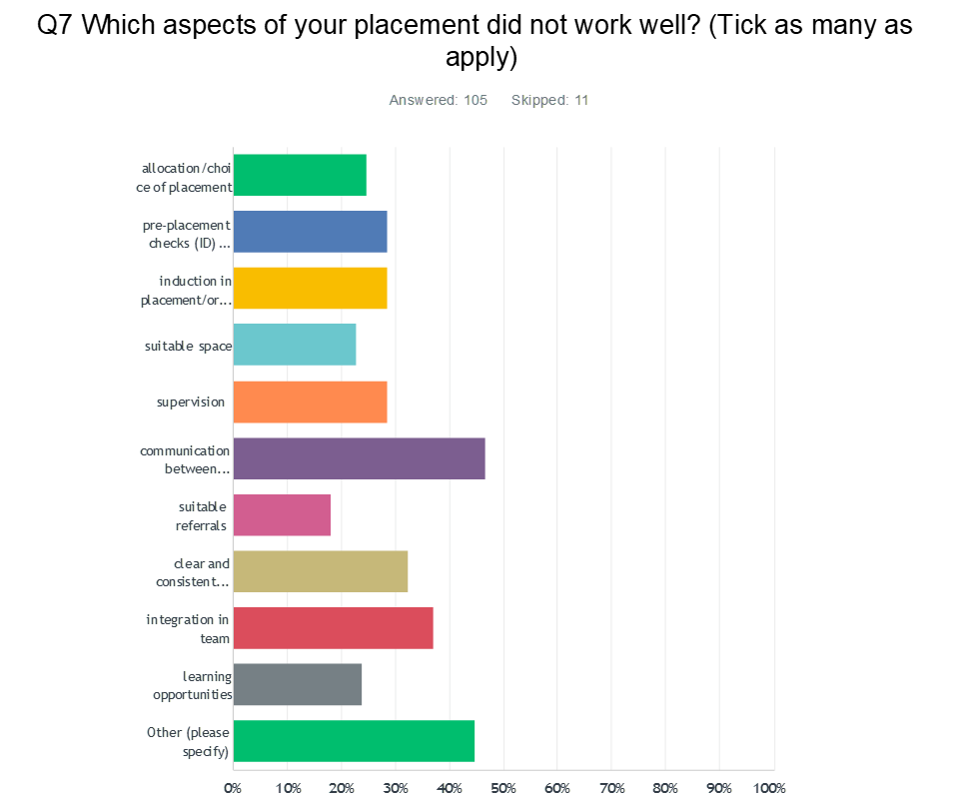

Answer choices for Chart Q7, aspects of the placement that did not work well. Allocation/choices of placement 24.76%. Pre-placement checks and on-boarding 28.57%. Induction in placement/organisation 28.57%. Suitable space 22.86%. Supervision 28.57%. Communication between university and placement 46.67%. Suitable referrals 18.10%. Clear and consistent feedback on learning 32.38%. Integration in team 37.14%. Learning opportunities 23.81%. Other 44.76%.

Chart Q8: Reflecting on your experience, what information was or would have been helpful for your placement providers about having a trainee. Tick as many categories as apply. Answer choices included: clear information on your modality and how it helps service users; information on practice issues; mutual expectations between organisation and trainee; limitations to trainee role; expectations for supervision; expectations for referrals and clinical experience; clear contact protocol; and named contact within university.

1. Verbatim quotes from respondents are written as “quote”
2. This will need to be updated regularly.
3. Please note that each student has several placements.