Stakeholder Briefing – Issue 2

Key Messages and links to 21 April 2020

Welcome to Health Education England’s weekly COVID-19 stakeholder bulletin.

HEE is working with partners to support the system-wide response to COVID-19. Our priority is to ensure trainees and learners are kept informed of immediate changes to their training and recruitment, as well as to support returners to the NHS.

In this bulletin we will provide:

- Overview of HEE and our partner’s national response to COVID-19
- An update from your regional office
- Signposting to useful resources and contact information

We are supporting all professions to rapidly grow to meet the needs of patients by:

As at 21st April 2020, HEE has supported around 20,000 nurses and midwives, 3,000 doctors and over 400 AHPs (data collection ongoing) to join the NHS front line. We also estimate that around 2,200 medical students from years 1-4 are volunteering in a variety of ways. Collectively that is around 25,000 students and trainees either directly deployed or volunteering.

Healthcare Scientists – Supporting over 50% of the final year Scientist Training Programme (STP) cohort on to the HCPC temporary register to allow them to use their skills differently to their normal working day. Trainees on the Higher Specialist Scientist Training Programme (HSST) have also been offered a pause in training while they focus on COVID-19 work.

Physician Associates - As part of our work to ensure a consistent, safe approach to the rapid deployment of student clinicians into the front line we have worked with the Faculty of Physician Associates at the Royal College of Physicians and regional teams to prepare model role descriptors for the PA workforce. The Faculty of Physician Associates have set up a COVID-19 special temporary register for graduate student PAs who have completed their University programmes but have yet to pass the PA national exam. More information here.

Supported Return to Training - If you missed our knowledge refresher and wellbeing webinars for doctors returning to training - you can now watch them online.

Nursing and Midwifery Students – If you missed our webinar last Friday with Chief Nurse, Mark Radford and Jess Sainsbury, Chair of the Royal College of Nursing Students Committee, you can view a recording here.

Continuation of academic study and supervision in practice was a prime consideration in developing plans for students with the Nursing and Midwifery Council and other partners. We have more sessions coming too, so do look out for these.

Allied Health Professionals – Health Education England is asking universities to contact their eligible Allied Health Professional (AHP) students to discuss their options for using their education programme to help with the response to the COVID-19 pandemic – you can find the Student Support Guidance and joint AHP leads letter on under the Student Support Guidance during COVID-19 drop down here.

Pharmacy - Joint guidance on facilitating the deployment of pharmacy undergraduate students to support the pharmacy workforce is available here.

We are ensuring core HEE work to support our NHS colleagues continues:

Several changes have been introduced for ARCPs scheduled to take place before August 2020, to enable as many trainees to progress to the next stage in their training as possible. Find out more about these changes here under the Training drop down here.

We are making sure all professions have the training they need to make a difference:

HEE e-Learning for Healthcare (e-LfH) - The COVID-19 programme is still being used extensively by the health and care workforce responding to the pandemic. To date it has been launched over 800,000 since it went live last month. The content is also being accessed in 98 countries across the world via eIntegrity.

In response to feedback from users you can now access content on the COVID-19 programme by selecting your role from a drop-down box on the e-LfH website. Short “how to” videos to help users with the registration process and accessing content are also now available.

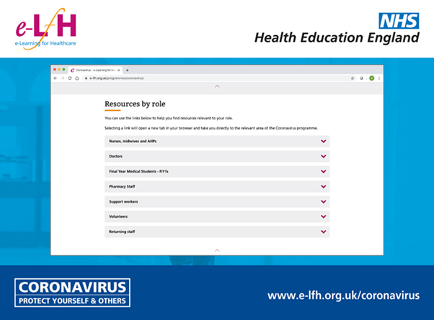

There are now resources for most members of the health and care workforce working in a range of settings including resources for Nurses, Midwives and AHPs Returning to work, being Redeployed or Up-Skilled including pathways for those who are internationally trained, from the independent sector and students who have opted into a revised programme structure.

Click here for more information and to access the programme.

Supporting the wellbeing of the NHS workforce by:

Implementing a Wellness Induction for all Interim Foundation Year 1 doctors. The induction aims to help maintain wellbeing during the COVID-19 pandemic. It provides personal guidance and signposting to services and resources. We’re also investigating how to adapt it for other parts of the workforce.

FURTHER INFORMATION

By following @NHS_HealthEdEng you can keep up to date with new information and resources as they are published. Most importantly are the notifications of webinars being broadcast during the week.

Right now, making sure we are communicating properly is obviously incredibly important. If there's any information you think is missing on HEEs webpages, please let us know by submitting your question to the HEE Q&A helpdesk.

