Stakeholder Briefing

Key Messages and links

Welcome to Health Education England’s weekly Covid-19 stakeholder bulletin.

HEE is working with partners to support the system wide response to COVID-19. Our priority is to ensure trainees and learners are kept informed of immediate changes to their training and recruitment, as well as to support returners to the NHS.

In this bulletin we will provide:

- Overview of HEE and our partner’s national response to COVID-19
- An update from your regional office
- Signposting to useful resources and contact information

We are supporting all professions to rapidly grow to meet the needs of patients by:

Medical - Almost 3,000 final-year medical students have now signed up to join the COVID-19 frontline, and hundreds began last week (April 13). Read the full story here
Nursing and Midwifery Returners - As part of system-wide planning, we are working as Team CNO and with our key stakeholders to support our colleagues working in health and social care. In this unprecedented situation we are working with those who have relevant skills and knowledge to support the national response.

We are supporting the Your NHS Needs You campaign asking former registrants to consider returning to support our health and care services.

We are also working in partnership with the Chief Nursing Officers from England, Scotland, Wales and Northern Ireland on UK-wide policy and guidance to support the deployment of additional nurses and midwives to support patients and families during the covid-19 outbreak. This includes registered nurses and midwives and colleagues from our own organisation and other arm’s length bodies (ALBs) who are registered nurses and midwives.

Nursing and Midwifery Students – Over 19,000 nursing and midwifery students from across the country have now opted to join NHS frontline staff in response to the COVID-19 pandemic.

These students were the first to be contacted by their university and asked about their interest and whether they would like to opt-in to a paid placement. This has now been extended to include all nursing cohorts eligible for the extended paid-placements as part of the revised education programmes permitted by the COVID-19 legislation. All second- and third-year undergraduate nursing students, second- and third-year midwifery students, and postgraduate nursing and midwifery students are also being contacted by their university to discuss their options.

AHPs - HEE is continuing to develop proposals to provide safe and beneficial opportunities for our AHP students that allows them to keep developing their skills while supporting the NHS at this difficult time. Universities are asked to contact their eligible AHP students to discuss their options for using their education programme to help with the response to the COVID-19 pandemic. The HEE-led COVID-19 AHP student data collection is now live for eligible second and third year undergraduate and postgraduate students to note and then report their preferences for opting-in to paid clinical practice. The details of students who opt-in will be reported by HEE to the ‘Regional Workforce Cells’ who will place students with NHS provider organisations. This data collection is to support the AHP Student Support Guide and the joint AHP leads letter (available here).
Guidance for students who do deploy is here.

We are ensuring core HEE work to support our NHS colleagues continues:
Postgraduate medical trainees continue to provide a significant contribution to service and are an essential part of plans to support the response to COVID-19. Therefore, it has been agreed to cease all planned rotations in May, June and July.
Letter from the four Statutory Education Bodies to all trainees, including information on management of ARCPs.
Read both letters can be found on our trainee information page

As NHS Nightingale Hospitals become operational, it is anticipated there may be requests for medical and dental trainees to be redeployed into them. Guidance for postgraduate medical and dental trainees has been uploaded to our website.
Frequently asked questions for trainees are updated regularly on this page.

Information and guidance around Quality during the Covid-19 pandemic
Health Education England is stopping all routine education quality activities during the Covid-19 pandemic. Our focus remains on the quality of the clinical learning environment and its impact on the safety of learners and patients. Our principles, expectations and information on how to raise concerns during this time are set out in the documents below:

HEE statement on stopping quality visits during Covid-19
Escalating concerns process during Covid-19
Quality Principles during Covid-19
We are making sure all professions have the training they need to make a difference:

HEE’s e-Learning for Healthcare (e-LfH) COVID-19 e-learning programme is available, free of charge, to all health and care professionals in the UK. It has been launched more than 650,000 times since it went live on 18 March 2020. The e-LfH content has also been made available, via eIntegrity, free of charge to health and care professionals working throughout the world and is being used in 79 countries to date. Thank you for continuing to share details about our COVID-19 e-learning programme.

Regularly updated and now includes:
- Essential Guidance from the NHS, UK Government, WHO and BMJ
- Public Health England – Personal Protective Equipment (PPE)
- Infection Prevention and Control
- Resources for Staff Working in Critical Care Setting
- Resources for Staff Working in Acute Hospital Setting
- Resources for Staff Working in Primary Care and Community Setting
- Resources for Nurses, Midwives and AHPs Returning to work, being Redeployed or Up-Skilled
- Resources for other Healthcare Staff Returning to Work
- Resources for End of Life Care COVID-19
- Resources for Specific Professions
- Resources for Volunteers supporting Health and Social Care
- Critical Care and Ward-Based Equipment Guides
- Staff Wellbeing and Resilience during COVID-19

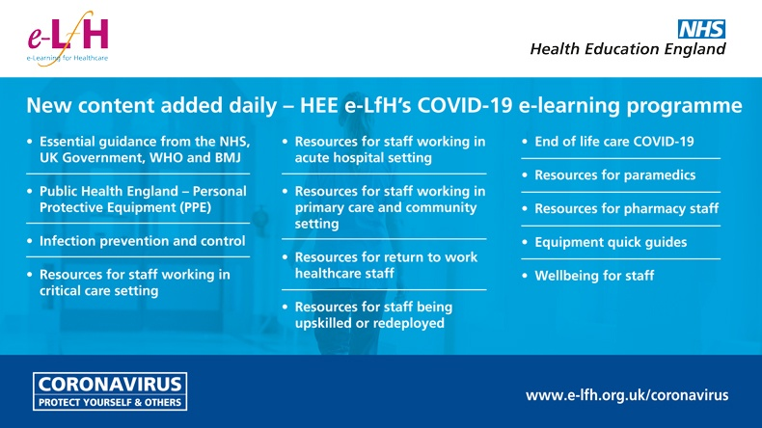

Supporting the wellbeing of the NHS workforce:

HEE is recruiting experienced medical educators, academics and others to support our educational functions. These roles, undertaken remotely, will support the welfare of our junior doctors at a time of increased stress.
Read the full story here

HEE is proud to support a mental wellbeing support package launched by the NHS. Our NHS people are doing extraordinary things in the face of an extraordinary challenge, and so need an extraordinary level of support. All NHS people will have access to a range of support through one point of contact:

- a free wellbeing support helpline 0300 131 7000, available from 7.00 am – 11.00 pm seven days a week, providing emotional support from trained volunteers and onward signposting to specialist financial advice, bereavement care and coaching
- a 24/7 text alternative to the above helpline - simply text FRONTLINE to 85258
- online peer to peer, team and personal resilience support, including through Silver Cloud, and free mindfulness apps including Unmind, Headspace Sleepio and Daylight

More information on support can be found here.

NORTH EAST AND YORKSHIRE REGIONAL UPDATE
The HEE team in the North East and Yorkshire have issued a number of bulletins in relation to Covid19 in recent weeks, containing both regional and nationally relevant advice and updates. The most recent was 16 April. Bulletins can be found here.

FURTHER INFORMATION
Webinars –
- On Friday 17 April at 7pm our Chief Nurse Mark Radford hosted a webinar and answered student nursing and midwives questions, providing advice and guidance. There are more planned and we’ll keep you updated.
- SuppoRTT - HEE has a series of webinars for doctors who are coming back from a break from clinical practice into an unprecedented and uncertain period of clinical work.
Find out more about upcoming webinars here
Watch recordings of previous webinars here

Right now, making sure we are communicating properly is obviously incredibly important. If there's any information you think is missing on HEE’s webpages, please let us know by submitting your question to the HEE Q&A helpdesk.

