Supported Employment Programme in NHS Trusts for Young People with Disabilities: Piecing the Puzzle Together

Short Version

Ian Kessler
Richard Griffin
Amanda Griffiths

King’s College London

June 2021

1: Introduction

Employment is a key social determinant of health and wellbeing, but people with disabilities face significant barriers to accessing and retaining work. Prior to COVID-19 (henceforth Covid) barely half (53.2%) of the people with a disability were employed, with this figure even lower for some conditions: for example, in the case of people with a severe or specific learning disability employment fell to just 17.6%. Covid is likely to exacerbate these poor labour market prospects, especially for young people with Special Education Needs and Disabilities, disproportionally affected in times of economic downturn.
A young person has Special Education Needs and Disabilities (SEND) if they have a learning difficulty and/or a disability and/or a physical or visual impairment that means they need special health and education support. In broad terms the support received by these young people is formalised in a local authority Education, Health and Care Plan (ECHP), which includes assistance into employment. Supported employment programmes are perhaps the key means of providing this assistance, equipping the young person with essential work-based knowledge, skills and experiences. This report explores supported employment interventions in the NHS, looking at how, why and with what effect they have been introduced and used.
The NHS is the largest employer in England with its responsibility as an ‘anchor institution’ and exemplar in providing employment opportunities to its local communities, increasingly being stressed by policymakers. Yet the propensity of healthcare employers to support the employment of young people with SEND remains at best patchy and fragile. By examining supported employment programmes in the NHS, this report seeks to facilitate employer engagement with supported employment programmes, and in so doing not only improve the life chance of young people with SEND but also contribute to the development of a more diverse and productive NHS workforce.
Our study examines the range of supported employment programmes:
- Work experience- short exposure to and experience of the workplace often tied to learning activities.
- Traineeships- more formal but still short-term programmes providing direct access for and preparation for work and employment.
- Supported Internships: formal programmes combining learning, skills development and job placements over an extended period, typically the academic year.
- Supported Apprenticeships: providing additional support and resourcing in pursuit of an approved apprenticeship standard.
The study aims to:
- Explore established practice on supported employment programmes in NHS England.
- Examine how such programmes have fared during Covid and the plans made to take them forward post pandemic.
- Present the challenges faced in developing such programmes and the measures taken to deal with them.
- Establish a repository of information on supported employment programmes in NHS England.
This short version of the report is divided into the following parts:
- Approach
- Supported Employment in Context
- Actors and Levels
- Programmes in Practice at Trust Level
- The Impact of Covid
- Summary and Recommendations

2: The Approach
Funded by HEE, this study was carried out between November 2020 to April 2021, comprising three main parts:
- A Rapid Literature Review: To position the study and sharpen its focus, in doing so providing points of reference for the findings.
- A Programme of Interviews: To develop insights into the design, operation and impact of supported employments programmes in the NHS from the perspective of different stakeholders. This was the core data base for the study. A total of 24 interviews were completed involving 33 individuals and centred on 10 case study Trusts, close to a third of Trusts delivering supported internship programmes in NHS England.
We concentrated on supported employment programmes in North-West London (NWL) Integrated Care System (ICS) with a focus on West London NHS Trust (WLT) and London North-West University Healthcare NHS Trust (LNWUHT) (especially its Northwick Park site). But the study explored developments in Yorkshire (Mid Yorkshire Hospitals NHS Trusts (MYHT)), the North-East (Newcastle-upon Tyne Hospitals Foundation Trust (NUTH)), the North-West (Manchester University NHS Foundation Trust (MFT)), Hampshire (Hampshire Hospitals NHS Foundation Trust (HHFT)) and Thames Valley (Oxford University Hospitals NHS Foundation Trust (OUH) and Royal Berkshire NHS Trust (RBT)).
The interviews were conducted with: local authority officers (Liverpool City, Brent, Harrow, Ealing); national programme Leads (DFN Project SEARCH and HEE Project Choice); key officers in NWL ICS and area networks (West London Alliance); Supported Internship Providers (Kaleidoscope-Sabre); and HEE Regional Talent for Care Leads; (Midlands, London, East and South of England); and Trust Training Leads.
- A Review of Advice and Guidance: To provide sources and information on advice and guidance on supported employment programmes.

3. Supported Employment in Context

3.1 What is supported employment?

The British Association of Supported Employment (BASE) defines supported employment as a model which ‘uses a partnership strategy to enable people with disabilities to achieve sustainable long-term employment, and businesses to employ valuable workers’. All forms of supported employment combine off-the-job learning with exposure to the host employer organisation and its work processes and procedures. However, moving up through the different types of programme from work experience through traineeships and internships to supported apprenticeships, they can be differentiated by:

- Increasing length
- Greater formalisation of the programme arrangements
- Deeper engagement with learning and work
- Higher intensity of support and,
- Closer proximity to permanent employment.

From amongst the four programme types, supported internships have attracted the most interest in the NHS. This is the intervention most explicitly geared towards preparing the young person with disabilities for employment. An emphasis on employment as the key outcome underpins DFN Project SEARCH and HEE Project Choice, the two supported internship programmes most common in NHS England. A recent presentation by DFN Project SEARCH lists 22 hospitals, covering 20 different Trusts delivering the programme, while Project Choice notes around 12 Trusts providing its programme.

In terms of design, the two internship programmes share core features. They are both aimed at young people with a range of disabilities, although drawing in the main from those with learning disabilities, especially autism. Participants are recruited from local special schools/colleges and typically have an EHCP with monies available to be drawn down to help fund programmes. DFN Project SEARCH and HEE Project Choice programmes follow the academic year, with interns accessing up to three job placements -one a term- with a host employer. The interns are supported by an on-site team which includes job coaches, who match job placements to the interns’ interests and capabilities and provide initial guidance in developing the necessary employability skills. This team is also available to support existing employees, trained to act as intern mentors in the respective placements.

There are slight differences of detail in the implementation of these two programmes. HEE Project Choice interns receive their learning on a designated day, devoting the rest of the week exclusively to their job placement. DFN Project SEARCH adopts a more blended approach, with interns leaving from and returning to a base room before and after their placements on each day of the working week. HEE Project Choice also has a slightly more developed support pathway linking different types of opportunity from work experience through to supported apprenticeships.

The notion of a supported, or inclusive, apprenticeship has perhaps received less attention in the NHS than supported internships. National policy makers have, however, addressed access to apprenticeships by those with disabilities in a series of reports. . Most recently HEE guidance has defined supported apprenticeships in terms of ‘reasonable adjustments’ allowable under the Equality Act, 2010. As HEE notes:

A ‘Supported Apprenticeship’ is an apprenticeship where reasonable adjustments are applied so that individuals with a learning difficulty or disability can achieve the apprenticeship. For example: additional time to complete the apprenticeship; support with recruitment; support with adaptations/reasonable adjustments in education support; and reduced working hours.

3.2 The Supported Employment Programmes Covered

In setting out the range of programmes introduced in our 10 case study NHS Trusts, Table 2 below indicates that the majority (8) have supported internships. In the main these were DFN Project SEARCH programmes although three Trusts (WLT, HHFT, NUTH) deliver HEE Project Choice, and one Trust (MFT) its own bespoke supported internship programme. The Trust histories with supported internships did, however, differ: a number operating them for many years, in some cases almost a decade (Barts, NUTH and the RBT), others much newer to the initiative (MYNH, LUHFT and WLT).
Table 2: Overview of Supported Employment Programmes in Case Study Sites
Trust | Programme | Sites | Start | Partners | Covid
1.Mid Yorkshire Hospitals NHS Trust | DFN Project SEARCH (Supported Internship (SI)* | -Pinderfields  -Dewsbury | Sept. 2017: Pinderfields  Sept. 2019: Dewsbury | Pinderfields:  -Highfield Special School  -Wakefield College  -Wakefield Council  -HFT-supported employment providers  Dewsbury:  -Kirklees College  -Kirklees Council  -C and K Careers -Real Employment | 2019-20 cohorts: academic content completed. No onsite placements. Three allowed to join 2020-21  2020-2: Joined on basis of academic content and work placement uncertainty. Not yet back on site. Those eligible offered placements 21-22
2.Barts | DFN Project SEARCH(SI)* | Royal London  Whipps Cross  Newham University Hospital | Sept 2013 | -Initially Whitefield Academy Trust  -Kaleidoscope Sabre
3.Royal Berkshire NHS FT | DFN Project SEARCH (discontinued SEARCH 20-21/own model) (SI)* | Mainly single site-Reading | Sept 2011 | -Brookfields Special School  -Reading College,  -Ways into Work- supported employment provider | 2019-20 cohort-academic context completed. Those completing placements rolled forward to 21-22. Slightly smaller 20-21 cohort. Given roll-over may skip intake in future year
4.Liverpool University NHS Trust | DFN Project SEARCH (SI)* | Broad Green  (Hoping to expand to Royal Liverpool and Aintree sites) | Sept. 2020 | -Liverpool City Council  -Greenbank College  -HFT-supported employment provider  -HSBC funding to refurbish base room | 2020-21 on-site- non Covid site
5.Newcastle upon Tyne Hospitals NHS Foundation Trust | HEE Project Choice (SI)* | Three main sites (2 hospitals and Trust HQ) | Sept 2012 | Connexions Teams Newcastle City Council | 2019-20: Funding for an additional term (Sept-Dec 2020) to complete placements
6.West London NHS Trust | HEE Project Choice  (Work experience for one year each student & SI) * | Two main sites: HQ and St. Bernards | 2019 | -Belevue Special Needs School  -Springpod (for virtual work experience)  Ealing Council | Front loaded education  Virtual work experience being developed
7.Hampshire Hospitals HNS FT | HEE Project Choice  (SI)*  4 Supported Apprentices | Winchester  Basingstoke (all supported apprentices)  Andover | Sept 2018 (SI) | -HEE (for supported apprenticeships)  -Basingstoke College of Technology (BCOT)  -Hampshire County Council (for internships) | No placement  Distance learning
8.MFT | Bespoke MFT SI programme (around 33 participants a year) | Three sites | Around 2016 | -Pure Innovation  -Local Colleges | No placement  On-line learning  Diverted onto other projects fund raising for Trust
9.OUH | Supported Traineeship (5 trainees, 13 week prog.) | Single site | Oct.2019-Dec 2020 (discontinued) | -Mencap  - HEE funding | No Placements since March 2020. Continued learning
10. LNWUHT (especially the Northwick Park site) | -DFN Project SEARCH  Apprenticeship (1)  -Work experience | Single Site: Northwick Park | Search: Sept. 2017  Apprentice: 2018  Work exp. 2019 | Harrow College  Kaleidoscope -Sabre  Harrow Council  Shaftesbury High School | Placements stopped  Continued distance learning,  Plans to return to site in Spring deferred but placement secured at another trust site  Ongoing family curriculum keeping families informed.
* DFN Project SEARCH and HEE Project Choice tend to have similar numbers at each site of between 10-12 interns. This cohort size is a standard requirement for these programmes, aligned with the requisite number of job coaches. Both programmes also routinely operate across the school year from September to July.

Additional features associated with our case study Trusts are worth noting:

- In some cases, supported employment programmes were delivered at particular sites rather than across the Trust as a whole, a testament to the incremental effort required to set up such schemes.

- There were examples of supported employment schemes other than internships: at OUH, traineeships; at WLT, work experience; and at HHFT, supported apprenticeships.

- A couple of case Trusts linked different types of programme to create a pathway of opportunity for young people with disabilities: at WLT the HEE Project Choice model of work experience leading to internships and at HHFT internships through to apprenticeships.

4. Actors and Levels

4.1 The Range of Actors

We came across many examples of support employment programmes driven by the passion of individual champions. Such a personal commitment was often crucial in sparking initial organisational interest in a programme. However, the introduction of programmes at scale and on a sustainable basis typically rested on the involvement of a wide range of stakeholders. Figure 1 below gives an overview of these actors, found at different levels of the health and social care system: NHS and sector-wide, regionally, locally and organisationally. In this chapter we explore how these stakeholders interact at the national, regional and locality levels. In the following chapter we explore their relationships at the organisational level.

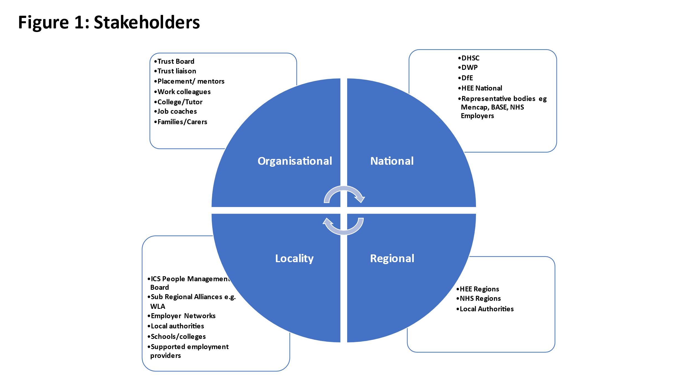
4.2 National Level
The Department of Work and Pensions contributes to the funding of programmes through the ‘Access to Work’ scheme, with the aim of supporting disabled people start or stay in work. A few sites (for example HHFT) reported this funding as a crucial component of programmes, others noted difficulties in accessing it. DWP provides support through its Jobcentre Plus service connecting to vacancies in the local area and as a possible source of young people with disabilities for traineeships (see OUH). Benefit support administered through the department also plays an important part in incentivising (or not) different life choices for these young people and their families.
The Department for Education (DfE) is heavily involved in the regulation of education and associated development pathways for young people with learning disabilities including transition into adulthood. Indeed, the DfE has at various times provided ‘seed corn’ funding to support young people with disabilities: for example, between 2014-18 DfE made available two grants of between £40-80,000 to all local authorities (depending on authority size) to encourage the growth of supported internships.
The Department of Health and Social Care engages with supported employment principally through NHS England/Improvement and Health Education England, NHS England/Improvement’s contribution to the employment of young people with disabilities has been limited. In 2015, it launched the Learning Disability Employment Programme (LDEP) and sought to encourage Trust engagement through a Learning Disabilities Pledge. Building on a commitment in the Five Year Forward Plan, the NHS has more recently launched a Workforce Disability Equality Standard (WDES), comprising a series of metrics against which Trusts can benchmark their performance in this domain. However, the WDES, in particular, barely touches on the notion of supported employment and few of the Trust interviewees covered in our study pointed to the LDEP or the WDES as stimulating or underpinning their supported employment programmes.

Health Education England has played a more direct and meaningful role in the development and implementation of supported employment programmes:

- HEE strategy and framework documents, for example, Talent for Care and Widening Participation strategies, have raised the profile of supported employment programmes.

-HEE has helped resource programmes, particularly through both national and regional funding (for example the supported apprenticeship programme at HHFT had benefitted from national funding and the traineeship at OUH).

-HEE became the provider of Project Choice in 2017, a programme taken up by three of our case studies Trusts (WLT, HHFT and NUTH).

At the same time HEE resourcing has inevitably been time limited and consequently restricted in scale. The adoption of HEE Project Choice programmes by Trusts has been growing but remains modest. In interviewing regional HEE TfC/WP leads there was an undoubted enthusiasm for supported employment programmes but an uncertainty about how they fitted within their portfolio of activities.

4.3 Local System and the Employer Levels

4.3.1 Themes

At the level of the local health and social care system, our pattern of interviews took us both to the local authority in the form of Liverpool County Council, and to partnerships of such authorities, in particular the West London Alliance (WLA), a network of seven London Boroughs. The WLA is pursuing a ‘programme of collaboration and innovation to improve outcomes for West London’, centred on employment and skills along with other issues including housing and transport.

There were striking similarities in the approaches adopted by LCC and WLA to supported employment programmes. In both cases:

- The initial stimulus for action on supported employment was provided by the DfE ‘seed corn’ grant noted above, used to develop the infrastructure for the roll out of programmes.
- A dedicated role was established to take this agenda forward.
- The supported employment programmes in these two localities initially cut across all sectors -health and non-health - in the respective catchment areas. This deepened the pool of employment opportunities available to interns on graduating; leveraged and pooled expertise; and created role models for other employers.
- There were focused attempts to establish supported internships within the local NHS Trusts, based on a recognition that Trusts:

  - were invariably a major employer in the catchment area.
  - had the capacity to host a scheme and provide employment going forward.
  - were a microcosm of the economy with scope to offer a diverse range of in-work experiences.

In both the LCC and WLA catchment areas there were concentrations of Trusts adopting both the DFN Project SEARCH and HEE Project Choice programmes.

4.3.2 Drivers and Connections

For LCC and WLA (with its constituent authorities), there were multiple factors encouraging the introduction of supported employment programmes. For example, in WLA supported employment became linked to a ‘economy and skills’ agenda centred on a notion of ‘inclusive economic growth’. There was also an ongoing local authority interest in how to use the significant funding devoted to young people with disabilities in a cost- efficient and -effective way.

As an initiative taken forward within the local economy, the setting up a supported employment programme at local systems level was, however, a complex and challenging process. As Figure 1 above indicates there are at least three different actors at the locality level- the local authority, the school/college and the supported employment provider (the latter providing programme models and resources). These three actors need, in turn, to connect to a fourth, the employer or Trust, hosting a programme.

As implied by Figure 2 below, the initial impetus for a programme can come from any one of these four main actors. However, Figure 2 also indicates the difficulties faced by local authorities and NHS employers in connecting with one another. Thus, in these respective organisations key points of contact are likely to be diffuse, in different and disparate departments and teams. Navigating through and to these contact points is a far from straightforward process, requiring knowledge and understanding of who to approach, when and for what purpose.

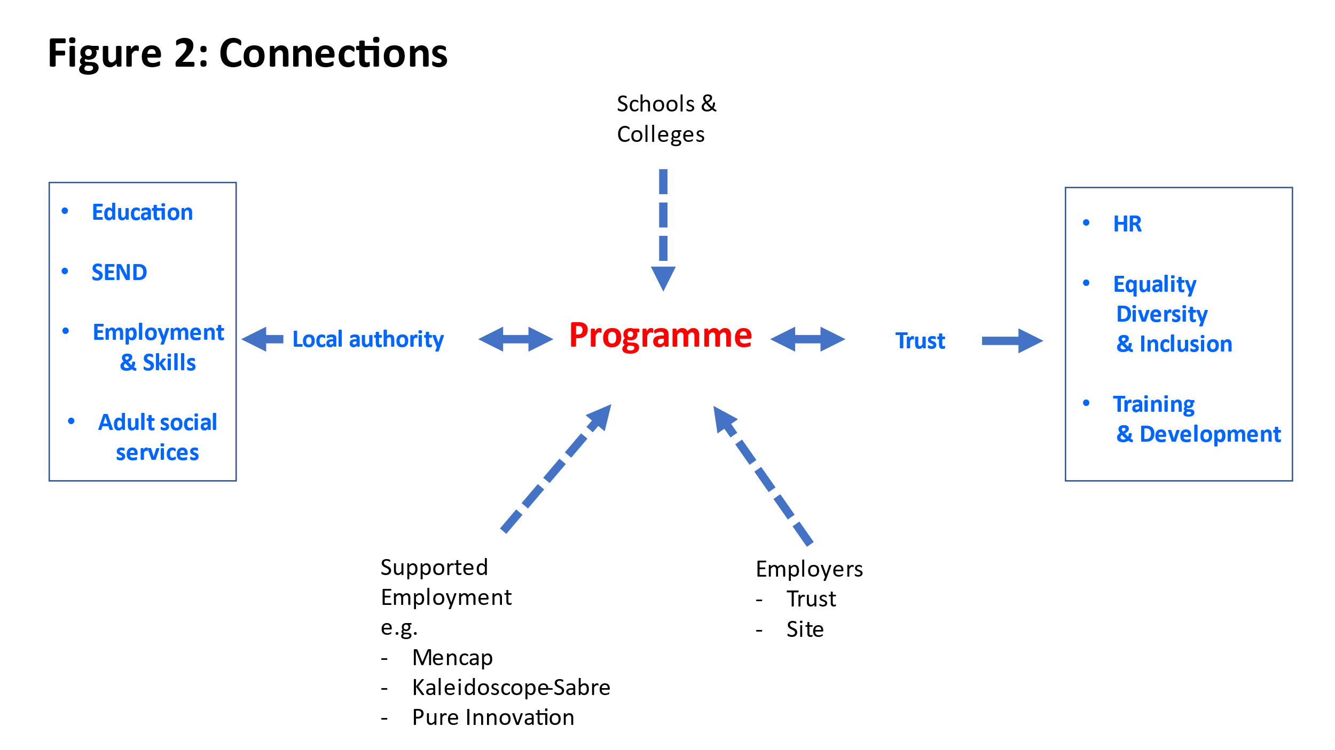
5. Delivering Supported Employment at Trust Level

5.1 The Development Cycle

Drawing upon the development cycle for supported employment programmes set out in Figure 2 below, this Chapter is the core of our report. It examines the introduction, challenges and operation of supported employment programmes in our ten case study Trusts.
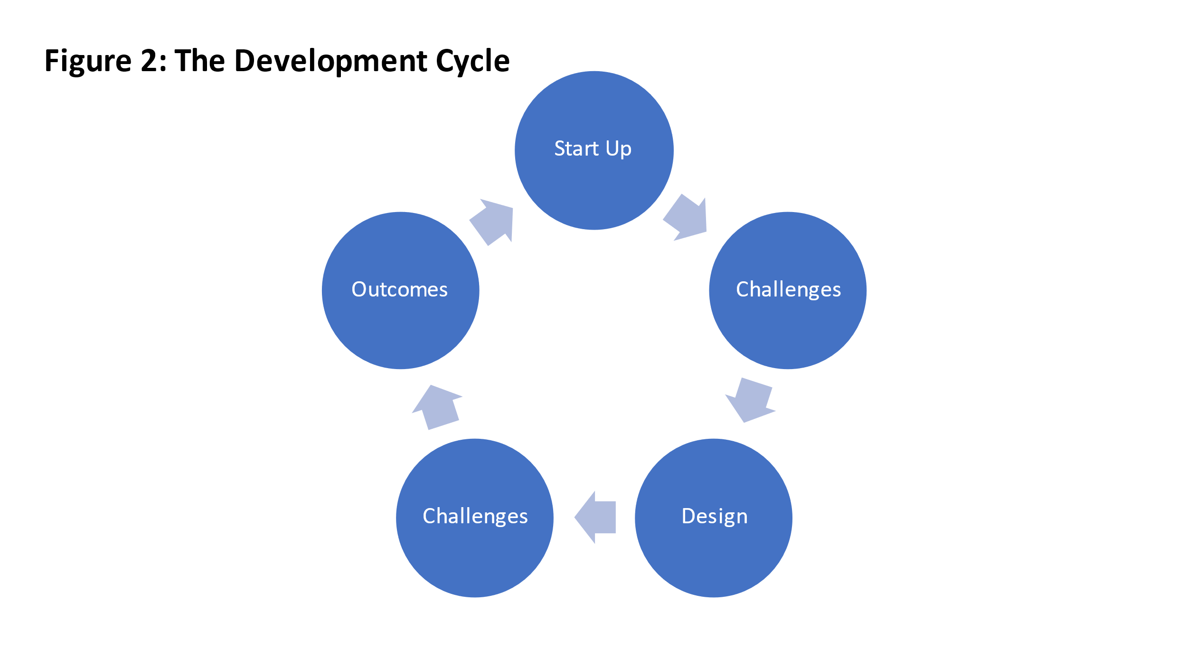

5.2 Start-up

Every supported employment programme has its own ‘creation story’ comprising two main parts:
- procedural – how the scheme was initially introduced; and
- substantive – why it was introduced.

5.2.1 The How

Some of our case Trusts were driven to introduce a supported employment a programme on the initiative of a particular stakeholder with a singular enthusiasm for the intervention. This proactive stakeholder could come from outside the Trust: for example, in the case of MYHT the driver was a local special school and attention has also been drawn to the role played by LCC and WLA in this respect. As commonly, the spark came from within the Trust, often from a postholder within the HR Directorate able to connect to a more senior manager with a shared passion for the prospective programme.

While most of our cases sought sign-off for their programme from the Trust board, these champions were sometimes able to take the programme forward ‘below the senior management radar.’ Such a low-key approach was possible given the absence of significant upfront direct programme costs to the Trust. In essence supported employment programmes were self-funding, with education and job coaching costs covered by monies associated with an EHCP. On-going resourcing could however be an issue. The need for a dedicated NHS in-house programme facilitator or co-ordinator, for example, was highlighted as crucial by many interviewees. There were other costs associated with programmes: in the case of DFN Project SEARCH the use of a base room and more generally in the case of supported internships, the time and commitment of mentors in job placements.

5.2.2 The Why

Two sets of underlying reasons for introducing a supported employment programme can be identified: ‘Hooks’ – the initial attraction- and ‘Slow Burners’- the benefits emerging more incrementally over time.

- Hooks

Hooks included:

- Symbolism

A supported employment programme could be seen by Trusts as a signal, typically to outside stakeholders, that the organisation is addressing the issue of inclusion. This is problematic if it renders the programme tokenistic, but more typically, what starts as a tokenistic exercise can quickly lead to an enthusiastic embrace of the scheme as slow burn benefits emerge (see below).

- The Social Responsibility Argument

A similar dynamic was at play at Trusts where weight was placed on the social responsibility case for supported employment: it was seen as ‘the right thing to do’, but quickly gave way to an appreciation of the scheme’s more tangible value to the host:

- Developing a Representative Workforce

Some Trusts viewed the take-up of supported employment as a means of establishing a workforce more representative of their local community.

- Creating a pathway of career development opportunities for young people with SEND

Two of our Trusts had explicitly linked supported employment interventions, creating a pathway of development opportunities for young people with disabilities. At WLT the established HEE Project Choice work experience programme was adapted as a feeder into its internship programme. At HHFT, the focus was on the connection between an HEE Project Choice supported internships and supported apprenticeships as a means of creating a pathway into full time. employment. This involved selecting an appropriate apprenticeship standard- in this case the level 2 Customer Services Practitioner standard- and the appointing of Trust staff dedicated to providing the additional learning support required by the apprentices.

- Slow Burners

Slow burner reasons are mainly considered later in the report as organisational outcomes. However, a few are worth briefly noting here:

- The Business Case

The Business Case argument is typically a cost-benefits analysis of a supported employment programme designed to establish its contribution to the organisation. It can be a powerful ‘hook’. However, it is equally noteworthy that the business case often only becomes apparent after the programme begins to generate unforeseen positive outcomes for the host organisation.

Other ‘slow burner’ reasons (to be elaborated below) include:

- Changing organisational culture.
- Bringing distinctive capabilities.
- Addressing staff vacancies.
- Establishing a talent pipeline of committed and enthusiastic employees.
- Positively impacting on staff morale.

5.3 Challenges

The challenges facing supported employment programmes in our case study Trusts ranged from simple inconveniences, readily overcome, to profound systemic challenges, often deeply engrained. The substantive challenges included the following:

- The base room: Of particular importance to DFN Project SEARCH, finding space for a base room in a busy hospital, with many demands on space, was not always straightforward.
- The practicalities of induction: Checks and identification for procedural purposes could be difficult where interns lacked basic documentation.
- Organisational change: Trusts are complex organisations, regularly subject to re-structuring with the potential to disrupt placements and the management of placements.
- Trust liaison contact: The smooth running of a programme often rests on the relationship with the Trust’s liaison contact and how well connected that individual is with the rest of the organisation.
- Placements: The availability of a range of job placements is essential to any supported employment programme and particularly internships. In the early days of a programme this is often where the main efforts of organisers lie. Given the responsibility and commitment required from work areas to take on interns, the absence of problems in finding and maintaining these placements in our case study Trusts was striking. It suggests a willingness at workplace level to embrace programmes. At the same time, various issues associated with placements were raised by our Trusts. For example, hosts organisations sometimes prejudged the appropriateness of job placements for young people with SEND. Many of the placements in our case Trusts were in facilities and estates (for example, portering, catering, cleaning). At the same, in most cases placements were to be found in a diverse range of settings, including clinical and highly technical ones. Indeed, the development of placements fitting the needs and interests of the young person with disabilities, was widespread in the cases. This was sometime reflected in a ‘job carving’ process, the bespoke design of placements and jobs to fit the skills and interests of the young person.
- Addressing Affective Needs
The emotional needs of young people with disabilities could be significant, with resource implications for managing them. To a large extent the main programmes –DFN Project SEARCH and HEE Project Choice – built this into their models, with a rich intern-job coach ratio. But the needs of interns with ’complex lives’ could go beyond those centred on the job.
- Engrained Attitudes and Fear of the Unknown
Uncertainty about supported employment, amongst employees in the host workforce could lead to an initial reluctance to engage with a programme. Open and direct communication and the provision of ‘myth-busting’ information was sometimes needed to address this uncertainty.
- Low Aspiration and Expectations
The most endemic and deep seated of challenges faced by supported employment programmes lay in the low aspirations and expectations held by and for young people with disabilities. Systemic low ambitions radically undermine the young person’s sense of self-worth and can negatively influence: the willingness of an employer to introduce a programme; the orientations of the family and the young people themselves as they engage; and their employment prospects going forward. The cause and effect of such low aspirations for young people with SEND were partly to be found in a skewed benefits system often incentivising the suppression of aspiration and expectation but also in an education system often assuming low achievement and employment as an unlikely option.

5.4 Impact

A basic distinction can be drawn between person- and organisation-centred outcomes from supported employment programmes. As an example of the person-centred outcomes are the health and broader quality of life benefits associated with employment for young people with SEND. An organisation-centred outcome includes the capacity of programmes to change an organisation’s culture in myriad positive ways (see below). Indeed, such programmes can create ‘win- win’ situations. Thus, good health not only benefits the young person but the community more generally as that person contributes to the local economy and draws less on its scarce health and social care resources. In this section we explore these various outcomes.

    - Jobs

The supported internship programmes delivered by our case Trusts were largely successful in finding jobs for participants. Whilst not the only possible career outcome- graduates could also go onto voluntary work, programmes of further education and development- full-time employment was ‘hard-wired’ as the default outcome of such programmes. DFN Project SEARCH set a target of around 60% of graduate interns moving into employment and in the main our case Trusts with DFN Project SEARCH (and HEE Project Choice) programmes were achieving this goal. Many of the jobs secured were within the host Trust. A key plank of the business argument for supported internships rested on interns as a previously neglected but valuable source of committed and enthusiastic labour, with lower turnover and sickness absence, and able to take up often hard to fill posts.

At the same time, a proportion of interns were moving to employment in other organisations, in part reflecting the preferences of graduates but also the contracting pool of jobs in host Trusts, particularly those running with a programme over many years. Notwithstanding the success in finding jobs, a few additional points on finding employment are worth noting:

  - Different employer approaches. There were Trusts strongly wedded to the value of interns as a source of employment, routinely ring-fencing jobs for them at the end of programmes. However, other Trusts viewed their contribution as exclusively resting on the provision of the training without any necessary commitment to providing future employments.
  - Intrinsic to the programme. Interviewees stressed the importance of focusing on job seeking from the outset of the programme rather than leaving this to the end when the process might be rushed.
  - Recruitment and Selection. Many of those interns who find jobs with the host Trust are already well known to it through the programme and indeed are often offered or encouraged to apply for a post. At the same time, many of our Trusts made ‘reasonable adjustments’ to the recruitment and selection process to facilitate employment, including:

      - A preview of the interview questions.
      - A written copy of the questions to refer to in the interview.
      - Bringing a supportive worker into the interview.

One of the most noteworthy adjustments was the working interview, taking place at the young person’s workplace and as they are doing their job. This allows the applicant to remain in a familiar environment while raising the visibility of their work-based capabilities and allowing them to be more easily referenced.

Notwithstanding these adjustments, difficulties remained with aspects of the recruitment process. In the NHS, indeed in most employing organisations now, applying for a job is typically an online process with technical support for many young people with SEND on supported employment programmes routinely required.

The basics of creating a job description (JD) can also be a procedural challenge, particularly in the context of ‘job carving’ which might require a new and dedicated JD. More generally, the job description often retains standard elements, such as ‘work experience’, which for these young people, new to the labour market, might find difficult to meet. Indeed, questions were raised about the sensitivity of the organisation’s recruitment and selection processes to the values of commitment, enthusiasm and innovation, typically found in young people with SEND. Sometimes difficult to pick up in a Trust’s existing selection procedures, these values were often closely aligned with those of the Trust and perhaps a better guide to employability than those criteria more routinely used, such as ‘work experience’.

  - Sustained employment

For the intern and other stakeholders, the most meaningful outcome is sustainable employment. As the interns move from the relatively sheltered environment of the programme to the more uncertain domain of work, it is a challenging outcome to achieve and often requires additional resourcing. HEE Project Choice commits to stay in contact with graduates and employers for up to five years after the programme. Follow on support for graduates of other programmes is less certain.

    - Apprenticeships

In this instance and in contrast to other interventions, the young person with SEND is taking up a position as a paid employee. As a progression route, apprenticeships can present specific challenges. In the case of HHFT attention was drawn to the resource intensive nature of this option. The new End Point Assessment (EPA) also throws up concerns, particularly centred on possibly intimidating procedures for the supported apprentices.

    - Organisational Change

In earlier sections exploring the objectives driving supported employment programmes we noted the capacity of such interventions to change organisational culture in positive ways. The presence of young people with SEND changes workforce attitudes towards this group- normalising their presence at the workplace and breaking down prejudices and myths. In a more general sense workforce morale can also be raised and attitudes to work shifted as the positive orientation of young people with SEND to work ‘rubs-off’ on the wider workforce. Moreover, there were various examples where young people on supported employment programmes had contributed to improvements in the delivery of a service. In one instance the simple presence of a young person was seen a calming influence on service delivery; in another the young person had the time and the capability to identify a hidden patient need – the desire for bottled water- and to take the necessary steps to meet it.

6. The Impact of Covid

6.1 General Response

Unsurprisingly Covid had heavily disrupted supported employment programmes, particularly supported internships with their reliance on extended job placements. Broadly, responses from lead national organisations have included:

- Calls for more intense collaboration and communication between partners and sites using established networks to share information and practice related to responses, so ensuring awareness of the programmes is sustained with stakeholders.
- Adaptation of programme design and delivery and the introduction of support mechanisms to deliver programmes in a Covid safe context and flexibly given restrictions and pressures. Examples included HEE Project Choice adapting their programme design and developing a wide range of new resources to be delivered face to face or remotely.
- HEE Project Choice developing a new virtual careers and work experience application designed for SEND students to be used during the pandemic and afterwards to reach larger numbers of schools and students.
- Updated Operational Planning and Guidance and new ways of operational working on sites. For example, HEE Project Choice had developed a comprehensive Operational Planning document on continued learning and adaptations sensitive to the challenges of Covid.

In addition, DFN Project Search had taken contingency steps, for example:

- Developing an ‘Autumn Curriculum’ including new ways of working for job coaches and educators.
- Encouraging each programme to develop a ‘Business Continuity Plan’ designed to ‘address possible scenarios and offer a variety of solutions’ in addressing them.
- Drafting a template plan centred on three such scenarios, where: base room capacity is reduced; students have difficulty returning to host employer sites; and placements have been reduced.
- Constructing a more detailed template for ‘Recovery Plans’ centred on preparing for returning to the host’, underpinned by objectives including:
  - Developing intern risk assessments
  - Organising family engagement sessions
- Addressing ‘the logistics of returning to the host’ with a focus on:
  - Covid testing
  - PPE requirements
  - Induction refresher
  - Pastoral care and safeguarding.

Summarising developments in our case study, it is clear from the Table 4 below that the impact of Covid can be considered in two parts:

- Interrupted programmes: where programmes were already in progress when Covid lockdowns struck.
- New programmes: where programmes were due to be launched during the pandemic.

Table 4: Supported Employment Programmes and Covid

MYHT | 2019-20 cohort:  - Academic content completed. No on-site placements. Three interns rolled forward to continue into 2020-21  2020-21 cohort:  - Went ahead with open day & recruited interns. Offered programme with learning but placements TBC.  - One site originally Covid free-planned placements, but a later upsurge postponed these..  - When interns returned, job placement priority for those who can’t continue for another year.  - More creative approach to job placement- other organisations/placements a few days a week.  - As an employment programme, job placement seen as essential.
RBT | 2019-20 cohort:  - Academic content completed.  - Those not completing placements rolled forward to 2021-22.  2020-21 cohort:  - Overlap between the two cohorts, so a slightly smaller 20-21 cohort.  - Reconvened for start of academic until latest lockdown.  - Given roll-over may skip intake in future year.
NUTH | 2019-20 cohort  - March to July no placements, alternative remote delivery in place (to replace first 2 points)  2020-21 cohort  - Cohort recruited.  - Overlaps with 19/20 cohort.  - Twice weekly lateral flow tests introduced.  - Interns plan return to college February 1st  - Full return to risk assessed covid secure placements planned March 8^{th.}  - All students offered vaccines.
LNWUHT | 2019-20 cohort:  - Interns stopped attending on site in March 2020 and the job placements stopped (halfway through 2nd rotation).  - All training was put on hold.  - Interns finish qualification on line.  - Third rotation back on site.  - Placements were risk assessed, reviewed and altered-to areas safe to work in without patient contact and Wards without covid and not in high-risk areas.  - 12 students. 2 left pre Covid. Of the 10 students, 8 returned on site and 5 have already found jobs.  2020-21 cohort:  - Cohort recruited.  - First term (Sept-Dec) off site based at the College, front loading the ASDAN qualification.  - Will allow 2 placements in following terms but ongoing uncertainty about return to site. An alternative hospital within the trust is hosting placements in the interim  - Family curriculum drafted to keep parents/carers informed.
LUHFT | 2020-21 cohort:  - Start of Project SEARCH 2020- decision to go ahead as planned.  - Facilities contractor pulled out placements because many staff shielding.  - Some in-house placements- e.g. outpatients- also withdrawn.  - went ahead with modified open day for 20-21 recruitment.  - 10 interns on Broad Green site Sept 2020 but no placements.  - Face to face training continued because interns arel classified as employees.  - First term combination of online and face to face learning.  - 2 placements not three planned.  - Classroom session re-arranged; masks and social distancing around hospital.  - Interns have been offered a Covid vaccination as part of the hospital staff. programme. Those with patient contact were prioritised first and all learners will have been vaccinated (first dose) by the end of January 2021.  - The programme lead did the vaccinations (she is a trained nurse) and their Tutor stayed with them to support them too.  - Job proposed (although not instituted) - Covid Janitor.
WLT | Work experience:  - Off site since Covid March 2020.  - Kept in contact with school and sent material for activities for students and Trust offered to come onto their site.  2020-21 cohort:  - Recruited 10 interns.  - Worked through the summer keeping in touch.  - September 2020 front loaded all the education so could concentrate on work placements after the new year.  - From Jan 2021 two out of 10 on placement- admin areas.  - The rest will drip feed from Jan through rest of year to get their hours on site.  - Extra work in classroom working on CVs, mock interviews/Maths and English up to Jan when take exams.
HHFT | - No placements.  - Distance learning.
MFT | - No placements.  - On-line learning.  - Diverted onto other projects e.g. fund raising for Trust.
OUH | - No Placements since March 2020.  - Continued learning.

.
6.2 Interrupted Programmes

With most supported employment programmes following the academic year, the first, March 2020 lockdown fell towards the end of Term 2 during the 2019-20 cycle, around two thirds of the way through the programme. In all of our Trusts on-site activities, including job placements, largely ceased. In some cases (for example RBT) most of the academic work had been completed. Elsewhere learning continued online. Often Trusts sought to retain contact with young people: for example, WLT remained in touch with work experience students by providing them with activities and exercises.

With interns missing their third placement, a few Trusts (NUTH, MYHT, RBT) were keen and able, with local authority support, to roll over some of their participants into the next academic year so securing them a final rotation. With these Trusts continuing to recruit interns for 2020-21, this resulted in two cohorts notionally being ‘on the books’ for the first term in the new academic year. At the same time, many of the 2019-20 interns had been through two placements, rendering some job ready. Indeed, in one case (Northwick Park) it was even possible to return interns on site in July with some success in finding interns jobs on completion.

Moreover, attention was drawn to ‘reverse job fairs’ in certain DFN Project SEARCH Trusts in London, where rather than prospective employers setting out their stall to attract future employees, the interns themselves showcased their capabilities and job readiness online. Some Trusts were able to find jobs for their 2019-20 interns, at times in areas of employment emerging in the context of Covid: for example, at NUTH four interns found jobs in a new Covid testing centre and at LUHFT a new job role of ‘Covid Janitor’ was proposed for one intern at Broad Green (although not eventually instituted).

6.3 New Programmes

Even during 2020 many of our case Trusts continued to recruit young people with SEND to their 2020-21 academic year programmes. In two Trusts- LUHFT and WLT- this was the first year, respectively for their Project SEARCH and HEE Project Choice programmes. WLT had continued to keep in touch with its prospective interns and their families following their selection earlier in the year, preparing them for and briefing them on the programme. As the new academic year started in September 2020, there was a slight relaxation of the national lockdown before movement into the tiered arrangements in November. In most Trusts students turned up at the start of the programme. However, the availability of job placements was narrowing at this time.

Involvement in 2020-21 programmes was, however, short lived. With the full lockdown from early January 2021 most job placements, went on hold. In general, there was a front loading of the educational component of the programme, with the online/distance system developed during the previous academic year.
In some cases, new learning and off-site work centred activities were developed: for example, at the Wythenshawe site of MFT, interns worked on a fund-raising project to recruit more dementia nurses. The most striking initiative was being developed at WLT, where working with a software company the Trust was seeking to develop a virtual work experience programme, adapted for ‘mainstream’ students with scope to extend it to young people with SEND.

At the time of our fieldwork, England was still firmly in lockdown, with new peaks in infections and hospitalisations, and consequently the future of this year’s programme, especially in terms of placements, was in doubt. It was stressed at national level that given the employment-centred nature of DFN Project SEARCH two placements were really required to meaningfully complete the programme.
At the time of writing and with all due caution, the situation for programmes and their placements appears much more positive, indeed in some Trusts interns have received vaccinations as part of the broader programme for all NHS staff allowing them to return to their work sites (see for example LUHFT).

Interns able to complete a placement in the first 2020-21 term might well be able to still complete two of their rotations, raising questions as to whether in some Trusts they will again be offered a roll-over term to acquire their third. Amongst those yet to complete any placements, the situation is more uncertain. Certainly, West London Alliance Councils have been considering options going forward to address the challenges associated with Covid to ensure that interns get the support they need to progress and host organisations can manage the impact on the cohorts coming through for the 2021-22 academic year.

7. Summary and Recommendations

A host of community actors have a stake in the employment of young people with disabilities. Most obviously the young people themselves, their health and life chances crucially impacted by their employment opportunities, but also: their families and carers, with an affective commitment to the young person’s present and future well-being; national and local policy makers responsible for resourcing their care and support; and employers and employees for whom these young people remain a potential source of valuable and valued labour.

Yet despite the self-evident personal, organisational and community gains from employing young people with disabilities, the proportion in paid work remains strikingly low, indeed for those with learning disabilities at well below one in five. Why is there such a disconnect between the high societal value of employing young people with disabilities and the low numbers in employment? A disconnect which the shadow of Covid threatens to deepen as labour market opportunities tighten.

As a self-proclaimed ‘good employer’, most recently re-framed as an ‘anchor institution’, with socio-economic responsibilities to its constituent local communities, the NHS has long been sensitive to the needs of young people with disabilities. A traditional emphasis on widening participation, taken-on by Health Education England and most recently overlapping with its Talent for Care agenda, has articulated commitment to the inclusion of these young people in the healthcare workforce. This has been underpinned more tangibly by resourcing and support for such an agenda, most strikingly illustrated by HEE taking on the role of Project Choice provider in 2017. This specific internship and work experience scheme sits alongside other providers of such supported employment programmes in the NHS, for example DFN Project SEARCH, and initiatives which have focused on traineeships and apprenticeships.

Yet for all the impressive resourcing and effort underpinning these activities, the number of supported internships in NHS England stands at barely more than three dozen from over two hundred Trusts. Indeed, for the majority of healthcare employers, the question is not so much how do we protect supported employment programmes for young people with SEND in the context of Covid, but how do we get started in the first place and in more challenging circumstances?

In talking to actors with a stake in supported employment programmes- work experience, traineeships, internships and apprenticeships- and in focusing on Trusts willing and able to adopt one or more of these programmes, our study has sought to provide some insight into the introduction and development of such programmes. In so doing we have also sought to signpost the reader to advice and guidance on such issues.

The paucity of supported employment programmes in the NHS no doubt reflects, in part, the diversity of actors with a stake in their implementation. The report highlights the interaction between these actors within and across different parts and levels of the NHS, and the complexities associated with bringing them together. The challenges faced by our case Trusts in adopting and operating programmes, ranging from the detailed practicality to the profoundly systemic, undoubtedly remain daunting. Yet in the main these challenges have been managed and addressed, allowing the Trusts to realise the benefits of initial hooks and slow burner aspirations which attracted them to these programmes. The cases highlight the capacity of programmes singly or in combination as a linked development pathway, not only to improve the life chances of the young people with SEND but to: develop workforces that more clearly reflect the demographics of their local communities; generate a supply of enthusiastic, committed and sometimes uniquely capable employees; and nurture more open, inclusive and innovative work cultures.

Striking in discussing the recent pandemic was not the way Covid had undermined and weakened supported employment programmes, but the way Trusts had fought to retain and adapt them, ensuring their survival post-crisis. Why fight so hard to retain schemes if their benefits were not proven and guaranteed? However, breaking through stereotypes and unconscious bias to introduce a scheme remains a challenge. Indeed, it was often only once implemented and experienced that the benefits of schemes became fully appreciated by key organisational actors. Too often schemes were introduced as a ‘leap faith’ on the back of efforts from one or two organisational champions with a passion for such programmes. In setting out the views and experiences of ‘good practice’ Trusts, this Report was designed to render supported employment schemes less a ‘leap faith’ and more a planned and routine part of the inclusion agenda in all NHS Trusts.

To facilitate this process further we set out below a series of recommendations which in line with the structure of our report are related to levels of the NHS system involved in the implementation of programmes:

National Recommendations

- NHS Arms-length bodies should work together, and with other government departments. to produce an NHS supported employment strategy and plan to achieve the NHS Long Term Plan aspiration of substantially increasing opportunities to work for people with disabilities in the NHS. This strategy should include:

- Revision of The Workforce Disability Equality Standard to include a metric associated with the number young people with disabilities involved in supported employment programmes.
- A requirement of Trusts to report on the number of places provided on supported employment programmes in their annual Equality Report (including nil responses).
- Contract tenders should require all potential contractors to participate in supported internships programmes (by offering job placements) being delivered by the contractor Trust or other NHS body.

- NHS Employers, NHSEI or HEE should develop a single on-line central resource available to all NHS employers, which collects ‘reasonable adjustments’ made by Trusts to allow the recruitment, selection and employment of young people (and adults) with disabilities. This resource could also sign-post employers to general information, advice and guidance in respect of supported employment.

- HEE should routinely collect (if it does not already) the number apprentices with SEND and regions should routinely review their numbers.

- A HEE/NHSEI led working party should be convened to explore whether and how supported apprenticeships might be developed by Trusts. This should include exploring more secure forms and sources of funding.

Recommendations for the regions

- Working through their People Boards, regions should devise and deliver medium term plans linked to national policy, to expand supported employment opportunities in their areas.

- HEE and NHSEI regions should collect information on supported employment programmes amongst the Trusts and other employers in their area. This should serve as a platform for facilitating the development and expansion of these programmes.

- The HEE regions should use their appropriate networks - work experience and apprenticeship - to promote such programmes in a sharper and more proactive way.

Recommendations at ICS level

- Aligned to regional plans, ICS People Boards should agree an overarching supported employment strategy and set system wide outcome-driven targets, such as the number of supported internships and employment rates. This strategy should be incorporated within ICS objectives in terms of health inequalities and supporting people with disabilities and wider workforce planning interventions such as school’s engagement.

- Create an ICS SEND system-wide group(s) that bring stakeholders together including social care employers, councils and supported employment agencies. This will allow the sharing of expertise and pooling of resources. (Attached as an Annex is a case study of a developing systems approach in North West London)

- Develop an “end-to-end” approach to supported employment that includes careers information, advice and guidance and in-work development through apprenticeships. The approach should also encompass inclusive recruitment and selection processes.

Recommendations for employers

- Aligned with the ICS supported employment strategy and plan, Trusts should connect with relevant stakeholders in local authorities to deliver employment and work experience opportunities locally.

- Annually ring fence a minimum number of posts/vacancies and work experience opportunities (including apprenticeships) that could be filled by young people with disabilities.

- Communicate across the organisation the benefits of supported employment and celebrate success.

- Dedicated posts should be identified to develop and manage supported employment programmes and work with local and regional stakeholders.

- All NHS staff should receive training on understanding autism, learning, sensory and physical impairments.

This summary provides key points from a full report separately available.
The authors would like to thank Health Education England for funding this project and all those who gave their time by participating in it. Given current work pressures in the NHS, participants were particularly generous with their time. Any errors or misinterpretations are those of the authors alone.
CBP-7540.pdf House of Commons (2020) Disabled People in Employment, Briefing Paper, August, London: Commons.
ONS, 2019
Coronavirus and the social impacts on young people in Great Britain 3 April to 10 May 2020.pdf
NHS England » NHS Long Term Plan p50
The full report includes a section reviewing the literature in disability and employment.
About Supported Employment | British Association for Supported Employment (base-uk.org)
Microsoft Word - Creating an Inclusive Apprenticeship offer 16 01 2 (publishing.service.gov.uk)
Paul Maynard taskforce recommendations - GOV.UK (www.gov.uk)
Hft | Empowering individuals | Supported employment
C+K Careers | High Quality Careers Services for Young People and Adults
Project SEARCH Royal Berkshire Hospital, Craven Road, Reading (2021) (findhealthclinics.com) 2019 delivers another milestone graduation ceremony for Royal Berkshire Hospital’s Project SEARCH students
Supported Employment Services, South East England - Ways into Work
Home - Pure Innovations
Supported internships | Mencap Traineeships | Mencap
NHS England » NHS Learning Disability Employment Programme
Employing people in the NHS with learning disabilities - NHS Employers
wdes-2020-metrics.pdf (england.nhs.uk)
Talent for care | Health Education England (hee.nhs.uk)
West London Alliance | Improving outcomes for over 20 years (wla.london)
Date (london.gov.uk)

