What Can I Claim For?
  - A Guide for Finance for HCPC Returners
Version 9.2, 11 October 2023

Introduction
NHS England’s (NHSE) Return to Practice HCPC Programme has been developed to support returners and practitioners to update their skills to maintain or renew their HCPC registration.

This guidance is designed to inform the returner about what they are eligible to claim for from their out-of-pocket expenses budget.

NHSE reserves the right to decline any claims that are not eligible within the current guidance.

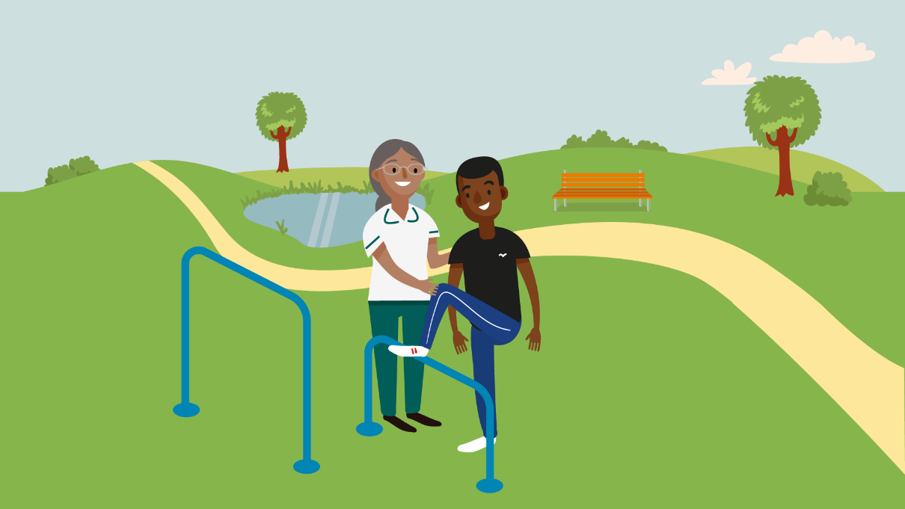

Eligibility Criteria: Returners
NHSE will reimburse up to £800 out of pocket expenses to support those registered on the NHSE Return to Practice Programme. You will need to claim via Selenity and include receipts or proof of payment (e.g. screen shot of payment being made from online bank account) for all claims, with the exception of mileage.

Claims need to be made within 28 days of the expense.
Please email england.r2pahp-hcs@nhs.net if there is a problem with submitting your claim within this timeframe.

Please note there is a minimal claimable amount of £10 at one time. If your claim amounts to less than £10 please submit multiple claims together until this threshold is reached.

Please allow up to 14 working days from the day you submit a ‘Selenity’ claim for payment to reach your account.

Sign up to the NHSE HCPC Return to Practice Programme - You will be assigned a unique NHSE Return to Practice Reference Number.

Returner will be invited to access the SharePoint Platform via email once they have signed up to the programme.

The SharePoint platform has details of how to create a Selenity Account and How to Create a Claim (please remember to check your junk mail for emails from Selenity).

All expenses (other than mileage) require a receipt to be submitted as evidence of your expense. For mileage you need to include the reason for your journey.

Claims should be submitted within 28 days of the date of expense. Should there be a problem with submitting expenses within this timeframe please email england.r2pahp-hcs@nhs.net

Claim then goes to checker for ‘Checker’ to approve - make sure limit of £800 overall is not exceeded. Then it goes to the’ Approver’ for final sign off

Claim goes to the Finance Team and is then paid via BACS payment into your nominated bank account.

Formal Study
Every expense item claimed for must be accompanied by a receipt or proof of payment.

Eligible Expenses
- ‘Formal study’ is a period of structured study which is provided by a person or organisation. This can include distance learning or e-learning, or any other type of course or programme that is relevant to your practice. Types of formal study that you might choose to take could include:
  - ‘Return to practice’ programmes run by educational institutions or other bodies;
  - relevant continuing professional development (CPD) courses;
  - relevant modules or elements currently included in programmes run by educational institutions; or programmes offered by professional bodies.

Non-eligible Expenses
- The funding is not designed to advance your scope of clinical practice. The aim is to provide funding for courses that will enable you to refresh and update skills and knowledge to meet the minimum requirements to register with the HCPC.
- NHSE will not fund courses that occur after HCPC registration has been applied for.

Overnight Accommodation
Every expense item claimed for must be accompanied by a receipt or proof of payment. All claims must be made within 28 days of expense.

Eligible Expenses
- Overnight accommodation up to £120 per night outside of London and £150 per night in London) to allow the returner to undertake relevant updating as part of their RtP journey.

- NB: Meal allowances are payable where Returners are away from home for more than five hours and over 5 miles from home. The maximum claim is £5.00 for lunch. For evening meals, you must be away from home for 10 hours or more and can claim a maximum of £15.00). Alcohol cannot be claimed for.

Non-eligible Expenses
- Relocation costs borne by the returner to allow them to undertake the RTP process.
- Additional accommodation costs e.g. use of minibar.etc.

Travel
Travel and parking claims can be made for all placements, paid or unpaid. Every expense item claimed for must be accompanied by a receipt or proof of payment. All claims must be made within 28 days of expense.

Eligible Expenses
- Travel relevant to updating of skills and knowledge e.g., to a course venue or to and from supervised placement from home location. This includes the use of public transport such as taxi, trains etc as well as private transport/own cars etc. Travel and parking claims can be made for all placements, paid or unpaid.
- When you self-register on the Non-Staff Selenity system please select the Mileage Interviewees option if you intend to claim for mileage (24p/mile).

Non-eligible Expenses
- NHSE cannot be held responsible for any parking or speeding fines.
- NHSE will not fund additional mileage whilst travelling on supervised practice placement. Driving between sites and/or patients’ homes and additional car parking charges incurred when on supervised practice placement should be claimed directly from placement organisations in line with their policies. They can use their placement support funding to cover this cost if they are an eligible organisation.

Placement Support
Travel and parking claims can be made for all placements, paid or unpaid. Every expense item claimed for must be accompanied by a receipt or proof of payment. All claims must be made within 28 days of expense.

Eligible Expenses
- Your funding can be used towards travel, uniform, childcare incurred as part of the clinical placement (up to the specified value of £800). You will need to provide name and proof of supporting organisation. Travel and parking claims can be made for all placements, paid or unpaid.
- Childcare: It has been acknowledged costs may be incurred to cover additional childcare to allow the returner to undertake placements (this can be taken form the overall £800).
- Parking: this will cover parking cost at the site of clinical placements, receipts required.
- Meals: To cover the buying of food and beverages to support clinical placements (NB: Meal allowances are payable where returners are away from home for more than five hours and over 5 miles from home. The maximum claim for lunch is £5).
- Uniform: Cost towards purchase of uniform if required - some placement providers will provide, please discuss with provider.

Non-eligible Expenses
- NHSE will not fund additional mileage whilst travelling on supervised practice placement i.e. to and from patients’ homes. We will also not fund additional car parking costs that occur within the placement hours beyond your initial base of work (e.g. you attend a second location during your placement day).
- Driving between sites and/or patients’ homes and additional car parking charges incurred when on supervised practice placement should be claimed directly from placement organisation in line with their policies. They can use their placement support funding to cover this cost.

Books/materials Relevant to Updating Professional Knowledge and Skills
Every expense item claimed for must be accompanied by a receipt or proof of payment. All claims must be made within 28 days of expense.

Eligible Expenses
- Items and materials relevant to your return to practice - e.g. textbooks, stethoscopes, nurse’s fob watches, essential technical equipment (e.g. Goniometer).

Non-eligible Expenses
- Please note that laptops, tablets, computers, mobile phones and any other IT equipment and consumables (such as printer ink or paper) will not be funded by the programme.
- Generic items such as water bottles, pens etc will not be funded by the programme.

Re-registration Fees
Every expense item claimed for must be accompanied by a receipt or proof of payment.

Eligible Expenses
- Claims for HCPC re-admission fee (currently £290.90) can be claimed to support returnees return to the register.

Non-eligible Expenses
- The HCPC registration fee for the two-year professional cycle (£196.24) (£98.12 per year) will not be funded.
- Tax on HCPC registration fee can be claimed back via HMRC
- Other professional memberships fees e.g., RCOT membership (some professional bodies offer reduced membership for returners).
- Tax on Professional body membership can be claimed back via HMRC.

Returnees receiving additional income support are advised to seek advice and understand the impact any additional payment may have.

NB: monies are not taxable and are being used to support the returnee in an education capacity. To ensure that all claims relate to education we will need to see receipts as proof of amount spent and items claimed for.

NHS England
Wellington House
133-155 Waterloo Road
London
SE1 8UG

This publication can be made available in a number of alternative formats on request.
© NHS England 2022 | PRref

