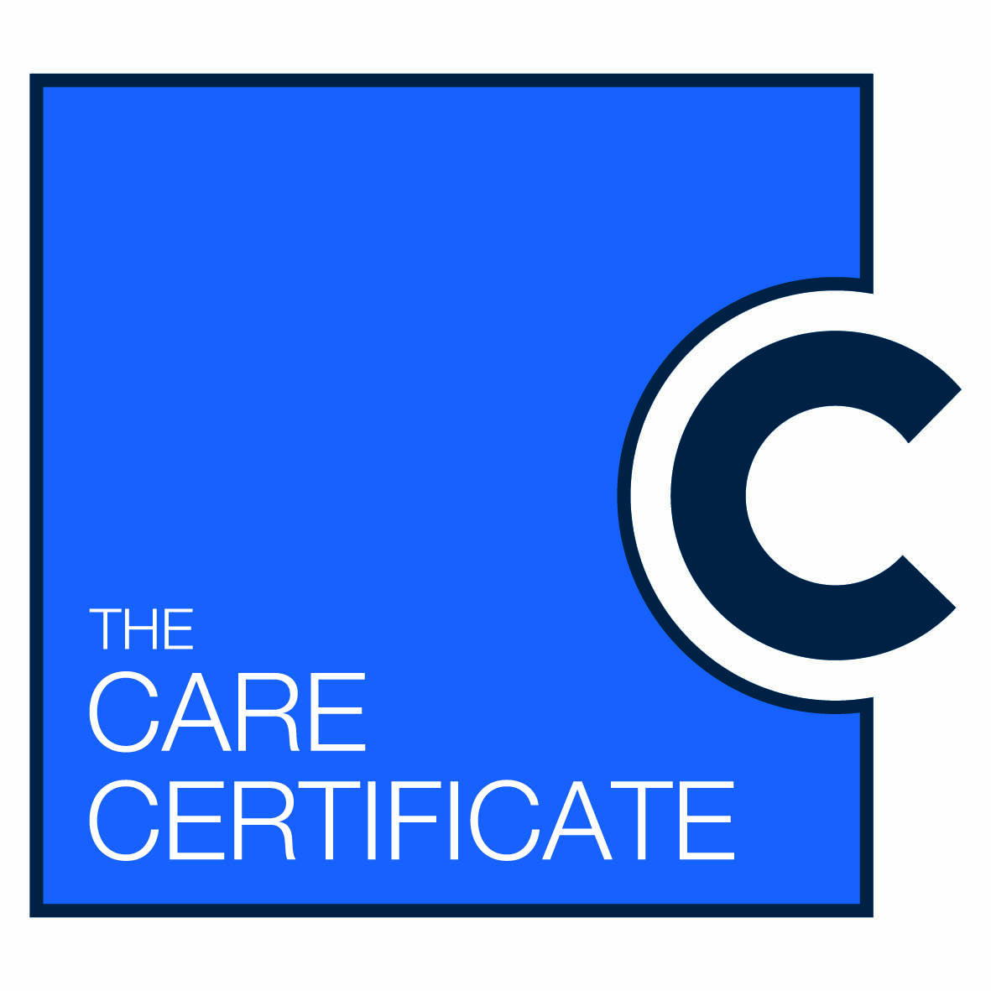**The Care Certificate**

**Rolling out in an area near you - April 2015**

From April 2015 any new Health Care Support Workers (HCSW) will be required to complete the new national Care Certificate training and assessment programme whilst being supervised in their area of work.

The Care Certificate aims to:

* Ensure that HCSWs that have direct patient involvement have the required values, behaviours, competencies and skills to provide high quality, compassionate care.
* Achieve competency sign off level of 15 standards of care in 12 weeks with support from classroom learning and direct line of supervision work place support and assessment.
* Holistic Assessment must take place in the work environment. Employers will need to demonstrate this Induction process for all new HCSW to meet CQC inspections from April 2015.

**This Programme will be rolling out in an area near you so if you require any further details please contact the lead for this in the Trust ***** or one of the Care Certificate implementation team:**

• Name

• Ext

• E mail

The programme is carried out in partnership with NHS Health Education England and:

